Національний технічний університет України «КПІ ім. Ігоря Сікорського»

Факультет Інформатики та Обчислювальної Техніки

Кафедра Автоматизованих Систем Обробки Інформації та Управління

Додаткова лабораторна робота

з дисципліни «Дискретна математика»

Виконав:

студент гр. ІС - 02

Плостак Ілля

Викладач:

доц. Рибачук Л.В.

Київ – 2020

### Зміст

Зміст 2

1 Постановка задачі 3

2 Результати виконання програми 4

3 Лістинг програми 5

### 1 Постановка задачі

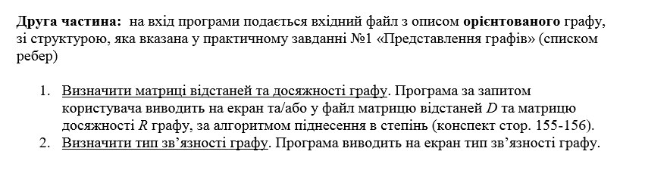

### 

### 2 Результати виконання програми

### Початок програми/пункт 4:

### 

Головне меню:

### 

Для Сильнозв’язного:

Граф:

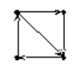

4 5

1 2

1 3

2 3

3 4

4 1

1) 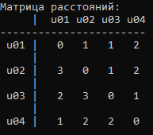

2) 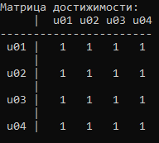

3) 

Для Одностороннєзв’язного:

Граф:

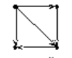

4 5

1 2

1 3

1 4

2 3

3 4

1) 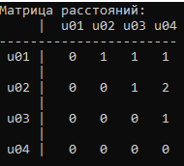

2) 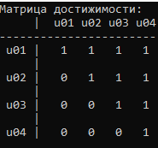

3) 

Для слабкозв’язного:

Граф:

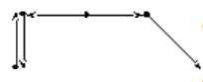

5 5

1 2

2 1

3 2

3 4

4 5

1) 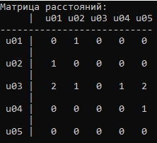

2) 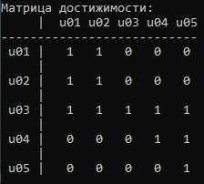

3) 

Для не зв’язного:

Граф:

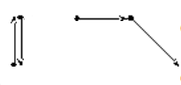

5 4

1 2

2 1

3 4

4 5

1) 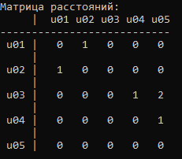

2) 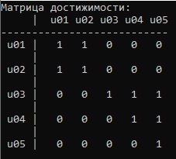

3) 

### 3 Лістинг програми

[main.cpp](https://github.com/feedblackg44/kpilabs/blob/master/LabDiskretka2.1/LabDiskretka2.1/main.cpp):

#include <iostream>

#include <math.h>

#include <limits>

#include <locale.h>

#include <iomanip>

#include "feed.h"

#include "functions.h"

using namespace std;

int main()

{

SetDefaults();

int edge,

apex;

int* Graph = GetGraph(&apex, &edge);

bool mode = GetBool("Введите режим в котором будет работать программа:\n1 - вывод на экран\n0 - вывод в файл", "Режим введён неправильно!", true);

string str_menu = "Добро пожаловать в программу работы с графом:"

"\n1 - Вывод матрицы расстояний"

"\n2 - Вывод матрицы достижимости"

"\n3 - Вывод типа связанности графа"

"\n4 - Сменить режим вывода"

"\n0 - Выйти из программы";

while (true)

{

system(ClearScreen);

int choice = GetInt(str_menu.c_str(), "");

system(ClearScreen);

int** matrix = MatrixOfDistance(Graph, apex, edge, mode, ORIENTED);

switch (choice)

{

case 1:

OutputMatrix("Матрица расстояний", matrix, apex, mode);

SystemPause();

break;

case 2:

OutputMatrix("Матрица достижимости", MatrixReach(matrix, apex, mode), apex, mode);

SystemPause();

break;

case 3:

ConnectivityType(Graph, apex, edge, mode);

SystemPause();

break;

case 4:

mode = GetBool("Введите режим в котором будет работать программа:\n1 - вывод на экран\n0 - вывод в файл", "Режим введён неправильно!", true);

break;

case 0:

exit(1);

}

}

SystemPause();

return 0;

}

[functions.h:](https://github.com/feedblackg44/kpilabs/blob/master/LabDiskretka2.1/LabDiskretka2.1/functions.h)

#pragma once

#define FileIN "./Graph_Weak.txt"

#define FileOUT "./Output.txt"

#define ORIENTED true

#define NON_ORIENTED false

int* GetGraph(int* apex, int* edge);

void PrintGraph(int* Graph, int size);

int** MatrixOfDistance(int* Graph, int apex, int size, bool mode, bool oriented);

void OutputMatrix(const char matrixName[], int** matrix, int apex, bool mode);

int** MatrixMult(int** matrix, int apex, int power);

bool IsThereZero(int** matrix, int apex);

int** MatrixReach(int** matrix, int apex, bool mode);

void ConnectivityType(int* Graph, int apex, int size, bool mode);

[functions.cpp:](https://github.com/feedblackg44/kpilabs/blob/master/LabDiskretka2.1/LabDiskretka2.1/functions.cpp)

#include <iostream>

#include <fstream>

#include <sstream>

#include <math.h>

#include <limits>

#include <locale.h>

#include <iomanip>

#include <string>

#include <vector>

#include "feed.h"

#include "functions.h"

using namespace std;

void PrintGraph(int* Graph, int size)

{

vector<int> GraphFirstNumbers(size);

vector<int> GraphSecondNumbers(size);

for (int i = 0; i < size * 2; i++)

{

if (i % 2 == 0)

GraphFirstNumbers[i / 2] = Graph[i];

else

GraphSecondNumbers[i / 2] = Graph[i];

}

cout << "Вот заданный граф:" << endl;

for (int i = 0; i < size; i++)

{

cout << GraphFirstNumbers[i] << " " << GraphSecondNumbers[i] << endl;

}

}

int* GetGraph(int* apex, int* edge)

{

ifstream inFile;

inFile.open(FileIN);

if (!inFile.is_open())

{

cerr << "Error: Could not open the file!" << endl;

SystemPause();

exit(1);

}

string str;

istringstream iss;

getline(inFile, str);

iss.str(str);

iss >> *apex;

iss >> *edge;

vector<int> Graph;

int length = 0;

while (getline(inFile, str))

{

length++;

int temp1, temp2;

istringstream iss_temp;

iss_temp.str(str);

iss_temp >> temp1;

iss_temp >> temp2;

Graph.push_back(temp1);

Graph.push_back(temp2);

}

for (int i = 0; i < Graph.size(); i++)

{

if (Graph[i] > *apex)

{

cerr << "Error: one of apexes is invalid!" << endl;

SystemPause();

exit(1);

}

}

if (length != *edge)

{

cerr << "Error: amount of edges is invalid!" << endl;

SystemPause();

exit(1);

}

int* temp = new int[*edge * 2];

for (int i = 0; i < *edge * 2; i++)

{

temp[i] = Graph[i];

}

inFile.close();

return temp;

}

int** MatrixOfDistance(int* Graph, int apex, int size, bool mode, bool oriented)

{

int** GraphSmezh = new int* [apex];

for (int i = 0; i < apex; i++)

{

GraphSmezh[i] = new int[apex];

for (int j = 0; j < apex; j++)

{

GraphSmezh[i][j] = 0;

}

}

vector<int> GraphFirstNumbers(size);

vector<int> GraphSecondNumbers(size);

for (int i = 0; i < size * 2; i++)

{

if (i % 2 == 0)

GraphFirstNumbers[i / 2] = Graph[i];

else

GraphSecondNumbers[i / 2] = Graph[i];

}

for (int i = 0; i < size; i++)

{

GraphSmezh[GraphFirstNumbers[i] - 1][GraphSecondNumbers[i] - 1] = 1;

if(!oriented)

GraphSmezh[GraphSecondNumbers[i] - 1][GraphFirstNumbers[i] - 1] = 1;

}

int h = 1;

int** matrix_res = new int* [apex];

for (int i = 0; i < apex; i++)

{

matrix_res[i] = new int[apex];

for (int j = 0; j < apex; j++)

{

matrix_res[i][j] = 0;

}

}

while (IsThereZero(matrix_res, apex) && h<=9)

{

int** temp_matrix = new int* [apex];

for (int i = 0; i < apex; i++)

{

temp_matrix[i] = new int[apex];

for (int j = 0; j < apex; j++)

{

temp_matrix[i][j] = 0;

}

}

temp_matrix = MatrixMult(GraphSmezh, apex, h);

for (int i = 0; i < apex; i++)

{

for (int j = 0; j < apex; j++)

{

if (temp_matrix[i][j] > 0 && matrix_res[i][j] == 0 && i != j)

{

matrix_res[i][j] = h;

}

}

}

h++;

}

return matrix_res;

}

int** MatrixReach(int** matrix, int apex, bool mode)

{

int** matrix_res = new int* [apex];

for (int i = 0; i < apex; i++)

{

matrix_res[i] = new int[apex];

for (int j = 0; j < apex; j++)

{

matrix_res[i][j] = 0;

}

}

for (int i = 0; i < apex; i++)

{

for (int j = 0; j < apex; j++)

{

if (i == j)

{

matrix_res[i][j] = 1;

}

else if (matrix[i][j] >= 1)

{

matrix_res[i][j] = 1;

}

}

}

return matrix_res;

}

void OutputMatrix(const char matrixName[], int** matrix, int apex, bool mode)

{

ostream* fout;

if (mode)

fout = &cout;

else

fout = new ofstream(FileOUT);

*fout << matrixName << ":" << endl;

for (int i = -2; i < apex; i++)

{

if (i == -2)

{

*fout << " | ";

for (int k = 1; k <= apex; k++)

{

if (k < 10)

*fout << " u0" << k;

else

*fout << " u" << k;

}

}

else if (i == -1)

{

*fout << "-------";

}

else

{

if (i < 9)

*fout << " u0" << i + 1 << " | ";

else

*fout << " u" << i + 1 << " | ";

}

for (int j = -2; j <= apex + 1; j++)

{

if (i == -1 && j >= 0 && j < apex)

{

*fout << "----";

}

else if (i >= 0 && j >= 0 && i < apex && j < apex)

{

*fout << matrix[i][j];

if (j + 1 != apex)

*fout << " ";

}

}

if (i >= 0 && i < apex - 1)

{

*fout << endl;

*fout << " |";

}

*fout << endl;

}

*fout << endl;

if (fout != &cout)

delete fout;

}

int** MatrixMult(int** matrix, int apex, int power)

{

int** outMatrix = new int* [apex];

for (int i = 0; i < apex; i++)

{

outMatrix[i] = new int[apex];

for (int j = 0; j < apex; j++)

{

outMatrix[i][j] = matrix[i][j];

}

}

for (int b = 1; b < power; b++)

{

int** tempMatrix = new int* [apex];

for (int i = 0; i < apex; i++)

{

tempMatrix[i] = new int[apex];

for (int j = 0; j < apex; j++)

{

tempMatrix[i][j] = outMatrix[i][j];

}

}

for (int i = 0; i < apex; i++)

{

for (int j = 0; j < apex; j++)

{

outMatrix[i][j] = 0;

for (int k = 0; k < apex; k++)

{

outMatrix[i][j] += tempMatrix[i][k] * matrix[k][j];

}

}

}

for (int i = 0; i < apex; i++)

{

delete tempMatrix[i];

}

delete[] tempMatrix;

}

return outMatrix;

}

bool IsThereZero(int** matrix, int apex)

{

bool result = false;

for (int i = 0; i < apex; i++)

{

for (int j = 0; j < apex; j++)

{

if (!matrix[i][j] && i != j)

result = true;

}

}

return result;

}

void ConnectivityType(int* Graph, int apex, int size, bool mode)

{

bool strong = true;

bool one_sided = true;

bool weak = true;

int** matrix = MatrixReach(MatrixOfDistance(Graph, apex, size, mode, ORIENTED), apex, mode);

for (int i = 0; i < apex; i++)

{

for (int j = 0; j < apex; j++)

{

if ((matrix[i][j] != matrix[j][i]) || (!matrix[i][j] && !matrix[j][i]))

strong = false;

}

}

for (int i = 0; i < apex; i++)

{

for (int j = 0; j < apex; j++)

{

if (!matrix[i][j] && !matrix[j][i])

{

one_sided = false;

}

}

}

int** matrix_non_or = MatrixReach(MatrixOfDistance(Graph, apex, size, mode, NON_ORIENTED), apex, mode);

for (int i = 0; i < apex; i++)

{

for (int j = 0; j < apex; j++)

{

if (!matrix_non_or[i][j])

weak = false;

}

}

if (strong)

cout << "Граф сильносвязный" << endl;

else if (one_sided)

cout << "Граф одностороннесвязный" << endl;

else if (weak)

cout << "Граф слабосвязный" << endl;

else

cout << "Граф не связный" << endl;

}

[feed.h](https://github.com/feedblackg44/kpilabs/blob/master/include/feed.h):

#pragma once

#define DEFAULT_DELAY 20 // Default delay for PrintFormatted func

#ifndef M_PI

#define M_PI acos(-1.0)

#endif

#ifdef _WIN32

#include <Windows.h>

#define ClearScreen "cls"

#else

#include <unistd.h>

#define ClearScreen "clear"

#endif

#pragma warning(disable : 4996)

#ifdef max

#undef max

#endif

double RoundTo(double number, int decimalPlace);

/*

* Round the number to specified precision (number of digits after the decimal point)

*/

double GetDouble(const char promptMessage[], const char failMessage[], bool clr = false);

/*

* Get double number from user in console using promptMessage and failMessage

*/

int GetInt(const char promptMessage[], const char failMessage[], bool clr = false);

/*

* Get integer number from user in console using promptMessage and failMessage

*/

bool GetBool(const char promptMessage[], const char failMessage[], bool clr = false);

/*

* Get bool value from user in console using promptMessage and failMessage

*/

double Minimum(double number1, double number2);

/*

* Return minimum number of two numbers

*/

void SetDefaults();

/*

* Everything that need to be done at the start of the program

*/

void PrintFormatted(const char name[], double number, int width, int precision, bool align);

/*

* Formatted printing.

*

* name - number's name to show

* number - number itself

* width - number of digits to show (0 to igonre)

* precision - number of digits after decimal point (0 to igonre)

* align - whether to align numbers by a decimal point

*/

void PrintSlow(const char str[], int delay, bool endline);

/*

* Slow animated-like printing.

*

* str - string to print

* delay - delay between printing symbols (milliseconds)

* endline - whether to print an endline symbol

*/

void CoutReset();

/*

* Reset current output stream flags

*/

void SleepFor(int milliseconds);

/*

* Program sleep time in milliseconds (same for Linux and Win)

*/

void ClearScr();

/*

* Clear screen in milliseconds (same for Linux and Win)

*/

void SystemPause();

/*

* Cross-platform system pause

*/

void BirthdayParty();

/*

* :)

*/

void LabHeader(int index);

/*

* Show index number of lab work, name and group

*/

const char* Declination(const char pluralWord234[], const char singleWord[], const char pluralWord[], int amount);

/*

* Get correct word form in dependance of its amount

*/

int RandomInInterval(int bottom, int upper);

/*

* Get random number from selected gap

*/

[feed.cpp](https://github.com/feedblackg44/kpilabs/blob/master/include/feed.cpp):

#include <iostream>

#include <cmath>

#include <limits>

#include <locale>

#include <iomanip>

#include <string>

#include <cstring>

#include <ctime>

#include "feed.h"

using namespace std;

void SetDefaults()

{

setlocale(LC_ALL, "ru-RU.UTF-8");

BirthdayParty();

}

double RoundTo(double number, int decimalPlace)

{

double D = round(number * pow(10, decimalPlace)) / pow(10, decimalPlace);

return D;

}

double GetDouble(const char promptMessage[], const char failMessage[], bool clr)

{

double d_Number;

while (true)

{

cout << promptMessage << "\n";

cin >> d_Number;

if (clr)

system(ClearScreen);

if (cin.fail())

{

cout << failMessage << "\n";

cin.clear();

cin.ignore(numeric_limits<streamsize>::max(), '\n');

}

else

{

return d_Number;

}

}

}

int GetInt(const char promptMessage[], const char failMessage[], bool clr)

{

float f_Number;

while (true)

{

cout << promptMessage << "\n";

cin >> f_Number;

if (clr)

system(ClearScreen);

if (cin.fail())

{

cout << failMessage << "\n";

cin.clear();

cin.ignore(numeric_limits<streamsize>::max(), '\n');

}

else

{

if (round(f_Number) == f_Number)

return round(f_Number);

else

cout << failMessage << "\n";

}

}

}

bool GetBool(const char promptMessage[], const char failMessage[], bool clr)

{

float f_Number;

while (true)

{

cout << promptMessage << "\n";

cin >> f_Number;

if (clr)

system(ClearScreen);

if (cin.fail())

{

cout << failMessage << "\n";

cin.clear();

cin.ignore(numeric_limits<streamsize>::max(), '\n');

}

else

{

if (f_Number == 1 || f_Number == 0)

return bool(f_Number);

else

cout << failMessage << "\n";

}

}

}

double Minimum(double number1, double number2)

{

if (number1 < number2)

return number1;

else

return number2;

}

void PrintFormatted(const char name[], double number, int width, int precision, bool align)

{

cout << name << " = ";

if (align)

cout << fixed;

else

cout << defaultfloat;

if (width > 0)

cout << setw(width);

if (precision > 0)

cout << setprecision(precision);

cout << number << endl;

}

void PrintSlow(const char str[], int delay, bool endline)

{

int count = strlen(str);

for (int i = 0; i < count; i++)

{

cout << str[i];

SleepFor(delay);

}

if (endline)

cout << endl;

}

void CoutReset()

{

cout << defaultfloat;

}

void SleepFor(int milliseconds)

{

#ifdef _WIN32

Sleep(milliseconds);

#else

milliseconds *= 1000;

usleep(milliseconds);

#endif

}

void ClearScr()

{

system(ClearScreen);

}

void SystemPause()

{

#ifdef _WIN32

system("pause");

#else

cout << "Press any key to continue . . .";

cin.ignore(numeric_limits<streamsize>::max(), '\n');

cin.get();

cout << endl;

#endif

}

void BirthdayParty()

{

time_t t = time(NULL);

tm* timePtr = localtime(&t);

if ((timePtr->tm_mday == 3) && (timePtr->tm_mon + 1 == 12))

{

cout << "Давайте поздравим с Днём Рождения разработчика - Плостака Илью :)\n" << endl;

SystemPause();

ClearScr();

}

}

void LabHeader(int index)

{

cout << "Лабораторная работа №" << index << endl;

cout << "Выполнил: Плостак Илья" << endl;

cout << "Группа: ИС-02\n" << endl;

}

const char* Declination(const char pluralWord234[], const char singleWord[], const char pluralWord[], int amount)

{

const char* resultWord;

if (amount % 10 <= 4 && amount % 10 >= 2 && (amount % 100 < 12 || amount % 100 > 14))

resultWord = pluralWord234;

else if (amount % 10 == 1 && amount % 100 != 11)

resultWord = singleWord;

else

resultWord = pluralWord;

return resultWord;

}

int RandomInInterval(int bottom, int upper)

{

srand(time(NULL));

int output = rand() % (upper - bottom) + bottom;

return output;

}