Національний технічний університет України «КПІ ім. Ігоря Сікорського»

Факультет Інформатики та Обчислювальної Техніки

Кафедра Автоматизованих Систем Обробки Інформації та Управління

Лабораторна робота №4

з дисципліни «Спеціальні розділи математики»

на тему

«Обчислення власних значень та власних векторів матриць»

Виконав:

студент гр. ІС-02

Плостак Ілля

Викладач:

доц. Рибачук Л.В.

Київ – 2021

**1. Завдання**

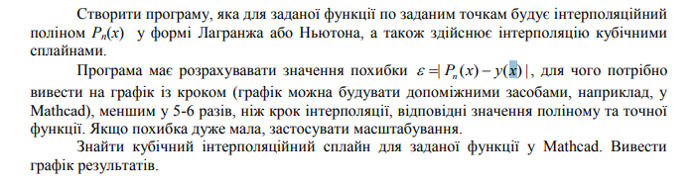

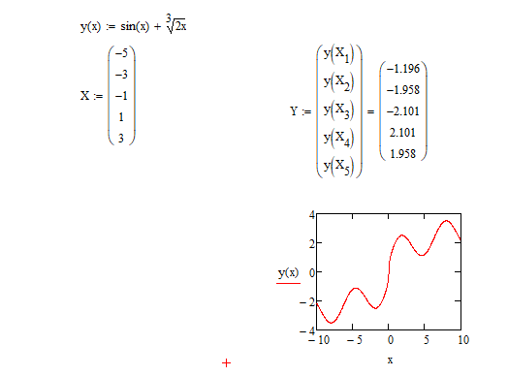

**2. Вигляд поліному Лагранжа**

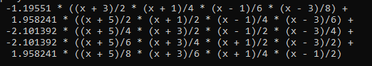

**3. Порівняльний графік функції та інтерполяційного поліному:**

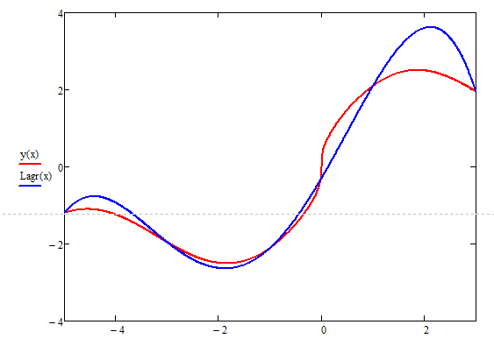

**4. Сплайни:**



**5. Порівняльний графік функції та сплайн-інтерполяції:**

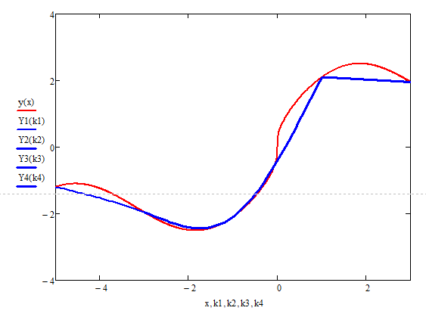

**6. Розв’язок інтерполяції сплайнами у Mathcad:**

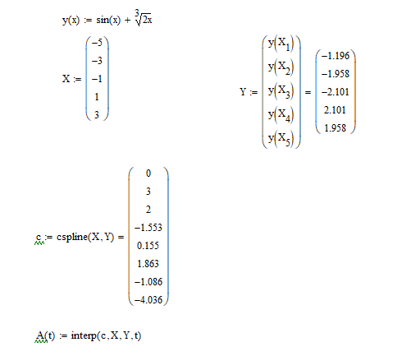

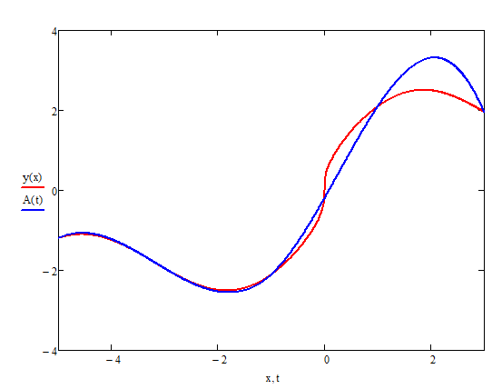

**7. Лістинг програми:**

Program.cs:

using System;

using MyClass;

namespace Lab5

{

class Program

{

static void Main(string[] args)

{

double[] arrX = { -5, -3, -1, 1, 3 };

Func<double, double> FuncToPolynom = x => Math.Sin(x) + Pow(2 * x, 1.0 / 3.0);

LagrangePolynom poly1 = new LagrangePolynom(arrX, FuncToPolynom);

poly1.CalculateLagrange();

Console.WriteLine("Result polynom is:");

Console.WriteLine(poly1);

Console.WriteLine();

QuadraticPolynom poly2 = new QuadraticPolynom(arrX, FuncToPolynom);

Console.WriteLine("Result polynoms are:");

for (int i = 0; i < poly2.Length; i++)

Console.WriteLine("\t{0}", poly2[i]);

Console.WriteLine();

for (double i = arrX[0]; i <= arrX[arrX.Length - 1]; i += (arrX[1] - arrX[0]) / 5)

Console.WriteLine("Error of Lagrange polynom in {0}: {1}", Math.Round(i, 1), Math.Abs(Math.Round((RoflanLagrangeCalculate(Math.Round(i, 1)) - FuncToPolynom(Math.Round(i, 1))), 6)));

Console.WriteLine();

for (double i = arrX[0]; i <= arrX[arrX.Length - 1]; i += (arrX[1] - arrX[0]) / 5)

{

if (i < arrX[1])

Console.WriteLine("Error of Spline polynom in {0}: {1}", Math.Round(i, 1), Math.Abs(Math.Round((RoflanSplineCalculate(Math.Round(i, 1), 1) - FuncToPolynom(Math.Round(i, 1))), 6)));

else if (i < arrX[2])

Console.WriteLine("Error of Spline polynom in {0}: {1}", Math.Round(i, 1), Math.Abs(Math.Round((RoflanSplineCalculate(Math.Round(i, 1), 2) - FuncToPolynom(Math.Round(i, 1))), 6)));

else if (i < arrX[3])

Console.WriteLine("Error of Spline polynom in {0}: {1}", Math.Round(i, 1), Math.Abs(Math.Round((RoflanSplineCalculate(Math.Round(i, 1), 3) - FuncToPolynom(Math.Round(i, 1))), 6)));

else

Console.WriteLine("Error of Spline polynom in {0}: {1}", Math.Round(i, 1), Math.Abs(Math.Round((RoflanSplineCalculate(Math.Round(i, 1), 4) - FuncToPolynom(Math.Round(i, 1))), 6)));

}

Console.ReadKey();

}

public static double Pow(double x, double power)

{

bool IsThereMinus = false;

if (x < 0)

IsThereMinus = true;

double numOut = Math.Pow(Math.Abs(x), power);

if (IsThereMinus)

return -numOut;

else

return numOut;

}

public static double RoflanLagrangeCalculate(double x)

{

return -1.19551 * ((x + 3) / 2 * (x + 1) / 4 * (x - 1) / 6 * (x - 3) / 8) +

1.958241 * ((x + 5) / 2 * (x + 1) / 2 * (x - 1) / 4 * (x - 3) / 6) -

2.101392 * ((x + 5) / 4 * (x + 3) / 2 * (x - 1) / 2 * (x - 3) / 4) -

2.101392 * ((x + 5) / 6 * (x + 3) / 4 * (x + 1) / 2 * (x - 3) / 2) +

1.958241 * ((x + 5) / 8 * (x + 3) / 6 * (x + 1) / 4 * (x - 1) / 2);

}

public static double RoflanSplineCalculate(double x, int index)

{

switch (index)

{

case 1:

return -1.19551 - 0.319111 * (x + 5) + 0 * (x + 5) * (x + 5) - 0.015564 * (x + 5) * (x + 5) * (x + 5);

case 2:

return -1.958241 - 0.505873 * (x + 3) - 0.093381 * (x + 3) * (x + 3) + 0.155265 * (x + 3) * (x + 3) * (x + 3);

case 3:

return -2.101392 + 0.983781 * (x + 1) + 0.838208 * (x + 1) * (x + 1) - 0.139701 * (x + 1) * (x + 1) * (x + 1);

case 4:

return 2.101392 - 0.071576 * (x - 1) + 0 * (x - 1) * (x - 1) + 0 * (x - 1) * (x - 1) * (x - 1);

}

return -1;

}

}

}

QuadraticPolynom.cs:

using System;

using System.Collections.Generic;

using System.Text;

namespace MyClass

{

public class QuadraticPolynom

{

private double[] _arrX;

private double[] _arrY;

private double[] _arrA;

private double[] _arrB;

private double[] _arrC;

private double[] _arrD;

private double[] _arrH;

private Func<double, double> _FuncY;

private string[] _result;

public QuadraticPolynom(double[] arr, Func<double, double> func)

{

_arrX = arr;

_FuncY = func;

int n = _arrX.Length - 1;

_arrY = new double[_arrX.Length];

_arrA = new double[_arrX.Length - 1];

_arrB = new double[_arrX.Length - 1];

_arrC = new double[_arrX.Length - 1];

_arrD = new double[_arrX.Length - 1];

_arrH = new double[_arrX.Length - 1];

_result = new string[n];

_result[0] = "Not calculated yet.";

for (int i = 0; i < _arrY.Length; i++)

{

_arrY[i] = _FuncY(_arrX[i]);

if (i != _arrY.Length - 1)

{

_arrA[i] = _arrY[i];

}

if (i != 0)

{

_arrH[i - 1] = _arrX[i] - _arrX[i - 1];

}

}

_arrC[0] = 0;

_arrC[_arrC.Length - 1] = 0;

double[][] matrix = new double[2][];

matrix[0] = new double[2];

matrix[1] = new double[2];

matrix[0][0] = 2 * (_arrH[1] + _arrH[2]); matrix[0][1] = _arrH[2];

matrix[1][0] = _arrH[2]; matrix[1][1] = 2 * (_arrH[2] + _arrH[3]);

double[] rightVec = { 3 * (((_arrY[2] - _arrY[1]) / _arrH[1]) - ((_arrY[1] - _arrY[0]) / _arrH[0])),

3 * (((_arrY[3] - _arrY[2]) / _arrH[2]) - ((_arrY[2] - _arrY[1]) / _arrH[1])) };

SystemOfEq Sys = new SystemOfEq(matrix, rightVec);

_arrC[1] = Sys._X[0];

_arrC[2] = Sys._X[1];

for (int i = 0; i < n; i++)

{

if(i == n - 1)

_arrD[i] = (-_arrC[i]) / (3 * _arrH[i]);

else

_arrD[i] = (_arrC[i + 1] - _arrC[i]) / (3 * _arrH[i]);

}

for (int i = 0; i < n; i++)

{

if (i == n - 1)

_arrB[i] = ((_arrY[i + 1] - _arrY[i]) / _arrH[i]) - (2 * _arrH[i] * _arrC[i] / 3);

else

_arrB[i] = ((_arrY[i + 1] - _arrY[i]) / _arrH[i]) - (_arrH[i] / 3 * (_arrC[i + 1] + 2 * _arrC[i]));

}

for (int i = 0; i < n; i++)

{

_result[i] = Math.Round(_arrA[i], 6).ToString();

if (_arrB[i] < 0)

_result[i] += " - ";

else

_result[i] += " + ";

_result[i] += Math.Abs(Math.Round(_arrB[i], 6)).ToString() + " * (x";

if (_arrX[i] < 0)

_result[i] += " + ";

else

_result[i] += " - ";

_result[i] += Math.Abs(Math.Round(_arrX[i], 6)).ToString() + ")";

if (_arrC[i] < 0)

_result[i] += " - ";

else

_result[i] += " + ";

_result[i] += Math.Abs(Math.Round(_arrC[i], 6)).ToString() + " * (x";

if (_arrX[i] < 0)

_result[i] += " + ";

else

_result[i] += " - ";

_result[i] += Math.Abs(Math.Round(_arrX[i], 6)).ToString() + ")";

_result[i] += " * (x";

if (_arrX[i] < 0)

_result[i] += " + ";

else

_result[i] += " - ";

_result[i] += Math.Abs(Math.Round(_arrX[i], 6)).ToString() + ")";

if (_arrD[i] < 0)

_result[i] += " - ";

else

_result[i] += " + ";

_result[i] += Math.Abs(Math.Round(_arrD[i], 6)).ToString() + " * (x";

if (_arrX[i] < 0)

_result[i] += " + ";

else

_result[i] += " - ";

_result[i] += Math.Abs(Math.Round(_arrX[i], 6)).ToString() + ")";

_result[i] += " * (x";

if (_arrX[i] < 0)

_result[i] += " + ";

else

_result[i] += " - ";

_result[i] += Math.Abs(Math.Round(_arrX[i], 6)).ToString() + ")";

_result[i] += " * (x";

if (_arrX[i] < 0)

_result[i] += " + ";

else

_result[i] += " - ";

_result[i] += Math.Abs(Math.Round(_arrX[i], 6)).ToString() + ")";

}

}

public string this[int index]

{

get => this._result[index];

}

public int Length { get => this._result.Length; }

}

}

LagrangePolynom.cs:

using System;

namespace MyClass

{

public class LagrangePolynom

{

private double[] _arrX;

private Func<double, double> _FuncY;

private string _result;

public LagrangePolynom(double[] arr, Func<double, double> func)

{

_arrX = arr;

_FuncY = func;

_result = "Not calculated yet.";

}

public void CalculateLagrange()

{

string strOut = "";

for (int k = 0; k < _arrX.Length; k++)

{

double curY = _FuncY(_arrX[k]);

strOut += "\t";

if (CountMinuses(_arrX[k], _arrX) % 2 == 1)

curY = -curY;

if(curY >= 0)

strOut += " ";

strOut += Math.Round(curY, 6).ToString();

strOut += " * (";

bool flag = false;

for (int i = 0; i < _arrX.Length; i++)

{

if (i != k)

{

if(flag)

strOut += " * ";

strOut += "(x";

if (_arrX[i] < 0)

strOut += " + " + (-_arrX[i]).ToString();

else

strOut += " - " + _arrX[i].ToString();

strOut += ")/" + (Math.Abs(_arrX[k] - _arrX[i])).ToString();

flag = true;

}

}

strOut += ")";

if (k != _arrX.Length - 1)

strOut += " +\n";

}

_result = strOut;

}

public override string ToString()

{

return this._result;

}

private static int CountMinuses(double num, double[] arr)

{

int counter = 0;

for (int i = 0; i < arr.Length; i++)

{

if(num - arr[i] < 0)

counter++;

}

return counter;

}

}

}

SystemOfEq.cs:

using System;

using System.Collections.Generic;

using System.Text;

namespace MyClass

{

public class SystemOfEq

{

private double[][] _Matrix;

private double[] _rightVector;

private int[] _numbersX;

private int _size;

public double[] _X { get; private set; }

public SystemOfEq(double[][] matrix, double[] rightVector)

{

_Matrix = matrix;

_rightVector = rightVector;

_numbersX = new int[rightVector.Length];

for (int i = 0; i < _numbersX.Length; i++)

{

_numbersX[i] = i;

}

_X = new double[rightVector.Length];

_size = rightVector.Length;

gaussAlgorithmTriangle();

gaussAlgorithmGetSolution();

}

private int[] getIndexOfMaxElement(int n)

{

int[] keys = new int[2];

double Max = Math.Abs(_Matrix[n][n]);

keys[0] = n;

keys[1] = n;

for (int i = n; i < _size; i++)

{

for (int j = n; j < _size; j++)

{

if (Math.Abs(_Matrix[i][j]) > Max)

{

Max = Math.Abs(_Matrix[i][j]);

keys[0] = i;

keys[1] = j;

}

}

}

return keys;

}

private double[] getMultipliersArray(int[] key, int n)

{

double[] arr = new double[_size];

for (int i = 0; i < _size; i++)

{

if (i != key[0] && i >= n)

{

arr[i] = _Matrix[i][key[1]] / _Matrix[key[0]][key[1]];

}

else

{

arr[i] = 0;

}

}

return arr;

}

private void swapRows(int numRow1, int numRow2)

{

for (int i = 0; i < _size; i++)

{

double tmp = _Matrix[numRow1][i];

_Matrix[numRow1][i] = _Matrix[numRow2][i];

_Matrix[numRow2][i] = tmp;

}

double temp = _rightVector[numRow1];

_rightVector[numRow1] = _rightVector[numRow2];

_rightVector[numRow2] = temp;

}

private void swapCols(int numCol1, int numCol2)

{

for (int i = 0; i < _size; i++)

{

double temp = _Matrix[i][numCol1];

_Matrix[i][numCol1] = _Matrix[i][numCol2];

_Matrix[i][numCol2] = temp;

int tmp = _numbersX[numCol1];

_numbersX[numCol1] = _numbersX[numCol2];

_numbersX[numCol2] = tmp;

}

}

private void gaussStep(int[] keys, double[] multipl, int n)

{

for (int i = n; i < _size; i++)

{

for (int j = n; j < _size; j++)

{

_Matrix[i][j] -= multipl[i] * _Matrix[keys[0]][j];

}

_rightVector[i] -= multipl[i] * _rightVector[keys[0]];

}

swapRows(n, keys[0]);

swapCols(n, keys[1]);

}

private void gaussAlgorithmTriangle()

{

for (int n = 0; n < _size; n++)

{

int[] maxKeys = getIndexOfMaxElement(n);

double maxA = _Matrix[maxKeys[0]][maxKeys[1]];

//Console.Write("\nCurrent max element: ");

//print(maxA);

if (maxA == 0)

{

Console.WriteLine("This system has no solutions!");

break;

}

double[] m = getMultipliersArray(maxKeys, n);

//Console.Write("\nCurrent vector of multipliers: ");

//print(m, _size);

gaussStep(maxKeys, m, n);

//Console.WriteLine("\nCurrent Matrix:\n");

//print(_Matrix, _size);

//Console.Write("Current right vector: ");

//print(_rightVector, _size);

//Console.WriteLine("-----------------------------------------------------------------");

}

}

private void gaussAlgorithmGetSolution()

{

for (int n = _size - 1; n >= 0; n--)

{

_X[n] = (_rightVector[n] - Solution(n)) / _Matrix[n][n];

}

for (int i = 0; i < _size; i++)

{

double temp = _X[i];

_X[i] = _X[_numbersX[i]];

_X[_numbersX[i]] = temp;

}

}

private double Solution(int n)

{

double output = 0;

for (int i = _size - 1; i > n; i--)

{

output += _Matrix[n][i] * _X[i];

}

return output;

}

public static void print(double[][] Matrix, int size)

{

for (int i = 0; i < size; i++)

{

for (int j = 0; j < size; j++)

{

Console.Write("{0:11} ", Math.Round(Matrix[i][j], 6));

}

Console.WriteLine();

}

}

public static void print(double[] Vector, int size)

{

for (int i = 0; i < size; i++)

{

Console.Write("{0} ", Math.Round(Vector[i], 6));

}

Console.WriteLine();

}

public static void print(double number)

{

Console.WriteLine(number);

}

}

}