**Abstract**

Abstract - Autistic children have difficulty with communication, difficulty with social interactions, obsessive interests, and repetitive behaviors; as a result, they face a high risk of getting into critical situations if they are left free and alone in the outside world. But they should not be caged for that. So, there is a need for systems that can help and protect them.

This paper brings an IoT-based support system prototype for children with ASD. This system uses the Internet of Things or IoT devices such as accelerometers, gas, temperature, and heart rate sensors linked up with a modern microcontroller called Arduino Uno for monitoring and helping children with autism spectrum disorder (ASD) to learn and improve their quality of life. The system uses its sensors to read the surrounding environment of the child and then analyze if there is any risky situation going around. Finally, based on the results, it notifies the parents or supervisor.

Additionally, a GSM module is used to communicate with the parents. The system keeps tracking all real-time surrounding environment data. It analyzes it using provided algorithms built up with different threshold values collected through experiments in different scenarios to determine whether any risk has occurred or not. All system units are tested, and all experimental values are studied from the real world.

Keywords - Autism Spectrum Disorder, Risk analysis, Internet of Things, Sensors, Arduino Uno.

1. **Introduction**

Autism spectrum disorder is a behavioral disorder that affects the communication and behavior of a person. It is a neurodevelopmental disorder. Autistic children have difficulties with communication, social interactions, obsessive interests, and repetitive behaviors.

Studies have shown that the disorder is influenced by both genetic factors in children and environmental factors that affect the development of the brain [1]. The first symptom of Autism in a child is typically revealed at the age of two or three. However, it is usually discoverable at the age of 18-24 months in most of the child. But it increases and changes over time throughout the life and growth of the child. However, Autism spectrum disorder differs from person to person but results in outcomes such as improper brain function development, problems in sensory processing ability, and exceptional social interaction skills [2]. Among various other kinds of autism spectrum disorder, it is measured based on different studies across the world that around 1% of people suffer from lifelong ASD disorder [3]. Also, it has been observed that the number of ASD children has been dramatically increasing. A public survey of 11 different regions of the United States estimates that 1 in 68 children has the disorder [4]. While in Bangladesh, it is around 6.2 among 1000 children who carry ASD disorder. However, there is no national epidemiological study on ASD in Bangladesh. The number of total patients is estimated to be 1.04 million [5]. The Internet of Things is a bunch of sensitive components that are connected through a network, and a central computing device communicates with each of these components, most commonly sensors that read environmental data in real-time to perform any specific task with any interaction of humans. There are enormous applications of IoT in the current world and every aspect of development. Although compared with others, IoT is not yet much popular with ASD patients but can be applied efficiently as studies figured out that children with this particular disorder show interest in technologies like IoT [6]. As a result, algorithms that are built on real-time risky data analysis can help the child to get more involved in the otter world. Besides, it can make the parents unconcerned all the time about their child's safety.

This work uses different sensors to build a risk analysis and support system based on the Internet of Things. This proposed system uses an Arduino Uno microcontroller for processing sensor data and running the algorithms and uses a GSM module to communicate with the parent if any critical situation occurs.

1. **Related works**

Helping ASD children can be served in many ways; as a result, several pieces of research have been conducted, and IoT systems have been introduced in this field. Both with unique and innovative or common and efficient ways.

[7] Autism Support System using RFID Technology (A. Sharmila Agnal, S. Janani, Chellekampalli Maneesha, K. Ramya) This study represented a device to identify the location of an autism spectrum disorder (ASD) child using a Radio Frequency Identification (RFID) which is a wearable device that is to be worn by the autistic child, which allows the parent to track the child anytime, anywhere. The RFID technology is implied for location tracking, and the location can be sent to the parent in the form of a standard text message via GSM.

[8] Emotion Recognition of Autism Children Using IoT (K.Lavanya, S.M.Anitha, J.Joveka2, R.Priyatharshni, Sreelakshmi Mahipal) In this one, they proposed an articulation acknowledgment strategy by utilizing thermal infrared (IR) information as detailed data to detect the facial expression of ASD child and analyze their status. Facial pictures give geometric and appearance examples of outward appearances and are touchy to brightening changes. Thermal facial images record facial temperature circulation and are hearty to light conditions. In this way, articulation acknowledgment is upgraded by apparent and thermal picture combinations.

[9] Improving the Life of Children Affected by Autism Spectrum Disorder with the Help of IoT (Ms. Gayathri, Ms.Saranya, Ms. Yashini, Mrs.B.Monica Jenefer) This paper explicated an innovative IoT system that supports the children with autism spectrum disorder (ASD) and also worked as a guide system of their physical health. The main aim was to sense their EEG (Electroencephalographic) waves and to keep track of them using smartphones. EEG probes that are present in the cap help in sensing their brain waves. Recorded brain signals get dispatched to the cloud by making use of the antenna that is present in the IoT module with GSM. The cloud acts as a storage system, and those signals are studied by the application built. The Guardian and the Therapists make use of this system to follow their children and can understand the complexity of the behavior.

[10] Role of IoT and ML for autistic people (Suruchi Dedgaonkar, Dr. Rajneesh Kaur SachdevaBedi, Kunil Kothari, Riya Loya, Dr. Suneel Godbole) This paper does a comparative study on the various systems currently being used to monitor the autistic patients' health and how it can be used for screening of autistic children. Considering that, the health aspects of such patients need to be treated and monitored with utmost care. Autistic patients may have different types of emotional states, which usually vary individually. Due to this diversity and uniqueness, it is challenging even for expert doctors to estimate the precise emotion state detection from the symptoms that are observed. Hence sessional monitoring and analysis of the patient are required.

[11] A support system for autistic children using Internet of Things technology (Noor M. Abdullah, Ahmad F. AL-Allaf) This paper introduces a prototype system of an IoT- based support system for ASD children. The system guides and monitors ASD children using a set of sensors linked to a modern Wi-Fi development kit called Particle Photon. The designed system also uses the Blynk platform (A hardware-agnostic IoT platform with mobile applications) to control and monitor the system sensors from the mobile device and communicate with parents or supervisors of the ASD child to alert them of any excessive and abnormal behavior by sending a notification or e-mail. In addition, the system contains a GPS unit to track the child's location and transmit the sensor data across the cloud to specialists and supervisors for analysis and study of the health status of ASD children. A calming unit (Arduino Uno, SD card, mini speaker) is added to the system to be used in the event of hypersensitivity or tension by emitting musical notes to calm the child until the parents arrive. All system units have been tested and validated.

1. **Proposed work**

|  |  |
| --- | --- |
| The introduced system is built with IoT that can be carried in a bag or attached to the arm of Autistic children and is capable of detecting various types of physical and mental activity of the children and also what is going around them in their surroundings.  It uses Arduino Uno as a central component; then, from the data received from various sensors, including MPU, Gas, BMP, and Heartrate, the microcontroller analyzes the chances of the children being involved in a risk that is harmful to health. In the case of detecting risk, sensors’ data are used both individually and co-relating to the other readings. Decisions from compound reading differentiate between normal life activities and risky activities. Then notify the parent via SMS using the GSM module.  Also, it catches the level of risk of that particular event. It doesn’t use the internet and doesn’t rely on other external systems or functions, which makes it an independently working prototype system.  This prototype offers the parents to unbind their autistic children from in-home or in-caged barriers of protection and let the children get into the outer world. |  |

1. **Methodology**

The build consists of a processing unit, a sensor unit, and a communication unit. Arduino Uno is used for processing, and a GSM module for communicating, while four different sensors are used in the sensing unit. Each of these components is briefly described in the following sub-sections –

**Processor (Arduino Uno R3)**

The proposed system uses Arduino Uno R3, the third and most popular version of the Uno family is a dual-inline-package ATmega328 AVR microcontroller board. It features an ATmega16U2 programmed as a USB-to-serial converter. [12] It has 20 I/O pins, a power jack, a USB connection, 32KB Flash memory, 1KB EEPROM, and 16,000Hz CLK speed. [13]

**Communication (GSM)**

A GSM module is a popular chip that is used in communication devices for sending and receiving SMS and calls. The SIM800L GSM/GPRS module is a miniature GSM modem that is capable of being integrated into a large number of IoT projects.

**Sensors**

The system includes four different sensors, both individually and in a compound manner.

**Acceleration**

The MPU6050 is a modern and powerful complete 6-axis motion tracking module. [14] Its embedded DMP runs a motion processing algorithm to detect acceleration, gravity, and angular motion. The formula (A = |X|+|Y|+|Z|) that is used in this work calculates the absolute summation of acceleration among all three axes. Table X.X shows ranges of acceleration in common and everyday movements - 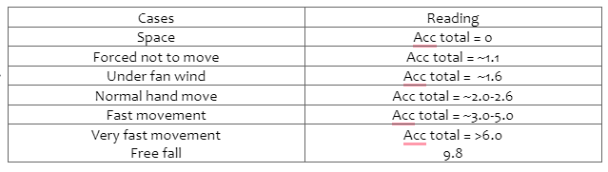

**Pressure and Humidity**

BMP-180 or Biometric detects the pressure, altitude, and temperature of its surroundings. Operated in the 3V to 5V range, the sensor can sense pressure in the range of 300-1100 hPa, which is around 9000m above and 500m below sea level. For temperature, it can measure between -40 to +85 °C.

**Heart rate**

The MAX30102 is an integrated heart rate and pulse oximetry module that operates around 3.3V to 5V power supply is capable of measuring heart rate and blood Oxygen using IR reflection.

**Gas**

The MQ-135, which operates around 5V power supply, can sense the presence of NOx, CO2, NH3, Alcohol, smoke, and Benzene and is capable of measuring the amount of these chemical elements in parts per million. The following table [15] shows the air quality index for detecting harmful range –

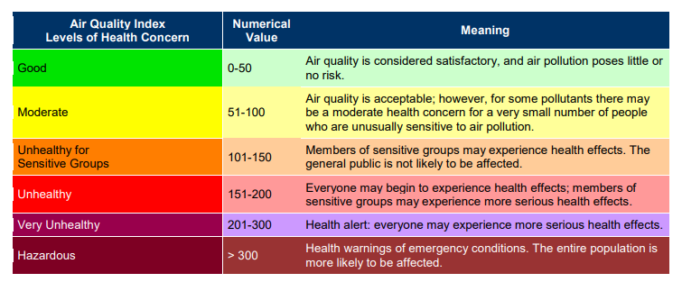

**Software**

Arduino IDE is a powerful but easy to use open source tool for writing, compiling and codes for Arduino Uno. This work used it as well. It can be installed in all common operating systems such as Windows, Mac, Linux. This is fresh for coding and hardware implementation.

1. **System Operation**

The system starts with Arduino Uno, which is connected to each of the sensors in the setup. It continuously captures the environment around it through different sensors’ data. Data is either observed immediately to check if any sensor’s value has crossed the normal limit or threshold. Or, the data are stored in Arduino for further calculation. In the risk detection phase, it catches events like getting into toxic gas, fire, smoke, falling from a high location or into a hole, accident, being afraid, getting senseless, being drawn into the water, and so on. Also, it detects the level of risk, such as high, medium, low, or lethal. Based on the risk, it immediately uses the GSM module to acknowledge parents or the supervisor of the children by SMS. The diagram shown in fig X.X shows the whole flow of the process.

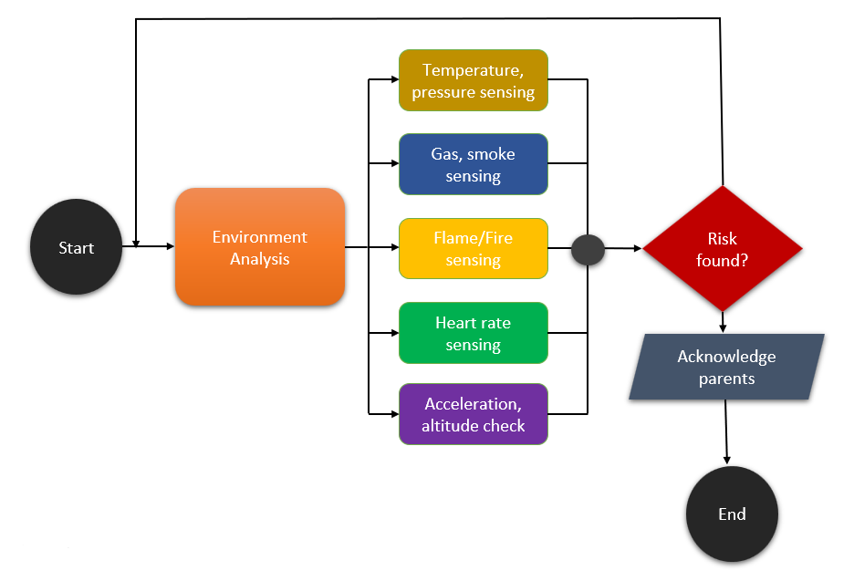

1. **Hardware implementation**

All of the components operate between the 3.3v to 9v range. Each module is assembled via wires with the central microcontroller board. Arduino and GSM modules are powered by external battery power sources, while all the other sensors are powered by the Arduino Uno itself. Figure X.X shows the primarily implemented system, Table X.X, X.X, X.X, X.X, X.X shows the connection pin diagrams.

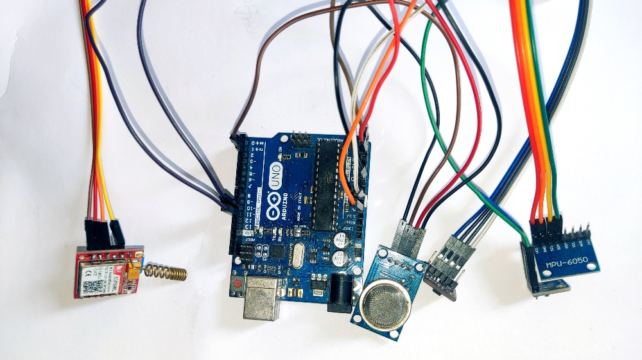

|  |  |
| --- | --- |
| MQ135(gas) | Arduino pin |
| VCC | 5V |
| GND | GND |
| A0 | A0 |
| D0 | 2 |

|  |  |
| --- | --- |
| MPU6050(Acceleration) | Arduino pin |
| VCC | 5V |
| GND | GND |
| SCL | A5 |
| SDA | A4 |

|  |  |
| --- | --- |
| MAX30102(Heart rate) | Arduino pin |
| VCC | 5V |
| GND | GND |
| A0 | A0 |
| D0 | 2 |

|  |  |
| --- | --- |
| BMP180(temperature, altitude, pressure) | Arduino pin |
| VCC | 5V |
| GND | GND |
| A0 | A5 |
| D0 | A4 |

|  |  |
| --- | --- |
| GSM Module | Arduino pin |
| VCC |  |
| GND | GND |
| RX | 10 |
| TX | 11 |

1. **Result – Physical testing,**
2. **Conclusion**

REFERENCES

[1] Hodges H, Fealko C, Soares N. Autism spectrum disorder: definition, epidemiology, causes, and clinical evaluation. Transl Pediatr. 2020 Feb;9(Suppl 1):S55-S65. doi: 10.21037/tp.2019.09.09.

[2] M. Lai, M. V. Lombardo, G. Pasco, A. N. V. Ruigrok, S. J. Wheelwright, S. A. Sadek, B. Chakrabarti, M. Consortium, and S. Baron-Cohen, “A Behavioral Comparison of Male and Female Adults with High Functioning Autism Spectrum Conditions,” PloS one, vol. 6, no. 6, e20835, 2011.

[3] Elsabbagh M, Divan G, Koh Y, Kim YS, Kauchali S, Marcín C, Montiel NC, Patel V, Paula CS, Wang C, Yasamy MT, andFombonne E.Global Prevalence of Autism and Other Pervasive Developmental Disorders.Autism Res. 2012;. 5: 160–179.

[4] Center for Disease Control and Prevention. Prevalence of autism spectrum disorder among children aged eight years – autism and developmental disabilities monitoring network, 11 sites, United States, 2010. MMWR Surveillance Summaries (Washington, DC) 2014;63:1–21.

[5] Rahman, Fazlur & Akhter, Shaheen & Biswas, Animesh & Abdullah, Abu-Sayeed. (2016). Study on Prevalence of Autism in Bangladesh. 10.13140/RG.2.2.33709.33765.

[6] Muhammad Javaid Afzal, Muhammad Waseem Ashraf, Shahzadi Tayyaba et al. Analysis and Real-Time Implementation of IoT in Autism, 17 June 2021, PREPRINT (Version 1) available at Research Square [https://doi.org/10.21203/rs.3.rs-610012/v1]

[7] A. S. Agnal, S. Janani, C. Maneesha and K. Ramya, "Autism Support System using RFID Technology,“ International Journal of Engineering and Advanced Technology (IJEAT), October 2019.

[8] Lavanya, K., Anitha, S. M., Joveka, J., Priyatharshni, R., & Mahipal, S. (2019). Emotion recognition of autism children using IoT. Int J Appl Eng Res, 14(6).

[9] S. Dedgaonkar, Dr. R. K. S. Bedi, K. Kothari, R. Loya and Dr. S. Godbole, “Role of IoT and ML for autistic people,” International Journal of Future Generation Communication and Networking Vol. 13, No. 3s, (2020), pp. 773–781.

[10] S. Dedgaonkar, Dr. R. K. S. Bedi, K. Kothari, R. Loya and Dr. S. Godbole, “Role of IoT and ML for autistic people,” International Journal of Future Generation Communication and Networking Vol. 13, No. 3s, (2020), pp. 773–781.

[11] N. M. Abdullah and A. F. AL-Allaf, "A support system for autistic children using Internet of Things technology," 2021 International Conference on Advanced Computer Applications (ACA), 2021, pp. 51-56, doi: 10.1109/ACA52198.2021.9626825.

[12] “Arduino - Board Description.” <https://www.tutorialspoint.com/arduino/arduino_board_description.htm/>.

[13] “ATmega328 Arduino Uno Board Working and Its Applications.” <https://www.elprocus.com/atmega328-arduino-uno-board-working-and-its-applications/>.

[14] “MPU6050 (Gyroscope + Accelerometer + Temperature) Sensor Module.” https://www.electronicwings.com/sensors-modules/mpu6050-gyroscope-accelerometer-temperature-sensor-module/.

[15] “epa-air-quality-index.” <https://www.miamidade.gov/environment/library/reports/epa-air-quality-index.pdf/>.

@article{kumar2017vehicle,

title={Vehicle Tracking and Anti-Theft System},

author={Kumar, G Ravi and Reddy, Ch Srinivasa and Prasanthi, KG and Sunita, G},

journal={i-Manager's Journal on Computer Science},

volume={5},

number={2},

pages={17},

year={2017},

publisher={iManager Publications}

}

@article{shemul2022design,

title={Design and Implementation of Low Cost Automatic Irrigation System using Microcontroller},

author={Shemul, Kowser Ahmed and Saha, Prianka and Bala, Diponkor},

journal={Journal of Applied Information Science},

volume={10},

number={2},

pages={01--05},

year={2022}

}

@inproceedings{chandra2019sign,

title={Sign languages to speech conversion prototype using the SVM classifier},

author={Chandra, Malli Mahesh and Rajkumar, S and Kumar, Lakshmi Sutha},

booktitle={TENCON 2019-2019 IEEE Region 10 Conference (TENCON)},

pages={1803--1807},

year={2019},

organization={IEEE}

}