Assignment 2

2024-10-02

#Boone - 1980-1999  
early_boone <- boone %>%   
 filter(year < 2000)  
  
#Calculate moving sum  
library(zoo)

##   
## Attaching package: 'zoo'

## The following objects are masked from 'package:base':  
##   
## as.Date, as.Date.numeric

moving_sum_early_boone <- rollapply(  
 early_boone$Area.Weighted.Mean.Precipitation..mm.per.day., width = 2,   
 FUN = sum, fill = NA, align = "right")  
  
#Turn into a data frame  
moving_early_boone <- data.frame(  
 Original_Data = early_boone,  
 Moving_Sum = moving_sum_early_boone  
) %>%   
 filter(Moving_Sum > 0)  
  
#Calculate annual two-day max  
movingearly_boone_annual <- moving_early_boone %>%   
 filter(Original_Data.year < 2000) %>%   
 group_by(Original_Data.year) %>%   
 summarise(twoday_max_annual = max(Moving_Sum))  
  
#Calculate return period  
rp_early_boone_moving <- moving_early_boone %>%   
 mutate(rank = rank(-Moving_Sum,  
 ties.method = "max")) %>%   
 filter(Moving_Sum > 0) %>%   
 mutate(number_events = 3986) %>%   
 mutate(weibull = (rank/number_events)) %>%   
 mutate(return_period = 1/weibull)  
#moving sum for 50-year 48-hour storm event = 66 mm  
  
#Plot annual two-day max + return period  
ggplot(movingearly_boone_annual, aes(x = Original_Data.year, y = twoday_max_annual)) +  
 geom_line() +  
 geom_smooth(method = "lm") +  
 geom_hline(yintercept = 66, color = "red", linetype = "dashed", size = 1) +  
 scale_x_continuous(breaks = seq(1980, 1999, 1)) +  
 labs(title = "Annual Maximum Two-Day Precipitation Events for Boone\nfrom 1980-1999",  
 x = "Year",  
 y = "Depth of precipitation (mm)") +  
 theme_bw() +  
 theme(axis.text.x = element_text(angle = 45, hjust = 1))

## Warning: Using `size` aesthetic for lines was deprecated in ggplot2 3.4.0.  
## ℹ Please use `linewidth` instead.  
## This warning is displayed once every 8 hours.  
## Call `lifecycle::last_lifecycle_warnings()` to see where this warning was  
## generated.

## `geom_smooth()` using formula = 'y ~ x'

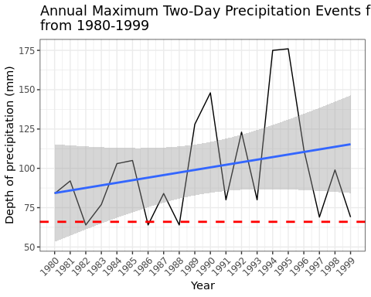

#Boone - 2000-2016  
late_boone <- boone %>%   
 filter(year >= 2000)  
  
#Calculate moving sum  
moving_sum_late_boone <- rollapply(late_boone$Area.Weighted.Mean.Precipitation..mm.per.day., width = 2, FUN = sum, fill = NA, align = "right")  
  
#Turn into a data frame  
moving_late_boone <- data.frame(  
 Original_Data = late_boone,  
 Moving_Sum = moving_sum_late_boone  
) %>%   
 filter(Moving_Sum > 0)  
  
#Calculate annual two-day max  
movinglate_boone_annual <- moving_late_boone %>%   
 filter(Original_Data.year >= 2000) %>%   
 group_by(Original_Data.year) %>%   
 summarise(twoday_max_annual = max(Moving_Sum))  
  
#Calculate return period  
rp_late_boone_moving <- moving_late_boone %>%   
 mutate(rank = rank(-Moving_Sum,  
 ties.method = "max")) %>%   
 filter(Moving_Sum > 0) %>%   
 mutate(number_events = 3460) %>%   
 mutate(weibull = (rank/number_events)) %>%   
 mutate(return_period = 1/weibull)  
#moving sum for 50-year 48-hour storm event = 80 mm  
  
#Plot annual two-day max and return period  
ggplot(movinglate_boone_annual, aes(x = Original_Data.year, y = twoday_max_annual)) +  
 geom_line() +  
 geom_smooth(method = "lm") +  
 geom_hline(yintercept = 68, color = "red", linetype = "dashed", size = 1) +  
 scale_x_continuous(breaks = seq(2000, 2016, 1)) +  
 labs(title = "Annual Maximum Two-Day Precipitation Events for Boone\nfrom 2000-2016",  
 x = "Year",  
 y = "Depth of precipitation (mm)") +  
 theme_bw() +  
 theme(axis.text.x = element_text(angle = 45, hjust = 1))

## `geom_smooth()` using formula = 'y ~ x'

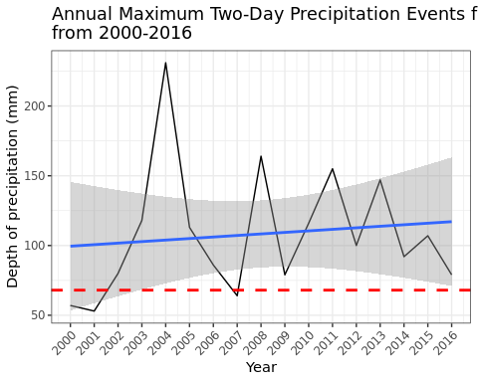

#Greensboro, 1980-1999  
early_greensboro <- greensboro %>%   
 filter(year < 2000)  
  
#Calculate moving sum  
moving_sum_early_greensboro <- rollapply(early_greensboro$Area.Weighted.Mean.Precipitation..mm.per.day.,   
 width = 2, FUN = sum, fill = NA,   
 align = "right")  
  
#Turn into data frame  
moving_early_greensboro <- data.frame(  
 Original_Data = early_greensboro,  
 Moving_Sum = moving_sum_early_greensboro  
) %>%   
 filter(Moving_Sum > 0)  
  
#Calculate annual two-day max   
movingearly_greensboro_annual <- moving_early_greensboro %>%   
 filter(Original_Data.year < 2000) %>%   
 group_by(Original_Data.year) %>%   
 summarise(twoday_max_annual = max(Moving_Sum))  
  
#Calculate return period  
rp_early_greensboro_moving <- moving_early_greensboro %>%   
 mutate(rank = rank(-Moving_Sum,  
 ties.method = "max")) %>%   
 filter(Moving_Sum > 0) %>%   
 mutate(number_events = 3291) %>%   
 mutate(weibull = (rank/number_events)) %>%   
 mutate(return_period = 1/weibull)  
#moving sum for 50-year 48-hour storm event = 55 mm  
  
#Plot annual two-day max and return period  
ggplot(movingearly_greensboro_annual, aes(x = Original_Data.year, y = twoday_max_annual)) +  
 geom_line() +  
 geom_smooth(method = "lm") +  
 geom_hline(yintercept = 55, color = "red", linetype = "dashed", size = 1) +  
 scale_x_continuous(breaks = seq(1980, 1999, 1)) +  
 labs(title = "Annual Maximum Two-Day Precipitation Events for Greensboro\nfrom 1980-1999",  
 x = "Year",  
 y = "Depth of precipitation (mm)") +  
 theme_bw() +  
 theme(axis.text.x = element_text(angle = 45, hjust = 1))

## `geom_smooth()` using formula = 'y ~ x'

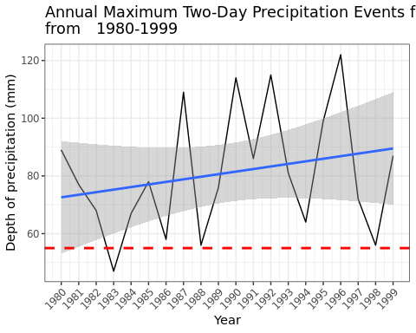

#Greensboro, 2000-2016  
late_greensboro <- greensboro %>%   
 filter(year >= 2000)  
  
#Calculate moving sum  
moving_sum_late_greensboro <- rollapply(late_greensboro$Area.Weighted.Mean.Precipitation..mm.per.day.,   
 width = 2, FUN = sum, fill = NA,   
 align = "right")  
  
#Turn into data frame  
moving_late_greensboro <- data.frame(  
 Original_Data = late_greensboro,  
 Moving_Sum = moving_sum_late_greensboro  
) %>%   
 filter(Moving_Sum > 0)  
  
#Calculate annual two-day max  
movinglate_greensboro_annual <- moving_late_greensboro %>%   
 filter(Original_Data.year >= 2000) %>%   
 group_by(Original_Data.year) %>%   
 summarise(twoday_max_annual = max(Moving_Sum))  
  
#Calculate return period  
rp_late_greensboro_moving <- moving_late_greensboro %>%   
 mutate(rank = rank(-Moving_Sum,  
 ties.method = "max")) %>%   
 filter(Moving_Sum > 0) %>%   
 mutate(number_events = 2879) %>%   
 mutate(weibull = (rank/number_events)) %>%   
 mutate(return_period = 1/weibull)  
#moving sum for 50-year 48-hour storm event = 55 mm  
  
#Plot annual two-day max and return period  
ggplot(movinglate_greensboro_annual, aes(x = Original_Data.year, y = twoday_max_annual)) +  
 geom_line() +  
 geom_smooth(method = "lm") +  
 geom_hline(yintercept = 55, color = "red", linetype = "dashed", size = 1) +  
 scale_x_continuous(breaks = seq(2000, 2016, 1)) +  
 labs(title = "Annual Maximum Two-Day Precipitation Events for Greensboro\nfrom 2000-2016",  
 x = "Year",  
 y = "Depth of precipitation (mm)") +  
 theme_bw() +  
 theme(axis.text.x = element_text(angle = 45, hjust = 1))

## `geom_smooth()` using formula = 'y ~ x'

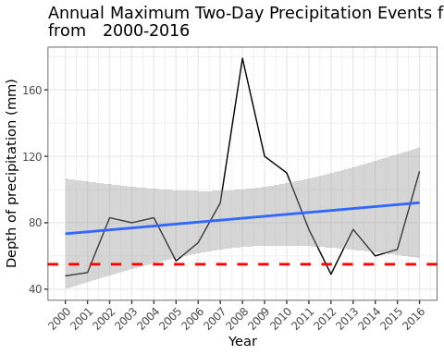

#Greenville, 1980-1999  
early_greenville <- greenville %>%   
 filter(year < 2000)  
  
#Calculate moving sum  
moving_sum_early_greenville <- rollapply(early_greenville$Area.Weighted.Mean.Precipitation..mm.per.day.,   
 width = 2, FUN = sum, fill = NA,   
 align = "right")  
  
#Turn into data frame  
moving_early_greenville <- data.frame(  
 Original_Data = early_greenville,  
 Moving_Sum = moving_sum_early_greenville  
) %>%   
 filter(Moving_Sum > 0)  
  
#Calculate annual two-day max  
movingearly_greenville_annual <- moving_early_greenville %>%   
 filter(Original_Data.year < 2000) %>%   
 group_by(Original_Data.year) %>%   
 summarise(twoday_max_annual = max(Moving_Sum))  
  
#Calculate return period  
rp_early_greenville_moving <- moving_early_greenville %>%   
 mutate(rank = rank(-Moving_Sum,  
 ties.method = "max")) %>%   
 filter(Moving_Sum > 0) %>%   
 mutate(number_events = 3393) %>%   
 mutate(weibull = (rank/number_events)) %>%   
 mutate(return_period = 1/weibull)  
#moving sum for 50-year 48-hour storm event = 59 mm  
  
#Plot annual two-day max and return period  
ggplot(movingearly_greenville_annual,   
 aes(x = Original_Data.year, y = twoday_max_annual)) +  
 geom_line() +  
 geom_smooth(method = "lm") +  
 geom_hline(yintercept = 59, color = "red", linetype = "dashed", size = 1) +  
 scale_x_continuous(breaks = seq(1980, 1999, 1)) +  
 labs(title = "Annual Maximum Two-Day Precipitation Events for Greenville\n  
 from 1980-1999",  
 x = "Year",  
 y = "Depth of precipitation (mm)") +  
 theme_bw() +  
 theme(axis.text.x = element_text(angle = 45, hjust = 1))

## `geom_smooth()` using formula = 'y ~ x'

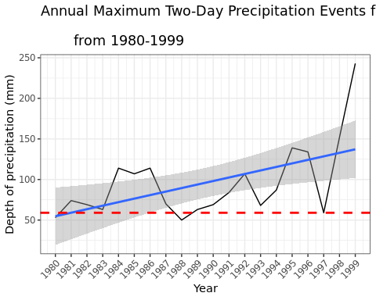

#Greenville, 1980-1999  
late_greenville <- greenville %>%   
 filter(year >= 2000)  
  
#Calculate moving sum  
moving_sum_late_greenville <- rollapply(late_greenville$Area.Weighted.Mean.Precipitation..mm.per.day.,   
 width = 2, FUN = sum, fill = NA,   
 align = "right")  
  
#Turn into data frame  
moving_late_greenville <- data.frame(  
 Original_Data = late_greensboro,  
 Moving_Sum = moving_sum_late_greenville  
) %>%   
 filter(Moving_Sum > 0)  
  
#Calculate annual two-day max  
movinglate_greenville_annual <- moving_late_greenville %>%   
 filter(Original_Data.year >= 2000) %>%   
 group_by(Original_Data.year) %>%   
 summarise(twoday_max_annual = max(Moving_Sum))  
  
#Calculate return period  
rp_late_greenville_moving <- moving_late_greenville %>%   
 filter(Moving_Sum > 0) %>%   
 mutate(rank = rank(-Moving_Sum,  
 ties.method = "max")) %>%   
 mutate(number_events = 2907) %>%   
 mutate(weibull = (rank/number_events)) %>%   
 mutate(return_period = 1/weibull)  
#moving sum for 50-year 48-hour storm event = 67 mm  
  
#Plot annual two-day max and return period  
ggplot(movinglate_greenville_annual, aes(x = Original_Data.year, y = twoday_max_annual)) +  
 geom_line() +  
 geom_smooth(method = "lm") +  
 geom_hline(yintercept = 67, color = "red", linetype = "dashed", size = 1) +  
 scale_x_continuous(breaks = seq(2000, 2016, 1)) +  
 labs(title = "Annual Maximum Two-Day Precipitation Events for Greenville\nfrom  
 2000-2016",  
 x = "Year",  
 y = "Depth of precipitation (mm)") +  
 theme_bw() +  
 theme(axis.text.x = element_text(angle = 45, hjust = 1))

## `geom_smooth()` using formula = 'y ~ x'

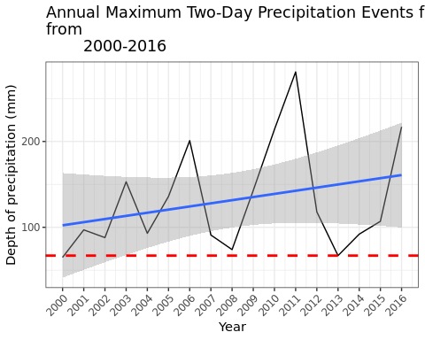

#Seasonal, Boone 1980-1999  
#Hurricane season  
hurricane_boone <- boone %>%   
 filter(month == 7:10) %>%   
 filter(year < 2000)

## Warning: There was 1 warning in `filter()`.  
## ℹ In argument: `month == 7:10`.  
## Caused by warning in `month == 7:10`:  
## ! longer object length is not a multiple of shorter object length

#Frontal season  
frontal_boone <- boone %>%   
 filter(month == 1:6 | month == 11:12) %>%   
 filter(year < 2000)

## Warning: There was 1 warning in `filter()`.  
## ℹ In argument: `month == 1:6 | month == 11:12`.  
## Caused by warning in `month == 1:6`:  
## ! longer object length is not a multiple of shorter object length

#Calculate moving sum durring hurricane season  
sum_boone_hurricane <- rollapply(  
 hurricane_boone$Area.Weighted.Mean.Precipitation..mm.per.day.,   
 width = 2, FUN = sum, fill = NA, align = "right")  
  
#Turn into data frame  
movingsum_boone_hurricane <- data.frame(  
 Original_Data = hurricane_boone,  
 Moving_Sum = sum_boone_hurricane  
) %>%   
 filter(Moving_Sum > 0)  
  
#Calculate return period  
rp_boone_hurricane <- movingsum_boone_hurricane %>%   
 filter(Moving_Sum > 0) %>%   
 mutate(rank = rank(-Moving_Sum,  
 ties.method = "max")) %>%   
 mutate(number_events = 355) %>%   
 mutate(weibull = (rank/number_events)) %>%   
 mutate(return_period = 1/weibull)  
#moving sum for 50-year 48-hour storm event = 52 mm  
  
#Calculate moving sum for frontal seaosn  
sum_boone_frontal <- rollapply(  
 frontal_boone$Area.Weighted.Mean.Precipitation..mm.per.day.,   
 width = 2, FUN = sum, fill = NA, align = "right")  
  
#Turn into data frame  
movingsum_boone_frontal <- data.frame(  
 Original_Data = frontal_boone,  
 Moving_Sum = sum_boone_frontal  
) %>%   
 filter(Moving_Sum > 0)  
  
#Calculate return period  
rp_boone_frontal <- movingsum_boone_frontal %>%   
 filter(Moving_Sum > 0) %>%   
 mutate(rank = rank(-Moving_Sum,  
 ties.method = "max")) %>%   
 mutate(number_events = 723) %>%   
 mutate(weibull = (rank/number_events)) %>%   
 mutate(return_period = 1/weibull)  
#moving sum for 50-year 48-hour storm event = 68 mm  
  
#Add new column specifying type  
rp_boone_frontal$StormType = "Frontal (1980-1999)"  
rp_boone_hurricane$StormType = "Hurricane (1980-1999)"  
  
#Combine into one data set  
boone_combined <- bind_rows(rp_boone_frontal, rp_boone_hurricane)  
  
#Plot - 1980-1999 only  
ggplot(boone_combined, aes(x = return_period, y = Moving_Sum, color = StormType)) +  
 geom_line() +  
 labs(title = "Return Period Storms in Boone for Frontal Season   
 and\nHurricane Season, 1980-1999",  
 x = "Return Period",  
 y = "Depth of precipitation (mm)") +  
 theme_bw() +  
 theme(axis.text.x = element_text(angle = 45, hjust = 1))

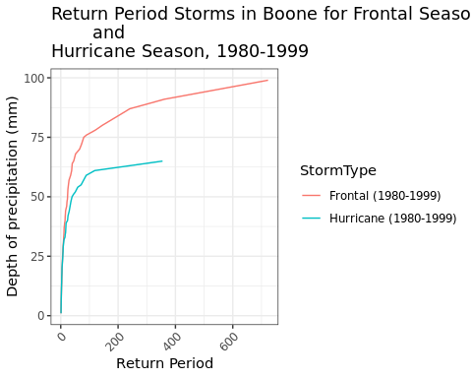

#Seasonal, boone 2000-2016  
#Hurricane season  
hurricane_boone_2016 <- boone %>%   
 filter(month == 7:10) %>%   
 filter(year >= 2000)

## Warning: There was 1 warning in `filter()`.  
## ℹ In argument: `month == 7:10`.  
## Caused by warning in `month == 7:10`:  
## ! longer object length is not a multiple of shorter object length

#Frontal season  
frontal_boone_2016 <- boone %>%   
 filter(month == 1:6 | month == 11:12) %>%   
 filter(year >= 2000)

## Warning: There was 1 warning in `filter()`.  
## ℹ In argument: `month == 1:6 | month == 11:12`.  
## Caused by warning in `month == 1:6`:  
## ! longer object length is not a multiple of shorter object length

#Calculate moving sum of hurricane season  
sum_boone_hurricane_2016 <- rollapply(hurricane_boone_2016$Area.Weighted.Mean.Precipitation..mm.per.day.,   
 width = 2, FUN = sum,   
 fill = NA, align = "right")  
  
#Turn into data frame  
movingsum_boone_hurricane_2016 <- data.frame(  
 Original_Data = hurricane_boone_2016,  
 Moving_Sum = sum_boone_hurricane_2016  
) %>%   
 filter(Moving_Sum > 0)  
  
#Calculate return period   
rp_boone_hurricane_2016 <- movingsum_boone_hurricane_2016 %>%   
 filter(Moving_Sum > 0) %>%   
 mutate(rank = rank(-Moving_Sum,  
 ties.method = "max")) %>%   
 mutate(number_events = 319) %>%   
 mutate(weibull = (rank/number_events)) %>%   
 mutate(return_period = 1/weibull)  
#moving sum for 50-year 48-hour storm event = 75 mm  
  
#Calculate moving sum of frontal season  
sum_boone_frontal_2016 <- rollapply(  
 frontal_boone_2016$Area.Weighted.Mean.Precipitation..mm.per.day.,   
 width = 2, FUN = sum, fill = NA, align = "right")  
  
#Turn into data frame  
movingsum_boone_frontal_2016 <- data.frame(  
 Original_Data = frontal_boone_2016,  
 Moving_Sum = sum_boone_frontal_2016  
) %>%   
 filter(Moving_Sum > 0)  
  
#Calculate return period  
rp_boone_frontal_2016 <- movingsum_boone_frontal_2016 %>%   
 filter(Moving_Sum > 0) %>%   
 mutate(rank = rank(-Moving_Sum,  
 ties.method = "max")) %>%   
 mutate(number_events = 595) %>%   
 mutate(weibull = (rank/number_events)) %>%   
 mutate(return_period = 1/weibull)  
#moving sum for 50-year 48-hour storm event = 55 mm  
  
#Add new columns to specify storm type  
rp_boone_frontal_2016$StormType = "Frontal (2000-2016)"  
rp_boone_hurricane_2016$StormType = "Hurricane (2000-2016)"  
  
#Combine all years  
boone_combined_all <- bind_rows(rp_boone_frontal, rp_boone_hurricane,   
 rp_boone_frontal_2016, rp_boone_hurricane_2016)  
  
#Plot  
ggplot(boone_combined_all, aes(x = return_period, y = Moving_Sum, color = StormType)) +  
 geom_line(size = 1) +  
 labs(title = "Return Period Storms in Boone for Frontal Season and\nHurricane Season",  
 x = "Return Period (Years)",  
 y = "Depth of Precipitation (mm)",  
 color = "Storm Type") +  
 scale_color_manual(  
 values = c("Frontal (1980-1999)" = "#FFCCCC",  
 "Frontal (2000-2016)" = "red",  
 "Hurricane (1980-1999)" = "#ADD8E6",  
 "Hurricane (2000-2016)" = "blue")) +  
 theme_bw() +  
 theme(axis.text.x = element_text(angle = 45, hjust = 1))

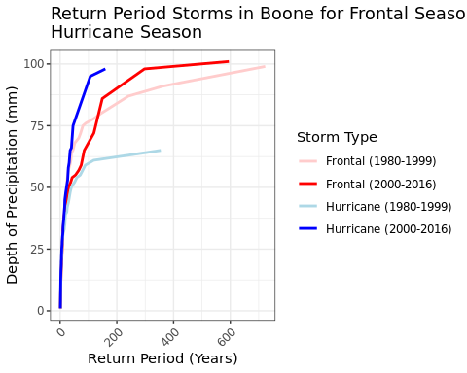

#Seasonal, Greensboro 1980-1999  
#Hurricane season  
hurricane_greensboro <- greensboro %>%   
 filter(month == 7:10) %>%   
 filter(year < 2000)

## Warning: There was 1 warning in `filter()`.  
## ℹ In argument: `month == 7:10`.  
## Caused by warning in `month == 7:10`:  
## ! longer object length is not a multiple of shorter object length

#Frontal season  
frontal_greensboro <- greensboro %>%   
 filter(month == 1:6 | month == 11:12) %>%   
 filter(year < 2000)

## Warning: There was 1 warning in `filter()`.  
## ℹ In argument: `month == 1:6 | month == 11:12`.  
## Caused by warning in `month == 1:6`:  
## ! longer object length is not a multiple of shorter object length

#Calculate moving sum of hurricane season  
sum_greensboro_hurricane <- rollapply(hurricane_greensboro$Area.Weighted.Mean.Precipitation..mm.per.day.,   
 width = 2, FUN = sum, fill = NA,   
 align = "right")  
  
#Turn into data frame  
movingsum_greensboro_hurricane <- data.frame(  
 Original_Data = hurricane_greensboro,  
 Moving_Sum = sum_greensboro_hurricane  
) %>%   
 filter(Moving_Sum > 0)  
  
#Calculate return period  
rp_greensboro_hurricane <- movingsum_greensboro_hurricane %>%   
 filter(Moving_Sum > 0) %>%   
 mutate(rank = rank(-Moving_Sum,  
 ties.method = "max")) %>%   
 mutate(number_events = 292) %>%   
 mutate(weibull = (rank/number_events)) %>%   
 mutate(return_period = 1/weibull)  
#moving sum for 50-year 48-hour storm event = 51 mm  
  
#Calculate moving sum of frontal season  
sum_greensboro_frontal <- rollapply(  
 frontal_greensboro$Area.Weighted.Mean.Precipitation..mm.per.day.,   
 width = 2, FUN = sum, fill = NA, align = "right")  
  
#Turn into data frame  
movingsum_greensboro_frontal <- data.frame(  
 Original_Data = frontal_greensboro,  
 Moving_Sum = sum_greensboro_frontal  
) %>%   
 filter(Moving_Sum > 0)  
  
#Calculate return period  
rp_greensboro_frontal <- movingsum_greensboro_frontal %>%   
 filter(Moving_Sum > 0) %>%   
 mutate(rank = rank(-Moving_Sum,  
 ties.method = "max")) %>%   
 mutate(number_events = 634) %>%   
 mutate(weibull = (rank/number_events)) %>%   
 mutate(return_period = 1/weibull)  
#moving sum for 50-year 48-hour storm event = 42 mm  
  
#Add columns specifying storm type  
rp_greensboro_frontal$StormType = "Frontal (1980-1999)"  
rp_greensboro_hurricane$StormType = "Hurricane (1980-1999)"  
  
#Comvine frontal and hurricane  
greensboro_combined <- bind_rows(rp_greensboro_frontal, rp_greensboro_hurricane)  
  
#Plot, 1980-1999 only  
ggplot(greensboro_combined, aes(x = return_period, y = Moving_Sum, color = StormType)) +  
 geom_line() +  
 labs(title = "Return Period Storms in Greensboro for Frontal Season   
 and\nHurricane Season, 1980-1999",  
 x = "Return Period",  
 y = "Depth of precipitation (mm)") +  
 theme_bw() +  
 theme(axis.text.x = element_text(angle = 45, hjust = 1))

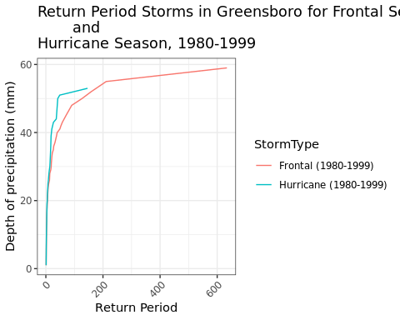

#Seasonal, Greensboro 2000-2016  
#Hurricane season  
hurricane_greensboro_2016 <- greensboro %>%   
 filter(month == 7:10) %>%   
 filter(year >= 2000)

## Warning: There was 1 warning in `filter()`.  
## ℹ In argument: `month == 7:10`.  
## Caused by warning in `month == 7:10`:  
## ! longer object length is not a multiple of shorter object length

#Frontal season  
frontal_greensboro_2016 <- greensboro %>%   
 filter(month == 1:6 | month == 11:12) %>%   
 filter(year >= 2000)

## Warning: There was 1 warning in `filter()`.  
## ℹ In argument: `month == 1:6 | month == 11:12`.  
## Caused by warning in `month == 1:6`:  
## ! longer object length is not a multiple of shorter object length

#Calculate moving sum of hurricane season  
sum_greensboro_hurricane_2016 <- rollapply(  
 hurricane_greensboro_2016$Area.Weighted.Mean.Precipitation..mm.per.day.,  
 width = 2, FUN = sum, fill = NA, align = "right")  
  
#Turn into data frame  
movingsum_greensboro_hurricane_2016 <- data.frame(  
 Original_Data = hurricane_greensboro_2016,  
 Moving_Sum = sum_greensboro_hurricane_2016  
) %>%   
 filter(Moving_Sum > 0)  
  
#Calculate return period  
rp_greensboro_hurricane_2016 <- movingsum_greensboro_hurricane_2016 %>%   
 filter(Moving_Sum > 0) %>%   
 mutate(rank = rank(-Moving_Sum,  
 ties.method = "max")) %>%   
 mutate(number_events = 285) %>%   
 mutate(weibull = (rank/number_events)) %>%   
 mutate(return_period = 1/weibull)  
#moving sum for 50-year 48-hour storm event = 69 mm  
  
#Calculate moving sum of frontal season  
sum_greensboro_frontal_2016 <- rollapply(  
 frontal_greensboro_2016$Area.Weighted.Mean.Precipitation..mm.per.day.,   
 width = 2, FUN = sum, fill = NA, align = "right")  
  
#Turn into data frame  
movingsum_greensboro_frontal_2016 <- data.frame(  
 Original_Data = frontal_greensboro_2016,  
 Moving_Sum = sum_greensboro_frontal_2016  
) %>%   
 filter(Moving_Sum > 0)  
  
#Calculate return period  
rp_greensboro_frontal_2016 <- movingsum_greensboro_frontal_2016 %>%   
 filter(Moving_Sum > 0) %>%   
 mutate(rank = rank(-Moving_Sum,  
 ties.method = "max")) %>%   
 mutate(number_events = 505) %>%   
 mutate(weibull = (rank/number_events)) %>%   
 mutate(return_period = 1/weibull)  
#moving sum for 50-year 48-hour storm event = 42 mm  
  
#Add columns specifying storm type  
rp_greensboro_frontal_2016$StormType = "Frontal (2000-2016)"  
rp_greensboro_hurricane_2016$StormType = "Hurricane (2000-2016)"  
  
#Combine all years  
greensboro_combined_all <- bind_rows(rp_greensboro_frontal,   
 rp_greensboro_hurricane,   
 rp_greensboro_frontal_2016,   
 rp_greensboro_hurricane_2016)  
  
#Plot all years  
ggplot(greensboro_combined_all, aes(x = return_period, y = Moving_Sum,   
 color = StormType)) +  
 geom_line(size = 1) +  
 labs(title = "Return Period Storms in Greensboro for Frontal Season   
 and\nHurricane Season",  
 x = "Return Period (Years)",  
 y = "Depth of Precipitation (mm)",  
 color = "Storm Type") +  
 scale_color_manual(  
 values = c("Frontal (1980-1999)" = "#FFCCCC",  
 "Frontal (2000-2016)" = "red",  
 "Hurricane (1980-1999)" = "#ADD8E6",  
 "Hurricane (2000-2016)" = "blue")) +  
 theme_bw() +  
 theme(axis.text.x = element_text(angle = 45, hjust = 1))

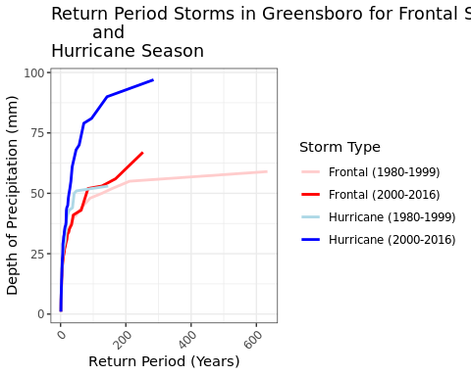

#Seasonal, Greenville 1980-1999  
#Hurricane season  
hurricane_greenville <- greenville %>%   
 filter(month == 7:10) %>%   
 filter(year < 2000)

## Warning: There was 1 warning in `filter()`.  
## ℹ In argument: `month == 7:10`.  
## Caused by warning in `month == 7:10`:  
## ! longer object length is not a multiple of shorter object length

#Frontal season  
frontal_greenville <- greenville %>%   
 filter(month == 1:6 | month == 11:12) %>%   
 filter(year < 2000)

## Warning: There was 1 warning in `filter()`.  
## ℹ In argument: `month == 1:6 | month == 11:12`.  
## Caused by warning in `month == 1:6`:  
## ! longer object length is not a multiple of shorter object length

#Calculate moving sum of hurricane season  
sum_greenville_hurricane <- rollapply(hurricane_greenville$Area.Weighted.Mean.Precipitation..mm.per.day.,   
 width = 2, FUN = sum, fill = NA,   
 align = "right")  
  
#Turn into data frame  
movingsum_greenville_hurricane <- data.frame(  
 Original_Data = hurricane_greenville,  
 Moving_Sum = sum_greenville_hurricane  
) %>%   
 filter(Moving_Sum > 0)  
  
#Calculate return period  
rp_greenville_hurricane <- movingsum_greenville_hurricane %>%   
 filter(Moving_Sum > 0) %>%   
 mutate(rank = rank(-Moving_Sum,  
 ties.method = "max")) %>%   
 mutate(number_events = 296) %>%   
 mutate(weibull = (rank/number_events)) %>%   
 mutate(return_period = 1/weibull)  
#moving sum for 50-year 48-hour storm event = 89 mm  
  
#Calculate moving sum of frontal season  
sum_greenville_frontal <- rollapply(  
 frontal_greenville$Area.Weighted.Mean.Precipitation..mm.per.day.,   
 width = 2, FUN = sum, fill = NA, align = "right")  
  
#Turn into data frame  
movingsum_greenville_frontal <- data.frame(  
 Original_Data = frontal_greenville,  
 Moving_Sum = sum_greenville_frontal  
) %>%   
 filter(Moving_Sum > 0)  
  
#Calculate return period  
rp_greenville_frontal <- movingsum_greenville_frontal %>%   
 filter(Moving_Sum > 0) %>%   
 mutate(rank = rank(-Moving_Sum,  
 ties.method = "max")) %>%   
 mutate(number_events = 623) %>%   
 mutate(weibull = (rank/number_events)) %>%   
 mutate(return_period = 1/weibull)  
#moving sum for 50-year 48-hour storm event = 44 mm  
  
#Add columns specifying storm type  
rp_greenville_frontal$StormType = "Frontal (1980-1999)"  
rp_greenville_hurricane$StormType = "Hurricane (1980-1999)"  
  
#Combine data  
greenville_combined <- bind_rows(rp_greenville_frontal, rp_greenville_hurricane)  
  
#Plot, 1980-1999 only  
ggplot(greenville_combined, aes(x = return_period, y = Moving_Sum,   
 color = StormType)) +  
 geom_line() +  
 labs(title = "Return Period Storms in Greenville for Frontal Season   
 and\nHurricane Season, 1980-1999",  
 x = "Return Period",  
 y = "Depth of precipitation (mm)") +  
 theme_bw() +  
 theme(axis.text.x = element_text(angle = 45, hjust = 1))

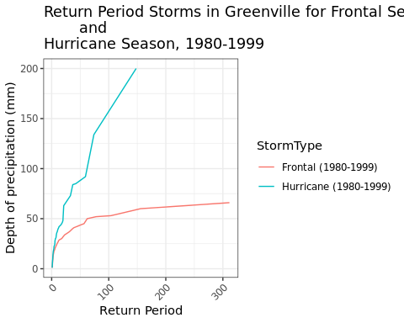

#Seasonal, greenville 2000-2016  
#Hurricane season  
hurricane_greenville_2016 <- greenville %>%   
 filter(month == 7:10) %>%   
 filter(year >= 2000)

## Warning: There was 1 warning in `filter()`.  
## ℹ In argument: `month == 7:10`.  
## Caused by warning in `month == 7:10`:  
## ! longer object length is not a multiple of shorter object length

#Frontal season  
frontal_greenville_2016 <- greenville %>%   
 filter(month == 1:6 | month == 11:12) %>%   
 filter(year >= 2000)

## Warning: There was 1 warning in `filter()`.  
## ℹ In argument: `month == 1:6 | month == 11:12`.  
## Caused by warning in `month == 1:6`:  
## ! longer object length is not a multiple of shorter object length

#Calculate moving sum of hurricane season  
sum_greenville_hurricane_2016 <- rollapply(  
 hurricane_greenville_2016$Area.Weighted.Mean.Precipitation..mm.per.day.,   
 width = 2, FUN = sum, fill = NA, align = "right")  
  
#Turn into data frame  
movingsum_greenville_hurricane_2016 <- data.frame(  
 Original_Data = hurricane_greenville_2016,  
 Moving_Sum = sum_greenville_hurricane_2016  
) %>%   
 filter(Moving_Sum > 0)  
  
#Calculate return period  
rp_greenville_hurricane_2016 <- movingsum_greenville_hurricane_2016 %>%   
 filter(Moving_Sum > 0) %>%   
 mutate(rank = rank(-Moving_Sum,  
 ties.method = "max")) %>%   
 mutate(number_events = 280) %>%   
 mutate(weibull = (rank/number_events)) %>%   
 mutate(return_period = 1/weibull)  
#moving sum for 50-year 48-hour storm event = 151 mm  
  
#Calculate moving sum of frontal season  
sum_greenville_frontal_2016 <- rollapply(frontal_greenville_2016$Area.Weighted.Mean.Precipitation..mm.per.day.,   
 width = 2, FUN = sum, fill = NA,   
 align = "right")  
  
#Turn into data frame  
movingsum_greenville_frontal_2016 <- data.frame(  
 Original_Data = frontal_greenville_2016,  
 Moving_Sum = sum_greenville_frontal_2016  
) %>%   
 filter(Moving_Sum > 0)  
  
#Calculate return period  
rp_greenville_frontal_2016 <- movingsum_greenville_frontal_2016 %>%   
 filter(Moving_Sum > 0) %>%   
 mutate(rank = rank(-Moving_Sum,  
 ties.method = "max")) %>%   
 mutate(number_events = 460) %>%   
 mutate(weibull = (rank/number_events)) %>%   
 mutate(return_period = 1/weibull)  
#moving sum for 50-year 48-hour storm event = 54 mm  
  
#Add columns specifying storm type  
rp_greenville_frontal_2016$StormType = "Frontal (2000-2016)"  
rp_greenville_hurricane_2016$StormType = "Hurricane (2000-2016)"  
  
#Combine all years  
greenville_combined_all <- bind_rows(rp_greenville_frontal,   
 rp_greenville_hurricane,   
 rp_greenville_frontal_2016,   
 rp_greenville_hurricane_2016)  
  
#Plot all years  
ggplot(greenville_combined_all, aes(x = return_period, y = Moving_Sum,   
 color = StormType)) +  
 geom_line(size = 1) +  
 labs(title = "Return Period Storms in Greenville for Frontal Season   
 and\nHurricane Season",  
 x = "Return Period (Years)",  
 y = "Depth of Precipitation (mm)",  
 color = "Storm Type") +  
 scale_color_manual(  
 values = c("Frontal (1980-1999)" = "#FFCCCC",  
 "Frontal (2000-2016)" = "red",  
 "Hurricane (1980-1999)" = "#ADD8E6",  
 "Hurricane (2000-2016)" = "blue")) +  
 theme_bw() +  
 theme(axis.text.x = element_text(angle = 45, hjust = 1))

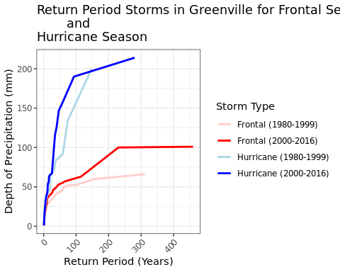

#Boone, 2016  
boone_2016 <- boone %>%   
 filter(year == 2016)  
  
#Calculate the moving sum  
moving_boone_2016 <- rollapply(  
 boone_2016$Area.Weighted.Mean.Precipitation..mm.per.day., width = 2,   
 FUN = sum, fill = NA, align = "right")  
  
#Turn into a data frame  
boone_2016_movingsum <- data.frame(  
 Original_Data = boone_2016,  
 Moving_Sum = moving_boone_2016  
) %>%   
 filter(Moving_Sum > 0)  
  
#Calculate two-day monthly max  
boone_2016_monthly <- boone_2016_movingsum %>%   
 group_by(Original_Data.month) %>%   
 summarise(twoday_max_monthly = max(Moving_Sum))  
  
#Change month to a factor  
boone_2016_monthly$Original_Data.month <- factor(boone_2016_monthly$Original_Data.month,   
 levels = 1:12,  
 labels = month.abb)  
  
#Plot the monthly two-day max precip  
ggplot(boone_2016_monthly, aes(x = Original_Data.month, y = twoday_max_monthly)) +  
 geom_bar(stat = "identity", fill = "skyblue") +   
 labs(title = "Monthly Two-Day Maximum Precipitation, Boone 2016",   
 x = "Month",   
 y = "Depth of Precipitation (mm)") +  
 geom_vline(xintercept = 6.5, linetype = "dashed", color = "red", size = 1) +  
 geom_vline(xintercept = 10.5, linetype = "dashed", color = "red", size = 1) +  
 annotate("text", x = 4.5, y = 60, label = "Hurricane Season", size = 3) +  
 annotate("text", x = 8.5, y = 60, label = "Frontal Season", size = 3) +  
 theme_bw()

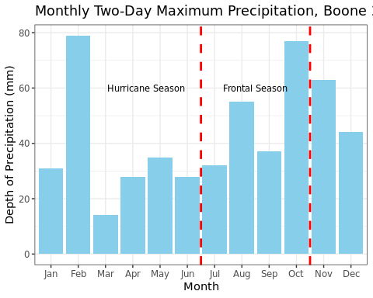

#Boone, 1995  
boone_1995 <- boone %>%   
 filter(year == 1995)  
  
#Calculate the moving sum  
moving_boone_1995 <- rollapply(  
 boone_1995$Area.Weighted.Mean.Precipitation..mm.per.day., width = 2,   
 FUN = sum, fill = NA, align = "right")  
  
#Turn into a data frame  
boone_1995_movingsum <- data.frame(  
 Original_Data = boone_1995,  
 Moving_Sum = moving_boone_1995  
) %>%   
 filter(Moving_Sum > 0)  
  
#Calculate two-day annual max  
boone_1995_monthly <- boone_1995_movingsum %>%   
 group_by(Original_Data.month) %>%   
 summarise(twoday_max_monthly = max(Moving_Sum))  
  
#Change month to factor  
boone_1995_monthly$Original_Data.month <- factor(boone_1995_monthly$Original_Data.month,   
 levels = 1:12,  
 labels = month.abb)  
   
#Plot the monthly two-day max precip   
ggplot(boone_1995_monthly, aes(x = Original_Data.month, y = twoday_max_monthly)) +  
 geom_bar(stat = "identity", fill = "skyblue") +   
 labs(title = "Monthly Two-Day Maximum Precipitation, Boone 1995",   
 x = "Month",   
 y = "Depth of Precipitation (mm)") +  
 geom_vline(xintercept = 6.5, linetype = "dashed", color = "red", size = 1) +  
 geom_vline(xintercept = 10.5, linetype = "dashed", color = "red", size = 1) +  
 annotate("text", x = 3.5, y = 110, label = "Hurricane Season", size = 3) +  
 annotate("text", x = 8.5, y = 110, label = "Frontal Season", size = 3) +  
 theme_bw()

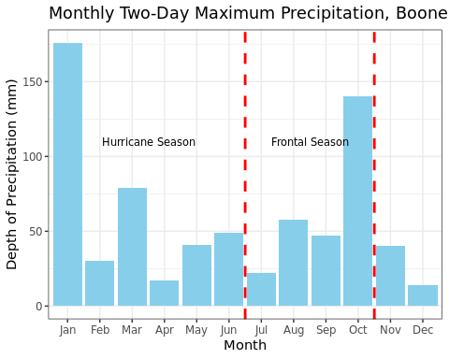

#Greensboro, 2016  
greensboro_2016 <- greensboro %>%   
 filter(year == 2016)  
  
#Calculate the moving sum  
moving_greensboro_2016 <- rollapply(  
 greensboro_2016$Area.Weighted.Mean.Precipitation..mm.per.day., width = 2,   
 FUN = sum, fill = NA, align = "right")  
  
#Turn into a data frame  
greensboro_2016_movingsum <- data.frame(  
 Original_Data = greensboro_2016,  
 Moving_Sum = moving_greensboro_2016  
) %>%   
 filter(Moving_Sum > 0)  
  
#Calculate two-day annual max  
greensboro_2016_monthly <- greensboro_2016_movingsum %>%   
 group_by(Original_Data.month) %>%   
 summarise(twoday_max_monthly = max(Moving_Sum))  
  
#Change month to a factor  
greensboro_2016_monthly$Original_Data.month <- factor(  
 greensboro_2016_monthly$Original_Data.month,   
 levels = 1:12,  
 labels = month.abb)  
  
#Plot the monthly two-day max precip  
ggplot(greensboro_2016_monthly, aes(x = Original_Data.month, y = twoday_max_monthly)) +  
 geom_bar(stat = "identity", fill = "skyblue") +   
 labs(title = "Monthly Two-Day Maximum Precipitation, Greensboro 2016",   
 x = "Month",   
 y = "Depth of Precipitation (mm)") +  
 geom_vline(xintercept = 6.5, linetype = "dashed", color = "red", size = 1) +  
 geom_vline(xintercept = 10.5, linetype = "dashed", color = "red", size = 1) +  
 annotate("text", x = 3, y = 80, label = "Hurricane Season", size = 3) +  
 annotate("text", x = 8.5, y = 80, label = "Frontal Season", size = 3) +  
 theme_bw()

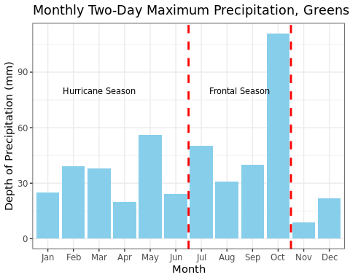

#Greensboro, 1995  
greensboro_1995 <- greensboro %>%   
 filter(year == 1995)  
  
#Calculate the moving sum  
moving_greensboro_1995 <- rollapply(  
 greensboro_1995$Area.Weighted.Mean.Precipitation..mm.per.day., width = 2,   
 FUN = sum, fill = NA, align = "right")  
  
#Turn into a data frame  
greensboro_1995_movingsum <- data.frame(  
 Original_Data = greensboro_1995,  
 Moving_Sum = moving_greensboro_1995  
) %>%   
 filter(Moving_Sum > 0)  
  
#Calculate two-day annual max  
greensboro_1995_monthly <- greensboro_1995_movingsum %>%   
 group_by(Original_Data.month) %>%   
 summarise(twoday_max_monthly = max(Moving_Sum))  
  
#Change month to factor  
greensboro_1995_monthly$Original_Data.month <- factor(  
 greensboro_1995_monthly$Original_Data.month,   
 levels = 1:12,  
 labels = month.abb)  
   
#Plot the monthly two-day max precip   
ggplot(greensboro_1995_monthly, aes(x = Original_Data.month, y = twoday_max_monthly)) +  
 geom_bar(stat = "identity", fill = "skyblue") +   
 labs(title = "Monthly Two-Day Maximum Precipitation, Greensboro 1995",   
 x = "Month",   
 y = "Depth of Precipitation (mm)") +  
 geom_vline(xintercept = 6.5, linetype = "dashed", color = "red", size = 1) +  
 geom_vline(xintercept = 10.5, linetype = "dashed", color = "red", size = 1) +  
 annotate("text", x = 3, y = 75, label = "Hurricane Season", size = 3) +  
 annotate("text", x = 8.5, y = 75, label = "Frontal Season", size = 3) +  
 theme_bw()

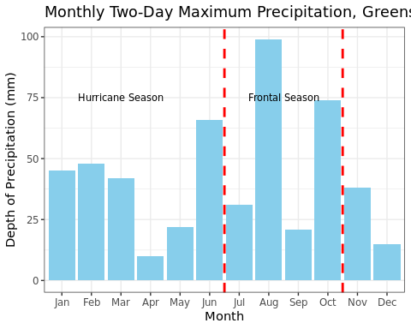

#Greenville, 2016  
greenville_2016 <- greenville %>%   
 filter(year == 2016)  
  
#Calculate the moving sum  
moving_greenville_2016 <- rollapply(  
 greenville_2016$Area.Weighted.Mean.Precipitation..mm.per.day., width = 2,   
 FUN = sum, fill = NA, align = "right")  
  
#Turn into a data frame  
greenville_2016_movingsum <- data.frame(  
 Original_Data = greenville_2016,  
 Moving_Sum = moving_greenville_2016  
) %>%   
 filter(Moving_Sum > 0)  
  
#Calculate two-day annual max  
greenville_2016_monthly <- greenville_2016_movingsum %>%   
 group_by(Original_Data.month) %>%   
 summarise(twoday_max_monthly = max(Moving_Sum))  
  
#Change month to a factor  
greenville_2016_monthly$Original_Data.month <- factor(  
 greenville_2016_monthly$Original_Data.month,   
 levels = 1:12,  
 labels = month.abb)  
  
#Plot the monthly two-day max precip  
ggplot(greenville_2016_monthly, aes(x = Original_Data.month, y = twoday_max_monthly)) +  
 geom_bar(stat = "identity", fill = "skyblue") +   
 labs(title = "Monthly Two-Day Maximum Precipitation, Greenville 2016",   
 x = "Month",   
 y = "Depth of Precipitation (mm)") +  
 geom_vline(xintercept = 6.5, linetype = "dashed", color = "red", size = 1) +  
 geom_vline(xintercept = 10.5, linetype = "dashed", color = "red", size = 1) +  
 annotate("text", x = 3, y = 150, label = "Hurricane Season", size = 3) +  
 annotate("text", x = 8.5, y = 190, label = "Frontal Season", size = 3) +  
 theme_bw()

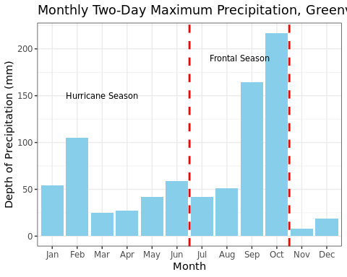

#Greenville, 1995  
greenville_1995 <- greenville %>%   
 filter(year == 1995)  
  
#Calculate the moving sum  
moving_greenville_1995 <- rollapply(  
 greenville_1995$Area.Weighted.Mean.Precipitation..mm.per.day., width = 2,   
 FUN = sum, fill = NA, align = "right")  
  
#Turn into a data frame  
greenville_1995_movingsum <- data.frame(  
 Original_Data = greenville_1995,  
 Moving_Sum = moving_greenville_1995  
) %>%   
 filter(Moving_Sum > 0)  
  
#Calculate two-day annual max  
greenville_1995_monthly <- greenville_1995_movingsum %>%   
 group_by(Original_Data.month) %>%   
 summarise(twoday_max_monthly = max(Moving_Sum))  
  
#Change month to factor  
greenville_1995_monthly$Original_Data.month <- factor(  
greenville_1995_monthly$Original_Data.month,   
 levels = 1:12,  
 labels = month.abb)  
   
#Plot the monthly two-day max precip   
ggplot(greenville_1995_monthly, aes(x = Original_Data.month, y = twoday_max_monthly)) +  
 geom_bar(stat = "identity", fill = "skyblue") +   
 labs(title = "Monthly Two-Day Maximum Precipitation, Greenville 1995",   
 x = "Month",   
 y = "Depth of Precipitation (mm)") +  
 geom_vline(xintercept = 6.5, linetype = "dashed", color = "red", size = 1) +  
 geom_vline(xintercept = 10.5, linetype = "dashed", color = "red", size = 1) +  
 annotate("text", x = 3, y = 90, label = "Hurricane Season", size = 3) +  
 annotate("text", x = 8.5, y = 90, label = "Frontal Season", size = 3) +  
 theme_bw()

