Q1. Monthly AC Sales (Bar Chart)

import pandas as pd
import matplotlib.pyplot as plt

df=pd.read_csv(r"D:\E2_10\e2_ds_10\bar.csv")
plt.bar(df["Month"],df["AC Sales"],color="#85AC75")
plt.title("Monthly Sales")
plt.xlabel("Month")
plt.ylabel("AC Sales")
plt.show()

Output :
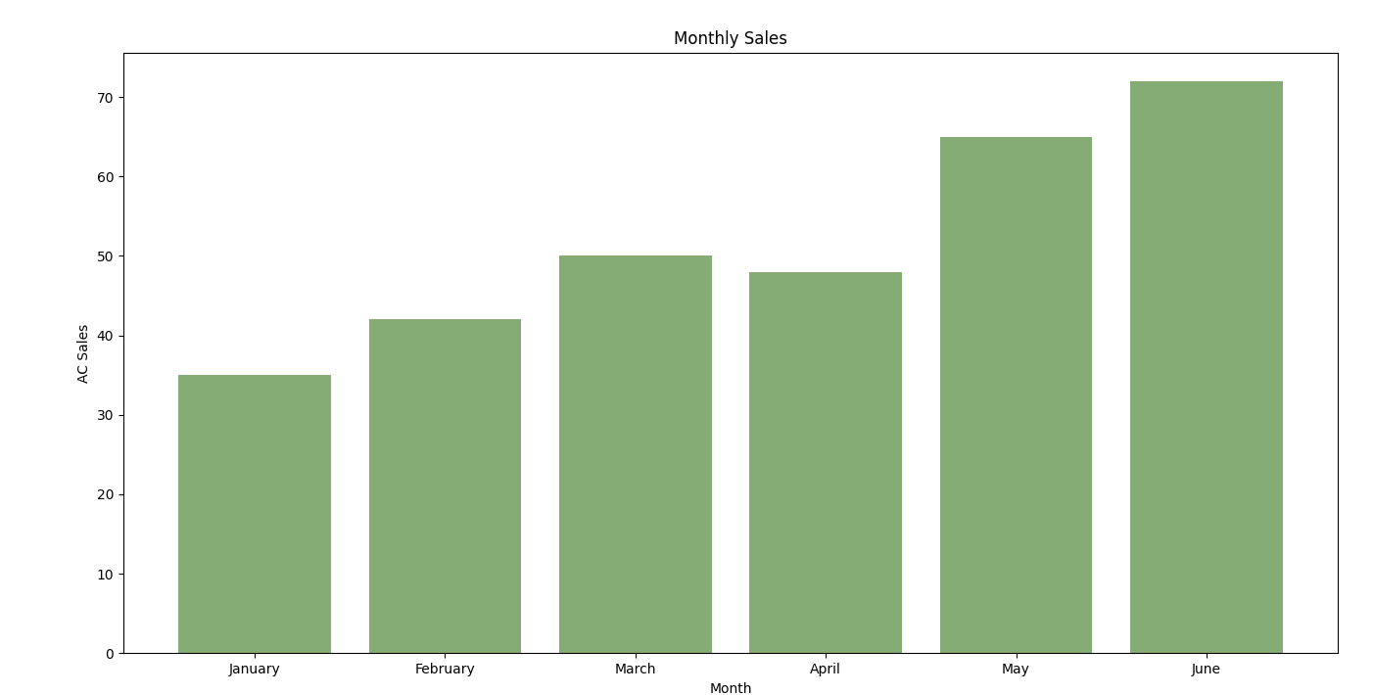

Q2. Monthly Laptop Sales (Line Chart)
An electronics store recorded the number of laptops sold during six months.
Month Laptop Sales

Write a Python program using Matplotlib to create a Line Chart showing the monthly laptop
sales trend.

import pandas as pd
import matplotlib.pyplot as plt

df=pd.read_csv(r"D:\E2_10\e2_ds_10\line.csv")
plt.plot(df["Month"],df["Laptop Sales"],marker='o')

plt.title("Monthly Sales")
plt.xlabel("Month")
plt.ylabel("Laptop Sales")
plt.show()

January 20
February 28
March 35
April 45
May 52
June 60

Output:
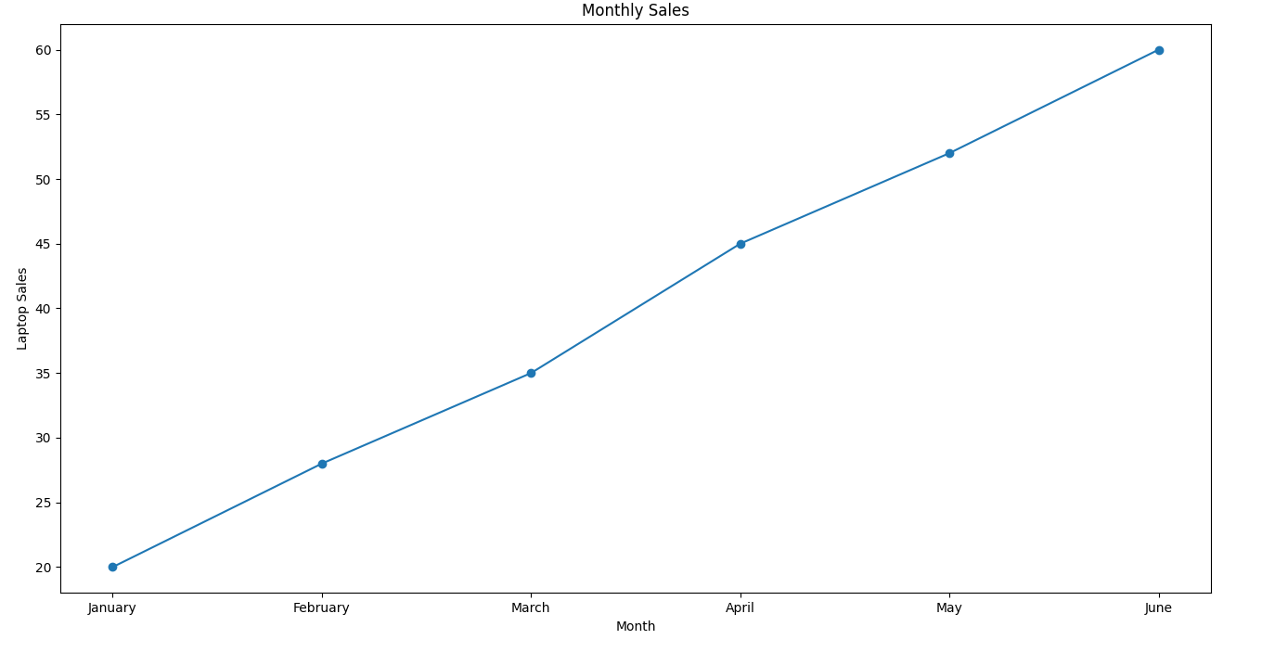

Q3. Smartphone Brand Sales (Pie Chart)
A mobile shop sold different smartphone brands during one month.
Brand Units Sold
Samsung 80
Vivo 60
Oppo 45
Xiaomi 50
Apple 35
Write a Python program using Matplotlib to create a Pie Chart representing the percentage of
sales of different smartphone brands.

Q4. Study Hours vs Marks (Scatter Plot)
The following data shows the study hours and marks obtained by students.
Study Hours Marks
2 40
3 48
4 58
5 67
6 75
7 83
8 92
Write a Python program using Matplotlib to create a Scatter Plot showing the relationship
between study hours and marks.

Q5. Employee Salary Distribution (Histogram)
A company recorded the monthly salaries (₹) of its employees.
Salary Data:
25000, 28000, 30000, 32000, 35000, 35000, 37000, 40000, 42000, 45000, 47000, 50000,
52000, 55000, 60000
Write a Python program using Matplotlib to create a Histogram showing the salary
distribution of employees.

Q6. Product Sales Comparison (Bar Chart)
A supermarket recorded the sales of different products.
Product Units Sold
Rice 120
Sugar 95
Cooking Oil 80
Tea 65

