Main step
- First run your splitter to convert long_video into short.
- Run the WAV script to generate the audio.
- Run add_noise to add noise with three different SNR.
- Run the mouth script to obtain mouth-region features. In the main function, you can run debug to start OpenCV and verify whether the features of each segment meet the requirements.
- Run the feature script to obtain four different video features and one audio feature.
- Run the two model training scripts.
Project structure
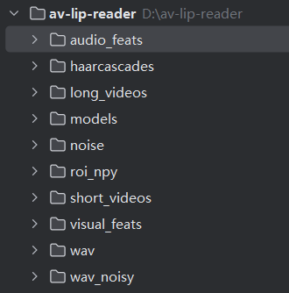
And I didn’t draw any diagram so you should add some like confusion matrix and so on.

