PERFICIENT — GLOBAL AI FIRST ACADEMY  AI Certifications — Capstone Case Study  Option 04 — Case Study Capstone · Global AI-First Academy | 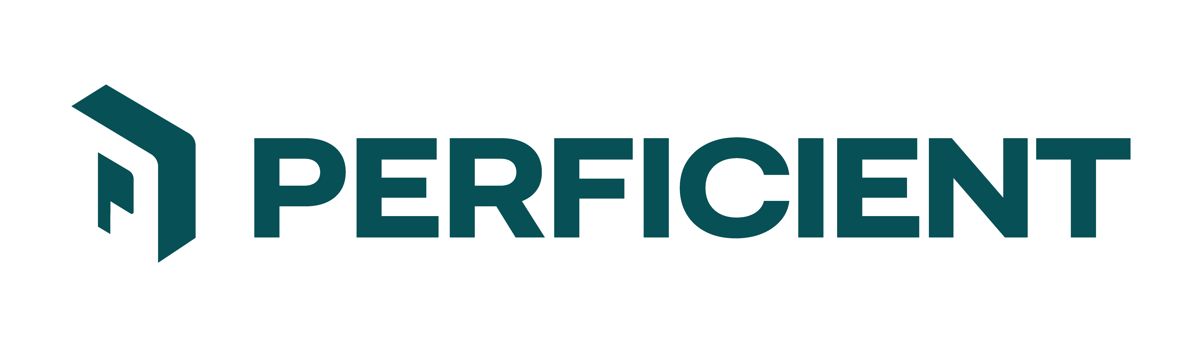
Case ID  L1_Case05_Open_Choice_Prototype | Level & Option  L1 — AI Augmented SDLC · Option 04 | Industry / Domain  Learner-defined
Open Choice: define the problem, source the data, build the AI-augmented prototype
SCENARIO
A prospective client has approached the firm with a business problem they have not yet been able to articulate crisply. There is no requirements document, no dataset waiting on a share drive, and no agreed definition of success - there is a frustrated stakeholder, a process that is costing more than it should, and an opening to prove that AI can help. This is the normal starting condition for a forward-deployed engagement, and the ability to work from it is the competency being assessed.
You are the engineer assigned to turn that opening into something demonstrable. The client is in healthcare, financial services, or manufacturing - or a domain you know better than we do. You decide which, you decide who the user is, and you decide what the solution does.
YOUR MISSION
Define a problem worth solving, source or create the data needed to solve it, and build a working AI-augmented prototype that a client stakeholder could watch and understand. Then show your working: the spec you wrote before you built, the context you engineered to get usable output, and the review you applied to what the AI produced for you.
WHAT'S IN THE SANDBOX
Nothing. That is the point of this option.
- No dataset is provided. You are responsible for sourcing or creating your own, and your data decisions are scored: where it came from, whether it is realistic, whether it contains cases your solution actually gets wrong, and how you handled anything sensitive.
- No starter code is provided. Structure the project yourself.
- No question set or label set is provided. Defining what correct means here is part of the work.
- If you would rather work from a prepared scenario with data supplied, take one of the other cases at this level instead. This option is not the easier path.
WHAT YOUR SOLUTION MUST DO
- Solve a real problem for a named user in a named domain. State the problem, the user, and what changes for them if this works, before any code.
- Follow a spec-first workflow. Write the spec, plan, and task breakdown before implementation, and keep them - they are deliverables, not scaffolding. Commit them separately from the implementation so the sequence is visible.
- Engineer the context deliberately. Use an instruction file (CLAUDE.md or .github/copilot-instructions.md), scoped references, or curated retrieval, and show what changed in the output because of it. A before-and-after comparison is the evidence.
- Include either a retrieval pipeline over your own documents or a working n8n automation with AI in the loop - whichever genuinely fits the problem. Say why you chose it over the other.
- Review what the AI generated for you across intent, tests, security, performance, and maintainability. Report at least one thing it got wrong that you caught and corrected.
- Find where your own solution fails, on your own data, and show it.
WHAT A STRONG SUBMISSION DEMONSTRATES
A strong submission looks like consulting work, not a coursework exercise. It picks a problem narrow enough to actually solve, sources data honestly, and is candid about what the prototype does not do. We would rather see a small thing that genuinely works and a clear account of its limits than a broad demo that collapses under a follow-up question. Time pressure and tradeoffs are expected - what is assessed is the judgement you applied under them, so tell us what you cut and why.
SUGGESTED TECH STACK & GETTING STARTED
Approach is yours to choose: no-code or low-code (n8n), AI-native tools (Claude Projects, Custom GPTs, NotebookLM, Gemini, Perplexity), code and frameworks (Python, LangChain, LlamaIndex, LangGraph, FastAPI, Streamlit), or any hybrid. Route model calls through the Portkey gateway where you can, so cost and latency are observable. Document what you chose and why you rejected the alternatives.
- Write down the problem, the user, and your definition of success. One paragraph. Do this first.
- Decide where your data comes from and note its provenance and limitations before you build on it.
- Write spec, plan, and tasks. Commit them before you write implementation code.
- Build the smallest version that demonstrates the idea end to end.
- Add your context artifact, re-run, and record what improved and what did not.
- Go looking for failures on your own data. Fix one, measure the effect, and report both.
WHAT TO SUBMIT
- Working prototype, demonstrable end to end via recording or transcript. It does not need to be production-ready and polish is explicitly not what is scored.
- Your problem statement: domain, user, problem, definition of success.
- Data provenance note: where the data came from or how you generated it, what it does and does not represent, and how you handled anything sensitive.
- Spec, plan, and task artifacts, with commit history showing they preceded the code.
- Context artifact plus before-and-after evidence of its effect on output.
- Your AI output review: what you checked, and at least one error you caught and corrected.
- Failure analysis on your own data, naming specific inputs that break the prototype.
- One slide pitching the solution, addressed to client stakeholders.
- Declared-effort statement: approximate hours, and what you chose to cut.
A NOTE FROM THE CHIEF LEARNING OFFICER
I put this option in deliberately, and I want to be honest about why. The prepared cases hand you a dataset and a defined problem, which is useful for practising a technique but is not how any real engagement begins. Here you get what a consultant actually gets: a vague complaint and an opportunity.
Choose something small. The most common failure I see is an ambitious problem statement attached to a prototype that only works on three hand-picked inputs. I would far rather read about a narrow tool that genuinely works, with an honest account of the ten things it cannot do, than a grand demo that cannot survive one question from the client. Show me the judgement, not the surface area.
Dr. KNS Acharya, Chief Learning Officer · Dr. Prithvi Sekhar Pagala, AI Technologies Pillar Lead
Global AI-First Academy | Perficient

