U3_L5_Project1_Fei

Fei Chen

I have selected PS34 as my chosen school because it is the school that I went to for elementary school. The only available regent exam data available for my school is living environment.

My school’s living environment mean score of 76.75 is slightly lower than the K-8 citywide living environment scores of 77.44 by 0.69 of the same school level. So that means my school is close to the average of the citywide living environment exam.

* In general, it appears that the city and my school is doing fairly well on the living environment exams in the high 70 range. The range of score is from 74-80 for my school, while citywide ranges from 40 – 96.8 and it is heavily concentrated in the 75-95 range.

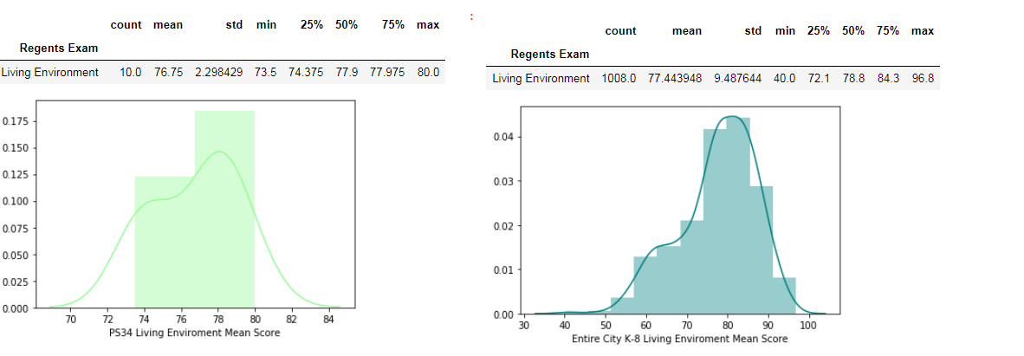

* Next, I want to see the trend of the mean score by year. The overall trend is a decrease for my school from year 2015 – 2016 as oppose to city wide where there is an increase in 2016 but then a decrease in 2017. In 2015, my school’s score was above the citywide average but then in 2016 my school was below average.

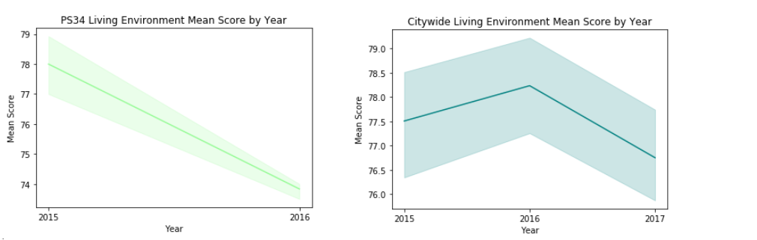

* Finally, I want to see what the other citywide regent exam score is to see if living environment is consider an “easier” subject than other courses. Living environment is consider 3th highest mean score so it is relatively “easier” than most of the regents. It appears that the city really need to focus on Algebra2 and Geometry because the mean are below 65 for these 2 schools.

