U3_L7_Project2

Hypothesis: Cholesterol have an effect on the risk of heart disease. The typical healthy cholesterol level is around 125 to 200mg/dl. The mean of the cholesterol level in the group is 246.69, which is much higher than regular cholesterol level.

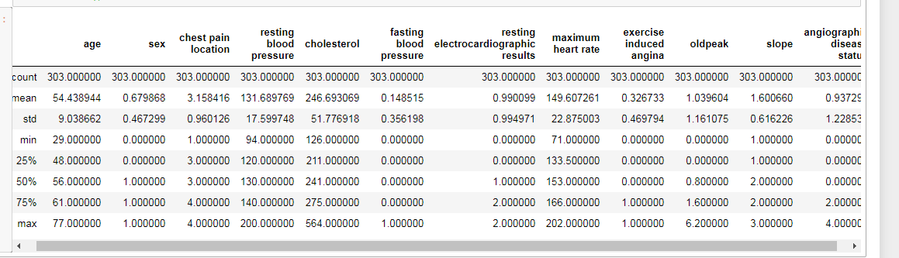

After exploring the data more with heat map and also scatter plot on the cholesterol and angiographic disease status (the higher the number there is more risk). It seems to indicate that there is no correlation between cholesterol and heart disease status with just a correlation of 0.071 on the heatmap.

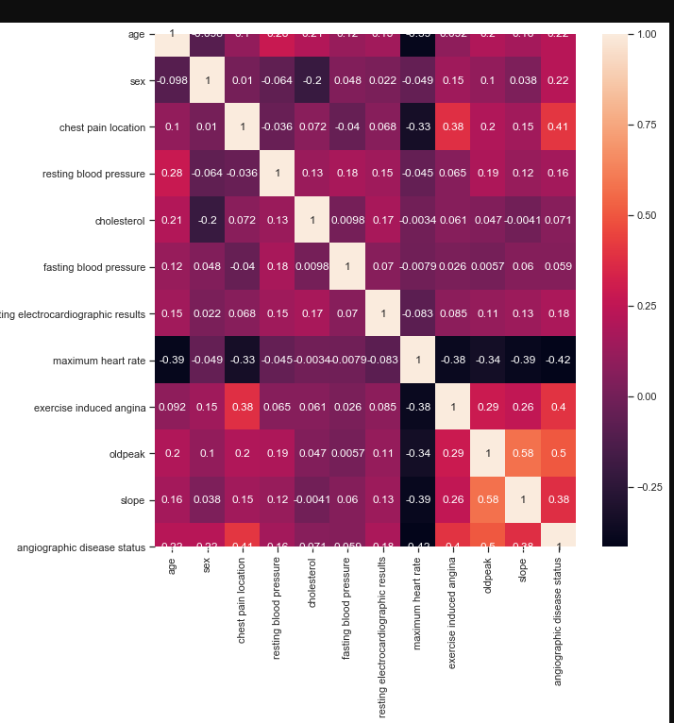

The scatter plot seems to also seems to show that cholesterol have no major effect on heart disease

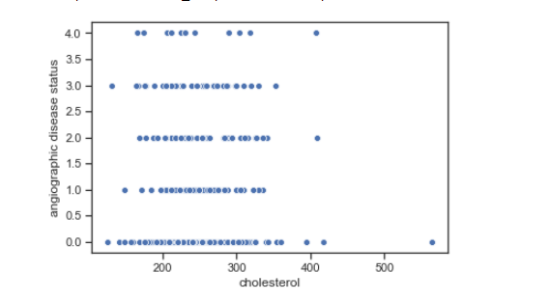

However, when the average of the cholesterol is taken from each group of angiographic heart status 1-4. The average cholesterol is higher for people in angiographic heart status 4 group than the other groups.

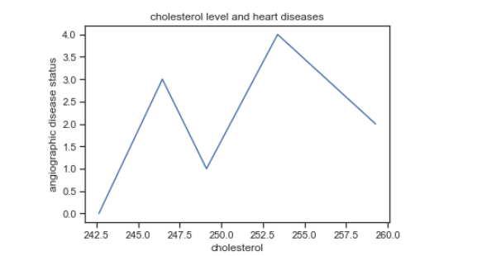

Conclusion, it appears that as your cholesterol level increase there is a higher chance of heart disease.