Finding Stable Curves between the Two Zones

Rohan Mishra

8/5/2022

When investigating combinations of Tc & Tin that give us stable curves in Concentration of A, we anticipated a linear effect in these curves. As overall temperature goes up, the concentration should be stable, and converge to a specific Concentration of A. Plot 1 below shows an example.

## [1] "done"

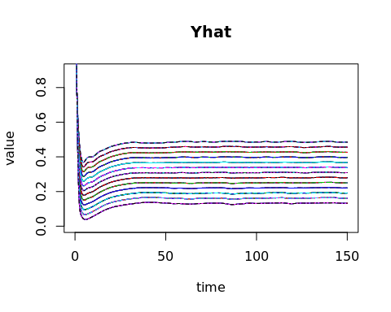

Plot 1

However, when looking at the raw data from simulations, a very different set of Concentration curves emerge, as shown on Plot 2.

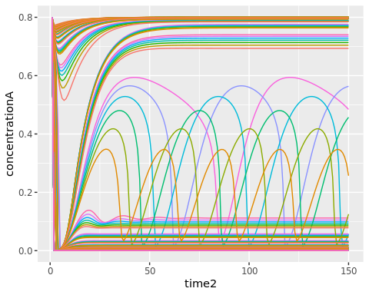

Plot 2

Looking at the raw data, we see a pattern at time 150: stable curves converge into 2 specific concentration values: 0.8 and 0.05.

When we plot each of the Final Concentration_A values for each simulation, we find a bimodal pattern around 0.05 and 0.8. There are very few simulations ending around 0.3 to 0.65. A histogram of Final Concentration values confirms this pattern.

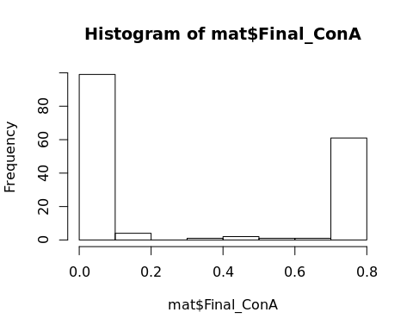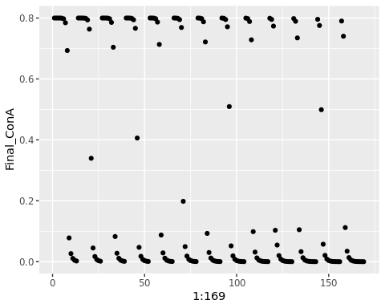

### Matrix Images

An image of a matrix X creates a grid of colored rectangles with colors corresponding to the values in X. Plot 2 shows an image of the matrix. The rownames of this matrix corresponds to Inlet Temperature, and the colnames correspond to Cooling Temperature. We can see a similar pattern emerge in this image as seen in Plot 1.

### Full Simulations

When looking at full simulations, a pattern emerges: Simulations with final values at either of the bimodal peaks has a stable concentration of A, while those in between the peaks have unstable concentrations of A.

Let Cooling Temperature be 340K, and have Inlet Temperature be one of: 260K, 300K, and 340K. The pattern described above can be clearly seen.

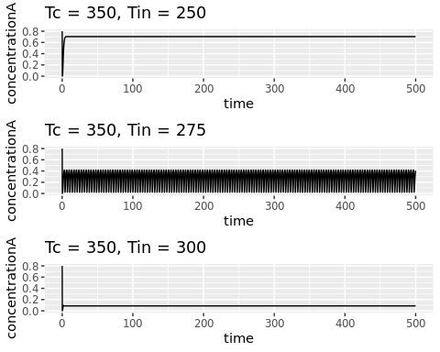

PLOT 3: Simulations either converge close to 0.8, 0, or are unstable and never truly converge

### Fei’s Ranges

When we zoom back into Fei’s original ranges and recreating Plot 1, we see that all Final Concentrations converge very near 0.8.

