Regression Write-Up

Rohan Mishra

2022-09-29

The goal of regression is to obtain estimates of the coefficients for two reasons:

1. They predict the output
2. They describe the relationships between the covariates and output

This report defines functional regression modeling and applies it to some reactor simulation data for illustration.

In classical statistics where data are measured in scalar format on each subject, a simple linear regression between an output $Y$ regressed on an input $X$ is often appropriate. This allows the analysts to 1) understand the relationship between $(X,Y)$ through the $β$ coefficients, and 2) make predictions of $Y$ for new values of $X$.

Consider the model

$$y=β_{0}+β_{1}×x$$

where the goal is to find $(β_{0},β_{1})$ such that the fitted value of $y$, denoted $\hat{y}$, is close to the observed $y$. *Ordinary Least Squares (OLS)*, often used to select the best coefficients, denoted as $({\hat{β}}_{0},{\hat{β}}_{1})$, is a measure of the distance between $y$ and $\hat{y}$. Assume $i=1,2,…,n$ subjects have measurements $(x_{i},y_{i})$, then the goal is to find $({\hat{β}}_{0},{\hat{β}}_{1})$ that minimizes the squared distances between $y_{i}$ and ${\hat{y}}_{i}$:

$$\min_{{\hat{β}}_{0},{\hat{β}}_{1}}\sum_{i=1}^{n}{(}y_{i}−{\hat{y}}_{i})^{2}, {\hat{y}}_{i}=({\hat{β}}_{0}+{\hat{β}}_{1}x_{i})$$

.

**Consider the case where the output variable $Y$ is in functional form**, such as the concentration of A, $C_{a}$, measured at multiple times. Assume further the input variable, $X$, is a scalar. A *functional regression* model, $fRegress$, is analogous to simple linear regression when both $(X,Y)$ are scalars (see above), except the $β$ coefficients are functions - *you need to add functions $({\hat{β}}_{0},{\hat{β}}_{1})$ so the results $\hat{y}$ is a function*. Denote functional coefficients by $({\hat{β}}_{0}^{f},{\hat{β}}_{1}^{f})$, and the observed and fitted outcomes by $(y_{i}^{f},{\hat{y}}_{i}^{f})$

In $fRegress$ the summation in OLS is replaced by an integration:

$$\min_{{\hat{β}}_{0}^{f},{\hat{β}}_{1}^{f}}\int_{i=1}^{n}{(}y_{i}^{f}−{\hat{y}}_{i}^{f})^{2}, {\hat{y}}_{i}^{f}=({\hat{β}}_{0}^{f}+{\hat{β}}_{1}^{f}x_{i}).$$

Functional coefficients can be efficiently calculated but not discussed in detail here. One intuitive way to think of them is as changes in the coefficient over time or space.

# Data Example

We selected a subset of the reactor simulated data where the *Concentration A*, denoted $[A]$, is determined by the *Input Temperature*, denoted *temp_Inlet.* The subset was selected to simplify this discussion by converging onto $[A]$ between $(0.75,0.8)$ for *temp_Inlet* randomly sampled from $Uniform(300,350)$.

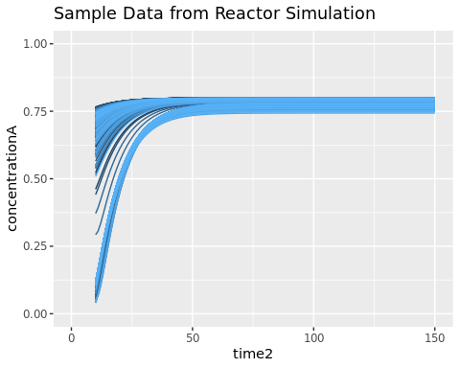

# Functional Regression Examples

We present 2 cases to illustrate functional regression.

## Output is Functional [A], Input is Scalar *temp_Inlet*

For the first model,

$$[A]=β_{0}^{f}+β_{1}^{f}×temp_Inlet,$$

the **functional coefficients $(β_{0}^{f},β_{1}^{f})$** are plotted. Note the *temp_Inlet* was normalized before fitting for statistical reasons, but has no impact on model fit other than the scale of the coefficients.

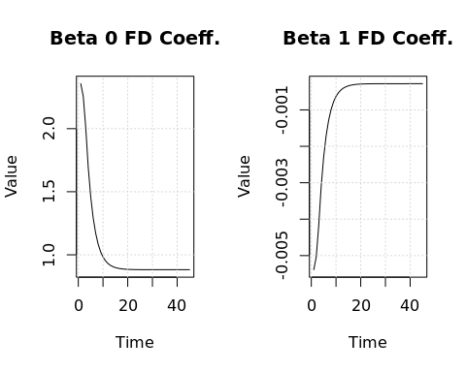

To predict $[A]$ for any *temp_inlet* value at each time point, add the value of the cofficient values at each time point $t$, $β_{0}(t)+β_{1}(t)×temp_Inlet$. The next plot shows these fitted values for a range of possible *temp_Inlet* inputs and represent the predicted $[A]$.

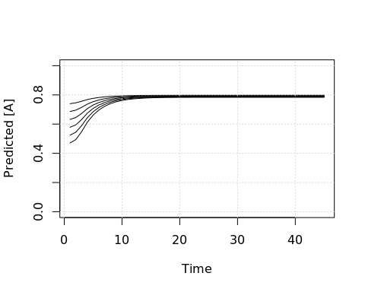

The relationship between the input *temp_Inlet* and output $[A]$ is understood by examining the coefficients shown above.

We interpret coefficient $β_{1}$ as follows. As the *temp_Inlet* increases and multiplied by $β_{1}$, the $[A]$ will decrease more. To be specific, at Time = 3, the value of $β_{1}=−0.005$. At $temp_Inlet=300$, this reduces $[A]$ by $−0.005×300=−1.5$. For $temp_Inlet=350$, $[A]$ is reduced by $−0.005×350=−1.75$.

Note that after time = 20 there is less redcution in $[A]$ since $β_{1}$ flattens out near 0.

To make a prediction, these reductions are added to $β_{0}$ for each time point. So for Time = 3 the predicted value of $[A]$ for $temp_Inlet=300$ is about $2.2−1.5=0.7$, and for $temp_Inlet=350$ is about $2.2−1.75=0.45$.

In the next plot we show these predicted $[A]$ curves.

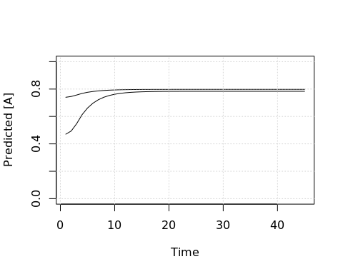

To test whether $β_{1}$ is differnt from 0 (i.e., not statistically significant), we use a permutation test. Where the red line falls above the dashed blue we say the coefficient is statistical different.

## [1] "Estimated Computing time = 40 seconds."

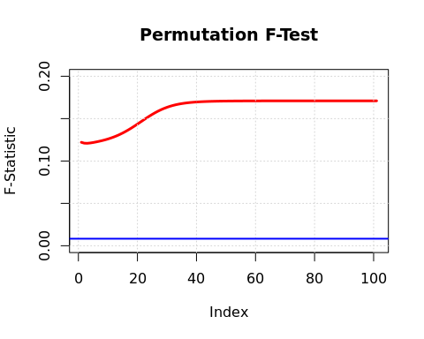

## Permuting the Covariates

*temp_Inlet* was permuted accross the sample curves, taking away the relationship between *temp_Inlet* & $[A]$ Curves.

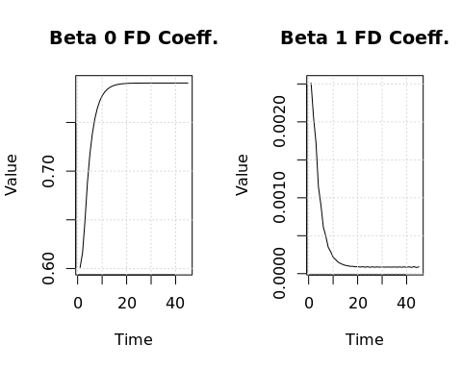

If we look at the $β_{1}$ coefficient plot, we see that it is much closer to 0 than in the previous model. Because of this, different *temp_Inlet* inputs will yield a curve very close to the $β_{0}$ coefficient curve.

When running the permutation test on this model, we see that the red line is strictly below the blue line.

## [1] "Estimated Computing time = 35 seconds."

