修改数据库连接 c：/data/conf/jdbc.properties

Myeclipse 设置字符集utf-8 window--preferences-workspace

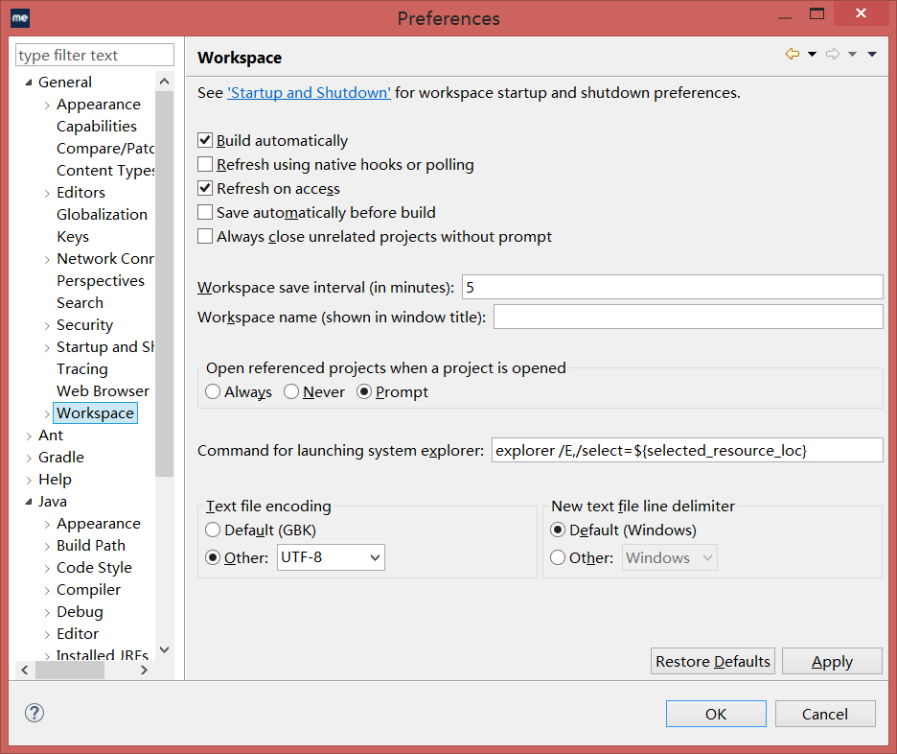

2启动服务

2.1Admin

右击admin工程run as - spring boot app

2.2右击site工程 run as - spring boot app

3jdk选择1.8

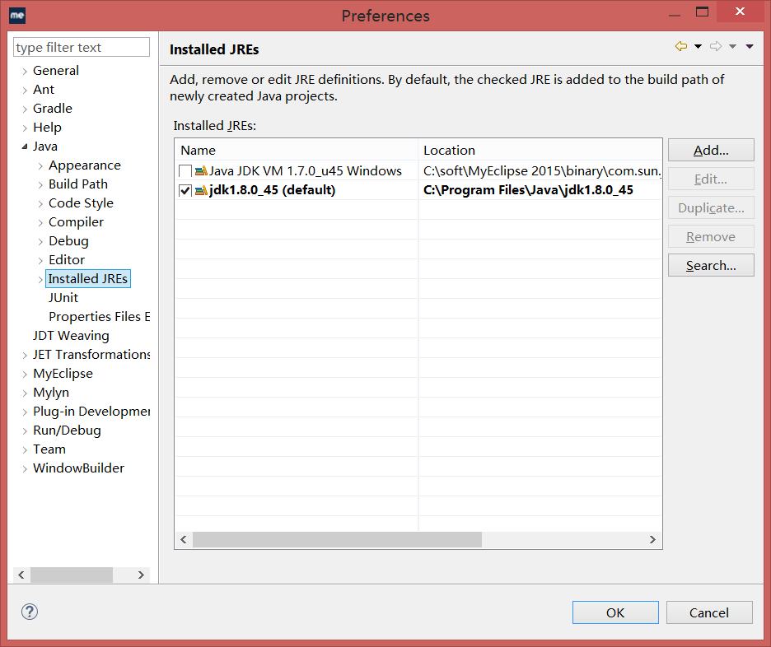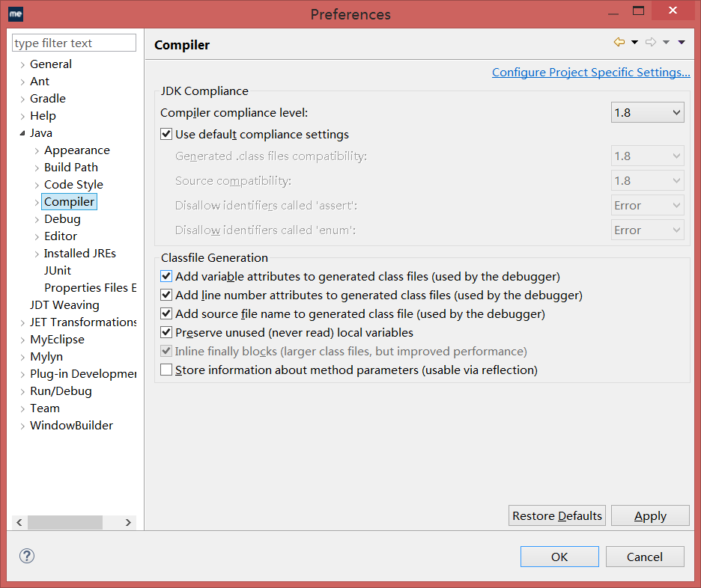

导入工程

File-import - gradle - gradle project

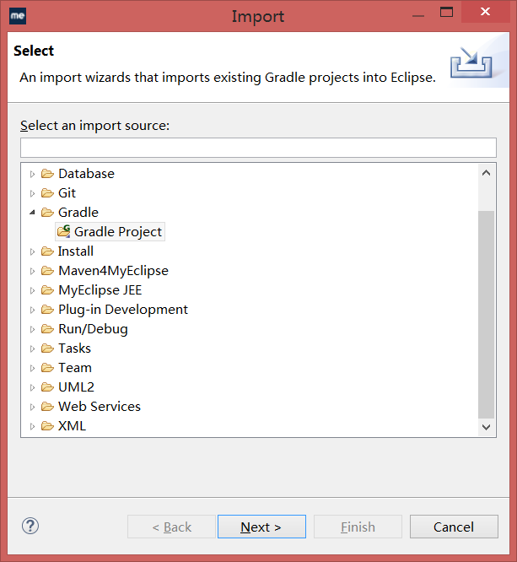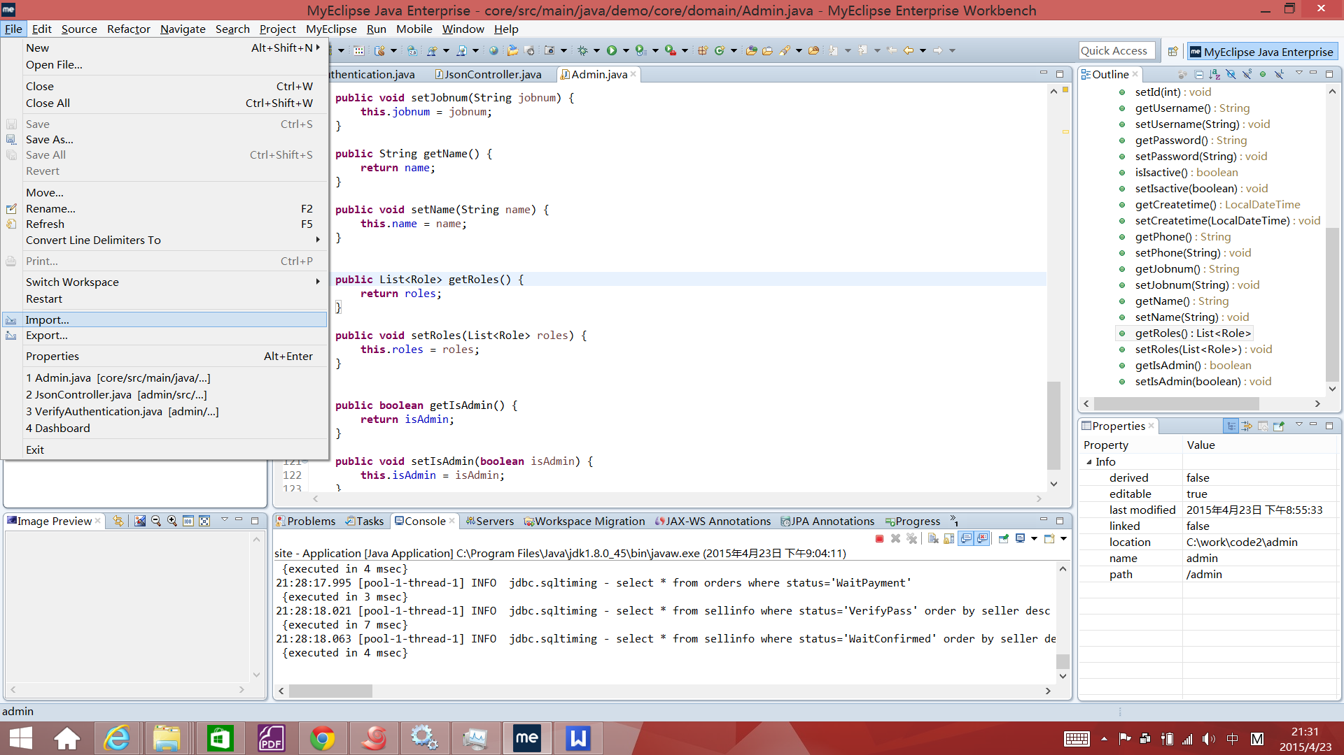

选择code 路径 --- build model ---finish

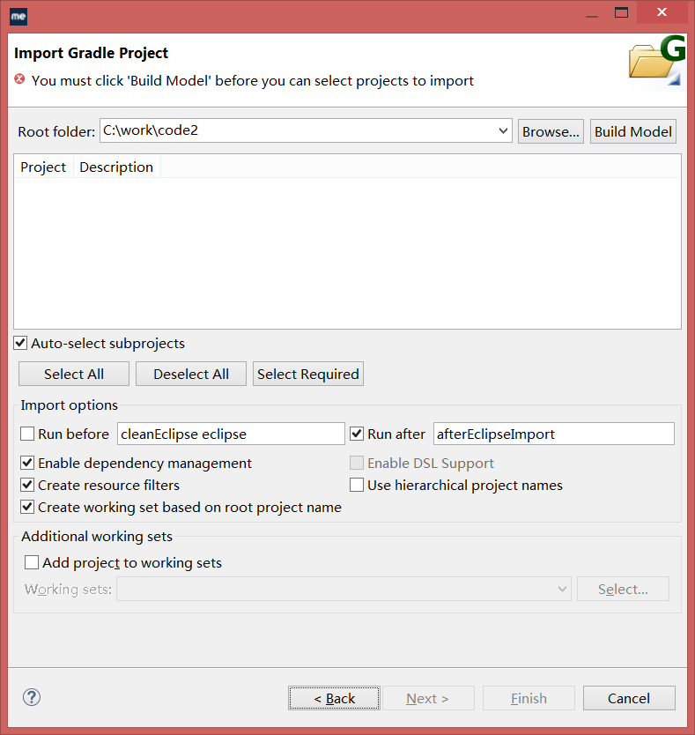

右击工程 properties -myeclipse-project facets

