**Analyzing Factors for Success at**

**League of Legends Worlds 2019**

By Feifan Gu, Sicheng Shen, Julie Wang

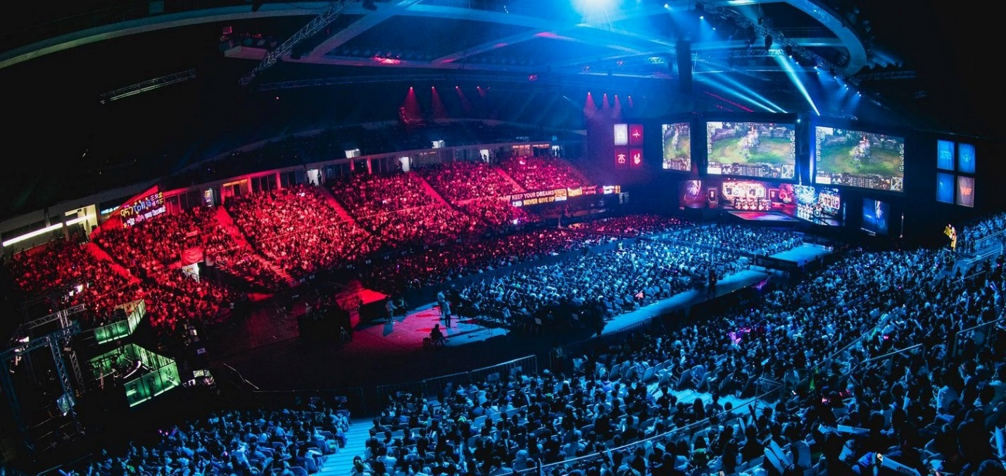

League of Legends is one of the biggest video games in the world. With an estimated 8 million concurrent players a day and a peak viewership of 44 million recorded at Worlds 2019, its fandom is one of the largest, most sustained, and most global of all the professional esports.

Professional League of Legends consists of several regional tournaments, and 2 global tournaments (MSI and Worlds). Global tournaments are often dominated by teams that tend to do well regionally. However, how can one predict which team will dominate not just regionally, but at Worlds? In this article, we will be examining how these teams differentiate themselves, and what factors may be influential and allow a team to make it out of the group stage and possibly placing in playoffs.

We are using in-game data about each team’s performance, obtained from Oracle Elixir, about regional and international performance statistics to understand how these teams could be categorized based on strengths and weaknesses, as well as examining if any factors can be informative for predicting team success.

**Cluster Analysis:**

As every team’s rank in 2019 Spring and Summer determined whether it would participate in the 2019 World Championship, we clustered the 16 teams who made it based on their game performance in those two seasons of competition. Specifically, we used the k-means method to cluster these teams based on 17 game performance stats, both in Spring and in Summer, which gave us 34 features overall. All these stats aim to measure a team’s style as is shown in the following, although we cannot eliminate the effect of a team’s synergy strength.

To summarize, these features measure 7 aspects of a team’s style: 1. Game speed; 2. Aggressiveness; 3. Defensiveness; 4. Early game performance; 5. Jungle resource control; 6. Extent of Jungle being Core; 7. Vision control.

The teams are divided into 4 clusters as following, and the average of regional rankings in Spring and Summer season playoffs are shown in the parentheses:

Here is how each cluster ranks in the 7 aspects:

Teams Cluster 1 have perfect early game performances and control of jungle resources, including Rift Heralds, dragons and Barons. Cluster 2 teams are aggressive with high game speed, but they lack defense and controlling jungle resource and vision. Teams in Cluster 3 are macro underperformers, and they overly rely on their lanes(micro) to carry the team. Cluster 4 Teams are pretty much the opposite of Cluster 2, as they are very defensive and good at early game and vision control, but not good at offense.

Looking at the best teams in each region, it’s easy to find that different regions have different dominant styles. Jungle resources control dominates in LPL and LCS, offense in LEC, and defensive in LCK. Overall, the first and fourth styles can ensure a stable performance in regionals, while the second and third ones have a larger variance in performance.

**Factor Analysis:**

To understand better, we found which gaming stats were most correlated to the final ranking in the World Championship. We quantified the ranking using numbers (the higher the rank, the larger the number) and calculated the Pearson Correlation between each gaming stat and the final ranking. We broke down the gaming stats into 2019 Spring and 2019 Summer for the analysis.

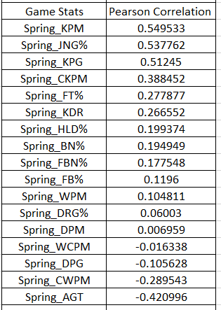

In 2019 Spring. we can see KPM, JNG%, and KPG have a very strong, positive correlation with placing higher, which indicates teams with more jungle control and aggression (more kills) are likely to perform well internationally. On the other hand, AGT has a moderate, negative correlation with having a good ranking in the final. High AGT means the games last a longer time. The teams focusing more on a scaling, late game team comp are less likely to perform well in the world championship.

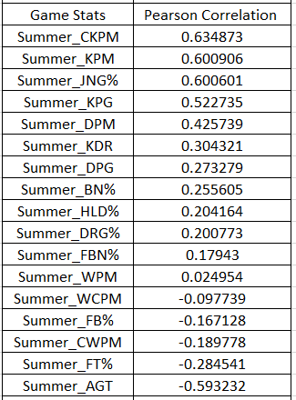

With the 2019 Summer stats. Still, KPM, JNG% and KPG have a strong, positive correlation. This time, CKPM also displays a strong, positive relationship, indicating the tradeoff of deaths for kills is also important. AGT has an even stronger influence on the ranking.

It's also worth noting that in Spring, DPG has a negative relationship with having a good ranking in world championship, but in Summer, DPG shows a positive, moderate relationship. In a nutshell, teams are changing strategies from Spring to Summer; teams playing more aggressively and focusing on getting objectives while willing to sacrifice deaths are more likely to win Worlds.

**Tournament Analysis:**

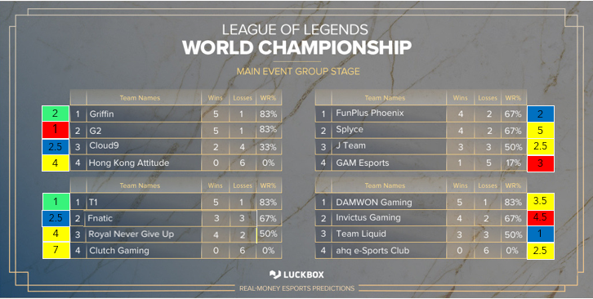

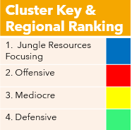

We see that in Worlds 2019 Group stage, 100% of the cluster 4 teams made it out. Most mediocre teams (cluster 3) were eliminated (as expected). Clusters 1 and 2 both had 2 teams each make it out of groups. Because of the Best of 1 format in these stages, it is likely the defensive teams performed well because they capitalized on a single mistake the opposite team made. In a longer series, the opposing team would have learned not to make that mistake in, and the series may have gone the other way.

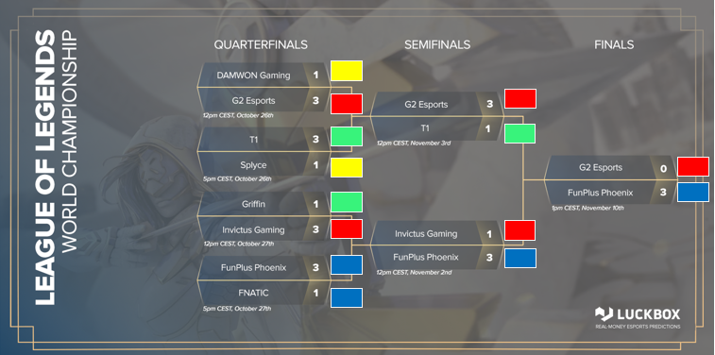



The playoffs feature a Best of 5 format. We see both mediocre teams get eliminated immediately, and both clusters 1 and 2 dominating on each side of the bracket, until the finals where cluster 1 reigns the winner. We see that cluster success is ranked as 1 > 2 > 4 > 3.

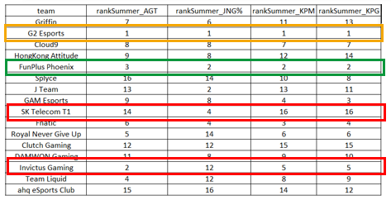

We see that our factor analysis is extremely correlated to winning, as the 1st and 2nd ranked teams are high in all 4 aspects. The teams in red, are previous world champions and you can see that they lag far behind in some factors while being extremely high in others.

The factors mentioned before prove that teams who are slow to make decisive decisions and secure advantages and/or objectives were not as likely contenders for Worlds’ champion.

In the future, we would like to examine the meta, patch trends, player playstyles, and team playstyle shifts in regional to international tournaments.