**Project 1.3 Coporate Investment Service System**

Team Member: Jingze Huang, Feifei Duan

**PostgreSQL Account:**

fd2400 Password: 2038

**Website URL:**

**Description:**

This is an Investment Service web application to bridge the information gap between the investors and companies. The investment data we used were downloaded from the website Crunchbase data dump. The app provides access to the information of main organizations across the world so that it can be easily discovered by both investors and companies. Users can filter, search, sort the data according to multiple features.

**Functionality:**

The final project implements all features described in the previous submitted project description and adds more interesting functions. It mainly includes four kinds of function:

* **Select Dataset:**

User can select the table they want to see such as *Company*, *People*, *Investment, Acquisition*

* **Filter:**

Investors can filter companies that they are interested in investing by several factors, such as *Location(Asia, Europe, North America ….)*, *Status(operating, acquired)*

* **Sorter:**

User can sort the result by several features, such as *Funding Rounds, First Founding Date*. And choose the sorting order (*ASC, DESC*).

* **Search:**

User can search certain tuples in the current table containing a keyword such as *Google, New York*.

**Interface:**

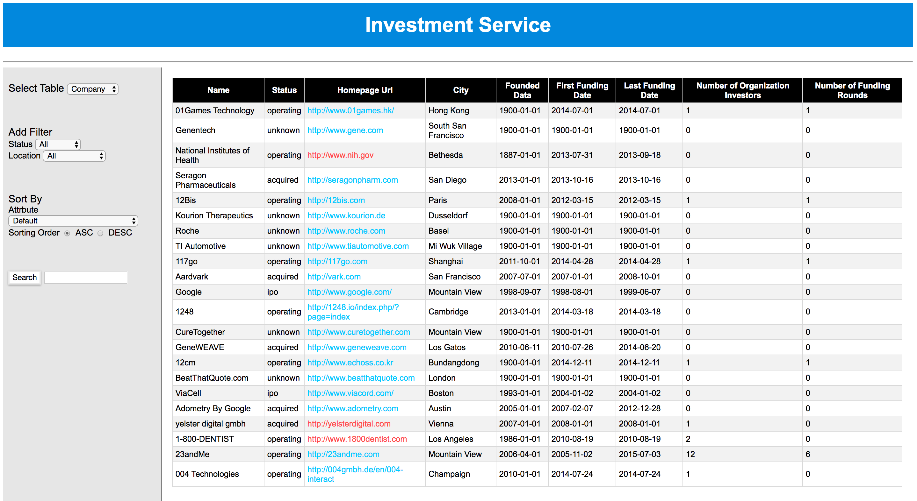

**User Story:**

* Select an ***operating*** **company** that contains key word *“****n****”*, and is located in ***USA*** *sorted by* ***Number of Funding Rounds*** *DESC*
* User can click on the***Homepage Url***to access to the website of the company

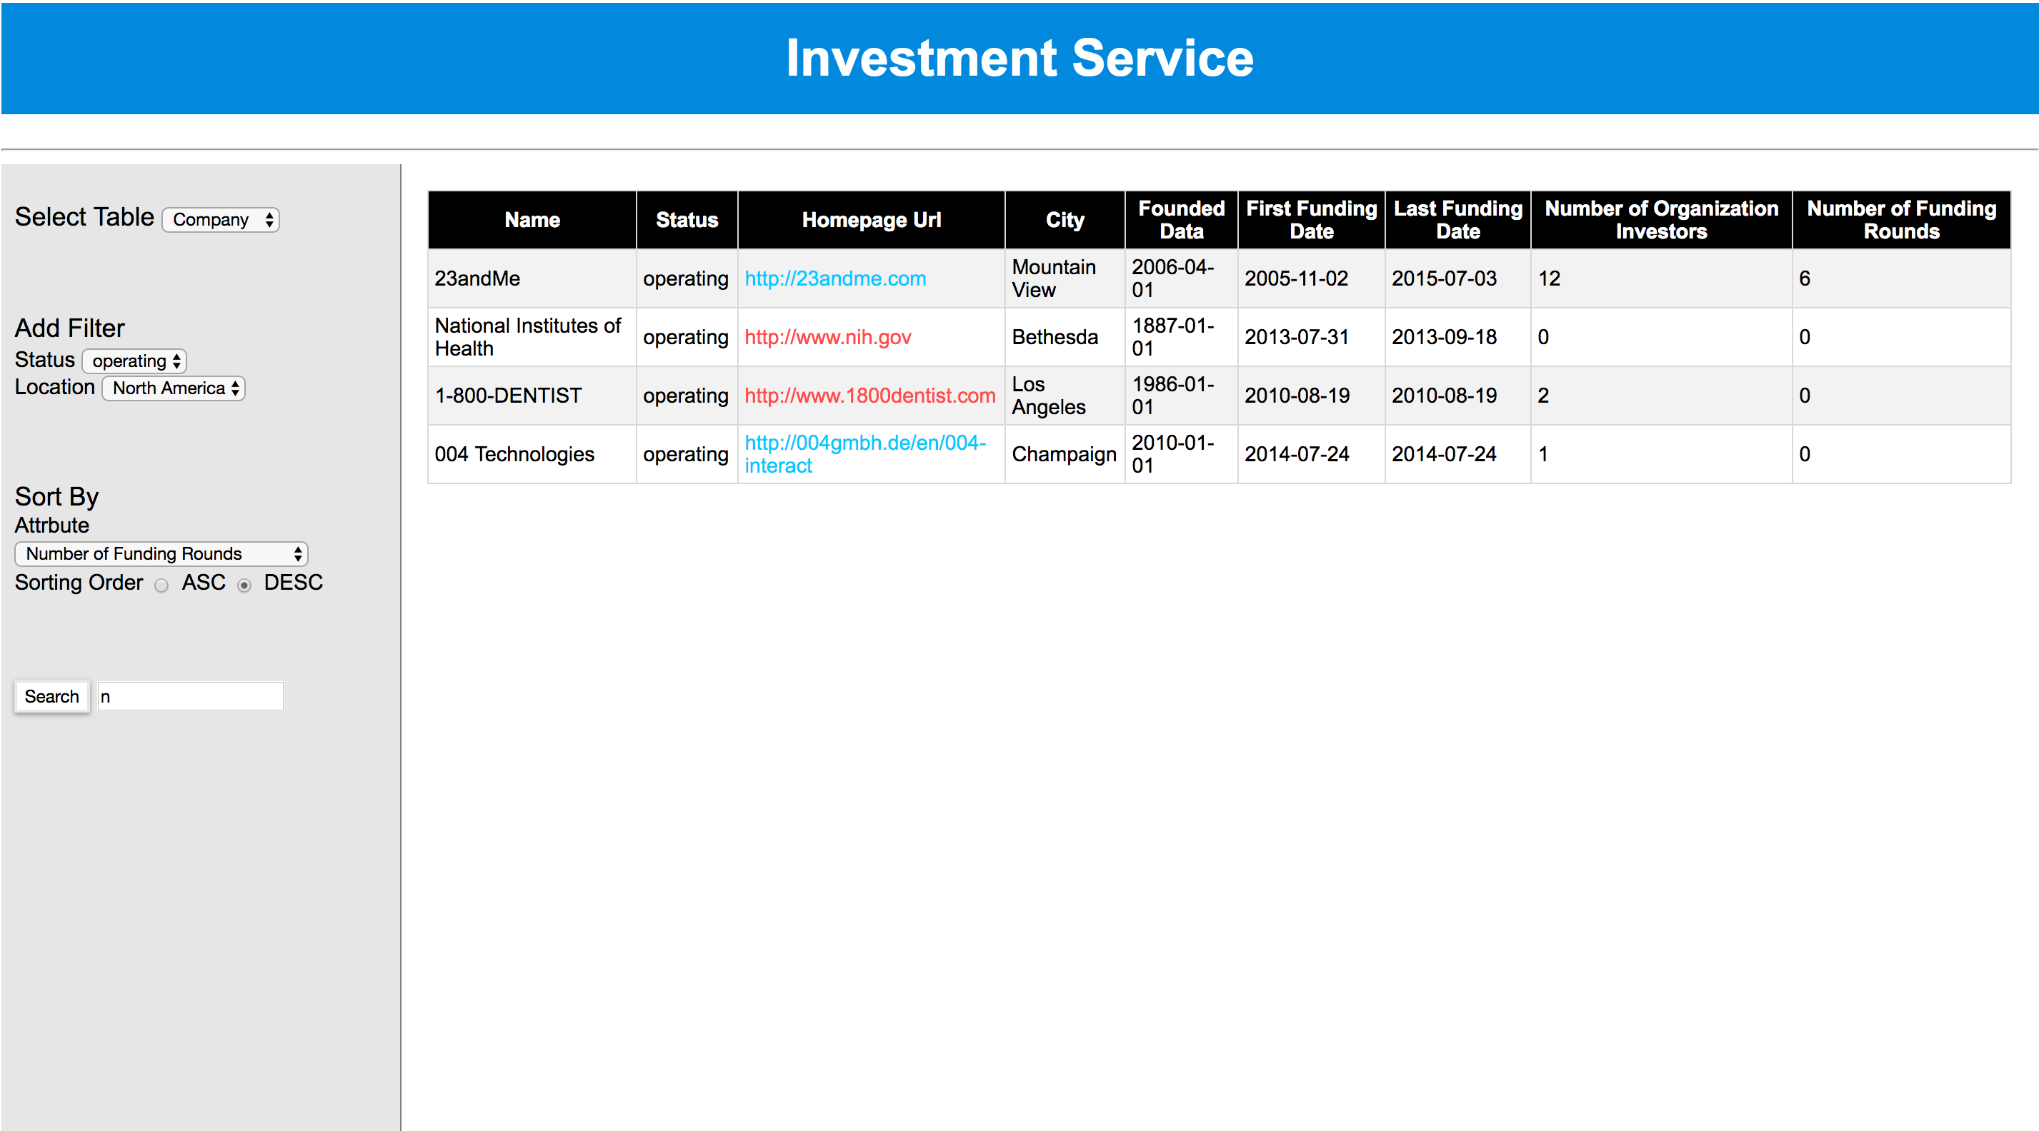

* Select an **investment** (by organization) that contains key word “**Google”** with a rounding type **Venture,** *sorted by* ***Raised Amount USD*** *ASC*

