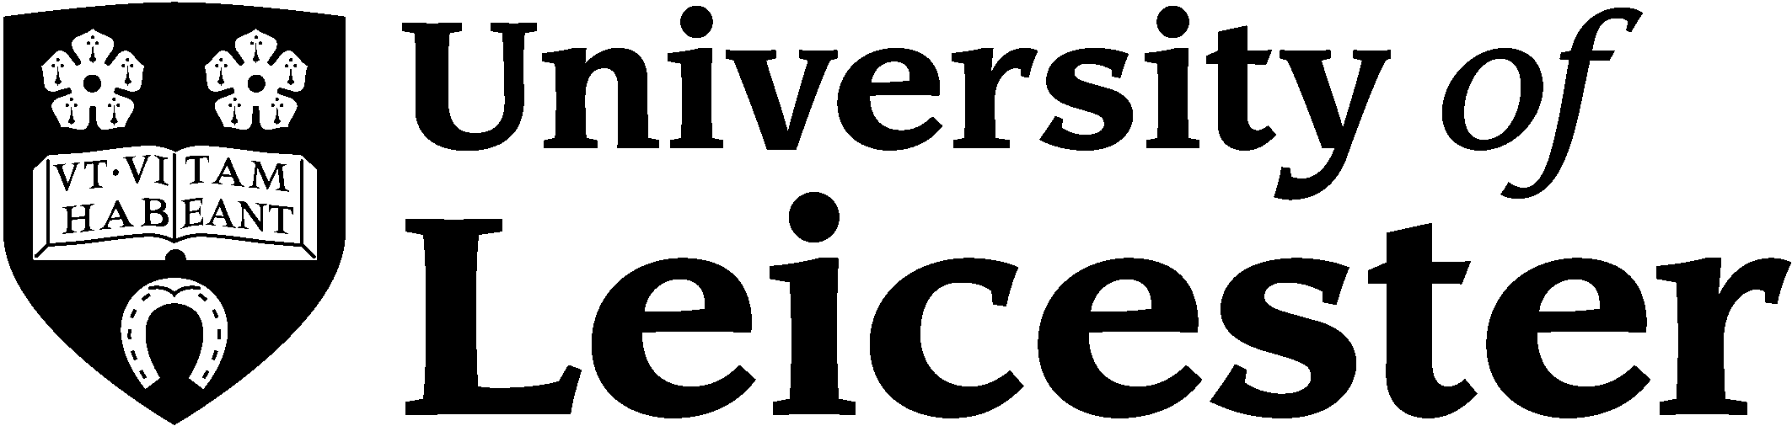 |  | ELECTRONIC AGC FORM
 |  | SCHOOL OF MANAGEMENT
SECTION 1: STUDENT TO COMPLETE
I.D. No:  109008973 |  |  |  |  |  | ENROLMENT/START DATE :  10/2010
PROGRAMME:  MSc Management | MODULE:  Dissertation and Research Methods |  |  |  | MODULE CODE:  MN7098
STUDENT DECLARATION: In submitting work to the University you are agreeing to the following statement:
“I declare that this assignment is my own work, that all sources of reference are acknowledged in full and that it has not been submitted for any other course“.

SECTION 2: TUTOR TO COMPLETE: COMMENT & GENERAL ASSESSMENT
Presentation of assignment and clarity of expression | Presentation shows a polished, coherent structure. Thoughts and ideas are clearly expressed. Fluent academic writing style. | Presentation carefully and logically organised. Thoughts and ideas clearly expressed. | Presentation satisfactory showing organisation and coherence. Language mainly fluent. | Presentation shows an attempt to organise in a logical manner. Meaning apparent, but language not always fluent. |  | Presentation is disorganised. Purpose and meaning of assignment is unclear and/or is poorly expressed.
Tutor to mark by inserting a X in the appropriate box.
Attention to the purpose of the assignment | Has addressed the purpose of the assignment comprehensively and imaginatively. | Has addressed the purpose of the assignment coherently and with some attempt to demonstrate imagination. | Has address the purpose of the assignment. | Some of the answer responds to the purpose of the question. |  | Answer fails to address the question set.
Tutor to mark by inserting a X in the appropriate box.
Critical analysis of literature/theory | The assignment demonstrates application of critical analysis. Arguments are well integrated. | Clear application of theory through critical analysis of the topic area. | Demonstrates some critical analysis of relevant theory. | Limited evidence of critical analysis. Tendency towards description. |  | Lacks critical analysis of theory. Purely descriptive.
Tutor to mark by inserting a X in the appropriate box.
Illustrations: Use of examples/evidence. | Appropriate examples are fully and reliably integrated and evaluated. | Some use of examples. Well integrated and evaluated. | Some use of examples. Some integration and evaluation attempted. | A little use of examples. Little integration and evaluation. |  | Very little use of examples. No evaluations.
Tutor to mark by inserting a X in the appropriate box.
Conclusions. | Analytical and clear conclusions well grounded in theory and literature showing reflection upon key issues. | Good understanding shown in summary of arguments based in theory/literature. | Some evidence of the conclusion being supported by theory/literature. | Limited conclusions only partially grounded n theory/literature. |  | None or unsubstantiated conclusions.
Tutor to mark by inserting a X in the appropriate box.

Comments (first and second markers):

Tutor marking this assignment | Date of marking (dd.mm.yyyy) | Mark Awarded | Grade Awarded
NAME OF MARKER |  | % | Grade

SECTION 3: STUDENT’S ASSIGNMENT (TO BE COMPLETED BY STUDENT)
WORD COUNT. To include everything except the AGC Form, references and appendices.
No of words = 15,764

Student to insert assignment below:

THE TECHNOLOGY INNOVATION STRATEGY OF CHINESE AUTOMOBILE COMPANY GEELY

By

Yixuan ZHU(109008973)

A Dissertataion
Submitted to University of Leicester
in Partial Fulfilment of the Requirements
for the Degree of Master of Science
in Management
in the School of Management

Leicester, United Kingdom

August, 2011
Table of Contents

Acknowledgements 4

Abstract 4

Chapter 1. INTRODUCTION 4

1.1Case background 4

1.2 Goals 4

1.3 Overall structure 4

1.4 Methodology 4

CHAPTER 2 Literature review 4

2.1 Technology integration 4

2.2 Technology innovation 4

2.3 Management integration 4

CHAPTER 3 Methodology 4

3.1 Research design 4

3.2 Research question 4

3.3 Data analysis 4

3.3.1 Analytic Hierarchy Process analysis 4

3.3.2 PEST 4

3.4 Merits and flaws of the chosen approach 5

Chapter 4 General introduction of Geely Company 5

4.1 Geely independent innovation 5

4.1.1 Company introduction: 5

4.1.2 R&D capacity 5

4.1.3 Human resource 5

4.1.4. Evolution strategy 5

4.2 M&A 5

4.2.1 Acquisition cases 5

4.2.2 Volvo 5

4.3 Other technology innovation modes of Geely 5

4.3.1 Geely cooperative innovation 5

4.3.2 Integrated innovation 5

4.3.3 import-learning then recreation 5

CHAPTER 5 Application of Analytic Hierarchy Process and PEST to Geely 5

5.1 AHP 5

5.2 PEST 5

5.2.1 Political Factors. 5

5.2.2 Economic Factors. 5

5.2.3 Social Factor. 6

5.2.4 Technology Factor. 6

5.3 Management integration 6

CHAPTER 6 CONCLUSIONS 6

6.1 Suggestion 6

6.2 Conclusion 6

Recommendations 6

Reflections 6

Bibliography 6

Appendices 6

Acknowledgements

I would like to express my gratitude to all those who helped me in the course of writing this dissertation. First, thanks to Mr. Juan Felipe Espinosa Cristia for his professional guidance, inspirations and the patience in supervisions. Secondly, thanks to the seven researchers from different fields for accepting my interviews. Thirdly, thanks to my family, for their constant support and encouragement. Finally, thanks to my friends, especially my boyfriend Feifei Hang helps me work out the problems. Without those assistances, this dissertation cannot be done.

Abstract

The economic globalisation brings companies all over the world to participate in. Last year in 2010, Chinese private-owned automobile company Geely completed transaction with Ford on Volvo takeover. It is a great breakthrough for Chinese automobile industry. While in this industry, technology innovation is the eternal impetus for companies’ development. Hence this article is mainly study on the way Geely applies the technology innovation strategy after the merger of Volvo and subsidiarily discusses how the company puts forward the management integration to coherent the technology innovation strategy. Knowledge about technology integration, technology innovation and management integration are reviewed from books, journals, magazines written by foreign and Chinese scholars. Interviews, literature and other information sources are used as the data source, while Analytic Hierarchy Process and PEST analysis approaches are applied to analyse the data and draw out the solution which is that Geely is applying a multiple kinds of technology innovation strategy, mainly relies on its independent innovation and assists by Volvo and other M&A companies while combine other kind of innovation modes, such as integrated innovation mode, import-learning then recreation mode. The research of this case could be a good reference for Chinese auto companies planning their technology innovation strategy.

Chapter 1. INTRODUCTION

1.1Case background
Since the establishment of China in 1949, the government has made a great effort in developing the automotive industry. So far, it has over 60 year’s development history and has built a fair integrity automotive industry system which becomes the world first automobile producing and selling place. China is called the auto making leading country, but this leading only refers to the number, not the quality (Fu, 2008). The quality of Chinese automobiles has a large gap with the western developed countries’, the comprehensive competitive capacity can only account for 40% - 50% for Japan, America or Germany. What is the problem of this? The reason is that technology strength is low and technology innovation capacity is weak. Merger and acquisition is a fast way to obtain technology and enhance companies’ core competitiveness. After 2000, China accessed WTO, some enterprises began to go out for merging overseas auto company (Zhao & Huang, 2004) and establish joint venture companies. But the rate of successful post-merger and acquisition is low (Lajoux, 2006), the results of technology exchange are barely satisfactory. On the other side, independent innovation is another important strategy applied by Chinese automobile companies. By this way, companies could have intellectual property of the products and the new techniques could bring clear competitive advantages. But it needs high qualified researches and development talents as well as money input and other requirements. So, what could be an good alternative to apply the technology innovation strategy.

Zhejiang Geely Holding Group (Geely Company), which is a Chinese private-owned automobile producer, always insists technology independent innovation. In August 2010, it successfully merged Volvo Car Corporation from Ford and caused a worldwide sensation. One year past, the merger is not the focus of attention, but how these two companies will integrate. Meanwhile, technology integration is an important aspect involved by the overall integration. Shown by the preliminary research result, Geely is performing multiple sorts of technology innovation strategy. Thus, how will Geely apply the strategy according to the importance of different mode?

1.2 Goals
This research focuses on two things: technology innovation strategy of Geely Company after takeover of Volvo and the management integration within the technology strategy. It aims at finding out what strategy could be considered as an appropriate alternative for Geely and how does the technology strategy influence the way of management integration? Companies often separate thinking of management and technology activities. However the wrong management decision can cause failure of technology strategy. The wrong technology strategy can cause regulatory barriers. So in this article these two elements are considered together.
The purport of this case study research is to providing a technology innovation development approach for Chinese automobile enterprises as a reference. It may not be the determined strategy with the development of Geely Company.

1.3 Overall structure
This paper is organised by the following six chapters:
Chapter 1: this chapter is the overall introduction which it is processing, concludes case background, research goals and overall structure.
Chapter 2: it elaborates the literature review which contents some important relating theories, such as technology integration, technology innovation and management integration. Management integration make the holistic organisational plan of merger enterprises (Drucker,1968), it includes technology strategy. Technology integration follows the organisational technology strategy (Iansiti 1998), while innovation is one of the goals of technology strategy.
Chapter 3: methodology, it expatiates the research design, data analysis means and limitations of chosen means. Both qualitative and quantitative research approaches are used to address the questions. The chapter also includes explanations of the reasons using Analytic Hierarchy Process analysing the internal technology innovation modes and using PEST to analysis the external environment research.

Chapter 4: it is some general information about Zhejiang Geely Holding Group; include independent innovation system, M&A cases and other technology innovation means.

Chapter 5: the data analysis by Analytic Hierarchy Process and PEST approach, the information collected from interviews and literatures are showed by mathematics way in Analytic Hierarchy Process tables. PEST analysis is demonstrated by a quantitative way along with related graphs, additional with management integration analysis of Geely and Volvo.

Chapter 6: the suggestions and conclusion of whole study.

1.4 Methodology
The research design of this article is case study. Both qualitative and quantitative research method will be used. Technology integration, technology innovation, management integration and some other knowledge are the basic theories. Analytic Hierarchy Process is used to analyse the object of this research Geely of its organisational technology innovation strategy. According to the usage of strategies applying PEST analysis analyse Geely’s external environment. Thus we have both internal, external analysis. In order to ensure the reliability and facticity, the related data and statistics are mainly from the telephone interviews of Geely’s R&D employee, management, technology perspective scholars and national information websites, like China Automotive Information Website, the specific explanation is in Chapter 3.

The graph below shows the structure of Chapter 4 and 5

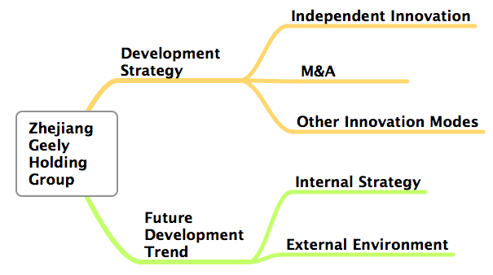
Figure 1.1 Structure of Chapter 4 & 5.

CHAPTER 2 Literature review

2.1 Technology integration
The development of new product requires two sorts of knowledge (Deng, Zheng & Lei 2004), one is general knowledge, it is the specialised knowledge on a certain science and technology field and it is the foundation knowledge of product design and R&D. The other one is system knowledge, it is the applying of general knowledge in the particular environment (includes constructing organisational production system, connect external suppliers, customers, internal management). Marco Ianisiti (1998) formulated a firms technology integration need address the match problem of general and system knowledge. Thus the participants of technology integration need not only have a good general knowledge, but also have strong system knowledge. Those people need do well in one specified technology field (like auto engine design) and cooperate with other product R&D staff, while also they need knowing how to coordinate the work of internal producing system, organisational management system and external relating value networks. In the activity of technology integration, company applies experiments to evaluate the impact of various technologies which belong to general knowledge on internal production systems, organisational management systems and external value networks, thus selecting the technologies. Through employees’ working experience transfer the system knowledge which resulting from the experiments to technology integration team, then applied to the next product innovation. Technology integration is the systematic evolution of the management on system knowledge, it guides the direction of enterprise’s system evolution. It is an important part of management integration, while it is the foundation process for merger companies technology innovation.

The formal definition of technology integration was first proposed by American theorist Marco Iansiti in 1998. He represents that the application of good resources, tools, instruments, problem solving approaches during organisations organising process is called technology integration. In fact before that some other researches already put forward their own understandings. For example Fleck (1994) demonstrated that, a company’s technology importing process need integrate with its internal technology resource and other comprehensive capabilities. The method notion of technology integration could be traced back earlier.

Combine national condition, some China’s researchers give their definitions of technology integration, one is: comprehensively utilise related knowledge on selecting, refining product design and producing technology, integrate those design and technology to produce a rational approach for manufacturing products (Lei Jiasu, 2005). However those definitions either are from the aspect of interior organisation, or focus on the national perspective or industry perspective.

For acquisition companies, technology integration means acquiring company evaluates the technologies from acquired company and select the technologies they need based on the expected goal. Then integrate them into future development plan (Marco&West, 1997).

There are three stages of technology integration (Fleck 1994).
- Evaluate and select technologies from Target Company.
- Import those technologies.
3. Technology integration after the acquisition.

People often think that technology integration begins after the merger, in fact, the evaluation and selection technology is the first step (Bohn, 1994). On one hand technology integration is not a passive process because, it includes company actively assess and choose the target firm according to the future demand and market requirement. On the other hand, the outcome of the technology integration is greatly depending on the initial select of the technology object. Andrew (1998) mentions that companies should think about the factors which will badly influence the integration as the final mission of assessment is to get core technology. Technology integration is the key activity to improve R&D efficiency, the speed of productivity and the products quality. The nature of technology integration is to combine multiple techniques then integrated effectively.

A decade years ago, the raise of market uncertainty bring out many new means of technology integration, the market is often occupied by the enterprises which are good at applying the technology integration (Xu, 2009). It is a means of innovation, bad technology integration would not be the fatal factor to the failure of acquisition, researches show that one a merger case failed, people all think it is the consequence of bad management, only a few think it is the problem from technology aspect. But almost all the successful M&A cases are doing well on technology integration (Wu 2004).

The way of firms developing core technology capacity via M&A is not only popular in developed countries, but also favour in China (Bai, 2002), previously, if a firm want to obtain other firm’s advanced technology, it will buy the licences. However this cannot help firm build its core competitive ability, neither get the latest, the state of art techniques, what is more, these technology cannot be internalised. Thus it cannot bring the constant competitive advantage to the firm. Therefore, Chinese companies pay attention to acquiring the ownership of Target Company’s technology and then achieve the internalisation of external knowledge and resources with integration (Zhao Ruilan, 2005).

There are four elements influence the acquiring company’s technology integration (Teece, 1996).
- Technology correlation. Every technique has its usage scale and correlation, so the diffusion of technology and innovation effect are emerged between the companies have technology correlation. The higher level of correlation, the lower difficulty of integration. According to the cooperation mode, technology correlation has three types, complementary, substitution and common use correlation.
- The ability to digestion and absorption technology. This ability represent the firm recognises, digests and apply new technology to bring commercial benefits. The strength of this ability is depending on the accumulated technology foundation of the enterprise itself. If the firm does not have a substantial technology foundation and it wants to use M&A to directly obtain technology, the failure rate will be very high.
- The characteristics of the technology. Technology could be divided into two categories, dominance and recessiveness. Dominance technologies are easy to learn and copy, recessiveness technology show up by practical form, it is high confidential situational and internal, this kind of technology not only rely on people how to perform it, but also influenced by the environment, the situation. Different industries and companies have different demands on technology knowledge transforming. If a firm has high demand on Target Company’s recessiveness technology, the technology integration will be a high skilled and difficult task.
- The differences on systems. A set of technology capital and employees constitute the density of technology capacity system. A firms’ organisational system, rules and working process determine the way of R&D staffs working and the stimulation of creativity. If the system destroyed, even with the same technology capital and working staff, the firm’s technology capacity system cannot operating as it in the past. Thus the greater differ of systems acquired and acquiring company have, the greater challenge on bother systems to reform, so does the risks of damage the original technology capacity

2.1.1 Technology strategy

Qiu Nong and Zhu Wei (2009) in their article “Technology Strategy Mode of State-owned Auto Companies” recommended three appropriate technology strategy modes for Chinese state-owned auto producers. One is innovation based on improvement mode, the second is cooperate development mode (this fit for many companies), the third is high-end injection mode. They describe these approaches can be used mixed. Lei She and Gu Yan (2006) in their article “spillover Effect of Independent Innovation in China’s Auto Industry” mentioned, China’s car industry has shown a multiple technology development mode, we have independent formate, internal capital driven mode, no intellectual property mode, technology import digestion and absorption then innovation mode. At last, join venture development mode. These formats are coexisting in China’s market. You Xianfeng (2008) in his article “Problems Faced by China’s Car Industry on technology Strategy” discussed China’s car industry have four strategies: native innovation mode, external authorise design mode, cooperating innovation mode and fully independent R&D mode.

2.2 Technology innovation
Management integration make the holistic organisational plan of merger enterprises (Drucker,1968), it includes technology strategy. Technology integration follows the organisational technology strategy (Iansiti 1998), while innovation is one of the goals of technology strategy. Technology innovation was first put forward by economist Joseph. A. Schumpeter, in his work “The Theory of Economic Development” in 1921. He demonstrated technology innovation is to introduce a brand-new association of factors of production to manufacturing system. This new association contents adopting a new material or a new feature of the material; applying a new producing mode; opening up a new market. The enrichment of research on technology innovation was since 1960s. Again, the great master of management Peter.F.Drucker (1968) defined it as a conduct to endure resources of new ability to create wealth. In 1962 J.L.Enos gave the definition in his work “Invention and Innovation in Oil-processing Industry”: technology innovation is the output of several behavioural syntheses which include invention selection, capital investment guarantee, build the organisation and so on. Edwin Mansfield though technology innovation is the beginning of companies to conceive a new product. After comprehensively conclude hundreds of papers, DECD give the definition from production innovation and craft innovation perspective: the remarkable change of technology on existing product or a new commodity and new craft.

China’s researchers on this area started in 1980s compare with the former research results, Chinese scholars have a large distance with them, but on the other hand, they have abundant knowledge to learn. An authoritative definition is from Tsinghua University professor Fu Jiayi (2006), he represents that technology innovation is entrepreneurs grab the potential opportunity, recombine factors and conditions of production, develop a higher efficiency, greater strength, lower expense production system, thereby introduce new products, new producing means, open new market or acquire new raw material or new suppliers for semi-manufactured goods, sum the up, it is a comprehensive process of science, organisation, commercial and finical. The professor of Zhejiang University named Xu Qingrui (2002) defines it as the formation of a new thinking uses to produce the products which meet the needs of market and consumers, it not only means create a new goods, but also include the popularisation, diffusion and applying process.

According to the degree of external dependence, technology innovation is divided into three kinds (Fu Jiaji, 2001), original innovation, integrated innovation, import learning recreation mode. The original mode is also called independent innovation. It means the firm’s innovation object is self-development and based on its own R&D. Integrated mode means the company recombine the current technology from other companies or its old technologies develop a new competitive technology. Import learning recreation mode based on import technologies and digestion and absorption them to realise creating new technique.

During the process of develop technology innovation, companies may face two kinds of uncertainty(Schilling, 2006), one is from R&D department, they cannot guarantee the output of technology innovation, the other is from market, market is always changing and customers needs always switch , these two factor impact a lot on companies product development, so when firms use M&A to seek technology, they decrease the risks of develop some original technologies that have unknown market react, also, companies could step into the new market, diminish entrance barrier with the help of acquiring company.

Technology innovation is the core activity of a firm, it is the core competitiveness. Enterprise could focus on three aspects to facilitate technology innovation (Rothman, 2009). 1. Idea, thinking determines the performance the new idea is the basic activity for creation, so companies need the employees are good at creative, develop a strong technology talent team is essential. 2. Operating, the operating of enterprises need solve two problems: producing what? How to produce it? Thus firms first need to learn the demand of market, not only know the current demand also inspect for potential and future needs. Then firms need know themselves well also learn about their rivals well. 3. Management. The mission of management is maintaining system, discipline and enthusiasm, innovation need management to keep the working passion.

According to Joseph Schumpeter (1921), the content of technology innovation has five aspects: product, craft, service and organising innovation. Production innovation means to reform or improve old goods and producing new products, it will increase the categories of firms, open up new market; craft innovation means to change, facilitate the producing means and process, include tools, instrument, material. Service innovation means transform new idea, new technique approach to new service (like in posting industry, E-commercial industry) organising innovation, firms reform the producing organising mode, it is a transform of system arrangement.

The feature of technology innovation (You & Xi, 2006):
1. Novelty: it describes the brand-new feature of products, crafts and services designed during the process of innovation.

- Creation: the R&D of new commodities, the adoption of new crafts and the new organising mode are all the expression of creation which is the nature of innovation.

- High input: the There will be a great amount of expenses on human resource, material resource and money from the R&D to the release of the new product. We can say that every step of the innovation need a certain amount of capital investment, the total input could be a great number.

- High risk: this is the inherent feature. Lots of the researches demonstrated that technology innovation is a high failure rate activity as about 90% of the works failed before being introduced to market.

- High income: according to related information, if the successful rate of technology innovation reach 20%, all the input could be returned and gained corresponding profits. Because the investment of new technology brings the advantage to companies for competing with competitors. It will give companies a period time of monopoly advantage. Therefore, firms favour to carry on innovation to maintain their developments.

- Periodicity: every technology innovation goes through many stages from invention to entering products into market. Thereafter, firms will develop another round of technology innovation according to the new market demands as the cycle keeps one by one.

- Co-ordination: technology innovation relates to the internal organisation (inc. research, development, producing, operating and sales), social condition, market situation, policies and etc.

Thus, technology innovation needs to be coordinated with the qualities of workers quality, the state of internal organisation and the external environment.

2.3 Management integration
The “Economists” had a critique on M&A: “corporate mergers have even higher failure rates than the liaisons of Hollywood starts. (Economist: July 22, 2000)” During six to twelve months after the merger deal signed the target company may appear some unsound performance, like the decline of dedication and commitment of workers and managers, the decrease of productivity, the increase of conflicts on culture differences, management approach, the losing of core management staff, skilled workers, foundation customers and market share, what is more, one third of the acquired company would be sold out again in five years after the merger, thus how to operate the M&A companies become a question for study and since 1990s, post-management integration become a more and more popular management research direction. To some extent, sign the deal is easy but gets integrated is hard (Wang & Zhang, 2000).

Management integration has four stages (Wasserstein, 1998):
1. Initial stage: in this stage, companies use the previous collected information, for example the results of data assessment, to get well known of the resources of the target companies and to build a rough plan on possible resources and the challenge of use these resources which include the core staff resources, the evaluation of management system and the technology capability in order to improve the complementary advantages. This also rapidly benefits on bringing management synergism and technology synergism after merger. Therefore, that will build an effective integration structure and will specify management integration system and information communication channel to decrease or eliminate the culture conflicts.

2. Foundation building stage: in this stage, the acquirer company develops an integration team and assigns the integration manager. The responsibilities of this manager include taking charge of the integrated business, effectively arranging combination, ensuring the integration which could be achieved in a certain time, supervising the performance going with the development plans of companies, training the employees of the target company, building communication channels for workers, summing up the duty of management, developing the system and improving mutual communication. It is a complicate and comprehensive task to integrate target companies into integration. Hence, it requires the specified standards and the professional and structured management approach.

3. Implement stage: this is the core stage of integration. After a throughout assessment and have built a fundamental condition, it is the time to introduce the content and approaches of integration, during this period, there will be some big changes happening within the company, thus the company should take some phased evaluations, use the feedback to adjust the integration plan. Meanwhile, the two companies keep communication to improve the progress.

4. Unified stage: as the ending stage, the focal point of the work is to evaluate the result of integration management. By steadily carrying on the operating tasks during the practice performance, companies should adjust the integration mode according to its industry feature.

Zhang Xiyong (2007) demonstrates that for some acquisition companies, they have high degree of strategic interdependency but low degree of organisation’s self-governing dependence, we call this kind of merger “absorb”. On the contrary, some acquisition companies have low strategic interdependency level but high organisation self-governing dependency, which is called simultaneity. If the acquisition companies have both high level of strategic and governing interdependence, they will be “symbiosis”. When processing the management integration, acquired firms should carefully analysis every component of the organisation based on the demands of different interdependence. Thus, firms could identify different approaches for different department (Sirower 2007).

In order to guarantee the quality of integration, firms could make a specified plan, which clearly defines the working schedule, responsibility and milestone of key issues, to improve the communication efficiency in order to ensure that the tasks could be done in a rational manner. The great master of management Peter Drucker concludes five principles of successful acquisition in his book “The Frontiers of Management”(1968: 240)
1.An acquisition will succeed only if the acquiring company thinks through what it can contribute to the business it is buying, not what the acquired company will contribute to the acquirer, no matter how attractive the expected “synergy” may work.

2.Successful diversification by acquisition like all successful diversification, requires a common core of unity, the tow business must share commons either in markets, technology, or future vision. In social science jargon, there has to be a “common culture” or at least a “cultural affinity”.

3.No acquisition works unless the people in the acquiring company respect the product, markets, consumers of the company they takeover. The acquisition must be a “temperamental fit”.
4.Within a year or so, the acquiring company must be able to provide top management for the firm it bought. Management cannot “buy”, the original manager may leave the acquired company.

5.Within the first year of a merger, it is important that a large number of people in the management groups of both firms receive substantial promotions across the lines.

For Chinese researchers, Wu Zhijun(2006) in his article “ Research on Management Integration During Enterprises M&A” demonstrates that management integration includes five parts, the whole integration content, strategy, organisation and system, human resource, organisational culture, financial affairs. Particularly, during integrating strategy, firms need pay more attention on three issues: the selection of acquisition strategy target, main business and diversified managing and mistakes of decision-making. The author represents that the goal of strategy integration is to develop core competitive capacity. Zhang Xiyong(2007) in his book “Firms M&A and Management Integration” focuses on the business and resources system integration. Also, he puts strategy integration at a very important place, and expresses that the successful merger means acquiring company has a clear and prospect strategy for both itself and the acquired company. Even though management integration contains many aspects, with the right strategies, all the departments will be able to follow the pace. Li Xianjun(2009) in her article “Primary research on Management Integration” discusses that the central points of management integration consist of combing management theory, managing skills and practice.

CHAPTER 3 Methodology

3.1 Research design

According to the classification of research design, there are five major sorts: experimental and related designs, cross-sectional design, longitudinal design, case study and comparative design (Bryman & Bell, 2011). The research design of this dissertation is a case study. It requires a specific and intensive analysis of a certain case which could be an organisation, a community, a single location or a person (Eisenhardt, 1989). Robert K. Yin (2009) defines case study is an empirical investigation, which focuses on a contemporary phenomenon among the real-life circumstances while the boundaries between the issue and its context are not clearly revealed and a mass sources of evidence are required.

The research object in this project is a Chinese automotive company, named Geely. The aim of this research is to develop a deep understanding of technology innovation strategy of Geely Company. Within the case, analytic hierarchy process and PEST analysis approaches are applied to reveal the result of the research.

In order to develop criteria for assessing the case study, logical tests of the research methods are required. As Bryman & Bell (2011) demonstrate that reliability, replication and validity are regarded as the criteria for evaluating the quality of a business research.

1. Reliability: to guarantee the reliability of all the data in the article, the primary data (such as all the data in analytic hierarchy process) are collected from telephone interviews (see Appendices) with Geely’s R&D management department employee, technology and management perspective scholars. Robert K. Yin (2009) puts forward that a rational approach of a case study is to corroborate interview data with information from other sources. Secondary data like “integrated innovation”, “cooperated innovation” and so on are also applied for data analysis. The information is collected from Geely’s internal reports, China’s national information websites and some national statistics reports.

2. Replication: it refers to under the same condition and assumption the research results conducted by different researchers in different places will be the consistent. Due to the important information is from Geely interior, the research results are drawn from those information, so it could be replicable when other people doing the research upon the consistent circumstance.

3. Validity: this concludes three kind of validity: construct validity, internal validity and external validity (Bryman & Bell 2011). Firstly, multiple sources of evidence are collected for analysing this case to develop the construct validity. Through the interviews, different opinions from different researchers were exchanged. Whether they approve or deny, the information all help come to a decision (Gillham, 2000). Secondly, internal validity requires researchers to find the causality in the case and to improve the relation within different factors (Yin, 2009). In this research, analytic hierarchy process is the approach which clearly illustrates the relations of different organisational internal factors while the PEST analysis describes external environment conditions. So it is appropriate to apply analytic hierarchy process and PEST analysis. Finally, external validity need researchers build a scale that the research result is concluded within this scale (Yin, 2009). This research is about technology strategy and the result is achieved upon the method of technology strategy.

3.2 Research question

This is the first case of Chinese private owned auto company acquired a world famous auto enterprise. Whatever from economic aspect, marketing aspect, organisational aspect there are lots of things we can study, but here only one thing can be focused, that is technology innovation strategy.

The research questions are:
1. From management perspective, how does Geely Company perform the technology innovation strategy for future development after takeover of Volvo?

2. How does Geely put forward their management integration to coherent with the technology innovation strategy?

Hatch (2006) discussed in his book Organisation Theory that the operation of an organisation facing two kind of environment, internal and external. The internal environment is composed of the employees of the organisation, the internal policies, mission and vision. However, the external environment is a broad category which has been divided into micro environment and macro environment. The micro environment is made of factors such as the customers, suppliers, distributors, competitors etc whereas; factors making up the macro environment include political, economic, social and technological forces. This research concentrated more on macro environment. As it is a case study research, both qualitative and quantitative research methods were applied to combine theories and practices. Furthermore, technology integration, technology innovation, management integration and other knowledge were used as the basic theoretical background. Specifically study on technology strategy of merger companies and management integration and apply the Analytic Hierarchy Process to analyse the technology innovation strategy of Geely Company. Thus, the PEST method could be used to analysis Geely’s external environment based on the major strategy. Next paragraph will explain the reasons why applying these two analysis approaches. Thus, we have both internal and external analysis. In order to ensure the reliability and facticity, the related data and statistics are mainly taken from the interviews of Geely’s R&D employee, auto industry researcher, management and technology aspect scholar and websites of China Association of Automotive Manufacturers, China Automotive Information Website and etc.

3.3 Data analysis

3.3.1 Analytic Hierarchy Process analysis

Analytic Hierarchy Process (AHP) was established by American theoretician Thomas L. Saaty(1990), and is used to analyse complicate questions for people to choose the best alternative by making a set of comparisons(Macharis, Springael, DeBrucker &Verbeke, 2004). It is an analysis means which combined qualitative and quantitative methods with systematic and hierarchy structure according to the research goal (Bensoussan & Fleisher, 2008). After well studying the related knowledge, the links between internal factors of the question will be obtained. The internal factors divide the complicate question into goal level, criterion level and alternative level according to the mutual relationship and subordinate relationship to distribute the factors (Ramanathan, 2001). It is an easy, flexible and useful decision-making approach. The fundamental theory is using related factors to analyse a complex question. Therefore, the complex question is the object of goal level where can only put one factor. Hence, the criterion level will be built by using the related elements which have almost the same importance to the goal. Then, the subordinate level, which is also called alternative level built by subsidiary related elements, will be developed. In addition to the subordinate level, the number of the elements is no more than 9. Thereafter, by using pair-wise comparison to get the relative importance of each factor in every level, applying mathematics approach to calculate the importance index of each element and adding all indexes to obtain the overall result, people will know which factor is more important than others (Saaty, 1990).

As mentioned before, the research question is about how Geely performs the technology innovation strategy after the acquisition of Volvo. From the initial study, it is learnt that Geely is applying a multi-type innovation approach, simultaneously performing independent innovation, merge companies to acquire technology, integrated innovation, cooperative innovation and import-learning then recreation modes. The research was aimed at finding out a more appropriate technology mode for the future development of Geely. AHP is capable to refine the viewpoints provided by various professors or experts, and is suitable for handling the problem in the circumstance which has multiple uncertainties and assessment criteria. This is quite suit for the situation in this case study (Vargas, 1990).

3.3.2 PEST

PEST analysis is used to scan the macro environment of a company since it is the acronym for Political, Economic, Social and Technological. It is a good approach for a firm to get known of the business position and to make strategic planning. It manifests an overview which needs to be taken into consider based on four external environment (Rugman, Collinson et al. 2006).

Political factors refer to how government performs in economic activities and to what extent authority intervenes the business performance. There are certain informal and formal regulations laid down by the state. And, the regulations have to be abided by every company who wants to operate in this country. Main political factors include (Bensoussan and Fleisher 2008) political stability, taxation laws, intellectual property rights, pricing regulations, trade regulations, entry mode regulations, employee wages and benefits. Political factors always have authoritative powers on pillar industries such as iron and steel industry, health care system, road and rail system industry and etc. The industry Geely Company belongs to is also one of the pillar industries. Automobile industry is deeply influenced by the national policies and regulations. The main factors above could contribute on the shaping of the political environment which is being faced by Geely Company.

Those factors, which have direct effects on a firm’s capital increase and decrease and consumers purchasing power, are sorted for economic factors. For example, the change of exchange rates impacts on the costs of the importing and exporting of products. The main factors are (Bensoussan and Fleisher 2008) economic growth, quality of infrastructure, rate of unemployment, stability of currency, skill level of employees, income distribution, effectiveness of financial institutions, exchange Rates, inflation and etc. Companies cannot live without economy. It is the essential part of macro environment.

Social factors contain all the staff within the society, like population, culture, moral principle, consumers habits, it shape people’s attitude. For example, with the improvement of women’s status, the products designed for women could be popular. The main social factors are(Bensoussan and Fleisher 2008): age distribution, education, changing lifestyle, gender Role, etc. The innovation of a new product will be influenced by the preference of the society. The more Geely Company knows about the social factors, the more prevalence this innovation will obtain.
Technology is the thing which brings core competitive capacity to companies. The development of technology causes the change of social distribution and industrial structure. It also stirs the globalisation phenomena. The main factors are (Bensoussan and Fleisher 2008): rate of technological innovation, rate of obsolesce of technology, technological development, new technological platforms, diffusion of technology, etc. As a technology intensive company, Geely needs to technology strategies applied by other companies.
Because this case study is about a company, it needs both internal and external environment analysis. PEST analysis contains three important aspects of the external environment of companies: policies, economy and society. Furthermore it contains the significant factor of an auto company - technology.

3.4 Merits and flaws of the chosen approach

Merits, as a case study, this research combines theory and practice, the conclusions are drawn from both academic and practical perspective. Telephone interviews bring primary information. Geely is a Chinese private owned automobile company, the technology strategy of this company has a sort of model significance to other auto firms.

Flaws, it is only one year’s time since the formal M&A of Zhejiang Geely Holding Group and Volvo Car Corporation. This is a developing case, the research result in this dissertation may be changed with the development of these two companies. It is providing a possible development strategy for Geely but not the determined plan.

Chapter 4 General introduction of Geely Company

Introduction

Auto industry is a high technology content, high product added value, resource intensive and extensive relating industry. It is the state pillar industry, thus the development of auto business can drive whole economy growth. From 1956 to 1992, China use 36 years rocketed up the car producing from zero to 1 million and use 8 years to double this number(You, 2008).The rapid development of technology and global economy brings the large scale of merger and acquisition of companies all around the world. However, the financial crisis in 2008 destroyed lots of the firms, even the big corporation like General Motors was bankrupt (Wang & Zheng,2009).

On the other hand, the crisis also brought opportunities, like Charles Dickens said “It was the best of times, it was the worst of times” (1859). Two years later, in 2010, the number of global acquisition shot up, total money accounted to $240 million, demonstrating a 33% year on year increasing compared to the situation in 2009 (Abo, 2011). Chinese automobile producer Zhejiang Geely Holding Group also took part in this new wave of cross-border M&A. On March 28th, 2010 Geely signed deal with Ford on takeover of Volvo, then in August, they finished the acquisition formalities. As there are many Failure examples of auto companies’ acquisition, sign is just the beginning of the takeover, the integration of Geely and Volvo is the core activity. With over 30 years’ development along with Chinese economy growth, Chinese auto firms have made a great progress. But compare with the developed western countries, this achievement seems a little faint. The products of Chinese automakers focus on low-end level. It can be summarised as “cheap price with unsound quality” so when our Chinese people heard of the M&A of Volvo, we are excited. As Abo(2011) describes that the acquistion is a great breakthrough of China’s native brand go out to seek for change, for new self-development route, it would create a new milestone to Chinese motor industry. The merger not only shows Geely’s own growth, but also represents the country’s automobile industry looking for breakthrough after thirty year’s evolution. Now the merger is not the centre issue but how Geely integrated Volov into its development plan.

It is learnt from the initial study that Geely Company is applying multiple modes of technology innovation modes, like the literature review chapter discussed some main innovation modes, such as original innovation, integrated innovation, import learning recreation mode, etc. Geely is performing them all, so how does those modes working together to fulfil the technology innovation strategy? This chapter will elaborate the usage of each mode, and next chapter will analysis all the information collected.

4.1 Geely independent innovation

4.1.1 Company introduction:

Zhejiang Geely Holding Group is launched in 1986, since 1997 the company enters car producing industry they use flexible operating system and sustaining independent innovation made them growth rapidly. Through over 20 years evolution, Geely has achieved great succeed in producing vehicles, auto bikes, car engines, gearbox, electric and electrical applications and auto accessories. At present the overall capital is over $12 billion. It is the only one private-owned company awarded Chinese top 10 auto manufactures and has been assessed as top 500 of China’s enterprises for five years in succession, moreover it was “the Fastest Developing and Best Growth Auto Enterprise within 50 years” which ranks in the top 10 of Chinese car industry

4.1.2 R&D capacity

The head office of Zhejiang Geely Holding Group is established in Hangzhou which is the capital city of Zhejiang provence, along in the bay cities, Geely has built four professional whole car manufacture centres and two more in the Northwest and Southwest of China. The overall production capacity reaches 300,000 cars, 300,000 engines and 300,000 gearbox. Particularly comparing with other China’s major auto enterprises, Geely is the only one company has the ability to produce all whole cars, gearboxes and engines.

Even though, the world was suffering from the economic crisis in 2008 and the car industry was badly impacted, Geely applies intelligent informational development strategy prevent them from the serious damage, the strategy helped the company achieve high quality, low cost and high efficient and high profit, thereby labour productivity and cost control was ranking in the leading of industry. This result is derive from Geely invests millions dollar every year in building organisational information system, hardware equipment, Internet construction and software system, etc. Therefore, the firm has a fast development in information technology while changed the traditional way of management made Geely easily decrease the production, management, quality cost. The Enterprise Resource Planning system enables the working indexes reaching international management target. The after sales service system GDMs control the compensation, quality decrease millions of expenses every month. The Purchase-Supply chain system guarantee the accessory supply in time every single time.

Geely Company has invested billions of dollars to build auto R&D centre and experimental centre over bay cities. In Shanghai, they build a new energy sources, environmental fuel, hybrid, electronic and classic auto R&D institute. In Ningbo, they build a research centre on engine, gearbox. In Luqiao, they have electric and electronic research centre. In addition to that, in order to enhance the independent innovation ability, Geely is preparing to construct a open R&D centre which has the world advanced technology and an application platform of innovation capacity on different part of the vehicle, and through those ability Geely could introduce four or five new cars to the market every year. Also, they are employing a number of excellent expects of car industry. The company has owned 320 patents, 4G18VVT engine is the one of self-development the power is up to 57.2 kw which has reached international advanced level. The independent R&D gearbox Z series has filled the gap of Chinese car industry and gained the only one first price of Chinese Auto Industry Technology Progress. EPS is one of the independent R&D products and made Geely become the first company to produce electronic power steering in Chinese car companies.

4.1.3 Human resource

By the end of 2010, Zhejiang Geely holding Group have over ten thousand employees, include 1500 technology engineers, accounts for 18% of their whole workers. They have four academicians, dozens foreign experts and doctors, hundreds of masters as well as senior engineers and researchers. Especially recent years Geely has introduced a number of senior technology talents and management staffs. The product R&D, education industry, technology quality, business managing and marketing of Geely are instrumental in its development and become the essential guarantee for the company catching up with the world famous car makers. The company has invested a great amount of money building Beijing Geely University, Sanya College of Hainan University and Zhejiang Automotive Vocational and Technology College to train future auto industry talents.

Geely is both an enterprise and a school, almost 70% of their workers are from their schools. Since ten years ago, geely has been training technology engineers in auto industry, till now, the number is account for 6000-7000 only in Zhejiang Provence. In Beijing Geely University, enrolled students numbered 2000, Sanya college of Hainan University enrolled students are also over 2000, Zhejiang Geely Auto Technician College have trained thousands of senior technicians. From tertiary diploma, undergraduate, postgraduate to PHD, post PHD,Geely have store a strong human resource for its future development. In the factory, the advocate “everyone is teacher, everyone is student” different with the traditional company management, here the employees teach supervisors how to do the tasks, workers are not the managed objects, their working talents are full to perform, the confidence increased, working efficiency raised, income also added. So far, workers have submitted 160,000 innovation cases which have brought 10 billion financial revenue.

4.1.4. Evolution strategy

In “Strategic Transition report of Geely” the company has clearly planed the evolution strategy from 2007 to 2015. The first stage is since 2007 to 2009, Geely wants to be a “well-known” company. The second stage is since 2010 to 2012, Geely wants to be an influential company. The third stage is from 2013 to 2015, Geely wishes to be a competitive brand. From this strategy plan wen can find Geely’s developing concept is from low to high end, so that they decided to begin at “making the common affordable car”. Use low price fair quality strategy entered the market and soon occupied a big share, therefore, they gained the well known from low-end market, because of the low price, Geely becomes very popular in China, the company use ten years’ time to achieve the survive mission. Then based on a certain amount of accumulation, they begin to raise the brand image, transform the “common affordable car” to “the most energy saving, environmental, safety car”. They hope Geely’s car can run all over the world.

Geely company and its subsidiary companies all passed ISO9000 certification and they also passed TS16949 certification in 2007. In order to meet the requirement of global market and organisation’s future strategy, Geely and its subsidiary companies are applying certification from Economic Commission for Europe, US Department of Transportation and US Environmental Protection Agency (Raja Irfan Sabir, 2009; Raja Irfan Sabir, Luo Liguo 2010). To perform their global strategy, by last year Geely has introduced right-hand drive cars (China is left-hand drive) to satisfied different countries customers, and other fifteen series economical automobiles include hatchback, notchback, SUV, SRV and other types cars. In Geely company the management notion is “humanity management, militarised efficient execute.” fully empowerment, strictly supervise, clearly assess are the instructions of every tasks and these are performing in every sector, factory, department. Dividing the workings into different levels based on their working capacity. Each level applies impartial, fair and open competition, superiors will prosper and inferior ones will be eliminated, moreover the whole process is totally transparent, so this management approach gives a great space for workers to free exert.

Since 2009 they began to update the products, the firm transfer the core competitive capacity from cost advantage to technology advantage. When the old products still have potential market, they are replacing by new products with higher level technology. Geely knows in the fierce competition, fast adjust products structure keep raising the products quality is the law of living. The firm decided to eliminate all old products, firstly they cleaned old factories, old equipments, replaced by world advanced equipments, introducing something with competitive capacity to producing new goods. Then the three original auto series of Geely “Haoqing, Meiri, Youliou” all eliminated instead by Emgramd, Gleaghe, Englon. Possessing the core technology is the basic of strengthening innovation system. The big challenge of car industry, so companies are working hard on researching new technology. Geely has been worked on hybrid fuel and electronic, pure electronic techniques and have some achievements.

As Ilan Alon, Marc Fetscherin and Marc Sardy (2008) demonstrated, in 2006 Geely changed their new energy car development and research work from schools enterprise cooperation to company’s dominate. They particularly establish Huapu new energy auto research institute. This movement derived from Geely successful introducing HaiShang hybrid power auto and Haiyu M100 carbonic car. The company plans to develop five hybrid power dual motor hybrid power cars and so on. The final goal is making electronic car. Besides, Geely has owned a series of science technology innovation products. The development and research of hybrid power auto and the other five projects are getting financial support from National 863 project.

Now Geely has owned 2800 various kinds of patents, invented 250 patents. Along with selling the car, they also sell services, accessories. For Geely, the after-sale service is also very important. To make the service run all over China and all over the world, the system must follow the pace of technology, at present, Geely provides 24 hours quick service for customers, that means the users of Geely cars can call for help any place in China. There are hundreds of employees working in the call centre to provide the after sale service at any time. Besides, the performance of this call centre is valued in the top class.

4.2 M&A

4.2.1 Acquisition cases
Since the beginning of Geely manufactures cars it keeps seeking advanced technology suppliers and resources owner from overseas, such as appearance design, automotive mode, manufacturing equipment, accessary supply. Geely has been working with abroad manufacturers for a long time. Up to now among the world’s top 20 automotive components and parts multinational companies, Geely has built cooperation relations with 16 of them. The large scale overseas M&A began in 2006. That year, Geely merged British Taxi enterprise Manganese Bronze Holding, establish the joint venture company in Shanghai (China) and the autos they produced are resold to British, as well as in China and many other countries. The classic taxi TX4 which is produced by the joint venture company was served Beijing 2008 Olympic Games, Shanghai 2010 EXPO, and Guangzhou 2010 Asian Games. In 2009 Geely acquired Australia auto components and parts enterprise Drivetrain Systems International (DSI), it was the world second independent gear box producer which has world leading technology and products. This M&A facilitated China’s gear box technique about 3 - 5 year’s level. At present Geely has built a factory to manufacture DSI products and next year in 2012 the products they produced will be used in Geely’s autos. This will enhance Geely products competitiveness and also bring a constant consolidation of DSI’s R&D capacity. In March 2010 Geely signed the deal with Ford use 1.8 billion dollar acquired Volvo then, in August, this M&A officially accomplished.

4.2.2 Volvo
Volvo Car Corporation was launched in 1927, the head office is in Gothenburg Sweden and hiring over 24,000 employees. At present, there are over 6 million consumers driving Volvo cars around the world. The major manufacturing factories are in Sweden and Belgium. Their sales and services network is spread 100 countries. The name of Volvo is from Latin, means sustain rolling. In 1999, Volvo became a part of Ford, and in 2010 August, it becomes a part of Geely. Since the founding of Volvo Corporation, safety has been regarded as the eternal goal of their corporation. Volvo is one of the top 500 world companies, and has four classic auto series: Sedan - S series, Estate - V series, Coupe - C series, Cross Country - XC series. The company is using advanced technology to produce various kinds of cars. In 1999, Ford corporation paid 6.45 billion dollar to buy Volvo and during these 20 years’s time, they invested no less than 10 billion dollar on Volvo’s product R&D while Volvo also inputted no less than 20 billion dollar on R&D. So every year, about 1 or 2 billion dollar is used on new product R&D. This amount is close to the investment of big companies like, BMW and Benz. On average, the number is 4% - 5% of their sales.So Volvo has lots of patents and technologies. They have many kinds of hybrid power and electronic cars. The safety technology is the number one of all car companies. The powerful R&D capacity of Volvo is also an important factor Geely wants to get. On company dimension Volvo Car Corporation is the biggest car enterprise in Nordic. At present, the independent operation capacity of Volvo R&D team is very strong, it has over 3000 technology engineers in Europe and the complete R&D system, sustainable development ability is also strength.

The reformation of Chinese auto industry is lagged, the preparation and mature phases are very short, China’s motor enterprises want to use a short time striving to gain the result as Japanese and Korean companies have strived for several decades. Geely’s strategy is “Working together with partner, learn from each other”, upon this instruction, Geely always looks for the right partners and learning, using their experience. Firstly, it built the relationship with Manganese Bronze and helped produce the accessories and the whole vehicle for London taxis. Then, it bought Drivetrain Systems International, an Australian gearbox producer, followed by the acquisition of Volvo. The task of Geely at this moment is to integrate Volvo into its global strategy. The relationship of Geely and Volvo is independence, the management from each side does not link to the other, they have to manage their own business well. Both sides have their own opinions. At present, a year after acquisition, Geely still has not perform extensive integration with Volvo, According to the current situation, Geely lacks throughout capacity to do so. They are afraid to take the same disastrous road as Mercedes-Benz and Chrysler, SAIC and Ssangyong, the relation of Geely and Volvo is more like brothers rather than father and son. Although they are applying separate management on each company, they build a Communication and Corporation committee to create mutual synergistic effect. The task they are doing now is looking for the technology synergistic effect.

In conclusion, Geely obtain 8 things from this merger:
- The worldwide ownership and use right of Volvo brand.
- 10 series sustainable development products; 3 high efficient, energy saving and environmental friendly product platforms with their upgrade strategy, four-wheel drive cars and the core components technology
- Brand new Volvo SPA platform, advanced auto safety test centre and vehicle road test site.
- Four whole car producing factories in four countries, total accounted to 568,000 units physical producing capability.
- One engine company, three auto parts companies and one 40% owned gear box suspension chassis accessories company.
- Volvo 83 years whole car and components development enperience, database, equipments, digital auto design platform, 4000 qualified R&D talents system.
- 2325 outlets sales network distributed in 100 countries.
- Over 10,000 patents and their intellectual property in auto engine, whole car, mode, safety technology, electronic control and other field total 1 billion dollar intangible assets.

4.3 Other technology innovation modes of Geely

4.3.1 Geely cooperative innovation
Geely also apply cooperative innovation mode to develop new products (Yang Jie,2007). Through cooperate with foreign research institute, Geely learn the R&D experience and advantage technology, the knowledge gradually become Geely’s own knowledge, those knowledge could transform to company’s R&D capacity. It reflects in the following aspects:

- Product development system. The work is to routinise the product developing process, Geely auto research centre uses the digitalisation engineering to manage all existing product, they are doing the digifax of every product. The building of digifax help Geely to apply optimisation, they can not only find the exact palce they want to improve in the car and also enhance the accurate of the matrix. After building a mass of digifaxes, the company could design the car body by three dimensional digifax, it largely dinimish the difficult when doing the positioning of components.

- Technology management system. Geely established their technology archives by learning the experience from cooperation of FIAT China Nanjing with foreign companies.

- Product validate, confirm system. This system include: product testing analysing system, reliable analysing and environment testing. The building of these three system lead Geely’s product development process enter the platform mode, and technology life-cycle management mode.

4.3.2 Integrated innovation
There is a notion in auto industry that is “ Not all the good accessories can ensure make up an excellent car” the accessories need a technology integrated process. The producing of Geely’s car integrated other companies technology, maybe they are not the best, but with the appropriate combination Geely makes the qualified cars. One example is Geely’s car “King Kong” from Englon series. In this car they not only put their independent innovation technology, also use SABS company’s advanced ABS EBD Mak6.0 technology. Geely said they are able to use the technology all over the world, they can integrated those technology to their products.

4.3.3 import-learning then recreation
Technology, management, brand and service are the key factors of an auto company. The join venture companies use the directly import technology and management to constantly improve their competitive capacity. But Geely is a private owned company and they are insisting independent innovation, so they are importing the talents of the auto industry, using these people to bring advanced technology and management skills(Wu Bei, Jin Chen & Wang Shanshan ,2008). But this is not a long term approach. Li Shufu also think there will be some bottleneck happening in some future days.

Those information are mainly collected from Geely’s website and the internal magazine “Geely Report”

CHAPTER 5 Application of Analytic Hierarchy Process and PEST to Geely

5.1 AHP
Belton and Stewart (2001) mention that to evaluate a company is high scientific, objective and may be prospective work, in order to assess Geely company in a right way, we need get known of the organisational goal and then seek for the data from the aspect we need. Develop the research on a set of rational scientific evaluation system. This system should be capable to show the Geely’s technology innovation strategy on M&A, independent innovation and other innovation means. How do them work, which one is more important and which part they may improve more. Thus, the system could bring the innovation capacity, viability and development ability while could exhibit the inherence relation among the elements. Hence Analytic Hierarchy Process (AHP) is the right approach meets all requirements. Because there is no researcher doing the AHP on Geely, so the table is totally designed by myself. In order to ensure the procedure fit for the requirement of scientific, accurate and useable, before build the assessment system, the principles made by Miles and Huberman (1994) are followed:

1. Combine scientific and feasibility. Feasibility means the data, information are reachable, the evaluation approach is public approbatory. Combine scientific and feasibility aims at under the rational means, highlighting the import elements, setting valid factors and use the reachable information to estimate them.

- Comprehensive and systematic. The system need a clear structure and each level is divided reasonably, there are some logical relation between the factors. So the elements can reflect the basic condition. Here all the influence elements are from internal organisation. I will use PEST analyse the external influence. Systematic is thinking the factor related to Geely most and from its organisational angle.

- Combine quantitative and qualitative approach. There are many factors effected on Geely’s global strategy, narrow down, there are many factors influences the self innovation and the acquired company’s performance. The selected factors cannot all be analysis by qualitative approach. So when designing the evaluation system, I mainly use the qualitative elements, assistance with quantitative factors.

- Relatively steady and dynamic, the innovation and development of Geely is a dynamic process, the factors could show the current condition and may be the future situation.

There are 2 main steps to complete the AHP analysis.

- Build the Hierarchy structure.
The problem need to be addressed in this research is Geely’s technology innovation strategy, thus this is the goal level. Then the factors relate to the strategy are: Geely’s independent innovation, M&A and other innovation modes. These three are put into criterion level. Finally the factors related to each criterion are listed under the branch. See table 1.

- Value the factors
Interviews and literature information discussed before are used as the source to weight each factors in the table and each level is calculated separately. Specific means is:

⓵. Build pairwise comparison matrix.
Like:
 | A1 | A2 |  | An
A1 | W1/W1 | W1/W2 | ... | W1/Wn
A2 | W2/W1 | W2/W2 | ... | W2/Wn
... | ... | ... |  | ...
An | Wn/W1 | Wn/W2 | ... | Wn/Wn

The pairwise comparison is according to the importance intensity:

Intensity of importance | Definition | Explanation
1 | Equal importance | Two factors contribute equally to the objective
3 | Somewhat more important | Experience and judgement slightly favour one over the other.
5 | Much more important | Experience and judgement strongly favour one over the other.
7 | Very much more important | Experience and judgement very strongly favour one over the other. Its importance is demonstrated in practice.
9 | Absolutely more important. | The evidence favouring one over the other is of the highest possible validity.
2.4.6.8 | Intermediate values | When compromise is needed

For example, if a1 is much more important than a2, so a1: a2 presents 5, reverse a2:a1 presents 1/5.

Ps: The factors in alternative level are compared with the ones under the same criterion factor.

⓶ calculate priority vector.
Divided each comparison value by the sum of the values in corresponding fields for the aggregation of the rows; namely, the sum of the percentage each comparison value occupies in its corresponding row (Shiau & Tsai, etc. 2002).
The formula of W is ：
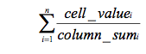
It shows the sum of the percentage each comparison value occupies in its corresponding row. An n x 1 matrix is acquired in this step.

⓷. Calculate the maximum eigen-value λmax:
Multiply the entire matrix with the acquired priority vector to produce an n x 1 matrix. Then divide this matrix by the priority vector to acquire unit vectors. Calculate sequentially the average of the unit vectors to acquire the maximum eigen-value λmax.
Formula:
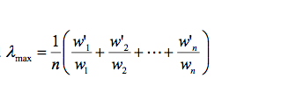
(Where W’ is the eigenvector, wi is the eigenvalue of criterion I, and λmax is the largest eigenvalue of the pair wise comparison matrix.)

⓸. Check consistency
During the pair-wise comparison, discrepancies might occur between the results of the comparison and the decision. The consistence ratio of Satty’s AHP is used to examine the consistency of the entire matrix. Test the consistency property. Where CI is the consistency index, CR is the consistency ratio, λmax is the largest eigenvalue of the pair wise comparison matrix, n is the matrix order, and RI is random index.
The formulas are：
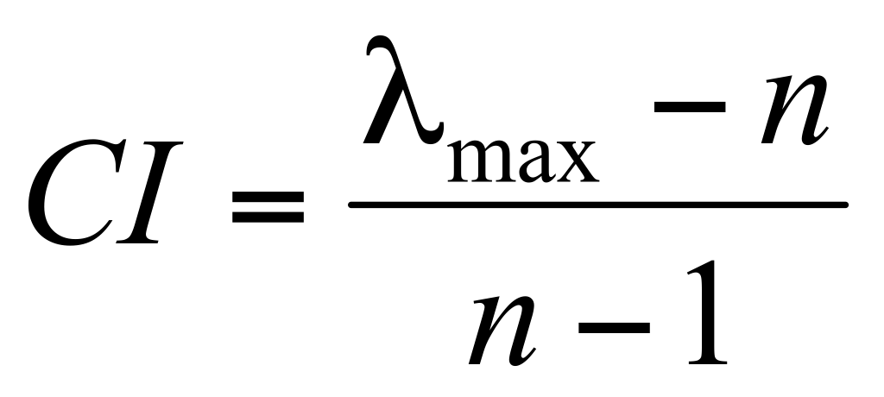
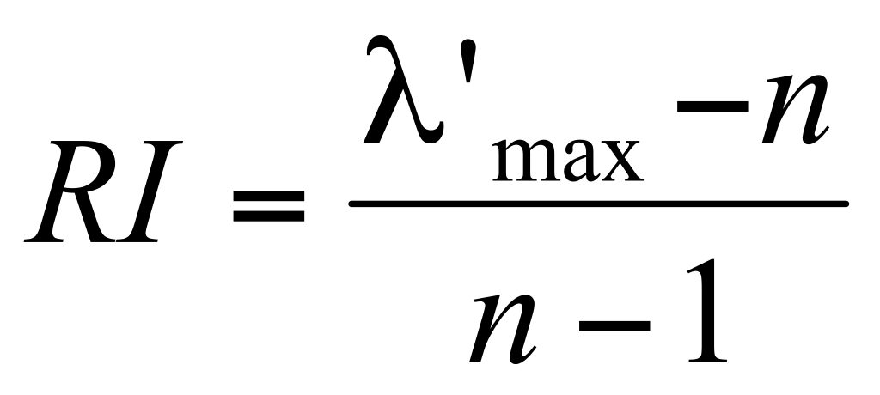
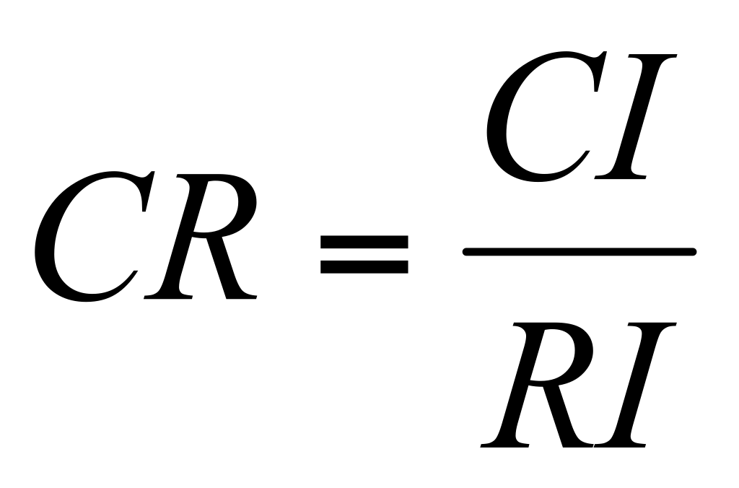
This is argued as one of AHP’s advantages which able to measure whether or not inconsistency occurs in the judgment process. If CR value is small than 0.1, the matrix is acceptable, if it is over 0.1, the matrix need to be corrected. In some parts decision makers should revise the original values in the pair wise comparison matrix until desired consistency level reached(Vargas, 1990).

Table 1:

Technology innovation strategy A1
Independent Innovation B1 | M&A  B2 | Other Innovation Means  B3
Management capacity C1 | Management capacity  C7 | The effect of these innovation modes  C13
Degree of R&D money investment C2 | R&D money input  C8 | Import learning then innovation C14
Quality of R&D staff  C3 | R&D output  C9 | Cooperative innovation  C15
Owned patent  C4 | R&D capacity  C10 | Integrated innovation  C16
Enterprise dimension C5 | Company dimension C11
Succeed rate of innovation C6 | Degree of cooperation with Geely C12

C1, quantitative index, it shows the decision making, communication activity and monitoring ability of managers in the organisation, as it is a subject adjusting and hard to measure by actual formula.

C2, qualitative index, use the number of money Geely invests in the technology innovation. Here according to the interview of Geely R&D centre worker, it is hard to say the exactly number of R&D investment, on average it is the 10% of total sales, when the sales increased the money input of R&D will also increase, because the company need new cars to enlarge sales.

C3, qualitative index, the previous paragraph has specifically introduced the R&D staff of Geely.

C4, qualitative index, this shows the research capability and so far Geely has owned 320 patents.

C5, C11, qualitative index, to measure a company’s dimension need many aspects data, like market share, revenue condition, employee number and so on. The dimension influence the quality of technology innovation.

C6, qualitative index, it is the output shows the capacity of Geely’s independent innovation. Although the money input in some extent influence the final result, the actual achievements are the thing actually determine the ability of a firm’s strength.

C7, quantitative index, the management team of new Volvo is made up by a international team, they have abundant experience in managing transnational car company.

C8, C9 qualitative index, through interview, the number is listed in the previous paragraph.

C10, quantitative index, it is a comprehensive critic on Volvo’s R&D level, transfer input to output and some certain field research result (like Volvo’s hybrid power cars).

C12, quantitative index, Geely has two M&A cases before the takeover of Volvo, so after the acquisition, how do these companies work, like now, Geely and Volvo are working together, on one hand Geely help Volvo to make strategies on China’s market, on the other hand, Volvo help Geely on its technology capacity.

C13, quantitative index, to combine the other innovation modes and measure the whole effects of them.

C14, C15, C16, qualitative index, except M&A, Geely also applies like integrated, cooperate and import, learning then innovation modes to improve its technology innovation strength. Separately study them to get how does each of them work.

According to the telephone interviews with Geely’s R&D management employee, auto industry researcher and other five management and technology researchers (see Appendices), The results are:

B | B1 | B2 | B3 | W
B1 | 1 | 2 | 3 | 0.5119
B2 | 1/2 | 1 | 4 | 0.3601
B3 | 1/3 | 1/4 | 1 | 0.1279

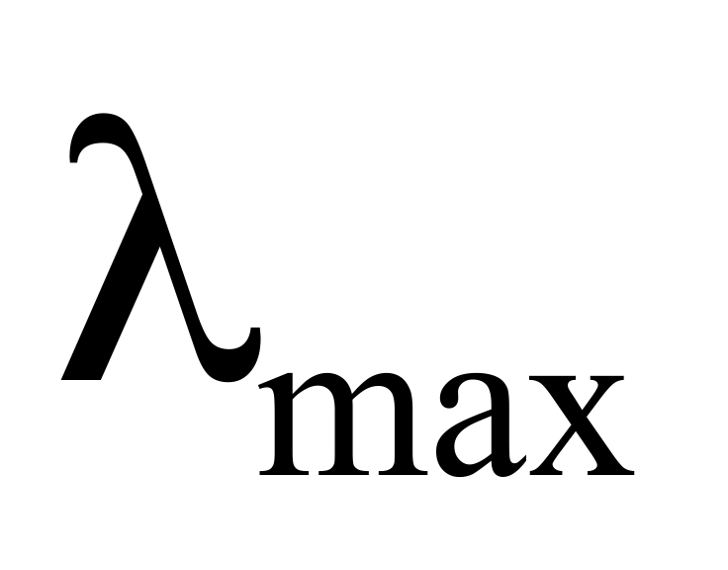＝3.1078 , ＝ 0.0539 , = 0.096 ≺ 0.1

C | C1 | C2 | C3 | C4 | C5 | C6 | w
C1 | 1 | 2 | 6 | 5 | 3 | 4 | 0.3793
C2 | 1/2 | 1 | 5 | 4 | 2 | 3 | 0.2488
C3 | 1/6 | 1/5 | 1 | 1/2 | 1/4 | 1/3 | 0.0434
C4 | 1/5 | 1/4 | 2 | 1 | 1/3 | 1/2 | 0.0654
C5 | 1/3 | 1/2 | 4 | 3 | 1 | 2 | 0.1604
C6 | 1/4 | 1/3 | 3 | 2 | 1/2 | 1 | 0.1024

=6.1470, =0.0245, = 0.0194 ≺ 0.1

C | C7 | C8 | C9 | C10 | C11 | C12 | w
C7 | 1 | 1/2 | 1/4 | 4 | 7 | 5 | 0.1973
C8 | 2 | 1 | 1/2 | 3 | 5 | 7 | 0.2465
C9 | 4 | 2 | 1 | 5 | 6 | 6 | 0.3901
C10 | 1/4 | 1/3 | 1/5 | 1 | 2 | 2 | 0.0752
C11 | 1/7 | 1/5 | 1/6 | 1/2 | 1 | 1/2 | 0.0403
C12 | 1/5 | 1/7 | 1/6 | 1/2 | 2 | 1 | 0.0504

= 6.3225 , =0.0645, =0.0512 ≺ 0.1

C | C13 | C14 | C15 | C16 | w
C13 | 1 | 2 | 6 | 2 | 0.4395
C14 | 1/2 | 1 | 5 | 2 | 0.2986
C15 | 1/6 | 1/5 | 1 | 1/4 | 0.0602
C16 | 1/2 | 1/2 | 4 | 1 | 0.2016

= 4.0657, =0.0219, = 0.0246 ≺ 0.1

Global strategy A1
Independent Innovation 51.19% | M&A  36.01% | Other Innovation Means  12.79%
Management capacity 19.42% | Management capacity  7.10% | The effect of these innovation modes  5.62%
Degree of R&D money investment  12.74% | R&D money input  8.88% | Import learning then innovation  3.82%
Quality of R&D staff  2.23% | R&D output  14.05% | Cooperative innovation  0.78%
Owned patent  3.35% | R&D capacity  2.71% | Integrated innovation  2.58%
Enterprise dimension  8.21% | Company dimension  1.45%
Succeed rate of innovation  5.24% | Degree of cooperation with Geely  1.82%

From the table we can see that, independent innovation is up to 51%, accounts the most important, followed by M&A 36% and other innovation modes 13%. Here come to the conclusion: Geely could focus on self-innovation while assist by Volvo and other acquired companies technology cooperation and insist applying multi types innovation modes.The conclusion is consistent with Geely’s current evolution strategy. Geely is the sign of independent innovation in Chinese auto industry(Yang Yali ,Chen Hao & Chen Lihua, 2010). Since the first car of Geely entered in Market, the president Li Shufu has made up his mind to operate his enterprise by independent innovation. But if Chinese auto enterprises want to catch up with and surpass western level, we need working very hard. To cultivate technology talents and enhance innovation ability or use every possible innovation mode, product technology and brand effect all over the world. Hence Geely while works hard on self-innovation, while takeover of Volvo and other advanced technology enterprises with the precious technology intellectual property and good brand images. The acquisitions may represent an air of China’s auto companies future development trend. The current state of Chinese car industry need the international brand to blaze a trail for their future road, they need the international firms to open the global market for them. As an independent innovation company, Geely bought Volvo showing it has the courage to exert its advantage. On the other hand, it leaves some questions for other Chinese companies to think, what are the attractions for those international big companies, except China’s domestic market, how could the China’s independent company achieve globalisation? Could they by fully rely on self strength or through overseas acquisition or other approaches? To rely on company’s own ability may cost a very long time, because the value and culture of a firm need time to develop, like Volvo, BMW, Benz, they have also been striving for dozens year to accumulate the current achievement. Overseas M&A may be a shortcut, the advanced technology and mature management system could bring a great progress to acquiring company, but there are big risks within the benefits, after merger, companies may encounter management, operating, market and financial threats, they all threat the company. Both means have merits and flaws, it depends on companies characteristic and the managers how to apply it.

AHP help us obtain the technology innovation strategy. Next, PEST analysis are applied to analyse external environment Geely is facing.

5.2 PEST

5.2.1 Political Factors.

By the end of last century, China’s political environment has been stable, the number of car holding is keeping increase. In 2010, the number of vehicle population was 77.08 million units, included 49.95 million sedans. The total demand number was over 1.4 million, and sedan’s demand was up to 12.4 million.

Supports:

⓵. Independent innovation support.
Independent innovation has been proposed as the national strategy by China’s president Hu Jingtao in national annual conference. To enhance independent innovation capability carrying through all aspects of modernisation. Improving the capability of independent innovation and building innovation oriented country. It has been written into China’s eleventh and twelfth “five year plan” (from 2006 - 2010 to 2011 - 2015), and lots of incentives promulgated successively. Hence the companies like Geely applying independent innovation could get governments support.

⓶. Automobile company support.
Auto industry is one of the national support project, as one of the prioritise pillar industries, auto companies get the financial and human resource investment.

⓷.Small-displacement vehicles policies.
Few years ago, China have some restrictions on small-displacement vehicles and some environmental vehicles. Since 2006, National Development and Reform Commission and other 6 departments public new policies on these types car, encouraging their production and sales.

⓸. Infrastructure construction strengthen
The state invests100 billion RMB(about 16 billion dollar) on the road construction. Road and highway are the important construction project of national investment, according to the report, by the end of 2010, most part of China’s rural area, towns, villages have county level highways.

Restrictions:

⓵ Tax fees on vehicles.
Chinese auto consume tax is over weight, 17% value added tax, 10% purchasing added tax, 3% to 8% consume tax and many other unaccountable taxes. This made consumers do not want to use the car. What is worse, too many tollgates in the highway increase the expense of car consuming.

⓶ Automobiles fuel consumption restriction
With the fast increase of the number of vehicles, the environmental pollution and the energy consuming become the serious issues concern by the government. In 2009, the dependency of China’s petroleum and crude oil on import was both over 50%, for petroleum, the number was raised from 51.4% in 2008 to 53.6%, crude oil was increase to 51.2%, the total holding number of autos was 62 million, consumed 134.8 million ton product oil. In 2010, the foreign dependency of petroleum was raised to 55.14%, while the crude oil was increased to 53.7%, like we have mentioned before, the auto population of 2010 was 77 million, consumed 246 million ton product oil. Thus government carried out a set of policies on environment and energy saving to guide auto industry’s developing direction. “Limits of Fuel Consumption for Passenger Cars” was the first police for control auto fuel consumption. It was issued first in 2005 and the second stage began from 2009, then the third stage will be in 2011. This policy lists the standards for different autos on fuel consuming. Each stage has the certain consumption number to restrict. With the third stage coming, domestic auto companies put a lot efforts on introducing energy conserving and greenhouse gas reducing cars, they know that, the policies only will be more and more strict in the future, because this is what the trend for future cars. In 2009, the government published “New Energy Car Manufacturing Companies and Product Access Rules”. It sets rules on the classification of new energy cars, the enter requirements and management means. In 2010, the state carried out “Few Complementary Policies of New Energy Cars”. At present, if a customer buy a environmental car he/she will get a certain amount of subsidy from the state. Those regulations are influencing the products structure of auto companies.

So as a M&A enterprise, Geely has a great advantage could learn from Volvo which is one of the leading companies making energy saving and hybrid power cars. Then, to be the lead to introduce such kind of cars in domestic market.

Development direction

With the begin of China’s twelfth “five year plan” (from 2011 to 2015), it is the time for auto industry adjust the production structure, transfer the evolution ways, drive the development of energy conversing and new energy cars, the authority want auto companies to adjust the industrial structure, optimise the distribution of resource, apply open up and independent innovation and using new energy car as a breakthrough point. Government will also help to build the appropriate, innovation and evolution circumstance for auto companies. The new polices will push the M&A recombination of auto firs, promote firms developing independent innovation, enhance innovation ability, building the independent brand. To 2015, China want to transfer from big auto country to strong auto country, for cast the producing output will reach 25 million, the domestic market share of independent innovation car enlarge to 40% while the export of this kind of auto will over 10% of its overall sales.

5.2.2 Economic Factors.

Economic factor is the foundation of China’s auto industry boost. Since “Open-up and Reform” policy in 1978, Chinese economy has been growth upon a high speed, under this situation, consumer durables has kept a fast speed development trend,especially the auto industry. By the end of 2008, China’s economy has been keeping the 10% development speed for five years(Abo, 2011), economists have a optimistic attitude for China’s future economy. The financial crisis in 2008 has a restricted influence in China’s domestic market. The developing speed is keep 8%, but China’s export business was badly influenced. The gab between wealthy and poor is distinguish, the consume capacity is quite differ from city and rural area.

- From economy aspect, China is stepping into high speed development of auto demand (source from China Economic Information Network web).

The growth of GDP and Disposable Income(DI) will bring the sustainable growth of the number of car. The Noble Memorial Prize in Economics owner and the father of European dollar, Robert Mundell gives the optimistic view to China’s economy development, he presents that in the next 20 years China’s economy will keep growth in the rate of 7%. Even through the country is facing resources shortage and pressure of rising RMB exchange rate (graph 1). Alone with the development of GEP, the disposable personal income also keep rising, in 2009. DI of urban residents was 17175 yuan, account for a 9.8% increase to 2008, and in 2010 the number was 19109 yuan, an increase of 7.8% (graph 2). With the raise of GDP and citizen’s disposable income, the number of car population is also growth (graph 3). (Ps:As the exchange rate of RMB to any currency is always changing, so RMB is kept as the calculation unit)

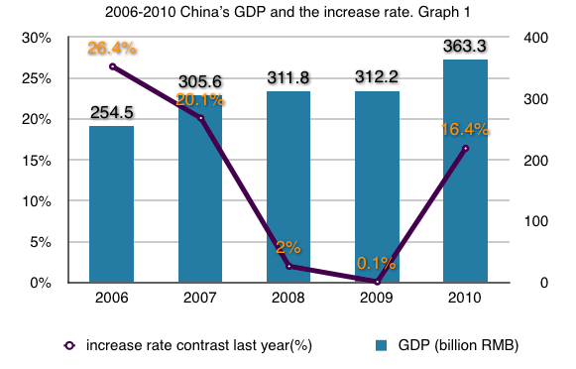
Data from China Economic Information Network web.

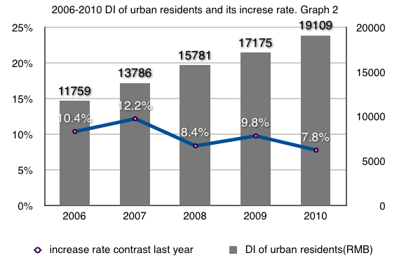
Data from China Economic Information Network web.

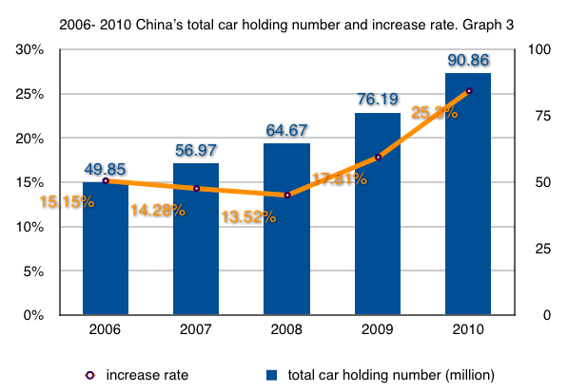
Data from China Automotive Information Website.

- According to the auto industry development history, China is entering fast development stage of auto demand, China’s domestic GDP is constantly growth. In 2009, personal GDP was about 3680 dollar, in 2010, the number was close to 4500 dollar. Different GDP level has different owning rate of personal car (graph 4). When a country’s GDP per capita reaches 1000 dollar, it enters start up stage of mass consumption. When GDP per capita reaches 3000 - 6000 dollar, it enters high auto demand development stage. When GDP per capita extend over 7000 dollar, it enters rapid growth of demand stage. Till the GDP per capita over 17000 dollar, the development speed will generally decline and keep a stable rising. Thus China’s overall situation is over 3000 dollar, the car demand amount will keep growth, meanwhile, along the coastal 10 provinces, their GDP per capita is close to 6000 dollar, those area will step to rapid growth of demand stage soon. From the international experience, when GDP per capita over 3000 dollar, private consume will be the main part of auto market, so China is in the period of private car consuming, especially the sedan consuming stage. Also from international auto market development history and the research, a country’s medium to long term passenger car evolution trend depends on the value of R (the definition of ‘value of R’ is that R= auto price / GDP per capita) when R valued 2 - 3, the penetration rate of car is rapid increasing. China’s advanced auto consuming area like Beijing, Shanghai, Guangzhou and so on are also follow that law. On recent years, China’s urbanisation process is accelerating, it reflects on throughout of the society. The urbanisation enlarge people’s activity area, the increase of moving activity also cause the increase of using transportation, then enlarge the demand of car. The urbanisation is directly driving auto industry’s evolution.

On the other hand, the world price of crude oil increased made domestic product oil price also increased. From customers view, the rise of fuel price increased the costs of using cars. So the common people would like to choose the economic car or even do not consider to but a car.

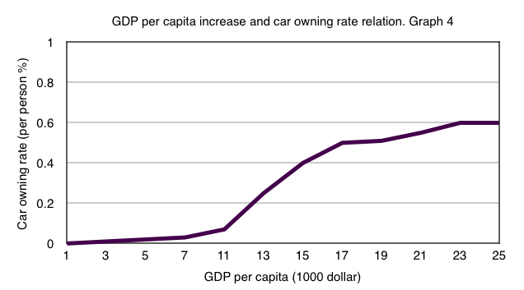

Data from website of China Association of Automotive Manufacturer.

5.2.3 Social Factor.

Currently, China have 355 auto brands, include 69% independent brands, but 90% of the market share is occupied by the foreign brand of China’s joint venture companies. The native auto companies are focus on low-emission economic vehicles(Wang Guangfeng & Li Zheng, 2009). One situation is that Chinese people have strong sense of national pride, but when purchasing some durable consumption goods, they prefer the foreign brands rather than Chinese native ones(Wei Cong & Yang Xiaobai, 2007). Hence the advantage of Geely’s independent innovation is not very obvious. However China is ongoing the transitional period from poor to whole comfortable, so the consume attitude changed a lot, cars are not the simple transportation tools any more, they need equip communication devices, entertainment instruments. In addition with more and more female join the white collar class, their increased income will cause the female type cars become a great potential market. Females pay more attention to beautiful appearance, exquisite internal decoration, high safety and easy to operate. From the population distributing scale, rural area could be another great market and since government policy “ auto go to countryside” published in 2009, only in the first half year, low price and small size autos enhance the total scales to 935,500 ones brought 64.46% increase of the same time in 2008. To some extent, the factor of society determined the demand of auto type and the auto production output. As what can be seen in the Graph 5, the main consumers are between 30-39 years old, accounts for 44.05% followed by age between 25-29 up to 37.08%, this two age classification are the main consumers on the other hand.

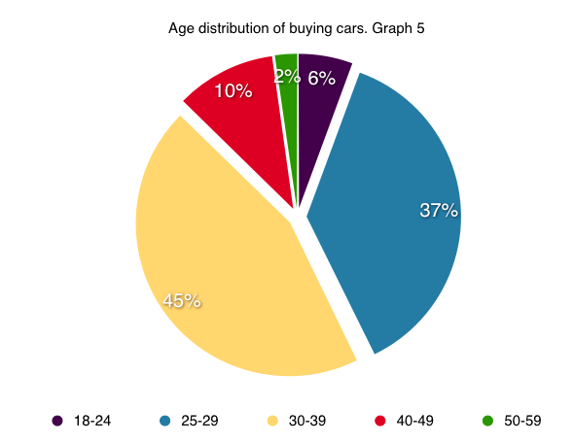
Data from website of China Association of Automotive Manufacturer

5.2.4 Technology Factor.

The real boost of China’s auto industry was since the end of 1970s (Rugman, Collinson, et al, 2006). At that time China’s technology capability was fell behind with the international average level about 20 - 30 years, the auto parts technology was even worser, but the companies use China’s huge market to attract foreign advanced companies to come to China, invest there, cooperated with them(Shi Liangping,2003). This indeed bring a great progress of China’s auto technology, meanwhile it costs a huge amount of expense on technology transfer fees. Now to compare with the international level, China’s auto technology and R&D capacity are still at low level. According to some statistics, the average number of multinational enterprise spend on R&D accounts to 5% - 6% of their sales income, but China’s independent company’s only account to 2% of the sales income(Xiao & Liu, 2007). Geely is much higher than the average number, its R&D investment up to 10% of the total sales. The domestic auto products technology content are low, many of the independent innovation products are setting in the low-end level. This could be a reason for Geely to perform the transition reform, this company need to get rid of the low-end image.

Among those strength auto countries development history, we learn that Japan and Korea are the countries use several decade to independent innovation and overtake to the leading class of auto technology. In the 1990s, Korean government decides to use 100 million dollar to push auto technology evolution, in 1995 they developed the flexible manufacturing system, in 1998 they developed computer integrated manufacturing system and 2001, they developed intelligent manufacturing system(Larry D. Qiu, 2005). Japan’s succeed is most from “Toyota Production system” and the spread of this approach, also from Japanese people’s strong learning, digestion then independent innovation ability. Last year, in 2010 Toyota was still the No.1 sales of world auto companies. They have kept this record for years. Same with Korean, Japanese government helped improve its auto industry and gave strict requirement on car safety and fuel use volume, so Japanese cars could stand in the top of European and American market after the first petroleum crisis. Learning from China’s neighbourhoods’ experience, independent technology innovation is the necessary road for China’s auto industry, only through independent innovation and R&D, auto companies could cultivate their own core competitive capacity.

Conclusion:
Through AHP analysis we get Geely’s technology innovation development strategy and PEST analyses the external environment the company facing. Difficulties are in the way of development, but Geely could have confidence about the future because the state offering support, economic condition boosting, social environment promoting. Meanwhile it has Volvo this powerful cooperation partner and other strategic alliances from all over the world.

5.3 Management integration

So as the AHP result shows that Geely will insist applying independent innovation strategy while deeply cooperate with Volvo. Because based on the current situation, totally rely on Volvo’s technology is impossible, it may cause the failure of this merger (Cai & Liu, 2011). At the beginning of merger, Li Shufu announced that: Geely is Geely, Volvo is Volvo, Geely will still run by Geely’s way, Volvo will be run be Volvo’s original management approach while it is strategically independent. They are distinct companies, Volvo is a Swedish business with a strong Scandinavian heritage, Geely is a Chinese business with a strong mission of wage earners. Volvo car designs in Sweden while its new factories are building in China now. To produce two different kinds of brand products in one factory is irrational. Stefan Jacoby said, Geely’s car is facing the salaried class, Volvo is a higher level brand, the target customers are upper class, so Li Shufu performs separated management in each company. But generally foreign companies always low down their product configuration to meet Chinese consumers’ need and change some criterion of technology, this will increase their competitiveness. So Geely thinks Volvo should take the similar strategy to change its predicament, but managers from Volvo believe that only by insist the uniform idea “one global market, one criterion” Volvo could guarantee its value all the time. Maybe it is the problem of independent management. Divarication could produce new idea, who knows this could not be a good idea. The two opinions are all right, they standing on different perspectives, so with the more exchanging of the views, they may bring a great future to Geely and Volvo.

Chinese traditional management theory Taoism has the same notion of the self management of Geely and Volvo. Taoism advocates “govern by doing nothing”, Geely’s non-intervention policy aims at giving full play to Volvo’s original value, maintain the stability of current R&D team. The analyser John Bonnell from JD Power indicated that a successful approach for Geely to operate Volvo is accepting and studying the management means of Volvo rather than dictate it, do not try to conquer it. The plan of Geely after the merger is to build 300,000 units manufacturing base for Volvo. In China, this need a nearly corresponding size of comprehensive management system and R&D institution as its headquarter in Sweden. In order to guarantee the quality and value of China’s Volvo, Geely need invite the senior managers, middle level cadres and also workers at the production line to take part in the construction process, select some management staff come to China to train Geely’s worker, this help fast improve the management level of China’s Volvo.

The react to Geely’s independent management was reported on a newspaper On May 3, 2011Financial Times Chinese Vision published an article named “Swedish satisfied the Chinese ‘Host’”. Last year, when Volvo was bought by Geely, Swedish people were worried about this may badly influence Swedish car industry, however a year past,in Sweden it is hard to find someone do not like the “new” host. In March this year, Volvo announced a plan that to hire 1200 workers in Sweden and Belgium, this news reduced the public concern of Geely may remove the working posts to China. Most of the recruits will be the technology engineers of Gothenburg's Volvo. It shows that even Geely has a great plan of production in China, most part of the R&D work will still be done in Europe.

If we use Peter Drucker’s successful Management integration theory (expatiated in Chapter 2) to measure current integration performance of Geely and Volvo, we could have optimist estimate on the post- merger results, because
- Geely and Volvo belong to the same industry - automobile. They are all carmakers ensure they have the “common core unity” share the “common culture”
- Geely is helping Volvo renew the reputation and expand the business in China.
After complete the merger transaction, the two company founded a Dialogue and Cooperation Committee made up by managers from both party. One of the goals is to coordinate Volvo’s global unified standard with China’s different market demands.
- Geely respect two things on Volvo: mature European commercial civilisation, the values formation of Volvo century.
These all meet the requirements. So we could believe Geely will manage well Volvo.

CHAPTER 6 CONCLUSIONS

6.1 Suggestion

1. Keep focusing on China’s market.
Since 2007 Geely started the strategic transformation, it plans to introduce its products to the global market. So it is adjusting its products structure to suit for the global customers. To be internationalisation is a good strategy, but China’s domestic market has become the world largest automotive market, hence Geely could keep concentrating on China’s market and treat the overseas market as the backup of China’s domestic market. Also from products perspective, Geely knows the needs of Chinese people more than other countries’, so it could play to their strength better in China’s market.

2. Pay more attention on hybrid power and environmental-friendly cars.
This is the trend of automobiles future. Unlimited use of non-renewable resource petrol and the environmental problem of greenhouse gas made auto makers to invent another energy saving and environmental friendly cars. The raise of public environmental awareness will bring prevalence of this kind of cars. So the earlier Geely introduce the hybrid power and environmental-friendly cars, the more opportunity to earn market advantage.

3. Continue to carry forward the human resource strategy.
There are merely few of auto enterprises have their own universities like Geely in China, this guaranteed the company has a well trained employee source as well as the management staff. So Geely may keep this strategy and make the best use of this advantage. In the mean time, Geely need use its strength to attract technology talents in and out of the nation. It is the professional and technical personnel could bring core competitiveness to an enterprise.

6.2 Conclusion

The boost of China’s economy has sprung the automobile industry. Foreign brands successively entered this market while domestic companies also strive for the best, with the shortage of core technology, brand influence and enough professional personnel, the development speed and effect of China’s automobile is barely satisfactory. Since 1997 Geely began to develop automobile business, it rarely gets policies support from government, does not have financial preference as joint venture companies as well, but by independent operating, it embarks on simple technology, auto components, employee training, then obtain initial achievements in low-end market. Developing core technology is the consistent goal for the company. With the accumulated experience and human source and the evolution approach of "generally following, partially surpassing, breakthroughs in key areas, attracting talents, universal cooperation, excelling the predecessors” Geely acquired two firms: British Taxi enterprise Manganese Bronze Holding in 2006 and Australia auto components and parts enterprise Drivetrain Systems International (DSI) in 2009 while began to apply strategic transformation in 2007. From using low price fair quality strategy to expand awareness “making the common affordable car” to apply high-technology, high-quality, high-efficiency and international strategy “make good cars that are the safest, most environmental friendly and most efficient, let Geely cars run all over the world.” In 2010, it completes the takeover of Volvo Car Corporation. So how will Geely perform the technology innovation strategy after this a series of M&A, by utilising acquirer companies’ technology, or applying integrated innovation, cooperated innovation, import - learning - innovation, or concentrate on independent innovation. Through interviews with Geely’s R&D employee, technology and management researchers, in addition of some other investigation, the possible strategy may be emphasis on self-innovation and assists by Volvo and other acquired companies technology cooperation while insist applying multi types innovation modes. To explain that depends on the contemporary condition, totally rely on Volvo’s technology is impossible it may cause the failure of the acquisition. So the president of Geely company Li Shufu announced that Li Shufu announced that: Geely is Geely, Volvo is Volvo, Geely will still run by Geely’s way, Volvo will be run be Volvo’s original management approach. On the other side, Geely strengthens by independent innovation and it is sign of Geely, so it should keep working on it, meanwhile by dint of Volvo, Manganese Bronze and DSI enhance the technology quality, innovate the world leading techniques, also extensively corporate with worldwide excellent automotive enterprises. Thus Geely could develop a Chinese automotive breakthrough road out of foreign investment and joint venture firms by owning self innovated technologies.

This paper represents a series of preliminary studies on technology innovation strategy of a China’s automobile company, Geely. It is well acceptable that technology innovation strategy is the core of an automobile company. From the initial reading I learnt that Geely is applying a multi-mode technology strategy. So how will the company performing it after the merger of Volvo become the research question? After several sorts of investigations and analysis the answer to the question is that: Geely is performing independent innovation for main technology innovation strategy assisted by M&A company while combine import-learning-recreation and other innovation modes. From reviewing the literature, finding the research questions, planning the research, then performing telephone interviews, obtain data, using AHP and PEST approaches analysing the data, finally address the research questions, complete the research. Even though not all the process can be seen in the dissertation, and there are few limitations within the research design, the output of the whole research is fulfil the initial objects. What I have done so far may be just an alternative for the issue, more research still need to be carried out in the future.

Recommendations

The technology innovation strategy obtain in this research also corresponds to technology strategy which draw by Qiu Nong and Zhu Wei (2009).

Reflections

The objectives in this article have been fulfilled. The outcomes are better than the initial expectations. The research process was carried on according to the schedule. One improvement is that telephone interview can only take for a short while, next time if possible, the face to face interview could be applied. During those months doing this research, connecting related researchers, waiting for responses, doing the telephone interview, I learnt a lot of thing on management experience, for example how to make a plan, in terms of time, knowledge learning, fulfil a plan. My communication skills, learning skills have been improved.

Bibliography

Abo, T. (2011). Competing Chinese and Foreign Films in Swelling Chinese Economy: Competition Strategies for Japanese, Western and Asian Firms, Lit Verlag.

Andrew.D.James, (1998) Integrating Technology Into Merger and Acquisition Decision Making. Technovation 18(8/9): 563- 573.

Bai Mei (2002) On the Knowledge and Technology based M & A. Economic Server (3) 52-54

Bensoussan, B. E. and C. S. Fleisher (2008). Analysis without paralysis: 10 tools to make better strategic decisions, FT Press.

Bensoussan, B. E. & C. S. Fleisher (2008). Analysis without paralysis: 10 tools to make better strategic decisions, FT Press.

Bohn R. (1994) Measuring and Managing Technological Knowledge. Sloan Management Review,(9):61-73.

Branson J. (1996) Transfer Technology Knowledge by International Corporation to Developing Countries. Erican Economics Review,(3):259-267.

Bryman, A. and E. Bell (2011). Business Research Methods, Oxford University Press.

Cai Chen & Liu Jieming (2011)Comparison and Revelation of Quality Management of China's Domestic Typical Auto Enterprises. School of Management, Wuhan University of Technology ICEE
Dickens, C. (1859). A tale of two cities, Easton Press.

Eisenhardt, K.M. (1989), ‘Building theories from case study research’, Academy of Management Review, Vol. 14, No. 4, pp. 532-550.

Fleck J, 1994, "Learning by trying: The implementation of configurational technology," Research Policy, 23, pp.637-52.

Fu Guangyun. (2008) Five Obstacles on Overseas M&A. International Finance News

Fu Jiaji. (2001). Innovation Science. Beijing. Tsinghua University Press

Fu Jiayi (2006) Study on the Management and Strategy Theory of Standards on the Basis of Technology Innovation, Studies in Science, 24(6)

Geely Report, available in Geely website: http://www.geely.com/news/glhb/32600.html

Gillham, B. (2000). The research interview, Continuum.

Greunz. L. (2004). Industrial structure and Innovation-evidence from European regions.

Guba, E.G. and Lincoln, Y.S. (1994), Competing paradigms in qualitative research, in:
Denzin, N.K. and Lincoln, Y.S. (eds.), Handbook of qualitative research, Sage
publications: Thousand Oaks.

Hatch, M. J. and A. L. Cunliffe (2006). Organization theory: modern, symbolic, and postmodern perspectives, Oxford University Press.

Jack Perkowski (2006) The Coming China Car Boom. Far Eastern Economic Review. www.feer.com

Janesick, V.J. (1994), The dance of qualitative research design, in: Denzin, N.K. and
Lincoln, Y.S. (eds.), Handbook of qualitative research, Sage publications: Thousand
Oaks.

J.L.Enos.(1962) Invention and Innovation in Oil-processing Industry. Petroleum Progress and Profits (MIT Press, Cambridge)

Kepner, C.H., and Tregoe, B.B., 1965: The rational manager: a systematic approach to problem solving and decision making. McGraw Hill: New York.

Larry D. Qiu. (2005) China’s Automotive Industry. Hong Kong: Hong Kong University of Science and Technology

Lajoux, A. R. (2006). The art of M&A integration: a guide to merging resources, processes, and responsibilities, McGraw-Hill.

Lei Jiasu (2005). Analysis of Technology Transfer Process in Enterprises' Technology Integration, Science of Science and Management, 26(4)

Lei She and Gu Yan (2006) spillover Effect of Independent Innovation in China’s Auto Industry. Shanghai Auto 2006(12)

Li Xianjun, (2009). Primary research on Management Integration. Journal of Management Sciences in China 2009(1-2)

Ilan Alon, Marc Fetscherin & Marc Sardy (2008) Geely motors: A Chinese automaker enters international markets. International Journal of Chinese Culture and Management. 11-4

Macharis, C., Springael J., De Brucker, K., Verbeke, A. (2004): Promethee and AHP: The design of operational synergies in multicriteria analysis. Strengthening Promethee with ideas of AHP. European Journal of Operational Research 153: 307−317.

Marco Iansiti and West J. (1997) "Technology Integration: Turning Great Research into Great Products." Harvard Business Review 75, no. 3 (May - June 1997): 69-78.
Marco Iansiti (1998) Technology integration: Making critical choices in a dynamic world Boston, Mass.: Harvard Business School Press

Marschan-Piekkari, R. and Welch C. (2004). Handbook of qualitative research methods for international business, Edward Elgar.

Miles, M.B. and Huberman, A.M. (1994), Qualitative data analysis, An expanded
sourcebook, Second edition, Sage publication: Thousand Oaks.

Peter F. Drucker.(1968) Frontiers of Management. New York; Truman Talley Books

Qiu Nong and Zhu Wei. (2009). Technology Strategy Mode of state-owned Auto Companies. China Market. 22: 34-39

Raja Irfan Sabir. (2009) An Evaluation of the Innovative Capabilities of Chinese Car Manufacturers[D]. Wuhan University of Technology.

Raja Irfan Sabir, Luo Liguo (2010) A Research on the Innovative Capabilities of Chinese Car Manufacturers by Analysing the Patent Information Chinese-German Institute of Intellectual Property, School of Management, Huazhong University of Science & Technology.

Ramanathan, R., 2001: A note on the use of the analytic hierarchy process for environmental impact assessment. Journal of Environmental Management, 63: 27−35.

Rubin, H. J. and I. Rubin (2005). Qualitative interviewing: the art of hearing data, Sage Publications.

Rugman, A. M., S. Collinson, et al. (2006). International business, Prentice Hall/Financial Times.

Rothman, Harry. (2009). The Handbook of Industrial Innovation. Sage Publications.

Saaty, T.L. 1990: How to make a decision: The Analytic Hierarchy Process. European Journal of Operational Research 48: 9−26

Saunders, M., P. Lewis, et al. (2009). Research Methods for Business Students, Pearson Education.

Schumpeter, J.A. 1912/1934: Theorie der wirtschaftlichen Entwicklung. Leipzig: Duncker &
Humblot. English translation published in 1934 as The Theory of Economic Development.
Cambridge, MA: Harvard University Press.

Scudder, G.D. and Hill, C.A. (1998), ‘A review and classification of empirical research in operations management’, Journal of Operations Management, Vol. 16, pp. 91-101.

Shi Liangping. (2003). On the national technology innovation system. Economic management.

Shiau, Y. C.; Tsai, T. P.; Wang, W. C.; Huang, M. L. 2002. Use questionnaire and AHP techniques to develop subcontractor selection system, in International Symposium on Automation and Robotics in Construction, 19th (ISARC) Proceedings, National Institute of Standards and Technology, Gaithers- burg, Maryland, 35–40.

Schilling, M. A. (2006). Strategic management of technological innovation, McGraw-Hill/Irwin.

Scherer, F.M. (1992) Research on Patents and the Economy: The State of the Art. Cambridge: Harvard University.

Sirower, M. L. (2007). The Synergy Trap, Simon & Schuster.

Souder W. (1987) Technology, In ovation and Performance after Mergers. Managerial Evaluation,(6):103-114.

Teece D. (1996) Firm Organisation,Industrial Structure and Technological Innovation. Journal of Economic Behaviour & Organisation, (2):193-24.

Vargas, L.G., 1990: An Overview of the analytic hierarchy process and its applications. European Journal of Operational Research, 48: 2−8.

Wang Guangfeng & Li Zheng,(2009) Technology Breakthrough,Externality and Enterprises Technology Mergers and Acquisitions Science and Technology Progress and Policy 2009.26(2)

Wang Ke & Zhang Xiaodong (2000) The Management Integration of Post-merger. Modern Economic Research 2000,(8) F2

Wasserstein, Bruce (1998). Big Deal: Mergers and Acquisitions in the Digital Age. New York: Warner Books.

Wei Cong & Yang Xiaobai (2007) The Merger Integration of Modern Companies. China Science and Technology Information 2007(23)

Weiss, R. S. (1995). Learning from strangers: the art and method of qualitative interview studies, Free Press.

Wu Bei, Jin Chen & Wang Shanshan (2008)The Analysis of R&D Outsourcing in Zhejiang Automobile Manufacturing Factory. Communications 5-19-23

Wu Youjun. (2004). Technological Innovation Capacity Index System. Business Research

Wu Zhijun (2006) Research on Management Integration During Enterprises M&A. Journal of Management Sciences in China 2009(6-1)

Xiao G & Liu J (2007) Self-determined innovation capability upgrading of advanced manufacturing enterprises:The key path and case analysis. Science Research Management. 28(3)

Xu Qiang. (2009) Analysis on the Status Quo and Prospect of Chinese Enterprises “Going-Global”. Public Commerce Servece

Xu Qingrui (2002). Dynamic capabilities-based strategy innovation: a theoretical frame work and empirical studies in Chinese firms. Journal of Zhejiang University(Science). 2002 3-3

Yang Jie. (2007) Research on Enterprise M&A Integration. Economy & Management Press, 2005

Yang Yali ,Chen Hao & Chen Lihua (2010). Strategy analysis of self-brand car in China. Computer and Communication Technology 319-322

Yin, R. K. (2009). Case study research: design and methods, Sage Publications.

You Xianfeng (2008) Problems Faced by China’s Car Industry on technology Strategy. Science of Management. 5: 47-50

Yu Peiyou & XI Junfang, (2006) Research on the knowledge transfer of the post technology-based merger integration. Science Technology Management 2006, 27(5)

Zahir, S., 1999: Clusters in group: Decision making in the vector space formulation of the analytic hierarchy process. European Journal of Operational Research 112: 620−−634.

Zhang Gang. (2001) The evolutionary process of firm' s capabilities based on technology transfer. Study in Scince 19(3)

Zhang Xiyong (2007) Firms M&A and Management Integration.Group Economics Research 4(07)

Zhao Ruilan. (2005) What should be Regarded in Chinese Enterprises Overseas M&A. International Financing, 2005:10

Zhao Wei, Huang Shangguo. (2004) Research on the Countermeasures of Accelerating Private Enterprises Cross-border M&A. International Economic and Trade Research, 2004:5

Zhong Gengshen & Zhang Hengyi (2003) Three Rules for The Integration After the Combination of Enterprises ShangDong Social Science 2003.2

Magazines and newspapers

Financial Times (2011) “Swedish satisfied the Chinese ‘Host’”, may 3, 2011

Geely Report (2010-04) Zhejiang Geely Holding Group internal magazine.

The Economist (2000) “How mergers go wrong”, The Economist, July 20, 2000

Websites:
China Association of Automotive Manufacturer http://www.caam.org.cn/

China Automotive Information. http://www.autoinfo.gov.cn/autoinfo_cn/index.htm

China Economic Information Network web. http://www.cei.gov.cn/

Geely website: http://www.geely.com/

Appendices
The main transcript of telephone interviews.

- Geely R&D employee

Compare with independent innovation, M&A, integrated innovation, cooperated innovation, which do you think is the most important mode for Geely to develop its technology innovation? And rank for the rest.
Our company is always applying independent innovation for the company’s development strategy and it will be continued. If you want me to rank them I believe self innovation is the most important approach, followed by the corporation of merged companies, because we cannot directly use the acquirer companies technology by the intellectual property problem, but we can building a cooperation relation, do you know that, in the automotive industry, even the competitors can build cooperation to research and develop technology. Integrated or cooperated or import and learning then innovation those modes we are also applying. Our development strategy is generally following, partially surpassing, breakthroughs in key areas, attracting talents, universal cooperation, excelling the predecessors.

(if 10 is the most important, how do you score them?)
Independent innovation 10, M&A 8, Other modes 7

How do you appraise the R&D system of Geely and Volvo? Such as the staff, the money investment and the research output.
I am a member of this system, so I think the technology system of Geely is really good, we have a very comfortable working environment, our R&D centre was qualified as Enterprise Technical centre and postdoctoral working station of nation level. Our website have more detailed introduction. We have hundreds of patents, inventions. There are over 1600 technicians, hundreds of masters, senior engineers, researchers, more than ten foreign experts, dozens of PHDs, 3 national academicians working in Geely’s R&D centre. So you can image what a strong team we are. The money investment is the confidential issue so I cannot tell you. Talking about the research output，every year we have dozens of new cars introduced to market.

I do not know Volvo’s R&D system very well, I haven’t been there before. But as far as I know, they have one of the world most advanced automobile crash testing centres. They have too many No.1 technologies, such as the airbag, the three point safety seat belt and so on, Volvo is the inventor of those remarkable equipments. There technology capability is much higher than ours and there technology engineers have more and better than Geely. After all it is an eighty-years history enterprise, Geely only has 24 years old. It is nature we have distance.

What is your estimate on the management of Geely and Volvo?
Our operation performance is the best evidence of the management situation. Each department fulfils its tasks and collaborating with the whole system. I think we are doing very well. Volvo corporation has worldwide reputation to attract the elites to working in, this is also the thing Geely is striving to do.

How do you think the way Geely separate manage Volvo and itself?
I believe Li Shufu, and I believe our company has a good management team which could make the right choice for both Geely and Volvo’s future.

What suggestions you would like to give to Geely for their technology or future development.
We are doing our best to improve Geely’s technology, and I think we could enlarge our market to a more extensive scale in the world.

2. Technology perspective researcher 1

What is your opinion on Geely’s aggregate level of Geely autos？
I think Geely autos quality is fair, the price is acceptable and after service is very good, I am using the Geely’s car. When I selecting the cars I value oil consumption and safety as well as the price, so Geely was recommended by my friends who is selling the cars.

Compare with independent innovation, M&A, integrated innovation, cooperated innovation, which do you think is the most important mode for Geely to develop its technology innovation? And rank for the rest.
You know the first car of Geely was made by the recombination of two other brands cars, and the primary stage of the technology innovation strategy was innovation by imitation, so the company learning a lot from other automobiles. Now it is applying independent innovation. As a Chinese people, I hope Geely could insist independent innovation, but absorb excellent technology from the acquirer companies, especially Volvo. Volvo is such a good company with world advanced technologies.

(if 10 is the most important, how do you score them?)
Independent innovation 9. M&A 8. Other modes 5

How do you appraise the R&D system of Geely and Volvo? Such as the staff, the money investment and the research output.

China’s automobile industry fall behind the western developed countries about dozens of years. Volvo R&D system is much better than Geely’s. But Geely is striving to catch up with. So if I score them

( How will score the R&D system of Geely and Volvo if 10 is the full mark.)
Geely : capability 4, human resource 3, investment 4, output 4
Volvo: capability 8 human resource 8, investment 9, output 7

What is your estimate on the management of Geely and Volvo?
Judging from the results, Geely is doing a little better than Volvo.

How do you think the way Geely separate manage Volvo and itself?
Now it is hard to say whether this is a good or bad decision, I think we need more time to test it.

What suggestions you would like to give to Geely for their technology or future development.
Geely should develop environmental friendly vehicles more, the air pollution problem is very serious, every year vehicles exhaust mass of green house gas to air. The western countries have the policies to lead auto industry working on the environmental friendly vehicles, we also need to do that.

3. Technology perspective scholar 2
What is your opinion on Geely’s aggregate level of Geely autos？
Not very good, I know their price is low, if I want to buy a car I will consider the higher quality and safety car.

Compare with independent innovation, M&A, integrated innovation, cooperated innovation, which do you think is the most important mode for Geely to develop its technology innovation? And rank for the rest.
M&A could strengthen Geely’s technology capability a lot, so M&A is the most important. Follow by independent innovation then other means.

(if 10 is the most important, how do you score them?)
M&A 10 ,Independent innovation 8, Other modes 4

How do you appraise the R&D system of Geely and Volvo? Such as the staff, the money investment and the research output.
Geely has universities, so I think they do not need worry about the human resource, the number of different kinds of research expects is more than our universities. So I think Geely R&D system is good, Volvo’s must be good.

( How will score the R&D system of Geely and Volvo if 10 is the full mark.)
Geely : capability 6, human resource 5, investment 3, output 6
Volvo: capability 9 human resource 7, investment 6, output 5

What is your estimate on the management of Geely and Volvo?
Each of them has the way to run a business, I think the managers are all qualified.

How do you think the way Geely separate manage Volvo and itself?
This is a smart way to do so, and very interesting, because from the previous M&A examples, the acquiring company always rush to integrated the acquirer company so that they will have different kinds of synergistic effect, but Geely is not rush to do that, in contrary, it keep independent management of Volvo, so Volvo could still keep the original operating approach.

What suggestions you would like to give to Geely for their technology or future development.
Geely should make full use of Volvo, learning the technology, management and other advanced enterprise operating methods.

4. Management perspective scholar 1

What is your opinion on Geely’s aggregate level of Geely autos？
Medium. I believe they have potential to do better.

Compare with independent innovation, M&A, integrated innovation, cooperated innovation, which do you think is the most important mode for Geely to develop its technology innovation? And rank for the rest.
If there is no intellectual property problem, M&A could be a very good way for learning advanced technology. For Geely, Volvo could be a very good teacher. So I think M&A is the most important, then independent innovation and other modes are the last.

(if 10 is the most important, how do you score them?)
M&A 9, Independent innovation 7, Other modes 5

How do you appraise the R&D system of Geely and Volvo? Such as the staff, the money investment and the research output.
Volvo is much better, the brand value of Volvo is much higher than Geely.

( How will score the R&D system of Geely and Volvo if 10 is the full mark.)
Geely : capability 6, human resource 5, investment no idea, output 5
Volvo: capability 9 human resource 9, investment on idea, output 6

What is your estimate on the management of Geely and Volvo?

Management is a very complex activity, the leadership, the level of trained employees, the organisational structure all related to the result of management. I think Volvo could do better, or they won’t acquired by Geely, Geely is a private owned company. But it merged Volvo so I think they are doing very well.

How do you think the way Geely separate manage Volvo and itself?
Maybe Geely is not capable to manage Volvo, so they need apply separate management.

What suggestions you would like to give to Geely for their technology or future development.
I think they could introduce some female car, many auto companies have the female kind of cars, small, beautiful and safety.

5. Management perspective researcher 2

What is your opinion on Geely’s aggregate level of Geely autos？
I have not drove a Geely’s car, so I can not give the critics

Compare with independent innovation, M&A, integrated innovation, cooperated innovation, which do you think is the most important mode for Geely to develop its technology innovation? And rank for the rest.
Auto industry is national pillar business, and Geely is always applying independent innovation, they could keep working on it.

(if 10 is the most important, how do you score them?)
Independent innovation 9, M&A 8, Other modes 3

How do you appraise the R&D system of Geely and Volvo? Such as the staff, the money investment and the research output.
( How will score the R&D system of Geely and Volvo if 10 is the full mark.)
Geely : capability 6, human resource 5, investment 4, output 6
Volvo: capability 6 human resource 6, investment 6, output 7

What is your estimate on the management of Geely and Volvo?
Both of them are doing well

How do you think the way Geely separate manage Volvo and itself?

I think the sooner they merged together, I mean two companies really management together, the higher Synergy Effects they will obtain. Maybe they are still in run-in phase.

What suggestions you would like to give to Geely for their technology or future development.
Environmental friendly cars are the development trend, they want to shape Volvo to be the luxury business car, this is not the development trend of auto industry, wester countries have been developed the environmental cars for years, and the people are would like to buy this kind of cars. So I hope they will change the direction to produce environmental friendly cars.

6. Management perspective scholar 3

What is your opinion on Geely’s aggregate level of Geely autos？
I think they are doing well among Chinese car companies, it is the one of the few private owned firms running in China, lots of the auto companies are state owned, supported by the state, Geely is running by itself. And even merged Volvo.

Compare with independent innovation, M&A, integrated innovation, cooperated innovation, which do you think is the most important mode for Geely to develop its technology innovation? And rank for the rest.
Independent innovation, then M&A and other modes, those modes could using together.

(if 10 is the most important, how do you score them?)

Independent innovation 10, M&A 8, Other modes 8

How do you appraise the R&D system of Geely and Volvo? Such as the staff, the money investment and the research output.
( How will score the R&D system of Geely and Volvo if 10 is the full mark.)
Geely : capability 8, human resource 7, investment 6, output 4
Volvo: capability 9 human resource 7, investment 7, output 5

What is your estimate on the management of Geely and Volvo?
Geely is doing very well so that they have the ability to merger Volvo.
Volvo as a famous band, they also have a good organisation structure and management approach.

How do you think the way Geely separate manage Volvo and itself?
I hope they can integrate together soon, separate management may not good for long term operation.

What suggestions you would like to give to Geely for their technology or future development.
Deal with the integration work as soon as possible.

7. Auto researcher

What is your opinion on aggregate level of Geely autos？
From my observation, if you only focus on the self-owned brand, Geely’s products are good, Chery, BYD or Changan and other self-owned auto brand all have their merits. Geely changed their products four years ago, and since then, they want to develop new impression on their products, so if you compare with the past and current products of Geely I could say they have made a great effort on it. But, if you put it in all the auto companies in China, whatever the joint venture or foreign investment, Geely still has lots of gaps need to be remove.

Compare with independent innovation, M&A, integrated innovation, cooperated innovation, which do you think is the most important mode for Geely to develop its technology innovation? And rank for the rest.
Well, as I know Li Shufu is separating manage Geely and Volvo, but I think Volvo could help Geely raise their technology a lot. So M&A and independent innovation are both very important, I do not have much information on their other innovation modes, if they have, I think that is good, those modes could enrich the technology innovation outputs.

(if 10 is the most important, how do you score them?)
Independent innovation 10, M&A 8, Other modes 7

How do you appraise the R&D system of Geely and Volvo? Such as the staff, the money investment and the research output.

They are not in the same level, Volvo’s system is much qualified than Geely’s. But, every year Volvo invests billions of dollars on the R&D, so the results are much better than Geely, in China, the average investment of the R&D is about 2-3% of the sales, I do not know the exactly number of Geely, I think recent years they are investing more then in the past.

How will score the R&D system of Geely and Volvo if 10 is the full mark?
Geely : capability 5, human resource 4, investment 3, output 4
Volvo: capability 7 human resource 6, investment 8, output 7

What is your estimate on the management of Geely and Volvo?
Each of them have their characteristics, in different cultures they are both doing well. And now they merged, and built a strong team to administrate both companies.

How do you think the way Geely separate manage Volvo and itself?
They have to do this way, or Geely will fail on this acquisition. Geely is not strong enough to integrate them together.

What suggestions you would like to give to Geely for their technology or future development.
I think it should focus on China’s market, I know that it is expanding the business overseas, but, it is a Chinese company, it knows China better than abroad, and also, China now become the world biggest market for automobiles, so when Geely have a strong foundation in China, then expand abroad.

