Molecular understanding of heterointerfaces: charge injection into organic semiconductors
Applicant | Dr. Feilong Liu
Host Institute | Max Planck Institute for Polymer Research, Mainz

- Introduction

The importance of organic electronics has been well-recognized by both academia and industry. On the scientific side, the 2000 Nobel Prize in chemistry was awarded to A. J. Heeger, A. G. MacDiarmid, and H. Shirakawa for their work on conductive polymers.¹ On the application side, manufacturers such as Samsung and LG have used the organic light-emitting diode (OLED) technology in a large-scale production of next-generation televisions and smart phone displays.^{[2]}
The chemical design and optimization of organic materials at a molecular scale is, however, still a challenging task. In most cases, empirical design rules and tedious screening procedures are used to identify suitable molecular structures. Computer simulations could help to speed up this process. However, these simulation techniques rely on the quantitative (predictive) models capable of linking molecular structures to mesocopic and microscopic materials properties. In the past decade, an number of advanced multi-scale simulation approaches have been developed to tackle charge transport in disordered organic semiconductors.^{[3]-[15]} Here, quantum chemical methods were used to calculate charge transfer rates between pairs of molecules. These rates were then used to parameterize the discrete master equation or continuum drift-diffusion equations and to study device-scale physics.
One of the remaining processes which lacks molecular understanding is the charge injection from electrodes (oxides) into disordered (amorphous) organic layers. Charge injection is clearly of vital importance for the overall device efficiency. Moreover, more and more materials with deep HOMOs and shallow LUMOs are being developed but large injection barriers impede their swift application in optoelectronic devices.
The mechanism of charge injection into conventional inorganic semiconductors is well-understood in the framework of Schottky metal-semiconductor contact, thermionic injection, and quantum tunneling.^{[16]} However, for charge injection into amorphous organic semiconductors, more complicated processes are involved. The electrons from the electrode are injected into molecules, i.e. in localized electronic states.^{[17]} Interfacial dipoles between the electrode and organic semiconductor modify the density of states (DOS) near the interface.^{[18]} The modified DOS can form an additional injection barrier even if the metal work function is aligned with ionization energy or electron affinity of the organic semiconductor.^{[19]} The image charge effect due to injected charge carriers can also change the injection barrier.^{[20],[21]} The Coulomb interaction between different localized electrons additionally impedes charge injection.^{[22]}
Recently it has been shown experimentally that by inserting a thin interlayer between the electrode and organic semiconductor, charge injection efficiency can be significantly improved, leading to nearly-ideal Ohmic contacts.^{[23]} Several different molecular combinations have been tested hinting that the effect is universal. Similar ideas (thin interlayer) has also been applied previously to the interfaces of organic semiconductor devices for controlling either the spintronic properties^{[24]} or the dissociation/recombination rates of charge-transfer states.^{[25]} To rationalize the role of the interlayer, the authors in Ref. [23] showed that the intrinsic effective hole injection barrier of approximately 0.4 eV is found even if the work function of the injecting electrode is well-below the HOMO of the organic semiconductor. When an interlayer is present, the injection becomes barrier-free. The authors also performed molecular dynamics/density functional theory calculations showing that the DOS broadening by interfacial dipoles can be eliminated by the interlayer, which spatially decouples the electrode and the organic semiconductor.
Although the role of interlayer on charge injection has been partly explained, we are still lacking a complete microscopic understanding of charge injection. The existing drift-diffusion models neglect effects such as DOS broadening,^{[26]} carrier relaxation,^{[27]} percolation,^{[28]} and Coulomb correlation effects.^{[22]} Therefore the extracted effective injection barrier value is lacking chemical insight. Simulations at the molecular level can be used to evaluate DOS broadening, but cannot predict the current-voltage characteristics in a device with a finite chemical potential (charge carrier density). Moreover, the interface is assumed to be flat, while the interfacial roughness of a few nanometers thick interlayer is expected to play a significant role. It would therefore be beneficial to combine the 3D master-equation description, capable of predicting device properties, with the underlying molecular (chemical and morphological) composition of the semiconducting layers. This will be the main methodological development of this project. The developed technique will then be used to better understand the role of the interlayer for the injection into materials with deep HOMOs.

- Aims

The goal of this project is twofold. First, we would like to combine the master equation description (finite charge carrier densities) with the molecular models with one charge (probe). Second, we would like to apply this technique to understand the mechanism of charge injection from electrode to disordered organic semiconductors. Here, the aim is to link molecular properties to device performance, and provide a quantitative microscopic explanation to the recent experimental results obtained at MPIP.^{[23]}
To achieve the goals, we divide the project into following steps:
- Acquiring expertise of the existing microscopic simulation techniques. I will study the molecular-level simulation tools developed in the group, which combine molecular dynamics simulation, density functional theory calculation, and DOS calculations including static and polarizable force fields.
- Development of mesoscopic device simulation methodology. For mesoscopic device simulation, I will study the kinetic Monte Carlo simulation tools developed by the group. In parallel, I will develop the 3D mean-field based master equation solver, including both lattice and off-lattice cases.
- Application to the charge injection. I will use the microscopic simulation techniques to calculate the system investigated in Ref. [23]. The key properties of interest are the DOS distribution with and without the injection interlayer, the electronic coupling between the molecules, and the charge transfer rates. I will then calculate the current density-voltage characteristics for the material systems with and without the injection interlayer, using 3D simulation tools including microscopic input from the molecular level, and compare with experimental results obtained in the group of Prof. Blom.
- Understanding charge transport for multiple organic semiconductor systems. After we fully understand the charge injection process, we can study the charge transport properties of several representative disordered organic semiconductors with Ohmic injection. The analysis will be based on experimentally obtained electrical characteristics of unipolar organic semiconductor devices. A recent work for hole transport in several representative molecules has been performed.^{[29]} However, the work in Ref. [29] still uses an indirect approach (combining macroscopic drift-diffusion simulation with parametrized functions representing molecular information).
- Investigation of electron injection and transport in disordered organic semiconductors. Electron injection and transport is less trivial: electron DOS typically contains exponential traps while hole DOS is usually trap-free. I will collaborate with experimental groups and use the above theoretical techniques to understand the electron injection and transport, especially the effect of molecular dipoles and polarization.
- Methodology

In the past nine years I have been working in theory and simulation of organic electronics. During my PhD in USA, I was involved in several research projects: the drift-diffusion modeling for OLEDs and OPVs (organic photovoltaic cells), percolation and MTR (multiple trapping and release) modeling for OFETs (organic field-effect transistors), theory of magnetic-field-modulated electroluminescence in OLEDs, and organic spintronics. During my first postdoc in Netherlands, I worked on multi-scale modeling and simulation of disordered organic semiconductors. I developed an off-lattice 3D master-equation technique for 3D simulations of DC and AC electrical characteristics for hole-transporting devices. I also developed a bipolar master-equation technique for computationally efficient simulation of bipolar charge-carrier transport and electron-hole recombination. By using both master-equation and kinetic Monte Carlo simulation approach, I investigated the Coulomb correlation effect between charge carriers residing on nearby molecules. As the next step in my career, I plan to explore the molecular-level models in order to obtain a microscopic understanding of organic semiconductor devices.
The following computational methodologies (see also Fig. 1) will be used and developed in this project:
  - Microscopic modeling tools
Molecular dynamics. GROMACS package will be used to generate the morphology of the system under investigation.

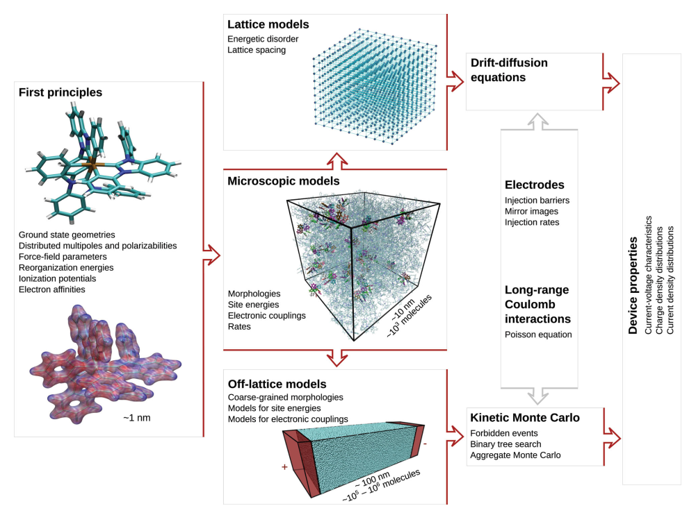
Fig. 1. A schematic of the multi-scale molecule-to-device simulation methodologies in disordered organic semiconductor devices to be used in this project. The picture is from Ref. [3].
Density functional theory. Gaussian and TURBOMOLE packages will be used to parameterize the
polarizable force fields and calculate the gas-phase ionization energies and electron affinities, as well as the electronic coupling elements in a given morphology.
Density of states (VOTCA-CTP, developed by Dr. D. Andrienko at MPIP-Mainz). This package will be used to calculate the DOS of the morphology including all electrostatic and induction contributions.
  - Mesoscopic modeling tools
3D Kinetic Monte Carlo simulation (VOTCA-CTP). This package will be used to calculate mesoscopic charge transport at the mesoscopic device scale. The electrical characteristics can be predicted. This method accounts for short-range Coulomb interaction between charge-carriers, but it is slow at low voltages.
3D Master Equation simulation (to be developed by me during this project). This tool has similar functions as the 3D Kinetic Monte Carlo tool in simulating the electrical characteristics of a device. But it is computationally efficient at low voltages. It accounts for Coulomb interactions in a mean-field way.
1D Drift-diffusion simulation. This is the fastest charge transport simulation tool. However, because it is a one-dimensional continuum simulation, it requires charge-carrier mobility functions as input from molecular-level simulations. It is not a fully predictive tool, but it can be used as a “fast check” of 3D solvers.

- Choice of the host institution

The project will be performed at the Theory Department at MPIP-Mainz, led by Prof. Kurt Kremer, who is a renowned scientist in multi-scale simulations of soft condensed matter systems. I will closely collaborate with Dr. Denis Andrienko and his group, who is developing computational techniques used for predictive simulation in organic electronics. He is one of the pioneers to discover that electrostatic and inductive properties of molecules are crucial for the description of mesoscopic properties of disordered organic semiconductors.^{[26],[30],[31]} This project will also have a strong link to the activities of the experimental group of Prof. Paul Blom, one of the leaders in investigating the physics of organic semiconductor devices. In particular, I will closely collaborate with Dr. Gert-Jan Wetzelaer, a group leader in Prof. Blom’s group, who will provide experimental measurements for the project.

- Work plan

Time Period Task
2 months | Studying the existing microscopic simulation techniques
6 months | Development of mesoscopic device simulation methodology (e.g. 3D master-equation simulation)
4 months | Calculation of microscopic properties as inputs for mesoscopic device simulation
4 months | Using mesoscopic device simulation tools for current density-voltage calculations, publication.
4 months | Understanding charge transport for multiple organic semiconductor systems from molecule to device, publication.
4 months | Investigation of electron injection and transport in disordered organic semiconductors, publication.

References
- “The Nobel Prize in Chemistry 2000”, Nobelprize.org. Nobel Media.
- OLED wikipedia page, https://en.wikipedia.org/wiki/OLED.
- P. Kordt, J. J. M. van der Holst, M. Al Helwi, W. Kowalsky, F. May, A. Badinski, C. Lennartz, and D. Andrienko, Adv. Funct. Mater. 25, 1955 (2015).
- V. Coropceanu, J. Cornil, D. A. da Silva Filho, Y. Olivier, R. Silbey, and J.-L. Brédas, Chem. Rev. 107, 926 (2007).
- J.-L. Brédas, J. E. Norton, J. Cornil, and V. Coropceanu, Acc. Chem. Res. 42, 1691 (2009).
- D. Beljonne and J. Cornil, Multiscale Modeling of Organic and Hybrid Photovoltaics, Springer (2014).
- D. Beljonne, J. Cornil, L. Muccioli, C. Zannoni, J.-L. Brédas, and F. Castet, Chem. Mater. 23, 591 (2011).
- A. Troisi, Chem. Soc. Rev. 40, 2347 (2011).
- D. Andrienko, Handbook of Materials Modeling (2018).
- A. Köhler and H. Bässler, Electronic Processes in Organic Semiconductors: An Introduction, Wiley (2015).
- M. Mesta, M. Carvelli, R. J. de Vries, H. van Eersel, J. J. M. van der Holst, M. Schober, M. Furno, B. Lüssem, K. Leo, P. Loebl, R. Coehoorn, and P. A. Bobbert, Nat. Mater. 12, 652 (2013).
- R. Coehoorn and P. A. Bobbert, Phys. Stat. Solidi A 209, 2354 (2012).
- N. Tessler, Y. Preezant, N. Rappaport, and Y. Roichman, Adv. Mater. 21, 2741 (2009).
- R. A. Marsh, C. Groves, and N. C. Greenham, J. Appl. Phys. 101, 083509 (2007).
- A. Massé, P. Friederich, F. Symalla, F. Liu, R. Nitsche, R. Coehoorn, W. Wenzel, and P. A. Bobbert, Phys. Rev. B 93, 195209 (2016).
- S. M. Sze, Physics of Semiconductor Devices (2nd ed.), John Wiley and Sons (WIE) (1981).
- V. I. Arkhipov, E. V. Emelianova, Y. H. Tak, and H. Bässler, J. App. Phys. 84, 848 (1998).
- M. A. Baldo and S. R. Forrest, Phys. Rev. B 64, 085201 (2001).
- B. N. Limketkai and M. A. Baldo, Phys. Rev. B 71, 085207 (2005).
- E. Tutiš, M.-N. Bussac, and L. Zuppiroli, Appl. Phys. Lett. 75, 3880 (1999).
- J. J. M. van der Holst, M. A. Uijttewaal, B. Ramachandhran, R. Coehoorn, P. A. Bobbert, G. A. de Wijs, and R. A. de Groot, Phys. Rev. B 79, 085203 (2009).
- F. Liu, H. van Eersel, B. Xu, J. G. E. Wilbers, M. P. de Jong, W. G. van der Wiel, P. A. Bobbert, and R. Coehoorn, Phys. Rev. B 96, 205203 (2017).
- N. B. Kotadiya, H. Lu, A. Mondal, Y. Ie, D. Andrienko, P. W. M. Blom, and G.-J. A. H. Wetzelaer, Nat. Mater. 17, 329 (2018).
- L. Schulz, L. Nuccio, M. Willis, P. Desai, P. Shakya, T. Kreouzis, V. K. Malik, C. Bernhard, F. L. Pratt, N. A. Morley, A. Suter, G. J. Nieuwenhuys, T. Prokscha, E. Morenzoni, W. P. Gillin, and A. J. Drew, Nat. Mater. 10, 252 (2011).
- I. H. Campbell and B. K. Crone, Appl. Phys. Lett. 101, 023301 (2012).
- F. May, B. Baumeier, C. Lennartz, and D. Andrienko, Phys. Rev. Lett. 109, 136401 (2012).
- A. Melianas, F. Etzold, T. J. Savenije, F. Laquai, O. Inganäs, and M. Kemerink, Nat. Commun. 6, 8778 (2015).
- A. Massé, R. Coehoorn, and P. A. Bobbert, Phys. Rev. Lett. 113, 116604 (2014).
- N. B. Kotadiya, A. Mondal, S. Xiong, P. W. M. Blom, D. Andrienko, and G.-J. A. H. Wetzelaer, Adv. Electron. Mater., 1800366 (2018).
- C. Poelking, M. Tietze, C. Elschner, S. Olthof, D. Hertel, B. Baumeier, F. Wuerthner, K. Meerholz, K. Leo, and D. Andrienko, Nat. Mater. 14, 434 (2015).
- M. Schwarze, W. Tress, B. Beyer, F. Gao, R. Scholz, C. Poelking, K. Ortstein, A. A. Guenther, D. Kasemann, D. Andrienko, and K. Leo, Science 352, 1446 (2016).

