Unraveling the physics of charge injection into disordered organic semiconductors through multi-scale simulation from molecule to device
Applicant | Dr. Feilong Liu
Host Institute | Max Planck Institute for Polymer Research, Mainz

- Introduction

The importance of organic electronics has been well-recognized by both academia and industry. On the scientific side, the 2000 Nobel Prize in Chemistry was awarded to A. J. Heeger, A. G. MacDiarmid, and H. Shirakawa jointly for their work on conductive polymers [1]. On the application side, manufacturers such as Samsung or LG have pushed the organic light-emitting diode (OLED) technology into large-scale production and viewed OLEDs as the next-generation display for smart phones [2]. In order for rational device design and optimization, it is crucial to understand the physics of charge-carrier dynamics, e.g., charge injection, transport, and recombination in organic semiconductor devices. However, this has been a challenging topic because the system is typically an ensemble of molecules packed in a disordered way. Microscopic methods such as quantum chemistry can be used to calculate charge transfer between a few molecules, but they are unable to describe the charge dynamics at the mesoscopic scale. Macroscopic continuum methods such as drift-diffusion can describe device-scale physics, but they typically involve empirical parameters and lack a direct linking to molecular properties. Because of the complexity in physics, advanced mesoscopic theoretical methods and simulation techniques have been developed in the past decade [3-7].
In order to maximize the efficiency of optoelectronic devices, an effective charge injection process from the metallic electrode into organic semiconductors is of vital importance. The physics of charge injection into conventional inorganic semiconductors have been well-understood, in the framework of Schottky metal- semiconductor contact, thermionic injection, and quantum tunneling [8]. However, for charge injection into amorphous organic semiconductors, more complicated physical processes are involved beyond a simple Schottky-contact theory. The electrons from electrode are injected into molecules, resulting in localized states in a random hopping network [9]. Interfacial dipoles between the electrode and organic semiconductor are observed experimentally which strongly modify the density of states (DOS) near the interface [10]. The modified DOS can then form an additional injection barrier even if the metallic work function is already in good alignment with HOMO or LUMO of the organic semiconductor [11]. The image charge effect due to injected charge carriers can also greatly modify the injection barrier [12,13]. The Coulomb interaction between different localized electrons can impede charge injection because the charge density near the electrode is high [14]. These effects can be observed at the device scale, but they are originated from the molecular and morphological properties. Therefore a systematic understanding cannot be achieved without using the advanced molecule-to-device simulation techniques.
Recently it has been shown experimentally that by inserting a thin interlayer between the electrode and organic semiconductor, charge injection efficiency can be significantly improved, leading to nearly-ideal Ohmic contacts [15]. Several different molecule combinations have been tested and the results are shown to be universal. The idea of a thin interlayer has been previously applied to the interfaces of organic semiconductor devices for controlling either the spintronic property [16] or the rates of charge-transfer states [17]. To understand the role of the interlayer here in Ref. [15], the authors showed that using macroscopic drift-diffusion simulations, an intrinsic effective hole injection barrier of approximately 0.4 eV is universally found even if the work function of the injecting electrode aligns well-below the HOMO of the organic semiconductor. When the thin interlayer is present, the injection becomes barrier-free. The authors also performed microscopic calculations using molecular dynamics/density functional theory showing that the DOS width is extended by interfacial dipoles near the interface while adding the interlayer decouples the dipolar effect between electrode and organic semiconductor.
Although the role of interlayer on charge injection has been partly explained, a complete understanding from molecule to device of the charge injection physics is not yet attained. For example, drift-diffusion modeling is a macroscopic approach, which neglects effects such as DOS broadening [18], carrier relaxation [19], percolation [20], and Coulomb correlation effects [14]. Therefore the extracted effective injection barrier value is lacking physical insight. Microscopic simulations at the molecular level can calculate DOS broadening, but it cannot directly calculate the current density-voltage characteristics. Moreover, the interface is assumed to be a flat surface. However, as the interlayer is only a few nanometers thick, the interfacial roughness is expected to play a role. It is thus a demand to develop advanced simulation methodologies such as the 3D master-equation method, linking directly the molecular information to the device electrical characteristics. As the next step, the advanced simulation tools can be used to unravel the physics of charge injection, aiming at a systematic understanding from molecule to device.

- Aims

The goal of this project is to understand the physics of charge injection from electrode to disordered organic semiconductors to the next level. We aim at a complete understanding from the molecular properties to the device performance, and a quantitative explanation to the recent experimental results [15]. We try to fully understand the reason why a thin interlayer can efficiently improve charge injection [15]. As the next step, we also try to understand and predict the charge transport in organic semiconductor devices with ideal Ohmic injection from molecule to device. To achieve the goals, we divide the project into following steps.
- Acquiring expertise of existing methodology and development of new methodology
  - Studying the existing microscopic simulation techniques
I will study the existing microscopic molecular-level simulation tools in the group, such as the molecular dynamics simulation, density functional theory calculation, DOS distribution calculation including dipoles and polarizations, etc.
  - Development of mesoscopic device simulation methodology
For mesoscopic device simulation, I will study the 3D kinetic Monte Carlo simulation tools developed by the group. I will also develop the 3D master equation method for charge transport simulation, including both lattice and off-lattice cases.
- Application to the charge injection physics
  - Calculation of microscopic properties as inputs for mesoscopic device simulation
I will use the microscopic simulation techniques to calculate the system investigated in Ref. [15]. The core properties of interest are the DOS distribution with and without the injection interlayer, the electronic coupling between the molecules, and the molecular reorganization energy, etc.
  - Using mesoscopic device simulation tools for current density-voltage calculations
I will calculate the current density-voltage characteristics for the material systems investigated in Ref. [15], with and without the injection interlayer, directly using advanced 3D simulation tools including microscopic input from the molecular level, and compare with experimental results. We aim at successful prediction of experimental results and a multi-scale understanding of the charge injection process.
- Understanding charge transport for multiple organic semiconductor systems from molecule to device
After we fully understand the charge injection process, we can study the charge transport properties of several representative disordered organic semiconductors with Ohmic injection. The analysis will be based on experimentally obtained electrical characteristics of unipolar organic semiconductor devices. A recent work for hole transport in several representative molecules has been performed [21]. However, the work in Ref. [21] still uses an indirect approach (combining macroscopic drift-diffusion simulation with parametrized functions representing molecular information). I will study existing and potentially more species of relevant molecules using fully predictive simulation for the charge transport properties.
- Investigation of electron injection and transport in disordered organic semiconductors
The research above is all about hole injection and transport. For the electron injection and transport, it is another nontrivial topic because the electron DOS typically contains exponential traps while hole DOS is usually trap-free. I will collaborate with experimental groups and use the above theoretical techniques to understand the electron injection and transport, especially the effect of molecular dipoles and polarization.

- Methodology

In the past 9 years I have been working in theory and simulation of organic electronics. During my PhD in US, I was involved in several research projects such as the drift-diffusion modeling for OLEDs and OPVs (organic photovoltaic cells), percolation and MTR (multiple trapping and release) modeling for OFETs (organic field-effect transistors), theory of magnetic-field-modulated electroluminescence in OLEDs, and organic spintronics. During my first postdoc in Netherland, I worked on multi-scale modeling and simulation of disordered organic semiconductors. I developed an off-lattice 3D master-equation technique for a full 3D
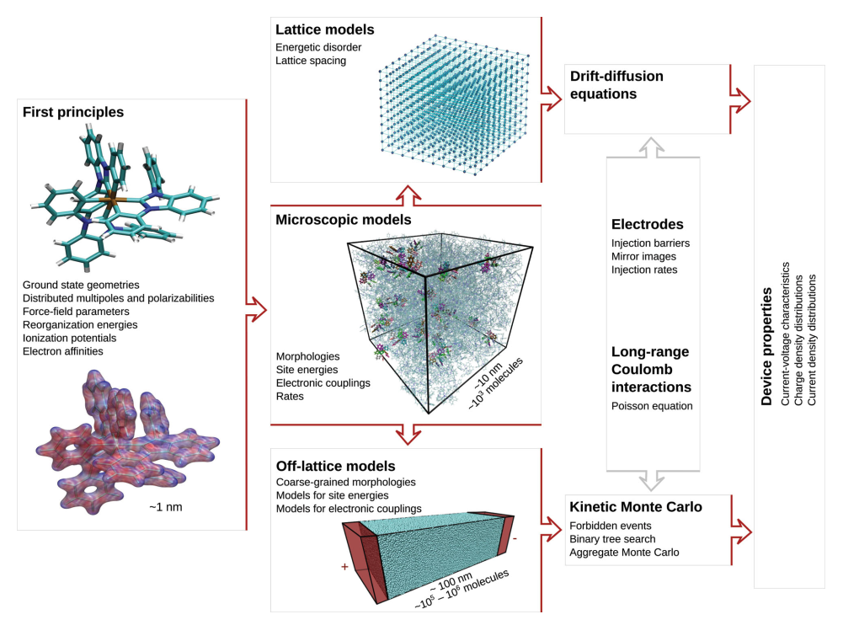
Fig. 1. A schematic of the multi-scale molecule-to-device simulation methodologies in disordered organic semiconductor devices to be used in this project. The picture is from Ref. [3].
parameter-free simulation from molecule to device predicting DC and AC electrical characteristics for hole-transporting devices. I also developed a bipolar master-equation technique for computationally efficient simulation of bipolar charge-carrier transport and recombination. By using both master-equation and kinetic Monte Carlo simulation approach, I investigated systematically the Coulomb correlation effect between charge-carriers. As the next step in my career, I plan to step in more on the molecular side, in order to obtain a full picture of understanding in organic semiconductor devices. As shown in Fig. 1, in this project, the following computational methodologies will be used.
  - Microscopic modeling tools
Molecular dynamics tool (e.g. GROMACS). This tool will be used to generate the morphology (spatial distribution and electrostatics) of the system under investigation.
Density functional theory tool (e.g. Gaussian). This tool will be used to calculate the energies (HOMO/LUMO) of the molecules in a given morphology.
Density of states tool (VOTCA-CTP, developed by Dr. D. Andrienko at MPIP-Mainz). This tool will be used to calculate the DOS of the morphology including all electrostatic and induction contributions.
  - Mesoscopic modeling tools
3D Kinetic Monte Carlo simulation (VOTCA-CTP). This tool will be used to calculate mesoscopic charge transport at the mesoscopic device scale. The electrical characteristics can be predicted. This method accounts for short-range Coulomb interaction between charge-carriers, but it is slow at low voltages.
3D Master Equation simulation (to be developed by me during this project). This tool has similar functions as the 3D Kinetic Monte Carlo tool in simulating the electrical characteristics of a device. But it is computationally efficient at low voltages. It takes the short-range Coulomb interaction in a mean-field way.
1D Drift-diffusion simulation. This tool is the fastest charge transport simulation tool. However, because it is a one-dimensional continuum simulation, it needs parametrized charge-carrier mobility functions as input from molecular-level simulations. It is not a fully predictive tool, but it can be used as a “fast check” during the work flow.

- Choice of the host institution

The project will be performed at the Theory Department at MPIP-Mainz, led by Prof. Kurt Kremer, who is a globally renowned scientist in theoretical physics and multi-scale simulation of molecular systems. I will closely collaborate with Dr. Denis Andrienko in this group, who has been developing and applying the molecule-to-device theoretical tool VOTCA for predictive simulation in organic electronics. Especially, he is one of the pioneers to discover that electrostatic and inductive properties of molecules play crucial roles on mesoscopic properties of disordered organic semiconductor devices [18,22,23]. This project will be conducted also in close collaboration with the experimental group of Prof. Paul Blom and Dr. Gert-Jan Wetzelaer at MPIP-Mainz. Prof. Paul Blom has been one of the leaders in investigating the physics of organic semiconductor devices combining both experimental and theoretical approaches.

- Work plan

Time Period Task
2 months | Aim 1.1. Studying the existing microscopic simulation techniques
6 months | Aim 1.2. Development of mesoscopic device simulation methodology (e.g. 3D master- equation simulation)
4 months | Aim 2.1. Calculation of microscopic properties as inputs for mesoscopic device simulation
4 months | Aim 2.2. Using mesoscopic device simulation tools for current density-voltage calculations, publication.
4 months | Aim 3. Understanding charge transport for multiple organic semiconductor systems from molecule to device, publication.
4 months | Aim 4. Investigation of electron injection and transport in disordered organic semiconductors, publication.

References
- “The Nobel Prize in Chemistry 2000”, Nobelprize.org. Nobel Media.
- OLED wikipedia page, https://en.wikipedia.org/wiki/OLED.
- P. Kordt, J. J. M. van der Holst, M. Al Helwi, W. Kowalsky, F. May, A. Badinski, C. Lennartz, and D. Andrienko, Adv. Funct. Mater. 25, 1955 (2015).
- D. Andrienko, Handbook of Materials Modeling (2018).
- M. Mesta, M. Carvelli, R. J. de Vries, H. van Eersel, J. J. M. van der Holst, M. Schober, M. Furno, B. Lüssem, K. Leo, P. Loebl, R. Coehoorn, and P. A. Bobbert, Nat. Mater. 12, 652 (2013).
- R. Coehoorn and P. A. Bobbert, Phys. Stat. Solidi A 209, 2354 (2012).
- A. Massé, P. Friederich, F. Symalla, F. Liu, R. Nitsche, R. Coehoorn, W. Wenzel, and P. A. Bobbert, Phys. Rev. B 93, 195209 (2016).
- S. M. Sze, Physics of Semiconductor Devices (2nd ed.), John Wiley and Sons (WIE), (1981).
- V. I. Arkhipov, E. V. Emelianova, Y. H. Tak, and H. Bässler, J. App. Phys. 84, 848 (1998).
- M. A. Baldo and S. R. Forrest, Phys. Rev. B 64, 085201 (2001).
- B. N. Limketkai and M. A. Baldo, Phys. Rev. B 71, 085207 (2005).
- E. Tutiš, M.-N. Bussac, and L. Zuppiroli, Appl. Phys. Lett. 75, 3880 (1999).
- J. J. M. van der Holst, M. A. Uijttewaal, B. Ramachandhran, R. Coehoorn, P. A. Bobbert, G. A. de Wijs, and R. A. de Groot, Phys. Rev. B 79, 085203 (2009).
- F. Liu, H. van Eersel, B. Xu, J. G. E. Wilbers, M. P. de Jong, W. G. van der Wiel, P. A. Bobbert, and R. Coehoorn, Phys. Rev. B 96, 205203 (2017).
- N. B. Kotadiya, H. Lu, A. Mondal, Y. Ie, D. Andrienko, P. W. M. Blom, and G.-J. A. H. Wetzelaer, Nat. Mater. 17, 329 (2018).
- L. Schulz, L. Nuccio, M. Willis, P. Desai, P. Shakya, T. Kreouzis, V. K. Malik, C. Bernhard, F. L. Pratt, N. A. Morley, A. Suter, G. J. Nieuwenhuys, T. Prokscha, E. Morenzoni, W. P. Gillin, and A. J. Drew, Nat. Mater. 10, 252 (2011).
- I. H. Campbell and B. K. Crone, Appl. Phys. Lett. 101, 023301 (2012).
- F. May, B. Baumeier, C. Lennartz, and D. Andrienko, Phys. Rev. Lett. 109, 136401 (2012).
- A. Melianas, F. Etzold, T. J. Savenije, F. Laquai, O. Inganäs, and M. Kemerink, Nat. Commun. 6, 8778 (2015).
- A. Massé, R. Coehoorn, and P. A. Bobbert, Phys. Rev. Lett. 113, 116604 (2014).
- N. B. Kotadiya, A. Mondal, S. Xiong, P. W. M. Blom, D. Andrienko, and G.-J. A. H. Wetzelaer, Adv. Electron. Mater., 1800366 (2018).
- C. Poelking, M. Tietze, C. Elschner, S. Olthof, D. Hertel, B. Baumeier, F. Wuerthner, K. Meerholz, K. Leo, and D. Andrienko, Nat. Mater. 14, 434 (2015).
- M. Schwarze, W. Tress, B. Beyer, F. Gao, R. Scholz, C. Poelking, K. Ortstein, A. A. Guenther, D. Kasemann, D. Andrienko, and K. Leo, Science 352, 1446 (2016).

