Make l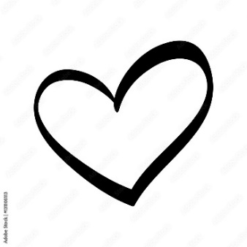ve.

Not babies.

Antinatalismus.