**RNS Institute of Technology, Bengaluru**

**Department of Computer Science and Engineering**

**Project Proposal for Kannada and Culture Department, Govt. of Karnataka**

***Title: SimplerMaps an android app***

# **Preamble**

The current most popular navigation app is Google Maps. Even after being so popular and widely used, it lacks a simple UI. The current Google Maps UI is cluttered with various functions and features that most people who aren’t tech-savvy don’t need or use at all. In turn it complicates and intimidates possible users from using the app at all.

# **Current Technology Limitations**

The current technology being widely used for navigation purpose is Google Maps. With its enormous advantages, it also has certain disadvantages

* **Language Restrictions:** Even though the places shown in the Google Maps have the local language(Kannada) translation, but the labels and text-views involved in the app are restricted to English only.
* **Complex UI:** Google Maps has a very complex UI which can be overwhelming and intimidating for a non-tech-savvy user.

# **Proposed Platform**

The app we are developing, SimplerMaps provides an easy to understand UI which makes the purpose of navigation as simple as possible.

# **Block Diagram**

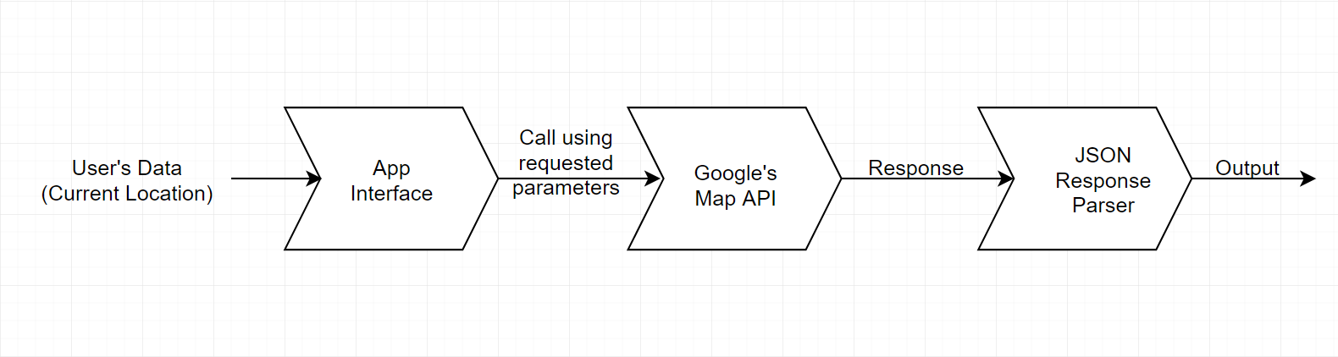

# **Objective**

* To eradicate language barriers by providing translations in local language for user’s convenience for interaction with the app.
* To provide elegant yet minimal UI to simplify user’s experience.
* To keep all the significant functionalities provided by current technologies intact.

**Target Audience**

SimplerMaps aims to target elderly or lesser tech-savvy demographic. Since it has an easy to use UI, it is expected to not intimidate new users for the purpose of navigation.

## **Functional Requirements**

1. Google Maps Android API
2. Google Places API for Android

# **Scalability**

Support can be extended to other local regional languages also.

## **Hardware Requirements**

* RAM: 8+ GB
* Disk Space: 10+ GB
* Screen Resolution: 1280 x 800

## Software Requirements

* Android Studio
* Android SDK
* Java Development Kit

**Project Associates:**

Shivam Nagpal (1RN16CS098), 7406532307

Yash Vora (1RN16CS123)

Vivek Kumar Singh(1RN16CS121)

**Supervision by:**

**Dr. G T Raju**, Professor and Head, Dept. of CSE, RNS Institute Technology,Bengaluru – 98, 9448308345, gtraju1990@yahoo.com