SimplerMaps an android app

# Preamble

The current most popular navigation app is Google Maps. Even after being so popular and widely used, it lacks a simple UI. The current Google Maps UI is cluttered with various functions and features that most people who aren’t tech-savvy don’t need or use at all. In turn it complicates and intimidates possible users from using the app at all.

# Current Technology Limitations

The current technology being widely used for navigation purpose is Google Maps. With its enormous advantages, it also has certain disadvantages

* **Language Restrictions:** Even though the places shown in the Google Maps have the local language(Kannada) translation, but the labels and text-views involved in the app are restricted to English only.
* **Complex UI:** Google Maps has a very complex UI which can be overwhelming and intimidating for a non-tech-savvy user.

# Proposed Platform

The app we are developing, SimplerMaps provides an easy to understand UI which makes the purpose of navigation as simple as possible.

# Objective

* To eradicate language barriers by providing translations in local language for user’s convenience for interaction with the app.
* To provide elegant yet minimal UI to simplify user’s experience.
* To keep all the significant functionalities provided by current technologies intact.

Target Audience

SimplerMaps aims to target elderly or lesser tech-savvy demographic. Since it has an easy to use UI, it is expected to not intimidate new users for the purpose of navigation.

## Functional Requirements

1. Google Maps Android API
2. Google Places API for Android

# Scalability

Support can be extended to other local regional languages also.

# Block Diagram

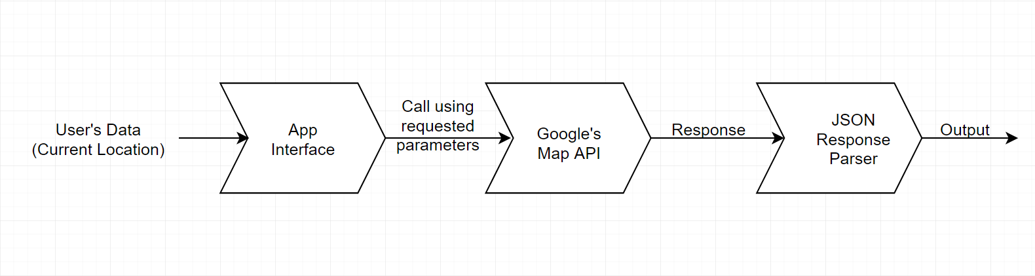

## Hardware Requirements

* RAM: 8+ GB
* Disk Space: 10+ GB
* Screen Resolution: 1280 x 800

## Software Requirements

* Android Studio
* Android SDK
* Java Development Kit