Thrust Stand — Complete Build Guide
Project Icarus | Options A / B / C | v6 — April 2026
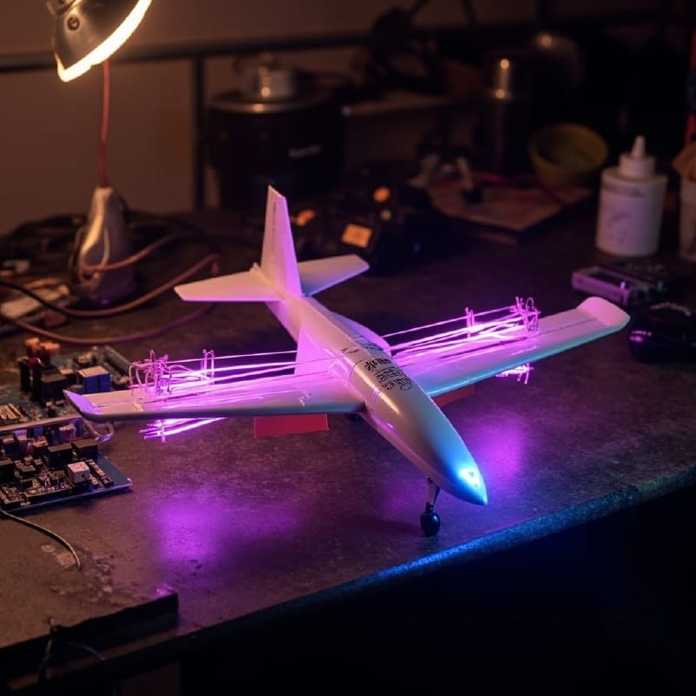
Project Icarus — Ion Wind Aircraft

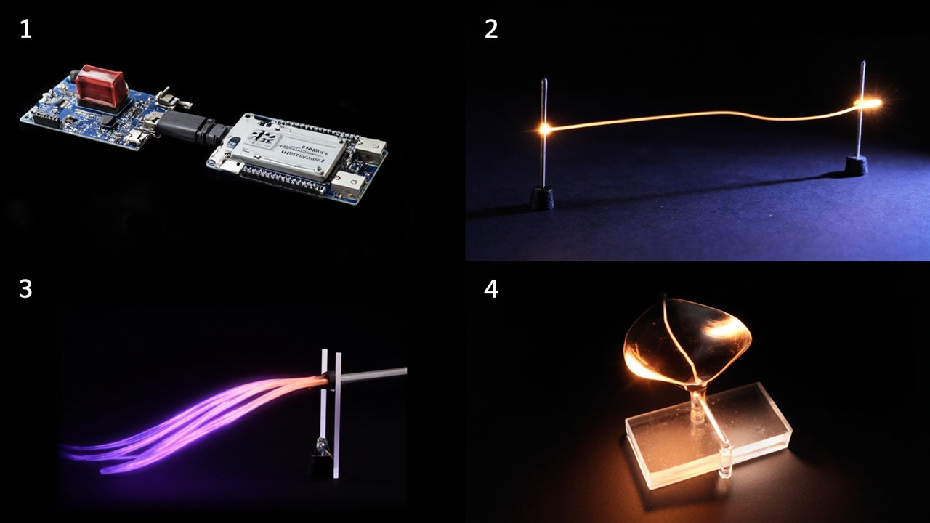
Fig 1 — ZVS Flyback Module

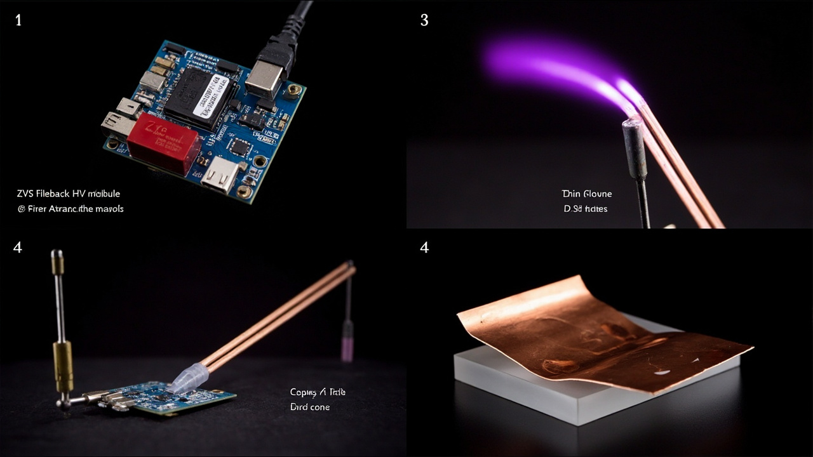
Fig 2 — Arduino Nano Every

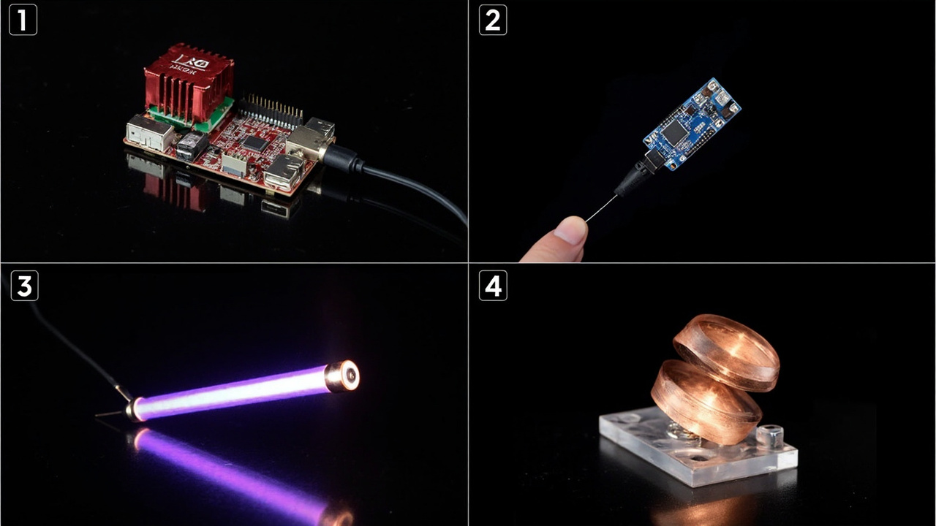
Fig 3 — Emitter wire with corona glow

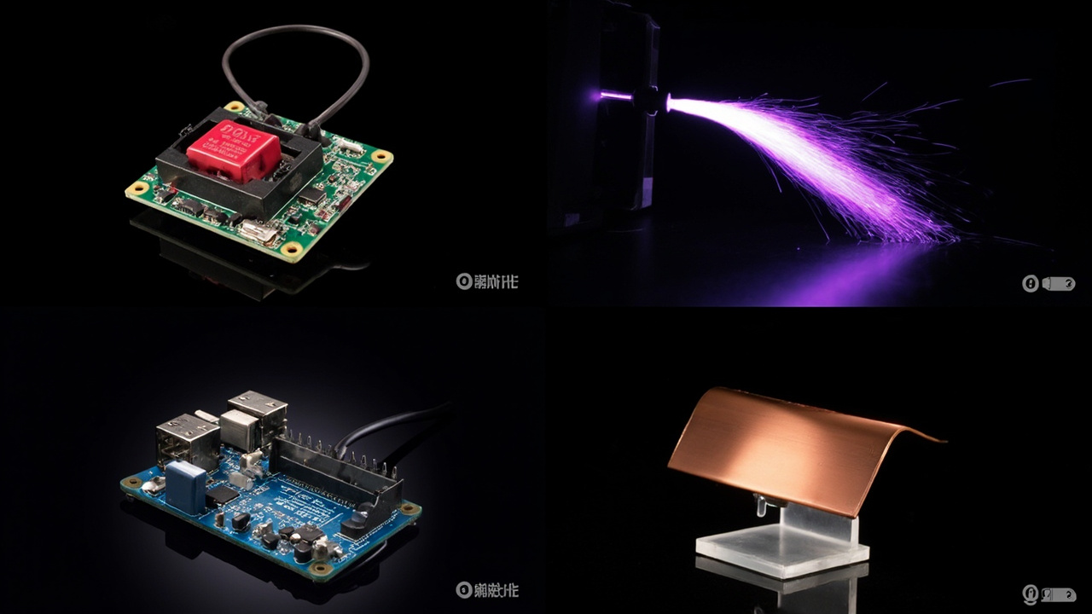
Fig 4 — NACA airfoil collector foil

Configuration Options
Option | Collector | Gap | Thrust | Cost
A (Starter) | NACA airfoil | 20mm | 169 mN | ~EUR64
B (Tandem) | NACA + tandem ducted | 8mm | 1627 mN | ~EUR80
C (+Steel Wool) | Wire-to-mesh + steel wool | 20mm | 234 mN | ~EUR69

WARNING: This system generates 20-50kV. Never touch the HV wires when powered. CORONA = soft violet glow (good). ARCING = bright white sparks (bad). Increase gap or reduce voltage if arcing occurs.

PART 1: Bill of Materials (BOM)
Component | Supplier | Price
ZVS Flyback Module | reichelt.de / Amazon | EUR10
Arduino Nano Every | reichelt.de | EUR10
Stainless wire 0.1mm x10m | Amazon.de | EUR6
Copper foil 0.05mm x5m | Amazon.de | EUR12
Acrylic sheet 3mm 20x30cm | Amazon.de / OBI | EUR10
M3 threaded rod + nuts | Amazon.de | EUR6
HX711 + Load Cell 5kg | Amazon.de | EUR12
Resistors 10M + 1M | Amazon.de / reichelt | EUR1
18650 holder x2 + batteries | Amazon.de | EUR8
Aluminum mesh + steel wool | Supermarket | EUR5

PART 2: Know Your Components

2.1 ZVS Flyback Module

Fig — 2.1 ZVS Flyback Module

4 terminals: 2 input (VCC+/GND-) and 2 HV output (HV+/HV-). Takes 5-12V DC, outputs 20-50kV AC.

2.2 Arduino Nano Every

Fig — 2.2 Arduino Nano Every

A0=HV divider reading, GND=common ground, 5V=power. Connect to PC via USB-mini.

2.3 Emitter Wire

Fig — 2.3 Emitter Wire

Very thin wire (0.1-0.2mm). Thinner = lower onset voltage. Stainless steel 0.1mm = most practical.

2.4 Collector Foil

Fig — 2.4 Collector Foil

Copper or aluminum, smooth, no sharp edges. Sharp edges = arcing instead of corona.

PART 3: Step-by-Step Assembly

STEP 1: Identify ZVS terminals
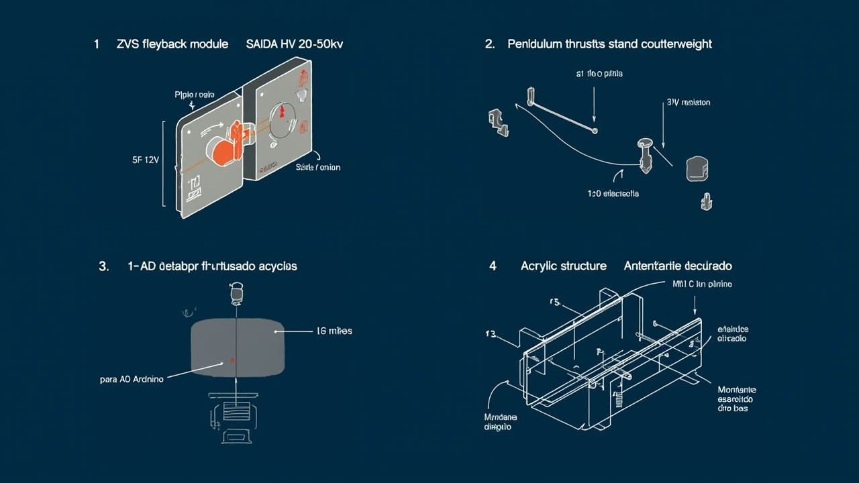
Fig — STEP 1: Identify ZVS terminals

INPUT: 2 small terminals — GND (ground) and VCC (5-12V positive)
HV OUTPUT: 2 large terminals — HV+ and HV-
The HV output wires go directly to the electrodes — DO NOT touch when powered!

STEP 2: Connect ZVS to power supply
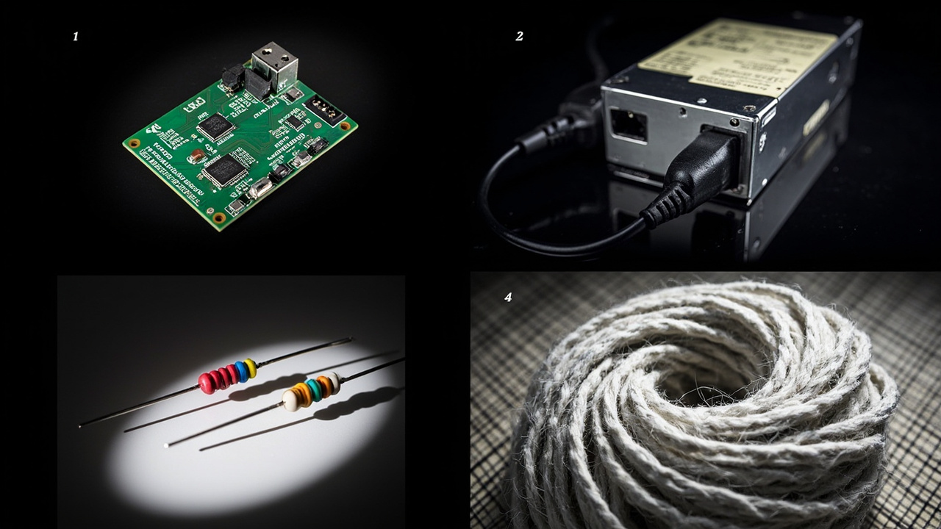
Fig — STEP 2: Connect ZVS to power supply

1. Connect ZVS VCC to positive of power supply (red wire of 18650 holder)
2. Connect ZVS GND to negative/ground of power supply (black wire)
3. Turn on power — a high-pitched hum = ZVS is working
4. If module gets hot >50C, turn off immediately — check polarity

STEP 3: Mount acrylic structure
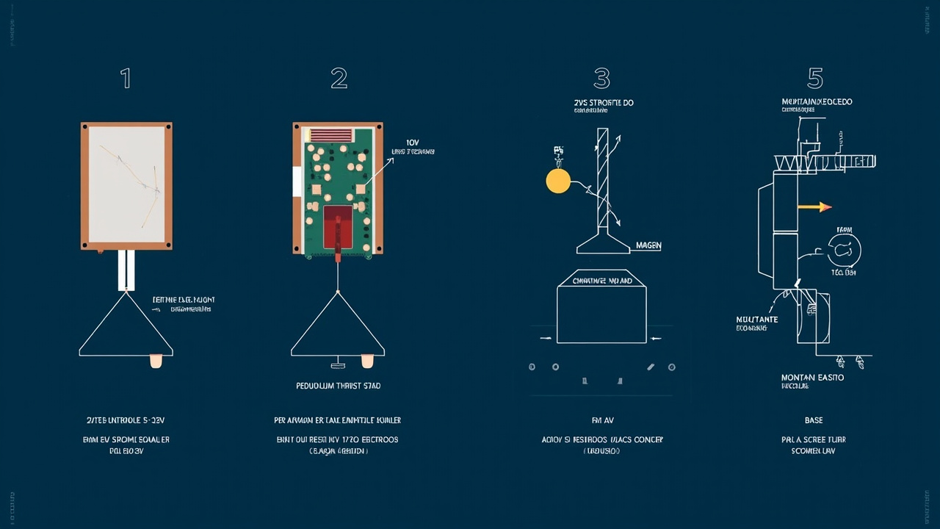
Fig — STEP 3: Mount acrylic structure

1. Cut acrylic: 2x 15cmx3cm (vertical posts) + 2x 20cmx3cm (top and base)
2. Drill 4x 3mm holes in each post (for M3 screws)
3. Assemble sandwich: base + left post + spacers + right post + base
4. Do NOT overtighten — you need to adjust the gap later

STEP 4: Stretch emitter wire
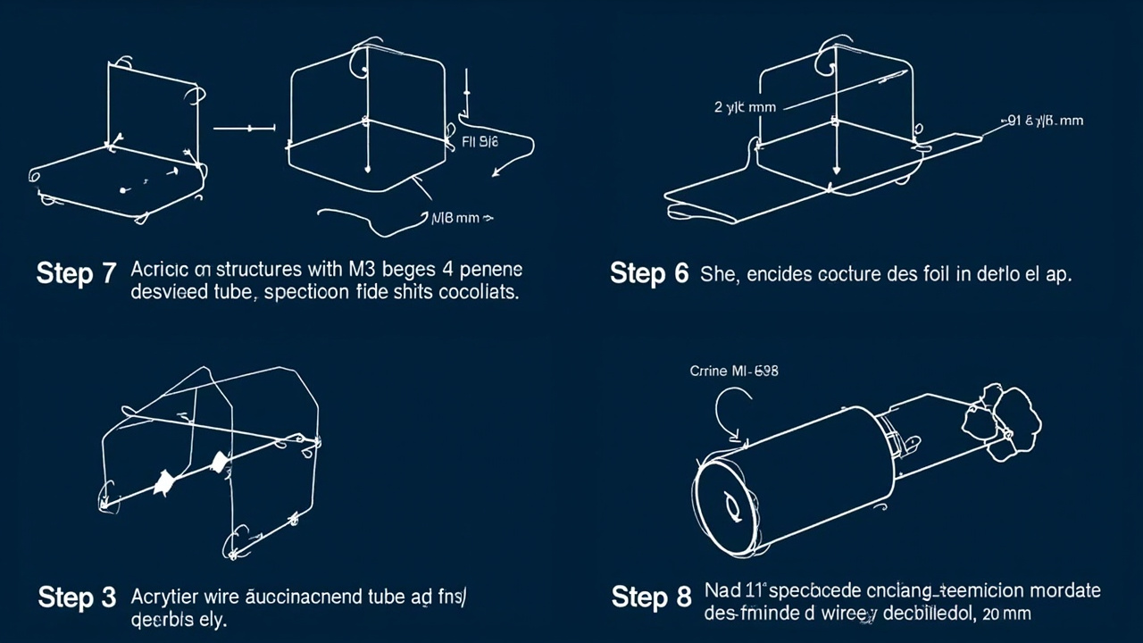
Fig — STEP 4: Stretch emitter wire

1. Thread 0.1mm wire between the two posts, centered
2. Stretch until taut like a guitar string — but not to the point of snapping
3. Wire must not touch anything, completely stretched and straight
4. Secure with electrical tape at the ends — do NOT use anything conductive

STEP 5: Mount collector foil (Option A)
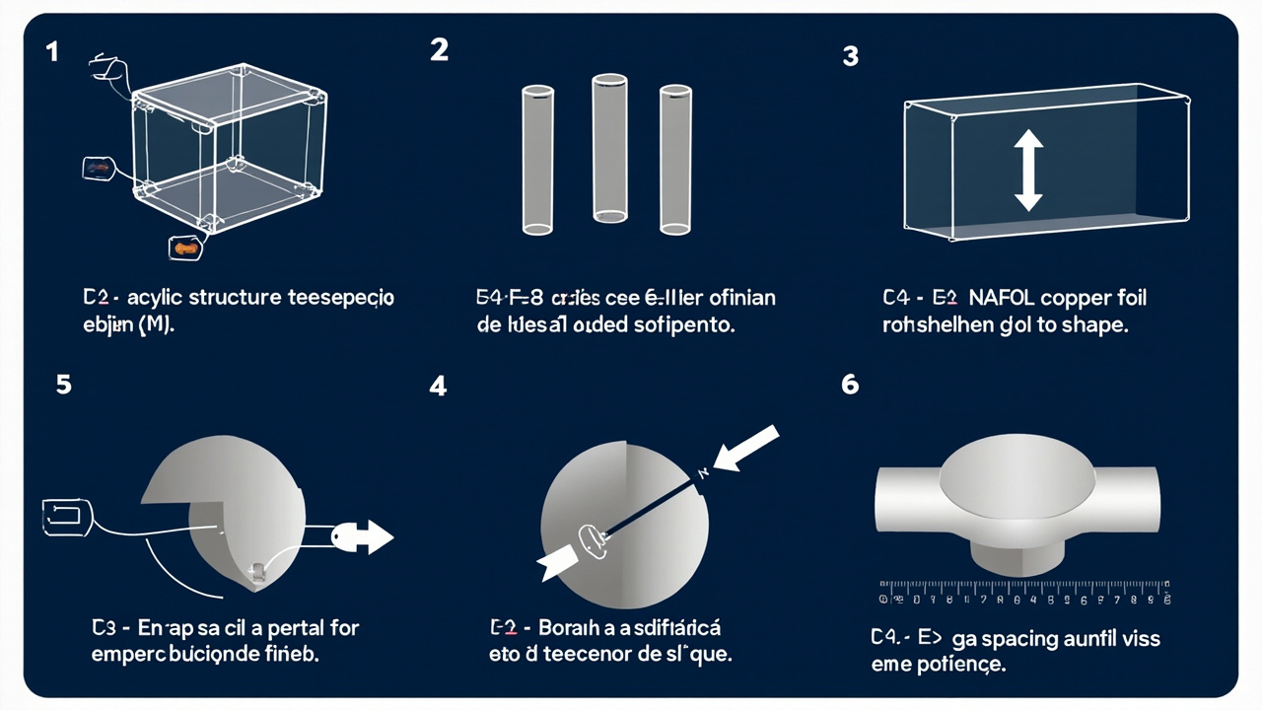
Fig — STEP 5: Mount collector foil (Option A)

1. Cut copper/aluminum strip ~2cm wide x 15cm long
2. Shape around a tube/cylinder to form an airfoil curve
3. Place collector parallel to the emitter wire
4. Gap: 20mm initial (adjust later based on results)

STEP 5C: Wire-to-mesh + Steel Wool (Option C)
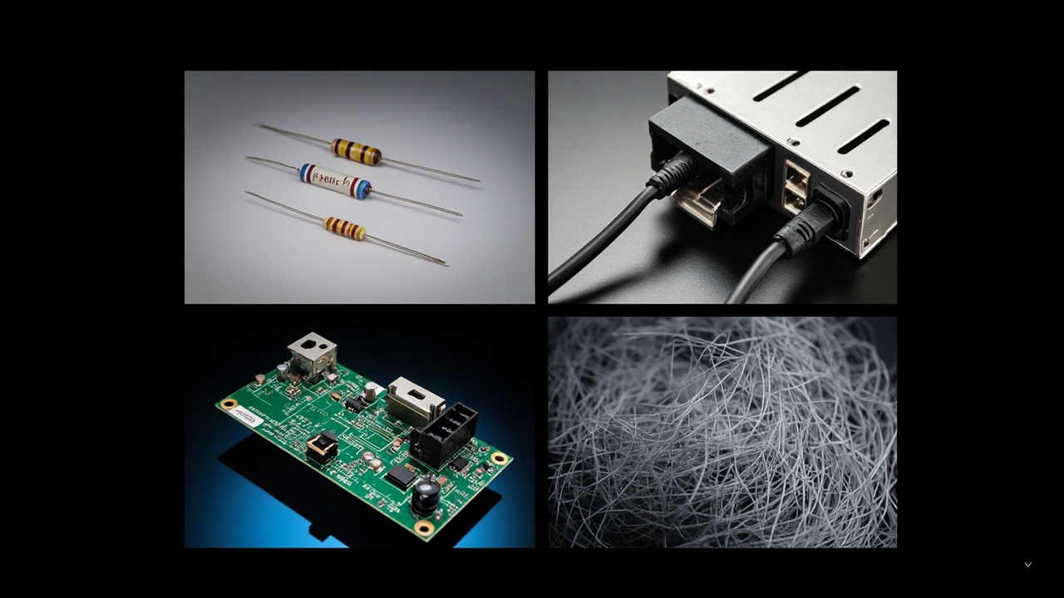
Fig — STEP 5C: Wire-to-mesh + Steel Wool (Option C)

1. Cut aluminum mesh ~5cm x 50cm (mosquito net type)
2. Stretch mesh over acrylic — stays flat but with texture (visible holes)
3. Cut steel wool #0000 or #00 (~5cm x 50cm)
4. Place steel wool ON TOP of the mesh — it stays suspended and makes electrical contact with the mesh
5. Connect mesh+steel wool to HV- wire (ground/cathode)
6. 3D texture = ~1.8x more thrust
7. Gap: 20mm (same safe as Option A)

STEP 6: Verify gap
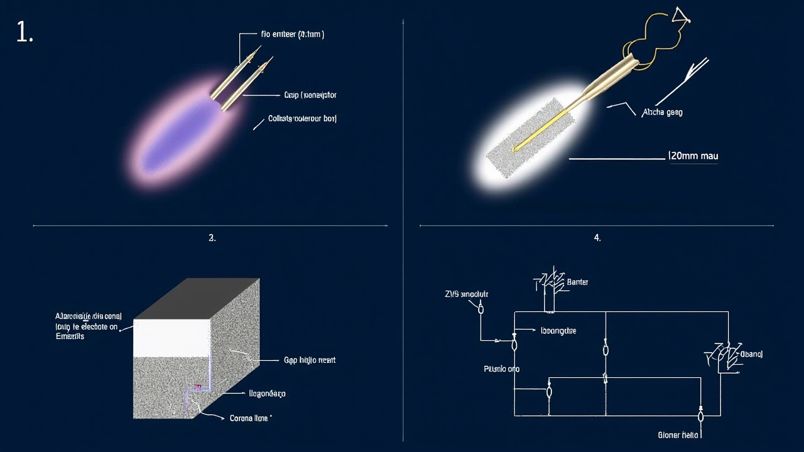
Fig — STEP 6: Verify gap

1. Use a ruler or caliper to measure the gap
2. Gap < 15mm = ARCING (sparks) instead of corona
3. Gap > 40mm = very weak thrust
4. 20mm = optimal starting point at 35kV
CORRECT: soft violet glow. WRONG: bright sparks = increase gap!

STEP 7: Connect HV wires
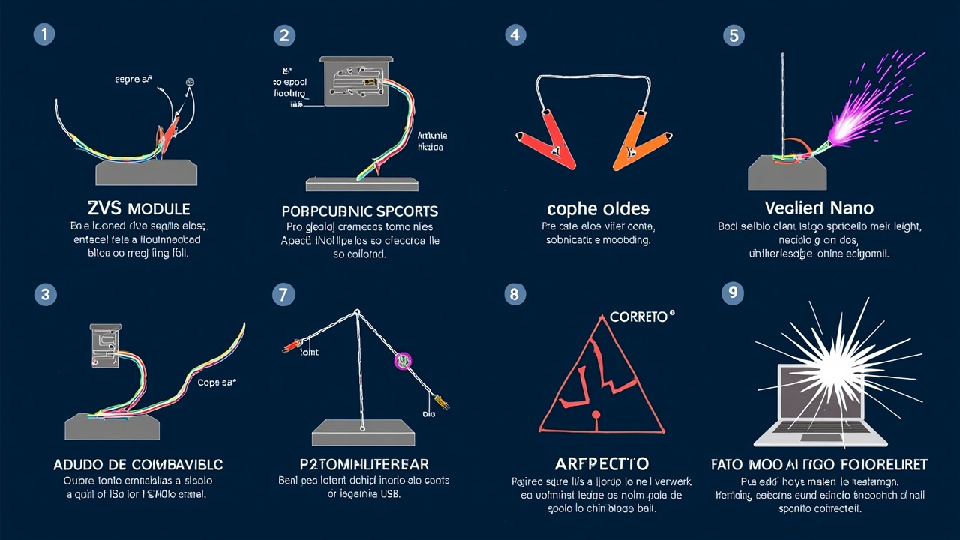
Fig — STEP 7: Connect HV wires

1. HV+ (ZVS) → emitter wire (anode/positive)
2. HV- (ZVS) → collector foil (cathode/negative)
3. Use flexible copper wire, good solder joint — bad connection = arcing

STEP 8: Mount HV voltage divider
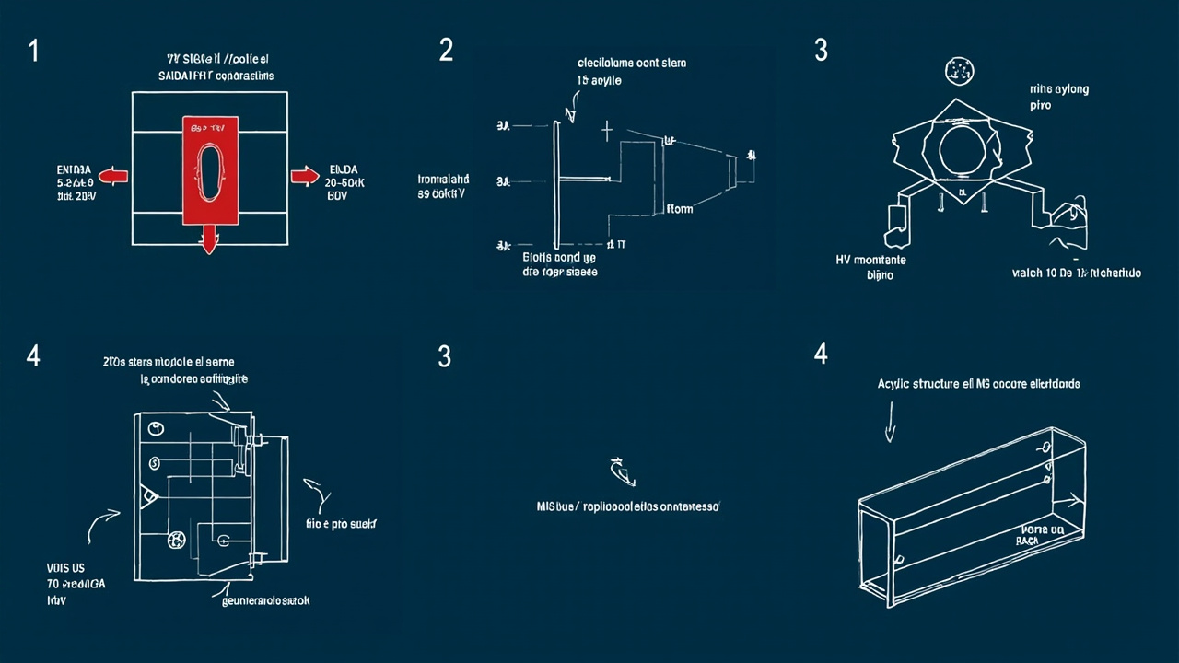
Fig — STEP 8: Mount HV voltage divider

1. Resistor 10M: connect to one HV output wire
2. Resistor 1M: connect in series (other side of 10M to the other HV wire)
3. Junction point (where the two resistors meet) → Arduino pin A0
4. Voltage at junction = Total HV Voltage / 11 (ex: 2.7V reading = ~30kV real)

STEP 9: Mount pendulum
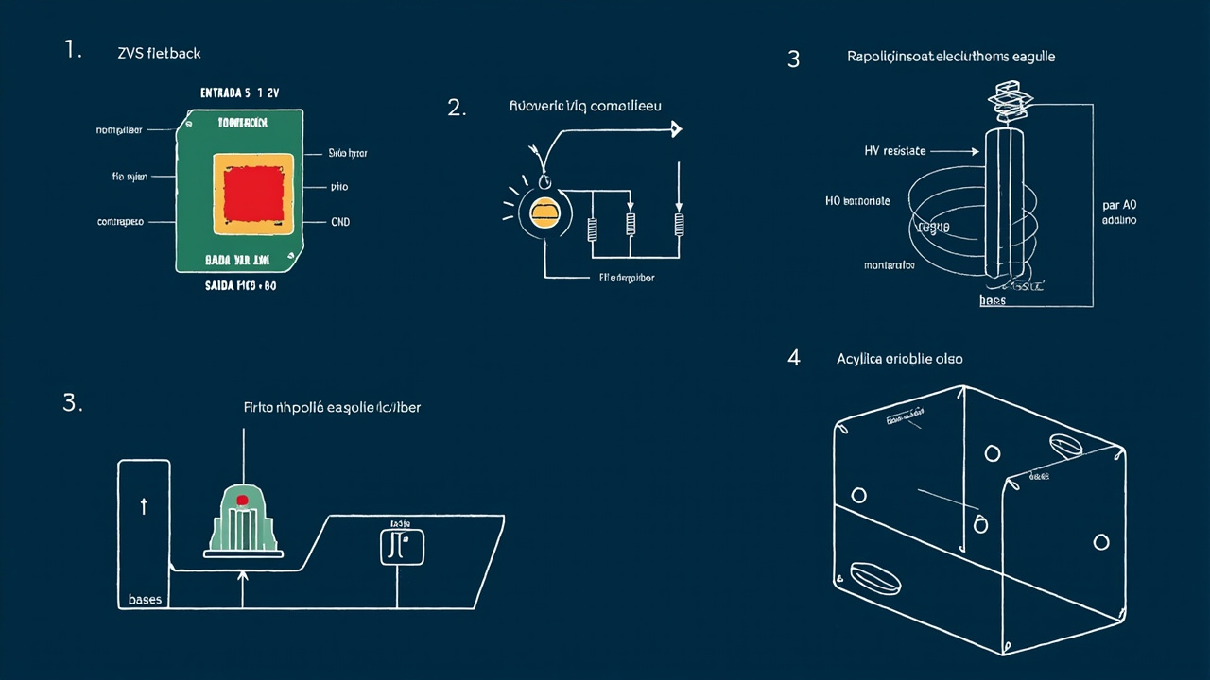
Fig — STEP 9: Mount pendulum

1. Tie nylon string/cord (20-30cm) to the top of the electrode structure
2. Hang from a pivot (pencil across two tables, or a nail in a wall)
3. Pendulum must swing freely in a horizontal plane
4. Electrode deflects toward the collector when HV is on

STEP 10: Calibrate pendulum with known weights
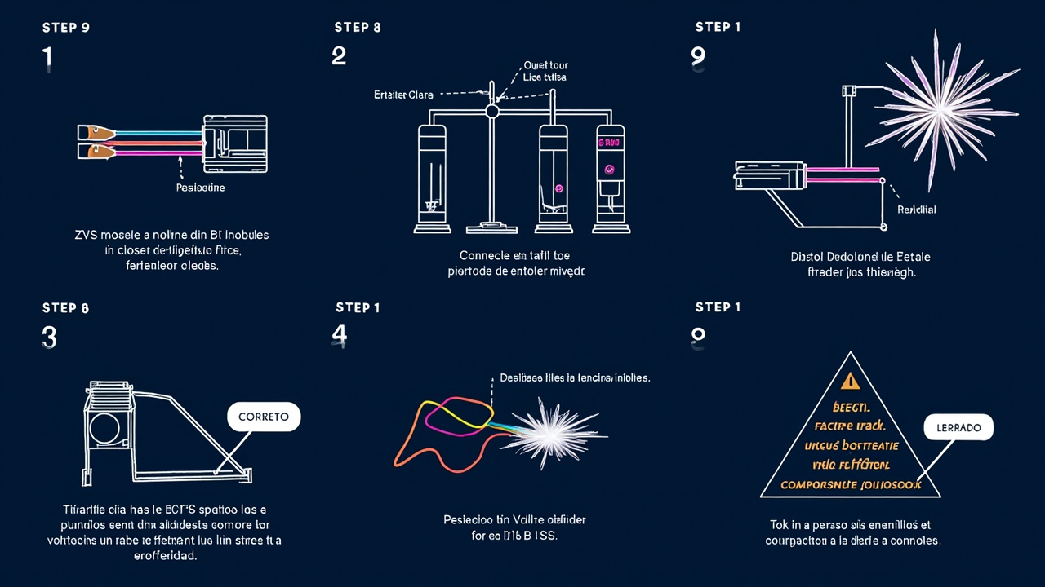
Fig — STEP 10: Calibrate pendulum with known weights

1. With HV OFF, hang known weights (M3 nuts ~1.5g each) on the pendulum string
2. Measure deflection for each weight:
- 0 = 0mm
- 1x M3 nut (~1.5g) = ~3mm
- 5x M3 nuts (~7.5g) = ~15mm
3. Save this table — you will use it to calculate real thrust

STEP 11: Connect Arduino
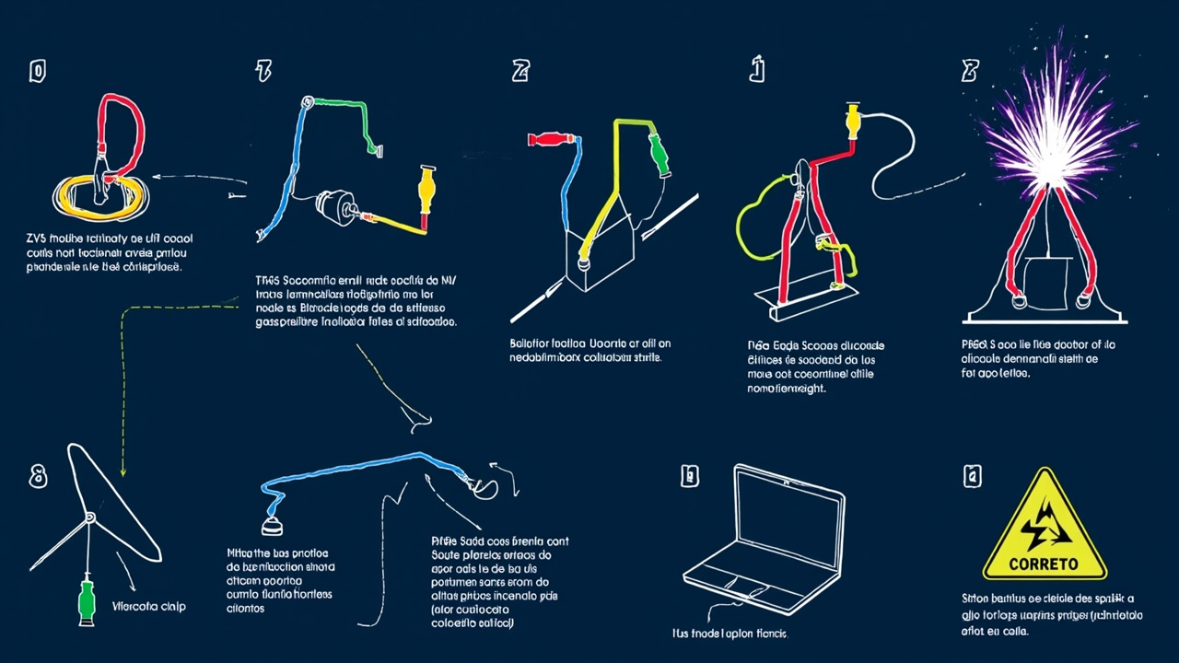
Fig — STEP 11: Connect Arduino

1. Divider junction point → Arduino pin A0
2. Arduino GND → ZVS GND (common ground)
3. Arduino → PC USB. Open Arduino IDE, Serial Monitor at 9600 baud.
Code:
void setup(){Serial.begin(9600);}
void loop(){
int raw=analogRead(A0);
float kV=raw*11.0/1023.0;
Serial.print("HV: ");Serial.print(kV,1);Serial.println(" kV");
delay(500);
}

STEP 12: First HV test
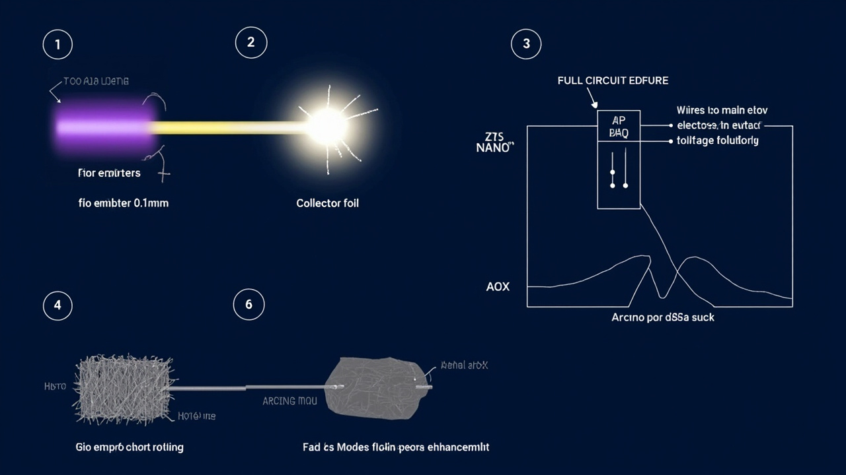
Fig — STEP 12: First HV test

1. Turn on ZVS, increase voltage slowly
2. Watch the pendulum — it starts deflecting toward the collector
3. Record: HV voltage (kV), maximum deflection (mm), anything unusual
4. CORONA = soft violet glow (good)
5. ARCING = bright white/blue sparks + loud hum = increase gap or reduce voltage

STEP 13: Calculate real thrust (mN)
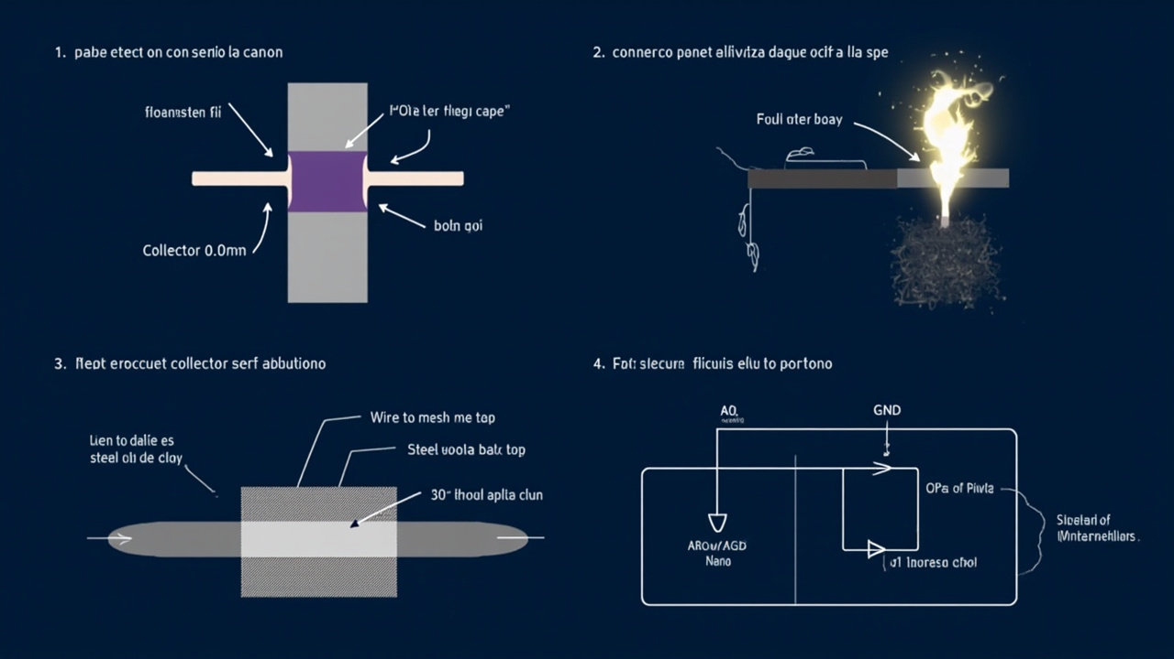
Fig — STEP 13: Calculate real thrust (mN)

Formula: Thrust(mN) = (deflection_mm/1000) x (weight_g x 9.81) x (L_gap/L_pendulum)

Example: L_pendulum=250mm, deflection=5mm, weight=50g:
Thrust = (5/1000)x(50x9.81)x(25/250) = 1.2 mN

PART 4: Suppliers
Supplier | Products | Notes
reichelt.de | Electronics, Arduino, HX711 | Best for electronics. EUR5.90 DE shipping.
Amazon.de | Wire, foil, hardware | Fast delivery. Consumables.
Pollin.de | Cheap components, refurb | EUR4.95 shipping.
Conrad.de | Lab equipment, power supplies | EUR5.99 shipping.
eBay.de | Wire, foil, used flybacks | DE sellers. Low prices.

PART 5: Troubleshooting
Low thrust: check wire is taut, increase voltage, collector is smooth, reduce gap (min 10mm at 35kV).
Arcing: increase gap, reduce voltage, check collector has no sharp edges.
ZVS not working: check polarity, supply voltage 5-12V/2A min, check for short circuits.

