Building a Serial Connection for TL-WR802N

### Specirications

According to [wikidevi.com](https://wiki.openwrt.org/toh/hwdata/tp-link/tp-link_tl-wr802n_1.0),

| TP-LINK TL-WR802N V1.0 | |

| ------------------------------------ |:---------------------------------:|

| Power: | 5 VDC, 0.55 A |

| Connector type: | USB Female Micro-B |

| CPU1: | Qualcomm Atheros QCA9533 (550 MHz)|

| FLA1: | 4 MiB (Winbond W25Q32) |

| RAM1: | 32 MiB (EMST M13S2561616A-5T) |

| WI1 chip1: | Qualcomm Atheros QCA9533 |

| WI1 802dot11 protocols: | bgn |

| ETH chip1: | Qualcomm Atheros QCA9533 |

| LAN speed: | 10/100 |

| LAN ports: | 1 |

| Default IP address: | 192.168.1.253 |

### OPENWRT

The [forum.openwrt.org](https://forum.openwrt.org/viewtopic.php?id=46475)

flash from the Web GUI

flash via TFTP would require connecting via serial port to tell U-Boot where to boot from.

[riskp](https://forum.openwrt.org/viewtopic.php?id=46475&p=2) submitted the openwrt image with and one without LuCI. This is the current trunk (Designated Driver) from 04-04-2016. It is not completely tested.

[WR802N image with LuCI](https://github.com/RickP/OpenWRT-for-WR802N/blob/master/openwrt-ar71xx-generic-tl-wr802n-squashfs-factory-no_luci.bin)

[WR802N image without LuCI](https://github.com/RickP/OpenWRT-for-WR802N/blob/master/openwrt-ar71xx-generic-tl-wr802n-squashfs-factory.bin)

[blacksmith](https://forum.openwrt.org/viewtopic.php?id=46475&p=2) also can flash the device through the GUI. Once flashed, the LED switches on for a second at every boot-up and then remains off.Login into SSH using the device's ipv6 address.

[gelse](<https://forum.openwrt.org/viewtopic.php?id=46475&p=2>) said, only one thing is not explicitly explained: the TFTP method does NOT work if the router and your computer are connected via normal LAN (with a switch). It only works if you directly connect both ethernet-cards with a cable.

The 841 can do TFTP without serial access via the bootloader.

### DD-WRT

[CTXSi](https://forum.openwrt.org/viewtopic.php?id=46475) can confirm that TFTP works for loading both stock TP-Link firmware and DD-WRT as long as you set your PC IP to 192.168.0.66 and change the filename for the firmware you are uploading to "wr802nv1_tp_recovery.bin". At the beginning, TL-WR802N_V1_150717 running on the router, currently DD-WRT v3.0-r27506 (07/09/15) std running on it.

[sisu13](<http://www.dd-wrt.com/phpBB2/viewtopic.php?t=260224&postdays=0&postorder=asc&start=0&sid=f12c98f06f63aed7e804b7fd764ffafe>)

No guarantees as I am a noob. But I think that I came across a solution for you in the process of bricking and unbricking WR802Nv1.   
  
1. Follow youtube video: https://www.youtube.com/watch?v=0k1sxwX5pMk   
2. Download Firmware version: http://www.tp-link.us/res/down/soft/TL-WR802N_V1_150717.zip (Other firmware versions have the upgrade error that you mentioned)   
3. As in video use IP 192.168.0.66 to TFTP.   
4. Rename the firmware to "wr802nv1_tp_recovery.bin"   
5. Plug the router into the ethernet and push in reset button for 3-4 seconds. (Make sure firewalls and antivirus turned off)   
  
This is my one and only idea. I hope it helps. If not, I am out of ideas.

[CTXSi](<http://www.dd-wrt.com/phpBB2/viewtopic.php?t=260224&postdays=0&postorder=asc&start=15>)

You need to set your PC IP to 192.168.0.66 (note the zero instead of the 1).When the router boots up (and you hold reset for 3 seconds) the router checks that IP address for a file named wr802nv1_tp_recovery.bin. The video sisu13 posted is long, but does a good job showing the process. My experience is with the US version, I don't know for sure about the Chinese version. But if you check the tftpd log it will tell you what the filename needs to be (see hesst's post for an example of the log).   
  
Note that when you load DD-WRT on this router you first need to connect to it via wifi to configure. The single port is assigned to the WAN by default. You can change that after connecting via wifi.

### Solder Wires

I have a WR802Nv1 with Chinese version (), But I can not upgrade my route to the 150717 version, no matter Chinese or US version. Through the router Web GUI to flash openwrt, I always got Error code: 18005. Through tftp, No luck.

Opening up the device you will be the PCB circuit board. You will need to solder 3 signal wire out for serial access. They are,

* TP_IN
* TP_OUT
* GND.

We will need to solder these 3 point out onto a header, so that we can connect a USB TTL converter, to access the console through the serial com port.

Remember which color would be TP_IN and which would be TP_OUT.

|  |  |
| --- | --- |
| USB comm device | TP-WR802N pin out |
| TXD | TP_IN |
| RXD | TP_OUT |
| GND | GND |

So I decided to build a serial port for this router. This graph is for TL-WR703N, Solder leads to IP_INand TP_OUT pads or ends of components attached to pads. There is a defined TP_GND pad on the circuit board but it’s on the underside of the board.

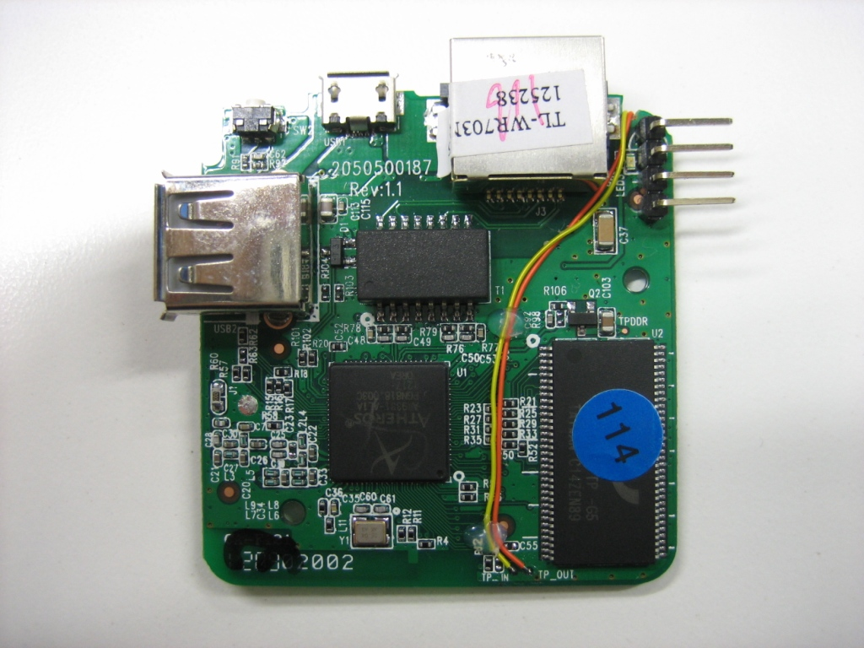

Image source: http://www.instructables.com/id/TL-WR703N-serial-port/

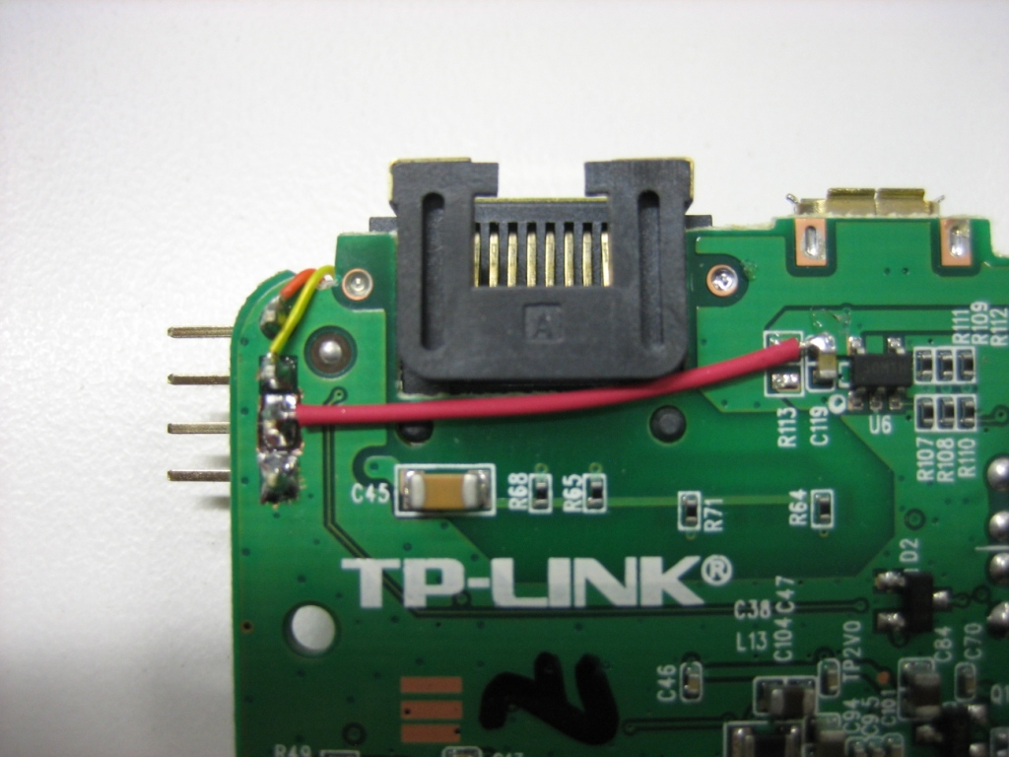

Image source: http://www.instructables.com/id/TL-WR703N-serial-port/

### Setup and Test

After the comm device is connected to the TL-WR802N circuit PCB, connect this USB comm device to your computer.

A virtual serial comm port will be created in the Device Manager.

[Building_a_Serial_Port_for_TL-WR703N](<http://wiki.villagetelco.org/index.php?title=Building_a_Serial_Port_for_TL-WR703N>)

My development environment is on a netbook running Ubuntu 10.04. I did a tail of /var/log/messages, plugged the USB adapter into the netbook, the device was recognized and was assigned as TTYUSB0.

I installed minicom, ran “minicom -s” to create the default minicom config file, changed the serial port to TTYUB0, set it to 115200,N,8,1 with software flow-control. I saved the config to “dfl” so that it would always come up that way, reset it, and applied power to the first “bricked” unit. I immediately got the U-Boot boot up output followed by OpenWRT boot up output. I tested a few long “ls -l” commands to ensure that the serial session wouldn’t freeze up from buffer overflow but everything worked just fine.

[Hacking the TP-Link TL-WR703N](<https://www.rs-online.com/designspark/hacking-the-tp-link-tl-wr703n>)

With the router reassembled I then connected the port to a PC via a USB to 3.3V serial cable that is designed for use with mobile phones and which terminates in a 2.5mm stereo jack. And on power up the terminal emulator displayed boot messages from the stock firmware.

A. Flashing the TL-WR703N from original firmware

(http://download.villagetelco.org/archive/firmware-1/secn/tp-wr703n/unstable/OpenWRT-Factory-Flash/Notes.txt)

------------------------------------------------  
The device can be reflashed using the web interface of the device.  
As shipped from the factory, the web user interface is in Chinese language, but it is fairly easy to find the  
firmware up load page. See screenshot file.  
  
The SECN alpha firmware image to use to flash from factory firmware is:  
  
openwrt-ar71xx-generic-tl-wr703n-v1-SN1_2-squashfs-factory.bin  
  
  
1. Power the device up and connect a PC configured so it can see the device on its default IP address on 192.168.1.1  
2. Point your web browser to this address to get the login page. Credentials are 'admin' and 'admin'  
3. When you are logged in, select the last item from the menu on the left.  
4. Select from the sub-menu items till you find the page for firmware upload.  
 The URL is http://192.168.1.1/userRpm/SoftwareUpgradeRpm.htm This is visible bottom left of screen.  
 It will show a text box to specify the file to be uploaded. A screen shot is attached.  
 Be careful as there is a similar page that is for uploading a saved configuration page.  
5. Click on the button to the right of the text box to start the upgrade process and confirm when prompted.  
6. The process takes a few minutes, then the device will restart (blue LED flashes).  
7. After the device has restarted (the blue LED stops flashing and is steady on) you should be able to telnet to 192.168.1.1  
  
B. Getting started  
--------------------------------------------  
1. Telnet to default address of 192.168.1.1  
2. Set the root password and exit  
3. SSH to 192.168.1.1  
4. Edit /etc/config/network to set IP, gateway and dns so it can get to the internet through your LAN.   
Example file below.  
5. Restart the box and ssh back in.  
6. Run the following commands:  
 # opkg update  
 # opkg install webif  
 # openssh-sftp-server  
7. Point your browser to the device address to get the config page.  
8. To browse to the file system from Nautilus (in Ubuntu)  
 Select Places/Connect to Server/  
 Select SSH  
 Enter IP of the TPLink device  
 Enter Username 'root'  
 Click Connect and enter root password when prompted  
  
----------------------------------------------  
# /etc/config/network  
  
config 'interface' 'loopback'  
 option 'ifname' 'lo'  
 option 'proto' 'static'  
 option 'ipaddr' '127.0.0.1'  
 option 'netmask' '255.0.0.0'  
  
config 'interface' 'lan'  
 option 'ifname' 'eth0'  
 option 'type' 'bridge'  
 option 'proto' 'static'  
 option 'ipaddr' '192.168.1.201'  
 option 'netmask' '255.255.255.0'  
 option 'dns' '8.8.8.8'  
 option 'gateway' '192.168.1.254'

Flashing the TL-WR703N (http://download.villagetelco.org/archive/firmware-1/secn/tp-wr703n/HowTo_Flash_WR703N.txt)  
----------------------  
  
The device can be reflashed using the web interface of the device.   
  
As shipped from the factory, the web user interface is in Chinese language, but it is fairly easy to find the   
firmware up load page.  
  
VillageTelco SECN firmware for the device is available here:  
http://villagetelco.org/download/tmp/firmware/secn/tp-wr703n/unstable/SECN-Factory-Flash/  
  
The original OpenWRT firmware image can be downloaded from here:  
http://downloads.openwrt.org/snapshots/trunk/ar71xx/openwrt-ar71xx-generic-tl-wr703n-v1-squashfs-factory.bin  
  
1. Power the device up and connect a PC configured so it can see the device on its default IP address 192.168.1.1   
  
2. Point your web browser to this address to get the login page. Credentials are 'admin' and 'admin'  
  
3. When you are logged in, select the last item from the menu on the left.  
  
4. Select from the sub-menu items till you find the page for firmware upload.   
 The URL is http://192.168.1.1/userRpm/SoftwareUpgradeRpm.htm  
 It will show a text box to specify the file to be uploaded.   
 Be careful as there is a similar page that is for uploading a saved configuration page.  
 See the screen shot image in the drectory where this file is stored.  
  
5. Click on the button to the right of the text box to start the upgrade process.  
  
6. The process takes a few minutes, then the device will restart (blue LED flashes).  
  
7. After the device has restarted (the blue LED stops flashing and is steady on) you should be able to connect  
 via web browser and ssh or telnet for the VT-SECN firmware, and telnet for the OpenWrt firmware.  
 IP addresses are 192.168.1.20 for VT-SECN firmware, and 192.168.1.1 for original OpenWrt firmware.

Upon completion the router will reboot and eventually drop into a root shell.

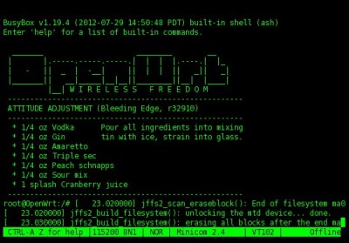

TL-WR703N:

<https://wiki.openwrt.org/toh/tp-link/tl-wr703n>

Configure the network:

<https://wiki.openwrt.org/doc/uci/network>

Install any optional software:

<https://wiki.openwrt.org/doc/techref/opkg>