1. **File description:**

|  |  |
| --- | --- |
| File name | description |
| ants | dependent package; https://github.com/ANTsX/ANTs |
| cc_matrix_and_cluster.m | Matlab script for regional correlation matrix and clustering |
| example_image_tomask.mat | Example data |
| Imdisp.m | Dependent file; https://github.com/marija-p/flourish_ipp/blob/master/ROS/tools/ojwoodford-sc-a35b88b/imdisp.m |
| Mask.mat | Example data |
| mask_and_register.m | Matlab script to generate blood vessel mask and register to atlas |
| mask_map.mat | Example data |
| PCA.m | Matlab script to compute PCA |
| rawData1_127x146x5000.dat | Example data |
| Readme.doc | This file |
| region_map.mat | Example data |
| regional_activity.m | Matlab script to generate activity in each brain region |
| vesselness2D.m | Dependent file; https://www.mathworks.com/matlabcentral/fileexchange/63171-jerman-enhancement-filter |

1. **Instructions for running the demonstration scripts**

The Matlab scripts in this folder are adapted to demonstrate analysis methods of the manuscript. The raw data for these demos were down-sampled version and only for a demonstration purpose.

1. **Blood vessel mask and atlas registration**

Run **mask_and_register.m** (line 1-16) to get the blood vessel mask (Fig. 1)

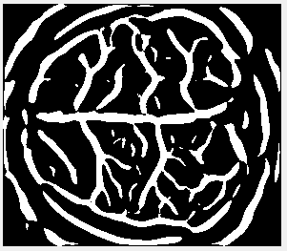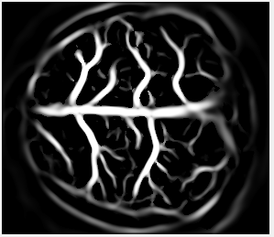

Fig. 1

Run **mask_and_register.m** (line 22-81) for atlas registration (Fig. 2)

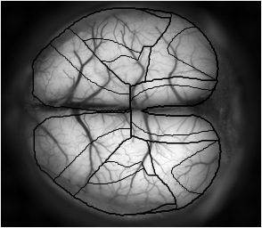

Fig. 2

1. **Activity of each brain region**

**Regional_activity.m** demonstrates the computation in **Figure 1e and extended data figure 1**.

1. **PCA**

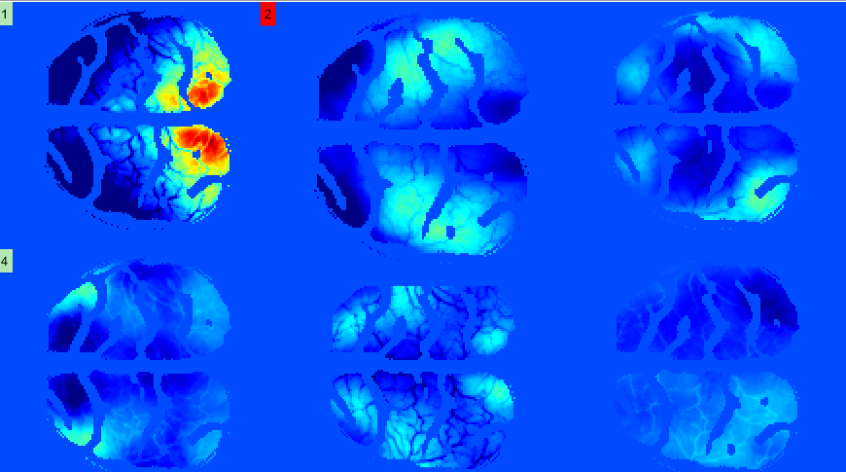**PCA.m** demonstrates the PCA method **used in Figure 3 and Figure 4**.

Expected result of PCA.m

1. **Regional correlation matrix and clustering**

**cc_matrix_and_cluster.m** demonstrates the analysis in **Figure 2**.

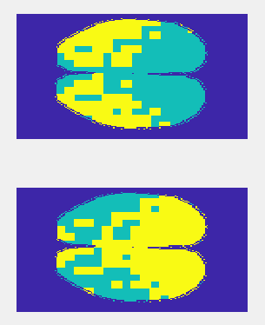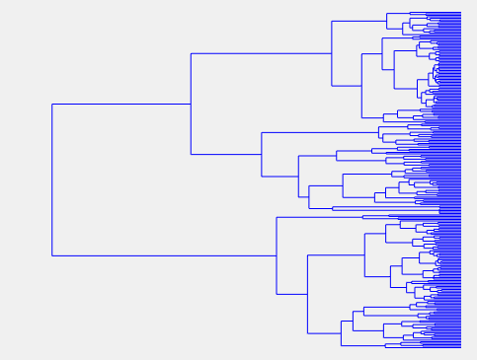

Expected result of cc_matrix_and_cluster.m