**AutoClose**:

括号自动补上结束符号。Using this script, typing ``(`` will result in (|), where | is the cursor position

**bufexplorer**: F2

**ctrlp**: F3

**NerdTree**: F4 树形浏览文件夹

**Tagbar**：F12 依赖于ctags

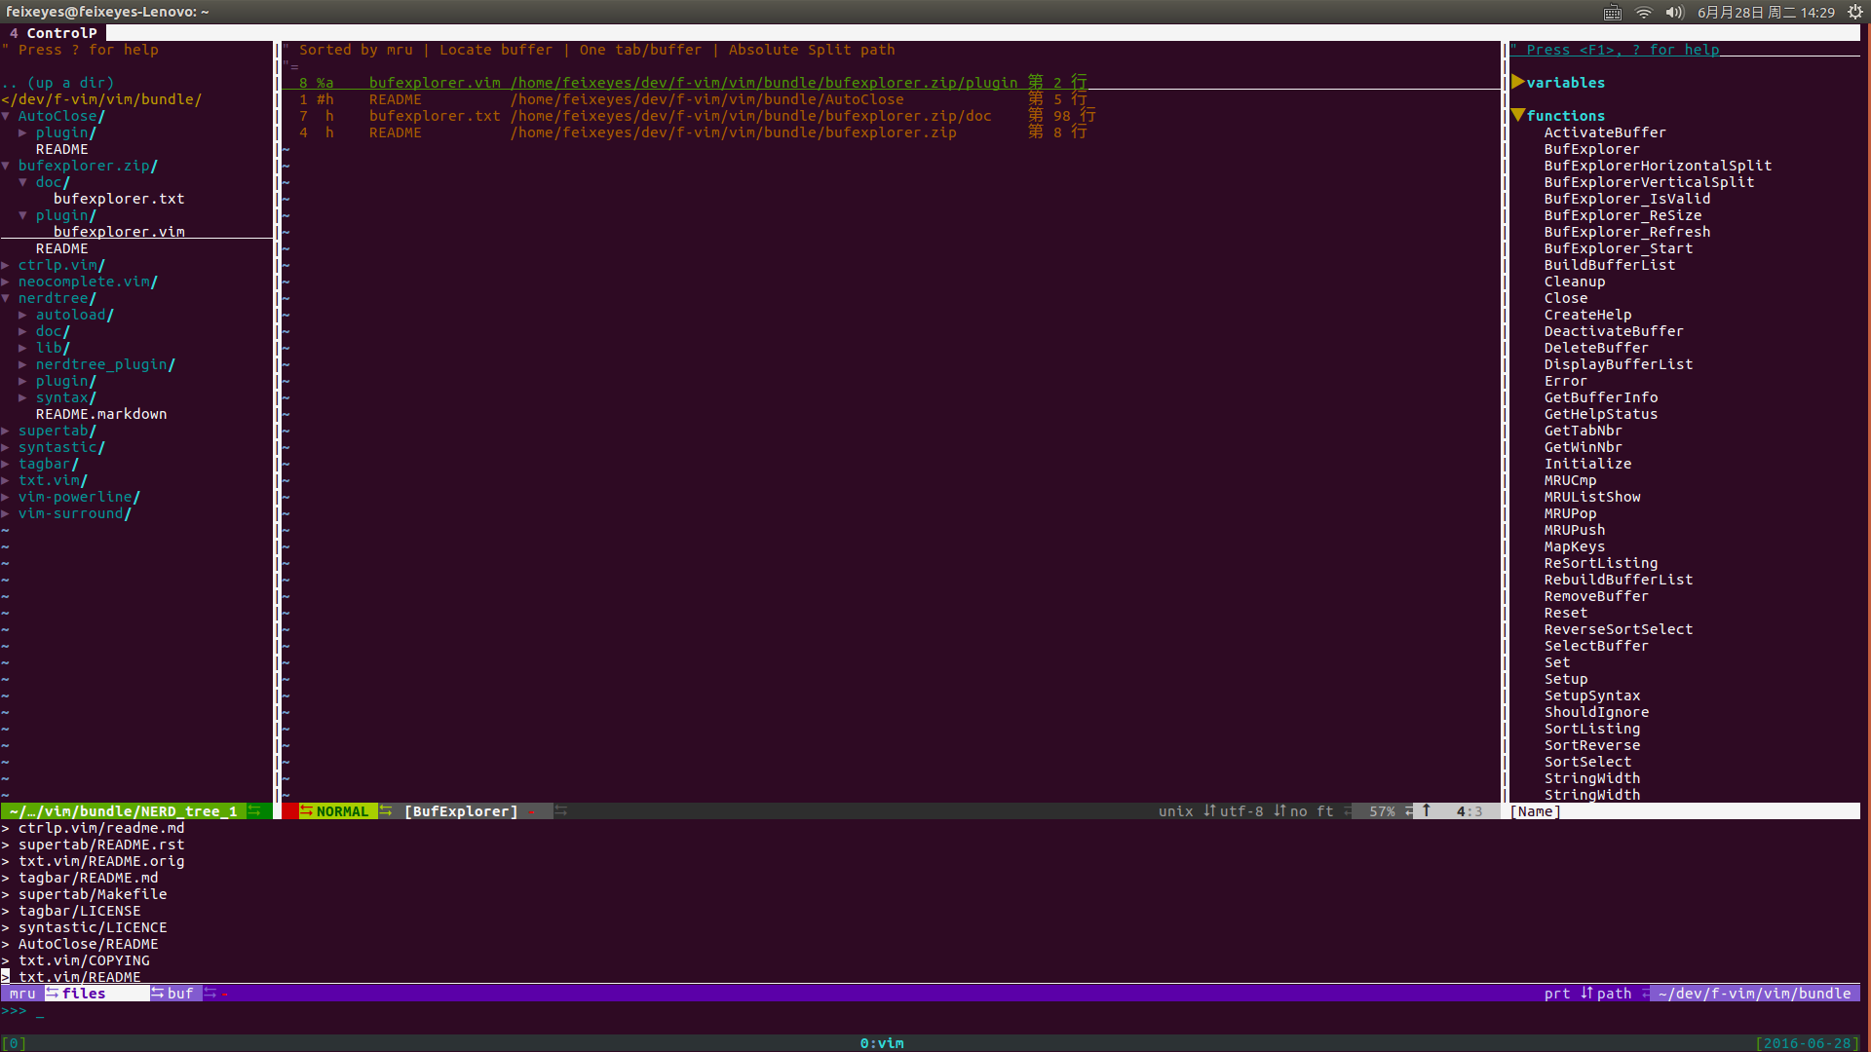

**bufexplorer**

**NerdTree**

**ctrlp**

**Tagbar**

neocomplete 自动补全

supertab:配合自动补全插件

syntastic：语法检查

txt.vim: 美化

vim-powerline：美化状态栏

debugger.py:

131 map <F5> :python debugger_run()<cr>

132 map <F6> :python debugger_command('step_into')<cr>

133 map <F7> :python debugger_command('step_over')<cr>

134 map <F8> :python debugger_command('step_out')<cr>