

SCHOOL OF ADVANCED TECHNOLOGY

ICT - Applications & Programming

Computer Engineering Technology – Computing Science

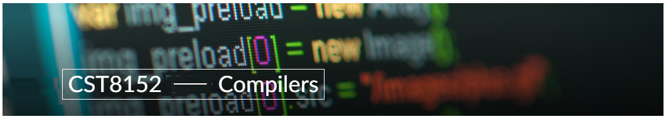

A21
Model Definitions (RE/Automaton)

Lab Professor / Lab Session:
Paulo Sousa / 310

Team:
Chenglong Wang – Id: 41008729

Language Name [JamesR]

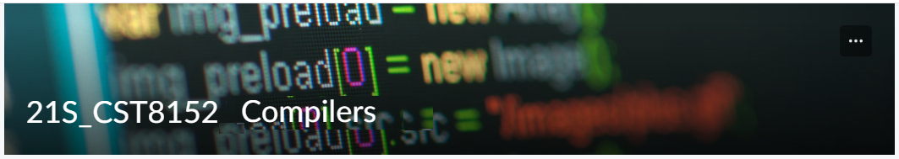

MODEL TASK FOR ASSIGNMENT 2.1 – JamesR

- Note: This task is part of the Assignment 2 from Compilers Course. Any problem, contact your lab professor.

Task 1: Language Symbols (2.0 marks)

List examples: Define main symbols to be used:
- Special symbols (ex: “{“, “(“, “<=”, etc.)
- Comments
- Variables
- Functions
- Literals (numbers, strings)
- Keywords
- Datatypes

Answer:

Special symbols (ex: “{“, “(“, “<=”, etc.):
[‘<’,’-‘, ‘(‘,’)’,,’,’,’/’,’*’]

Comments
SLC: //
MLC: /* */

Variables (Suggestion: Use CamelCase Syntax):
Ex: professorName, age, var1, _PI… (start with letters and continue with letters, digits or underline.

Functions
Ex: fact <- function(num){/* body function */ }
Ex: define the function name (as variables) and use the notation followed by <- and keyword function. Then pass the parameters separated by commas. Put the implementation in a pair of {}.

Literals (numbers, strings)
Numbers:
-Int: 0, 10, -12
-Float: .5, 3.14
-Strings: ‘Hello’, ”My name is James”
Rule:
Int: Sequence of digits
Floats: Sequence of digits separated by one single dot.
Strings: Sequence of chars between single quotes OR doble quotes

Keywords: {if, else, while, repeat, for, function, in, next, break, TRUE, FALSE}

Datatypes: int, gloat, string

Task 2: RE – Regular Expression (3.0 mark)

Lexeme Classes: Define the classes to be used in your regular expression:

Answer:
L = {‘a’-‘z’ | ‘A’-‘Z’}
D = {‘0’- ‘9’}
T = {‘<’}
H = {‘-‘}
P = {‘.’}
O = {‘(’}
C = {’)’}
S = {‘/’}
E = {‘\n’}
U = {‘_’}
Q = {‘ }
R = {“ }
A = {‘#’}
W= {‘*’}
X(Other) = {^(L.D.T.H.P.LB.RB…)}
Define the RE to be used for: variables, literals and keywords:

Answer:
* Comments:
- SLC: A^(E)*E
- MLC: SW^(W)*WS
* Variables(VID):
- L(L|D|U)*
* Methods(MET):
- L(L|D|U)*
* Literals:
- Numbers
- Int: D+
- Float: D*PD+
- Strings: Q^Q*Q, R^R*R

* Keywords(KEY):
- {“if”, “else”, “while”, “repeat”, “for”, “function”, “in”, “next”, “break”, “TRUE”, “FALSE”}

Task 3: TD – Transition Diagram (3.0 marks)

Activity: Starting from the previous lexeme classes and obeying the RE, it is possible to define the automata for your language:

Answer (draw / copy image of the automata):
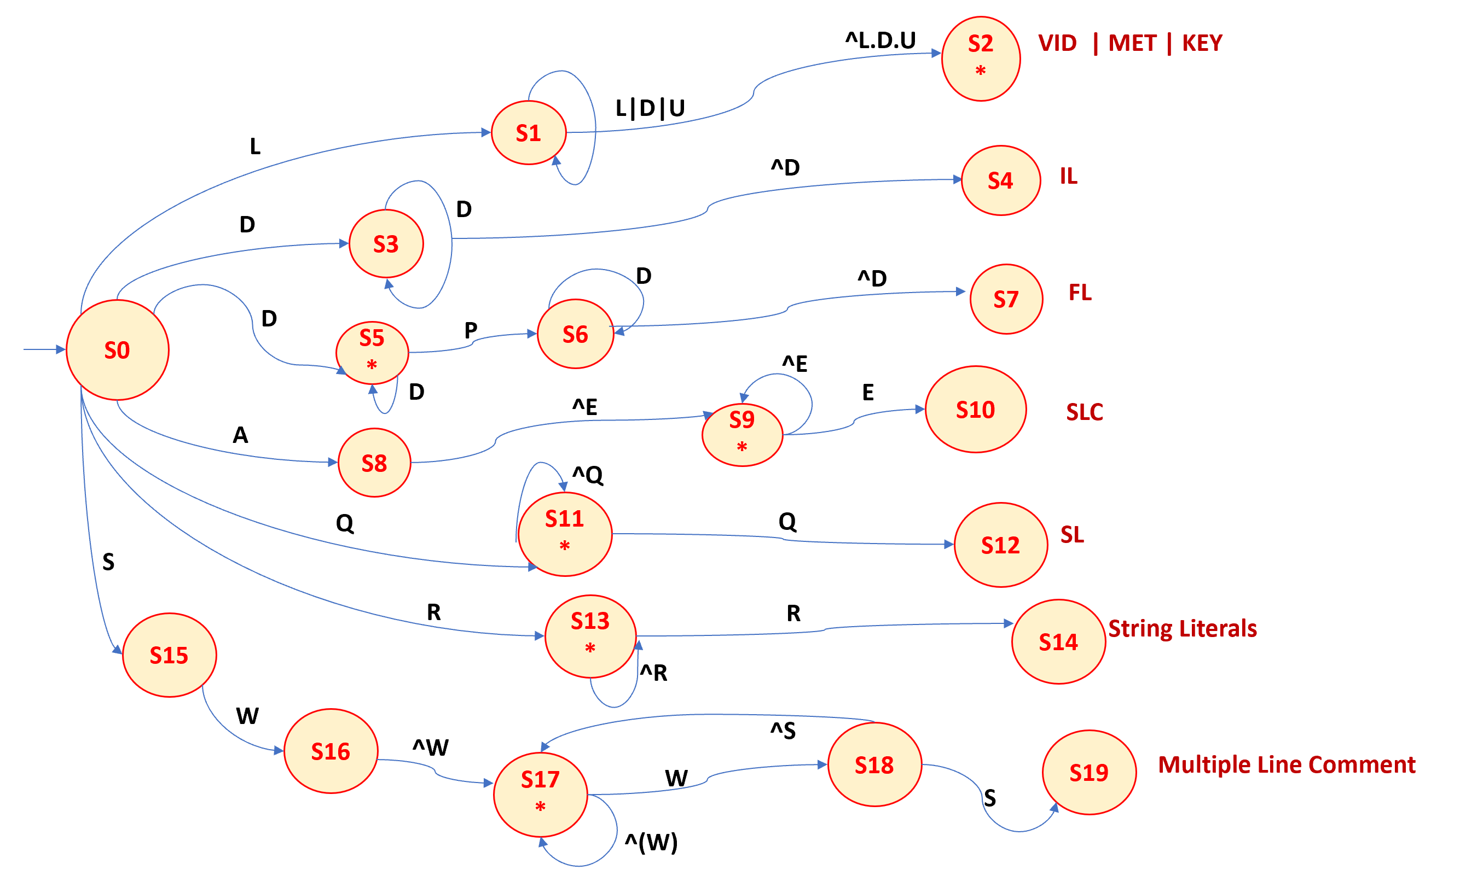

Task 4: TT – Transition Table (2.0 marks)

Activity: Now, it is possible to define the TT for these lexemes:

Answer (Transition Table):
Input | Input Symbol |  |  |  |  |  |  |  |  |  |  |  |  |  | Output
State \ Classes | 0 | 1 | 2 | 3 | 4 | 5 | 6 | 7 | 8 | 9 | 10 | 11 | 12 | 13 | Type
 | L(A-Z) | D(0-9) | T(<) | H(-) | P(.) | O('(') | C(’)’) | S(/) | E(\n) | U(_) | Q(') | R(") | W(*) | A(#)
S0 | S1 | S3 | ES | ES | ES | ES | ES | S7 | ES | ES | S11 | S13 | ES | S8
S1 | S2 | S1 | S2 | S2 | S2 | S2 | S2 | S2 | S2 | S1 | S2 | S2 | S1 | S1
S2
S3 | S4 | S3 | S4 | S4 | S4 | S4 | S4 | S4 | S4 | S4 | S4 | S4 | S4 | S4
S4
S5 | ES | S5 | ES | ES | S6 | ES | ES | ES | ES | ES | ES | ES | ES | ES
S6 | S7 | S6 | S7 | S7 | S7 | S7 | S7 | S7 | S7 | S7 | S7 | S7 | S7 | S7
S7
S8 | S9 | S9 | S9 | S9 | S9 | S9 | S9 | S9 | S10 | S9 | S9 | S9 | S9 | S9
S9 | S9 | S9 | S9 | S9 | S9 | S9 | S9 | S9 | S10 | S9 | S9 | S9 | S9 | S9
S10
S11 | S11 | S11 | S11 | S11 | S11 | S11 | S11 | S11 | S11 | S11 | S12 | S11 | S11 | S11
S12
S13 | S13 | S13 | S13 | S13 | S13 | S13 | S13 | S13 | S13 | S13 | S14 | S13 | S13 | S13
S14
S15 | ES | ES | ES | ES | ES | ES | ES | ES | ES | ES | ES | S16 | ES | ES
S16 | S17 | S17 | S17 | S17 | S17 | S17 | S17 | S17 | S17 | S17 | S17 | S17 | S18 | S17
S17 | S17 | S17 | S17 | S17 | S17 | S17 | S17 | S17 | S17 | S17 | S17 | S17 | S18 | S17
S18 | S17 | S17 | S17 | S17 | S17 | S17 | S17 | S17 | S19 | S17 | S17 | S17 | S17 | S17
S19
ES = Error State

Update: Jun 1st 2024.

Adapted from resources developed by Prof. Svillen Ranev (Algonquin College, 2019)

