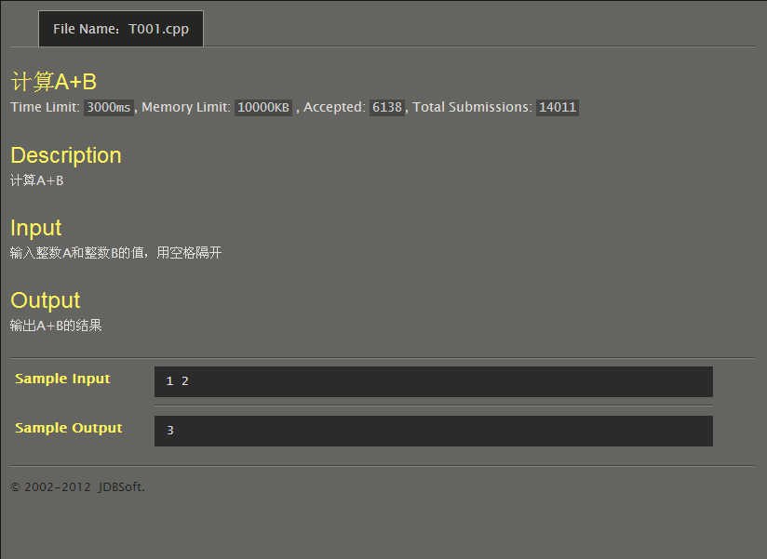
#include<stdio.h>
int main()
{
int a,b,sum;
scanf("%d%d",&a,&b);
sum=a+b;
printf("%d\n",sum);
return 0;
}
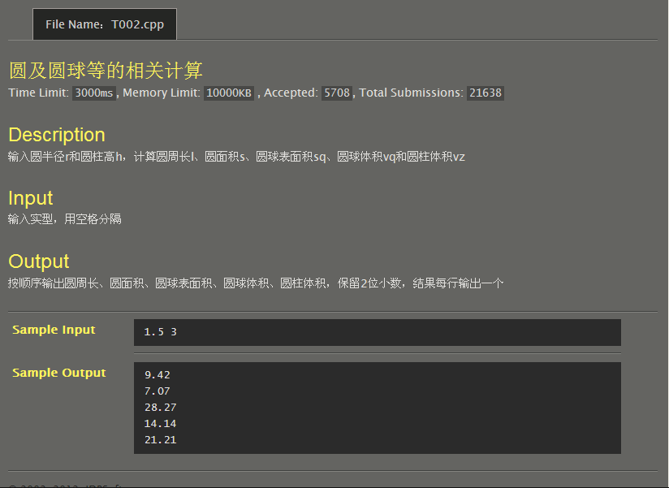
#include<stdio.h>
#define PI 3.1415926
int main()
{
double r,h,l,s,sq,vq,vz;
scanf("%lf%lf",&r,&h);
l=2*PI*r;
s=PI*r*r;
sq=4*PI*r*r;
vq=PI*r*r*r*4/3;
vz=PI*r*r*h;
printf("%.2lf\n%.2lf\n%.2lf\n%.2lf\n%.2lf\n",l,s,sq,vq,vz);
return 0;
}
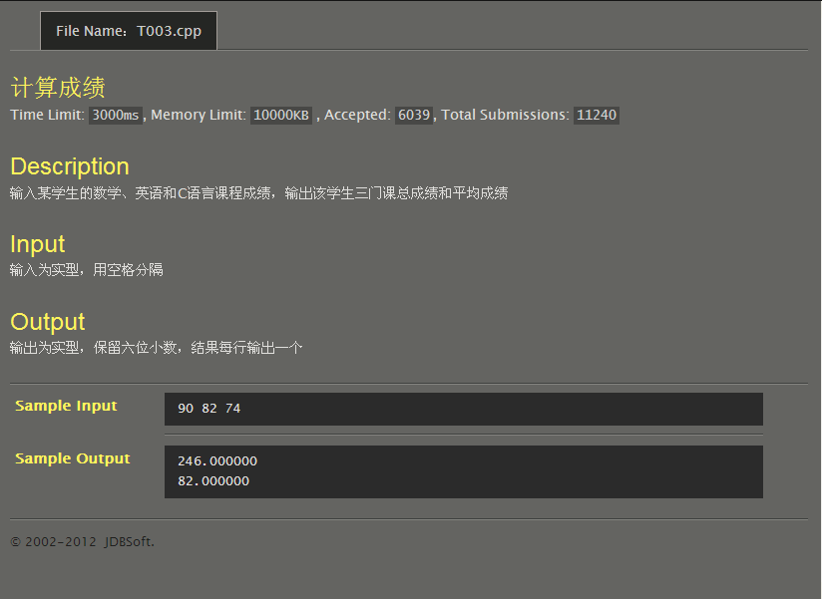
#include<stdio.h>
int main()
{
double ma,eng,c,sum,ave;
scanf("%lf%lf%lf",&ma,&eng,&c);
sum=ma+eng+c;
ave=sum/3;
printf("%lf\n%lf\n",sum,ave);
return 0;
}
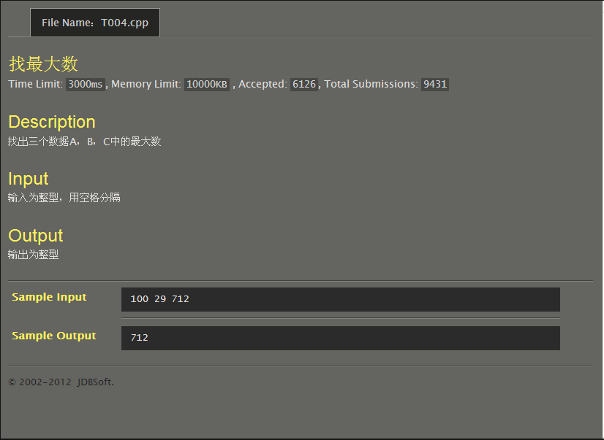
#include<stdio.h>
int main()
{
int a,b,c,m;
scanf("%d%d%d",&a,&b,&c);
if (a>b) m=a;
else m=b;
if (m<c) m=c;
printf("%d",m);
return 0;
}
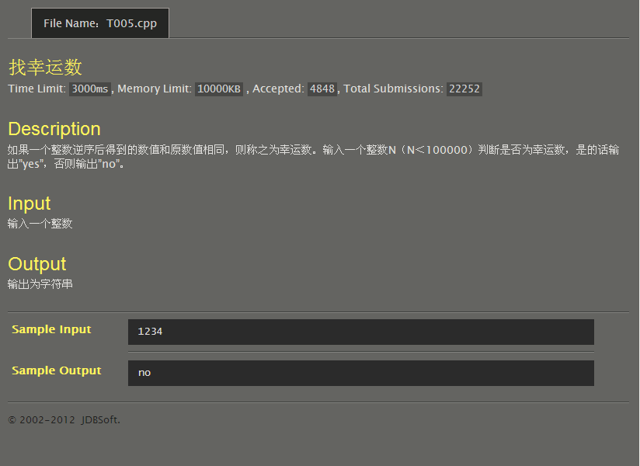
#include<stdio.h>
int main()
{
int n;
scanf("%d",&n);
if ((1000<n<10000)&&(n/1000==n%10)&&(n/100%10==n/10%10)) printf("yes\n");
else if((100<n<=1000)&&(n/100==n%10)) printf("yes\n");
else if((10<n<=100)&&(n/10==n%10)) printf("yes\n");
else if(0<n<=10) printf("yes\n");
else printf("no\n");
return 0;
}
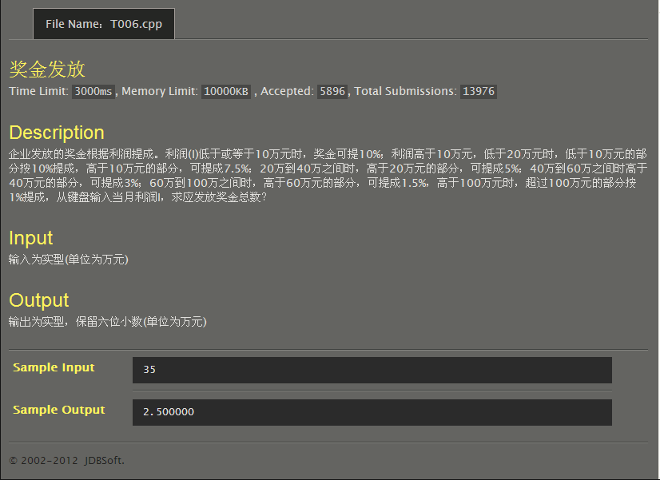
#include<stdio.h>
int main()
{
double l,bon;
scanf("%lf",&l);
if(l<=10) bon=l*0.1;
else if(l<20) bon=1+(l-10)*0.075;
else if(l<40) bon=1.75+(l-20)*0.05;
else if(l<60) bon=2.75+(l-40)*0.03;
else if(l<100) bon=3.35+(l-60)*0.015;
else bon=3.95+(l-100)*0.01;
printf("%lf\n",bon);
return 0;
}
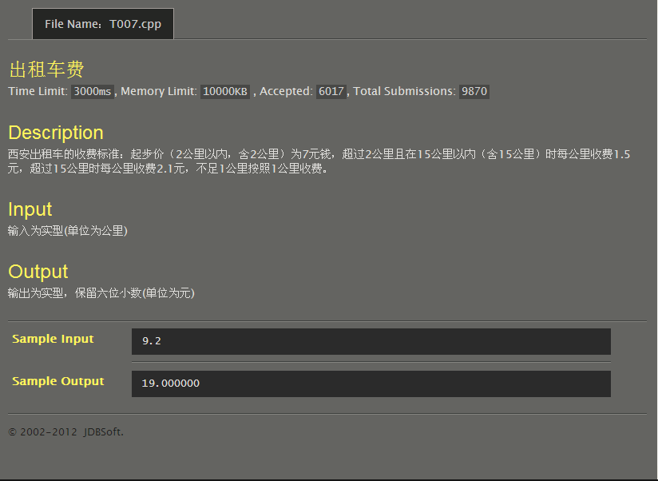
#include<stdio.h>
int main()
{
double d,m;
scanf("%lf",&d);
if(d<=2) m=7;
else if(d<=15){
if(d-2==(int)(d-2)) m=7+(d-2)*1.5;
else m=7+((int)(d-2)+1)*1.5;
}
else if(d-15==(int)(d-15)) m=26.5+(d-15)*2.1;
else m=26.5+((int)(d-15)+1)*2.1;
printf("%lf\n",m);
return 0;
}
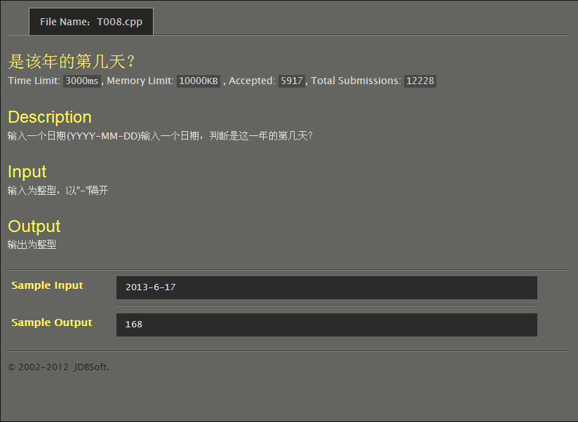
#include<stdio.h>
int main()
{
int y,m,d,Days,sum;
scanf("%d-%d-%d",&y,&m,&d);
if((y%4==0&&y%100!=0)||(y%400==0)) Days=29;
else Days=28;
switch(m){
case 1:sum=d;break;
case 2:sum=31+d;break;
case 3:sum=31+Days+d;break;
case 4:sum=62+Days+d;break;
case 5:sum=92+Days+d;break;
case 6:sum=123+Days+d;break;
case 7:sum=153+Days+d;break;
case 8:sum=184+Days+d;break;
case 9:sum=215+Days+d;break;
case 10:sum=245+Days+d;break;
case 11:sum=276+Days+d;break;
case 12:sum=307+Days+d;break;
}
printf("%d\n",sum);
return 0;
}
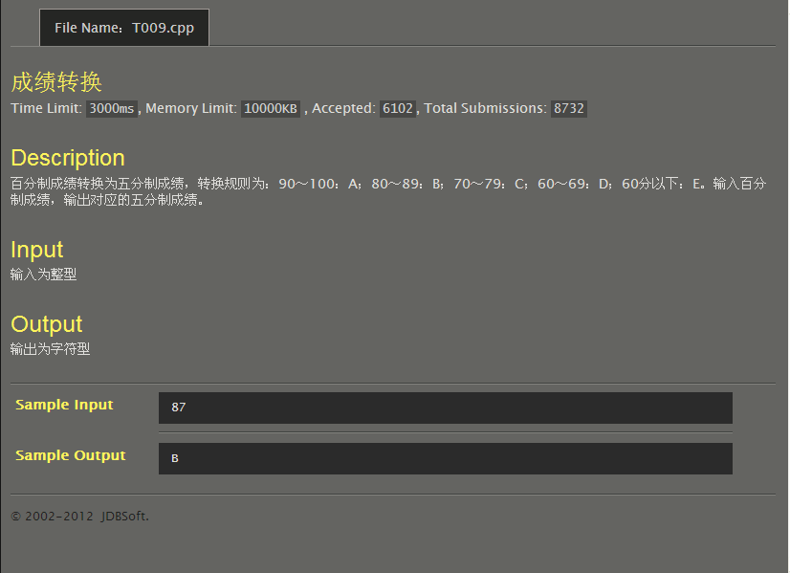
#include<stdio.h>
int main()
{
int i;
scanf("%d",&i);
if(i>=90) printf("A\n");
else if(i>=80) printf("B\n");
else if(i>=70) printf("C\n");
else if(i>=60) printf("D\n");
else printf("E\n");
return 0;
}
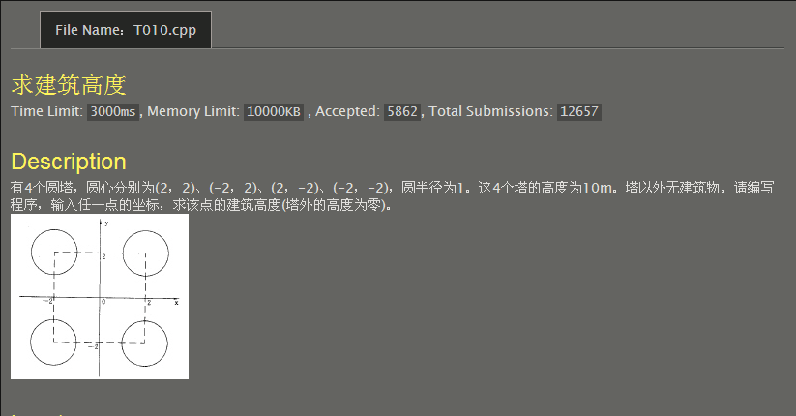
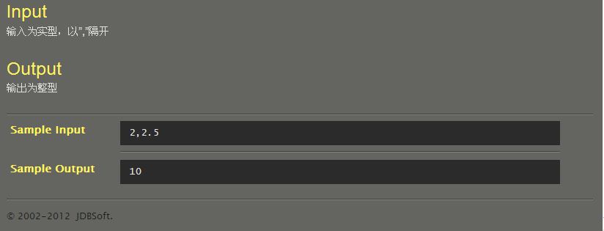
#include<stdio.h>
int main()
{
double x,y;
scanf("%lf,%lf",&x,&y);
if((x-2)*(x-2)+(y-2)*(y-2)<=1) printf("10");
else if((x-2)*(x-2)+(y+2)*(y+2)<=1) printf("10");
else if((x+2)*(x+2)+(y-2)*(y-2)<=1) printf("10");
else if((x+2)*(x+2)+(y+2)*(y+2)<=1) printf("10");
else printf("0");
return 0;
}
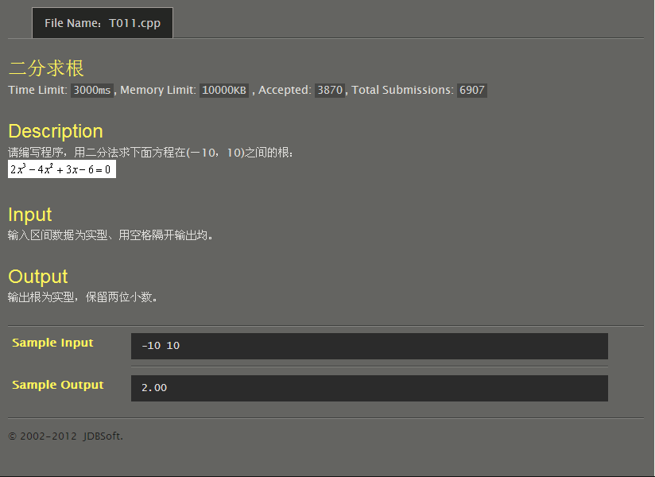
#include<stdio.h>
int main()
{
double l,x,r;
scanf("%lf %lf",&l,&r);
while((2*l*l*l-4*l*l+3*l-6)!=0&&(2*r*r*r-4*r*r+3*r-6)!=0){
x=(l+r)/2;
if((2*l*l*l-4*l*l+3*l-6)*(2*x*x*x-4*x*x+3*x-6)<=0)
r=x;
else l=x;
}
if(2*l*l*l-4*l*l+3*l-6==0) printf("%.2lf",l);
else printf("%.2lf",r);
return 0;
}
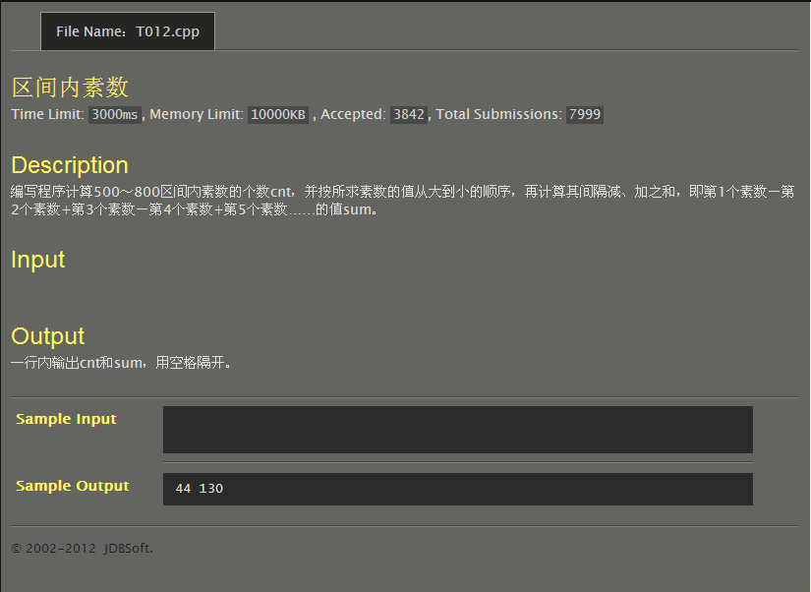
#include<stdio.h>
#include<math.h>
int main()
{
int i=800,t=2,cnt=0,sum=0;
double e=-1;
while(i>=500){
while(t<=i-1){
if(i%t==0) break;
t++;
}
if(t==i) e=pow(-1,cnt),sum=sum+e*i,cnt++;
i--;
t=2;
}
printf("%d %d",cnt,sum);
return 0;
}
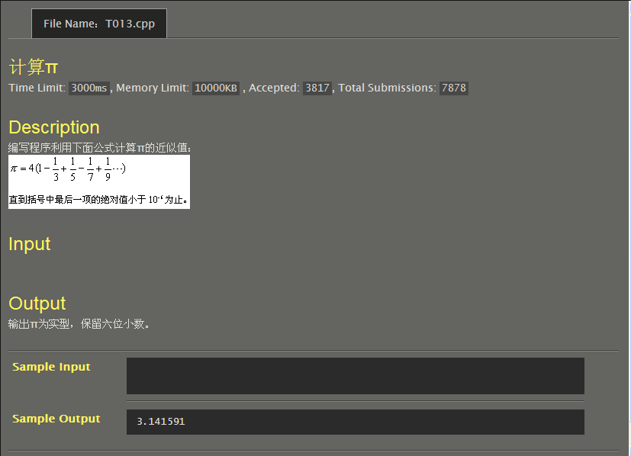
#include<stdio.h>
#include<math.h>
int main()
{
int a=1;
double b=1,pi=0,c=1;
while(fabs(c)>=1e-6)
pi=pi+c,b=b+2,a=-a,c=a/b;
pi=pi*4;
printf("%lf\n",pi);
return 0;
}
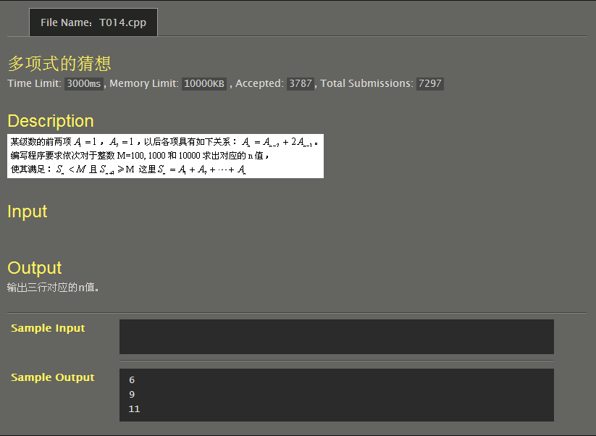
#include<stdio.h>
int main()
{
int a1=1,a2=1,n=2,sum=2,t;
while(sum<=100){
t=a1;
a1=a2;
a2=t+2*a2;
sum=sum+a2;
n++;
}
printf("%d\n",n-1);
while(sum<=1000){
t=a1;
a1=a2;
a2=t+2*a2;
sum=sum+a2;
n++;
}
printf("%d\n",n-1);
while(sum<=10000){
t=a1;
a1=a2;
a2=t+2*a2;
sum=sum+a2;
n++;
}
printf("%d\n",n-1);
}
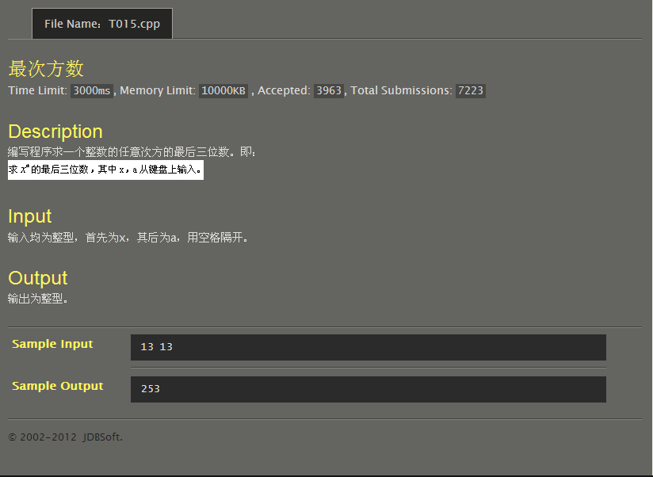
#include<stdio.h>
int main()
{
int x,a,s,n=1;
scanf("%d %d",&x,&a);
s=x;
if(a!=0){
for(;n<a;n++)
{
s=s*x;
if(s>=1000) s=s/100%10*100+s/10%10*10+s%10;
}
}
printf("%d\n",s);
return 0;
}
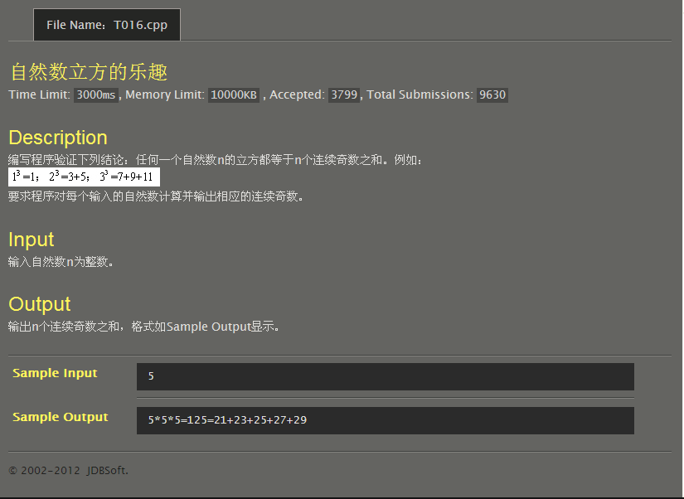
#include<stdio.h>
int main()
{
int m,n,s;
scanf("%d",&n);
s=n*n*n;
printf("%d*%d*%d=%d=",n,n,n,s);
for(m=1;s!=n*m;m++);
if(n%2==1){
for(s=-n/2;s<n/2;s++)printf("%d+",m+2*s);
printf("%d",m+n/2*2);
}
else{
for(s=-n/2;s<n/2-1;s++)printf("%d+",m+s*2+1);
printf("%d",m+(n/2-1)*2+1);
}
return 0;
}
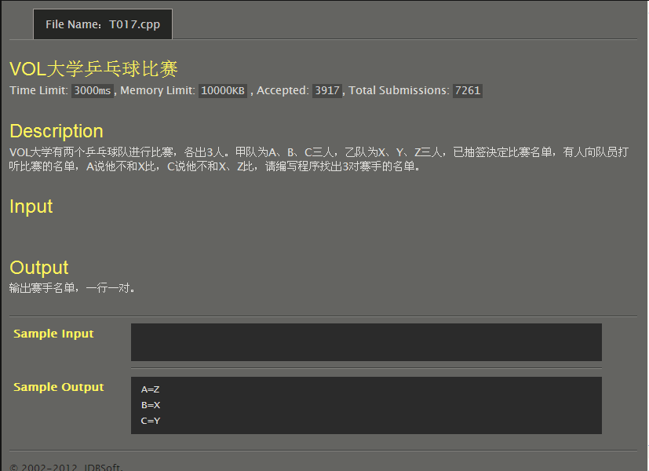
#include<stdio.h>
int main()
{
char a,b,c,x,y,z;
a='A',b='B',c='C',x='X',y='Y',z='Z';
printf("%c=%c\n",a,z);
printf("%c=%c\n",b,x);
printf("%c=%c\n",c,y);
return 0;
}
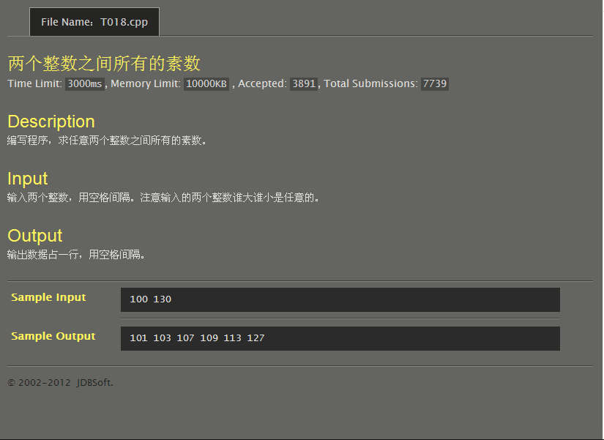
#include<stdio.h>
int main()
{
int a,b,t;
scanf("%d %d",&a,&b);
if(a>b)t=a,a=b,b=t;
for(;a<b;a++){
for(t=2;t<a;t++)if(a%t==0) break;
if(t==a)printf("%d ",a);
}
return 0;
}
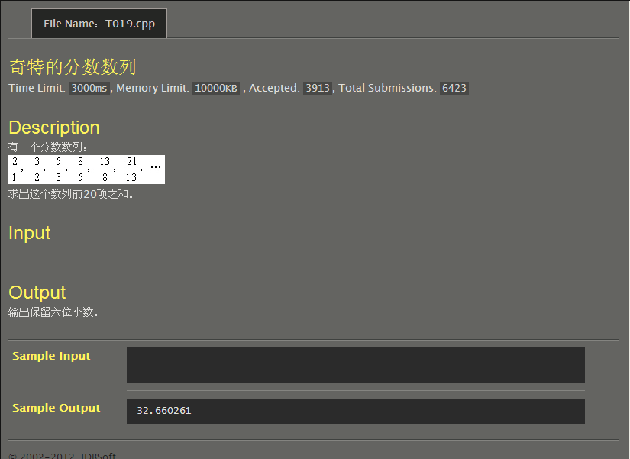
#include<stdio.h>
int main()
{
int n=1;
double a1=1,a2=2,a3,sum=2;
while(n<=19){
a3=a1+a2;
sum=sum+a3/a2;
a1=a2;
a2=a3;
n++;
}
printf("%lf\n",sum);
return 0;
}
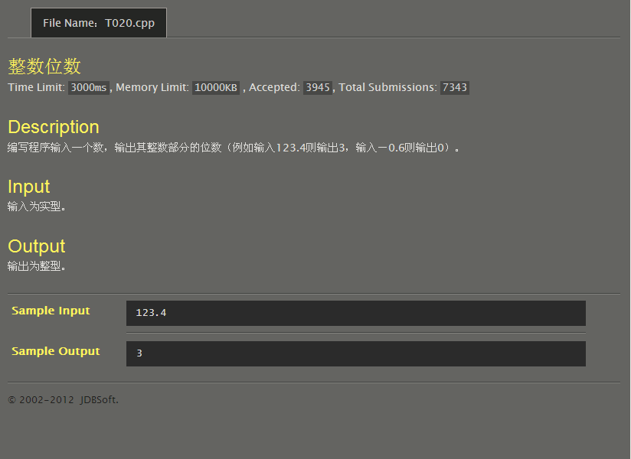
#include<stdio.h>
#include<math.h>
int main()
{
double a;
int n=0;
scanf("%lf",&a);
a=fabs(a);
if(a<=1)printf("0\n");
else{
while(a>1){
a=a/10;
n++;
}
printf("%d\n",n);
}
return 0;
}
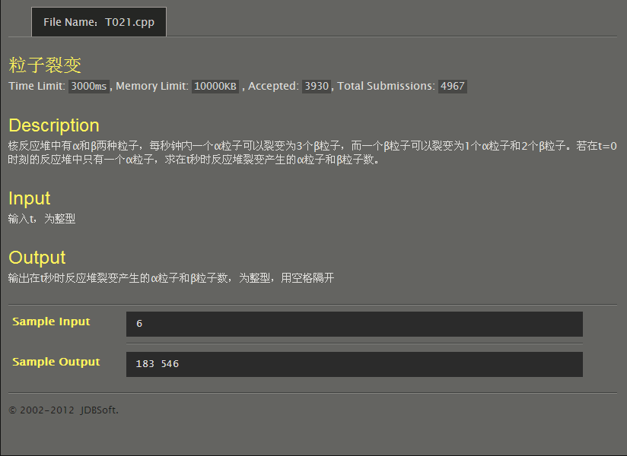
#include<stdio.h>
int main()
{
int a=1,b=0,t,m,n=0;
scanf("%d",&t);
while(n<t){
m=b;
b=3*a+2*b;
a=m;
n++;
}
printf("%d %d",a,b);
return 0;
}
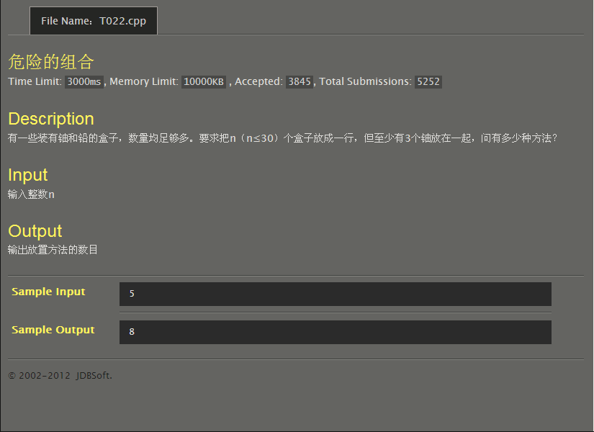
#include<stdio.h>
#include<math.h>
int main()
{
int n;
int f(int n);
scanf("%d",&n);
printf("%d\n",f(n));
}
int f(int n)
{
int a;
if(n==1||n==2)
a=0;
else if(n==3)
a=1;
else if(n==4)
a=3;
else
a=f(n-1)*2+pow(2,n-4)-f(n-4);
return a;
}
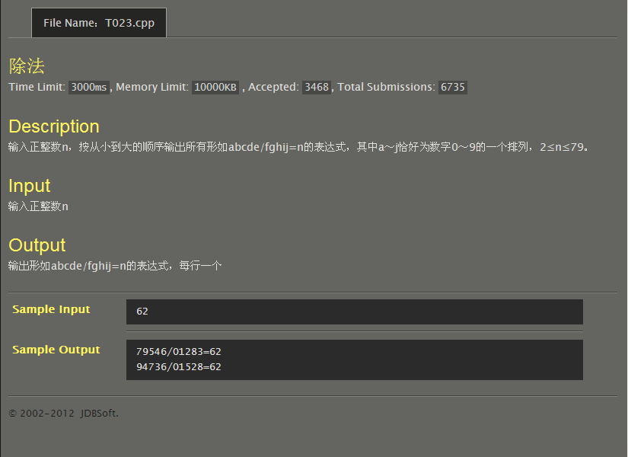
#include<stdio.h>
int main()
{
int n,x=1234,y=1,a,b,c,d,e,f,g,h,i,j;
scanf("%d",&n);
for(;x<49383&&y<98765;x++){
y=x*n;
a=x/10000%10;
b=x/1000%10;
c=x/100%10;
d=x/10%10;
e=x%10;
f=y/10000%10;
g=y/1000%10;
h=y/100%10;
i=y/10%10;
j=y%10;
if(a==b||a==c||a==d||a==e||a==f||a==g||a==h||a==i||a==j) continue;
if(b==c||b==d||b==e||b==f||b==g||b==h||b==i||b==j) continue;
if(c==d||c==e||c==f||c==g||c==h||c==i||c==j) continue;
if(d==e||d==f||d==g||d==h||d==i||d==j) continue;
if(e==f||e==g||e==h||e==i||e==j) continue;
if(f==g||f==h||f==i||f==j) continue;
if(g==h||g==i||g==j) continue;
if(h==i||h==j) continue;
if(i==j) continue;
printf("%05d/%05d=%d\n",y,x,n);
}
return 0;
}
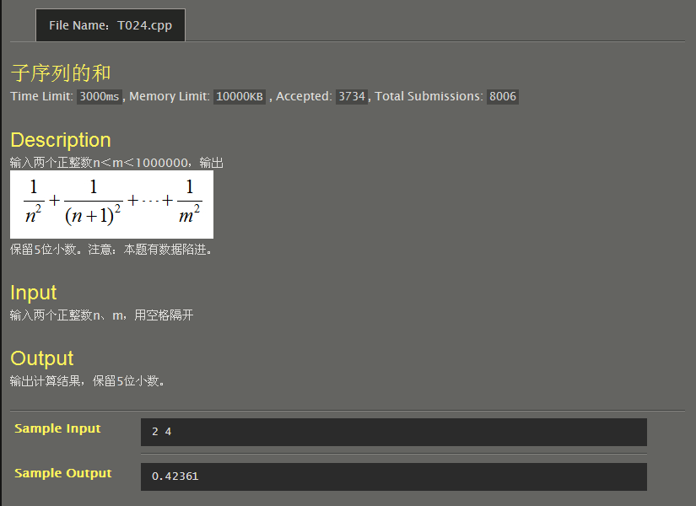
#include<stdio.h>
#include<stdlib.h>
#include<math.h>
int main()
{
int m,n,i;
double x,s=0;
scanf("%d%d",&n,&m);
for(i=n;i<=m;i++)
{
x=pow(i,2.0);
s=s+1/x;
}
printf("%.5lf\n",s);
return 0;
}
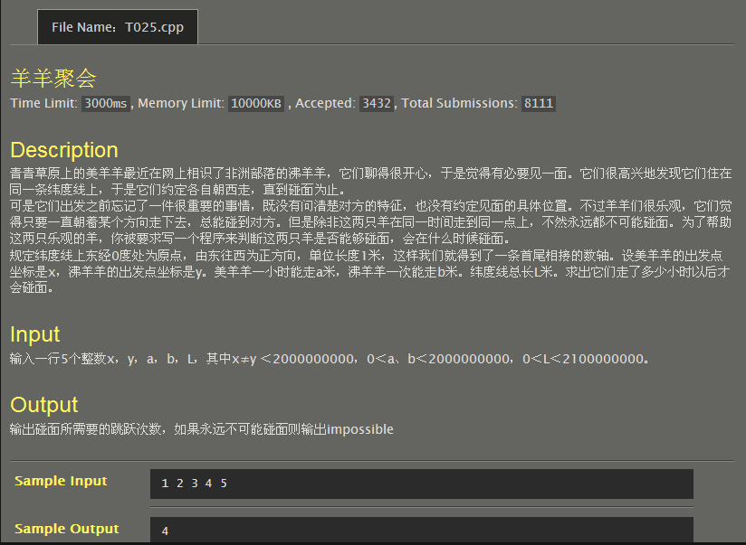
#include<stdio.h>
int main()
{
int x,y,a,b,L;
double t;
scanf("%d%d%d%d%d",&x,&y,&a,&b,&L);
if(a==b) printf("impossible\n");
else if(x>y){
if(a>b)y=L-x+y,t=(double)y/(a-b);
else y=x-y,t=(double)y/(b-a);
if((int)t==t)printf("%d\n",(int)t);
else printf("%lf\n",t);
}
else {
if(a>b)y=y-x,t=(double)y/(a-b);
else y=L-y+x,t=(double)y/(b-a);
if((int)t==t)printf("%d\n",(int)t);
else printf("%lf\n",t);
}
return 0;
}
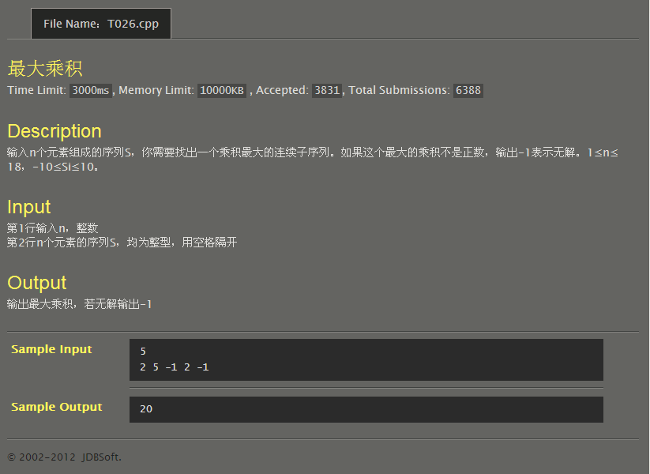
#include<stdio.h>
int _max(int a,int b)
{
return a>b?a:b;
}
int a[20];
int f[20][20];
int main()
{
int n,i,j,s=0;
scanf("%d",&n);
for(i=0;i<n;i++)
scanf("%d",&a[i]);
for(j=1;j<n;j++)
f[0][0]=a[0],f[0][j]=f[0][j-1]*a[j];
for(i=1;i<n;i++)
{
f[i][i-1]=1;
for(j=i;j<n;j++)
f[i][j]=f[i][j-1]*a[j];
}
for(i=0;i<n;i++)
for(j=i;j<n;j++)
s=_max(s,f[i][j]);
if(s==0)printf("-1\n");
else printf("%d\n",s);
return 0;
}
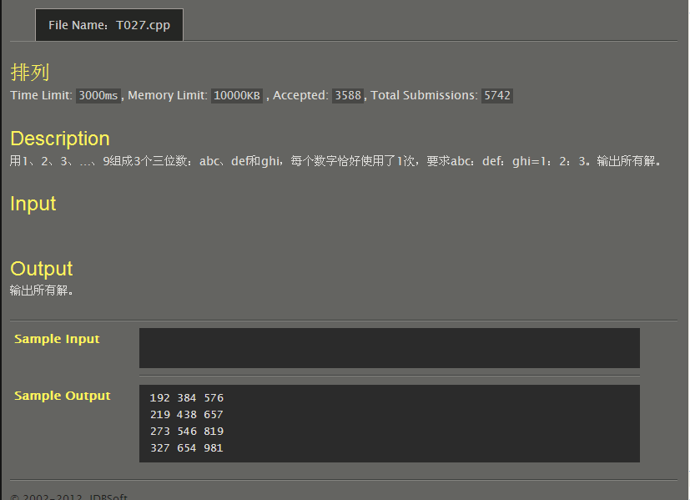
#include<stdio.h>
int main()
{
int x=192,y,z,a,b,c,d,e,f,g,h,i;
for(;x<328;x++){
y=2*x;
z=3*x;
a=x/100%10;
b=x/10%10;
c=x%10;
d=y/100%10;
e=y/10%10;
f=y%10;
g=z/100%10;
h=z/10%10;
i=z%10;
if(a==b||a==c||a==d||a==e||a==f||a==g||a==h||a==i||a==0) continue;
if(b==c||b==d||b==e||b==f||b==g||b==h||b==i||b==0) continue;
if(c==d||c==e||c==f||c==g||c==h||c==i||c==0) continue;
if(d==e||d==f||d==g||d==h||d==i||d==0) continue;
if(e==f||e==g||e==h||e==i||e==0) continue;
if(f==g||f==h||f==i||f==0) continue;
if(g==h||g==i||g==0) continue;
if(h==i||h==0) continue;
printf("%d %d %d\n",x,y,z);
}
return 0;
}
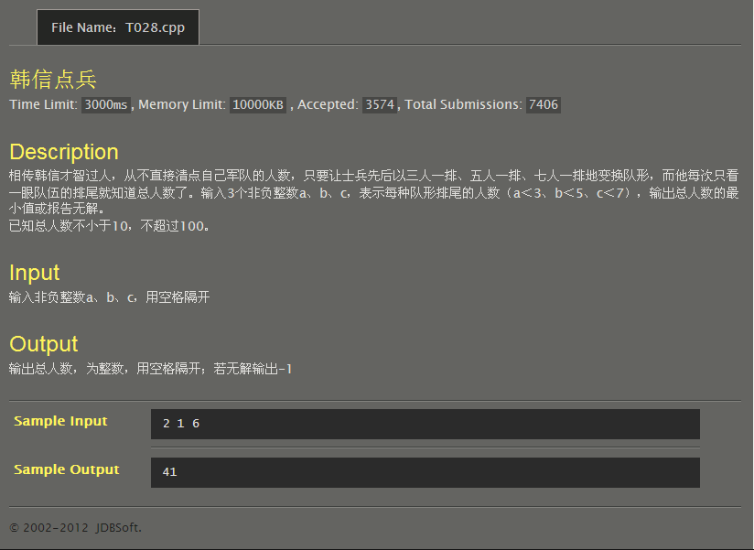
#include<stdio.h>
int main()
{
int a,b,c,sum=10;
scanf("%d%d%d",&a,&b,&c);
for(;sum<=100;sum++){
if(sum%3==a&&sum%5==b&&sum%7==c){ printf("%d\n",sum);
break;
}
}
if(sum==101)printf("-1\n");
return 0;
}
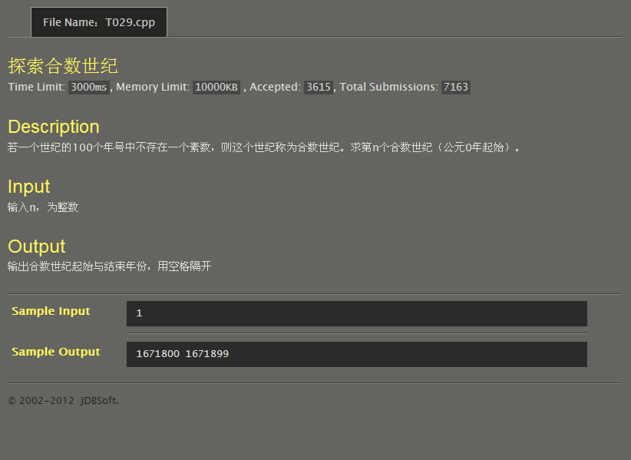
#include<stdio.h>
#include<math.h>
int main()
{
int ce,y,m,n,a=0;
scanf("%d",&n);
for(ce=0;;ce+=100){
for(y=ce+1;y<ce+100;y+=2){
for(m=3;m<sqrt(y);m+=2){
if(y%m==0) break;
}
if(m>=sqrt(y)) break;
}
if(y==ce+101) a++;
if(a==n) break;
}
printf("%d %d\n",ce,ce+99);
return 0;
}
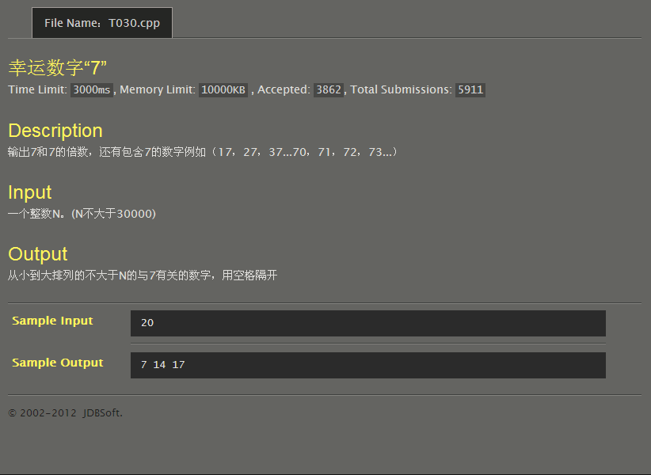
#include<stdio.h>
int main()
{
int n,i;
scanf("%d",&n);
for(i=1;i<=n;i++){
if(i%7==0) printf("%d ",i);
else if(i/1000%10==7||i/100%10==7||i/10%10==7||i%10==7) printf("%d ",i);
}
return 0;
}
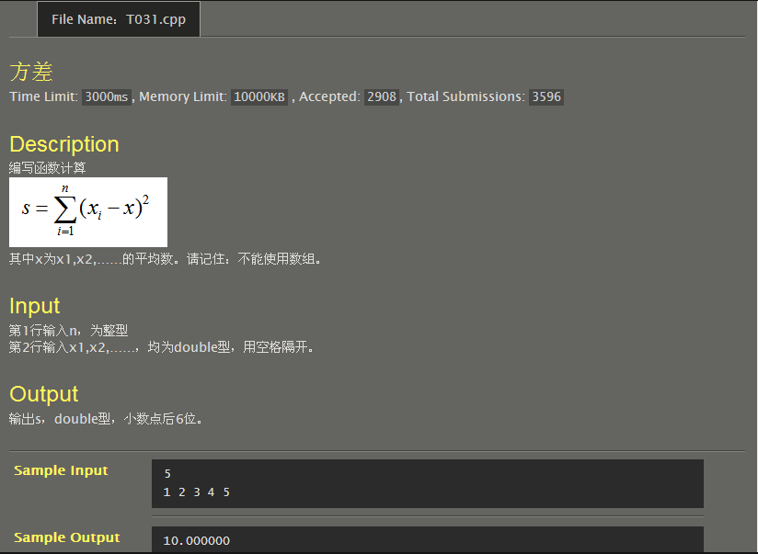
#include<stdio.h>
double a[100000000];
int main()
{
int n,i;
double ave,sum=0;
scanf("%d",&n);
for(i=0;i<n;i++)
{
scanf("%lf",&a[i]);
sum=sum+a[i];
}
ave=sum/n;
for(i=0,sum=0;i<n;i++)
sum=sum+(a[i]-ave)*(a[i]-ave);
printf("%lf\n",sum);
return 0;
}
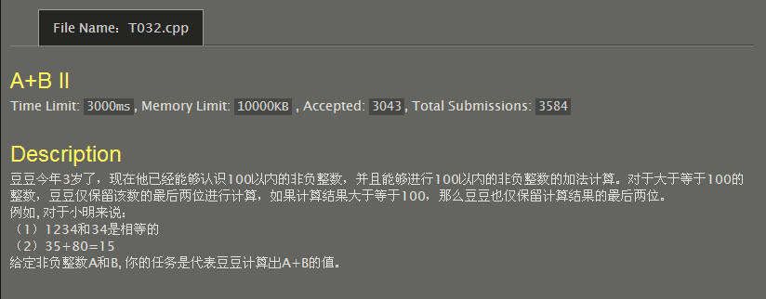
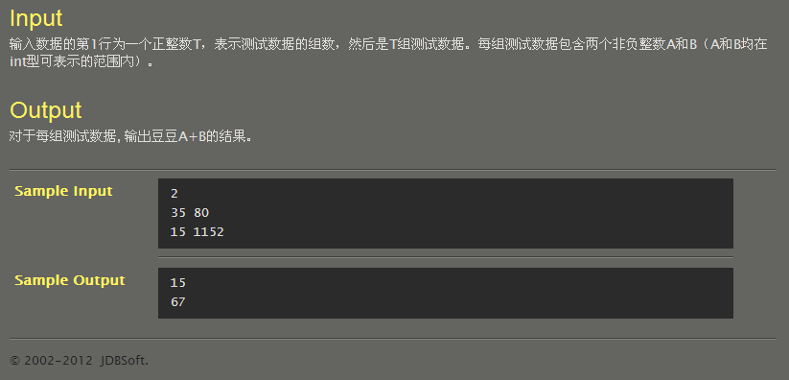
#include<stdio.h>
int f[100000000];
int main()
{
int n,i;
scanf("%d",&n);
for(i=0;i<n;i++)
{
int a,b;
scanf("%d%d",&a,&b);
f[i]=a+b;
}
for(i=0;i<n;i++)
{
if(f[i]>100) f[i]=f[i]/10%10*10+f[i]%10,printf("%d\n",f[i]);
else printf("%d\n",f[i]);
}
return 0;
}
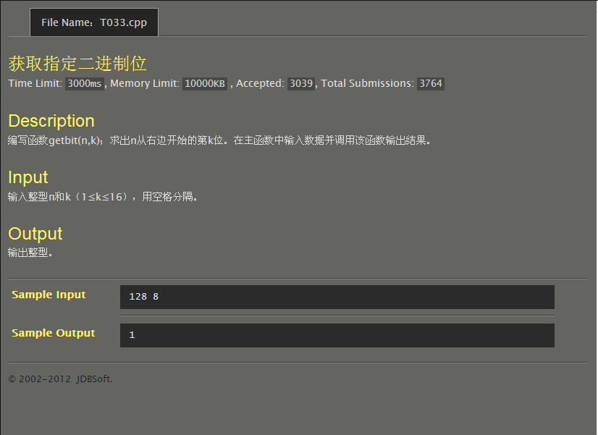
#include<stdio.h>
#include<math.h>
int getbit(int n,int k)
{
n=n>>k-1;
return n&1;
}
int main()
{
int n,k;
scanf("%d%d",&n,&k);
printf("%d",getbit(n,k));
return 0;
}
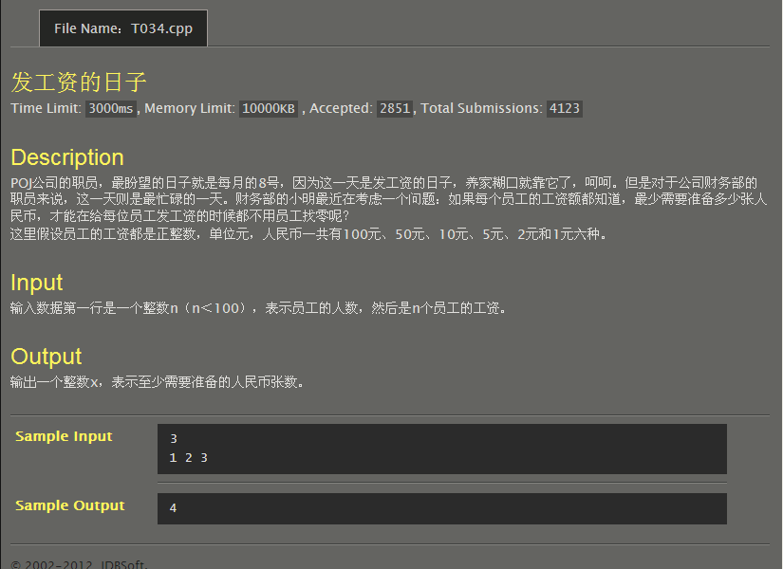
#include<stdio.h>
int _min(int n)
{
int i=0;
if(n>=100) i=n/100%10,n=n/10%10*10+n%10;
if(n>=50) i+=1,n-=50;
if(n>=10) i+=n/10%10,n%=10;
if(n>=5) i+=1,n-=5;
if(n>=2) i+=n/2,n%=2;
if(n==1) i+=1;
return i;
}
int f[100];
int main()
{
int n,i,sum;
scanf("%d",&n);
for(i=0;i<n;i++)
scanf("%d",&f[i]);
for(sum=0,i=0;i<n;i++)
sum=sum+_min(f[i]);
printf("%d\n",sum);
return 0;
}
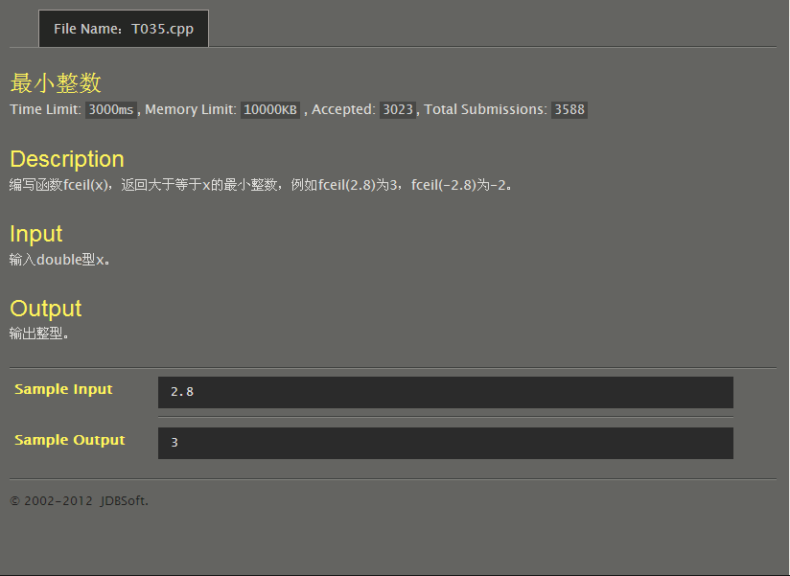
#include<stdio.h>
int fceil(double x)
{
if(x>0)
{
if((int)x==x) return x;
else return (int)x+1;
}
else return (int)x;
}
int main()
{
double x;
scanf("%lf",&x);
printf("%d\n",fceil(x));
return 0;
}
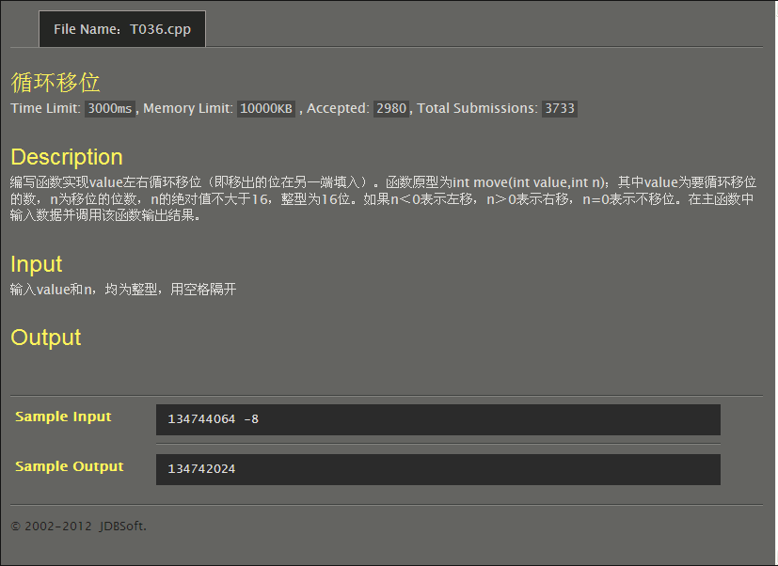
#include<stdio.h>
int _move(int value,int n)
{
int t;
if(n>0)
t=value>>n|value<<32-n;
else {
n=-n;
t=value<<n|value>>32-n;
}
return t;
}
int main()
{
int value,n;
scanf("%d%d",&value,&n);
printf("%d\n",_move(value,n));
return 0;
}
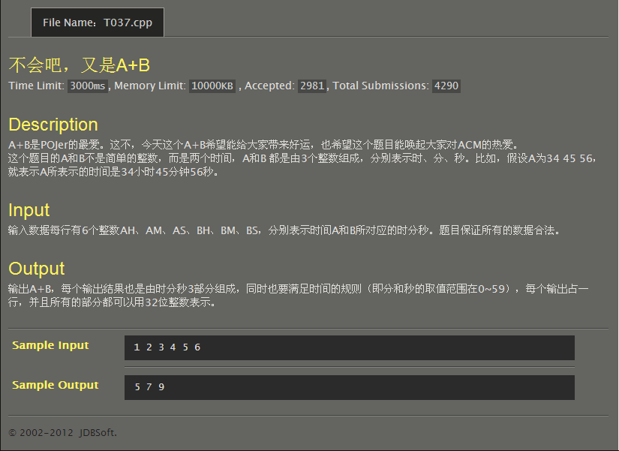
#include<stdio.h>
void timesum(int AH,int AM,int AS,int BH,int BM,int BS)
{
int h=0,m=0,s=0;
if(AS+BS>59) s=(AS+BS)-60,m++;
else s=AS+BS;
if(AM+BM>59) m+=((AM+BM)-60),h++;
else m=AM+BM;
h+=(AH+BH);
printf("%d %d %d\n",h,m,s);
}
int main()
{
int AH,AM,AS,BH,BM,BS;
scanf("%d%d%d%d%d%d",&AH,&AM,&AS,&BH,&BM,&BS);
timesum(AH,AM,AS,BH,BM,BS);
return 0;
}
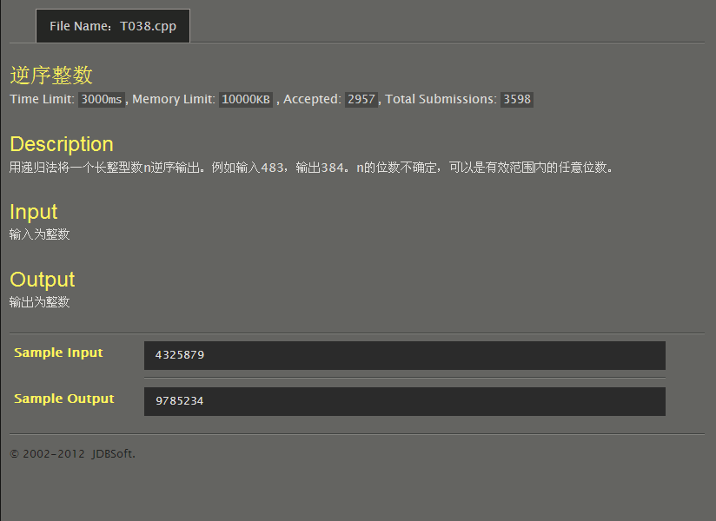
#include<stdio.h>
void f(long int n)
{
int m;
m=n%10;
printf("%d",m);
n/=10;
if(n!=0) f(n);
}
int main()
{
long int n;
scanf("%d",&n);
f(n);
return 0;
}
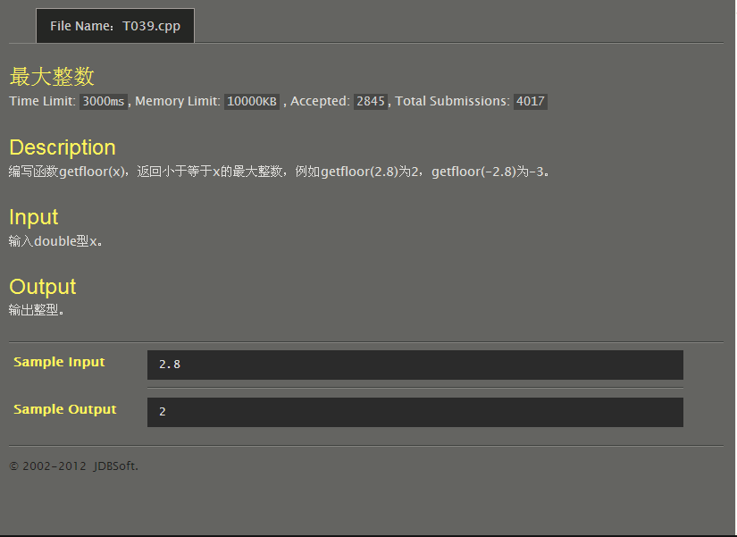
#include<stdio.h>
int getfloor(double x)
{
if(x>0) return (int)x;
else return (int)x-1;
}
int main()
{
double x;
scanf("%lf",&x);
printf("%d\n",getfloor(x));
return 0;
}
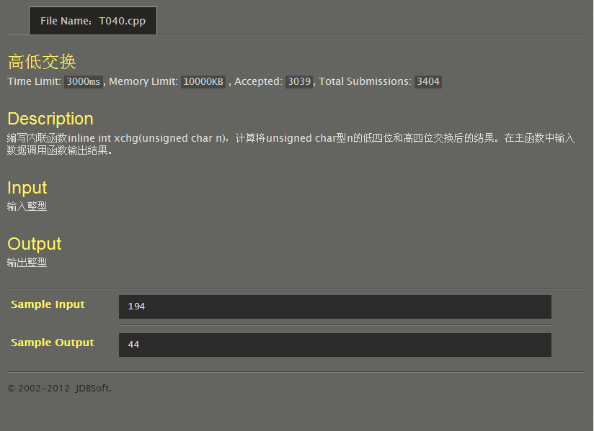
#include<stdio.h>
inline int xchg(unsigned char n)
{
n=n>>4|n<<4;
return n;
}
int main()
{
unsigned char n;
scanf("%d",&n);
printf("%d\n",xchg(n));
return 0;
}
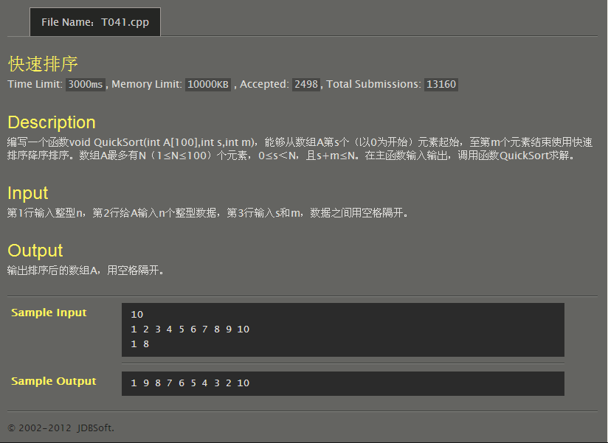
#include<stdio.h>
void QuickSort(int A[100],int s,int m)
{
int i,t;
for(;s<=m;s++)
{
for(i=s;i<=m;i++)
if(A[s]<A[i])
{
t=A[s];
A[s]=A[i];
A[i]=t;
}
printf("%d ",A[s]);
}
}
int main()
{
int s,m,n,i,A[100];
scanf("%d",&n);
for(i=0;i<n;i++)
scanf("%d",&A[i]);
scanf("%d%d",&s,&m);
for(i=0;i<s;i++)
printf("%d ",A[i]);
QuickSort(A,s,m);
for(i=m+1;i<n;i++)
printf("%d ",A[i]);
return 0;
}
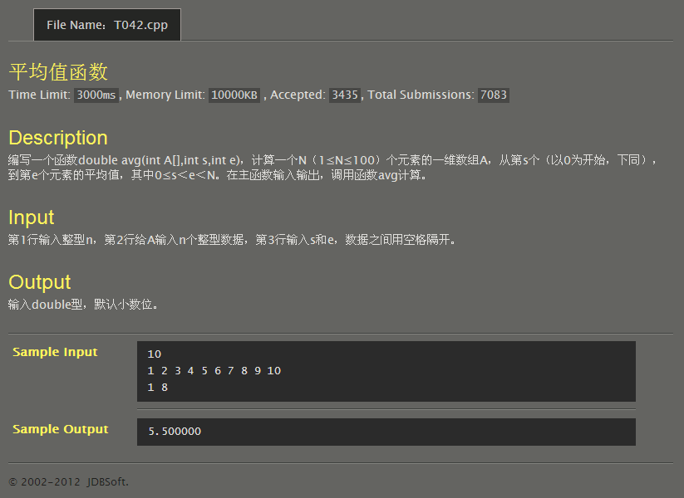
#include<stdio.h>
double avg(int A[100],int s,int e)
{
double sum;
for(sum=0;s<=e;s++)
sum=sum+A[s];
return sum;
}
int main()
{
int A[100],s,e,i,n;
double a;
scanf("%d",&n);
for(i=0;i<n;i++)
scanf("%d",&A[i]);
scanf("%d%d",&s,&e);
a=avg(A,s,e)/(e-s+1);
printf("%lf\n",a);
return 0;
}
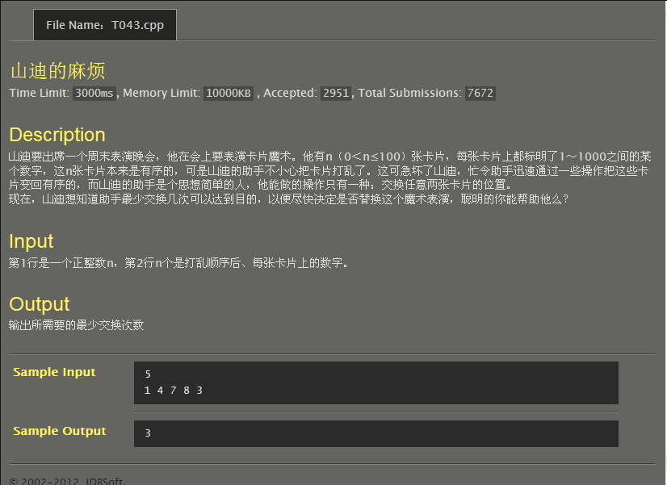
#include<stdio.h>
int main()
{
int n,a[100],i,j,s=0,t=0;
scanf("%d",&n);
for(i=0;i<n;i++)
scanf("%d",&a[i]);
for(i=0;i<n-1;i++)
for(j=i+1;j<n;j++)
{
if(a[i]>a[j]) s++;
else if(a[i]<a[j]) t++;
}
s=s>t?t:s;
printf("%d\n",s);
return 0;
}
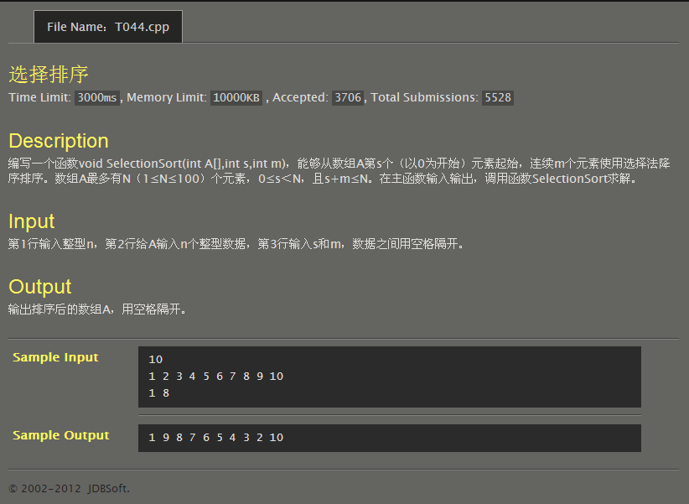
#include<stdio.h>
void SelectionSort(int A[],int s,int m)
{
int i,t,n;
for(n=s;n<=s+m-1;n++)
{
for(i=n;i<=s+m-1;i++)
if(A[n]<A[i])
{
t=A[n];
A[n]=A[i];
A[i]=t;
}
printf("%d ",A[n]);
}
}
int main()
{
int s,m,n,i,A[100];
scanf("%d",&n);
for(i=0;i<n;i++)
scanf("%d",&A[i]);
scanf("%d%d",&s,&m);
for(i=0;i<s;i++)
printf("%d ",A[i]);
SelectionSort(A,s,m);
for(i=m+1;i<n;i++)
printf("%d ",A[i]);
return 0;
}
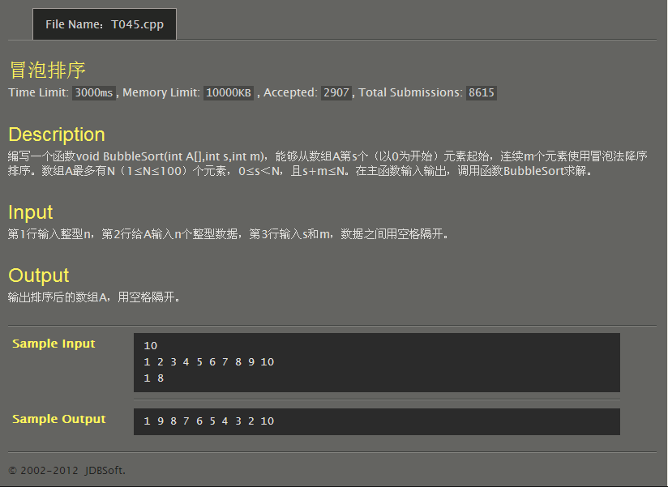
#include<stdio.h>
void SelectionSort(int A[],int s,int m)
{
int i,t,n;
for(n=s;n<=s+m-1;n++)
{
for(i=n;i<=s+m-1;i++)
if(A[n]<A[i])
{
t=A[n];
A[n]=A[i];
A[i]=t;
}
printf("%d ",A[n]);
}
}
int main()
{
int s,m,n,i,A[100];
scanf("%d",&n);
for(i=0;i<n;i++)
scanf("%d",&A[i]);
scanf("%d%d",&s,&m);
for(i=0;i<s;i++)
printf("%d ",A[i]);
SelectionSort(A,s,m);
for(i=m+1;i<n;i++)
printf("%d ",A[i]);
return 0;
}
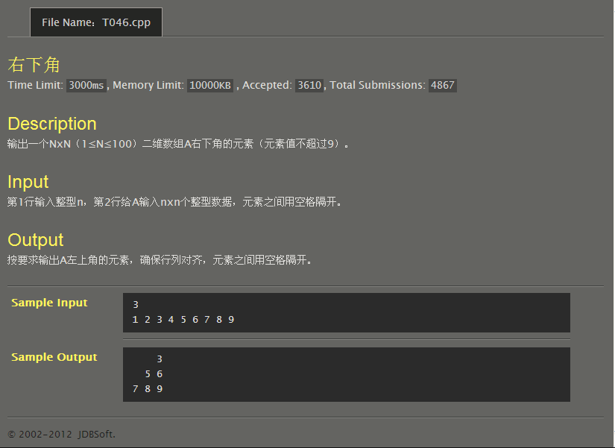
#include<stdio.h>
int main()
{
int a[100][100],n,i,j;
scanf("%d",&n);
for(i=0;i<n;i++)
for(j=0;j<n;j++)
scanf("%d",&a[i][j]);
for(i=0;i<n;i++)
for(j=0;j<n;j++)
{
if(j<n-i-1) printf(" ");
else printf("%d ",a[i][j]);
if(j==n-1) printf("\n");
}
return 0;
}
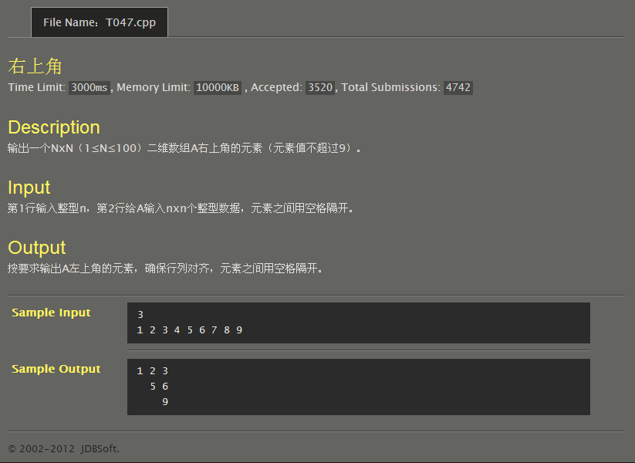
#include<stdio.h>
int main()
{
int a[100][100],n,i,j;
scanf("%d",&n);
for(i=0;i<n;i++)
for(j=0;j<n;j++)
scanf("%d",&a[i][j]);
for(i=0;i<n;i++)
for(j=0;j<n;j++)
{
if(j<i) printf(" ");
else printf("%d ",a[i][j]);
if(j==n-1) printf("\n");
}
return 0;
}
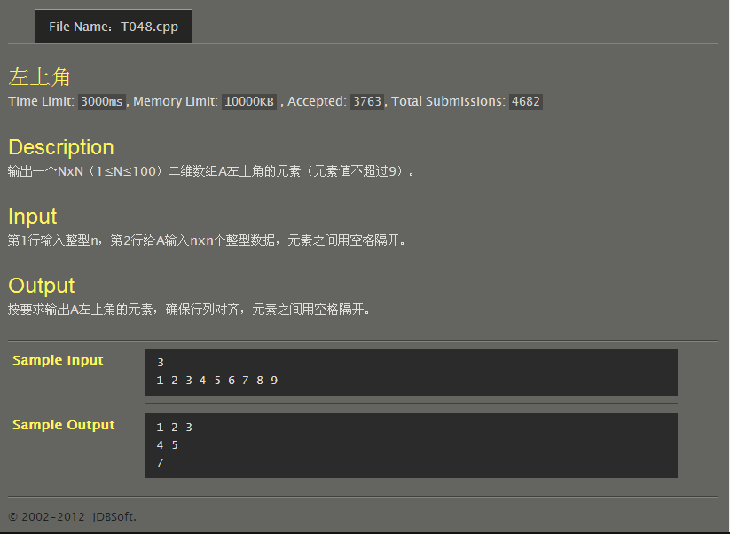
#include<stdio.h>
int main()
{
int a[100][100],n,i,j;
scanf("%d",&n);
for(i=0;i<n;i++)
for(j=0;j<n;j++)
scanf("%d",&a[i][j]);
for(i=0;i<n;i++)
for(j=0;j<n;j++)
{
if(j>n-i-1) printf(" ");
else printf("%d ",a[i][j]);
if(j==n-1) printf("\n");
}
return 0;
}
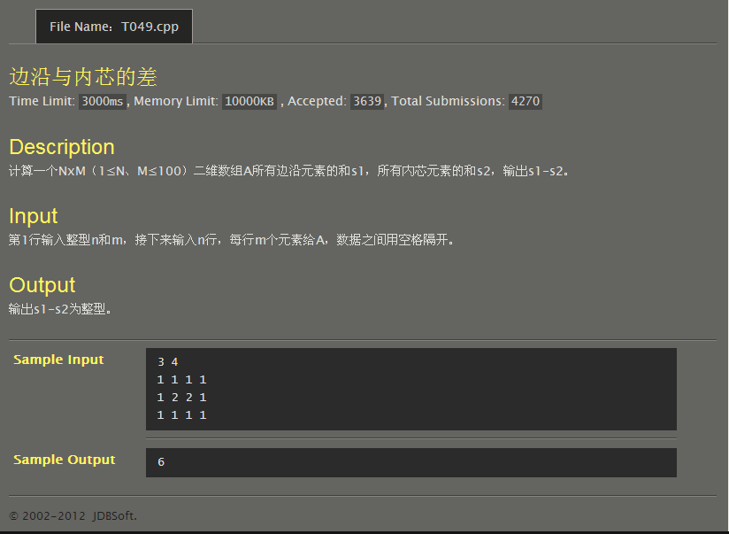
#include<stdio.h>
int main()
{
int a[100][100],n,m,i,j,s1,s2;
scanf("%d%d",&n,&m);
for(i=0;i<n;i++)
for(j=0;j<m;j++)
scanf("%d",&a[i][j]);
for(j=0,s1=0;j<m;j++)
s1=s1+a[0][j]+a[n-1][j];
for(i=1,s2=0;i<n-1;i++)
{
s1=s1+a[i][0]+a[i][m-1];
for(j=1;j<m-1;j++)
s2=s2+a[i][j];
}
printf("%d\n",s1-s2);
return 0;
}
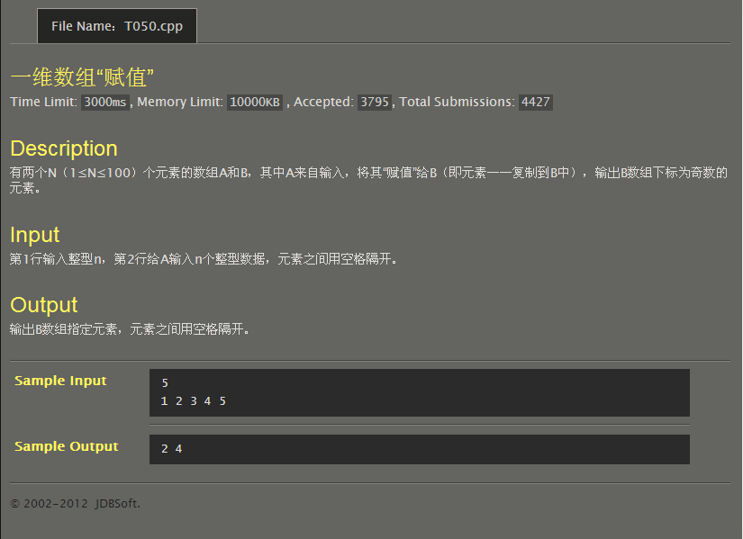
#include<stdio.h>
int main()
{
int a[100],b[100],i,j,n;
scanf("%d",&n);
for(i=0;i<n;i++)
{
scanf("%d",&a[i]);
b[i]=a[i];
}
for(i=1;i<n;i+=2)
printf("%d ",b[i]);
return 0;
}
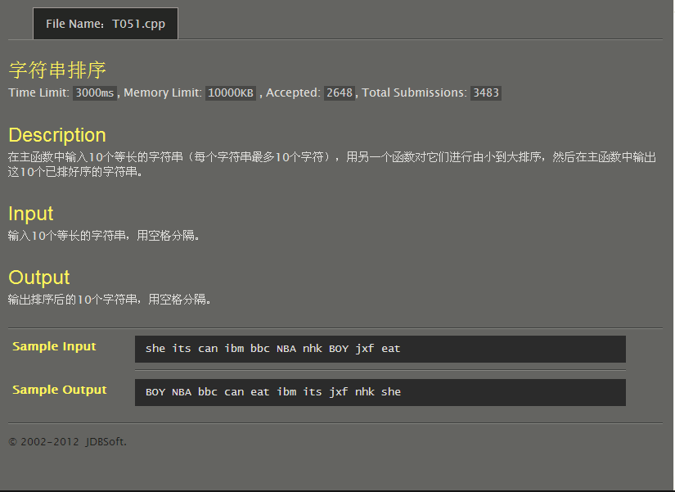
#include<stdio.h>
#include<string.h>
int main()
{
char a[10][10];
char b[10];
int i,j;
for(i=0;i<10;i++)
scanf("%s",&a[i]);
for(i=0;i<9;i++)
for(j=0;j<9-i;j++)
if(strcmp(a[j],a[j+1])>0)
strcpy(b,a[j]),strcpy(a[j],a[j+1]),strcpy(a[j+1],b);
for(i=0;i<10;i++)
printf("%s ",a[i]);
return 0;
}
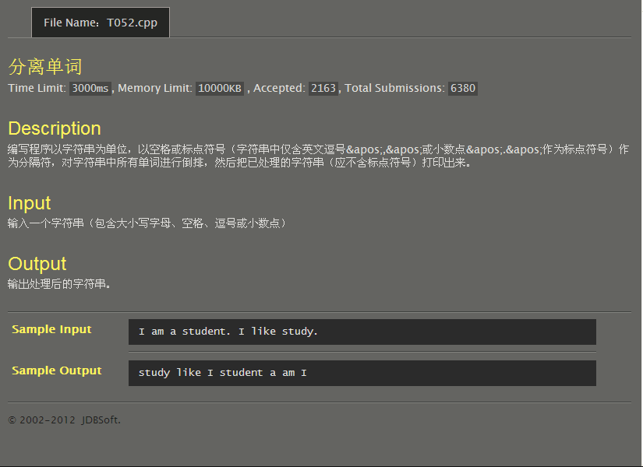
#include<stdio.h>
int main()
{
char a[10000],b[1000][10];
int i,j=0,k=0,m;
gets(a);
for(i=0;;i++)
{
if(a[i]==' '||a[i]==','||a[i]=='.'||a[i]=='\0')
{
for(m=0;j<i;j++,m++) b[k][m]=a[j];
k++;
for(;;i++) if(a[i+1]!=' '&&a[i+1]!=','&&a[i+1]!='.'){
j=i+1;
break;
}
}
if(a[i]=='\0')break;
}
for(i=k-1;i>=0;i--) printf("%s ",b[i]);
return 0;
}
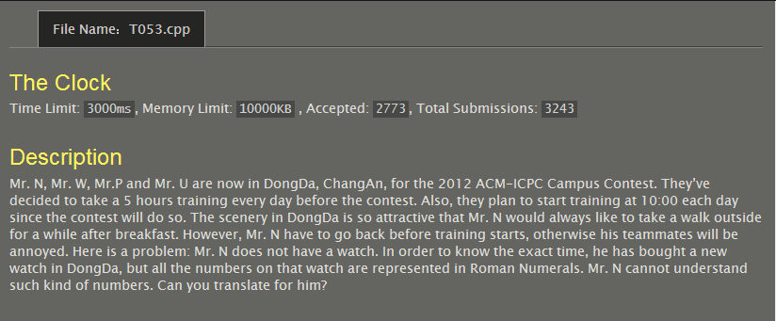
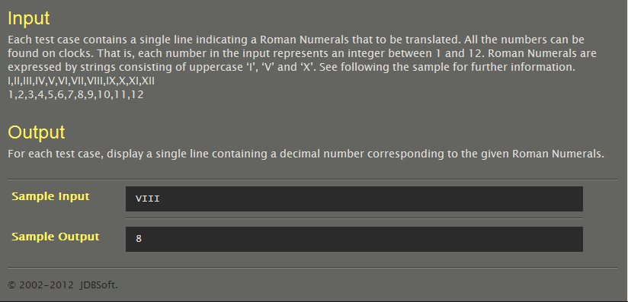
#include<stdio.h>
#include<string.h>
int main()
{
char A[][5]={"I","II","III","IV","V","VI","VII","VIII","IX","X","XI","XII"};
char B[5];
int i=0;
while((B[i]=getchar())!='\n')
i++;
B[i]='\0'; //这一句不能落下，否则结果都是13，不过为啥？
for(i=0;;i++)
{
if(strcmp(A[i],B)==0)
{
printf("%d\n",i+1);
break;
}
}
return 0;
}
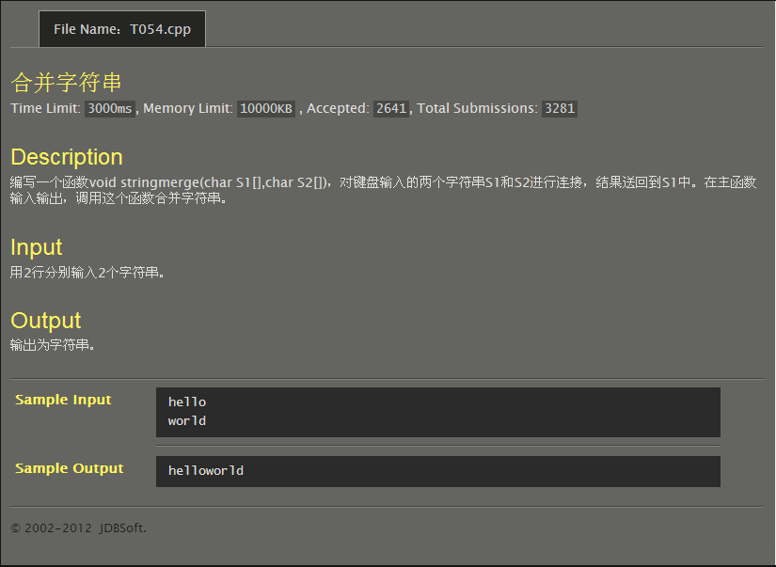
#include<stdio.h>
#include<string.h>
void stringmerge(char s1[],char s2[])
{
strcat(s1,s2);
}
int main()
{
char s1[10000],s2[10000];
gets(s1);
gets(s2);
stringmerge(s1,s2);
puts(s1);
return 0;
}
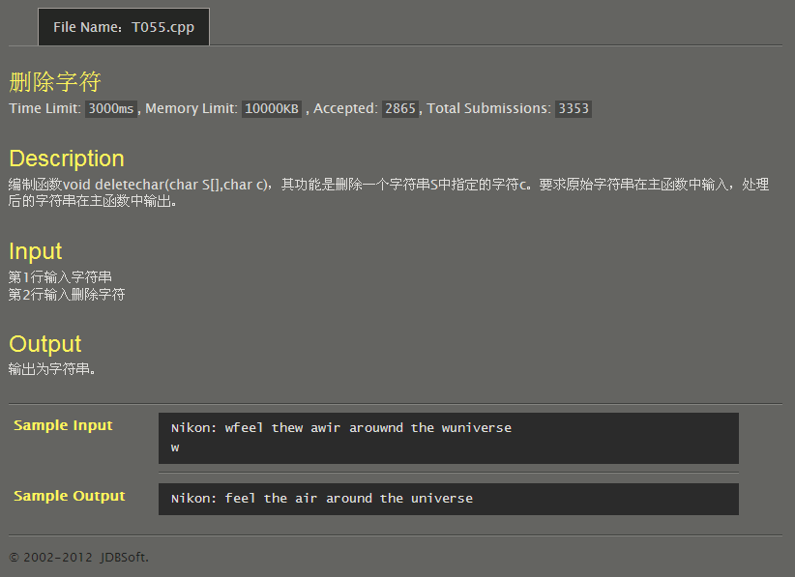
#include<stdio.h>
void deletechar(char s[],char c)
{
int i;
for(i=0;;i++)
{
if(s[i]==c)continue;
if(putchar(s[i])=='\0')break;
}
}
int main()
{
char s[10000],c;
gets(s);
scanf("%c",&c);
deletechar(s,c);
return 0;
}
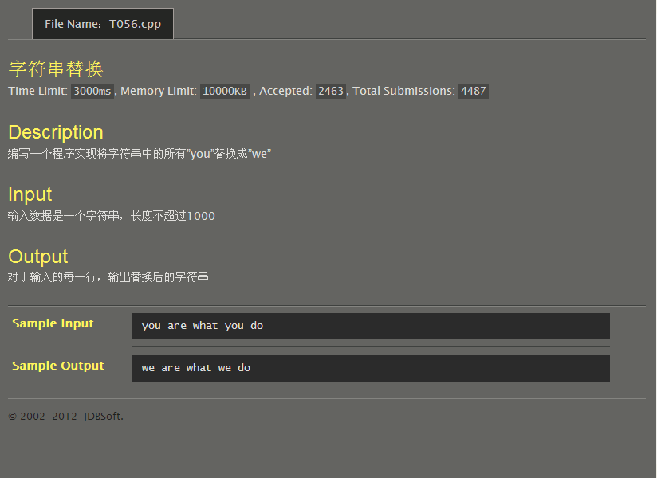
#include<stdio.h>
#include<string.h>
int main()
{
char a[1000];
int i,n;
gets(a);
n=strlen(a);
for(i=0;i<n;)
{
if(a[i]=='y'&&a[i+1]=='o'&&a[i+2]=='u')
{
printf("%s","we");
i+=3;
continue;
}
putchar(a[i]);
i++;
}
return 0;
}
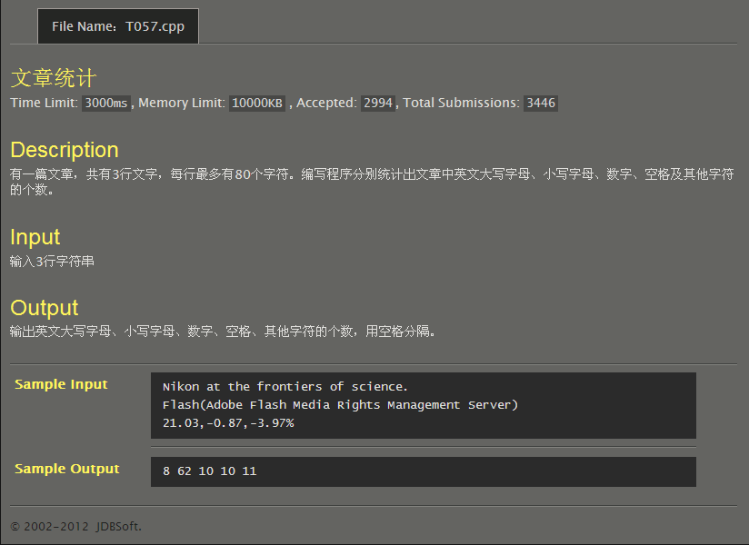
#include<stdio.h>
#include<string.h>
int main()
{
int i=0,j=0,k=0,m=0,n=0,x,y,z,t;
char a[80],b[80],c[80];
gets(a);
gets(b);
gets(c);
x=strlen(a);
y=strlen(b);
z=strlen(c);
for(t=0;t<x;t++)
{
if(a[t]>='A'&&a[t]<='Z')i++;
else if(a[t]>='a'&&a[t]<='z')j++;
else if(a[t]>='0'&&a[t]<='9')k++;
else if(a[t]==' ')m++;
else n++;
}
for(t=0;t<y;t++)
{
if(b[t]>='A'&&b[t]<='Z')i++;
else if(b[t]>='a'&&b[t]<='z')j++;
else if(b[t]>='0'&&b[t]<='9')k++;
else if(b[t]==' ')m++;
else n++;
}
for(t=0;t<z;t++)
{
if(c[t]>='A'&&c[t]<='Z')i++;
else if(c[t]>='a'&&c[t]<='z')j++;
else if(c[t]>='0'&&c[t]<='9')k++;
else if(c[t]==' ')m++;
else n++;
}
printf("%d %d %d %d %d\n",i,j,k,m,n);
return 0;
}
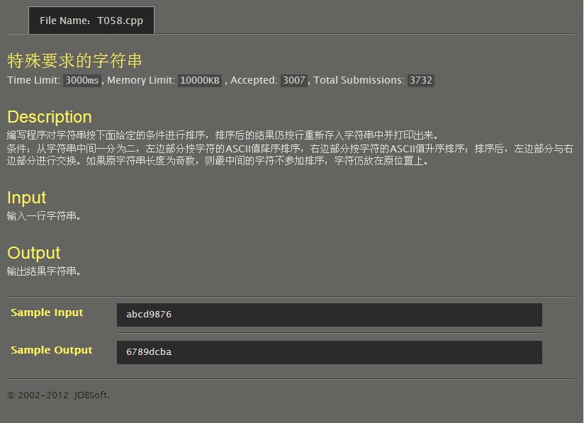
#include<stdio.h>
#include<string.h>
int main()
{
char a[10000],b[5000],c[5000],t,k;
int n,i,j;
gets(a);
n=strlen(a);
if(n%2==0)
{
for(i=0;i<n/2;i++)
b[i]=a[i];
for(i=n/2;i<n;i++)
c[i-n/2]=a[i];
for(i=1;i<n/2;i++)
for(j=0;j<n/2-i;j++)
if(b[j]<b[j+1]) t=b[j],b[j]=b[j+1],b[j+1]=t;
for(i=1;i<n/2;i++)
for(j=0;j<n/2-i;j++)
if(c[j]>c[j+1]) t=c[j],c[j]=c[j+1],c[j+1]=t;
strcat(c,b);
puts(c);
}
else
{
for(i=0;i<n/2;i++)
b[i]=a[i];
for(i=n/2+1;i<n;i++)
c[i-(n/2+1)]=a[i];
for(i=1;i<n/2;i++)
for(j=0;j<n/2-i;j++)
if(b[j]<b[j+1]) t=b[j],b[j]=b[j+1],b[j+1]=t;
for(i=1;i<n/2;i++)
for(j=0;j<n/2-i;j++)
if(c[j]>c[j+1]) t=c[j],c[j]=c[j+1],c[j+1]=t;
printf("%s",c);
putchar(a[n/2]);
printf("%s",b);
}
return 0;
}
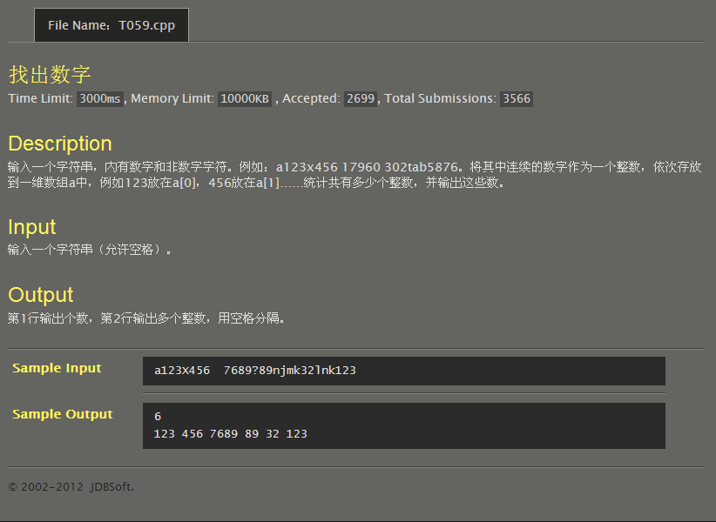
#include<stdio.h>
#include<string.h>
int main()
{
char a[1000][10],b[10000];
int i,j,k,n,s,t;
gets(b);
n=strlen(b);
for(i=0,j=0;i<=n;i++)
{
if((b[i]>='0'&&b[i]<='9')&&(b[i-1]<'0'||b[i-1]>'9'))
s=i;
if((b[i]>='0'&&b[i]<='9')&&(b[i+1]<'0'||b[i+1]>'9'))
{
t=i;
for(k=s;k<=t;k++)
a[j][k-s]=b[k];
j++;
}
}
printf("%d\n",j);
for(i=0;i<j;i++)
printf("%s ",a[i]);
return 0;
}
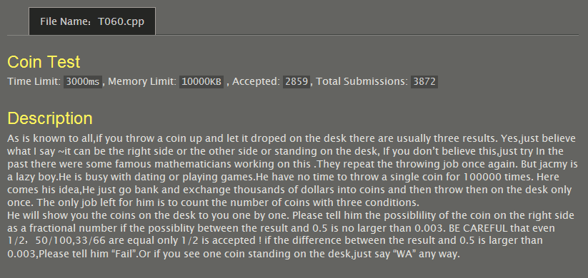
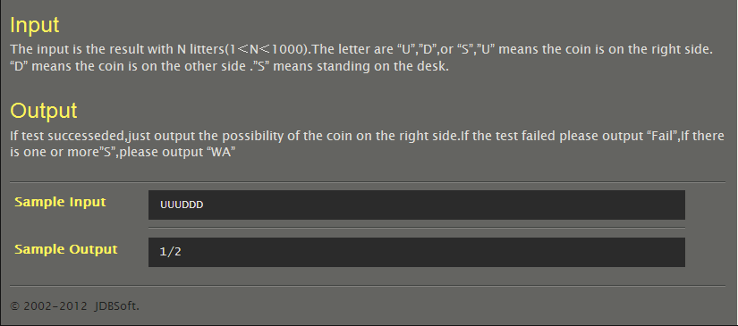
#include<stdio.h>
#include<string.h>
#include<math.h>
int main()
{
char a[1000];
int n,i,j,k=0,t;
gets(a);
n=strlen(a);
for(i=0,j=0;i<n;i++)
{
if(a[i]=='S')
{
printf("WA\n");
k++;
break;
}
if(a[i]=='U')j++;
}
if(k==0)
{
if(fabs((double)j/n-0.5)>0.003)printf("Fail\n");
else
{
if(n%j!=0) printf("%d/%d",j,n);
else
{
k=n;
t=j;
while(k%t!=0)
{
i=k%t;
k=t;
t=i;
}
n/=t;
j/=t;
printf("%d/%d\n",j,n);
}
}
}
return 0;
}

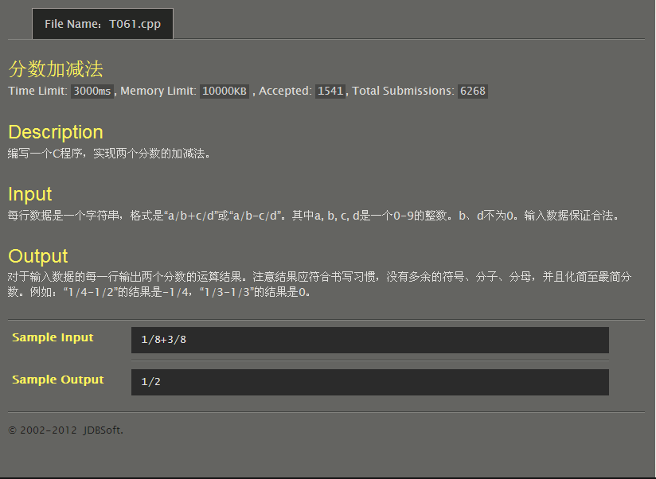
#include<stdio.h>
int main()
{
char s[10];
int i,j,a,b,c,d;
gets(s);
a=s[0]-48,b=s[2]-48,c=s[4]-48,d=s[6]-48;
i=b;
while(i%d!=0)i+=b;
a*=(i/b);
c*=(i/d);
if(s[3]=='+')
{
a+=c,b=a,c=i;
if(c%b==0)c/=b,printf("1/%d\n",c);
else
{
while(c%b!=0)j=c%b,c=b,b=j;
a/=j,i/=j;
printf("%d/%d\n",a,i);
}
}
if(s[3]=='-')
{
a-=c,b=a,c=i;
if(b==0)printf("0\n");
else if(b<0)
{
b=-b;
if(c%b==0)c/=b,printf("-1/%d\n",c);
else
{
while(c%b!=0)j=c%b,c=b,b=j;
a/=j,i/=j;
printf("-%d/%d\n",a,i);
}
}
else
{
if(c%b==0)c/=b,printf("1/%d\n",c);
else
{
while(c%b!=0)j=c%b,c=b,b=j;
a/=j,i/=j;
printf("%d/%d\n",a,i);
}
}
}
return 0;
}
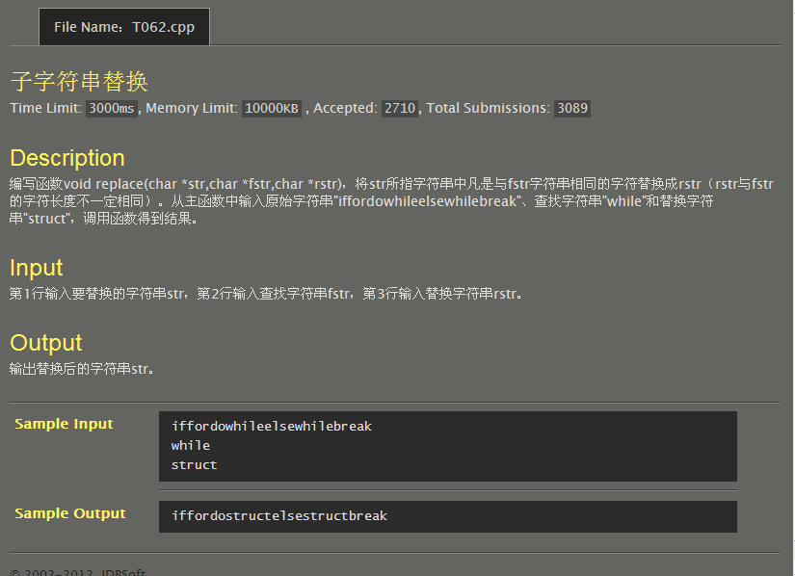
#include<stdio.h>
#include<string.h>
void _replace(char *str,char *fstr,char *rstr)
{
int i,j,k,n=strlen(fstr),s,t=strlen(rstr);
char a[1000];
for(i=0;;i++)
{
j=0;
if(str[i]=='\0') break;
for(k=i;j<n;k++,j++){
if(str[k]==fstr[j])continue;
else break;
}
if(j==n){
for(j=0;j<i;j++) a[j]=str[j];
a[i]='\0';
strcat(a,rstr);
for(j=i+t,s=k;;j++,s++){
a[j]=str[s];
if(str[s]=='\0') break;
}
strcpy(str,a);
}
}
}
int main()
{
char a[1000],b[100],c[100],*str=a,*fstr=b,*rstr=c;
gets(str);
gets(fstr);
gets(rstr);
_replace(str,fstr,rstr);
puts(str);
return 0;
}
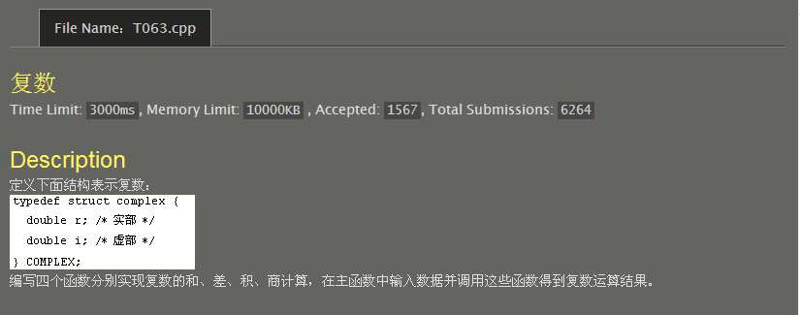
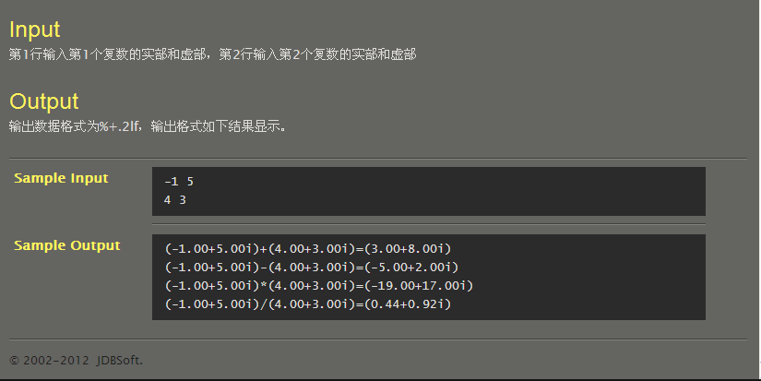
#include<stdio.h>
void add(double *p1,double *p2,double *p3,double *p4)
{
*p1+=*p3;
*p2+=*p4;
}
void mns(double *p1,double *p2,double *p3,double *p4)
{
*p1-=*p3;
*p2-=*p4;
}
void multi(double *p1,double *p2,double *p3,double *p4)
{
double t=*p1;
*p1=t*(*p3)-(*p2)*(*p4);
*p2=(*p2)*(*p3)+t*(*p4);
}
void div(double *p1,double *p2,double *p3,double *p4)
{
double s=*p1;
*p1=(s*(*p3)+(*p2)*(*p4))/((*p3)*(*p3)+(*p4)*(*p4));
*p2=((*p2)*(*p3)-s*(*p4))/((*p3)*(*p3)+(*p4)*(*p4));
}
int main()
{
double a,b,c,d,*p1=&a,*p2=&b,*p3=&c,*p4=&d;
scanf("%lf%lf%lf%lf",&a,&b,&c,&d);
double m=a,n=b,s=c,t=d;
add(p1,p2,p3,p4);
printf("(%.2lf+%.2lfi)+(%.2lf+%.2lfi)=(%.2lf%+.2lfi)\n",m,n,s,t,*p1,*p2);
*p1=m,*p2=n;
mns(p1,p2,p3,p4);
printf("(%.2lf+%.2lfi)-(%.2lf+%.2lfi)=(%.2lf%+.2lfi)\n",m,n,s,t,*p1,*p2);
*p1=m,*p2=n;
multi(p1,p2,p3,p4);
printf("(%.2lf+%.2lfi)*(%.2lf+%.2lfi)=(%.2lf%+.2lfi)\n",m,n,s,t,*p1,*p2);
*p1=m,*p2=n;
div(p1,p2,p3,p4);
printf("(%.2lf+%.2lfi)/(%.2lf+%.2lfi)=(%.2lf%+.2lfi)\n",m,n,s,t,*p1,*p2);
return 0;
}

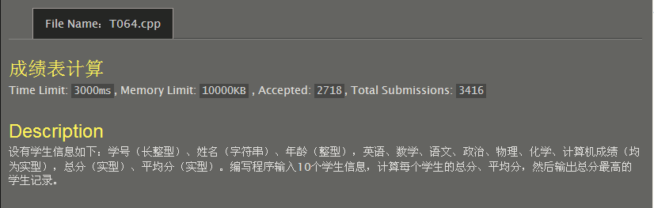
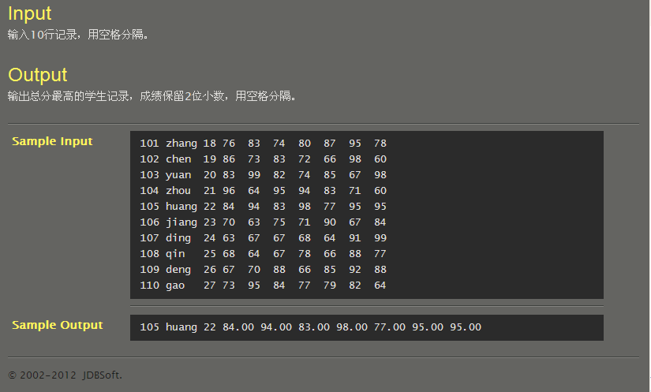
#include<stdio.h>
struct tagGRADE{
long int no;
char name[21];
int age;
double English,math,Chinese,politics,physics,chemistry,computer;
};
int main()
{
struct tagGRADE a[10];
int i,j;
double sum[10];
for(i=0;i<10;i++)
scanf("%d%s%d%lf%lf%lf%lf%lf%lf%lf",&a[i].no,&a[i].name,&a[i].age,&a[i].English,&a[i].math,&a[i].Chinese,&a[i].politics,&a[i].physics,&a[i].chemistry,&a[i].computer);
for(i=0;i<10;i++)
sum[i]=a[i].English+a[i].math+a[i].Chinese+a[i].politics+a[i].physics+a[i].chemistry+a[i].computer;
for(i=0,j=0;i<10;i++) if(sum[j]<sum[i]) j=i;
printf("%d %s %d %.2lf %.2lf %.2lf %.2lf %.2lf %.2lf %.2lf",a[j].no,a[j].name,a[j].age,a[j].English,a[j].math,a[j].Chinese,a[j].politics,a[j].physics,a[j].chemistry,a[j].computer);
return 0;
}
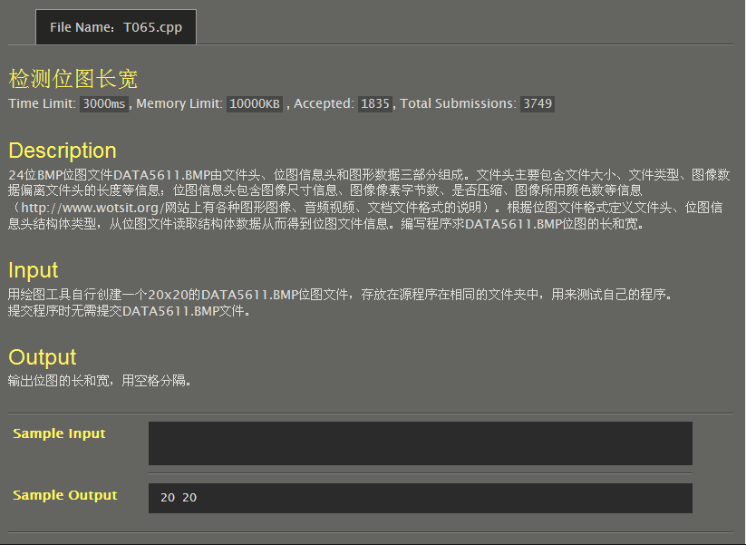
#include<stdio.h>
#pragma pack(1)
struct BITMAPFILEHEADER{
unsigned short bfType;
unsigned int bfSize;
unsigned short bfReserved1;
unsigned short bfReserved2;
unsigned int bfOffBits;
};
struct BITMAPINFOHEADER{
unsigned int biSize;
long biWidth;
long biHeight;
unsigned short biPlanes;
unsigned short biBitcount;
unsigned int biCompression;
unsigned int biSizeImage;
long biXPelsPerMeter;
long biYPelsPerMeter;
unsigned int biClrUsed;
unsigned int biClrImportant;
};
int main()
{
BITMAPFILEHEADER bmfh;
BITMAPINFOHEADER bmih;
FILE *bmp;
bmp=fopen("DATA5611.BMP","rb");
if(bmp!=NULL){
fread(&bmfh,sizeof(BITMAPFILEHEADER),1,bmp);
fread(&bmih,sizeof(BITMAPINFOHEADER),1,bmp);
printf("%d %d\n",bmih.biWidth,bmih.biHeight);
fclose(bmp);
}
return 0;
}
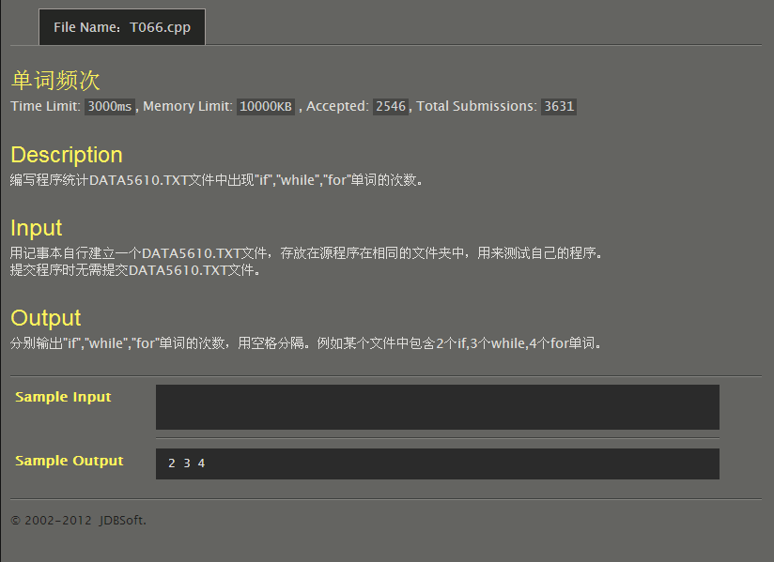
#include<stdio.h>
int main()
{
FILE *fp;
int i=0,j=0,k=0;
char a;
fp=fopen("DATA5610.TXT","r");
if(fp!=NULL){
while(!feof(fp)){
fscanf(fp,"%c",&a);
if(a=='i') if(fgetc(fp)=='f')i++;
else fseek(fp,-1,1);
else if(a=='w'){
if(fgetc(fp)=='h') if(fgetc(fp)=='i') if(fgetc(fp)=='l') if(getc(fp)=='e')j++;
else fseek(fp,-4,1);
else fseek(fp,-3,1);
else fseek(fp,-2,1);
else fseek(fp,-1,1);
}
else if(a=='f'){
if(fgetc(fp)=='o') if(fgetc(fp)=='r')k++;
else fseek(fp,-2,1);
else fseek(fp,-1,1);
}
}
fclose(fp);
}
printf("%d %d %d\n",i,j,k);
return 0;
}

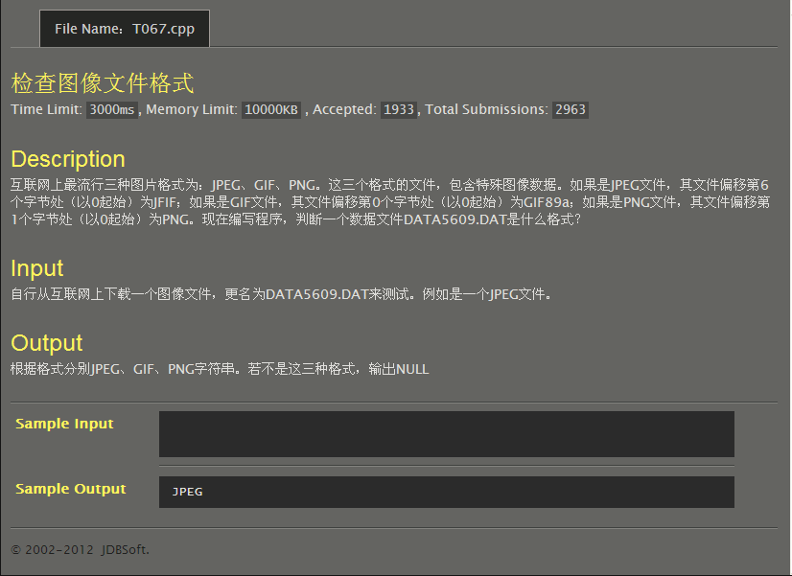
#include<stdio.h>
#include<string.h>
int main()
{
FILE *fp=fopen("DATA5609.DAT","r");
char a[7],b[4],c[5];
int i;
if(fp!=NULL){
for(i=0;i<6;i++) a[i]=fgetc(fp);
a[6]='\0';
fseek(fp,1L,0);
for(i=0;i<3;i++) b[i]=fgetc(fp);
b[3]='\0';
fseek(fp,6L,0);
for(i=0;i<4;i++) c[i]=fgetc(fp);
c[4]='\0';
if(strcmp(a,"GIF89a")==0){ printf("GIF\n");
return 0;
}
else if(strcmp(b,"PNG")==0){ printf("PNG\n");
return 0;
}
else if(strcmp(c,"JFIF")==0){ printf("JPEG\n");
return 0;
}
else printf("NULL\n");
return 0;
}
return 0;
}
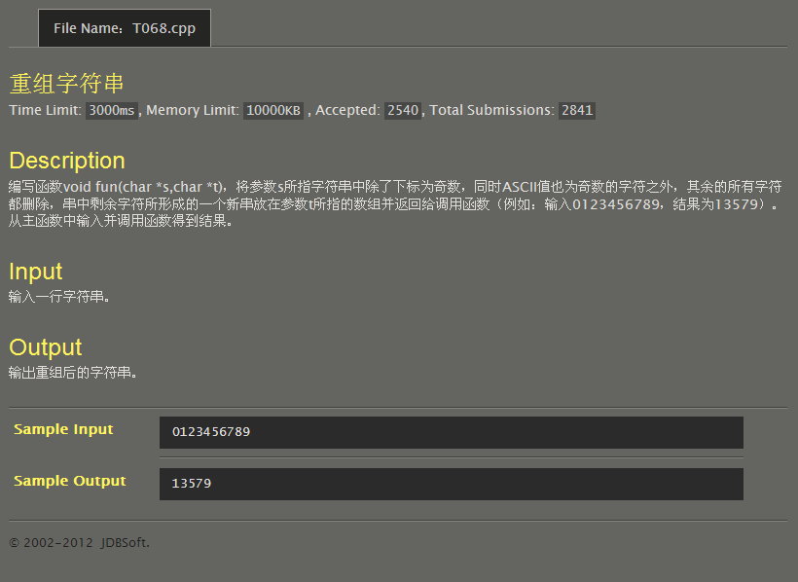
#include<stdio.h>
#include<string.h>
void fun(char *s,char *t)
{
int i,j,n;
n=strlen(s);
for(i=1,j=0;i<n;i+=2)
if(s[i]%2==1) t[j]=s[i],j++;
}
int main()
{
char a[1000],b[1000],*s=a,*t=b;
gets(s);
fun(s,t);
puts(t);
return 0;
}
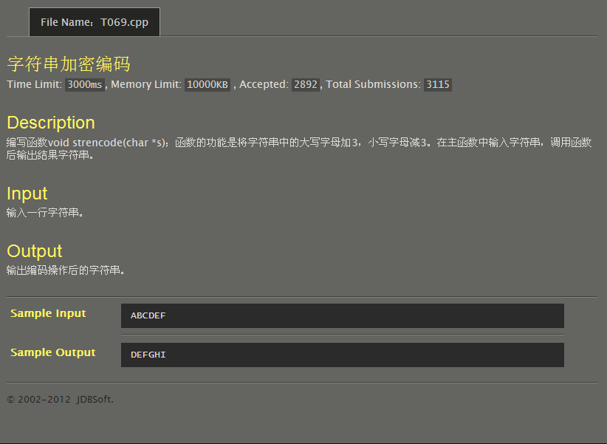
#include<stdio.h>
#include<string.h>
void strencode(char *s)
{
char n,i;
n=strlen(s);
for(i=0;i<n;i++){
if(s[i]>64&&s[i]<91) s[i]+=3;
if(s[i]>96&&s[i]<123) s[i]-=3;
}
}
int main()
{
char a[1000],*s=a;
gets(s);
strencode(s);
puts(s);
return 0;
}
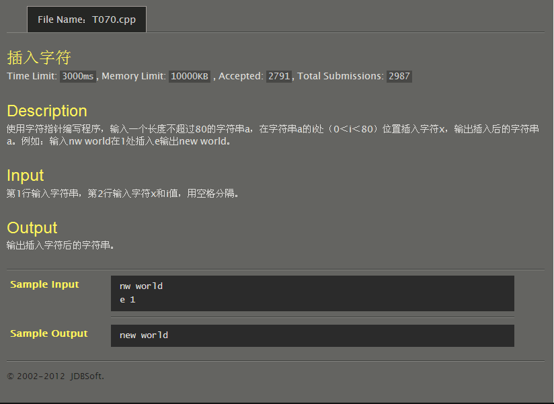
#include<stdio.h>
#include<string.h>
int main()
{
char a[81],b[82],*s=a,x;
int i,j,n;
gets(s);
n=strlen(s);
scanf("%c %d",&x,&i);
for(j=0;j<i;j++) b[j]=a[j];
b[i]=x;
for(j=i;j<n;j++) b[j+1]=a[j];
b[n+1]='\0';
puts(b);
return 0;
}
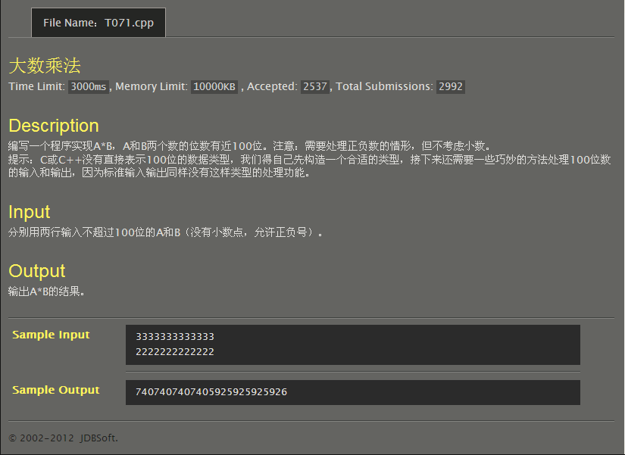
#include<stdio.h>
#include<string.h>
#include<stdlib.h>
int main()
{
char a[102],b[102],c[100][300],t;
int i,j,k,m,n,s,f[300],u=0;
gets(a);
gets(b);
m=strlen(a),n=strlen(b);
if(a[0]=='-'){
u++;
for(i=0;i<m;i++)a[i]=a[i+1];
m-=1;
}
if(b[0]=='-'){
u++;
for(i=0;i<n;i++)b[i]=b[i+1];
n-=1;
}
if(u==1)printf("-");
for(i=n-1,k=0;i>=0;i--,k++){
for(j=m-1,s=0,t=48;j>=0;j--,s++){
c[k][s]=((a[j]-48)*(b[i]-48)+t-48)%10+48;
t=((a[j]-48)*(b[i]-48)+t-48)/10+48;
}
if(t!=48) c[k][s]=t,c[k][s+1]='\0';
else c[k][s]='\0';
}
s=0;
while(c[n-1][s]!='\0')s++;
for(i=0;i<n;i++){
j=0;
while(c[i][j]!='\0')j++;
for(k=j+i-1,t=j-1;k>=i;k--,t--) c[i][k]=c[i][t];
for(k=0;k<i;k++)c[i][k]=48;
for(k=j+i;k<s+n-1;k++)c[i][k]=48;
}
for(i=0;i<s+n-1;i++)
for(f[i]=0,j=0;j<n;j++)f[i]=f[i]+c[j][i]-48;
for(i=0,j=0;i<s+n-1;i++){
t=f[i];
f[i]=(f[i]+j)%10;
j=(t+j)/10;
}
if(j!=0){
f[i]=j;
for(j=i;j>=0;j--)printf("%d",f[j]);
}
else for(j=i-1;j>=0;j--)printf("%d",f[j]);
return 0;
}

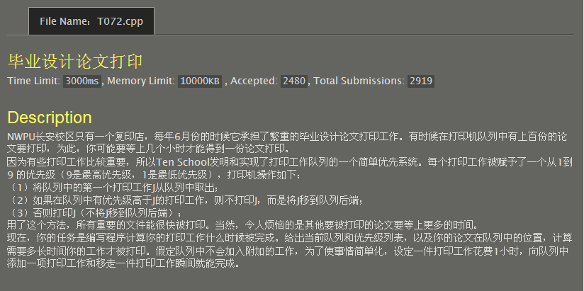
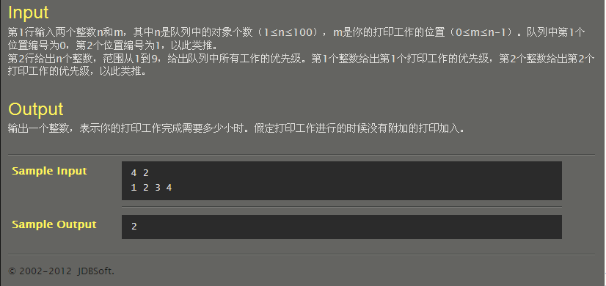
#include<stdio.h>
int main()
{
int n,m,i,cnt=1,a[100];
scanf("%d %d",&n,&m);
for(i=0;i<n;i++)
scanf("%d",&a[i]);
for(i=0;i<n;i++)
if(a[i]>a[m]) cnt++;
for(i=0;i<m;i++)
if(a[i]==a[m]) cnt++;
printf("%d\n",cnt);
return 0;
}
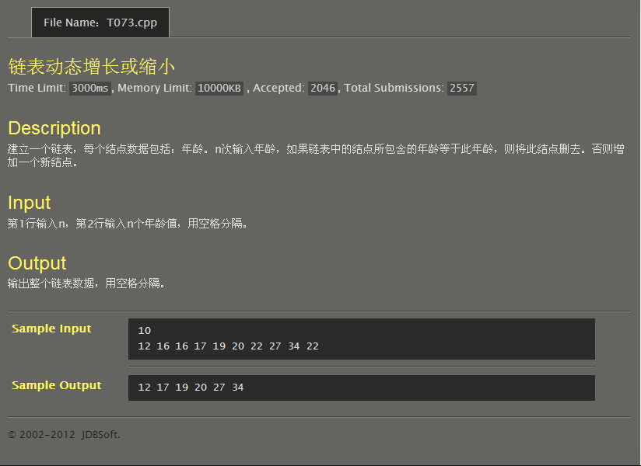
#include<stdio.h>
#include<stdlib.h>
typedef struct tagNode{
int data;
struct tagNode *prev,*next;
}Node,*LinkList;
void CreateLink(LinkList *L,int n)
{
LinkList p,q,s;
int u;
p=*L=(LinkList)malloc(sizeof(Node));
p->prev=NULL;
s=(LinkList)malloc(sizeof(Node));
p->next=s,s->prev=p,s->next=NULL;
scanf("%d",&s->data);
for(;n>1;n--){
u=0;
p=(*L)->next;
s=(LinkList)malloc(sizeof(Node));
scanf("%d",&s->data);
while(p!=NULL){
if(p->data==s->data){
if(p->next==NULL){
p->prev->next=NULL;
free(p),free(s),p=NULL;
}
else{
q=p->prev->next=p->next;
p->next->prev=p->prev;
free(p),p=q,u++;
}
}
else{
if(p->next!=NULL) p=p->next;
else{
if(u!=0) p=p->next,free(s);
else{
p->next=s,s->prev=p,p=s->next=NULL;
}
}
}
}
}
}
int main()
{
LinkList L;
int n;
scanf("%d",&n);
CreateLink(&L,n);
while(L->next!=NULL){
L=L->next;
printf("%d ",L->data);
}
return 0;
}
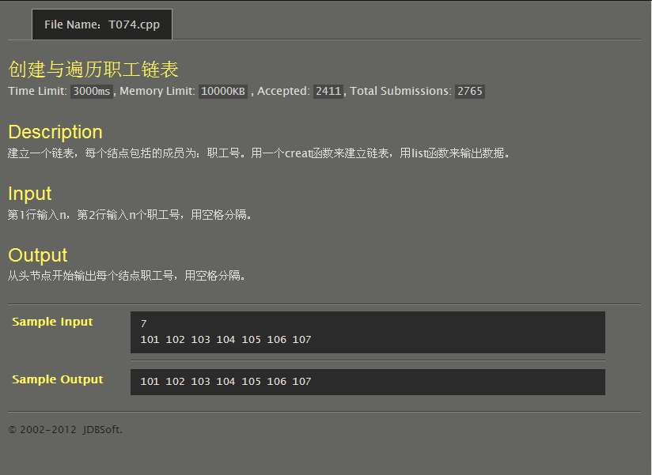
#include<stdio.h>
int main()
{
int i,n,a[10000];
scanf("%d",&n);
for(i=0;i<n;i++)
scanf("%d",&a[i]);
for(i=0;i<n;i++)
printf("%d ",a[i]);
return 0;
}
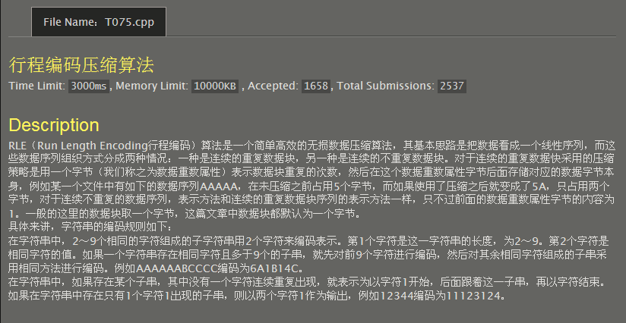
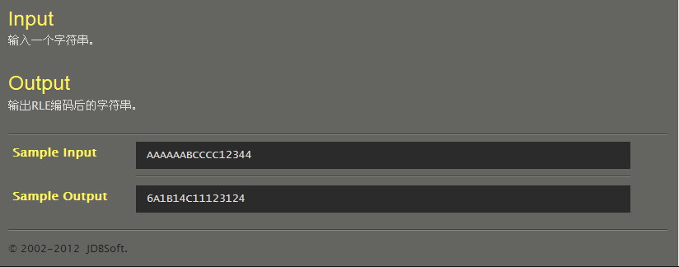
#include<stdio.h>
#include<string.h>
int main()
{
char a[1000],b[1000];
int i,j,k,s,t,m,n;
gets(a);
n=strlen(a);
for(i=0,m=0;i<n;){
if(a[i]==a[i+1]){
for(j=i,k=1;;j++){
if(a[j]==a[j+1])k++;
else break;}
if(k>9){s=k/9,t=k%9;
for(;s>0;s--)b[m]='9',b[++m]=a[i],m++;
if(t==1)b[m]='1',b[++m]=a[i],b[++m]='1',m++,i=j+1;
else b[m]=t+48,b[++m]=a[i],m++,i=j+1;}
else b[m]=k+48,b[++m]=a[i],i=j+1,m++;}
if(i==n)break;
if(a[i]=='1'&&a[i+1]!='1') b[m]='1',b[++m]='1',i++,m++;
if(i==n)break;
if(a[i]!='1'&&a[i]!=a[i+1]){j=i;
while(a[j]!=a[j+1]&&a[j+1]!=a[j+2]){
if(a[j+2]=='\0'||a[j+2]=='1'){j++;
break;}
j++;}
b[m]='1';
for(k=i,m++;i<=j;i++,m++)b[m]=a[i];
b[m]='1';
m++;}
if(i==n)break;}
b[m]='\0';
printf("%s",b);
}
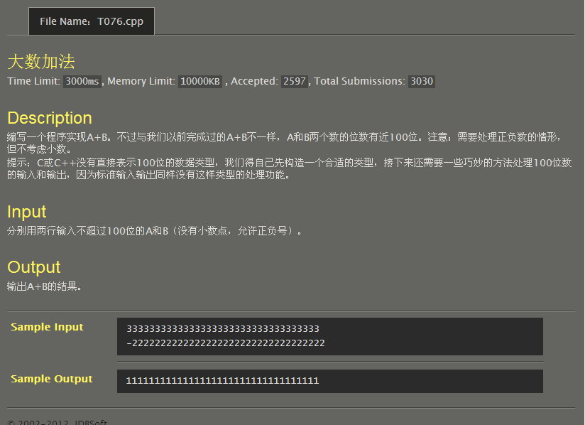
#include<stdio.h>
#include<string.h>
int main()
{
char a[102],b[102],c[200],*p=a,*q=b,*r;
int i,j,m,n,u=0,f[200];
gets(a);
gets(b);
m=strlen(a),n=strlen(b);
if(a[0]=='-'){
u++;
for(i=0;i<m;i++)a[i]=a[i+1];
m-=1;}
if(b[0]=='-'){
u++;
for(i=0;i<n;i++)b[i]=b[i+1];
n-=1;}
if(u==1){
if(m<n) r=p,p=q,q=r,u=m,m=n,n=u;
if(m==n){for(i=0;i<m;i++)if(a[i]<b[i]){
r=p,p=q,q=r;
break;}}
for(i=m-1,u=n-1;i>=m-n;i--,u--)q[i]=q[u];
for(i=0;i<m-n;i++)q[i]=48;
for(i=m-1;i>=0;i--){
if(p[i]>=q[i]) f[i]=p[i]-q[i];
else{
u=i;
if(p[u-1]==48){
f[i]=p[i]+10-q[i];
while(p[u-1]==48){
p[u-1]='9';
if(p[u-2]!=48)p[u-2]-=1;
u--;}}
else f[i]=p[i]+10-q[i],f[i-1]-=1;}}
for(i=0;;i++)if(f[i]!=0)break;
for(;i<m;i++)printf("%d",f[i]);}
else{if(m<n) r=p,p=q,q=r,u=m,m=n,n=u;
for(i=m-1,j=n-1;i>=m-n;i--,j--)q[i]=q[j];
for(i=0;i<m-n;i++)q[i]=48;
for(i=m-1,j=0;i>=0;i--){
f[i]=(p[i]-48+q[i]-48+j)%10;
j=(p[i]-48+q[i]-48+j)/10;}
if(u==2) printf("-");
if(j!=0){ printf("%d",j);
for(i=0;i<m;i++)printf("%d",f[i]);}
else for(i=0;i<m;i++)printf("%d",f[i]);}
return 0;
}
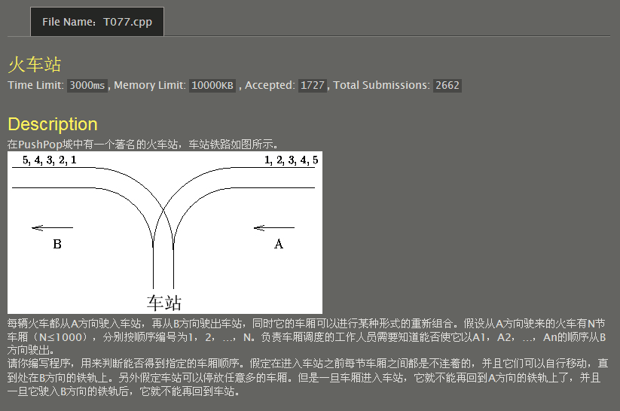
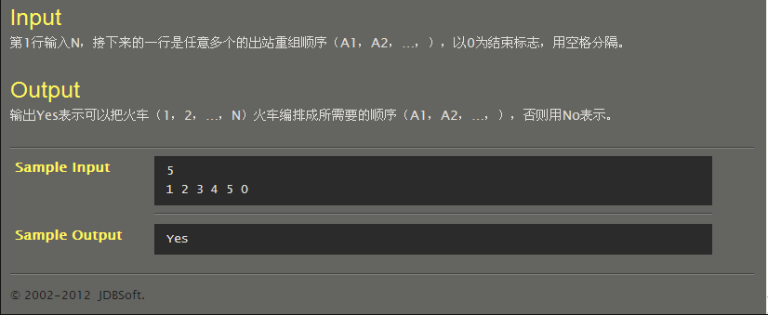
#include<stdio.h>
#include<stdlib.h>
typedef struct tagNode{
int data;
struct tagNode *prev,*next;
}Node,*LinkList;
int Judge(int a[]){
int i=0,j=1;
LinkList L,p=L=(LinkList)malloc(sizeof(Node)),s;
while(a[i]!=0){if(j==a[i])j++,i++;
if(a[i]==0)break;
if(j<a[i]){for(;j!=a[i];j++){
s=(LinkList)malloc(sizeof(Node));
s->data=j,s->prev=p,s->next=NULL,p->next=s,p=s;}
i++,j++;}
if(a[i]==0)break;
if(j>a[i]){if(p->data!=a[i])return 0;
else {p->prev->next=NULL,s=p->prev;
free(p),p=s;}
i++;}
if(a[i]==0)break;}
if(a[i]==0)return 1;
}
int main()
{
int i,n,a[1000];
scanf("%d",&n);
for(i=0;i<=n;i++)scanf("%d",&a[i]);
if(Judge(a)==1)printf("Yes\n");
else printf("No\n");
return 0;
}
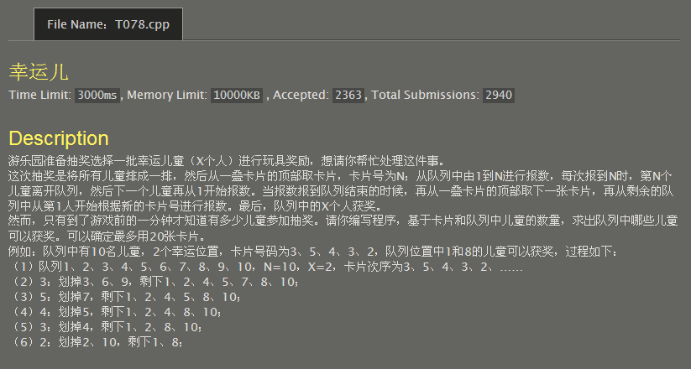
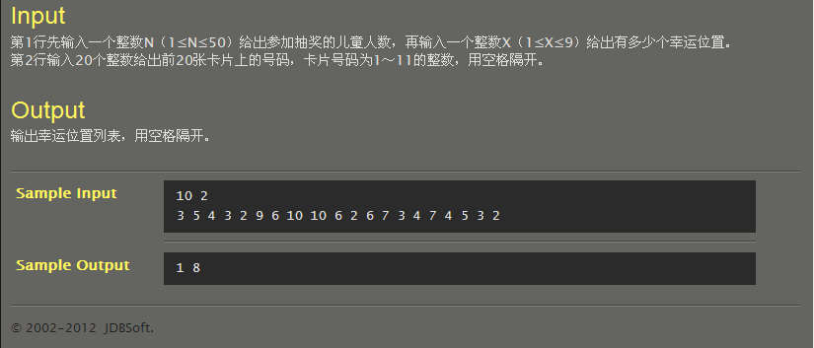
#include<stdio.h>
#include<stdlib.h>
typedef struct tagNode{
int data;
struct tagNode *next;
}Node,*LinkList;
void CreateLink(LinkList *L,int n)
{
LinkList p,s;
int i;
p=(*L)=(LinkList)malloc(sizeof(Node));
p->data=n;
for(i=1;n>0;n--,i++){
s=(LinkList)malloc(sizeof(Node));
s->data=i;
p->next=s,p=s;
}
p->next=NULL;
}
int main()
{
int i,j,m,n,x,a[20];
LinkList L,p,s,t;
scanf("%d %d",&n,&x);
CreateLink(&L,n);
for(i=0;i<20;i++) scanf("%d",&a[i]);
for(i=0;L->data!=x;i++){
m=L->data;
p=L,t=s=L->next;
for(j=1;j<m+1;j++){
if(j%a[i]==0){
t=p->next=s->next;
free(s),s=t;
(L->data)--;
if((L->data)==x)break;
}
else p=s,s=s->next;
}
}
p=L->next;
while(p!=NULL){
printf("%d ",p->data);
p=p->next;
}
}
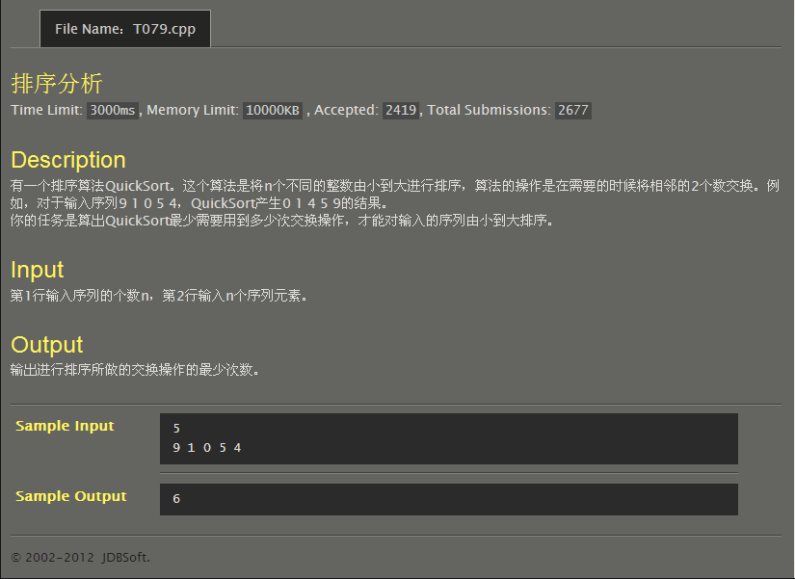
#include<stdio.h>
int main()
{
int i,j=0,k,t,n,a[1000];
scanf("%d",&n);
for(i=0;i<n;i++)scanf("%d",&a[i]);
for(;;){
for(i=0;i<n-1;i++){
if(a[i]>a[i+1])t=a[i],a[i]=a[i+1],a[i+1]=t,j++;
}
for(k=0;k<n-1;k++){
if(a[k]>a[k+1])break;
}
if(k==n-1)break;
}
printf("%d",j);
return 0;
}
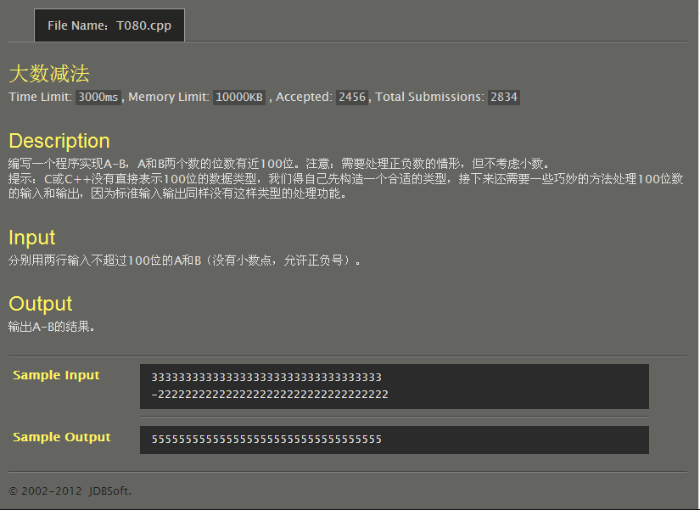
#include<stdio.h>
#include<string.h>
int main()
{
char a[102],b[102],c[200],*p=a,*q=b,*r;
int i,j,m,n,u=0,v=0,f[200];
gets(a);
gets(b);
m=strlen(a),n=strlen(b);
if(a[0]=='-'){
u++;
for(i=0;i<m;i++)a[i]=a[i+1];
m-=1;}
if(b[0]=='-'){
v++;
for(i=0;i<n;i++)b[i]=b[i+1];
n-=1;}
if((u==0&&v==0)||(u==1&&v==1)){
if(u==0&&v==0){
if(m<n) r=p,p=q,q=r,u=m,m=n,n=u,printf("-");
if(m==n){for(i=0;i<m;i++)if(a[i]<b[i]){printf("-");
r=p,p=q,q=r;
break;}}}
else {
if(m<n) r=p,p=q,q=r,u=m,m=n,n=u;
else if(m==n){for(i=0;i<m;i++)if(a[i]<b[i]){
r=p,p=q,q=r;
break;}
if(i==m) printf("-");}
else printf("-");}
for(i=m-1,u=n-1;i>=m-n;i--,u--)q[i]=q[u];
for(i=0;i<m-n;i++)q[i]=48;
for(i=m-1;i>=0;i--){
if(p[i]>=q[i]) f[i]=p[i]-q[i];
else{
u=i;
if(p[u-1]==48){
f[i]=p[i]+10-q[i];
while(p[u-1]==48){
p[u-1]='9';
if(p[u-2]!=48)p[u-2]-=1;
u--;}}
else f[i]=p[i]+10-q[i],p[i-1]-=1;}}
for(i=0;;i++)if(f[i]!=0)break;
for(;i<m;i++)printf("%d",f[i]);}
else{
if(u==1)printf("-");
if(m<n) r=p,p=q,q=r,u=m,m=n,n=u;
for(i=m-1,j=n-1;i>=m-n;i--,j--)q[i]=q[j];
for(i=0;i<m-n;i++)q[i]=48;
for(i=m-1,j=0;i>=0;i--){
f[i]=(p[i]-48+q[i]-48+j)%10;
j=(p[i]-48+q[i]-48+j)/10;}
if(j!=0){ printf("%d",j);
for(i=0;i<m;i++)printf("%d",f[i]);}
else for(i=0;i<m;i++)printf("%d",f[i]);}
return 0;
}
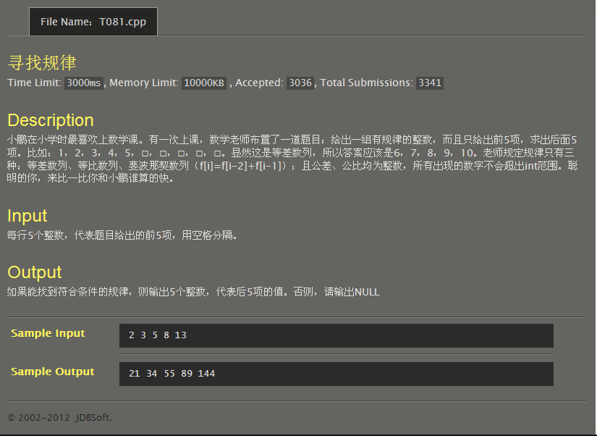
#include<stdio.h>
int main()
{
int i,j,k,a[10];
for(i=0;i<5;i++)scanf("%d",&a[i]);
if(a[1]-a[0]==a[2]-a[1]&&a[2]-a[1]==a[3]-a[2]&&a[3]-a[2]==a[4]-a[3]){
j=a[1]-a[0],k=a[4];
for(i=0;i<5;i++)printf("%d ",k+=j);}
else if(a[2]==a[0]+a[1]&&a[3]==a[1]+a[2]&&a[4]==a[2]+a[3]){
for(i=3,j=4;i<8;i++,j++)printf("%d ",a[j+1]=a[i]+a[j]);}
else if(a[0]!=0&&a[1]!=0&&a[2]!=0&&a[3]!=0&&a[4]!=0){
j=a[1]/a[0];
if(a[2]==j*a[1]&&a[3]==j*a[2]&&a[4]==j*a[3]){
k=a[4];
for(i=0;i<5;i++)printf("%d ",k*=j);}}
else if(a[0]==0&&a[1]==0&&a[2]==0&&a[3]==0&&a[4]==0)printf("0 0 0 0 0");
else printf("NULL");
return 0;
}
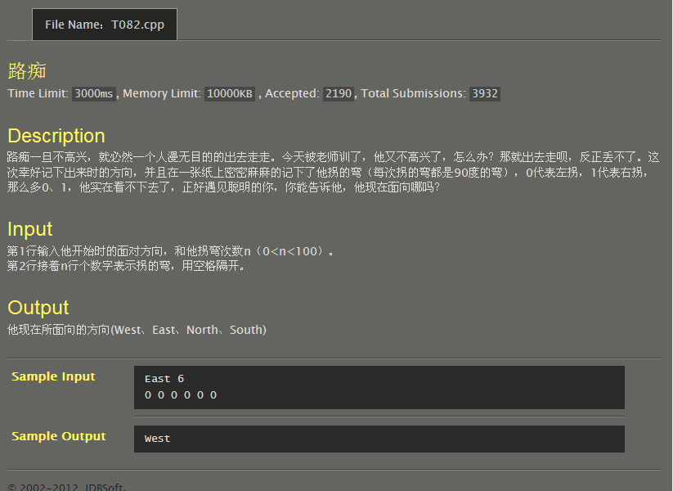
#include<stdio.h>
#include<stdlib.h>
#include<string.h>
typedef struct tagNode{
char data[6];
struct tagNode *prev,*next;
}Node,*LinkList;
int main()
{
char a[6];
int i,n,b[100];
LinkList p,s,L;
scanf("%s %d",a,&n);
for(i=0;i<n;i++)scanf("%d",&b[i]);
p=L=(LinkList)malloc(sizeof(Node));
strcpy(p->data,"West");
s=(LinkList)malloc(sizeof(Node));
p->next=s,s->prev=p,strcpy(s->data,"South"),p=s;
s=(LinkList)malloc(sizeof(Node));
p->next=s,s->prev=p,strcpy(s->data,"East"),p=s;
s=(LinkList)malloc(sizeof(Node));
p->next=s,s->prev=p,strcpy(s->data,"North"),p=s;
p->next=L,L->prev=p,p=L;
while(strcmp(p->data,a))p=p->next;
for(i=0;i<n;i++){
if(b[i]==0)p=p->next;
else p=p->prev;
}
printf("%s",p->data);
return 0;
}
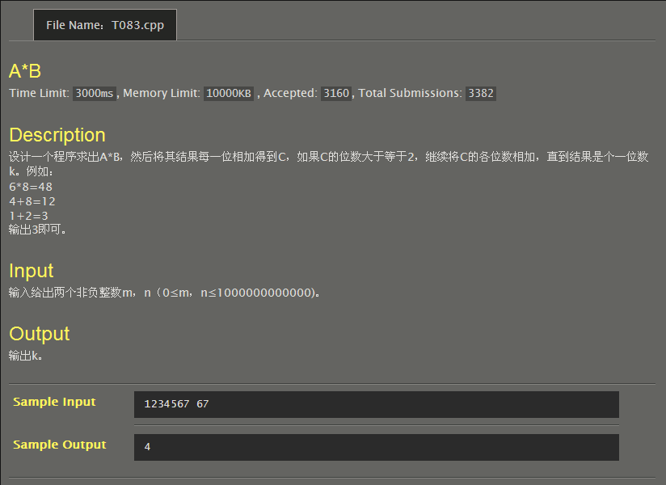
#include<stdio.h>
int main()
{
int i,j,k,m,n;
scanf("%d%d",&m,&n);
i=m*n;
while(i>9){k=0;
while(i>9){
k=k+i%10;
i/=10;}
i=i+k;}
printf("%d",i);
return 0;
}
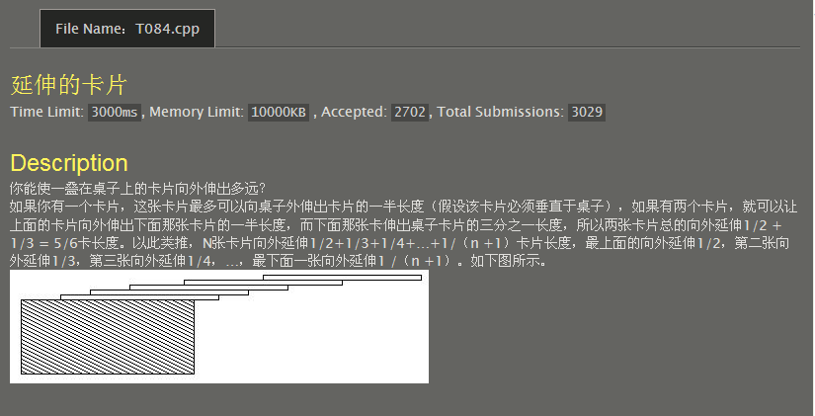
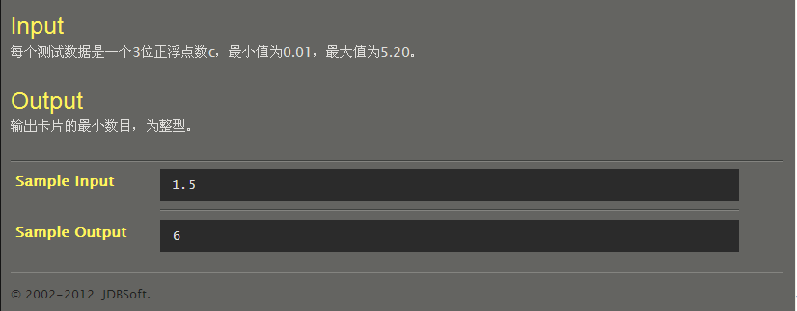
#include<stdio.h>
int main()
{
int i=2;
double b=0,c;
scanf("%lf",&c);
while(b<c){b=b+1.0/i;
i++;}
printf("%d",i-2);
return 0;
}
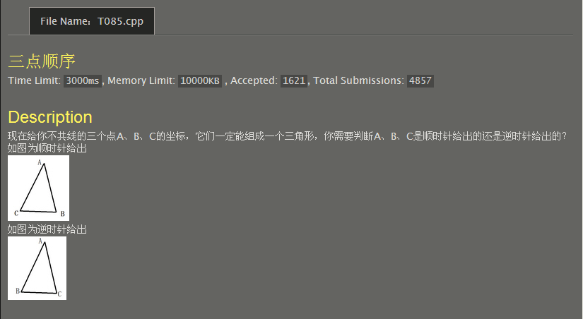
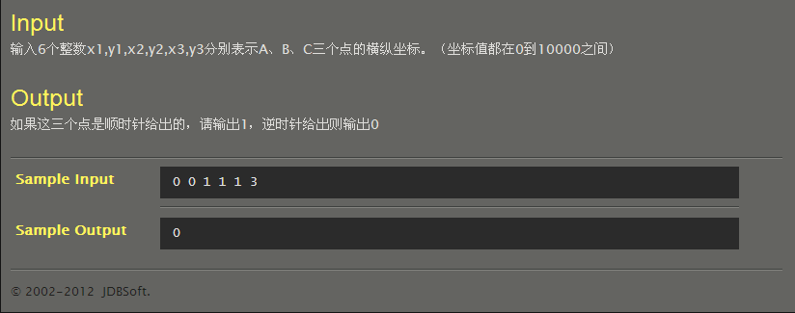
#include<stdio.h>
int main()
{ int x1,y1,x2,y2,x3,y3;
scanf("%d%d%d%d%d%d",&x1,&y1,&x2,&y2,&x3,&y3);
int flag=1,co;
co=(x2-x1)*(y3-y1)-(x3-x1)*(y2-y1);
if(co>0)flag=0;
printf("%d\n",flag);
}

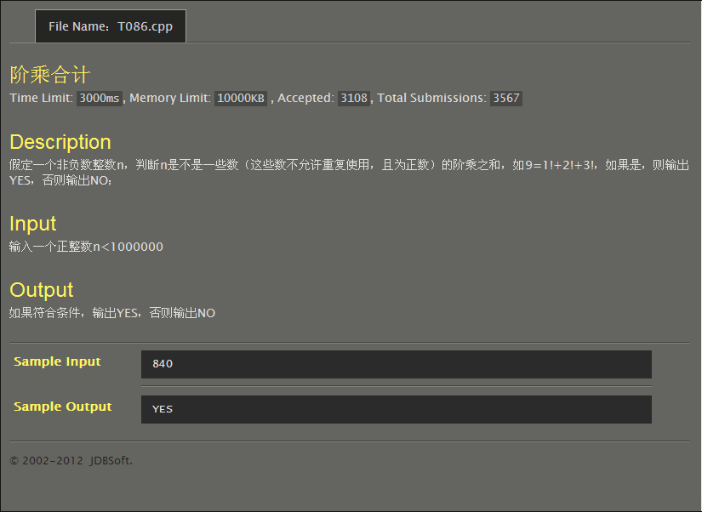
#include <stdio.h>
int fun(int n)
{
int i,m=1,sum=0;
for(i=1;i<12;i++)
{
m*=i;
sum+=m;
if(n==m) return 1;
if(m>n) break;
}
if(sum-m<n) return 0;
else
return fun(n-m/i);
}
int main()
{
int n;
scanf("%d",&n);
if(fun(n))
printf("YES\n");
else
printf("NO\n");
return 0;
}
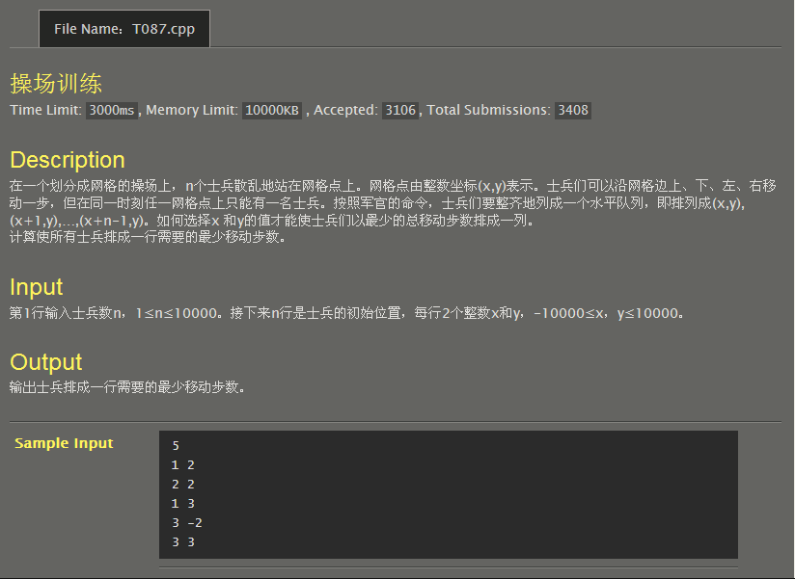
#include <stdio.h>
#include <math.h>
int main()
{int i,j,t,a[10000],b[10000],n,x,sum=0;
scanf("%d",&n);
for(i=0;i<n;i++)
scanf("%d%d",&a[i],&b[i]);
for(i=0;i<n;i++)
for(j=i+1;j<n;j++)
if(a[i]>a[j])
{t=a[j];
a[j]=a[i];
a[i]=t;
}for(i=0;i<n;i++)
for(j=i+1;j<n;j++)
if(b[i]>b[j])
{t=b[j];
b[j]=b[i];
b[i]=t;
}for(i=0;i<n;i++)
a[i]-=i;
for(i=0;i<n;i++)
for(j=i+1;j<n;j++)
if(a[i]>a[j])
{t=a[j];
a[j]=a[i];
a[i]=t;
}x=(n+1)/2-1;
for(i=0;i<n;i++)
sum+=(fabs(b[x]-b[i])+fabs(a[x]-a[i]));
printf("%d\n",sum);
return 0;
}
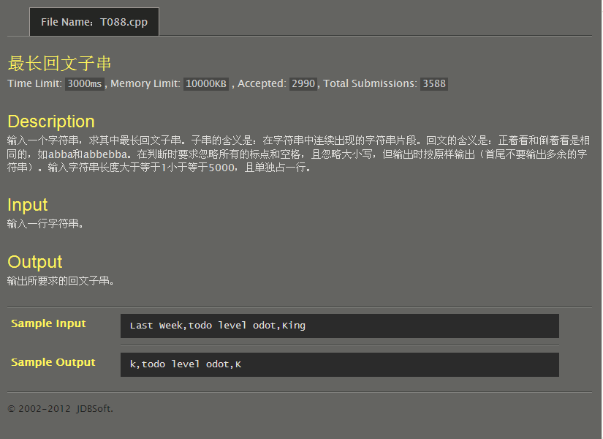
#include <stdio.h>
#include <string.h>
#include <ctype.h>
int main()
{char s[5001],s1[5000];
int pri[5000],max=0,len,i,j,x,y,m=0;
gets(s);
len=strlen(s);
for(i=0;i<len;++i)
{if(isalpha(s[i])) //是否为字母
{pri[m] = i; //保存实际位置
s1[m++] = toupper(s[i]); //转换为大写字母
}}for(i=0;i<len;i++)
{for(j=0;i-j>=0&&i+j<len;j++)
{if(s1[i-j]!=s1[i+j]) break;
if(2*j+1>max)
{max=2*j+1;
x=pri[i-j];
y=pri[i+j];
}}for(j=0;i-j>=0&&i+j<len;j++)
{if(s[i-j]!=s1[i+j+1]) break;
if(2*j+2>max)
{max=2*j+2;
x=pri[i-j];
y=pri[i+j+1];
}}}
for(i=x;i<=y;i++)
printf("%c",s[i]);
printf("\n");
return 0;
}
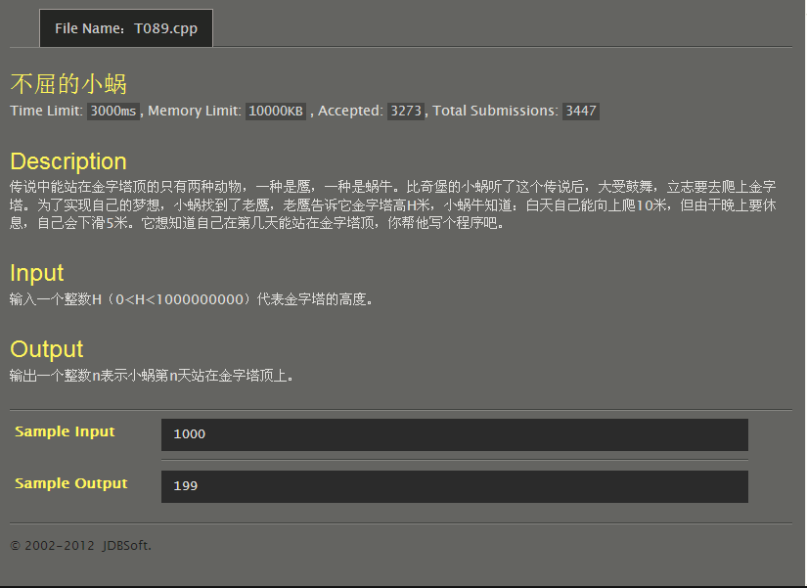
#include<stdio.h>
int main()
{
int i,H,Days;
scanf("%d",&H);
for(i=0;;i++)if(5*i+10>=H)break;
printf("%d",i+1);
return 0;
}
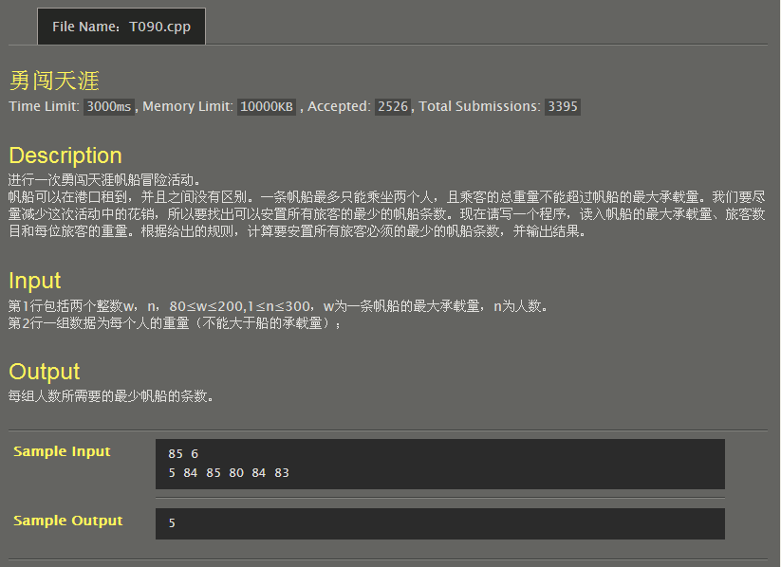
#include <stdio.h>
#include <stdlib.h>
int main()
{ int w,n;
int a[500];
int sum=0,i,j,t;
scanf("%d%d",&w,&n);
for(i=0;i<=n-1;i++)
scanf("%d",&a[i]);
for(i=0;i<n;i++)for(j=0;j<=n-i-2;j++)if(a[j]<a[j+1])t=a[j+1],a[j+1]=a[j],a[j]=t;
j=0;
for(i=n-1;i>=0;i--)for(j=0;j<i;j++)if(a[i]+a[j]<=w&&a[i]!=-1&&a[j]!=-1){a[i]=-1,a[j]=-1,sum++;
break;}
for(i=0;i<=n-1;i++)if(a[i]!=-1)sum++;
printf("%d\n",sum);
return 0;
}
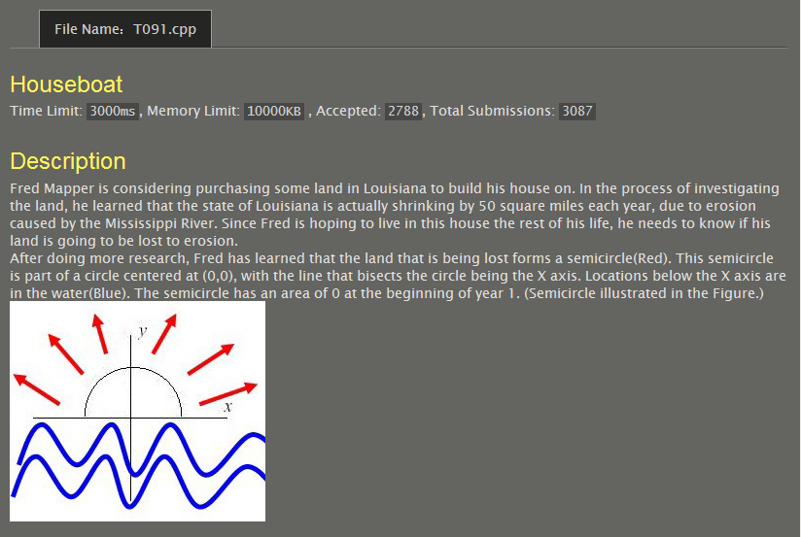
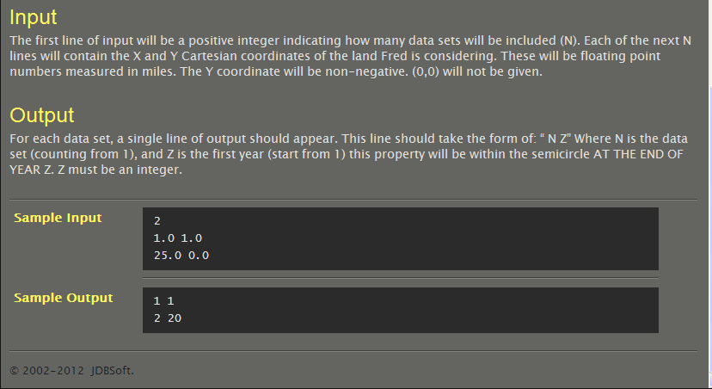
#include<stdio.h>
#define pi 3.1415926
int main()
{
int i,year,n,a[100];
double x[100],y[100],r;
scanf("%d",&n);
for(i=0;i<n;i++)
scanf("%lf%lf",&x[i],&y[i]);
for(i=0;i<n;i++){
r=x[i]*x[i]+y[i]*y[i];
for(year=1;;year++){
if((double)year*100/pi>=r)break;}
a[i+1]=year;}
for(i=1;i<n+1;i++)printf("%d %d\n",i,a[i]);
}
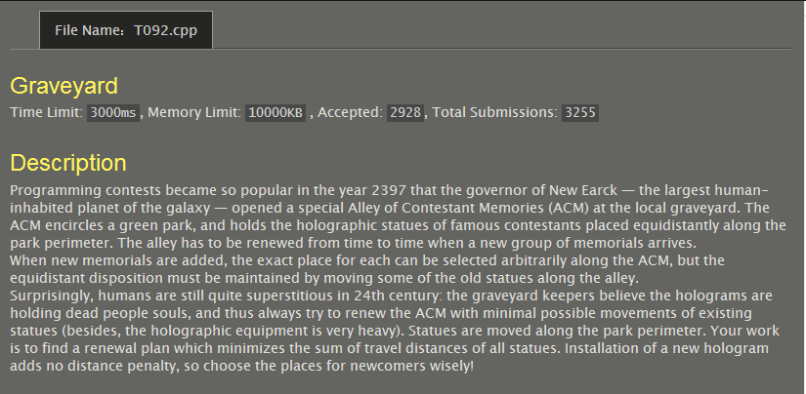
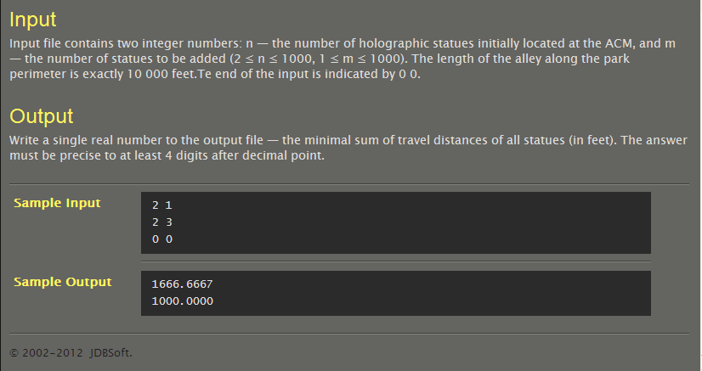
#include <stdio.h>
#include <math.h>
int main()
{int n,m,i;
double s,a;
while((scanf("%d%d",&n,&m))!=EOF)
{if(n==0&&m==0) break;
s=0;for(i=1;i<n;i++)
{a=i*1.0/n*(n+m);
s+=fabs(a-floor(a+0.5))/(n+m);
}printf("%.4f\n",s*10000);
}return 0;
}
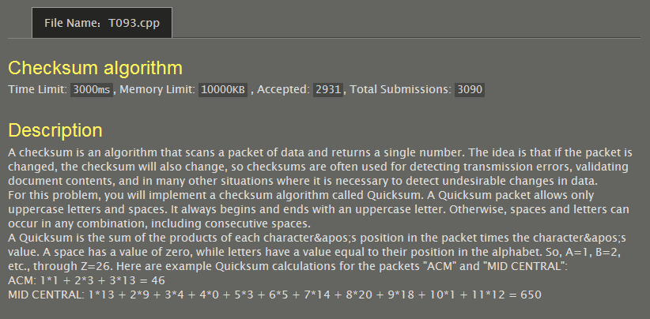
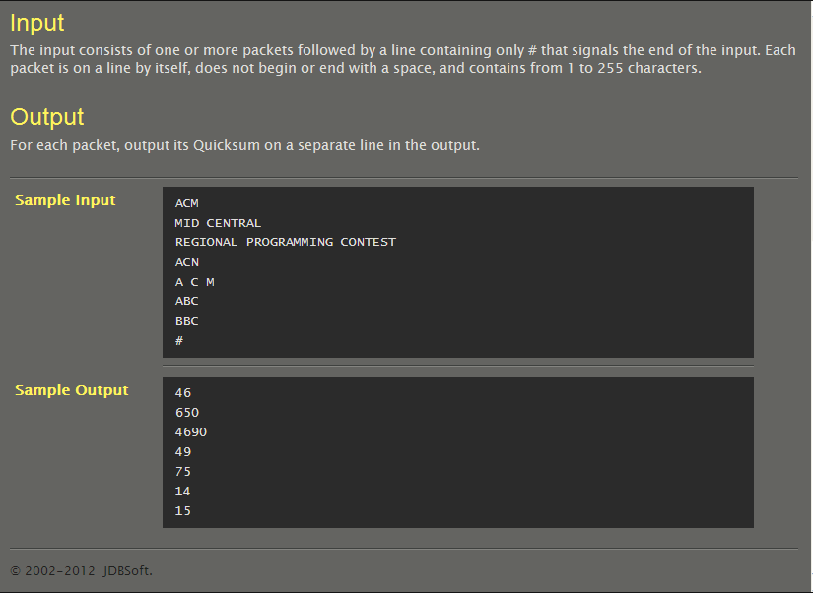
#include<stdio.h>
int main()
{
char a[100][300],c;
int i,j,k,b[100];
for(i=0;;i++){for(j=0;((c=getchar())!='\n')&&c!='#';j++)a[i][j]=c;
if(c=='\n')a[i][j]='\0';
if(c=='#')break;}
for(k=0;k<i;k++)
for(j=0,b[k]=0;a[k][j]!='\0';j++)
{if(a[k][j]==' ')continue;
else b[k]=b[k]+(j+1)*(a[k][j]-64);}
for(k=0;k<i;k++)printf("%d\n",b[k]);
}
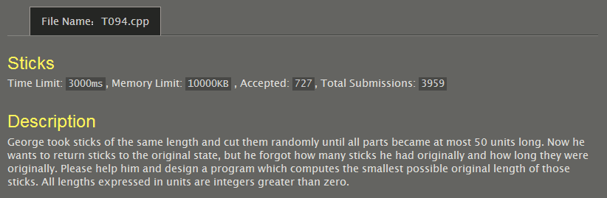
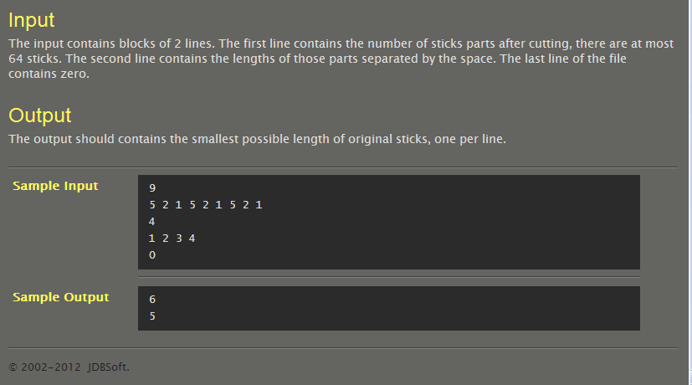
#include <stdio.h>
#include <string.h>
#include <stdlib.h>
int len[64],n,minlen,get;
int used[64];
void quickSort(int a[],int s,int m)
{ int i,j,t;
if(s<m){ i=s,j=m+1;
while(1){ while(i+1<64&&a[++i]>a[s]);
while(j-1>-1&&a[--j]<a[s]);
if(i>=j)break;
t=a[i],a[i]=a[j],a[j]=t; }
t=a[s],a[s]=a[j],a[j]=t;
quickSort(a,s,j-1);
quickSort(a,j+1,m);}}
//现在的长度，已用的根数，剩余根数
int dfs(int nowlen,int nowget,int cnt)
{ if(cnt>=n) return 0;
if(get==nowget) return 1;
int i;
int f=0;
if(nowlen==0) f=1;
for(i=cnt;i<n;i++)
{if(!used[i]){if(len[i]+nowlen==minlen){
used[i]=1;
if(dfs(0,nowget+1,nowget))return 1;
used[i] = 0;
return 0;}
else if(len[i]+nowlen<minlen)
{ used[i]=1;
if(dfs(nowlen+len[i],nowget,i+1))return 1;
used[i]=0;
if(f) return 0;
while(i+1<n&&len[i]==len[i+1]) i++;}}}
return 0;
}
int main()
{ int i, tollen;
while(scanf("%d",&n)!=EOF&&n!=0)
{ tollen = 0;
int j=0,p;
for(i=0;i<n;i++)
{ scanf("%d",&p);
if(p<=50)
{ len[j]=p;
tollen+=len[j];
j++;}}
n=j;//总段数
quickSort(len,0,n-1);//将棍子按大到小排列
for(minlen=len[0];;minlen++)
{ if(tollen%minlen) continue;
for(i=0;i<64;i++)
used[i]=0;//重置所有棍子
get=tollen/minlen;
if(dfs(0,0,0))
{ printf("%d\n",minlen);
break;}}}
return 0;
}
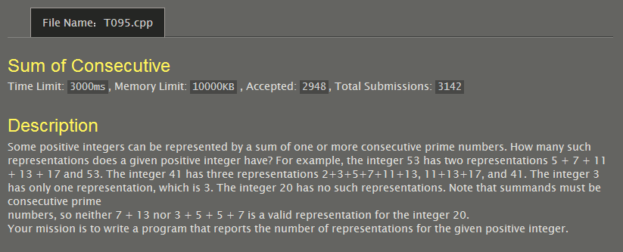
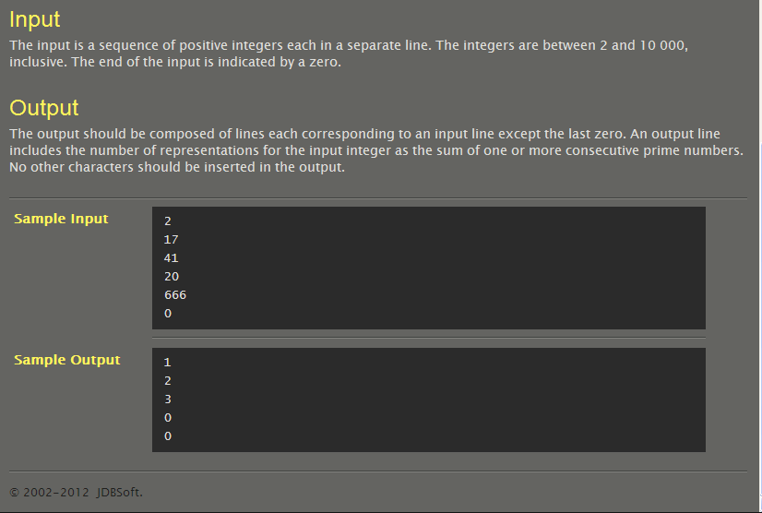
#include<stdio.h>
#include<math.h>
int main()
{
int in[1000],prime[1230],i,j,k,s,out[1000],cnt=0;
for(i=0;;i++){
scanf("%d",&in[i]);
if(in[i]==0)break;
cnt++;}
prime[0]=2;
for(i=3,k=1;i<10001;i++){
if(i%2==0)continue;
else{for(j=0;prime[j]<=sqrt(i);j++){
if(i%prime[j]==0)break;}
if(prime[j]>sqrt(i))prime[k]=i,k++;}}
for(i=0;in[i]!=0;i++){
for(j=0,out[i]=0;prime[j]<=in[i];j++)
{ if(prime[j]==in[i]){
out[i]++;
break;}
for(k=j,s=0;;k++){
s=s+prime[k];
if(s==in[i]){out[i]++;
break;}
else if(s>in[i])break;}}}
for(i=0;i<cnt;i++)printf("%d\n",out[i]);
}
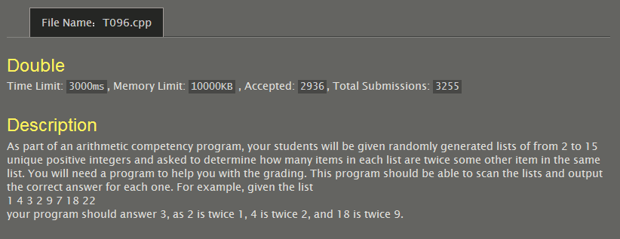
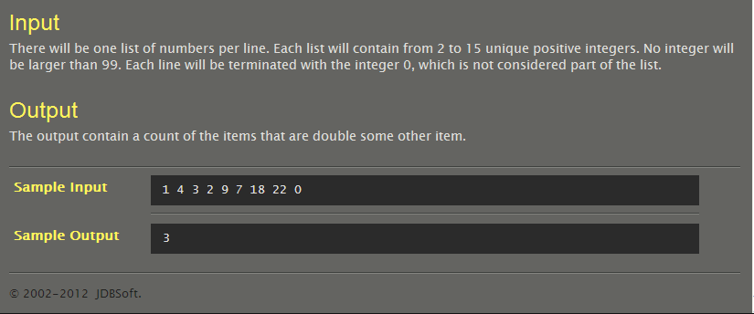
#include<stdio.h>
int main()
{
int in[20],i,j,cnt=0;
for(i=0;;i++){
scanf("%d",&in[i]);
if(in[i]==0)break;}
for(i=0;in[i]!=0;i++)
for(j=0;in[j]!=0;j++){
if(in[i]/in[j]==2&&in[i]%in[j]==0)cnt++;}
printf("%d",cnt);
}
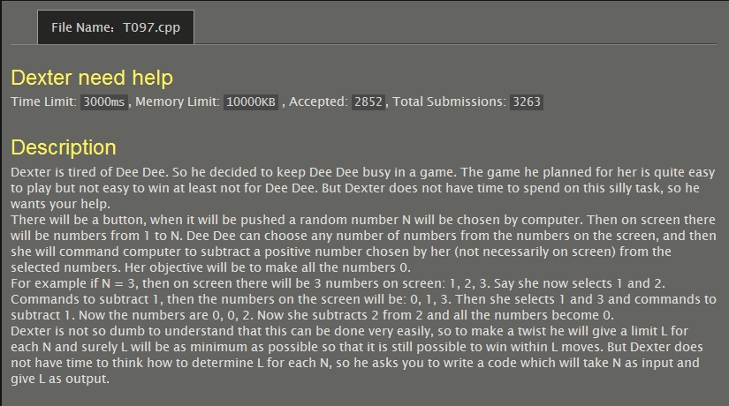
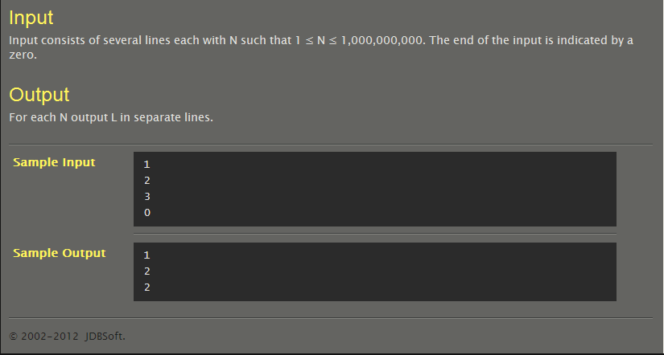
#include <stdio.h>
int fun(int a)
{if(a==1) return 1;
else return fun(a/2)+1;
}int main()
{int a,x;
while(scanf("%d",&a)&&a!=0)
{x=fun(a);
printf("%d\n",x);
}return 0;
}
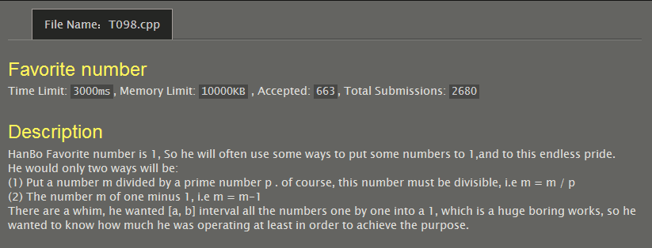
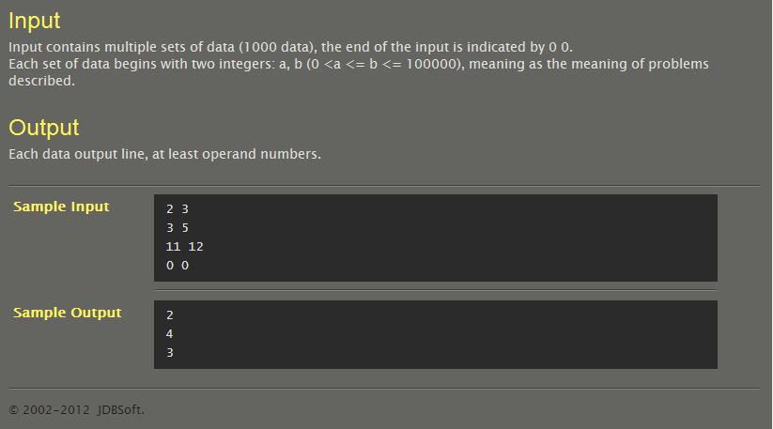
#include<stdio.h>
#include<math.h>
int min(int a,int b){return a<b?a:b;}
int prime[10000];
int cnt;
int isprime[100010]={0};
int dp[100010]={0},sum[100010]={0};
int countmin(int x)
{ int i,lim=sqrt(x)+1;
if(dp[x]!=0)return dp[x];
dp[x]=dp[x-1]+1;
int xx=x;
for(i=0;i<cnt&&prime[i]<=lim&&xx!=1;i++)
{ if(x%prime[i]==0)
{ while(xx%prime[i]==0)xx/=prime[i];
dp[x]=min(dp[x],dp[x/prime[i]]+1); } }
if(xx!=1)dp[x]=min(dp[x],dp[x/xx]+1);
return dp[x];}//得出m->1的最少操作次数
void calprime()
{ int i=2,j;
for(i=2;i<=100000;i++)
isprime[i]=1;
cnt=0;
for(i=2;i<=100000;i++)
{ if(isprime[i])
{ prime[cnt]=i;
cnt++;
for(j=i*i;i<400&&j<=100000;j+=i)
isprime[j]=0; }
}//筛法求出100000以内的所有素数；
for(i=2;i<=100000;i++)countmin(i);}
int main()
{ int a,b,i;
calprime();
for(i=2;i<=100000;i++)sum[i]=sum[i-1]+dp[i];
while(scanf("%d%d",&a,&b)!=EOF&&a!=0&&b!=0)
{ printf("%d\n",sum[b]-sum[a-1]); }
return 0;
}
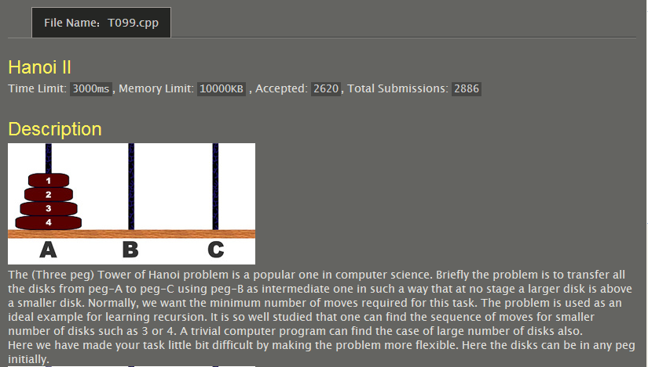
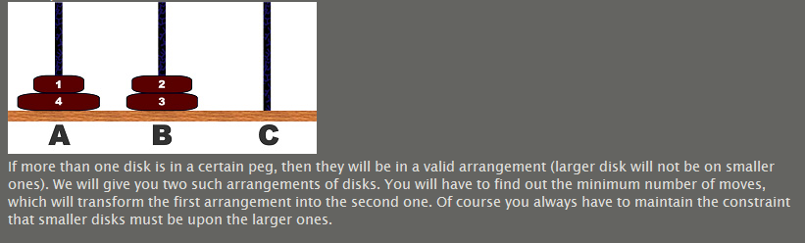
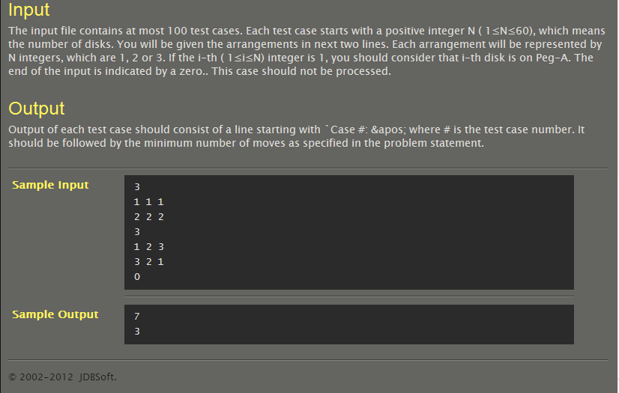
#include <stdio.h>
#define M 70
int start[M], targe[M];
long long f(int *p, int k, int fina)
{if(k==0) return 0;
if(p[k]==fina) return f(p,k-1,fina);
return f(p,k-1,6-fina-p[k])+(1LL<<(k-1));
}int main ()
{long long ans;
int n, cas = 0;
while(scanf("%d",&n), n)
{for(int i = 1; i <= n; i++) scanf("%d",&start[i]);
for(int i = 1; i <= n; i++) scanf("%d",&targe[i]);
int c = n;for(;c>=1&&start[c]==targe[c];c--);
if(c==0) {printf("0\n"); continue;}
int other = 6 - start[c] - targe[c];
ans = f(start,c-1,other)+f(targe,c-1,other)+1;
printf("%lld\n",ans);
}
return 0;
}
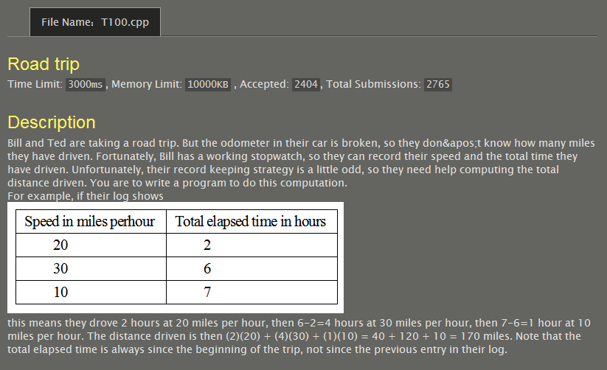
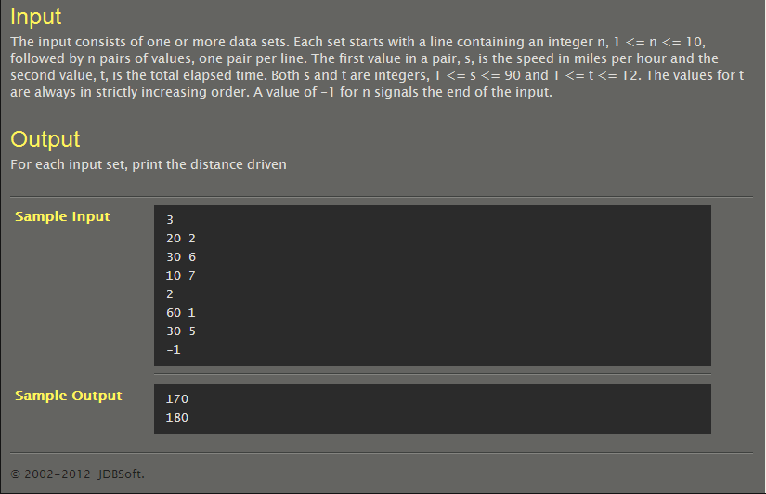
#include<stdio.h>
#include<stdlib.h>
int main()
{
int i,j,n,*p,b[1000],cnt=0;
scanf("%d",&n);
while(n!=-1){b[cnt]=0,p=(int*)malloc(n*2*sizeof(int));
for(i=0;i<n;i++)for(j=0;j<2;j++)scanf("%d",p+i*2+j);
b[cnt]=p[0]*p[1];
for(i=1;i<n;i++)b[cnt]=b[cnt]+(p[i+i+1]-p[i+i-1])*p[i+i];
cnt++,free(p),scanf("%d",&n);}
for(i=0;i<cnt;i++)printf("%d\n",b[i]);
}

