**4、函数——函数模板**

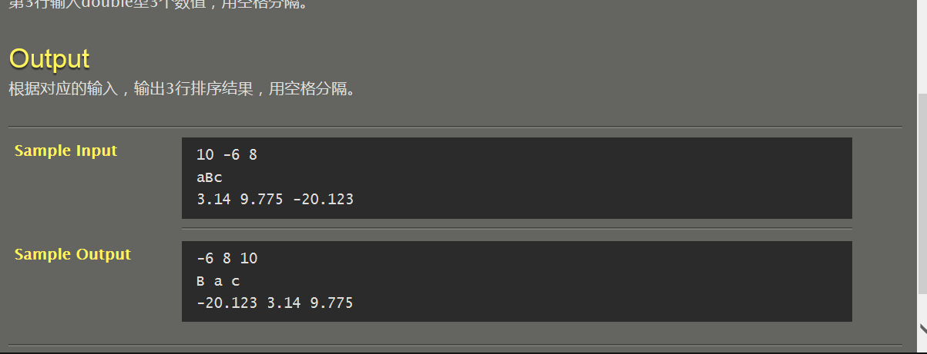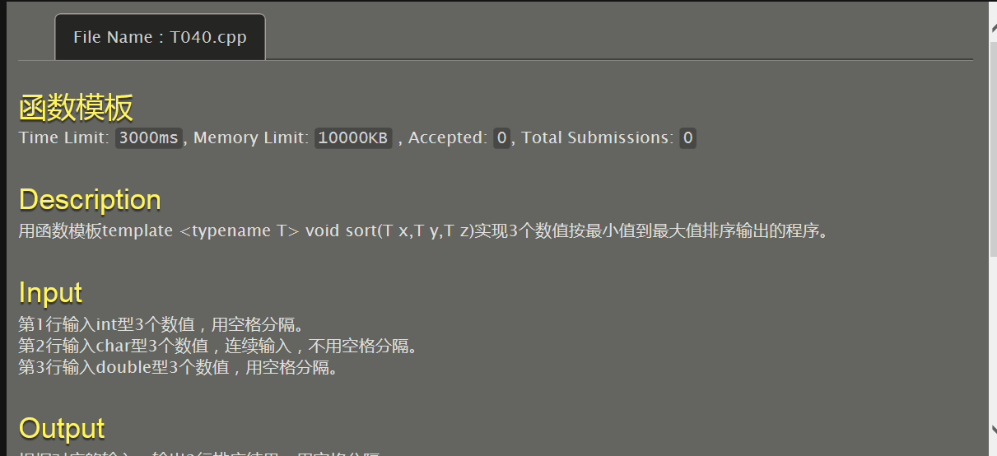

#include <iostream>

using namespace std;

template <typename T>void sort(T x,T y,T z)

{

if(x>y&&y>z)cout<<z<<" "<<y<<" "<<x<<endl;

if(x>z&&z>y)cout<<y<<" "<<z<<" "<<x<<endl;

if(y>x&&x>z)cout<<z<<" "<<x<<" "<<y<<endl;

if(z>x&&x>y)cout<<y<<" "<<x<<" "<<z<<endl;

if(y>z&&z>x)cout<<x<<" "<<z<<" "<<y<<endl;

if(z>y&&y>x)cout<<x<<" "<<y<<" "<<z<<endl;

}

int main()

{

int a,b,c;

char d,e,f;

double g,h,i;

cin>>a>>b>>c>>d>>e>>f>>g>>h>>i;

sort(a,b,c);

sort(d,e,f);

sort(g,h,i);

return 0;

}

PJOER的烦恼

#include <stdio.h>

int main()

{

int n;

int a[32],i,j,k;

scanf("%d",&n);

j=n;

k=0;

for(i=0;i<32;i++)

{ a[i]=j%2;

j=j/2;

k++;

if(j==1)

{ a[i+1]=1;

k=k+1;

break;

}

if(j==0)

break;

}

for(i=k-1;i>=0;i--)

printf("%d",a[i]);

printf("\n");

return 0;

}

大数减法

#include <stdio.h>

#include <string.h>

#define max(a,b) a>b?a:b

#define min(a,b) a>b?b:a

int sum[101];

void jia(char a[],char b[])

{

int flag=0,i,len1,len2,lenmax,lenmin;

len1=strlen(a),len2=strlen(b);

lenmax=max(len1,len2),lenmin=min(len1,len2);

for(i=1;i<=lenmax;i++)

{

if(i<=lenmin)

{

sum[lenmax-i]=a[len1-i]+b[len2-i]-'0'-'0'+flag;

if(sum[lenmax-i]>=10)

{

sum[lenmax-i]=sum[lenmax-i]-10;

flag=1;

}

else flag=0;

}

else{

if(len1>len2)

{

sum[lenmax-i]=a[len1-i]-'0'+flag;

if(sum[lenmax-i]>=10)

{

sum[lenmax-i]=sum[lenmax-i]-10;

flag=1;

}

else flag=0;

}

else

{

sum[lenmax-i]=b[len2-i]-'0'+flag;

if(sum[lenmax-i]>=10)

{

sum[lenmax-i]=sum[lenmax-i]-10;

flag=1;

}

else flag=0;

}

}

}

if(flag==1)

printf("1");

for(i=0;i<lenmax;i++)

printf("%d",sum[i]);

printf("\n");

}

void jian(char a[],char b[])

{

int flag=0,i;

int len1,len2;

len1=strlen(a),len2=strlen(b);

for(i=1;i<=len1;i++)

{

if(i<=len2)

{

if(a[len1-i]-b[len2-i]-flag>=0)

{

sum[len1-i]=a[len1-i]-b[len2-i]-flag;

flag=0;

}

else

{

sum[len1-i]=a[len1-i]-b[len2-i]-flag+10;

flag=1;

}

}

else

{

if(a[len1-i]-flag-'0'>=0)

{

sum[len1-i]=a[len1-i]-flag-'0';

flag=0;

}

else

{

sum[len1-i]=a[len1-i]-flag+10-'0';

flag=1;

}

}

}

for(i=0;i<len1&&sum[i]==0;i++);

for(;i<len1;i++)

printf("%d",sum[i]);

printf("\n");

}

void compare(char a[],char b[])

{

int len1,len2;

len1=strlen(a),len2=strlen(b);

if(len1>len2||(len1==len2&&strcmp(a,b)>0))

jian(a,b);

else if(strcmp(a,b)!=0)

{

printf("-");

jian(b,a);

}

else

printf("0\n");

}

int main()

{

char a[100],b[100];

gets(a);

gets(b);

if(a[0]=='-'&&b[0]!='-')

{

printf("-");

jia(&a[1],b);

}

else if(a[0]=='-'&&b[0]=='-')

compare(&b[1],&a[1]);

else if(a[0]!='-'&&b[0]=='-')

jia(a,&b[1]);

else

compare(a,b);

return 0;

}

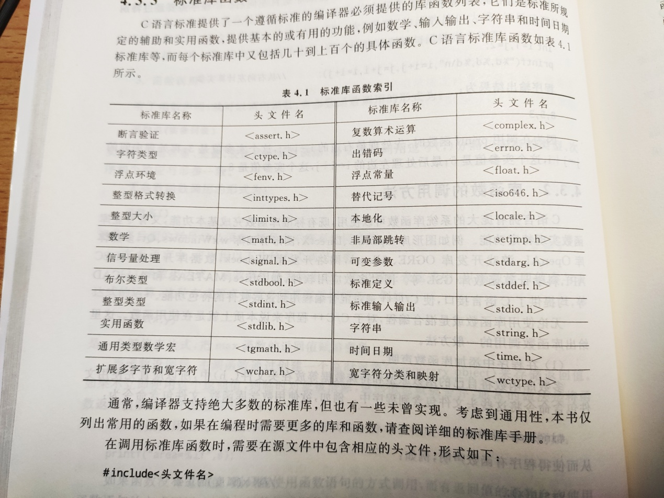

16、大小写转换

#include <stdio.h>

#include <math.h>

#include <string.h>

int main()

{

char input[80];

int i;

gets(input);

FILE *in;

in = fopen("in.dat","w");

fputs(input,in);

_fcloseall();

for (i=0;input[i];i++)

{

if ('A'<=input[i]&&input[i]<='Z') input[i]+=32;

}

puts(input);

return 0;

}

//P54 46、幸运数

#include <stdio.h>

#include <stdlib.h>

#include <math.h>

#include <string.h>

int pow1(int a,int b)

{

int i,result=1;

for (i=0;i<b;i++)

{

result = result*a;

}

return result;

}

int main()

{

int n=0,a,b,sum=0;

scanf("%d",&a);

b=a;

while(b!=0)

{

b = b/10;

n++;

}

b=a;

while(b!=0)

{

sum = sum + pow1(b%10,n);

b = b/10;

}

if (sum==a) printf("YES");

else printf("NO");

return 0;

}

//P51 44、星期几

#include <stdio.h>

#include <stdlib.h>

#include <math.h>

#include <string.h>

int main()

{

char day[10];

gets(day);

if (strcmp(day,"Monday")==0) printf("Piano");

else if (strcmp(day,"Tuesday")==0) printf("Handwriting");

else if (strcmp(day,"Wednesday")==0) printf("Boxing");

else if (strcmp(day,"Thursday")==0) printf("Drawing");

else if (strcmp(day,"Friday")==0) printf("Etiquette");

else printf("No arrangements");

return 0;

}