Online Vehicle Software OTA Filing System — User Manualv2.6.2
Source: 汽车软件在线升级备案系统 用户手册 v2.6.2 (Chinese). This file is a faithful English translation of the text. Figure/image placeholders are kept with original captions and page references. Open this HTML directly in Microsoft Word and use “Save As” to export to .docx.

Table of Contents

1 Introduction

1.1 Purpose
This manual provides operating guidance for corporate users of the “Online Vehicle Software OTA Filing System.” With this system, users can complete the Enterprise Management Capability filing, Model & Function filing, specific Upgrade Activity filing, and Change/Extension applications.

1.2 Intended Audience
Personnel who use the “Online Vehicle Software OTA Filing System.”

1.3 General Rules
- Entering “1 character” in this system means one character regardless of whether it is a Chinese character, letter, number, or special symbol.
- Unless otherwise specified, attachments support doc/docx/pdf formats, each up to 50 MB, and 1–10 files per upload.
- Unless otherwise specified, all inputs, selections, and attachment uploads are required fields.

2 System Overview

2.1 Feature Summary
The “Online Vehicle Software OTA Filing System” integrates the business applications of Enterprise Management Capability filing, Model & Function filing, specific Upgrade Activity filing, and Change/Extension applications. After registration, enterprises can fill in basic information, submit filings, view filing details, edit filing information, perform company information changes, and submit change/extension applications.
Only after the Enterprise Management Capability filing is approved can the enterprise submit the first-time Model & Function filing. Only after the first-time Model & Function filing for a model is approved can the enterprise proceed with change/extension filing for that model and file specific upgrade activities.

3 User Guide
Open your browser and visit: https://ota.miit-eidc.org.cn/ to access the system. Supported browser: Chrome.

3.1 Login Center

3.1.1 Sign In
Open the browser and enter https://ota.miit-eidc.org.cn/ to access the login page. Enter username, password, and verification code, then click “Login” to enter the system.
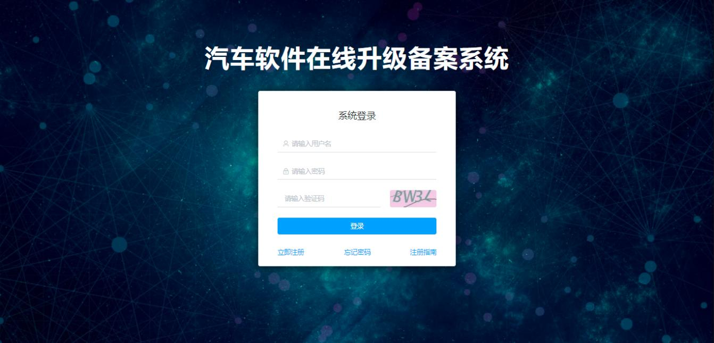
[Figure 3-1: Login Page — image placeholder, original p.5]

3.1.2 Sign Out
After signing in, click “Sign Out” or, if the system times out due to inactivity, you will be redirected to the login page and need to log in again.
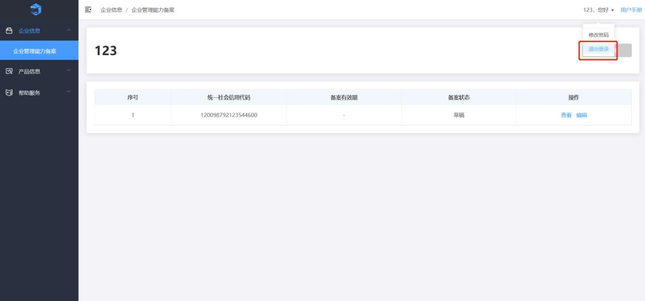
[Figure 3-2: Sign-out Page — image placeholder, original p.6]

3.1.3 Forgot Password
Click “Forgot Password” on the login page. Enter the email address used during registration and click “Send Verification Code.” The system sends a code to your email. Enter the code, set a new password, and click “Change” to complete.
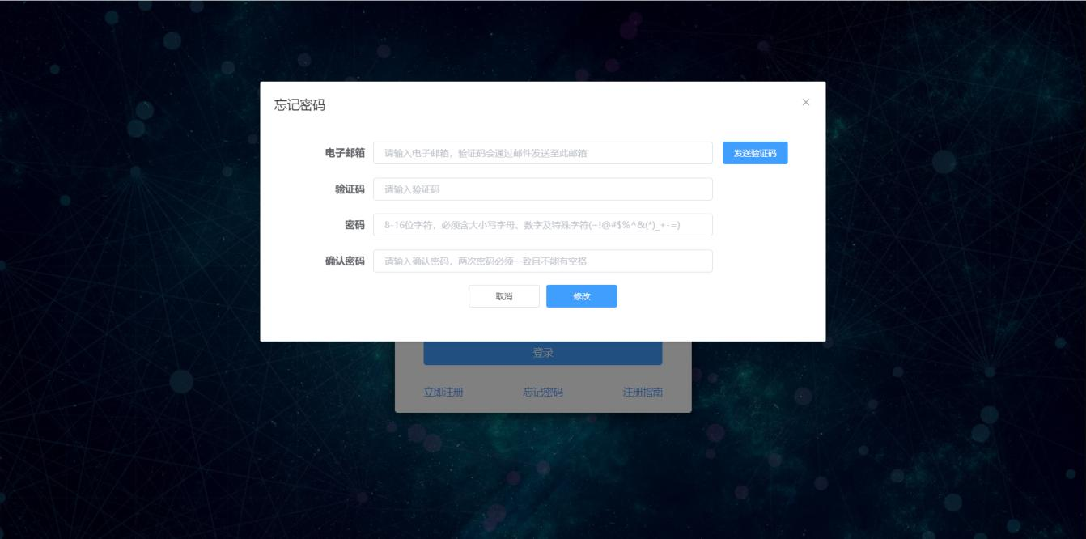
[Figure 3-3: Password Recovery — image placeholder, original p.6]
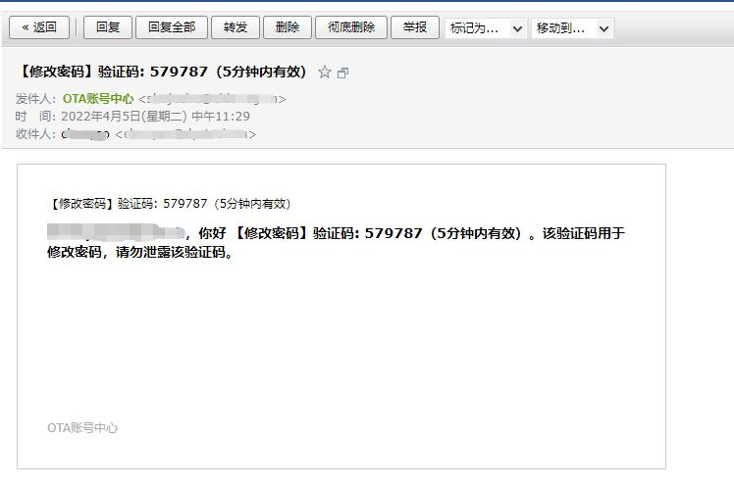
[Figure 3-4: Password Change Email — image placeholder, original p.7]

3.1.4 Change Password
Click “Change Password” in the top-right corner. Enter the original password, new password, and confirm the new password. Click “Reset” to clear inputs or “Submit” to save changes.
Notes:
- The new password and confirmation must match and must not contain spaces.
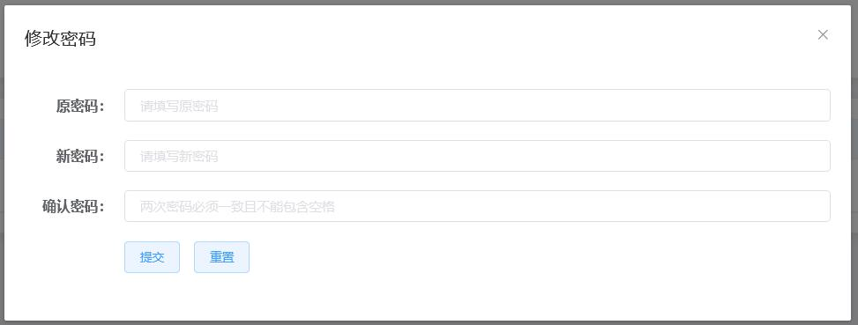
[Figure 3-5: Change Password — image placeholder, original p.7]

3.1.5 Create Sub-Account
Log in with the enterprise (parent) account. From the menu, choose System Management → Personnel Management, then click “Create Account.” Fill in the form and click “OK” to create a sub-account. In the list, click “Enable” to activate the sub-account. You can also Edit or Disable; disabled sub-accounts cannot log in.
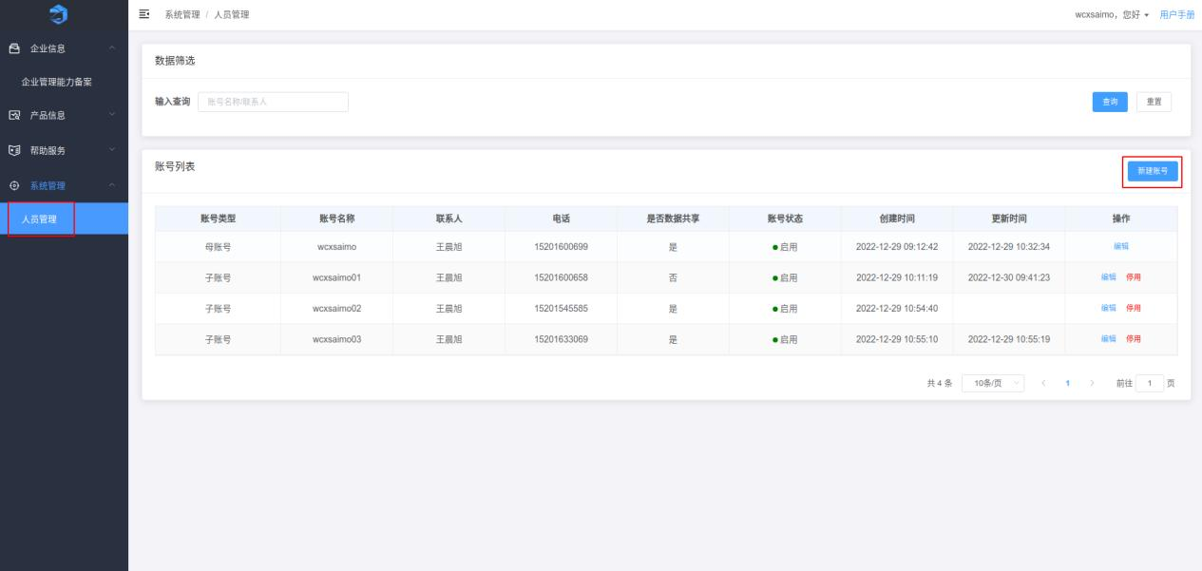
[Figure 3-6: Create Account — image placeholder, original p.8]
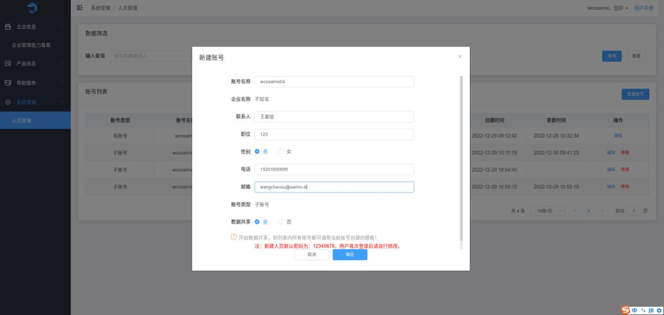
[Figure 3-7: Create Account Dialog — image placeholder, original p.8]
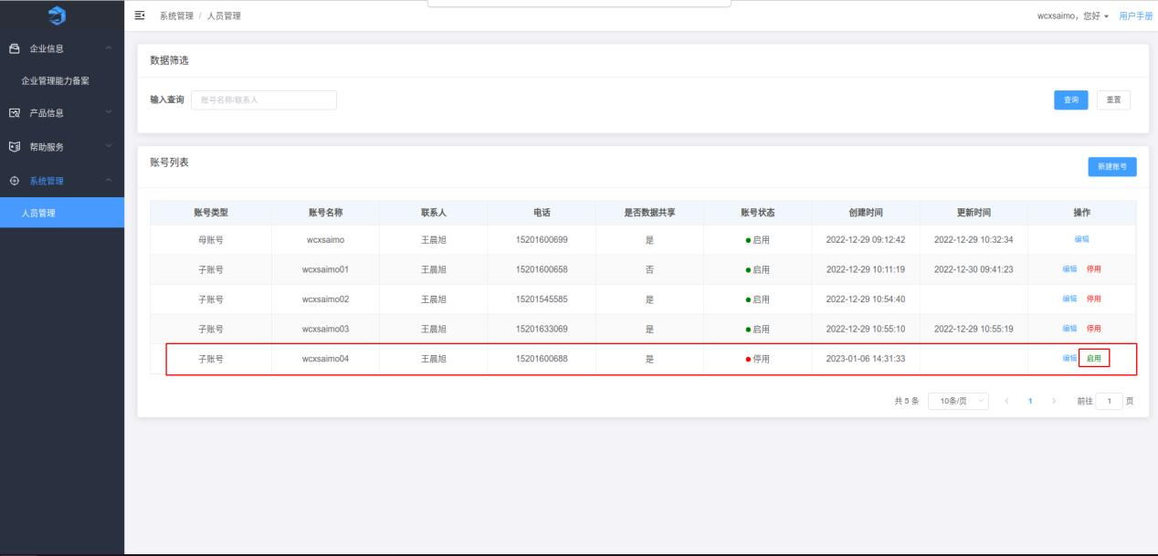
[Figure 3-8: Personnel Management List — image placeholder, original p.9]
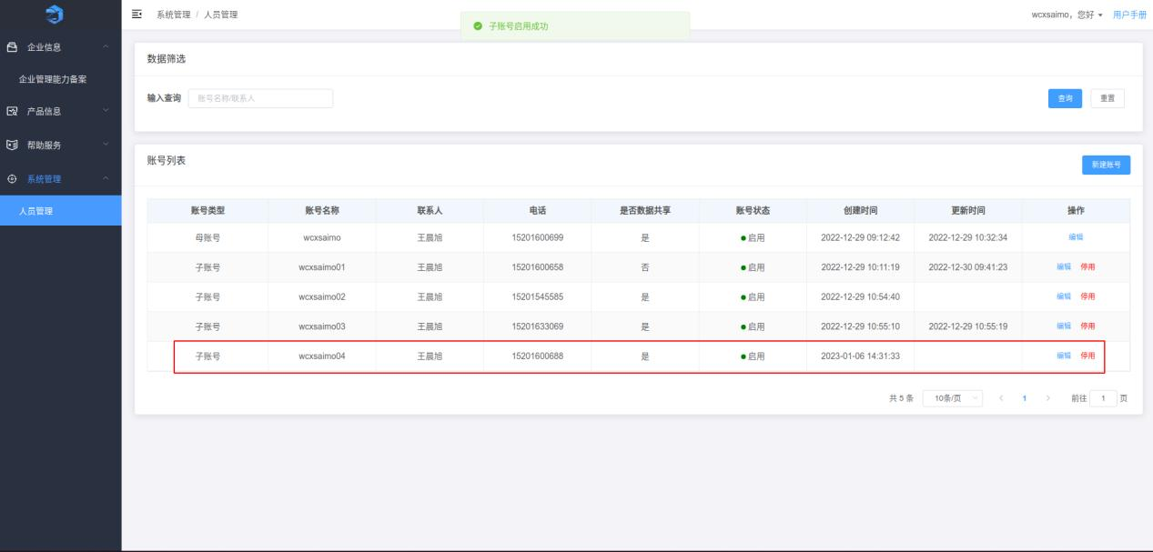
[Figure 3-9: Personnel Management List — image placeholder, original p.9]
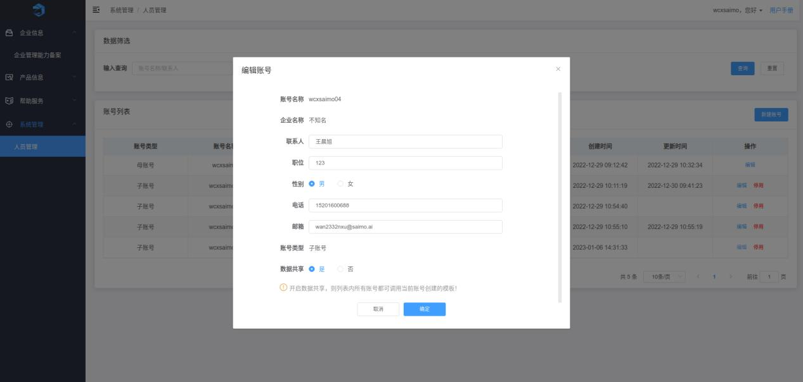
[Figure 3-10: Sub-Account Edit — image placeholder, original p.10]
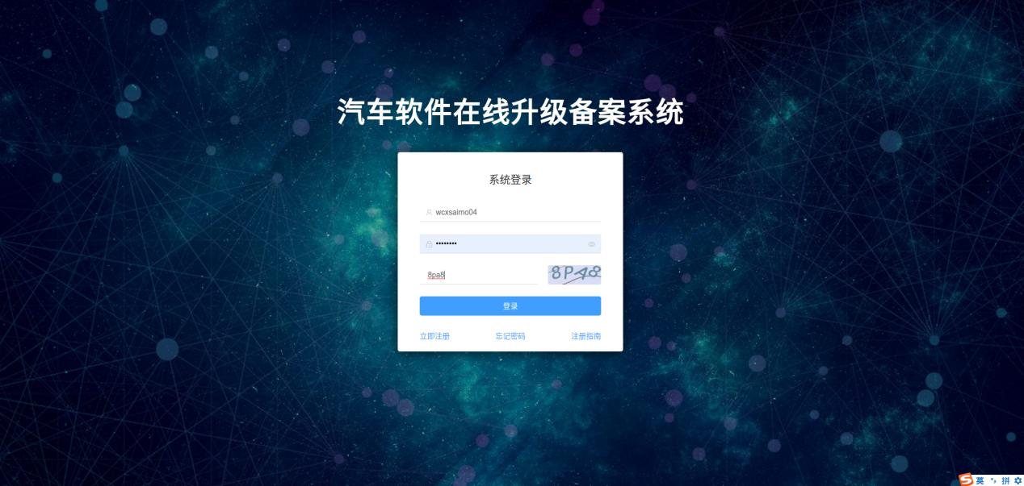
[Figure 3-11: Sub-Account Login — image placeholder, original p.10]
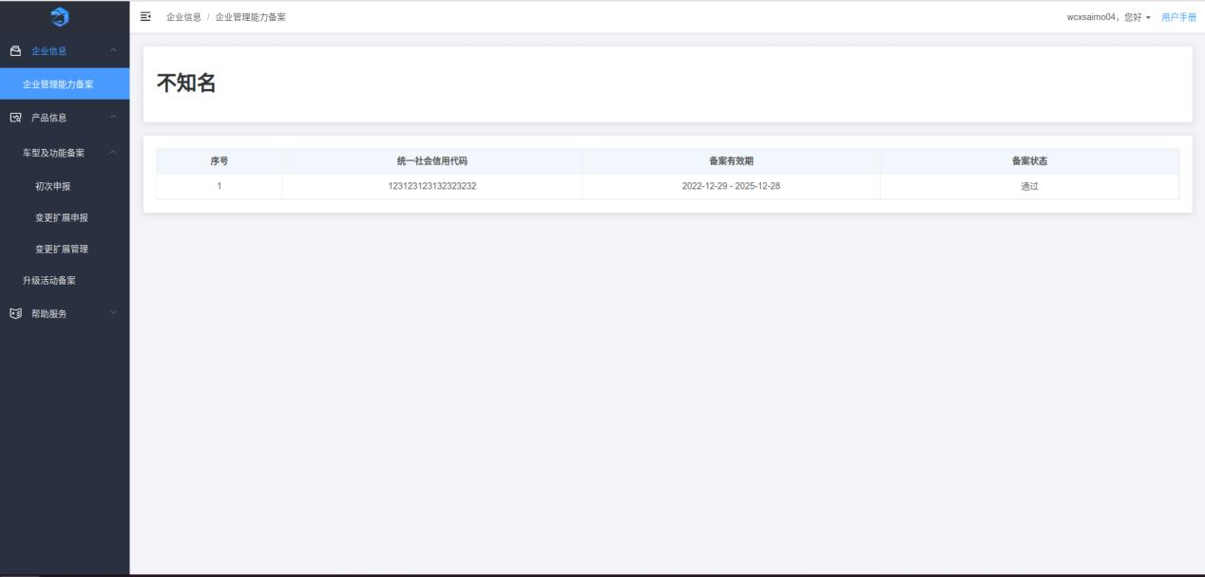
[Figure 3-12: Login Successful — image placeholder, original p.11]

3.2 Company Information

3.2.1 Enterprise Management Capability Filing
New enterprise users can create a filing application on the Enterprise Management Capability Filing page. Users with an existing filing entry can view filing details there.
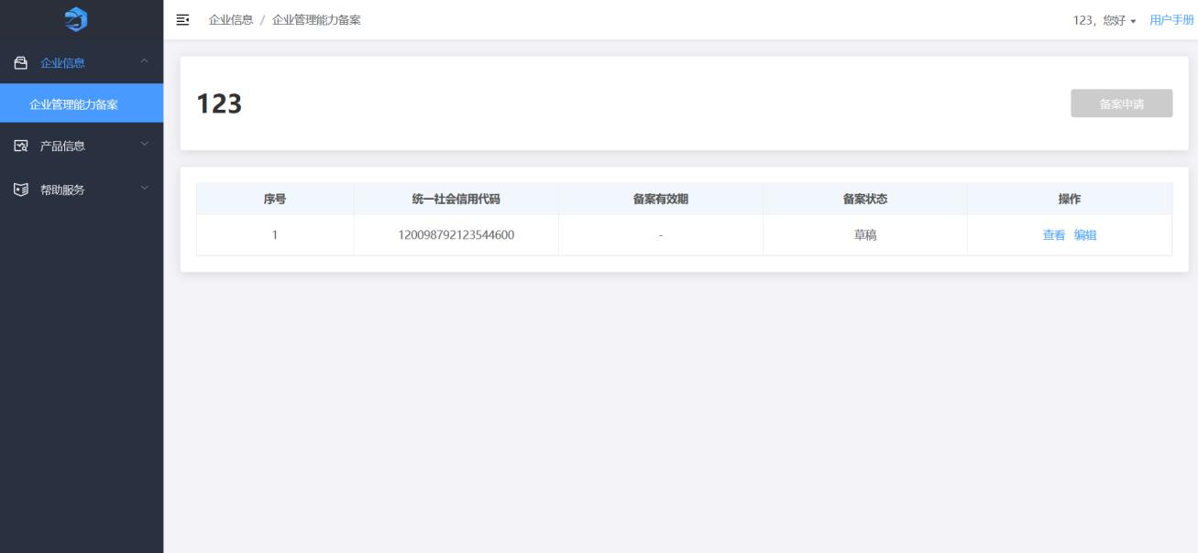
[Figure 3-13: Filing List — image placeholder, original p.11]
Click “Filing Application,” fill in the filing information, upload attachments, and click “Submit” to complete the filing and await approval.
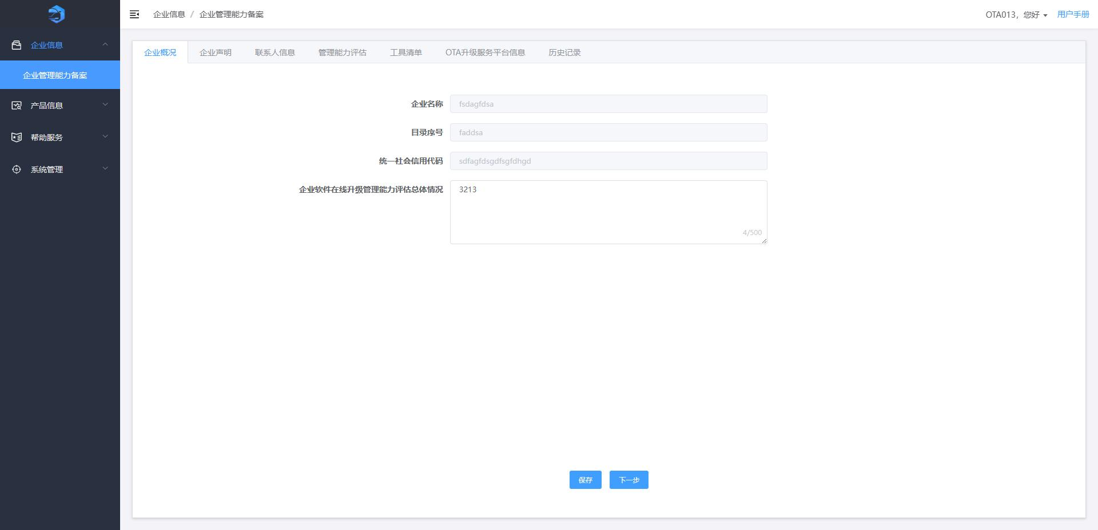
[Figure 3-14: Enterprise Overview — image placeholder, original p.12]
On “Enterprise Overview”:
- Click “Save” to keep the information. Re-entering the page shows saved data.
- Click “Next” to go to “Enterprise Declaration.”
Notes: “Enterprise Name,” “Catalog Number,” and “Unified Social Credit Code” cannot be modified.
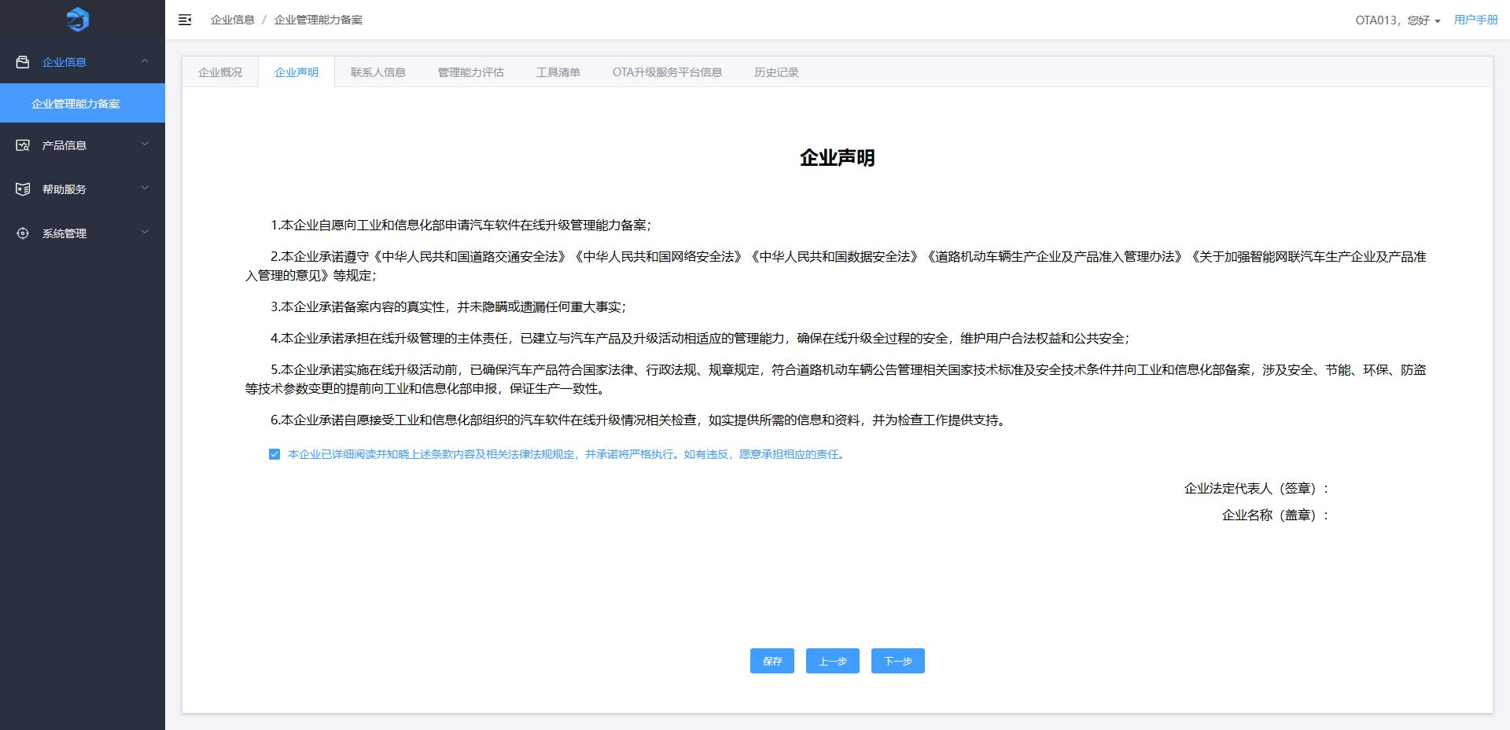
[Figure 3-15: Enterprise Declaration — image placeholder, original p.12]
On “Enterprise Declaration”:
- Read and tick the acknowledgment, click “Save.”
- Click “Previous” to go back to “Enterprise Overview.”
- Click “Next” to go to “Contact Information.”
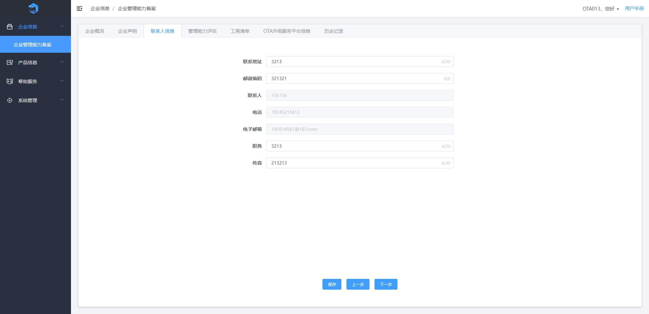
[Figure 3-16: Contact Information — image placeholder, original p.13]
On “Contact Information”:
- Fill in contact details and click “Save.”
- Click “Previous” to go back to “Enterprise Declaration.”
- Click “Next” to go to “Capability Assessment.”
Notes: “Contact Person,” “Phone,” and “Email” cannot be modified.
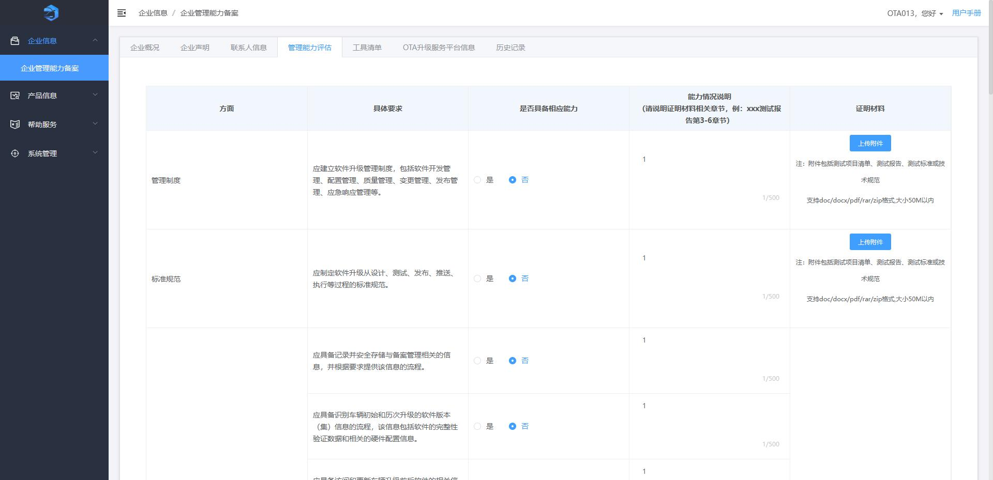
[Figure 3-17: Capability Assessment — image placeholder, original p.14]
On “Capability Assessment”:
- Upload attachments as required, then click “Save.”
- Click “Previous” to go back to “Contact Information.”
- Click “Next” to go to “Tool List.”
Notes: Uploaded materials must meet the attachment requirements shown on the page.
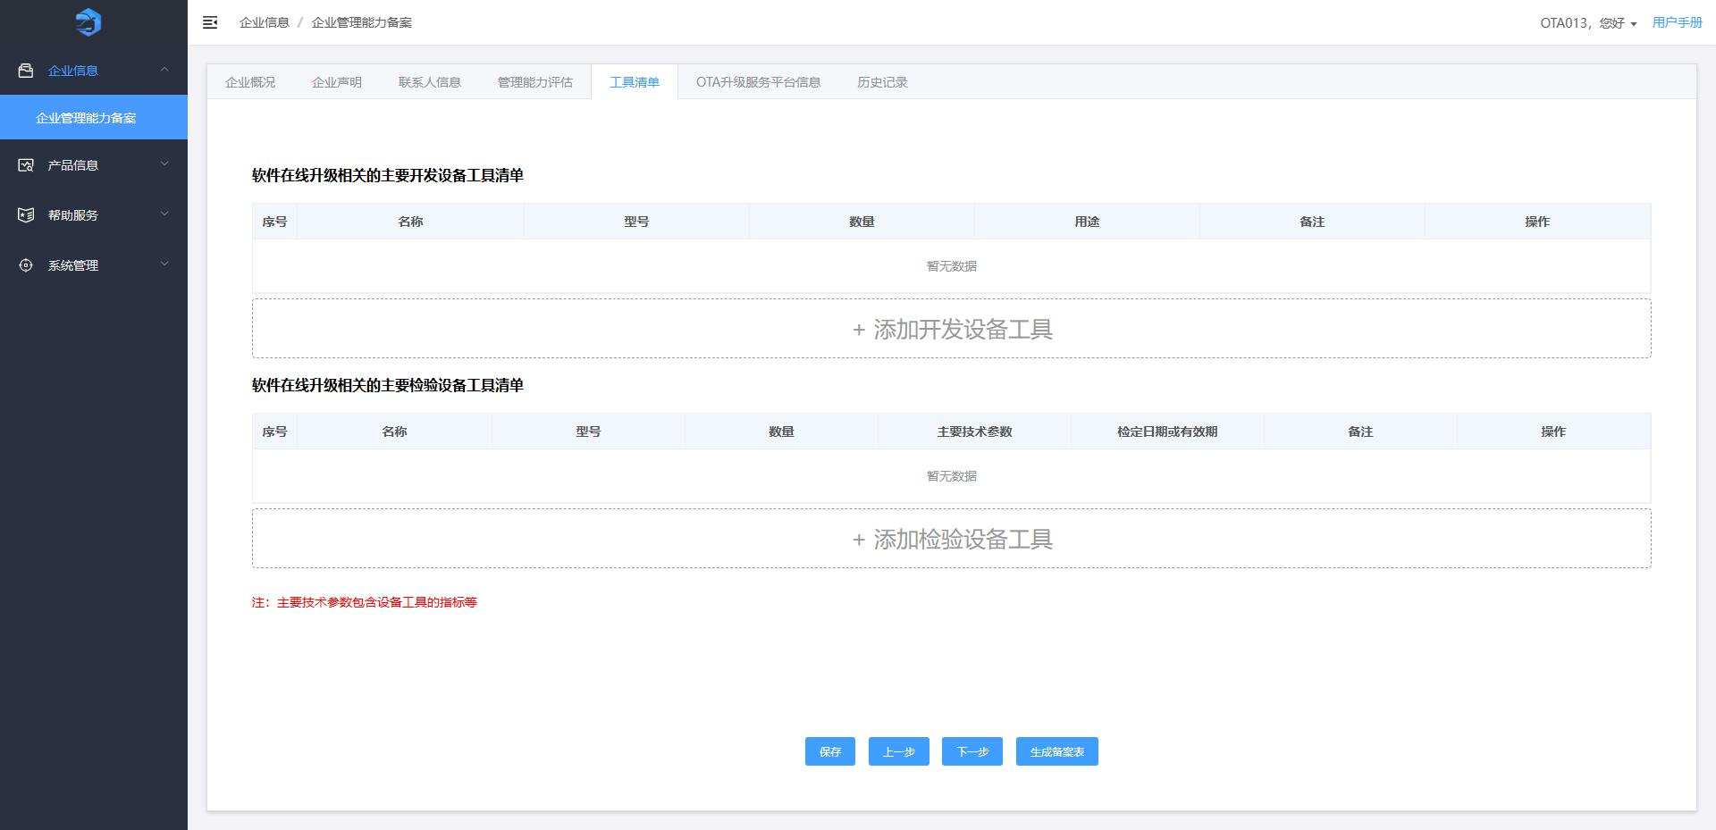
[Figure 3-18: Tool List — image placeholder, original p.14]
On “Tool List”:
- Click “Add Development Equipment/Tools” to add items to the development tools list.
- Click “Add Inspection Equipment/Tools” to add items to the inspection tools list.
- Use “Delete” in the Actions column to remove an entry.
- Click “Save.”
- Click “Previous” to go back to “Capability Assessment.”
- Click “Generate Filing Form” to proceed to “Information Confirmation & Submission.”
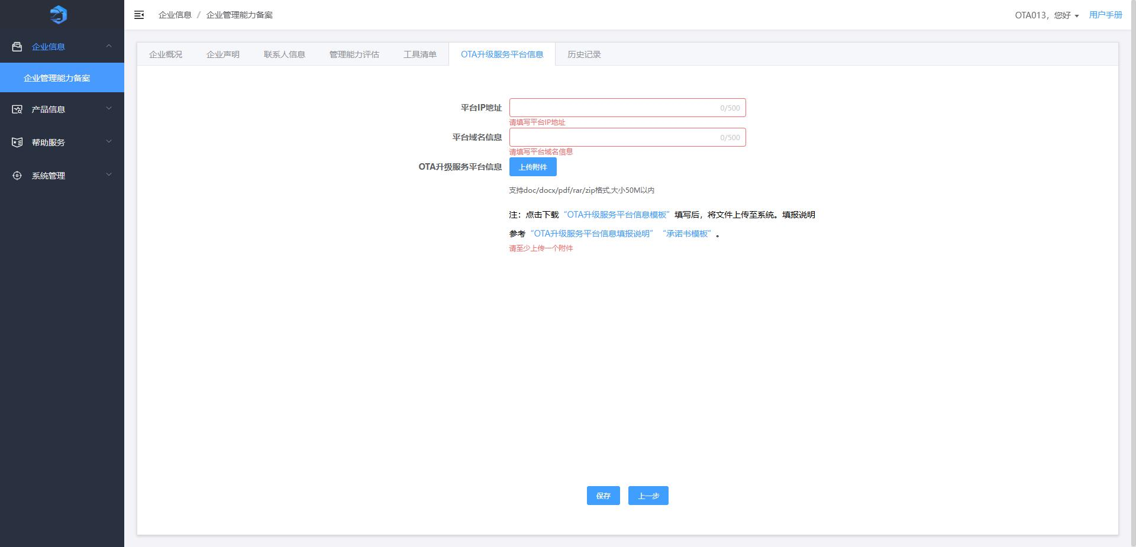
[Figure 3-19: OTA Upgrade Service Platform Information — image placeholder, original p.15]
On “OTA Upgrade Service Platform Information”:
- You can download templates such as “Platform Info Template,” “Platform Info Instructions,” and “Letter of Commitment.”
- Fill in platform-related information and upload attachments. If the main subject is not a vehicle manufacturer, a letter of commitment is required.
- Click “Save,” “Previous” to go back, or “Next” to continue to “Information Confirmation & Submission.”
Note: Platform information is not printed into the filing form.
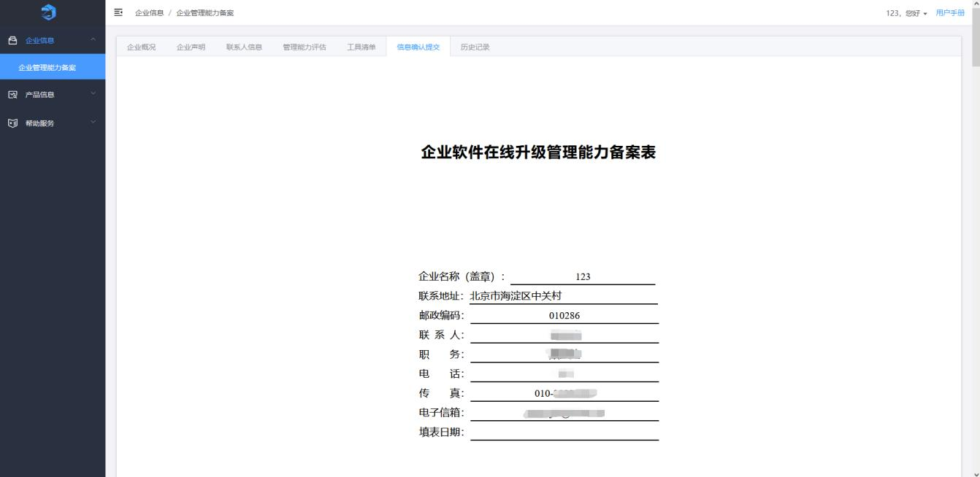
[Figure 3-20: Information Confirmation & Submission — image placeholder, original p.16]
On “Information Confirmation & Submission”:
- The complete filing form is shown. After the form is generated, other pages become read-only.
- Click “Download Filing Form” to save locally.
- Click “Upload Attachments” to provide the signed-and-stamped scanned copy.
- Click “Resume Editing” to delete the generated form and make pages editable again.
- Click “Submit,” confirm in the dialog, then a “History” tab is added showing submissions and review history.
Notes:
- Download, sign, and stamp the filing form; then upload the scanned copy.
- The form date should be the date when you downloaded the filing form.
- Ensure the uploaded filing form matches the data entered in the system.
- Attachments must meet the on-page requirements.
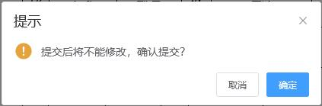
[Figure 3-21: Confirmation Dialog — image placeholder, original p.17]
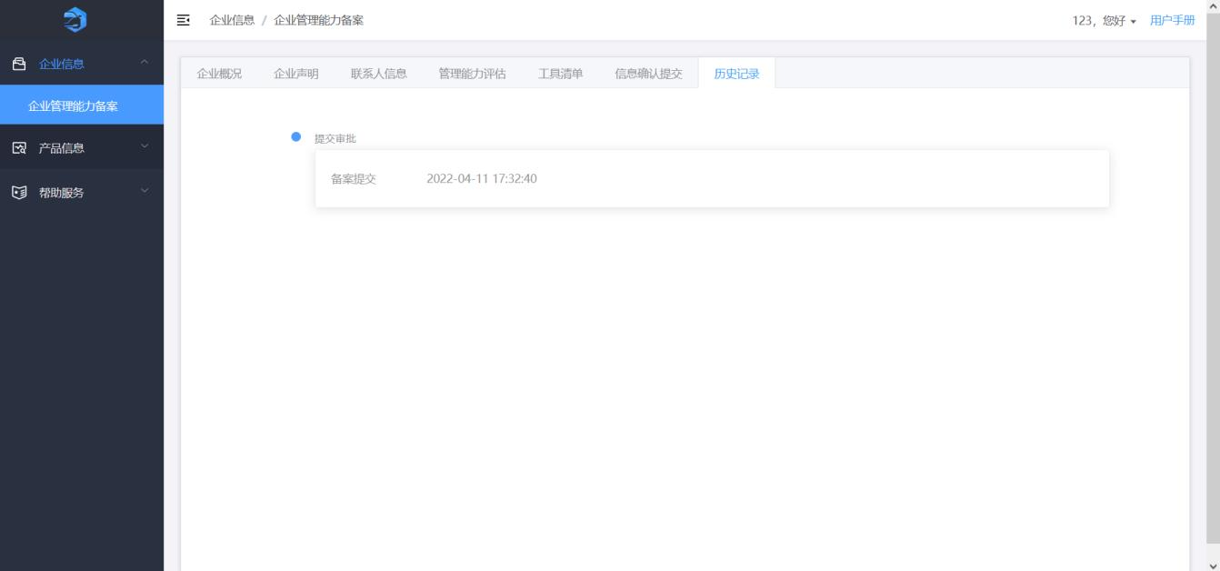
[Figure 3-22: Filing History — image placeholder, original p.17]
Click “Company Information Change” in the list to modify information of an approved Enterprise Management Capability filing, then “Submit” again.
For enterprises whose filing was approved but did not complete the “OTA Upgrade Service Platform Information,” clicking “Company Information Change” will show a dialog:
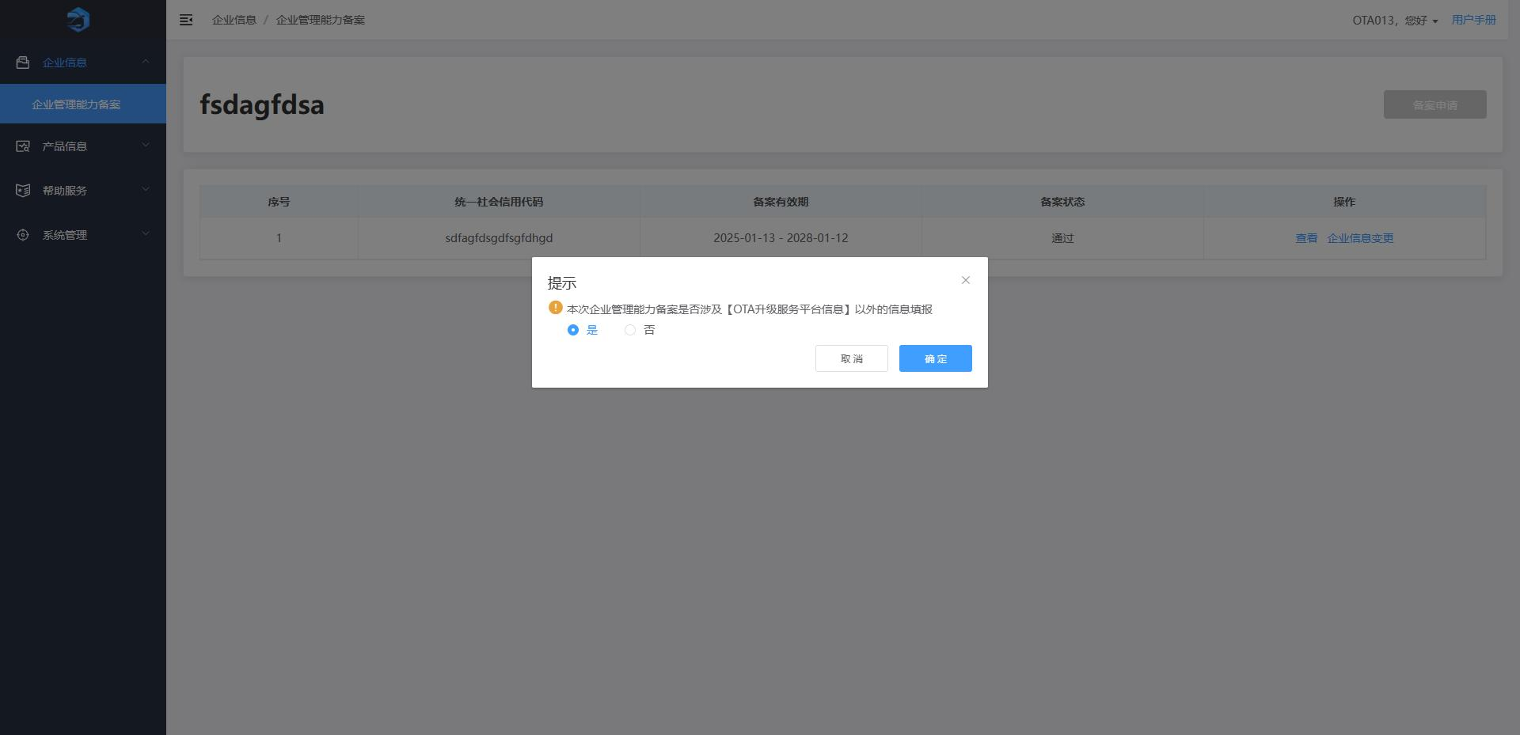
[Figure 3-23: Company Info Change Dialog — image placeholder, original p.18]
- Select “Yes” to resume editing on the “Information Confirmation & Submission” page (all except registered info can be edited).
- Select “No” to edit only the “OTA Upgrade Service Platform Information” page.
Note: Only after supplementing and passing review of the “OTA Upgrade Service Platform Information” can you continue to file upgrade activities. Selecting “Yes” updates the filing validity period upon approval; selecting “No” does not. This dialog appears only the first time you supplement platform information; after approval, it no longer appears for subsequent changes.
You can also click “Edit” in the list to modify the filing information and then submit again.
Click “View” to see filing details and approval history.

3.3 Product Information

3.3.1 Model & Function Filing — First-time Application
The page shows the first-time application list, supporting data filtering, creating new filings, viewing details, and editing filing information.
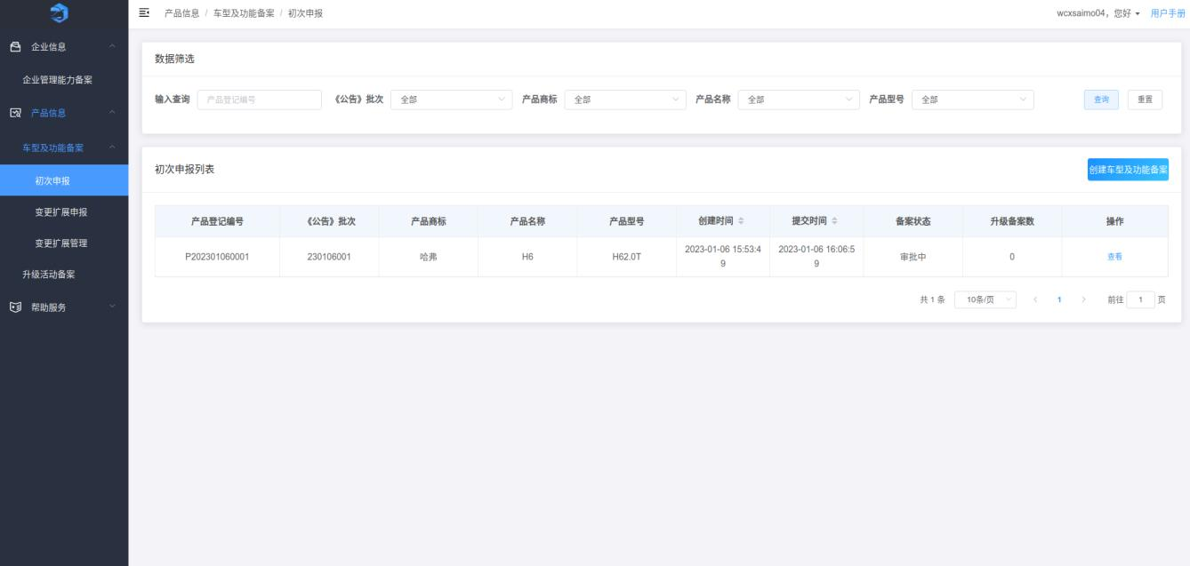
[Figure 3-24: First-time Filing List — image placeholder, original p.19]
Parent account: supports fuzzy search by product registration number and by submitting account; also supports hierarchical filters: “Announcement Batch,” “Product Brand,” “Product Name,” and “Product Model.”
Sub-account: supports fuzzy search by product registration number and hierarchical filters as above.
Click “Search” to display results; click “Reset” to clear conditions.
Click “Create Model & Function Filing,” fill in information, upload attachments, and click “Submit.”
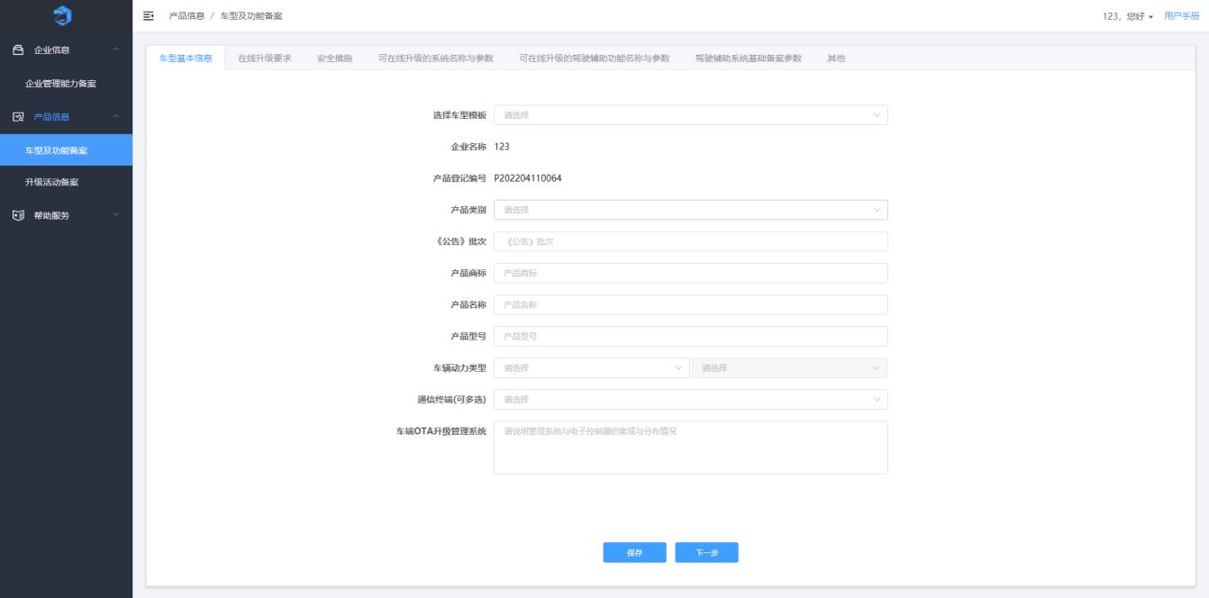
[Figure 3-25: Vehicle Basic Info — image placeholder, original p.20]
On “Vehicle Basic Information”:
- Fill in required fields and click “Save.”
- Click “Next” to go to “Online Upgrade Requirements.”
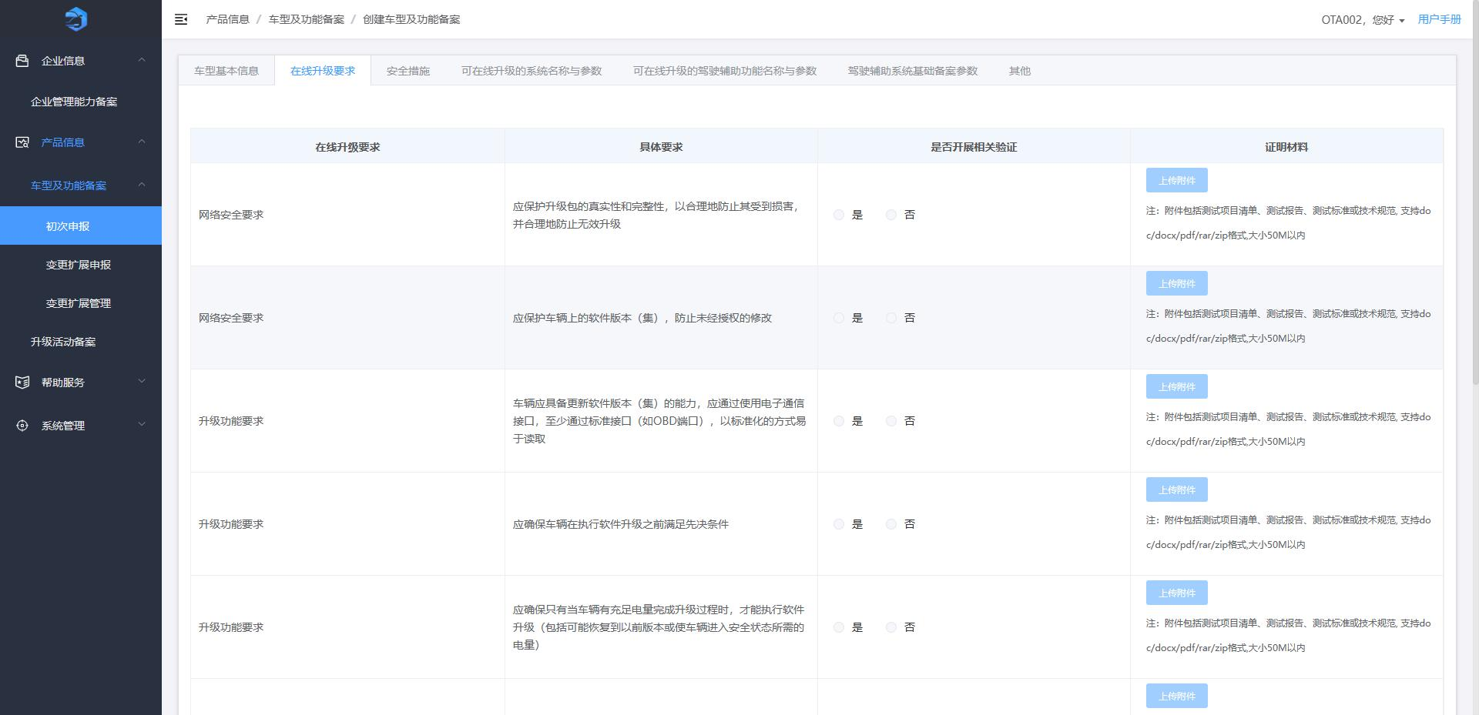
[Figure 3-26: Online Upgrade Requirements — image placeholder, original p.20]
On “Online Upgrade Requirements”:
- Upload attachments as required; click “Save.”
- Click “Previous” or “Next” to navigate to “Safety Measures.”
Notes: Attachments must meet the on-page requirements.
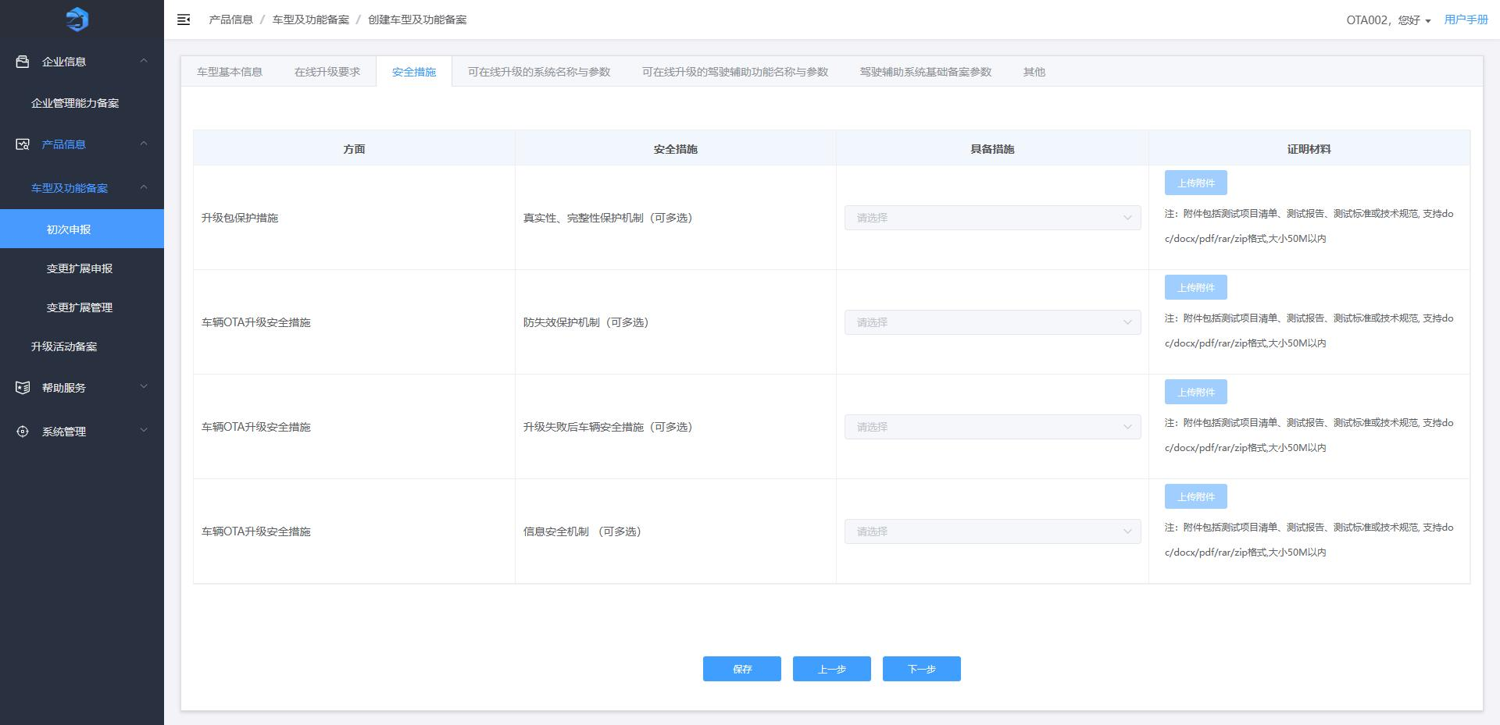
[Figure 3-27: Safety Measures — image placeholder, original p.21]
On “Safety Measures”:
- Fill in information and upload attachments; click “Save.”
- Navigate back/forward; “Next” goes to “Upgradable System Names & Parameters.”
Notes: Attachments must meet the on-page requirements.
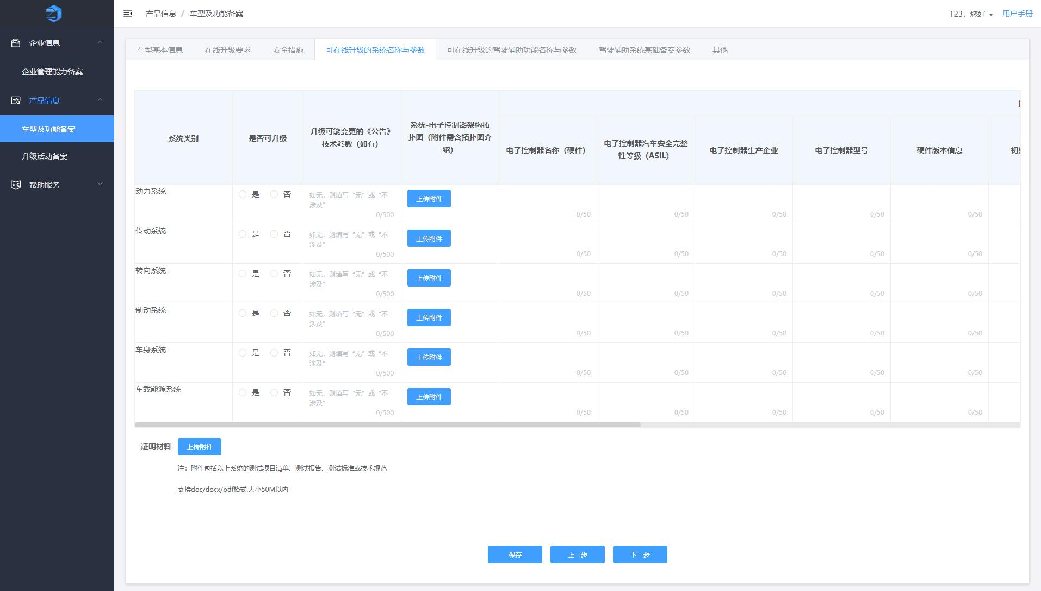
[Figure 3-28: Upgradable System Names & Parameters — image placeholder, original p.22]
On “Upgradable System Names & Parameters”:
- Fill in data; upload attachments.
- If multiple controllers are upgradable, click “Add Controller” to add records.
- For systems beyond the six listed, click “Add System” to add entries.
- Use “Delete” to remove an entry.
- Click “Next” to go to “Upgradable Driver Assistance Function Names & Parameters.”
Notes: Attachments must meet the on-page requirements.
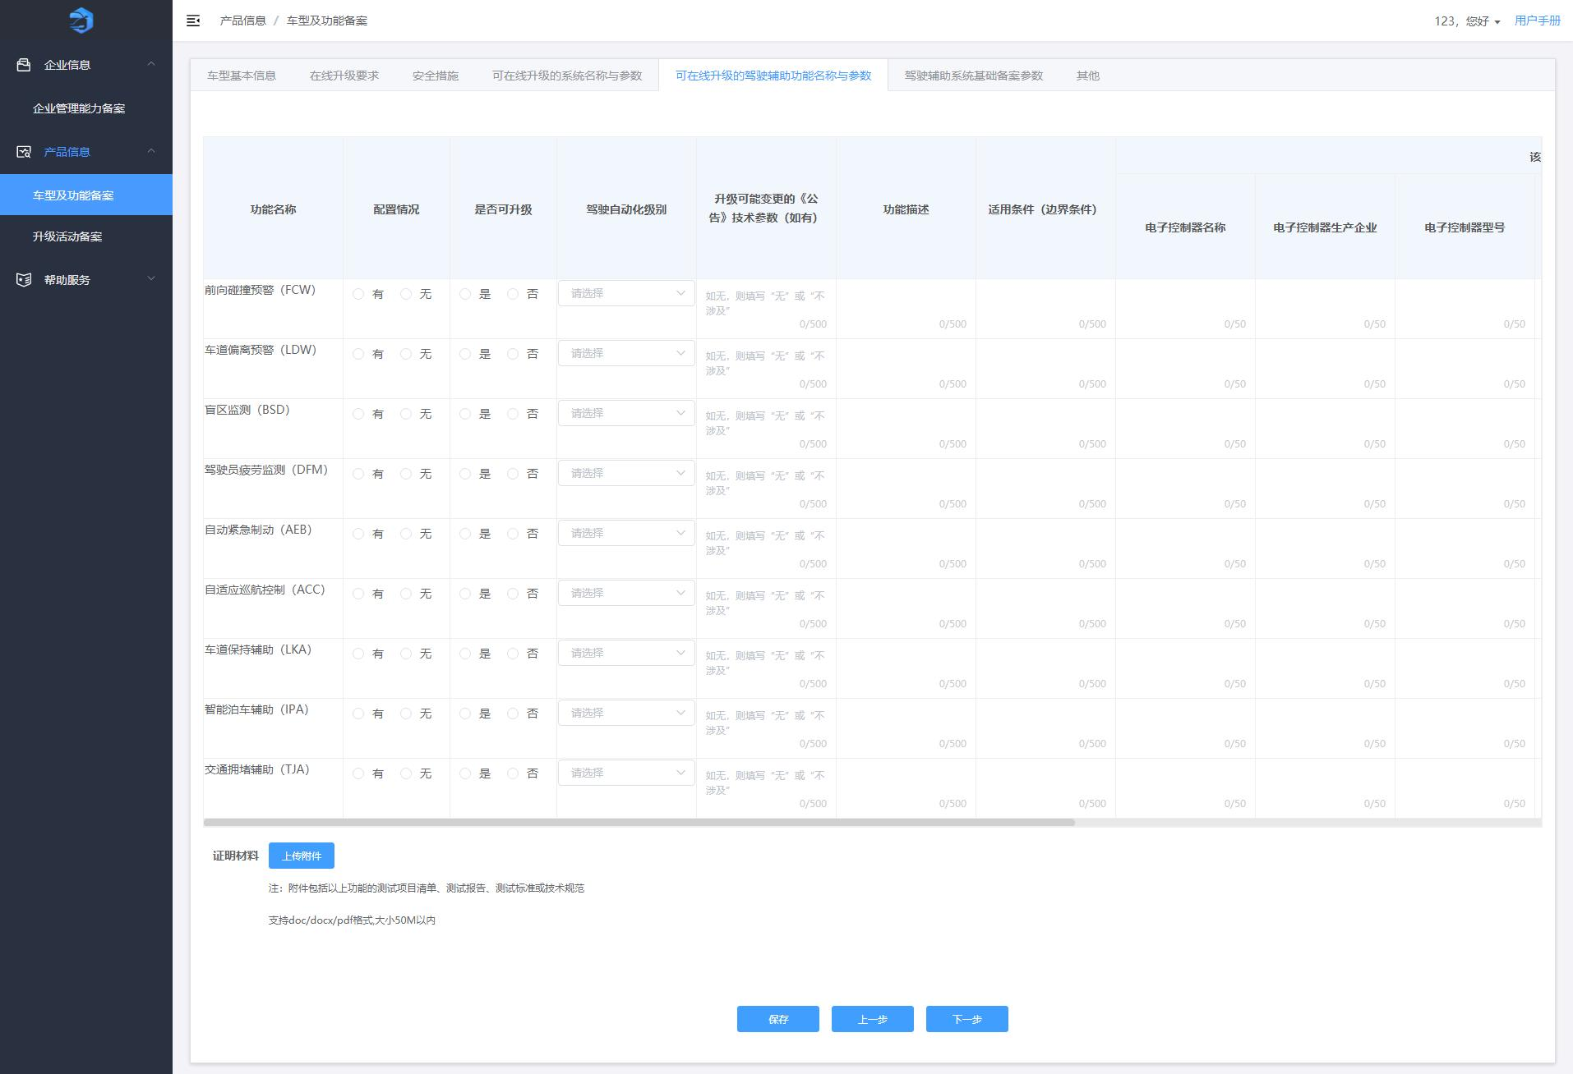
[Figure 3-29: Upgradable Driver Assistance Function Names & Parameters — image placeholder, original p.23]
On “Upgradable Driver Assistance Function Names & Parameters”:
- Fill in function data; upload attachments.
- If multiple controllers are involved, click “Add Controller.”
- For functions beyond the nine listed, click “Add Function” to add entries.
- Use “Delete” to remove entries, “Save,” then “Next” to go to “ADAS Base Filing Parameters.”
Notes: Attachments must meet the on-page requirements.
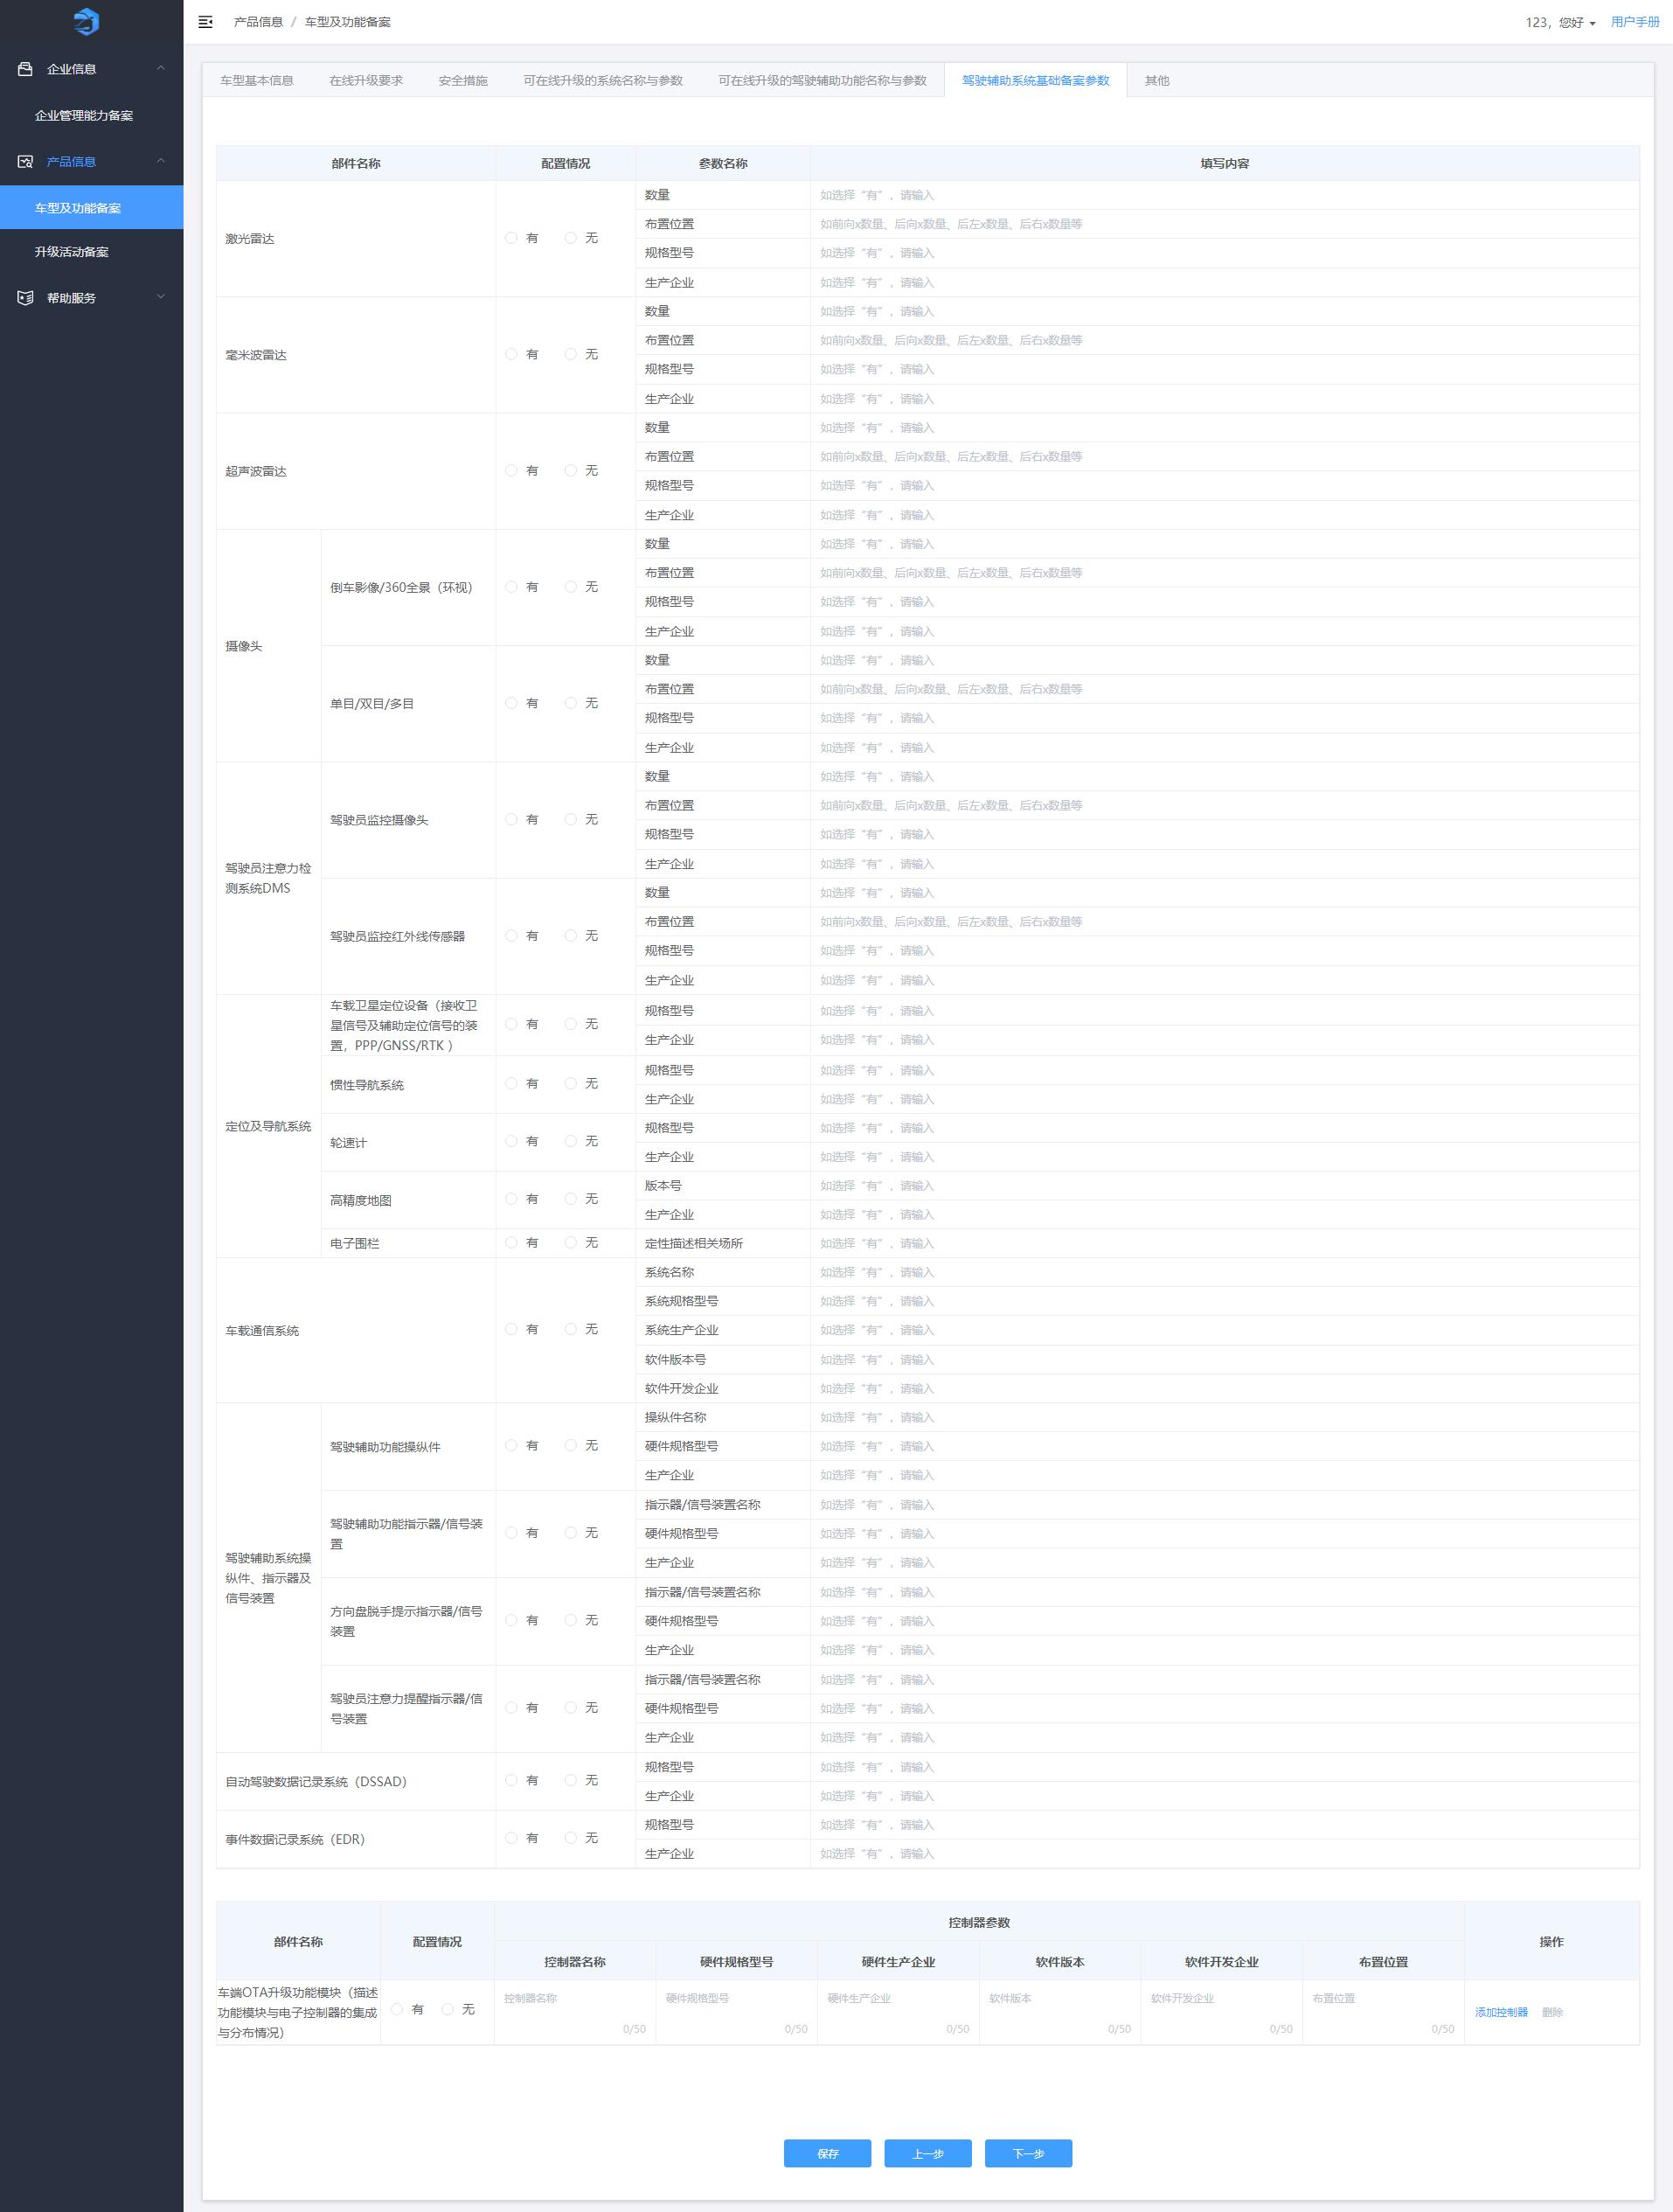
[Figure 3-30: ADAS Base Filing Parameters — image placeholder, original p.25]
On “ADAS Base Filing Parameters”:
- If multiple controllers apply, click “Add Controller” to add records; use “Delete” as needed.
- Click “Save,” then “Next” to go to “Others.”
[Figure 3-31: Others — image placeholder, original p.26]
On “Others”:
- Fill in information and click “Save.”
- Click “Previous” to go back; click “Submit” and confirm to complete filing. A “History” tab is added to show submissions and review history.
Notes: Attachments must meet the on-page requirements.
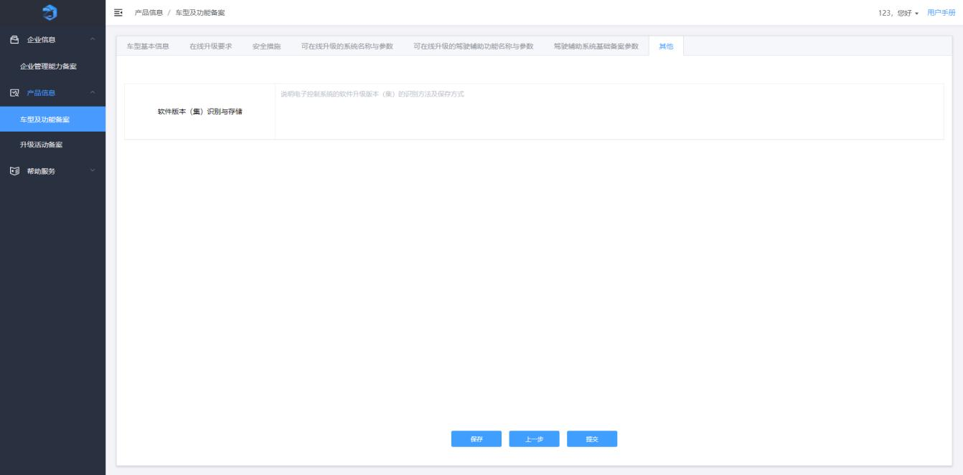
[Figure 3-32: Submission Confirmation Dialog — image placeholder, original p.26]
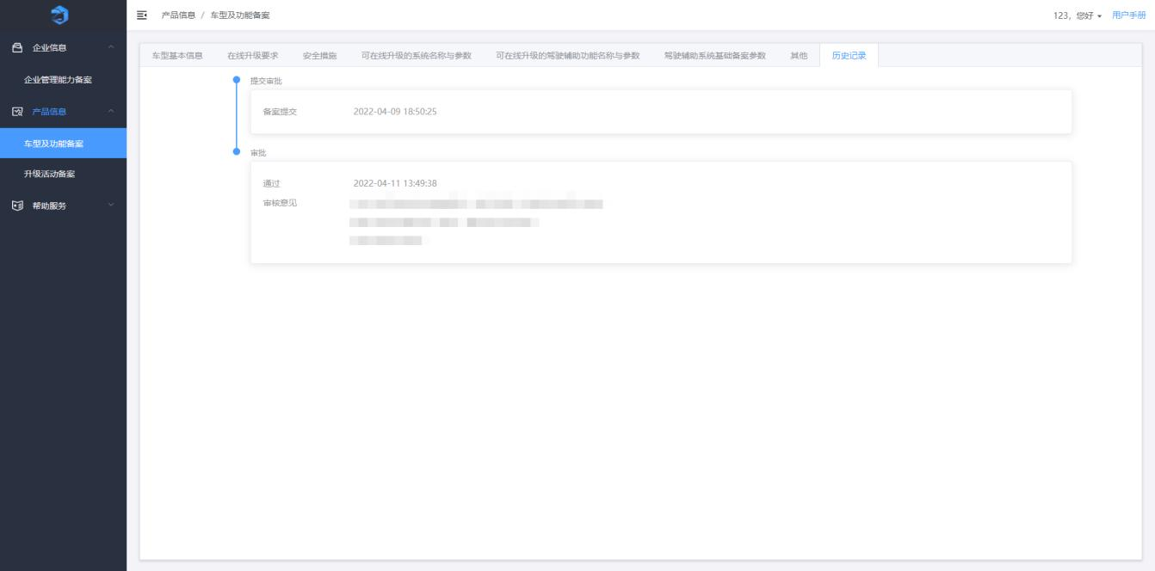
[Figure 3-33: Filing History — image placeholder, original p.27]
Click “Edit” in the list to modify and re-submit.
Click “View” to see filing details and approval history.
Click “Approve” in the first-time application list to approve change filings submitted by sub-accounts.

3.3.2 Model & Function Filing — Change/Extension Application
This page shows the change/extension application list, supporting data filtering, change/extension submission, and viewing details.
[Figure 3-34: Change/Extension Application List — image placeholder, original p.26]
Supports fuzzy search by registration number and hierarchical filters by “Announcement Batch,” “Product Brand,” “Product Name,” and “Product Model.”
Click “Search” to display results; click “Reset” to clear.
Click “Change/Extend,” modify information, upload attachments, and click “Submit.”
[Figure 3-35: Vehicle Basic Information — image placeholder, original p.27]
On “Vehicle Basic Information” (change):
- Modify and click “Save.”
- Click “Next” to “Online Upgrade Requirements.”
[Figure 3-36: Online Upgrade Requirements (Change) — image placeholder, original p.27]
On “Online Upgrade Requirements” (change):
- Modify, upload attachments, click “Save.”
- Navigate back/forward; “Next” goes to “Safety Measures.”
Notes: Attachments must meet requirements.
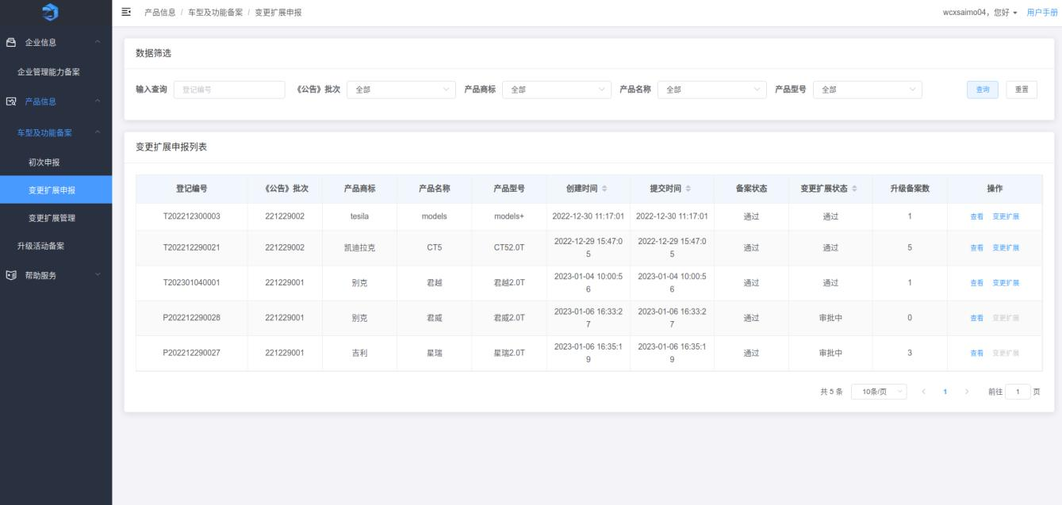
[Figure 3-37: Safety Measures (Change) — image placeholder, original p.28]
On “Safety Measures” (change):
- Modify information, upload attachments, click “Save.”
- “Next” goes to “Upgradable System Names & Parameters.”
Notes: Attachments must meet requirements.
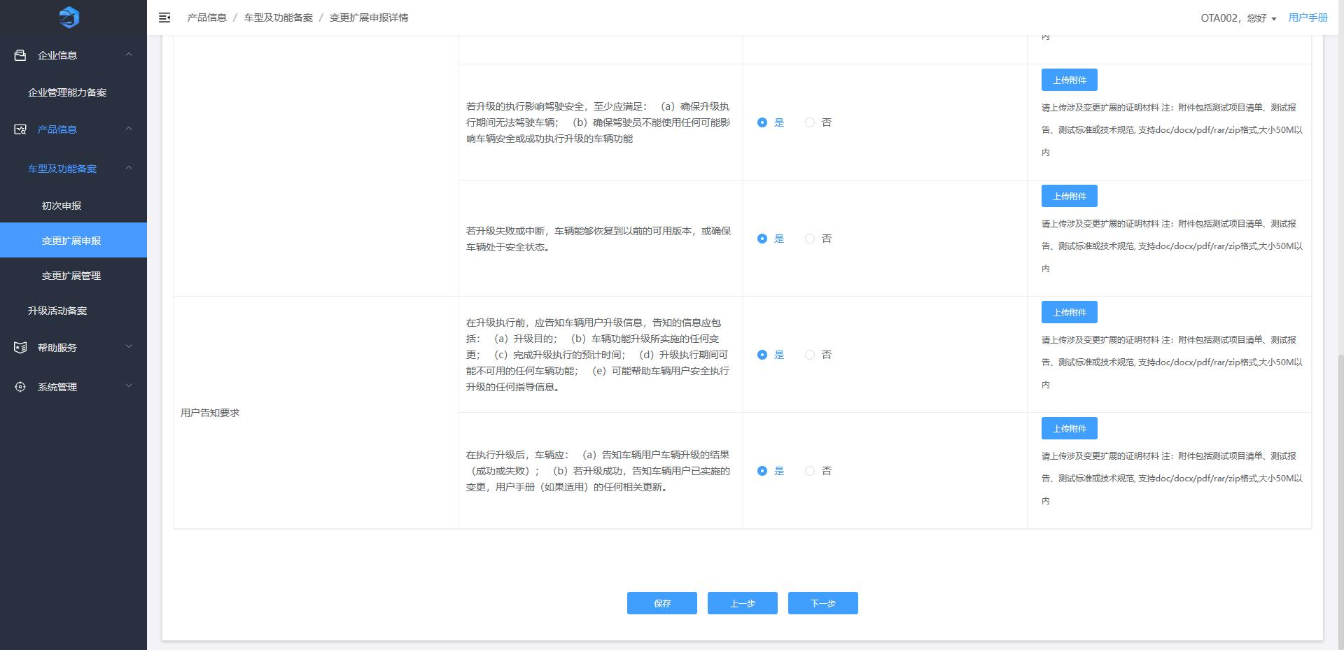
[Figure 3-38: Upgradable System Names & Parameters (Change) — image placeholder, original p.29]
On “Upgradable System Names & Parameters” (change):
- Modify and upload; click “Save.”
- “Next” goes to “Upgradable Driver Assistance Function Names & Parameters.”
Notes: Attachments must meet requirements.
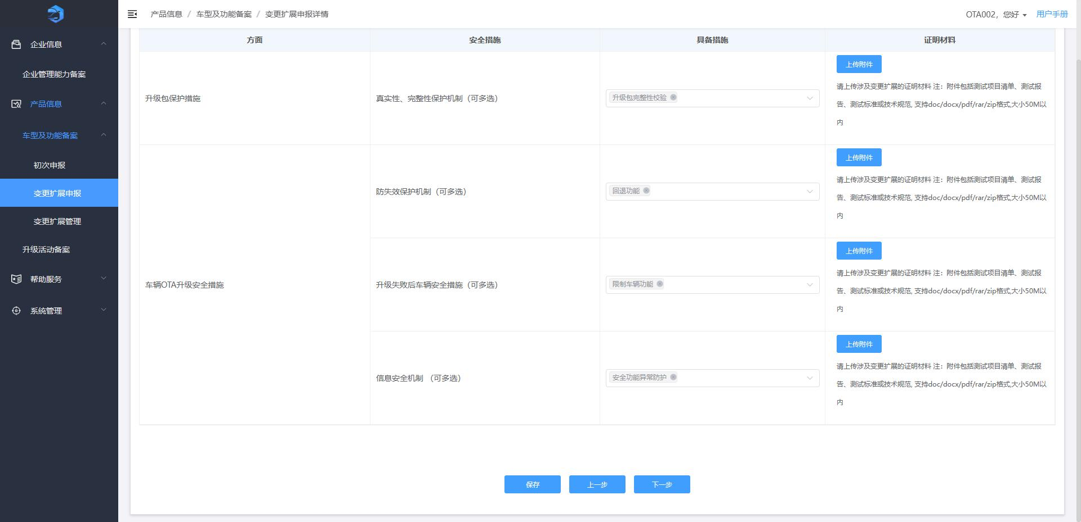
[Figure 3-39: Upgradable Driver Assistance Functions (Change) — image placeholder, original p.30]
On “Upgradable Driver Assistance Function Names & Parameters” (change):
- Modify and upload; click “Save.”
- “Next” goes to “ADAS Base Filing Parameters.”
Notes: Attachments must meet requirements.
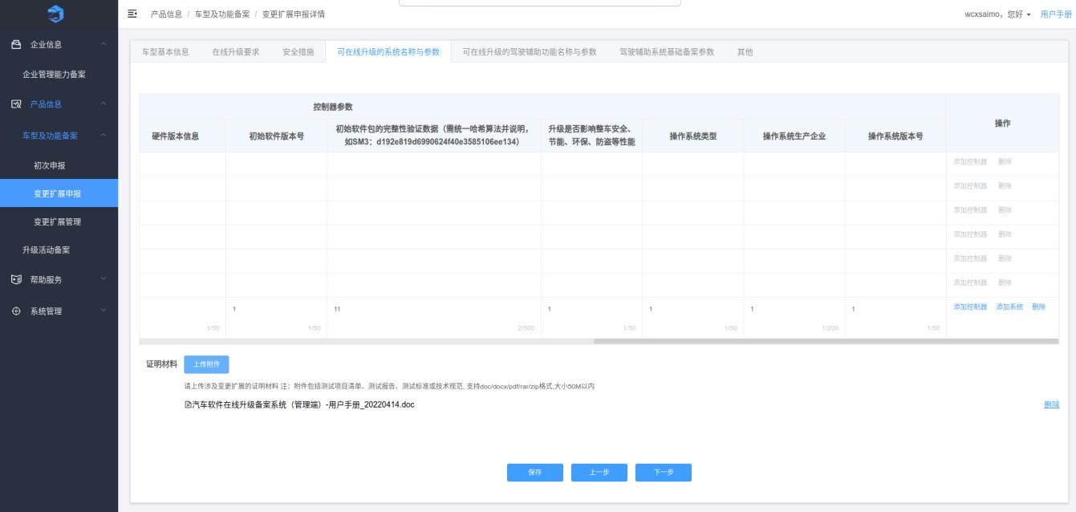
[Figure 3-40: ADAS Base Filing Parameters (Change) — image placeholder, original p.31]
On “ADAS Base Filing Parameters” (change):
- Click “Save.”
- “Next” goes to “Others.”
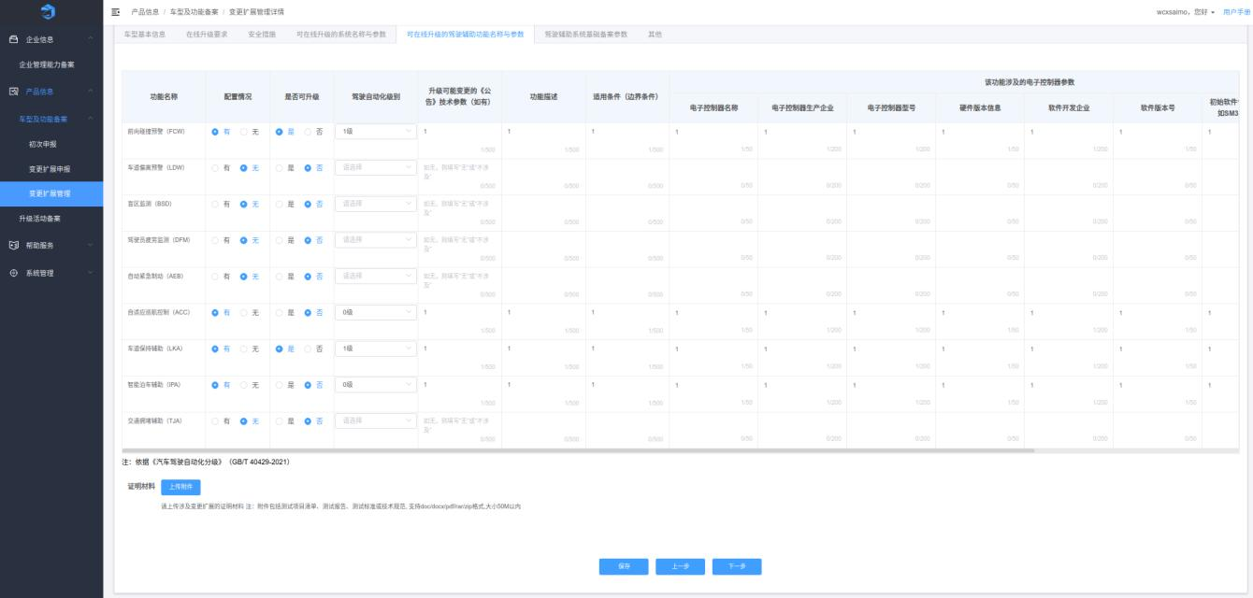
[Figure 3-41: Others (Change) — image placeholder, original p.31]
On “Others” (change):
- Modify, click “Save.”
- Click “Submit” and confirm to complete; a “History” tab shows submissions and review history.
Notes: Attachments must meet requirements.
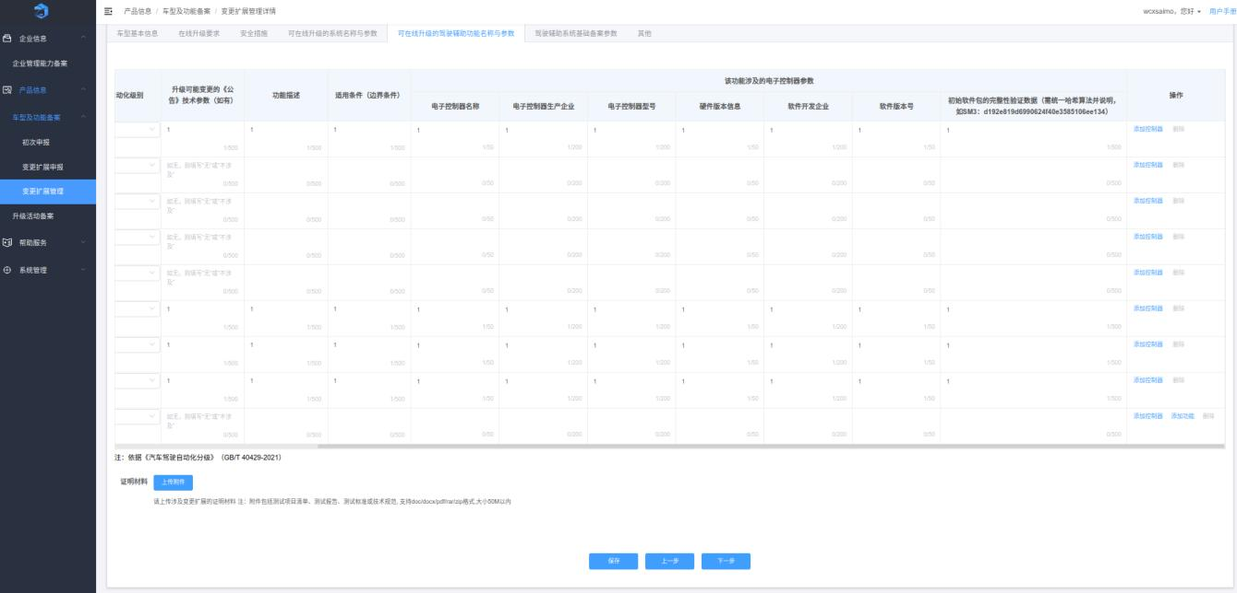
[Figure 3-42: Submission Confirmation (Change) — image placeholder, original p.32]
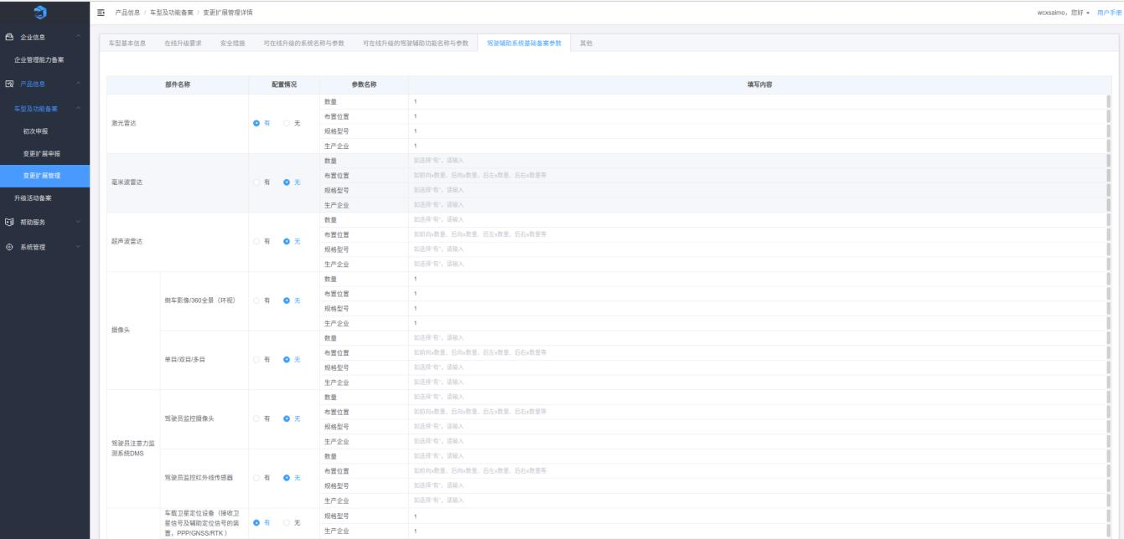
[Figure 3-43: History (Change) — image placeholder, original p.32]
Click “Edit” to modify and resubmit. See section 3.3.1.2.
Click “View” to see filing details and approval history.

3.3.3 Model & Function Filing — Change/Extension Management
This page shows data after changes submitted from the Change/Extension Application page.
[Figure 3-44: Change/Extension Management (Parent) — image placeholder, original p.33]
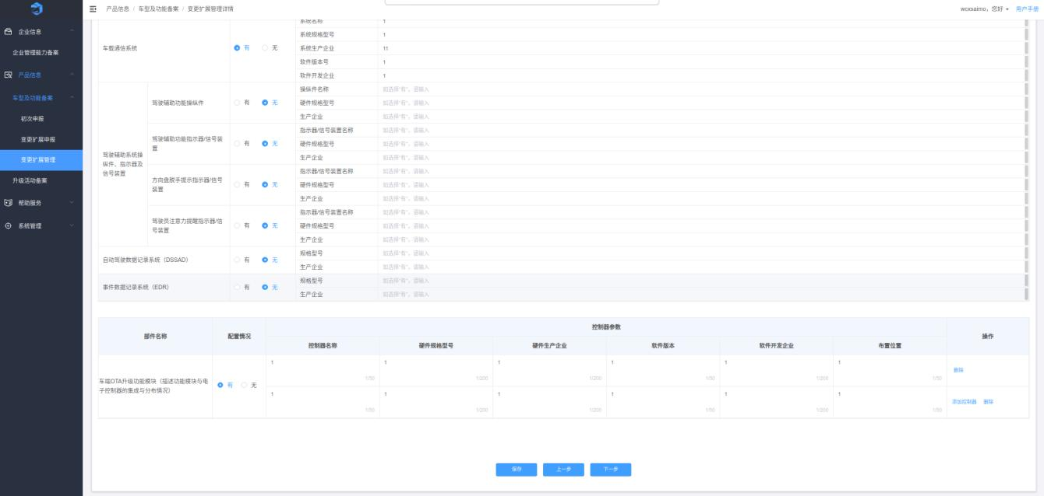
[Figure 3-45: Change/Extension Management (Sub-account) — image placeholder, original p.33]
Supports fuzzy search by Product Registration Number, Submitting Account (parent), Announcement Batch, Product Brand, Product Name, and Product Model; hierarchical filters are available.
Click “Search” to display results; click “Reset” to clear.
Click “Edit” to modify filing information and resubmit.
Click “View” to see filing details and approval history.
Click “Delete” to remove change filing information.
Click “Approve” to process change filings submitted by sub-accounts.

3.3.4 Upgrade Activity Filing
This page shows the list of upgrade activity filings. You can create new filings, view details, edit information, and end upgrades.
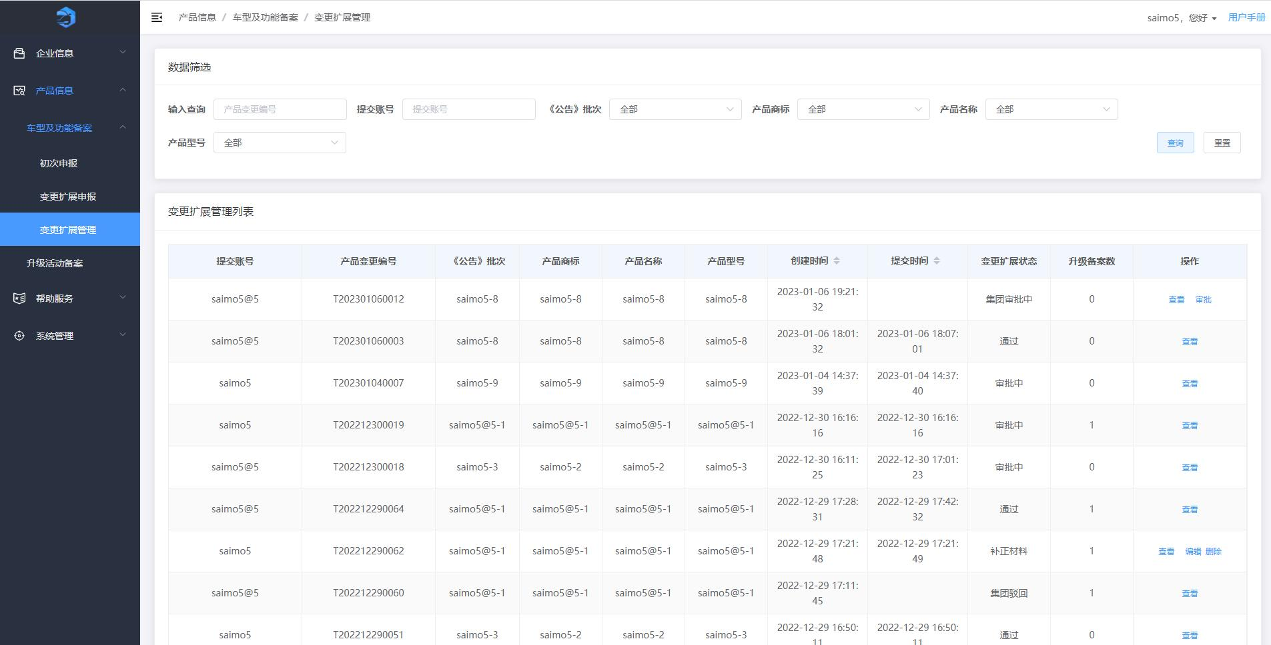
[Figure 3-46: Upgrade Activity Filing Home — image placeholder, original p.35]
Parent account: supports fuzzy search by Upgrade Filing Number and by submitting account; also supports hierarchical filters by Announcement Batch, Product Brand, Product Name, and Product Model.
Sub-account: supports fuzzy search by Upgrade Filing Number and hierarchical filters as above.
Click “Search” to display results; click “Reset” to clear.
Click “Create Upgrade Activity Filing,” fill in information, upload attachments, then click “Submit.”
[Figure 3-47: Target Vehicle Models — image placeholder, original p.36]
On “Target Vehicle Models”:
- Template selection: In the first tab, you can select a previously approved upgrade activity filing with data sharing enabled as a template. For multiple upgrades of the same model, the latest is used as the template.
- Click “Save,” then “Next” to go to “Target Vehicles for This Upgrade.”
Notes: Product Brand, Product Name, Product Model, and Powertrain Type are taken from approved Model & Function filings and are not editable.
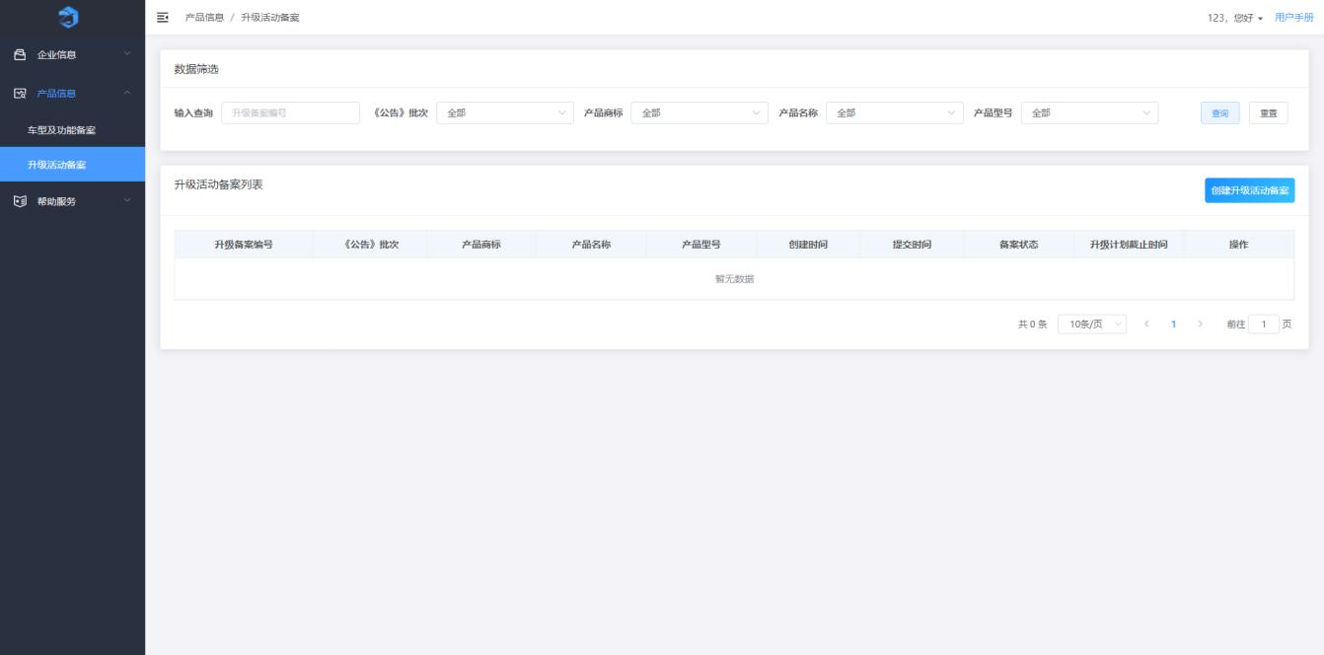
[Figure 3-48: Basic Info of This Upgrade Activity — image placeholder, original p.37]
On “Basic Info of This Upgrade Activity”:
- Click “Template” to download the template; click “Upload Attachments” to upload.
- Click “Save,” then “Previous” or “Next” to go to “Target Vehicles for This Upgrade.”
[Figure 3-49: Target Vehicles for This Upgrade — image placeholder, original p.37]
On “Target Vehicles for This Upgrade”:
- Fill in information; click “VIN Upload” to upload VIN files.
- Click “Save”; navigate back/forward; “Next” goes to “Upgrade Impact Assessment.”
Notes: The VIN attachment must meet the on-page requirements.
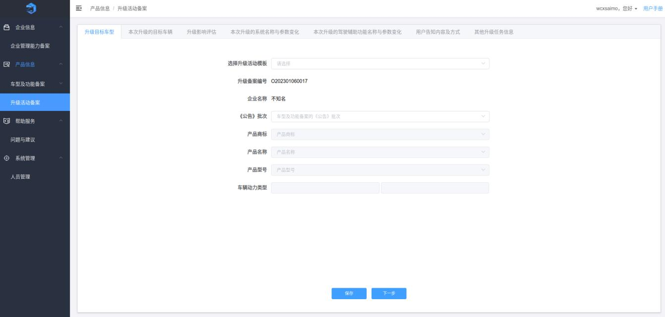
[Figure 3-50: Upgrade Impact Assessment — image placeholder, original p.38]
On “Upgrade Impact Assessment”:
- Fill in information; upload attachments; click “Save.”
- Navigate back/forward; “Next” goes to “System Names & Parameter Changes in This Upgrade.”
Notes: Attachments must meet the on-page requirements.
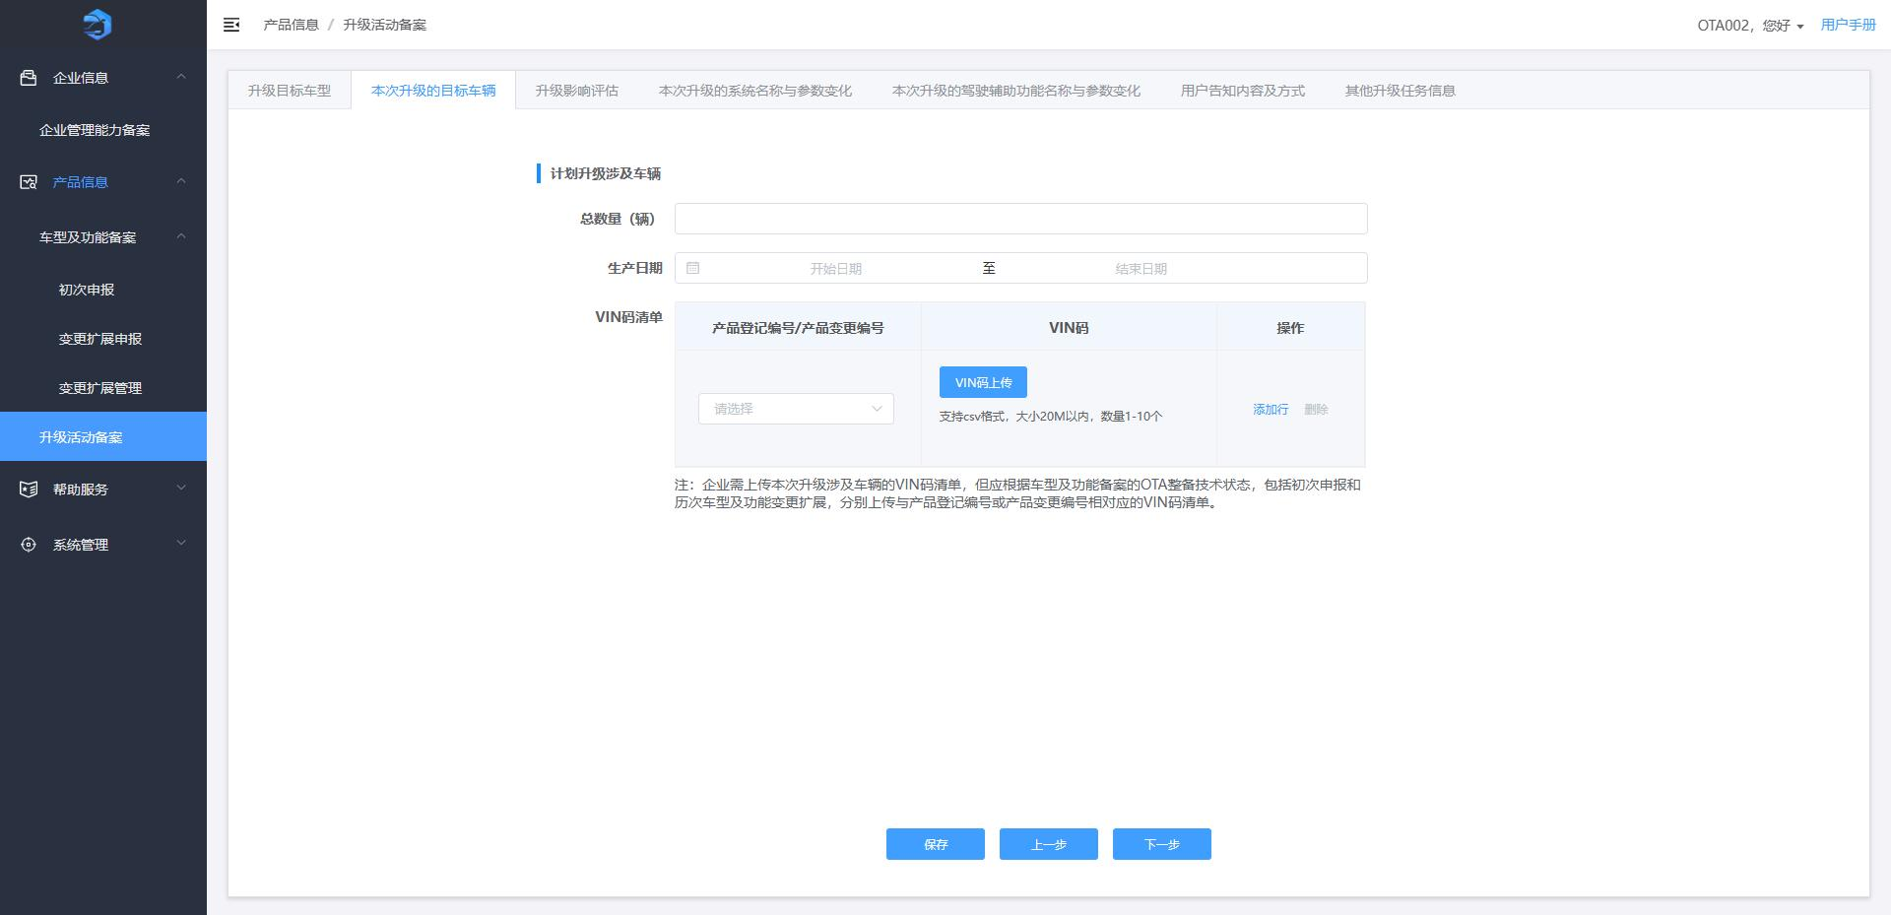
[Figure 3-51: System Names & Parameter Changes — image placeholder, original p.39]
On “System Names & Parameter Changes in This Upgrade”:
- If multiple controllers are upgraded, click “Add Controller” to add controller parameter records.
- If other systems are upgraded, click “Add System” to add entries.
- Use “Delete” to remove entries; “Save”; “Next” to go to “Driver Assistance Function Names & Parameter Changes.”
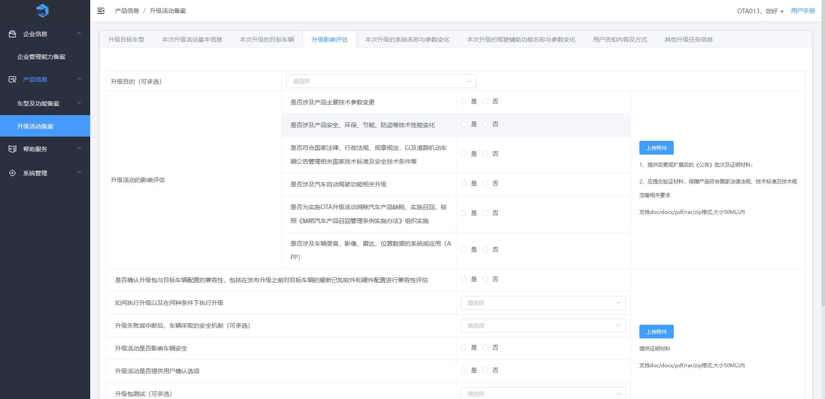
[Figure 3-52: Driver Assistance Function Names & Parameter Changes — image placeholder, original p.40]
On “Driver Assistance Function Names & Parameter Changes in This Upgrade”:
- If other functions are upgraded, click “Add” to add records; use “Delete” as needed.
- Click “Save,” “Previous,” or “Next” to go to “User Notification Content & Method.”
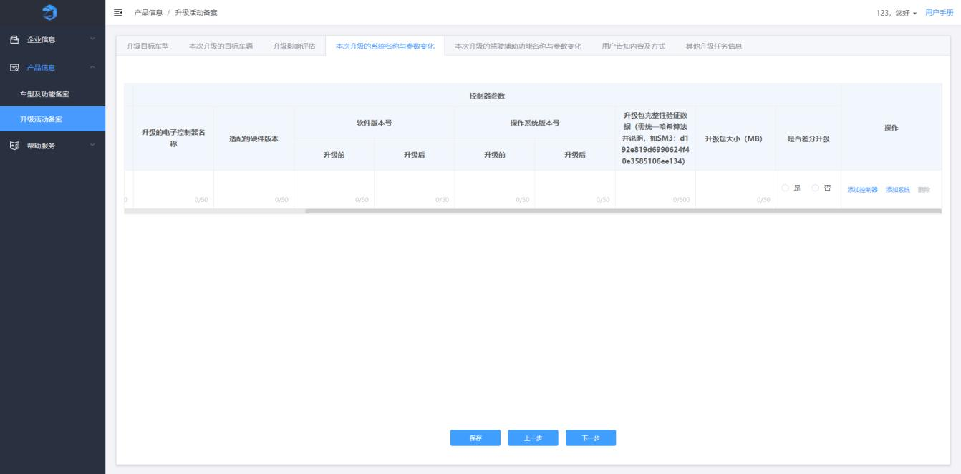
[Figure 3-53: User Notification Content & Method — image placeholder, original p.41]
On “User Notification Content & Method”:
- Fill in information; upload attachments; click “Save.”
- Navigate back/forward; “Next” goes to “Other Upgrade Task Information.”
Notes: Attachments must meet the on-page requirements.
[Figure 3-54: Other Upgrade Task Information — image placeholder, original p.41]
On “Other Upgrade Task Information”:
- Fill in information and click “Save.”
- Click “Submit,” confirm, then the filing is submitted for review. A “History” tab is added to show submissions and review history.
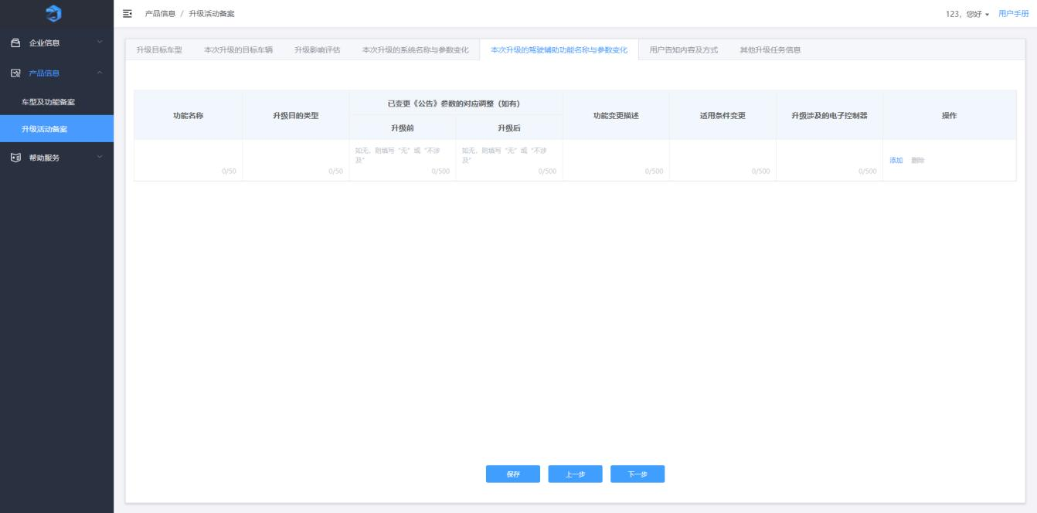
[Figure 3-55: Submission Confirmation — image placeholder, original p.42]
Note: If a dialog appears during submission prompting you to perform Company Information Change, see section 3.2.1.2.
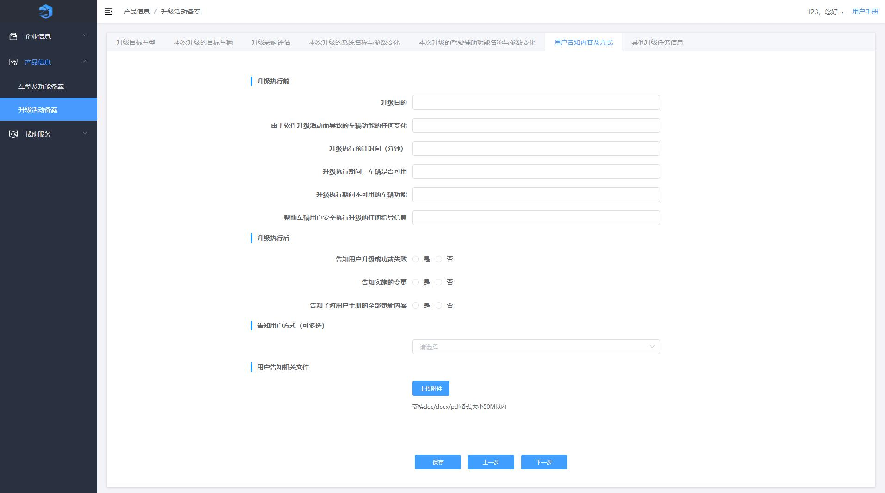
[Figure 3-56: History — image placeholder, original p.42]
Click “Edit” to modify the upgrade activity filing and resubmit. See section 3.3.2.2.
Click “View” to see details and approval history.
Click “End Upgrade,” fill in completion status, upload attachments, click “OK,” confirm again, and the upgrade will be ended successfully. A “Upgrade Completion Status” preview page is generated for review.
[Figure 3-57: Completion Status Form — image placeholder, original p.44]
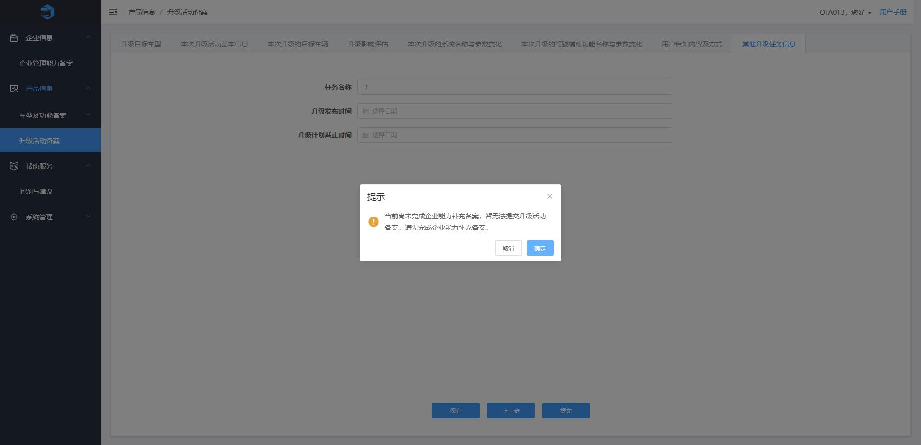
[Figure 3-58: Confirmation Dialog — image placeholder, original p.44]
[Figure 3-59: Upgrade Completion Status — image placeholder, original p.45]
Click “Approve” to review change filings submitted by sub-accounts.

3.4 Help & Services

3.4.1 Questions & Suggestions
On the Questions & Suggestions page, users can create items categorized by topic about the use of the Online Vehicle Software OTA Filing System. Click “Create Question” to submit.
Contact:
- 010-68200289
- 010-68200267
- 010-56177904
- 010-56177905
Office Hours: Monday to Friday (excluding public holidays), 08:30–11:30 and 13:00–17:00.
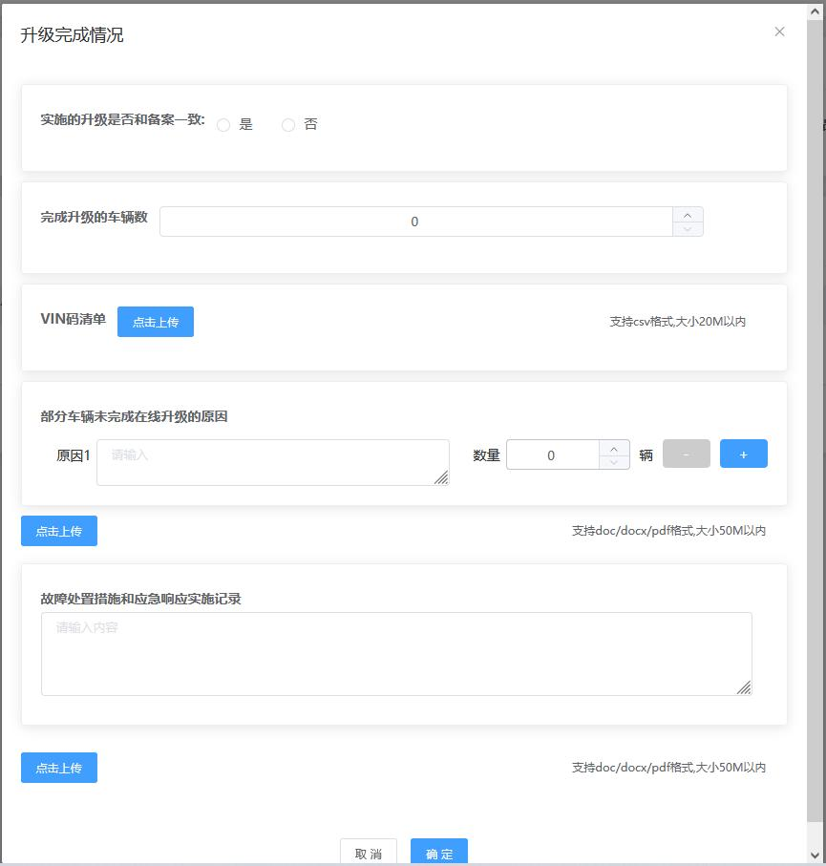
[Figure 3-60: Help — Questions & Suggestions — image placeholder, original p.46]

Prepared by Wenning (AI). Translation focuses on accuracy and terminology consistency: OTA=Over-the-Air, ADAS=Advanced Driver Assistance Systems. If you require a .docx file with embedded images, please reply and I will produce it in the format you prefer as soon as image extraction is available.

