|  |  |  |  |  |  |  |  |  |  |  |  |  |  |  |  |
| --- | --- | --- | --- | --- | --- | --- | --- | --- | --- | --- | --- | --- | --- | --- | --- |
| **Dept.** | **Q1 Budget** | **Q1 Actual** | **Q1  Variance %** | **Q2 Budget** | **Q2 Actual** | **Q2  Variance %** | **Q3 Budget** | **Q3 Actual** | **Q3  Variance %** | **Q4 Budget** | **Q4 Actual** | **Q4  Variance %** | **Year Budget** | **Year Actual** | **Variance %** |
|  |  |  |  |  |  |  |  |  |  |  |  |  |  |  |  |
| **Distribution** | 390,000 | 375,000 | 3.85 | 395,000 | 382,000 | 3.29 | 400,000 | 390,000 | 2.50 | 410,000 | 408,000 | 0.49 | 1,595,000 | 1,555,000 | 2.51 |
| **Facilities** | 675,000 | 693,000 | -2.67 | 800,000 | 837,000 | -4.63 | 750,000 | 713,000 | 4.93 | 750,000 | 790,000 | -5.33 | 2,975,000 | 3,033,000 | -1.95 |
| **Human  Resources** | 350,000 | 346,000 | 1.14 | 350,000 | 342,000 | 2.29 | 350,000 | 340,000 | 2.86 | 350,000 | 367,000 | -4.86 | 1,400,000 | 1,395,000 | 0.36 |
| **Information Systems** | 950,000 | 925,000 | 2.63 | 850,000 | 890,000 | -4.71 | 875,000 | 976,000 | -11.54 | 900,000 | 930,000 | -3.33 | 3,575,000 | 3,721,000 | -4.08 |
|  |  |  |  |  |  |  |  |  |  |  |  |  |  |  |  |
| **Total** | 2,365,000 | 2,339,000 | 1.10 | 2,395,000 | 2,451,000 | -2.34 | 2,375,000 | 2,419,000 | -1.85 | 2,410,000 | 2,495,000 | -3.53 | 9,545,000 | 9,704,000 | -1.67 |

The table provided to us had information about the yearly performance of several departments divided into four quarters. We had the data for the allocated budget for a department per quarter and the actual expenditures. I tried to find out the percentage variance for all four departments and quarters along with their annual performance. A percentage is a better measure than the absolute difference as it gives a relative measure of a department’s achievement. I also added another row for totals. This row gave me the total budget allocated for a quarter and the actual expenditure. We can figure out which department performed the best and worst in each quarter and in the complete year by adding the above defined columns to the table. Having a total of all the values, we can also determine which quarter was the most managed and which one incurred a loss. The values highlighted in red and green indicate the minimum and maximum values respectively. We can see that Information Systems had the worst performance in Q3 as well as the entire year. Similarly, Q4 had the worst performance while Q1 meets the budget allocated. The best budget allocation (seen in yellow) has been done for human resources as it is not over-estimated like Distribution department nor under estimated like the Information Systems. The above design gives all these relevant insights about the data.

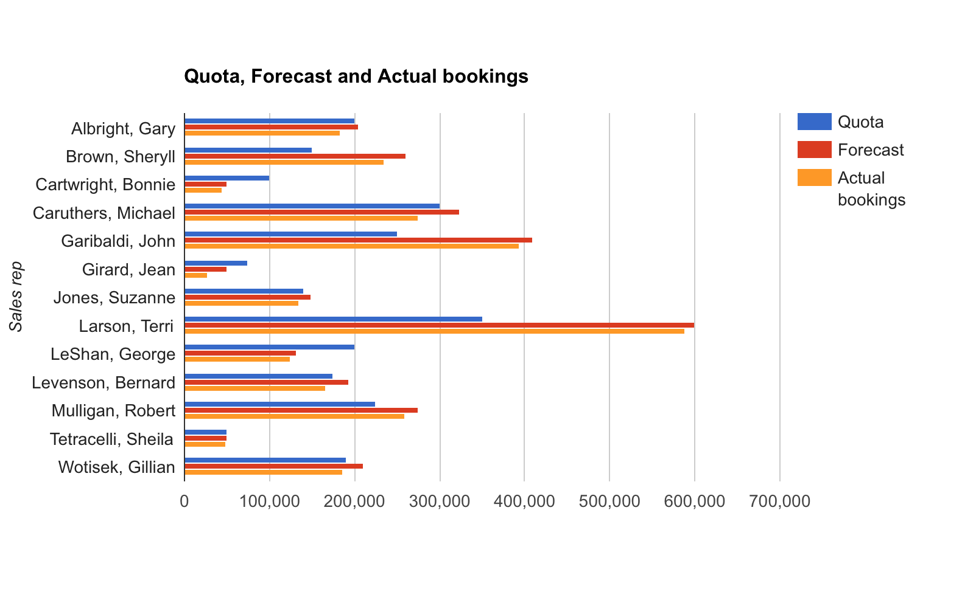

The table provided to us had an information on some sales representatives and their performance during some time. This time is unknown and is assumed to be constant for all the candidates. An analyst looking at this data would be the most concerned about how well or worse does a sales representative perform his task. Each representative has a certain quota and a prediction of how many booking is he likely to make. These parameters are to be measured against actual bookings the sales representative makes. This information can be visualized and analyzed using a clustered bar graph, where we can observe how well does a candidate perform. I used a horizontal bar graph instead of a vertical bar graph because of two main reasons mentioned in the whitepaper. The text associated with the bars was long, and there were a lot of bars to be made. Using a vertical bar graph would have forced me to squeeze the labels resulting in a poor aesthetic appeal. The legend describes the quota, forecast and actual bookings for a certain candidate with a divergent color scheme. This graph solves our purpose as the analyst can determine a relation between the parameters for each of the candidate. It is evident from the graph that Gary Albright, was close in meeting his actual quota, whereas Sheryll Brown, surpassed her quota. The graph is also capable of giving an insight of how well did a candidate perform.