# VISUALIZATION OF MARRIAGE DISSOLUTION RATES IN ARIZONA

**Dataset Used**

|  |  |  |  |  |  |  |
| --- | --- | --- | --- | --- | --- | --- |
|  | 2010 | 2011 | 2012 | 2013 | 2014 | 2015 |
| Apache | 1 | 1 | 0.8 | 1.1 | 1 | 0.9 |
| Cochise | 4.9 | 4.5 | 4.4 | 3.2 | 2.9 | 3.6 |
| Coconino | 3.9 | 2.9 | 3.1 | 2.8 | 2.6 | 2.6 |
| Gila | 3.9 | 3 | 3.2 | 2.5 | 3 | 2.2 |
| Graham | 5.1 | 3.6 | 5 | 4.1 | 3.5 | 4.2 |
| Greenlee | 5.3 | 4.7 | 5 | 4.1 | 4.9 | 4.5 |
| La Paz | 2.1 | 1.8 | 1.5 | 0.6 | 0.8 | 1.6 |
| Maricopa | 3.5 | 4.2 | 4.9 | 4.5 | 4.6 | 4 |
| Mohave | 2.6 | 3.3 | 3 | 2 | 1.9 | 2.8 |
| Navajo | 1.5 | 2.3 | 2.3 | 1.9 | 2.3 | 2 |
| Pima | 4.1 | 4.2 | 4 | 3.8 | 3.7 | 3.4 |
| Pinal | 2.9 | 2.9 | 2.2 | 1.6 | 2.3 | 2.2 |
| Santa Cruz | 2.8 | 2.3 | 1.7 | 2 | 2 | 2.9 |
| Yavapai | 4.3 | 4.3 | 4.9 | 3.7 | 3.2 | 3.4 |
| Yuma | 3.7 | 3.6 | 3.9 | 4.7 | 3.6 | 3.9 |

I cleaned the data before importing it in Tableau. Got rid of the un-necessary columns and rows.

Choropleth Map of Arizona for the year 2015 showing dissolution of marriage rates by county **based on equal interval classification**. The darker the color is the higher is the dissolution rate.

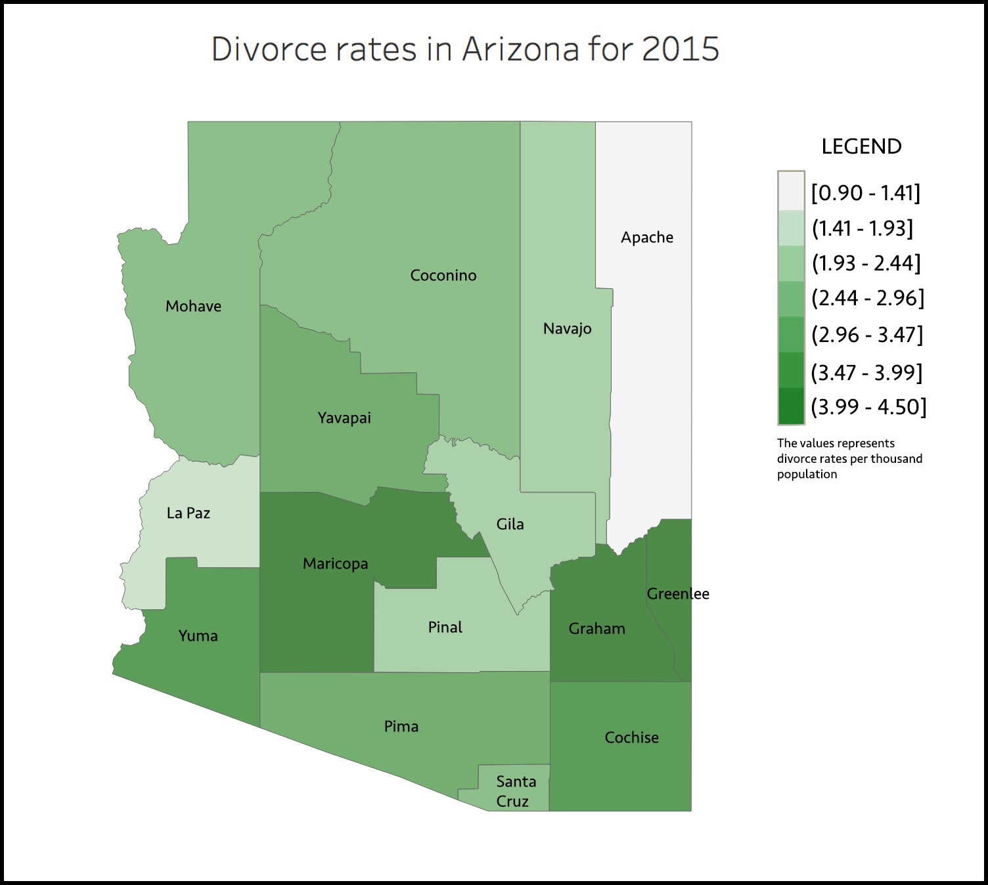

Choropleth Map of Arizona for the year 2015 showing dissolution of marriage rates by county **based on quantile classification**. The darker the color is the higher is the dissolution rate.

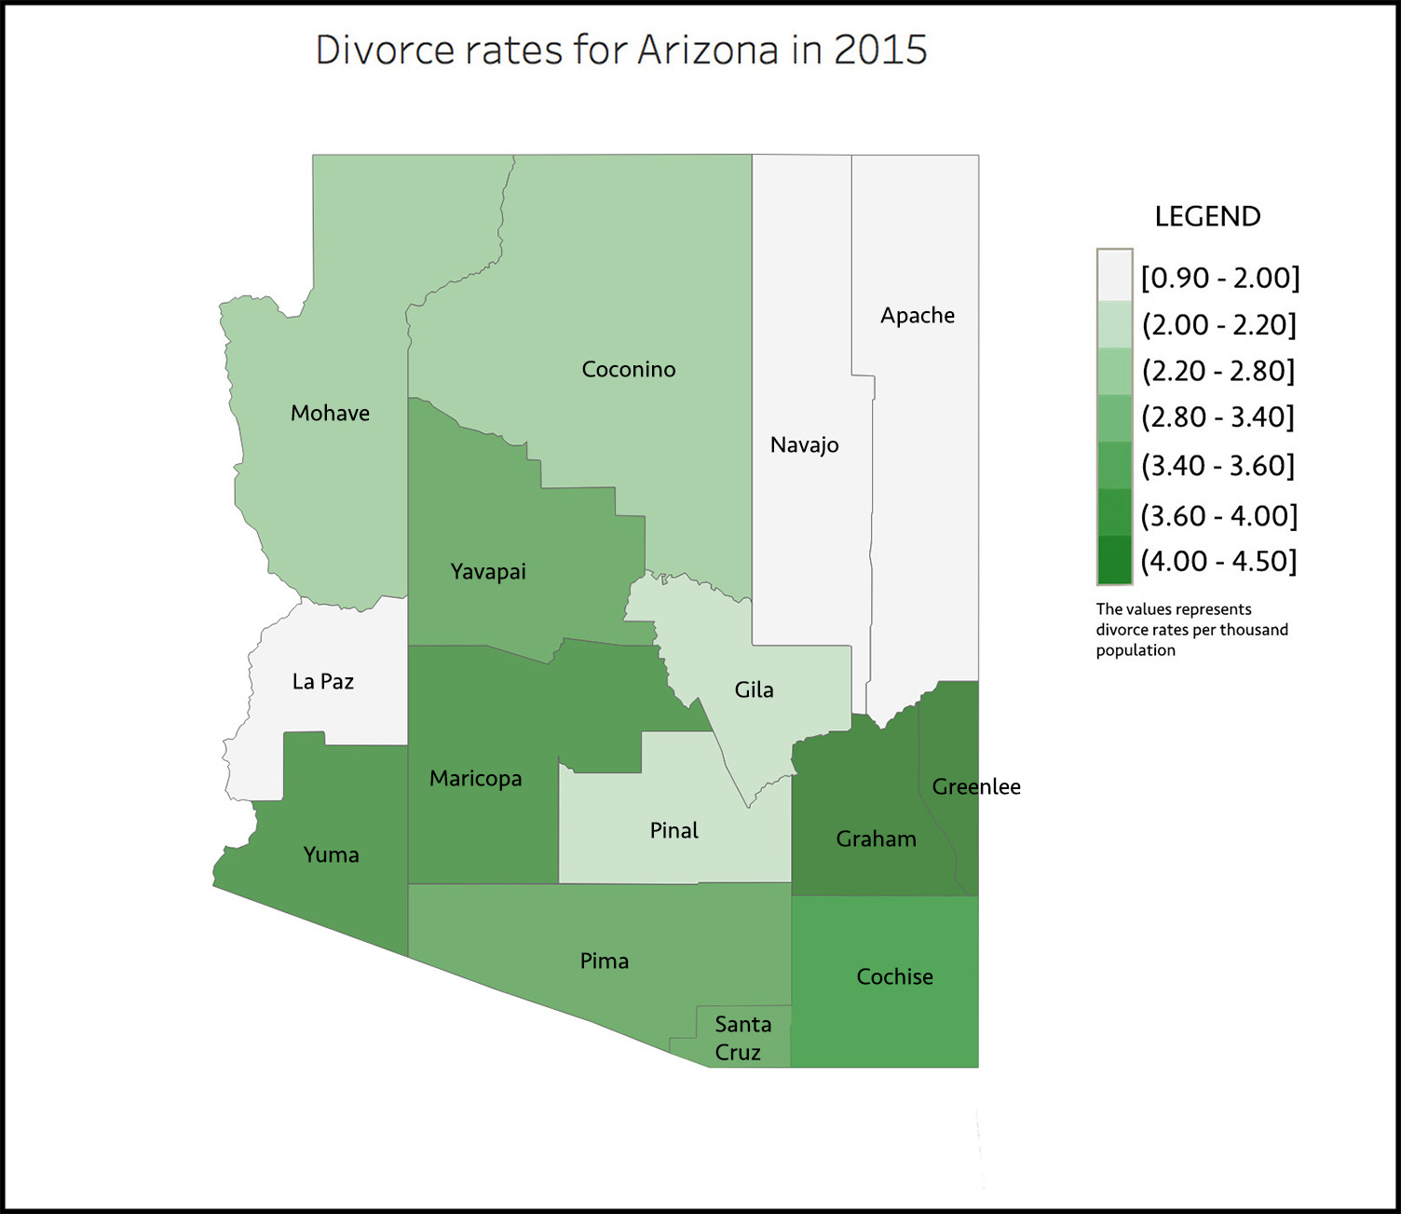

Series of small multiples showing dissolutions per county per year from 2010-2015

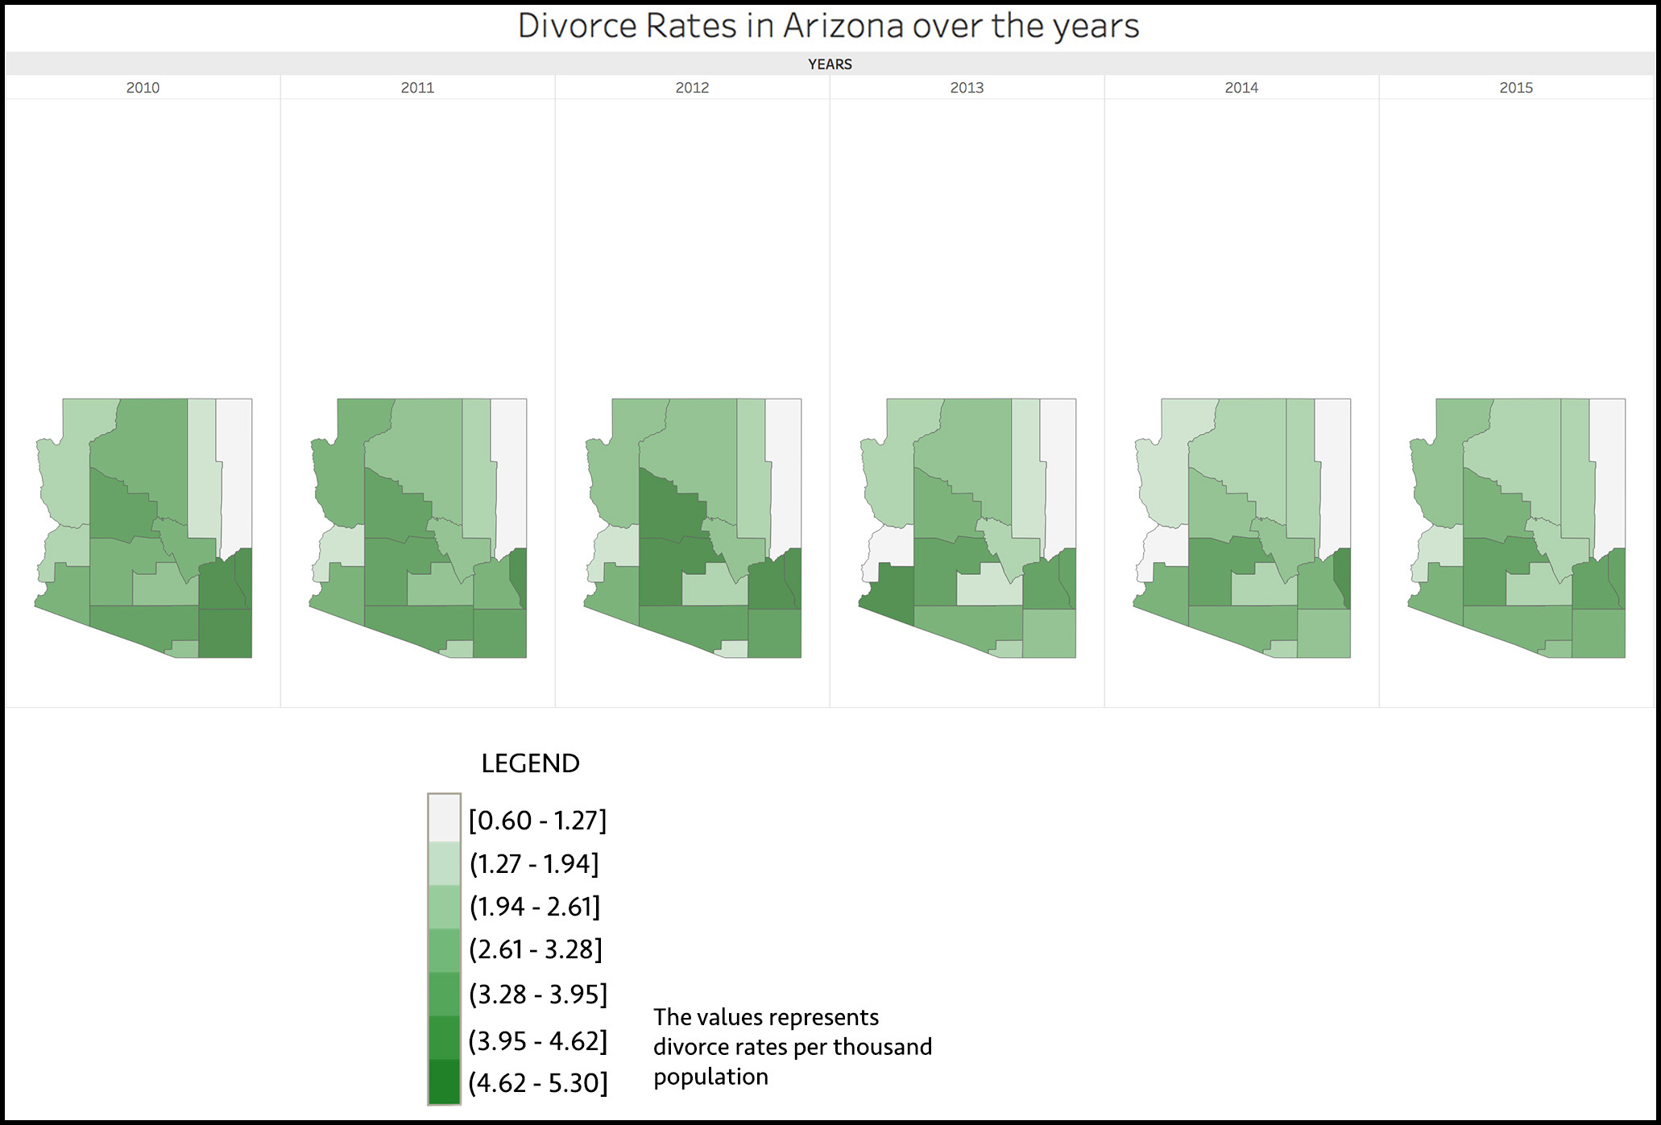

The above image shows small multiples to visualize the divorce rates in Arizona over the years 2010 – 2015. I have chosen the equal interval classification for this part. The entire range of data values (max - min) is divided equally into 7 bins. Such results when projected onto a map are easily interpreted and the legend does not contain any missing values or gaps.

The data does not follow an uneven distribution and follows a bell curve. This type of data can be visualized effectively using equal interval classification.

* This method emphasizes the amount of an attribute relative to one another and gives an absolute view how the divorce rate is varying in a county over the years.
* We can look over a county and using the legend we can determine if the divorce rates are going up or going down.
* We can identify the outliers easily by observing county’s that have unusually higher/lower divorce rates.
* We can even compare the trend of two counties using the above image. If a county had high divorce rates in one year with respect to other, how has it changed over time.