**Name:** **Nikhil Lohia**

**Other Team Members:** Aishwarya Pratap Singh, Ayushi Jain, Rahul Aakunuru

One of the main insights of our project is analyzing a player’s performance over the. We are using a stacked area graph to analyze this metric and I own this module. Stacked area graphs are useful for comparing multiple variables changing over an interval. I am using a spline-based area as it makes the graph look aesthetically pleasing. The years are presented on the X-Axis, whereas the Y-Axis shows the total number of runs scored.

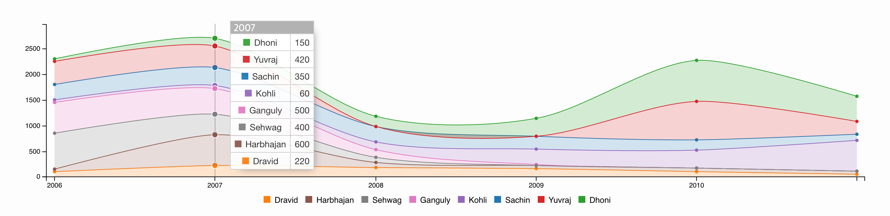

*Figure: Performance of Team India over the years*

**Overview**:

Each color in the graph represents a player and the width defines the number of runs scored by that specific player. The graph follows the *Shneiderman’s* mantra as it gives an overview of the team’s performance. Overall areas show the total runs scored by a team in a year. Higher areas represent a high scoring team. In cricket, high scoring teams generally win matches. By observing the player colors, we can also determine which players have been consistent over time. In the above example, we can see that Dravid has been a consistent player over the years, while Yuvraj started off as a hard hitter, phased out in the middle and regained his form later. If we hover over the graph at any point, we have the details on demand and we know the individual contribution of each player.

**Work done so far:**

I have implemented the above basic structure of the graph using D3 and related libraries. The graph has been tested with some sample data and the results appear to give some insights. The graph loads the data of the selected team at a time and uses a divergent color scheme to show the different players.

**Future work planned:**

I still need to figure out if I can display some more data about a player when the user clicks on some area of the graph. This information could be the strike rate of the player or something else based on his batting performance. In our project, we also have a scatterplot for all the matches played by a team and we plan to use the concept of brushing to select some points. If possible, I plan to plot the same graph with the set of players selected in the scatter plot. This will give a better view of the player’s performance as per the user’s interest.