URL  
<https://music-timeline.appspot.com/#>

Visualization Description and Representative Image

Music is an integral part of almost everyone’s life with varied tastes. I came upon a visualization which gives some good insights about the popular genres throughout the time. The visualization is based on how many Google Play Music users have an artist or album in their music library. Let us have a look.

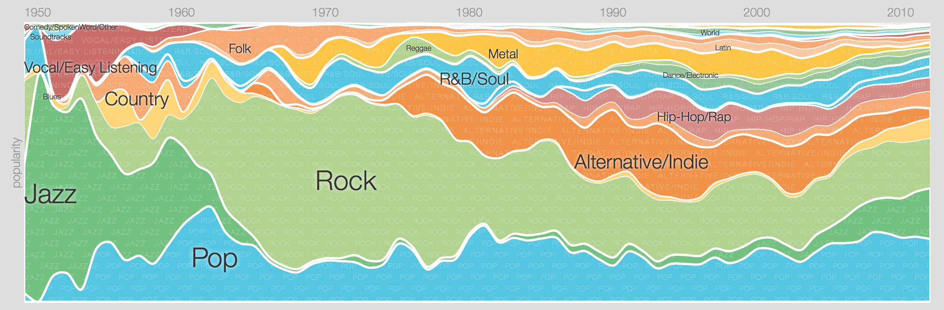

Music exhibits a continuous property and such type of data is represented generally through a streamgraph. Since the genre is a nominal data, the visualization uses a divergent color scheme and each of them uses a different color. The x-axis gives a timeline from 1950 till date while popularity of a genre is shown by the width of each strip. I found this visualization very interesting as it gives a crisp idea about how popular the genre is, and what is their relative contribution in a single place. Music genres like Jazz generally dominated in the period 1950-60’s while Pop music and Blues have been pretty consistent. Rock music seems really popular during the 70’s but lost its share as time passed. The visualization uses Shneiderman’s principle of overview first, zoom and filter, and then details on demand. The visualization offers interaction and we can click on any genre to get a better view of more specialized genres. Here is a view when we click on Blues.

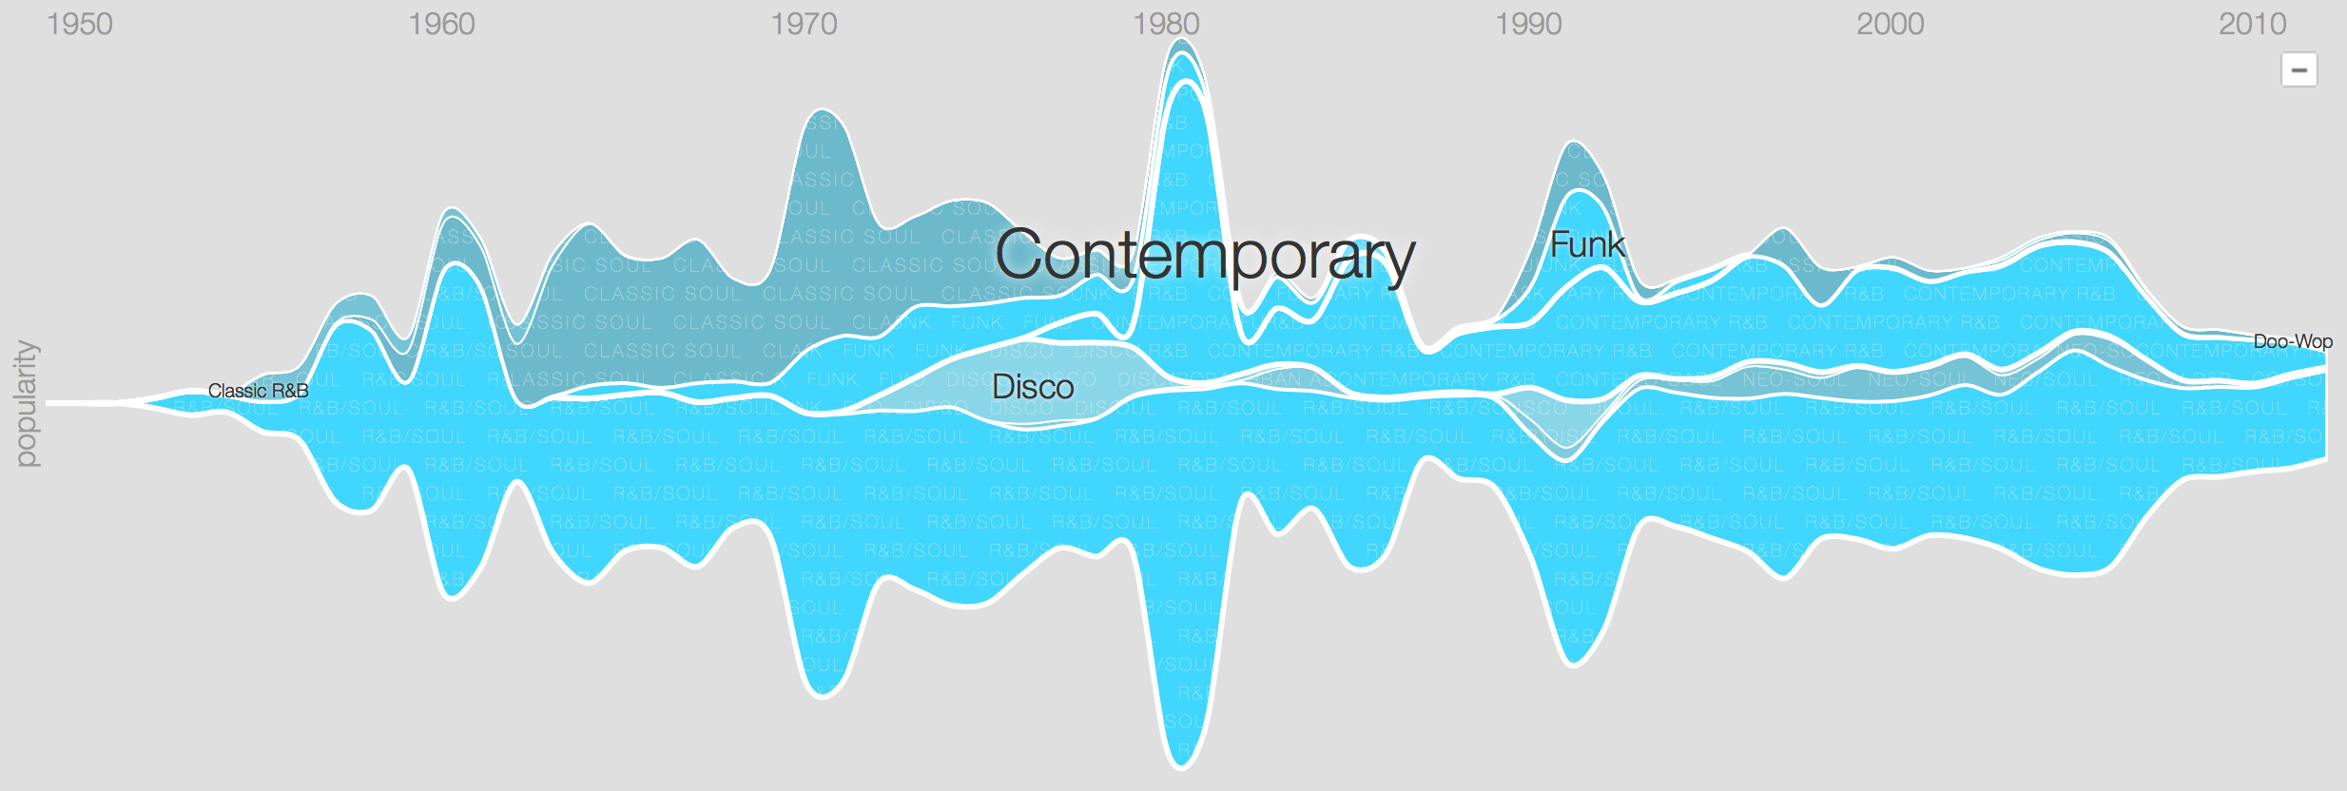

This view gives a better detail how Rhythm and Blues progressed over time. The categories are now divided into specialized genres (Contemporary/Funk/Disco etc.) using a sequential color scheme as the data relates in some way. Clicking on any genre now takes you a level deeper and we see personal artists' contribution to these genres. Here is a sample when I click on Classic Soul.

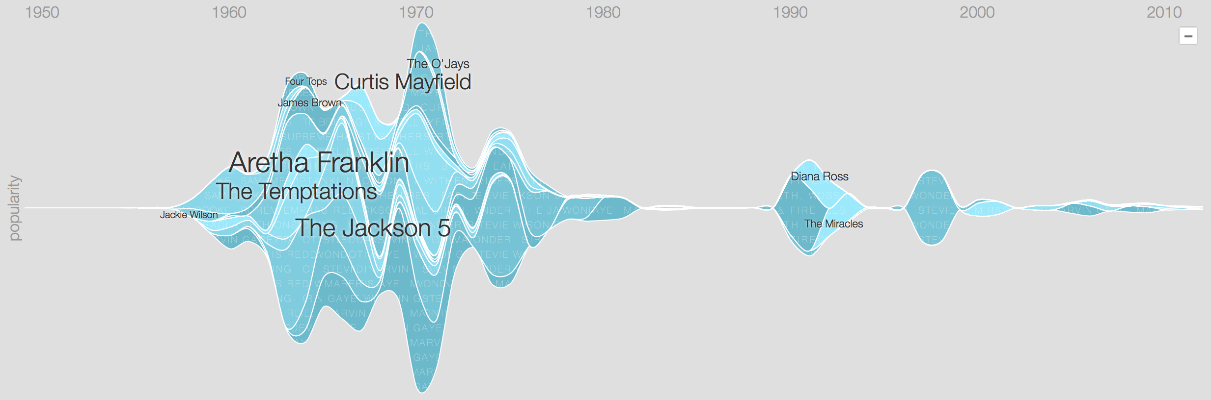

The visualization is really appealing, but it is overwhelming at the same time. It is difficult to know what all genres/categories are covered in the data and there is no legend which maps colors to the categories. The user needs to hover over the smaller strips to know about the genre which can get frustrating sometimes. Since a lot more music is produced in the current time, the data is normalized, which may give a little misleading result. Also, we have not considered music before the 1950’s simply because very less data is available about it.