GRAPH
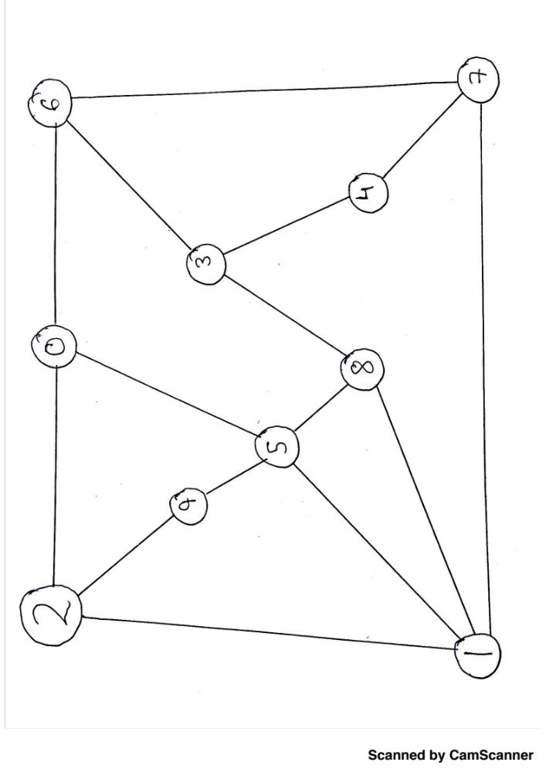

DESIGN PROCESS AND METHOD:

From the given adjacency matrix, it is evident that we have an undirected graph. To start with the graph drawing, I had a few design principles in my mind:
- The graph should have least number of intersections.
- Since I had the entire sheet available to me, I need not worry about making it compact.
- The graph should be aesthetically appealing.
It took me 3-4 iterations to come up with a graph that had no intersections between edges and I came up with the above design such that the nodes are spaced out properly. I did not use any specific algorithm to come up with such a kind of graph and it can be therefore drawn in several other ways. The vertices are represented by circles with the vertex number inside them. The length of the edges does not play any role here and each one of them have an equal weightage. I chose straight edges over curved as it gives a more planar feel to the graph. I considered several aesthetics while drawing the graph as given by P Eades and R Tamassia[1]
- Avoid edge crossings
- Avoid bends in edges
- Distribute vertices uniformly
The graph is a pretty simple one and it gives a bleak idea about how the nodes are connected. Nodes 5 and 1 have the most number of adjacent neighbors while node 9 and 4 have the least number of adjacent neighbors.

[1] G.D. Battista, P. Eades, R. Tamassia, and I.G. Tollis. Annotated bibliography on graph drawing. General Graphs. pg 7

