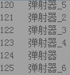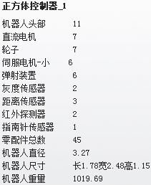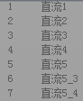





def get(x):

return robot_drv.get_dist(x)

def moto(vl,vr):

robot_drv.set_motors(1,vl,2,vl,3,vr,4,vr)

def press():

robot_drv.set_motors(121,6000,122,6000,123,6000,124,6000)

def stop():

moto(10,10)

for i in range(200):press()

robot_drv.stop_all_motor()

def drive(v):

robot_drv.set_motors(5,100,6,100,7,100)

press()

while get(33)>140 and get(33)>get(34):moto(v,int(v*3/5))

while get(34)>140 and get(34)>get(33):moto(int(v*3/5),v)

v2=max(v-int(abs(get(31)-get(32))/32),-5)

if get(31)>get(32):moto(v2,v)

else:moto(v,v2)

def go(v,t=100000):

robot_drv.start_time();

while robot_drv.get_time()<t:drive(v)

def turnleft(degree):

robot_drv.stop_all_motor()

robot_drv.sleep(100)

while abs(degree-get(60))>15:moto(-15,15)

while abs(degree-get(60))>3:moto(-4,4)

robot_drv.stop_all_motor()

robot_drv.sleep(100)

def turnright(degree):

robot_drv.stop_all_motor()

robot_drv.sleep(100)

while abs(degree-get(60))>15:moto(15,-15)

while abs(degree-get(60))>3:moto(4,-4)

robot_drv.stop_all_motor()

robot_drv.sleep(100)

def cross(v1,v2=40,t=310):

while get(37)!=255 and get(38)!=255:drive(v1)

go(v2,t)

def fly(v,vl=0,vr=0):

if vl==0:vl=vr=v

while get(37)!=48 and get(38)!=48:drive(v)

moto(vl,vr)

robot_drv.sleep(1000)

robot_drv.stop_all_motor()

def jump():

while get(59)>300:drive(20)

robot_drv.set_joints(101,180,102,180,103,180,104,180)

robot_drv.stop_all_motor()

robot_drv.sleep(500)

for i in range(36):

robot_drv.set_motors(121,1850,122,1500,123,1850,124,1500)

for i in range(36):robot_drv.set_motors(120,1500,125,1500)

robot_drv.set_joints(101,0,102,0,103,0,104,0)

robot_drv.stop_all_motor()

robot_drv.sleep(500)