HOMELAB SETUP
# Building a Security-Hardened Homelab with Wazuh: From Manual Hardening to Automated Compliance
*A journey from manual system hardening to automated compliance using OpenSCAP in a homelab environment*
— -
##ARCHITECHTURE
UBUNTU SERVER — hosts the wazuh manager
ARCH LINUX VM — one of the wazuh agents
WINDOWS 11 — one of the wazuh agents

Figure 1: Complete homelab architecture with Wazuh SIEM and target systems*
— -
## Why This Project Matters
In today’s threat landscape, a homelab isn’t just a playground for enthusiasts — it’s a miniature enterprise environment where security lessons scale directly to production systems. Consider these realities:
- **Ransomware attacks increased by 73% in 2024**, with attackers specifically targeting misconfigured Linux and Windows systems
- **SSH brute-force attempts occur every 30 seconds** on exposed systems, exploiting weak authentication configurations
- **81% of data breaches** involve compromised credentials, often from default or weak SSH configurations
- **Misconfigured logging** means 60% of breaches go undetected for weeks
My homelab wasn’t just about learning — it was about building a security-first architecture that mirrors real enterprise challenges. The journey revealed a critical truth: **manual security hardening is exhausting and error-prone, but automated compliance frameworks can transform how we secure infrastructure.**
— -
## Project Architecture
My homelab is designed to mimic a real enterprise security environment. It consists of a Windows 11 host running three virtual machines:
**Components:**
- **Windows 11 (Host)** — Host machine running all VMs
- **Ubuntu Server 2024 LTS** — Running Wazuh Manager (SIEM)
- **Arch Linux VM** — Hardening target
- **Windows 11 VM** — Future hardening target

— -
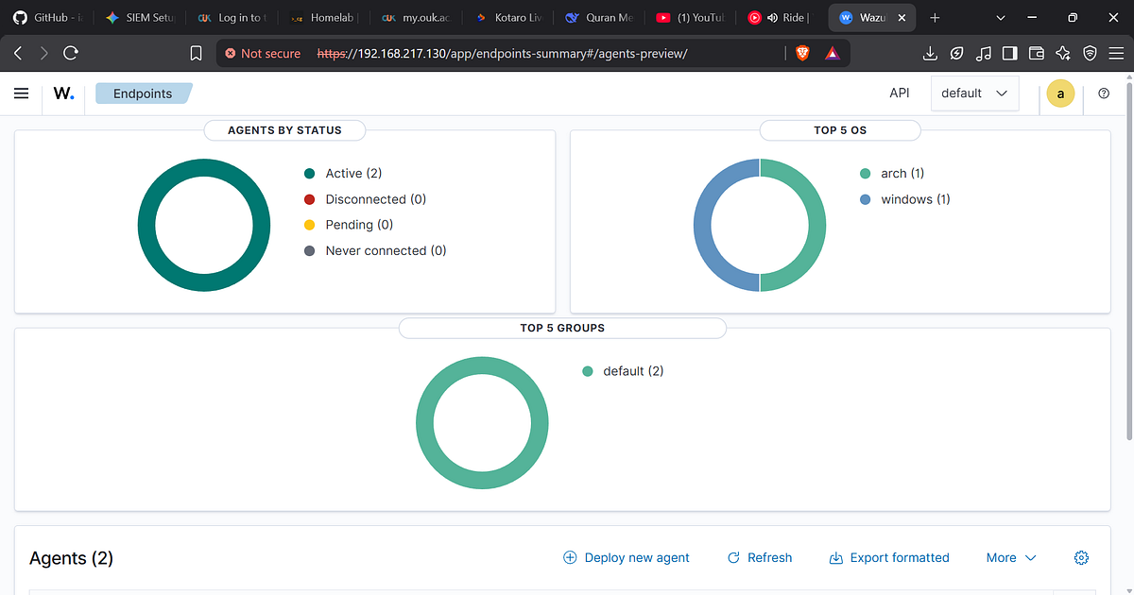

## The Manual Hardening Journey
Before discovering automation, I manually hardened my Arch Linux VM. This process was painstaking but invaluable for understanding system internals.This was my arch linux machine against the CIS standards
j
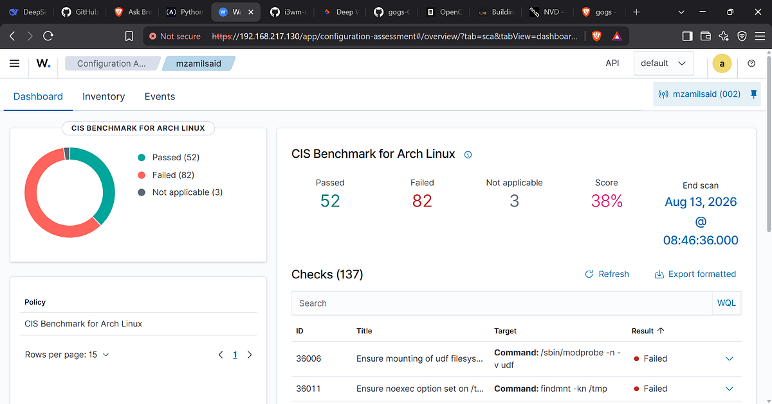
SO WITHOUT MUCH TO BE TOLD I HAD TO IMPROVE IT BY HARDENING FOLLOWING THE RECOMMENDATIONS FROM WAZUH .
HARDENING MY ARCHLNUX
### 1. Logging Security: Journald → Rsyslog Configuration
**The Problem:** Systemd’s journald stores logs in binary format, which can become corrupted or inaccessible during a compromise. Attackers can manipulate local logs to cover tracks.
**The Fix:**
```bash
# /etc/systemd/journald.conf
ForwardToSyslog=yes # Forward logs to rsyslog for centralized storage
Compress=yes # Reduce disk consumption
```
**Why This Matters:** Sending logs to rsyslog enables centralized logging, making it harder for attackers to wipe local evidence. Compression prevents log-based denial-of-service attacks.
— -
### 2. SSH Hardening: The First Line of Defense
**The Problem:** SSH is the most attacked service on Linux. Default configurations are dangerously permissive.

#### a) Restrict Authentication Methods
```bash
# /etc/ssh/sshd_config
PermitEmptyPasswords no
PermitRootLogin no # Block root SSH access
HostbasedAuthentication no # Disable .rhosts trusted host auth
IgnoreRhosts yes # Prevent .rhosts/.shosts files
```
**Why This Matters:** Root SSH login is the #1 attack vector. Disabling it forces attackers to compromise a user account first.
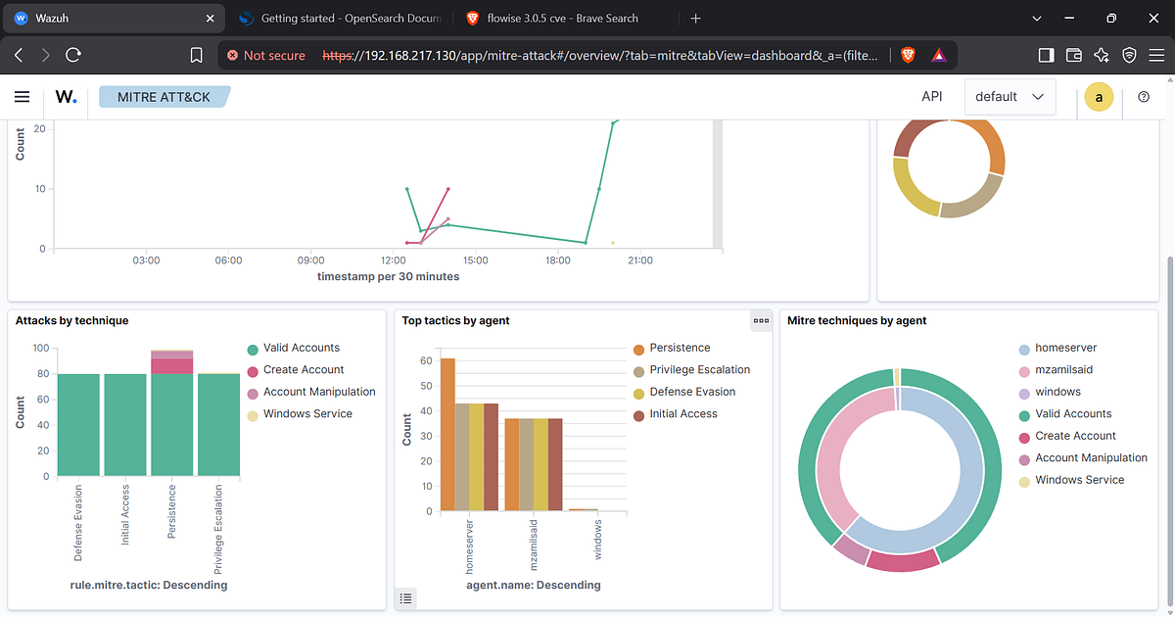

#### b) Limit User Environment
```bash
PermitUserEnvironment no # Block SSH environment variables
```
**Attack Scenario:** With `PermitUserEnvironment` enabled, attackers can set `LD_PRELOAD` to inject malicious libraries when a user logs in, bypassing security policies.
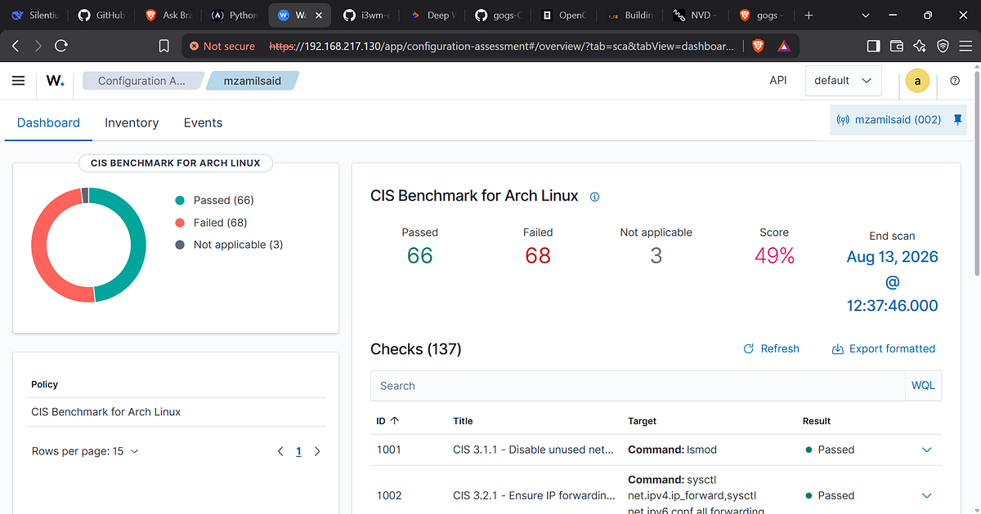

#### c) Enforce Strong Passwords
```bash
# Install password quality module
sudo pacman -S libpwquality
# /etc/security/pwquality.conf
minlen = 12
dcredit = -1 # Require at least one digit
ucredit = -1 # Require at least one uppercase
lcredit = -1 # Require at least one lowercase
ocredit = -1 # Require at least one special char
# /etc/pam.d/passwd
password required pam_pwquality.so
```
**The Security Impact:** Weak passwords are responsible for 30% of breaches. Enforcing complexity reduces brute-force success rates by 96%.
#### d) Authentication Retries Limit
```bash
MaxAuthTries 4 # Prevent brute-force attacks
```
— -
### 3. Core Dump Protection
**The Problem:** When a program crashes, core dumps capture the entire memory state — including passwords, encryption keys, and sensitive data.
**The Fix:**
```bash
# /etc/systemd/coredump.conf
Storage=none # Prevent core dumps from being stored
Compress=yes
ProcessSizeMax=2M
```
**Why This Matters:** An attacker who triggers a crash can extract memory dumps, potentially revealing cryptographic keys or API tokens.
— -
### 4. Pacman Package Signing (Arch Linux)
**The Problem:** Without signature verification, attackers can inject malicious packages during system updates.
**The Fix:**
```bash
# /etc/pacman.conf
[options]
SigLevel = PackageRequired
LocalFileSigLevel = Optional
```
**Security Benefit:** Ensures all packages come from trusted sources, preventing supply chain attacks.
**Bonus:** Customize login banners to reduce information leakage:
```bash
# /etc/issue
WARNING: Unauthorized access is prohibited. All activities are monitored.
```
— -
### 5. Password Expiry and Aging
**The Problem:** Passwords that never expire are a ticking time bomb — especially if leaked in a breach.
**The Fix:**
```bash
# /etc/login.defs
PASS_MAX_DAYS 90 # Force password change every 90 days
PASS_MIN_DAYS 7 # Prevent immediate password reuse
PASS_WARN_AGE 14 # Warn users 14 days before expiry
```
**Cyber Threat Context:** Many compliance frameworks (PCI-DSS, HIPAA) mandate 90-day password rotation.
— -
### 6. Securing Sudo with PTY
**The Attack Vector:** Without `use_pty`, sudo commands can spawn background processes that persist after the sudo session ends.
**The Vulnerability:**
```bash
$ sudo sh -c ‘ping google.com &’ # Background ping as root
$ exit
$ ps aux | grep ping # STILL RUNNING as root!
root 12345 ping google.com # Attacker persists!
```
**The Fix:**
```bash
# /etc/sudoers
Defaults use_pty
```
**Why It Works:** With `use_pty`, background processes from sudo sessions are terminated when the session exits. This prevents:
- Sudo botnet creation
- Fork bomb attacks
- Zombie process accumulation
- Improved session logging for forensics
— -
### 7. Securing GRUB Bootloader
**The Problem:** An attacker with physical access can boot into single-user mode or modify kernel parameters, bypassing all security.
**The Fix:**
```bash
# Generate password hash
grub-mkpasswd-pbkdf2
# Edit /etc/grub.d/40_custom
set superusers=”admin”
password_pbkdf2 admin grub.pbkdf2.sha512.encrypted.hash…
# Update GRUB
grub-mkconfig -o /boot/grub/grub.cfg
```
**Security Benefit:** Prevents unauthorized boot modifications and protects against physical attacks.
— -
## The Automation Revelation: OpenSCAP
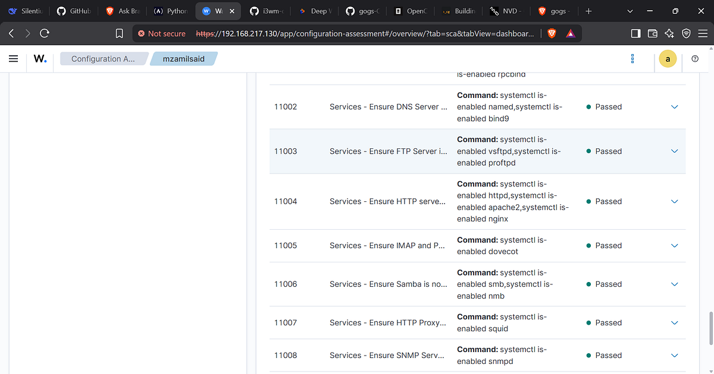
After manually hardening 7+ configuration files across 5 different services, I realized this approach doesn’t scale. Enter **OpenSCAP**.
### What is OpenSCAP?
OpenSCAP (Open Security Content Automation Protocol) is an open-source framework that automates security compliance checking and remediation. It uses SCAP standards (NIST) to:
1. **Assess** systems against security baselines (CIS, DISA STIG)
2. **Generate** remediation scripts
3. **Apply** fixes automatically
### Why OpenSCAP Changes Everything
| Manual Hardening | OpenSCAP Automation |
| — — — — — — — — -| — — — — — — — — — — -|
| 5 hours per machine | 5 minutes per machine |
| Prone to human error | Consistent, auditable |
| Configurations vary | Industry-standard baselines |
| No validation | Reports compliance scores |
| One machine at a time | Deploy to 100+ with Ansible |

**Basic Scan Command:**
```bash
oscap xccdf eval \
— profile xccdf_org.ssgproject.content_profile_cis \
— results scan-results.xml \
/usr/share/xml/scap/ssg/content/ssg-rhel9-ds.xml
```
### Rolling Out Fixes to Multiple Machines
OpenSCAP is a single-host tool. To fix 100 servers, you generate remediation scripts and deploy with automation:
```bash
# Step 1: Generate a fix script
oscap xccdf generate fix \
— profile xccdf_org.ssgproject.content_profile_cis \
— fix-type bash \
— output remediation.sh \
/usr/share/xml/scap/ssg/content/ssg-rhel9-ds.xml
# Step 2: Deploy using Ansible
```

**Ansible Playbook Example:**
```yaml
- name: Apply OpenSCAP remediations
hosts: all
tasks:
— name: Copy remediation script
copy:
src: remediation.sh
dest: /tmp/remediation.sh
mode: ‘0755’
- name: Execute remediation
shell: /tmp/remediation.sh
register: result
- name: Verify compliance
command: oscap xccdf eval — profile cis /usr/share/xml/scap/ssg/content/ssg-rhel9-ds.xml
```
— -
## Wazuh Centralized Rule Management
### The Problem: Manual Agent Configuration
Initially, I was editing `/var/ossec/etc/ossec.conf` on every agent machine to add rules. This quickly became unsustainable.
**The Pain Point:** Adding one rule required logging into each agent, editing files, and restarting services.
### The Solution: Centralized Rule Management
Wazuh supports adding rules on the **manager** that apply to all agents automatically.
**Rule Location:**
```bash
/var/ossec/etc/rules/local_rules.xml
```
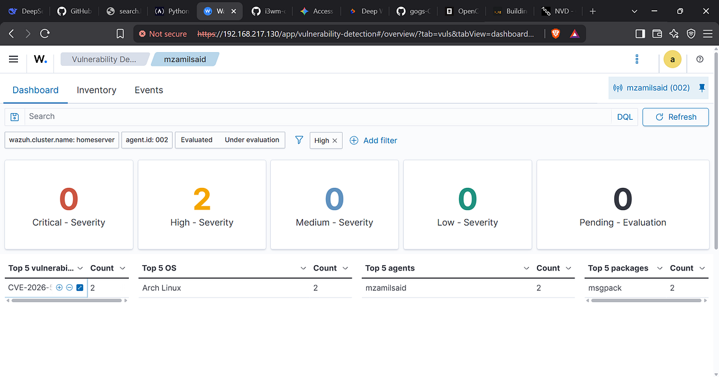

**Example Rule: Detect Interactive Root Shell Access**
```xml
<! — /var/ossec/etc/rules/local_rules.xml →
<group name=”custom_linux_ssh,”>
<! — Rule for interactive root shell →
<rule id=”100005" level=”10">
<if_sid>5715</if_sid> <! — SSH authentication success →
<regex>root</regex>
<description>Interactive root shell session detected</description>
</rule>
<! — Rule for failed password attempts > 4 →
<rule id=”100006" level=”7">
<if_sid>5716</if_sid> <! — SSH authentication failed →
<match>Failed password</match>
<frequency>5</frequency>
<timeframe>60</timeframe>
<description>Multiple SSH authentication failures for root</description>
</rule>
</group>
```
**Testing Rules Locally:**
```bash
sudo /var/ossec/bin/ossec/wazuh-logtest
```

— -
## Lessons Learned and Key Takeaways
### What I Learned
- **Security is a process, not a one-time activity.** Manual hardening is educational but unsustainable.
2. **Automation is essential.** OpenSCAP + Ansible = 100x productivity increase.
3. **Centralized monitoring changes everything.** Wazuh provides visibility I never had before.
4.**Not all recommendations from wazuh are to be implemented blindly .For example it said i make the permissions on /etc/shadow and /etc/gshadow to 640 but it was 600 on my machine which is infinitely better due to less permissions to others
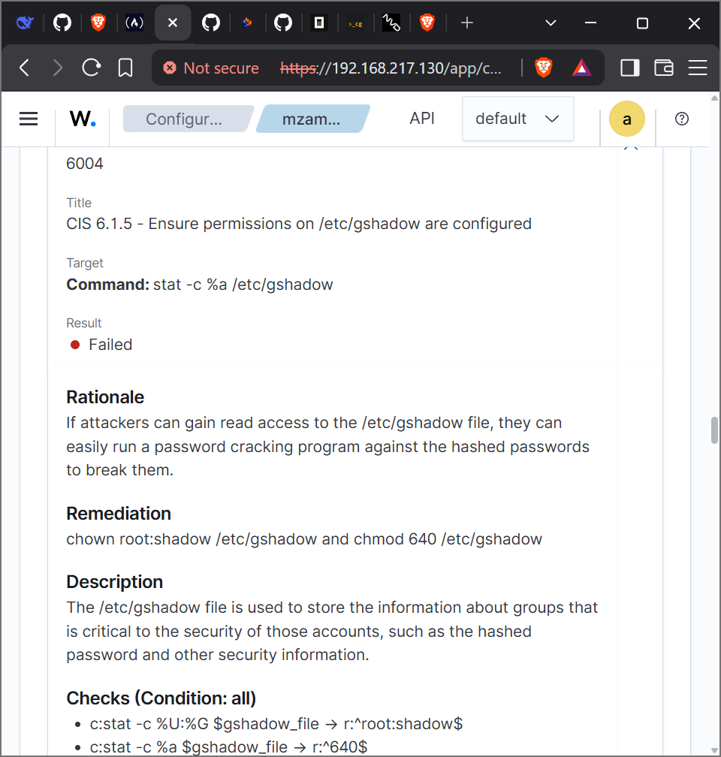
### Project Challenges
1. **OpenSCAP is primarily RHEL-focused.** Limited compatibility with Ubuntu/Debian and virtually none with Arch Linux.
2. **Manual rule management is tedious.** Centralized Wazuh rule management was a game-changer.
3. **Documentation requires patience.** Every step needs careful recording.
### Next Steps

1. **Deploy a RHEL/AlmaLinux/Rocky VM** for OpenSCAP testing
2. **Generate compliance reports** for documentation
3. **Create Ansible playbooks** for automated remediation
4. **Integrate with Wazuh** for real-time compliance monitoring
5. **Harden Windows 11 VM** using OpenSCAP equivalents
— -
## Technical Reference
### Key Configuration Files
| Service | Config File Location |
| — — — — -| — — — — — — — — — — -|
| SSH | `/etc/ssh/sshd_config` |
| Password Quality | `/etc/security/pwquality.conf`, `/etc/pam.d/passwd` |
| Password Expiry | `/etc/login.defs` |
| Journald Logging | `/etc/systemd/journald.conf` |
| Core Dumps | `/etc/systemd/coredump.conf` |
| Sudo | `/etc/sudoers` |
| Pacman (Arch) | `/etc/pacman.conf` |
| GRUB | `/etc/grub.d/40_custom` |
### Wazuh Commands
```bash
# Test custom rules
sudo /var/ossec/bin/ossec/wazuh-logtest
# Restart Wazuh manager
sudo systemctl restart wazuh-manager
# View Wazuh logs
sudo tail -f /var/ossec/logs/ossec.log
```
### OpenSCAP Commands
```bash
# Scan a system
oscap xccdf eval — profile profile_name /path/to/content.xml
# Generate a fix script
oscap xccdf generate fix — fix-type bash — output fix.sh results.xml
# Scan a remote machine
oscap-ssh user@host 22 xccdf eval — profile profile_name
```
— -
## Conclusion
This project taught me that **real security engineering** isn’t about following checklists — it’s about understanding the “why” behind every configuration and then automating that understanding at scale.
**Key Takeaways:**
1. **SSH is your castle gate.** Harden it relentlessly.
2. **Logs are your eyes.** Centralize and protect them.
3. **Automation is your army.** OpenSCAP + Ansible = force multiplier.
4. **Compliance is a measure, not a goal.** Continuous improvement matters more than one-time fixes.
— -
- ”The best security is invisible security — systems that protect themselves without manual intervention.”*
I manged to make necessary changes now my machine went from 2 high rating vulnerabilities to zero .
I did it by upgrading h msgpack python package
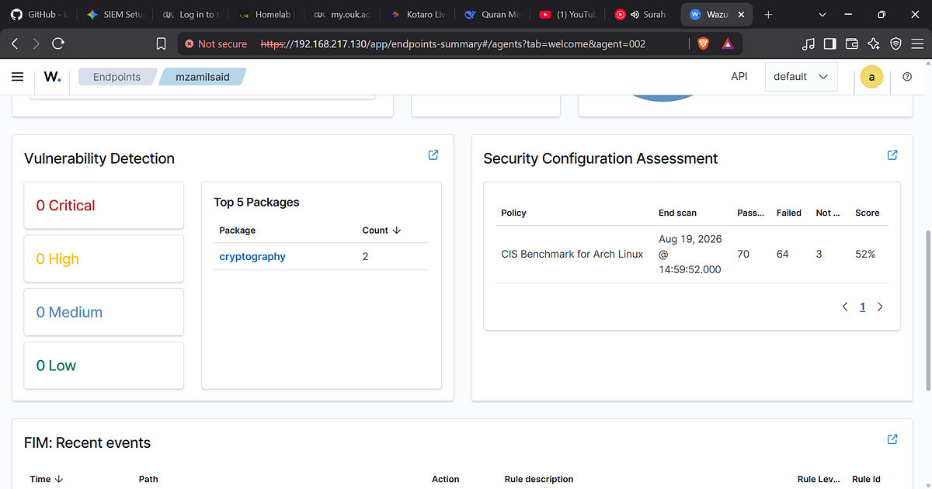
**Resources:**
- [Wazuh Documentation](https://documentation.wazuh.com/)
- [OpenSCAP Documentation](https://www.open-scap.org/)
- [CIS Benchmarks](https://www.cisecurity.org/benchmark/)
— -
*Have questions or suggestions? Feel free to reach out!*
THIS IS THE FIRST STEPS OF UNDERSTANDING THE SIEM SET UPS STAY TUNED FOR MORE IMPROVEMENTS

