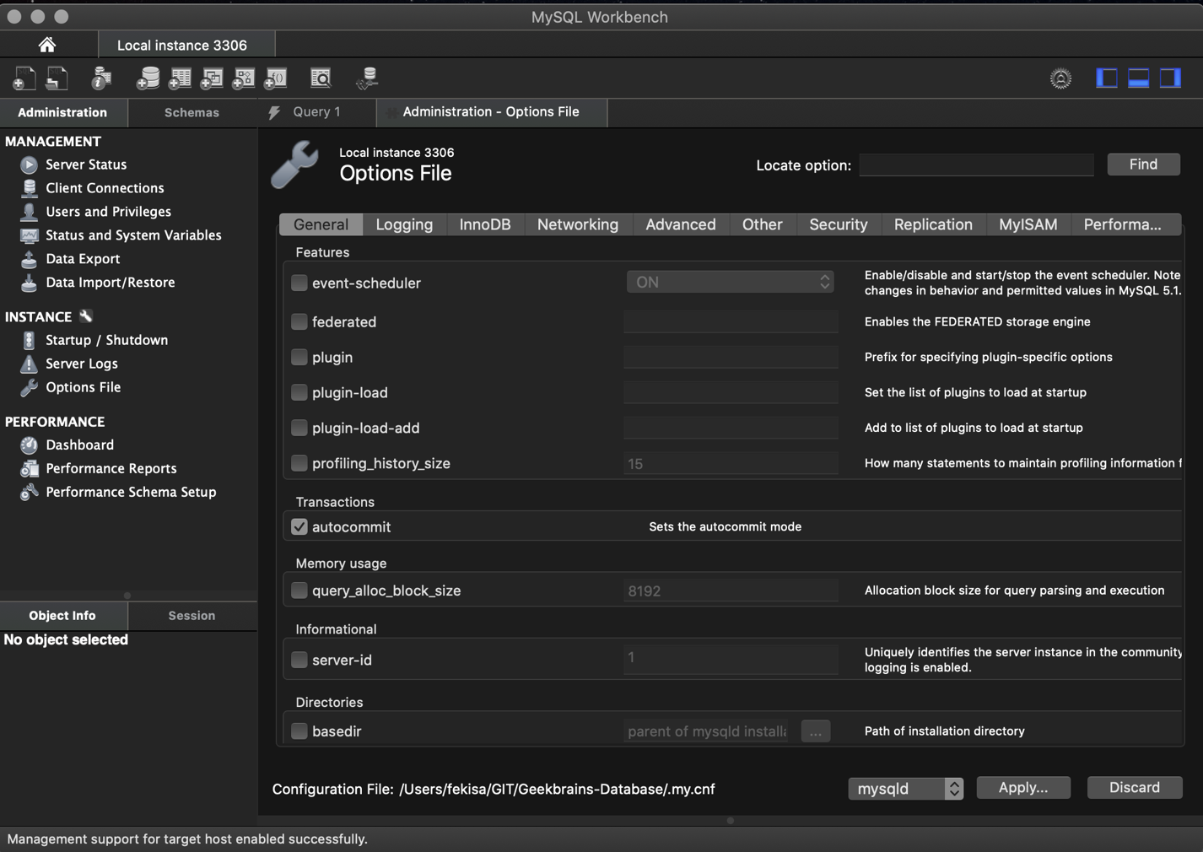

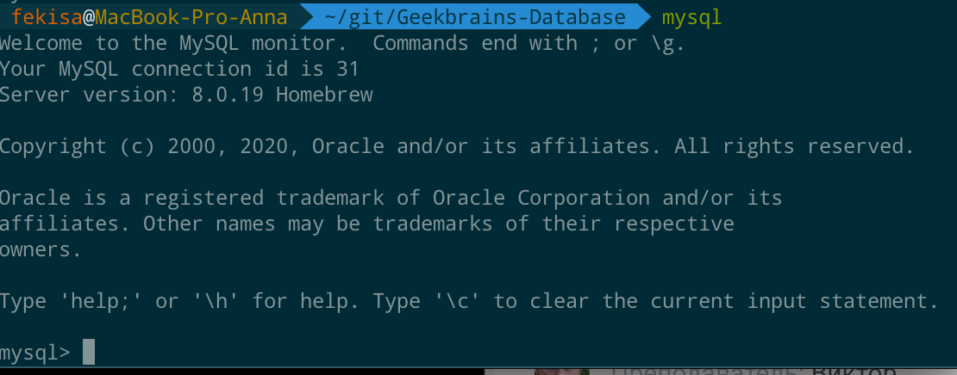

**Задание №2**

fekisa@MacBook-Pro-Anna  ~/git/Geekbrains-Database  mysql

Welcome to the MySQL monitor. Commands end with ; or \g.

Your MySQL connection id is 37

Server version: 8.0.19 Homebrew

Copyright (c) 2000, 2020, Oracle and/or its affiliates. All rights reserved.

Oracle is a registered trademark of Oracle Corporation and/or its

affiliates. Other names may be trademarks of their respective

owners.

Type 'help;' or '\h' for help. Type '\c' to clear the current input statement.

mysql> CREATE DATABASE example;

Query OK, 1 row affected (0,01 sec)

mysql> SHOW VARIABLES LIKE 'datadir';

+---------------+-----------------------+

| Variable_name | Value |

+---------------+-----------------------+

| datadir | /usr/local/var/mysql/ |

+---------------+-----------------------+

1 row in set (0,00 sec)

mysql> USE example

Database changed

mysql> SHOW TABLES;

Empty set (0,00 sec)

mysql> CREATE TABLE users

-> (

-> Id INT,

-> Name VARCHAR (20)

-> );

Query OK, 0 rows affected (0,04 sec)

mysql> SHOW TABLES;

+-------------------+

| Tables_in_example |

+-------------------+

| users |

+-------------------+

1 row in set (0,01 sec)

mysql> exit

Bye

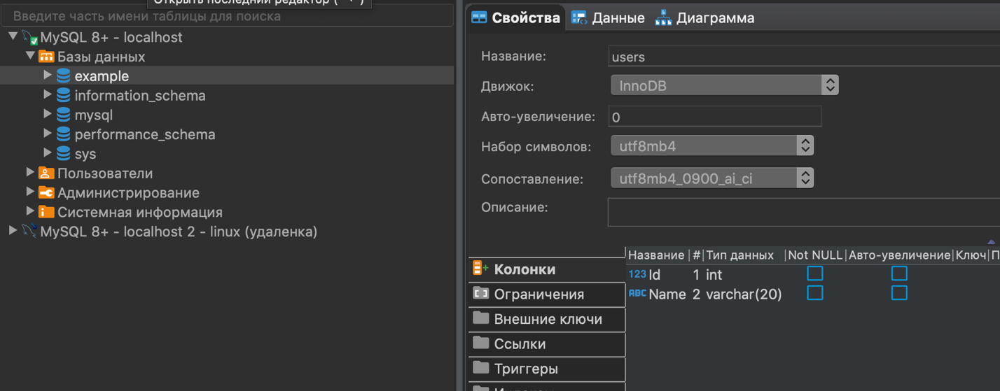

fekisa@MacBook-Pro-Anna  /usr/local/var/mysql/example  mysqldump example > sample.sql

fekisa@MacBook-Pro-Anna  /usr/local/var/mysql/example  ls

sample.sql users.ibd

fekisa@MacBook-Pro-Anna  /usr/local/var/mysql/example  tail -10 sample.sql

/*!40101 SET SQL_MODE=@OLD_SQL_MODE */;

/*!40014 SET FOREIGN_KEY_CHECKS=@OLD_FOREIGN_KEY_CHECKS */;

/*!40014 SET UNIQUE_CHECKS=@OLD_UNIQUE_CHECKS */;

/*!40101 SET CHARACTER_SET_CLIENT=@OLD_CHARACTER_SET_CLIENT */;

/*!40101 SET CHARACTER_SET_RESULTS=@OLD_CHARACTER_SET_RESULTS */;

/*!40101 SET COLLATION_CONNECTION=@OLD_COLLATION_CONNECTION */;

/*!40111 SET SQL_NOTES=@OLD_SQL_NOTES */;

-- Dump completed on 2020-04-12 10:22:08

fekisa@MacBook-Pro-Anna  /usr/local/var/mysql  mysql

Welcome to the MySQL monitor. Commands end with ; or \g.

Your MySQL connection id is 44

Server version: 8.0.19 Homebrew

Copyright (c) 2000, 2020, Oracle and/or its affiliates. All rights reserved.

Oracle is a registered trademark of Oracle Corporation and/or its

affiliates. Other names may be trademarks of their respective

owners.

Type 'help;' or '\h' for help. Type '\c' to clear the current input statement.

mysql> CREATE DATABASE sample;

Query OK, 1 row affected (0,01 sec)

mysql> exit

Bye

fekisa@MacBook-Pro-Anna  /usr/local/var/mysql  cd example

fekisa@MacBook-Pro-Anna  /usr/local/var/mysql/example  mysql sample < sample.sql

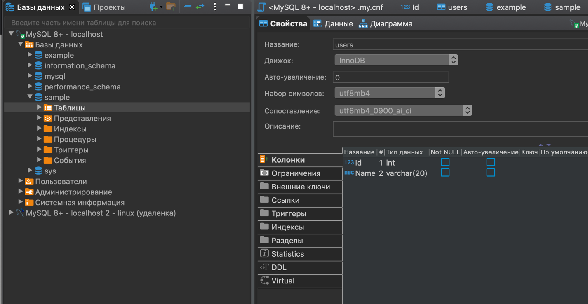

**Задание №3 по желанию**

mysqldump --where="true limit 100" mysql help_keyword > mysql_help_keyword.sql