**CARES PLATFORM: A PATIENT MANAGEMENT SYSTEM**

A Capstone Project

Presented to Information Technology Department

**Cebu Technological University  
 Argao Campus**

Lamacan, Argao, Cebu

In Partial Fulfillment of the Requirements for the Degree of

BACHELOR OF SCIENCE IN INFORMATION TECHNOLOGY

**MARK LOUIL DIACAMOS**

**KRYSTAL MAE DICDICAN**

**JOVANIE FELAMIN**

**KENT GESORO**

**LORD KIANN MACARAYA**

MAY 2025

**INTRODUCTION**

A Patient Management System (PMS) is an important administrative tool to manage paperwork and keep patient records. It increases efficiency through the centralization of patient information for speedy retrieval, lowering the chances of lost or incomplete records (Ramakrishna, P., 2024). Centralized patient information facilitates doctors to view complete medical histories, reducing errors and enhancing correct diagnosis (Kruse et al., 2016). As health needs surge, there is an even greater need for effective patient management systems. These systems maximize patient care, standardize workflows, and enhance service provision by minimizing administrative tasks. Traditional paper-based processes or older computer-based systems, on the other hand, tend to lead to delays, inefficiencies, and scattered patient information, ultimately affecting the quality of care offered (Smith et al., 2020). With such challenges, the world's healthcare industry has turned to digitalization to improve patient management and health service delivery. More than 70% of nations have introduced Health Information Systems (HIS) to improve care delivery, showing that digitalization has become an international imperative in the healthcare industry (World Health Organization, 2022). An essential component of HIS, patient management systems (PMS) speed up access to clinical information, minimize errors, and improve patient outcomes (OECD, 2023).

Internationally, the digitization of healthcare systems is a priority, and institutions are embracing PMS for better service delivery and patient outcomes. Research indicates that digital tools greatly enhance hospital performance as well as decision-making through data visualization, predictive analytics, and workflow automation that optimizes resource utilization (Brown & White, 2024). Implementation of PMS follows global healthcare digitalization trends that highlight the need for technology-based patient management to improve the quality and accessibility of healthcare services (World Health Organization, 2022). Through data-driven insights, hospitals and clinics globally have enhanced patient care coordination, streamlined administrative processes, and improved the accuracy of treatment. Yet, even with the worldwide trend towards e-health solutions, most developing nations still grapple with disjointed and antiquated healthcare management systems.

In the Philippines, the health system is still fragmented, creating inequalities in service quality and accessibility (World Health Organization, 2023). As per a research conducted by WHO in 2023, 40% of the country's rural health facilities still use manual tracking of patients, which causes inefficiencies and poor care coordination. Numerous healthcare providers continue using paper-based data management, and this contributes to inefficiencies, challenges in retrieving patient records, and higher risks of data loss and misinterpretation (Negosyante, 2022). These issues emphasize the imperative need for digital transformation in healthcare facilities in order to enhance patient outcomes and facilitate smooth coordination among healthcare practitioners. As the nation progressively moves towards the use of digital healthcare solutions, the incorporation of a PMS in medical institutions will be key to filling gaps in patient record-keeping, making workflows more efficient, and enhancing the accessibility of healthcare. One such institution that reflects the necessity for modernization is the Eduardo J. Aboitiz Cancer Center (EJACC) that functions within the Philippine healthcare system and needs cutting-edge solutions to offer better patient care.

The Eduardo J. Aboitiz Cancer Center (EJACC) also experiences similar challenges at the local level. At present, EJACC is working in a healthcare environment that calls for modernization and requires a unified platform to enhance service integration, patient tracking, and reporting accuracy since it is a specialty clinic that handles an increasing volume of cancer patients. With the rising number of cancer patients that need specialized treatment, the implementation of a PMS is a necessity to enable EJACC's mission in providing timely and precise healthcare services. To counter these issues, the CARES Platform—a customized Patient Management System—will be created for EJACC. By giving healthcare professionals real-time access to patient records, this platform will allow for timely diagnosis, treatment, and follow-up care, so that patients will receive uninterrupted and well-coordinated care (Jones et al., 2021). Additionally, incorporating centralized digital platform will improve harmonization between walk-in patients and referred patients by DASIG RHUs, improve communication among healthcare professionals, and reduce service delivery delays (Lee et al., 2022). Beyond improving coordination, the PMS will introduce advanced features to further optimize EJACC’s healthcare services.

One notable feature of this platform is its reporting and dashboard features, which will automatically produce real-time information on patient demographics, treatment success, and resource use (Doe et al., 2023). These functions will allow EJACC to detect patterns, streamline operations, and anticipate gaps in patient care. By enhancing service delivery, patient tracking, and real-time reporting, this platform is a revolutionary move towards the modernization of cancer care management at EJACC. The integration of automated healthcare technology is likely to yield dramatic improvements in efficiency, patient satisfaction, and overall healthcare quality (Garcia et al., 2024). In addition, as the world's healthcare institutions become increasingly digitalized, introducing CARES platform to EJACC will not just augment its internal processes but also ensure that it is in compliance with global digital healthcare regulations. By taking EJACC to the top of leading-edge healthcare management, this project represents a critical milestone toward innovative cancer care management in the Philippines and ensures timely, high-quality, and well-organized care for every patient.

**OBJECTIVES**

This project aims to develop a **CARES Platform: A Patient Management System (PMS) for the Eduardo J. Aboitiz Cancer Center (EJACC)** to improve the delivery of healthcare services, tracking of patients, and decision-making.

The first objective is to *develop* the CARES Platform: A Patient Management System (PMS) that will maximize the effectiveness of the delivery of health services in EJACC's cancer program. This will be done by increasing coordination of both walk-in patients and those referred by the DASIG Rural Health Units (RHUs). The system also facilitates the streamlining of patient management operations, such as the processing of personal patient requests and scheduling mass screening events, covering the entire process from pre-enrollment to post-treatment follow-ups. Further, the system will have automated reporting and interactive dashboards to give real-time reports on patient trends, treatment outcomes, and resource utilization. These functionalities are meant to help in data-driven decision-making and overall improved healthcare management.

Furthermore, this project aims to *implement* the CARES Platform within EJACC, ensuring seamless integration with existing workflows and training healthcare personnel for effective system utilization. Lastly, it is essential to conduct a comprehensive *evaluation* to ascertain its efficiency in improving the delivery of services, workflow simplification, and healthcare outcomes. The evaluation should encompass extensive system testing, precise performance analysis, and gathering of user feedback to verify that the platform satisfies the demands of healthcare providers and patients alike. Through the incorporation of digital solutions, the project complies with international best practices in healthcare IT to guarantee a patient-centric and evidence-based method of cancer care management.

**REVIEW OF RELATED LITERATURE AND STUDIES**

**RELATED LITERATURE**

The use of integrated digital health systems has greatly enhanced patient management, coordination of services, and healthcare decision-making at institutions (World Health Organization, 2022). As institutions change to become more modern, the use of Patient Management Systems (PMS) has become a necessity in enhancing workflow and improving service delivery. This segment discusses literature in the areas of healthcare digitalization, patient tracking, reporting automation, and efficiency in healthcare systems to serve as a basis for creating a PMS for the Eduardo J. Aboitiz Cancer Center (EJACC).

Digitalization in healthcare has resulted in the creation of multiple Electronic Health Record (EHR) systems and patient management software, which provide real-time access to healthcare data and enhance patient care. Smith et al. (2020) highlight that centralized digital platforms strengthen care coordination, lower administrative burdens, and provide timely interventions, in line with the goals of this project. In addition, Doe et al. (2021) underscore the place of data-driven decision-making in healthcare service optimization, showing how digital solutions play a part in efficiency in operational processes and better patient outcomes. One of the remarkable developments in healthcare digitalization is the application of electronic systems for patient-reported information, especially in oncology. Jiang et al. (2019) explain how electronic systems enable cancer patients to document side effects and monitor treatment, resulting in better patient engagement and early intervention.This supports the need for a PMS with integrated tracking and monitoring capabilities, ensuring that healthcare providers can respond promptly to patient needs.

Beyond patient tracking, hospitals that have implemented automated management systems have reported substantial improvements in workflow efficiency and overall service quality. A study by IBIMA Publishing (2024) highlights the role of integrated hospital management systems in reducing wait times, optimizing resource allocation, and streamlining healthcare operations. Similarly, Servidio & Cronin (2018) suggest that digital tools enhance hospital performance through data analytics and automation, reinforcing the necessity of real-time reporting and dashboard functionalities in the proposed PMS. Building on these findings, Amegroups (2024) explore how digital tools improve hospital performance using the AHP-Delphi approach, emphasizing the importance of aligning technology with existing workflows to maximize efficiency. Their insights reinforce the idea that successful digital integration must be tailored to institutional needs, a principle that will guide the PMS implementation at EJACC.

**RELATED STUDIES**

Several studies have examined the effectiveness of patient management systems in various healthcare settings. A study by Brown & White (2024) found that the implementation of PMS in hospitals significantly enhances decision-making by offering predictive analytics, data visualization, and automated patient tracking. This study supports the integration of analytical tools within EJACC’s CARES platform to improve service efficiency.

In the Philippines, Negosyante (2022) carried out a research on the issues of patient record management in public hospitals. The results showed that paper-based systems caused inefficiencies, delays, and more risks of misinterpretation of data. This research highlights the necessity of digital transformation within the Philippine healthcare industry, thus affirming the applicability of the proposed platform for EJACC. In addition, Lee et al. (2022) investigated the effect of electronic patient tracking systems on health care coordination in community clinics. The researchers established that electronic systems enhanced communication among health care workers, decreased wait times for patients, and improved service delivery overall. This provides a basis for incorporating patient tracking functionality into the CARES Platform to enhance coordination within EJACC. A further research by Garcia et al. (2024) analyzed the contribution of automated reports in health management. The research indicated that real-time reporting systems offered key information on patient demographics and treatment efficacy, culminating in informed decision-making. These findings align with the objectives of the platform in improving EJACC’s healthcare outcomes.

**RELATED SYSTEMS**

The development of an efficient CARES platform for the Eduardo J. Aboitiz Cancer Center (EJACC) requires intense research on current healthcare digital platforms to draw useful learnings about functionalities that optimize patient care and automate administrative functions. Through a consideration of top-notch systems such as Carevive, MEDITECH, and CareCloud, we are able to discern important learnings and best practices to implement into the CARES platform.

Of these systems, Carevive stands out with a niche concentration on oncology patient management, with an emphasis on remote monitoring and patient-reported outcomes (PROs). The system is particularly superior in patient screening by PROs, total patient management, post-treatment care, and psychosocial care, with strong navigation functionality and precision report generation, and is thus particularly suited to ongoing, individualized cancer care (Basch, 2017).

Conversely, MEDITECH provides a full Electronic Health Record (EHR) system with a firm base for handling patient information in multiple healthcare environments. Its major capabilities include user registration with role-based access, safeguarding data, patient screening, strong patient management, post-treatment follow-up, SMS and email alerts, a broad scope of report generation options, and a focus on a wide-ranging, integrated strategy for healthcare data management (Jha, 2010).

Meanwhile, CareCloud provides cloud-based practice management, EHR, and revenue cycle solutions, focusing on flexibility and accessibility. Its strengths lie in user registration via a patient portal and EHR, integrated patient screening, patient management tools, patient engagement features like SMS and email notifications for reminders and alerts, and diverse report generation, catering to the needs of modern healthcare practices (Dolan, 2014). When considering the ideal PMS for EJACC, integrating the strengths of these systems is crucial. This integrated approach should prioritize comprehensive patient screening and management, effective post-treatment support, integrated psychosocial support and navigation tools, robust reporting capabilities, and effective patient communication, ultimately optimizing patient care and enhancing operational efficiency at EJACC (Buntin et al., 2010).

**TABLE 1**

**COMPARATIVE MATRIX FOR RELATED SYSTEMS**

|  |  |  |  |  |
| --- | --- | --- | --- | --- |
| **SYSTEM FEATURES** | **CAREIVE: Remote Patient Management System** | **MediTech: EHR Software** | **CareCloud: Modern Cloud-Based Healthcare Solutions & Services** | **CARES Platform: A Patient Management System** |
| 1. User Registration | X | X | ✔ | ✔ |
| 1. Patient Screening | ✔ | ✔ | ✔ | ✔ |
| 1. Patient Management | ✔ | ✔ | ✔ | ✔ |
| 1. Post Treatment | ✔ | ✔ | X | ✔ |
| 1. Patient Home Visit | X | X | X | ✔ |
| 1. Psychosocial Support | ✔ | X | X | ✔ |
| 1. Navigation Tool | ✔ | X | X | ✔ |
| 1. SMS & Email Notification | X | ✔ | ✔ | ✔ |
| 1. Letter of Agreement(LOA) Generation | X | X | X | ✔ |
| 1. Report Generation | ✔ | ✔ | ✔ | ✔ |
| **PERCENTAGE** | 60% | 50% | 50% | 100% |

**Legend: ✔ - Applicable X - Not Applicable**

**CONCEPTUAL FRAMEWORK**

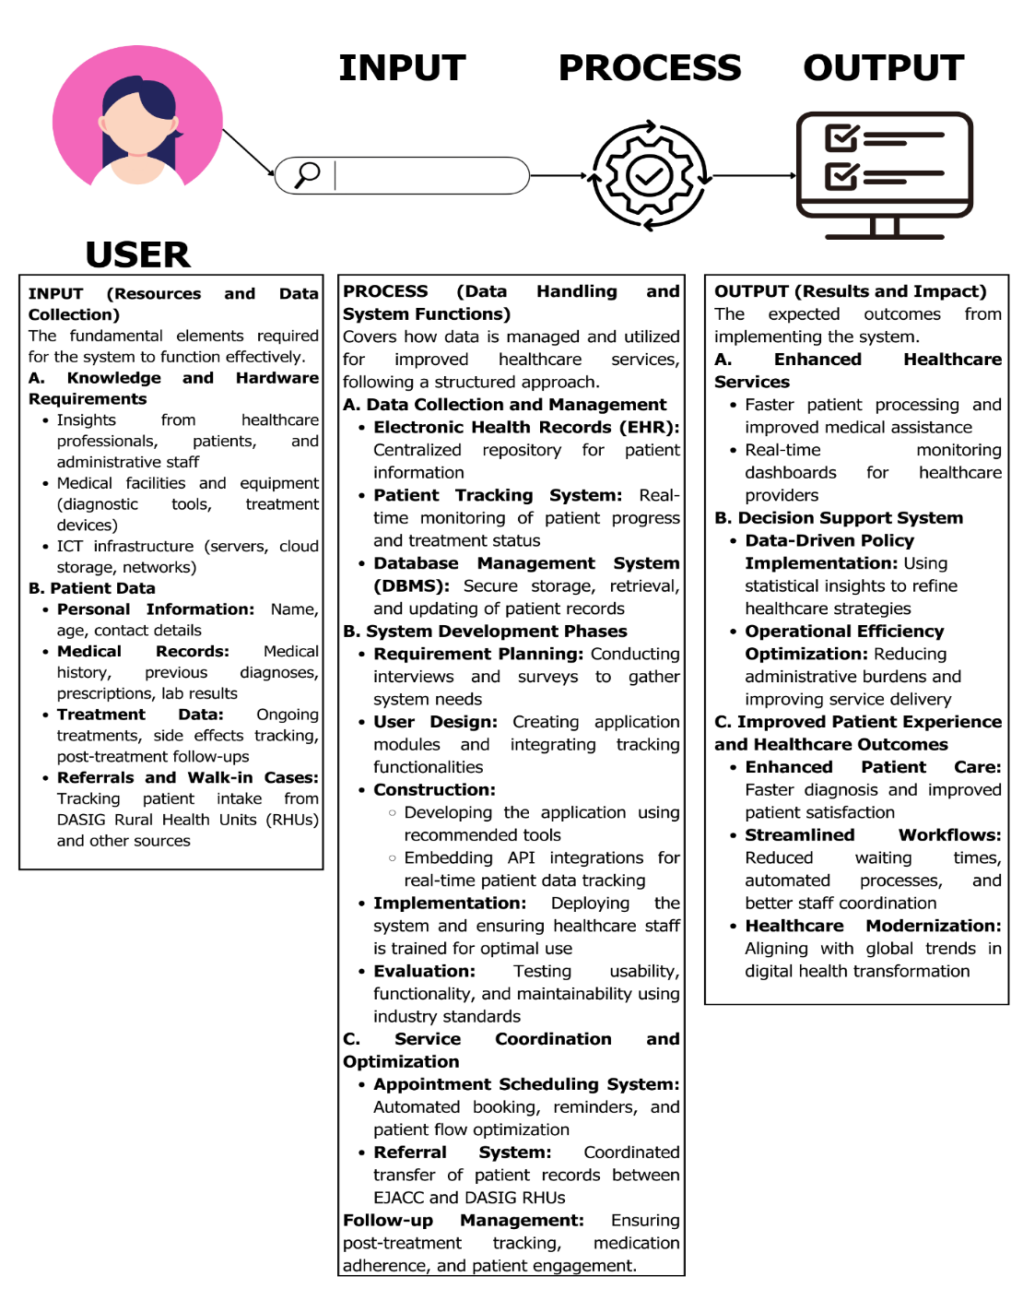To guide the development and implementation of the CARES Platform, this project adopts a conceptual framework based on the Input-Process-Output (IPO) model. This framework serves as a visual and analytical tool that outlines the flow of information, system functions, and intended outcomes. It helps illustrate how various components of the system interact to achieve the overall goal of improving cancer care services at the Eduardo J. Aboitiz Cancer Center (EJACC).

*Fig 1. IPO Model of the CARES Platform*

As shown in figure 1, the IPO model illustrates the flow of data and processes that contribute to the successful development, implementation, and operation of the CARES platform. The RAFI Cares Platform follows an *Input-Process-Output (IPO) model*, ensuring a structured approach to healthcare data management and patient assistance.

**INPUT.** The system collects essential healthcare data, including patient records, treatment history, referrals, and walk-in cases from DASIG Rural Health Units (RHUs). Insights from healthcare professionals, medical facilities, and ICT infrastructure further enhance system functionality.

**PROCESS.** The platform efficiently manages and processes patient data through various system functions. It has an Electronic Health Records (EHR) system for centralized patient data, a Patient Tracking System for real-time tracking, and a Database Management System (DBMS) for safe data storage. Other features are appointment booking, automated referrals, and post-treatment follow-ups to enhance healthcare service provision.

**OUTPUT.** Ensure that the anticipated outcome is more efficient and data-based healthcare service. The system supports better patient care through quicker diagnostics and real-time observation, enhances decision-making through data-based policies, and updates healthcare through automated processes and digital transformation programs.

Through the combination of these features, the RAFI Cares Platform is designed to increase healthcare productivity, decrease administrative loads, and enhance patient experience in rural populations.

\

**SCOPE AND LIMITATION**

This project involves the development and implementation of a CARES Platform: A Patient Management System (PMS) tailored for the Eduardo J. Aboitiz Cancer Center (EJACC).

The project scope entails improving the effectiveness of health service delivery in EJACC's cancer program through better coordination for walk-in and referred patients from DASIG Rural Health Units (RHUs), rationalizing patient management processes from pre-enrollment to post-treatment follow-ups, such as individual patient request and mass screening activities, and enabling automated reporting and interactive dashboards to reveal real-time patient trends, treatment efficacy, and resource usage, facilitating data-driven decision-making and enhanced healthcare management. In addition, the scope encompasses smooth integration of the PMS into EJACC's workflows, training healthcare staff for efficient utilization of the system, and assessing the performance of the system in streamlining service delivery, optimizing workflow processes, and enhancing health outcomes.

Although the project promises to deliver an integrated CARES platform for EJACC, there are certain limitations that need to be recognized. The project's primary focus is on developing a platform specifically for EJACC, and integration with other healthcare facilities or systems beyond those directly involved with EJACC and the DASIG RHUs may be limited. The development of the PMS will prioritize core patient management functionalities, and advanced features outside the defined objectives may not be included in the initial implementation. The success of the PMS implementation will depend on the active participation and cooperation of EJACC personnel during the training and adoption phases. Finally, data migration from existing systems (if any) will be considered, but the complexity and completeness of this process may present limitations.

**SIGNIFICANCE OF THE STUDY**

This research is highly significant as it addresses the imperative need for effective patient management systems in healthcare, more so in areas experiencing issues with fragmented and antiquated systems, like in the Philippines. Development and establishment of the CARES Platform will reap tremendous value for different stakeholders.

**PATIENTS**. The CARES platform will improve the quality and availability of care by allowing real-time access to patient data, which supports timely diagnosis, treatment, and follow-up. This will lead to ongoing and coordinated care, eliminating delays and enhancing patient satisfaction.

**EJACC PERSONNEL.** The system will simplify workflow and enhance service delivery by eliminating administrative inefficiencies. Automated reporting and dashboard features will offer EJACC staff data-driven insights regarding patient patterns, treatment efficacy, and resource utilization, facilitating more streamlined operations and anticipatory problem-solving.

**MEDICAL PROFESSIONAL.** The CARES platform will promote greater communication and cooperation among medical professionals, including the personnel at Rural Health Units (RHUs). Through a centralized database of patient information, the system will reduce the delays in the delivery of services and facilitate smooth coordination between care levels. This will enable more informed decision-making and enhance the overall efficiency of the medical professionals.

**HEALTHCARE SYSTEM.** The project is consistent with international trends and best practices in the digitalization of healthcare and supports the advancement of healthcare management modernization. Effective operation of the PMS at EJACC can be a role model for other healthcare organizations, helping to propagate the use of digital technology in enhancing efficiency, patient care, and the general quality of healthcare in the region.In summary, this project has the potential to transform cancer care management at EJACC, offering significant improvements for patients, EJACC personnel, medical professionals, and the broader healthcare system.

**RESEARCH METHODOLOGY**

**Research Design**

This project will utilize the Agile approach to the development and application of the CARES Platform: A Patient Management System (PMS) for the Eduardo J. Aboitiz Cancer Center (EJACC). Agile approach is chosen for its ability to offer flexibility and iterative improvement, enabling ongoing feedback and adjustment during the project life cycle, which is most important to ensure that the final product will effectively address the particular needs of EJACC and its stakeholders. Agile will be defined by incremental development, wherein the system will be built in chunks, with each cycle producing a working prototype to enable early and regular feedback. Continuous communication and collaboration with our project owner, RAFI, and end-users (EJACC staff) will be ensured throughout the development process through frequent meetings to report on progress, solicit feedback, and ensure project goal alignment. In addition, the development process will also be flexible to cater to changes in requirements or priorities, which is what is needed in healthcare environments where requirements might change quickly and suddenly and will also retain an eye on user needs, making the system easy to use, efficient, and effective in facilitating their workflows. Moreover, the "Process" component of the IPO (Input-Process-Output) or Conceptual Framework will be detailed through the following stages, executed iteratively within the Agile framework:

**A. Database Collection and Management**

CARES Platform database collection and management will entail the integration of a centralized Electronic Health Records (EHR) repository with secure storage and access to complete patient medical histories. This means that healthcare providers can readily retrieve pertinent information for use in clinical decisions. In addition, there will also be a real-time Patient Tracking System that will track patients' progress and treatment status in order to provide continuity of care and enable early intervention.

For effective management of the data, the project's Database Management System (DBMS) will be PostgreSQL, providing secure storage, retrieval, and updating of patient records. Proper indexing, normalization of data, and relational schema design will ensure data integrity, high performance, as well as future expansion capabilities.

**B. System Development Phases**

**Sprint I: Requirement Planning**

This initial stage involves conducting regular weekly meetings with RAFI and EJACC personnel to gather system needs. Within the Agile framework, this is an ongoing process, with requirements being refined and prioritized throughout the project based on feedback. These meetings involve RAFI addressing critical system requirements such as user registration, beneficiary verification, cancer screening, cancer treatment, patient home visit, post-treatment follow-up, psychosocial support, and navigation services.

User registration is a core functionality that provides secure access control and user authentication for beneficiaries as well as administrators. The system needs to provide for easy and effective registration without compromising data security and integrity. Beneficiary validation is another important aspect, where there should be a formalized process of eligibility verification through document submission and approval processes. This will make sure that qualified people are the only ones able to use the services offered by CARES.

The cancer screening feature allows individual and mass screenings with scheduling appointments, recording results, and monitoring screening history. The feature ensures early and systematic detection and intervention of cancer. Cancer management, in contrast, comprises the maintenance of patient records with diagnosis information, treatment plans, progress monitoring, and medical history. With centralized information, healthcare professionals can provide improved and customized care.

For home-based patients, the system allows for scheduling and recording patient home visits. Healthcare providers can record visits, ensuring good follow-up and continuity of care. Post-treatment monitoring is another critical feature that monitors patients' recovery status and follow-up appointments. This mechanism ensures treatment plan adherence and timely interventions if necessary.

Psychosocial support is another critical feature, giving beneficiaries access to counseling services and community resources. This feature is supposed to tackle the mental and emotional state of patients receiving treatment. Finally, the navigation services feature serves as a referral system, referring users to other centers or institutions in case CARES does not meet their particular needs. This is to provide beneficiaries with the required assistance even if some services are not available within CARES.

Major activities for this phase are carrying out stakeholder interviews and discussions to comprehend system requirements, identifying system functionalities, constraints, and goals, and determining priorities based on feasibility, urgency, and effects. The dynamic backlog is kept up to date to guarantee ongoing refinement of system requirements so that the system requirements and organizational objectives remain in sync. The weekly reporting and presentation will also be carried out by the team to monitor progress, correct problems, and maintain congruence with project objectives and stakeholder expectations.

**Sprint II: User Design**

This phase involves the development of application modules and the integration of tracking features. In Agile, user design is also iterative and collaborative, with prototypes being created and the inclusion of user feedback in every cycle to ensure that the system satisfies user requirements. Preliminary wireframes and user interface (UI) mockups are created to present a visual image of the system. Prototypes are made to visualize user interaction and system processes. Ongoing feedback is collected from stakeholders and end-users, making adjustments to the designs based on usability testing findings. User-friendliness and accessibility are maintained during this stage to develop an effective and intuitive interface.

Additionally, the team works closely with RAFI via Figma to come up with the user interface and experience. RAFI gives the core design specifications such as the color scheme, anticipated structure, and form architectures. From these requirements, the team develops and fine-tunes existing designs to meet the specified needs. The team gives weekly updates on the progress of the design to RAFI, and there is prompt feedback and adjustments if required. This cyclical process guarantees that each element of the user interface is in agreement with user expectations and functional specifications. The procedure goes on in a loop until the team and RAFI agree on the final design. This process allows for improvement continually, making sure that usability, accessibility, and visual attractiveness are maximized before embarking on the development stage.

**Sprint III: Construction**

This stage includes creating the application with suggested tools and incorporating API integrations for tracking real-time patient data. Incremental building and testing are stressed in agile development, and working software is produced in short cycles.

The frontend will be done using React.js, which is a dynamic responsive JavaScript framework that provides the ability for an interactive user interface. The backend will be constructed with Django, which is a powerful secure Python framework supporting effective data management as well as implementation of the system logic.

PostgreSQL will be utilized for database management to provide secure and scalable storage of patient information and healthcare data. For easy communication between the backend and frontend, Django REST Framework (DRF) will be utilized for API building.

Version control is going to be handled by Git and GitHub to facilitate collaborative development, tracking changes, and having a well-organized codebase. Peer code reviews will be carried out during the building phase to ensure high coding standards are maintained. The system will be continuously refined from testing outcomes and stakeholder input to ensure that functionality, security, and usability are maximized prior to release.

**Sprint IV: Implementation**

This stage involves deploying the system and ensuring healthcare staff is trained for optimal use. Agile implementation is also iterative, with the system being rolled out in phases and user feedback used to make adjustments. The implementation phase begins with deploying the system in a controlled environment before full-scale implementation. Training sessions are conducted for healthcare staff to ensure proper system usage, supported by documentation and user manuals for reference. A phased rollout strategy is implemented to minimize operational disruptions. Continuous monitoring is carried out to address any issues reported by users, ensuring smooth system adoption and functionality.

**Sprint V: Evaluation**

This final phase involves testing usability, functionality, and maintainability against industry standards. In Agile, testing is ongoing, with testing conducted along the way during development and user feedback to guide improvements. ISO compliance is achieved through adherence to standards like ISO 9001 (Quality Management) and ISO 27001 (Information Security) to ensure quality, security, and reliability.

Performance analysis is performed to measure system efficiency, response rates, and scalability across various conditions. Security tests, such as security audits and penetration tests, are undertaken to detect vulnerabilities and safeguard data.

User satisfaction surveys are gathered to evaluate satisfaction and determine areas of additional improvement. The system output is compared against initial requirements to confirm if all project objectives are effectively met.

Final reporting and documentation consolidate system performance findings, problems recognized, and suggested solutions for future improvement. This analysis process guarantees the system stays strong, secure, and in compliance with user requirements and industry standards.

**Respondents of the Study**

The survey will target key stakeholders who interact with the CARES Platform in their daily operations. The EJACC Administrators will be among the main respondents—they manage patient registrations, approve screenings, coordinate treatments, and oversee operations. Since they know the platform inside and out, they can offer detailed feedback about how well it supports their workflows.

Another essential group is the beneficiaries themselves—patients using the platform. Their feedback is particularly significant because it will determine how usable and accessible the platform is to the patient. The team also wishes to hear from LGU and RHU Personnel, who operate in local and rural health units. These users act as bridges in terms of referrals and screenings of patients, so their opinions will determine how effective the platform is in coordinating activities among various healthcare entities.

Further input will be provided by Healthcare Professionals utilising the system for clinical decision-making and IT Support Staff, who will be responsible for the technical reliability and smooth running of the site. With this array of respondents, the team is able to ensure that the evaluation process considers the views of front-end users as well as back-end support personnel.

**Sample Size Distribution**

To ensure a manageable yet representative evaluation, the team will use stratified sampling with a total of 25 respondents distributed proportionally across the key stakeholder groups.

|  |  |
| --- | --- |
| **Category** | **Number of Respondents** |
| EJACC Administrators | 5 |
| Beneficiaries | 6 |
| LGU/RHU Personnel | 5 |
| Healthcare Professionals | 5 |
| IT Support Staff/Expert | 4 |
| **Total Respondents** | 25 |

*Table 2. Respondents of the Study*

**Data Collection Process**

The collection of survey data will utilize a stratified sampling design to facilitate representative participation from all user categories. The methodology ensures that all stakeholder categories have their representation in the evaluation process, yielding balanced feedback that captures the varied platform users' experiences. The sample size will be calculated against the number of users in each category and minimum threshold required to provide statistically significant and reliable results.

Data gathering will be undertaken during the post-implementation evaluation period, giving users an adequate amount of time to familiarize themselves with the system and form well-informed opinions about how it works and whether or not it is effective. This timing gives feedback that is derived from system usage and not impression, a more accurate and representative set of evaluation data.

Administration of surveys will employ multiple channels to achieve high response rates and support varied user preferences. The CARES Platform will incorporate online questionnaires directly, enabling users to submit feedback in conjunction with their normal system interactions.

**Data Treatment**

To analyze user feedback, a combination of quantitative and qualitative methods will be used. For quantitative analysis, weighted mean calculations will be applied to Likert scale ratings and ISO evaluation scores. This method offers a reliable way to measure overall satisfaction and performance by accounting for how often each rating is selected. For each survey question, the weighted mean formula is used:



Where:

f = frequency of each rating

x = the value of the rating (1–5)

This will determine which of the system's features or components are working effectively and which might require more development. Along with the user satisfaction scale, an ISO-consistent rating system is provided. This measures adherence to ISO 9001 and ISO 27001 guidelines on the basis of system quality and security. The ISO rating scale employs the same 5-point Likert structure to maintain consistent scoring across categories.

Meanwhile, qualitative feedback in open-ended questions will be analyzed using content analysis. This enables the research team to determine recurring themes, concerns of users, or ideas for improvement—explaining the numerical scores with qualitative user experiences and perceptions. Mixing statistical data with actual user stories ensures a fuller understanding of the platform's strengths and weaknesses in this mixed-method methodology.

|  |  |  |
| --- | --- | --- |
| **Rating Scale** | **Descriptive Rating** | **Description** |
| 5 | Strongly Agree | **Highly Satisfied** – The user is very satisfied with the system's features, design, accessibility, and reliability. |
| 4 | Agree | **Satisfied** – The system meets user expectations and performs effectively in day-to-day use. |
| 3 | Neutral | **Moderately Satisfied** – The system is generally acceptable but may need improvement in some areas. |
| 2 | Disagree | **Dissatisfied** – The system falls short in usability or functionality, affecting the user experience. |
| 1 | Strongly Disagree | **Highly Dissatisfied** – The system fails to meet user needs and presents usability challenges. |

*Table 3. Likert Scale for User Satisfaction*

|  |  |  |
| --- | --- | --- |
| **Rating** | **Descriptive Rating** | **Description** |
| 5 | Excellent | Process is highly effective and consistently meets quality standards. |
| 4 | Good | Process performs well, with minor issues. |
| 3 | Satisfactory | Meets basic requirements but needs improvement. |
| 2 | Poor | Process has clear inefficiencies or gaps. |
| 1 | Very Poor | Process fails to meet quality requirements. |

*Table 4. Performance Rating Scale for ISO 9001 – Quality Management*

|  |  |  |
| --- | --- | --- |
| **Rating** | **Descriptive Rating** | **Description** |
| 5 | Very Secure | No known vulnerabilities and has strong data protection. |
| 4 | Secure | Minor issues and has strong overall security. |
| 3 | Moderate | Some vulnerabilities and acceptable risk level. |
| 2 | Insecure | Significant weaknesses and requires action needed. |
| 1 | Very Insecure | Major vulnerabilities and requires urgent attention. |

*Table 5. Security Rating Scale for ISO 27001 – Information Security*

**SERVICE COORDINATION AND OPTIMIZATION**

**Service Coordination and Optimization** within the CARES platform will be enhanced through several integrated systems designed to improve efficiency and continuity of care. The *Appointment Scheduling System* will allow beneficiaries to book cancer screenings and follow-up visits, with appointment details and reminders sent directly via email or SMS. This ensures that patients are well-informed and less likely to miss scheduled services.

For broader care support, a navigation tool for the referral *system* will be implemented to facilitate the structured transfer of patient records between EJACC and partner Rural Health Units (RHUs). Where necessary, beneficiaries will be directed to a navigation system providing referral choices to similar services by other organizations or departments that can respond to their particular needs.

In addition, Follow-up Management will be important by allowing tracking of post-treatment, monitoring drug compliance, and keeping patients active through real-time feedback and alerts. This feature will also document home visits and interactions with psychosocial services. Collectively, these coordination systems will be embedded throughout the CARES platform to streamline service delivery, strengthen inter-agency collaboration, and ultimately enhance patient health outcomes.

**SYSTEM METHODOLOGY**

**1. External Interface Requirements**

The CARES Platform will feature several key external interfaces to facilitate user interaction, data exchange, and system integration within the EJACC environment.

**1.1 User Interfaces**

The primary user interface will be web-based, developed using React.js. This will provide an interactive and responsive experience for various users, including:

* **EJACC Admin:** The interface will include forms and modules for user registration, beneficiary validation, scheduling and documenting cancer screenings and home visits, managing patient records (diagnosis, treatment plans, progress), post-treatment monitoring, and accessing psychosocial support and navigation service functionalities. The design will prioritize usability and accessibility, incorporating feedback gathered through iterative prototyping and collaboration with RAFI using Figma. Key considerations include intuitive navigation, clear data presentation, and adherence to EJACC's design guidelines (color scheme, layout, form structures).
* **Beneficiaries:** Beneficiaries will have an interface for registration, accessing screening schedules, viewing their records, and potentially accessing support resources. The user-friendliness and accessibility of this interface will also be a priority.

**1.2 Hardware Interfaces**

1. Server Side

The web-based interface will necessitate compatibility with standard desktop computers, laptops, and potentially tablets used by EJACC staff. It will also require printers for generating reports, patient documents, and other necessary paperwork and scanners possibly for uploading documents related to beneficiary validation or patient records.

1. Client Side

The system is a web based applications, clients referring to beneficiaries are required to use modern web browser such as google chrome. The computer or mobile phone to be used must have an internet connection in order to access the system.

**1.3 Software Interfaces**

The CARES Platform will interact with other software systems through Application Programming Interfaces (APIs). The construction phase mentions using Django REST Framework (DRF) for API development, indicating the platform will likely expose and consume APIs for real-time Patient Data Tracking and inter-module communication. The system will embed API integrations to facilitate this, suggesting potential interaction with existing EJACC data systems or external data sources. DRF will also enable communication between the frontend (React.js) and the backend (Django) of the CARES Platform itself.

1. Server Side: A development database will be hosted locally by PostgreSQL and the production database will be hosted centrally.
2. Client Side: An OS is capable of running a modern web browser which supports HTML version 3.2 or higher.

**1.4 Communication Interfaces**

The operation of the system will be highly reliant on stable network communication. It will use common internet protocols like TCP/IP and HTTP/HTTPS to allow access to its web-based interface and provide API interactions. In light of the confidentiality of patient data, the use of secure communication protocols—especially HTTPS—will be paramount. This guarantees that information passed between users and the system is kept confidential and remains unchanged throughout the process.

**2. Functional Requirements**

The functional requirements of the CARES Platform are built around the real workflows of EJACC and its partner RHUs. The system allows secure registration and account management for administrators, health workers, and beneficiaries. It supports accurate patient record handling, streamlined cancer screening (both individual and mass), and automated generation of Letters of Authorization (LOAs). Patients can access tailored cancer management services, submit requirements, and track their treatment and recovery through built-in follow-up and monitoring tools. Beyond medical care, the platform includes psychosocial support, home visit scheduling, and a Navigation Tool that connects patients to other helpful services. Altogether, these functional features ensure that the CARES Platform provides a complete, patient-focused system that improves coordination, enhances care delivery, and supports EJACC in its goal of providing compassionate and modern cancer care.

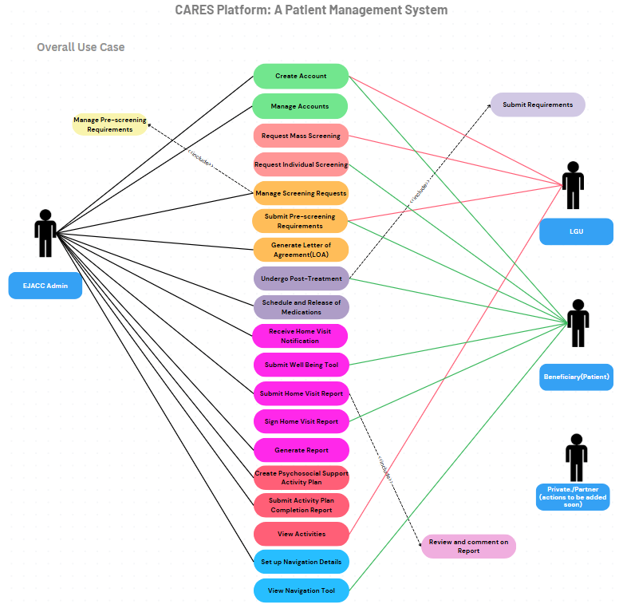

*Figure 2. CARES Platform Overall Use Case*

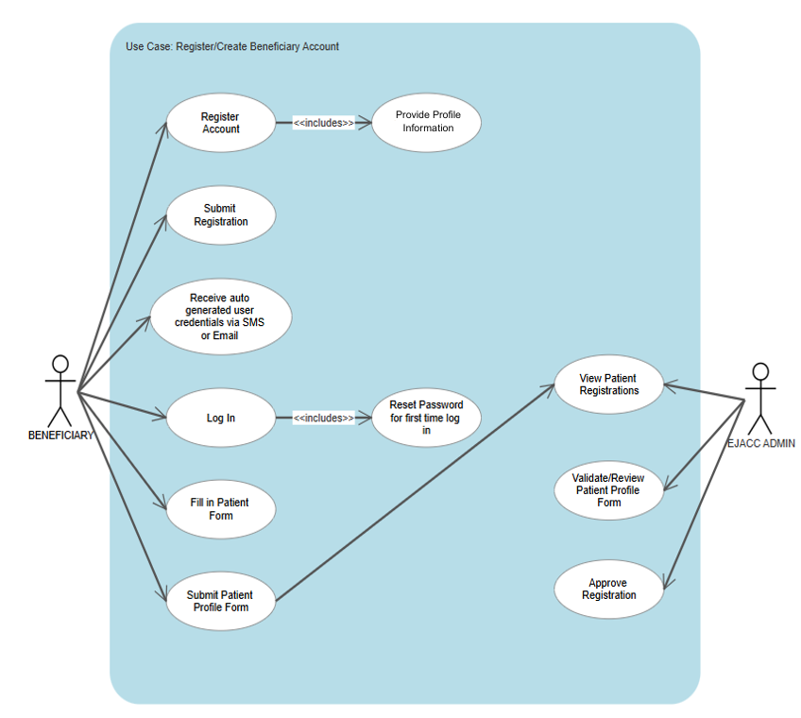

*Figure 3. Use Case for Beneficiary Registration*

This use case diagram illustrates the process of registering a beneficiary account, highlighting the interactions between the Beneficiary and the EJACC Admin from account creation to registration approval.

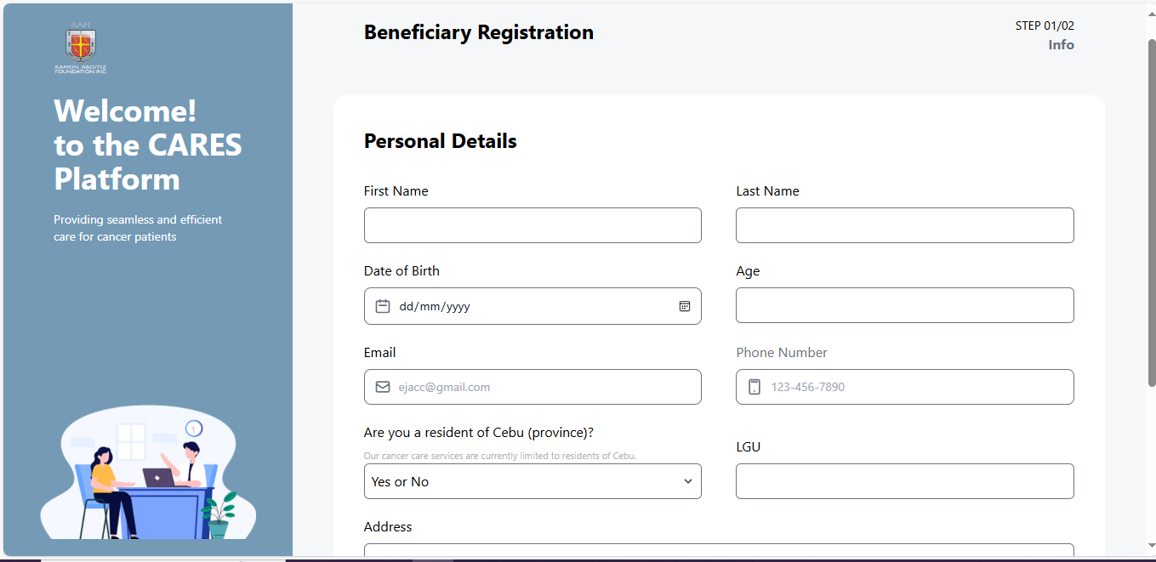

*Figure 4. User Interface for Beneficiary Account Registration*

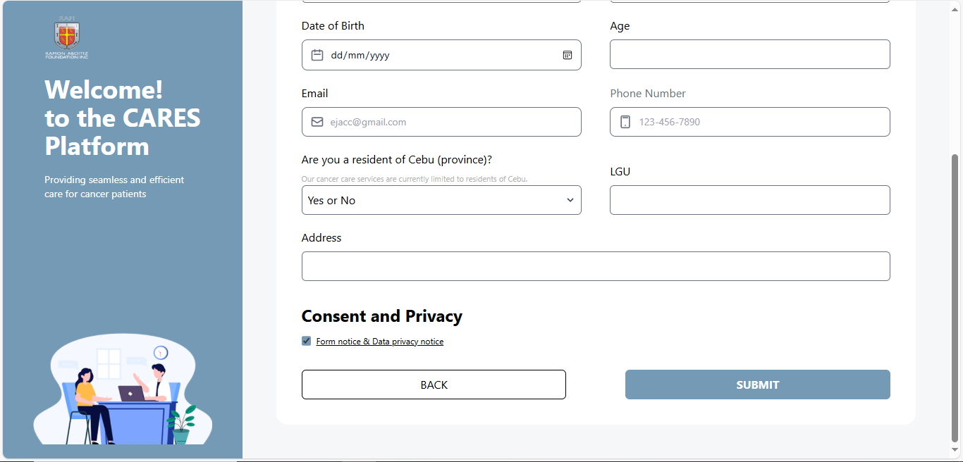

*Figure 5. User Interface for Beneficiary Account Registration*

Figures 4 and 5 shows the interface for account registration that the beneficiary will have to fill up and submit to access the platform.

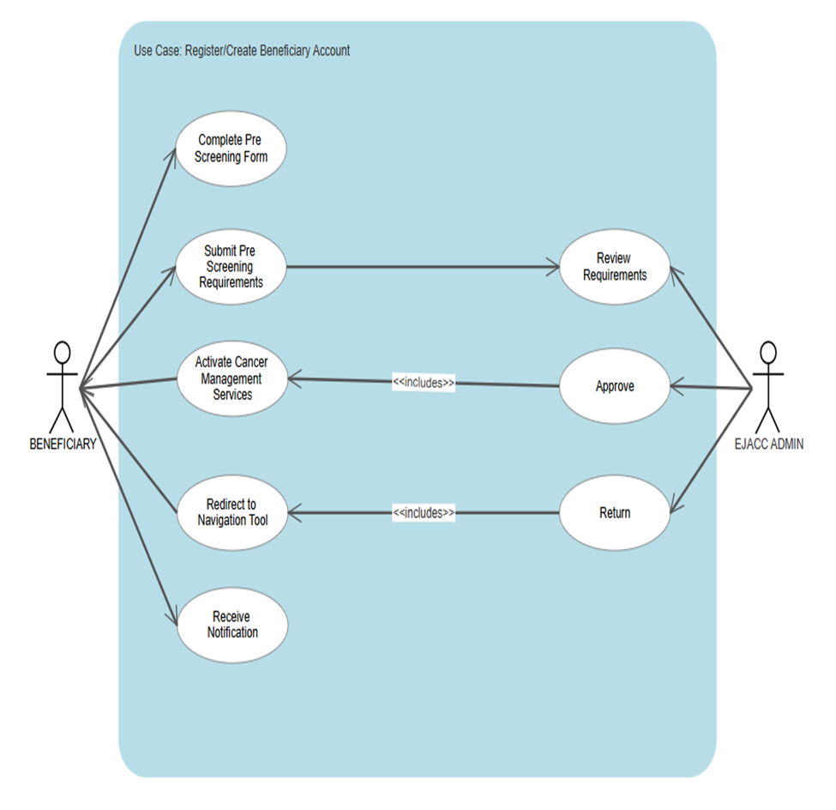

*Figure 6. Use Case for Pre-Screening Process - New Patient*

This use case diagram illustrates the pre-screening process for new cancer management patients, showing the interactions between the Beneficiary and EJACC Admin from form submission to activation of services and navigation support.

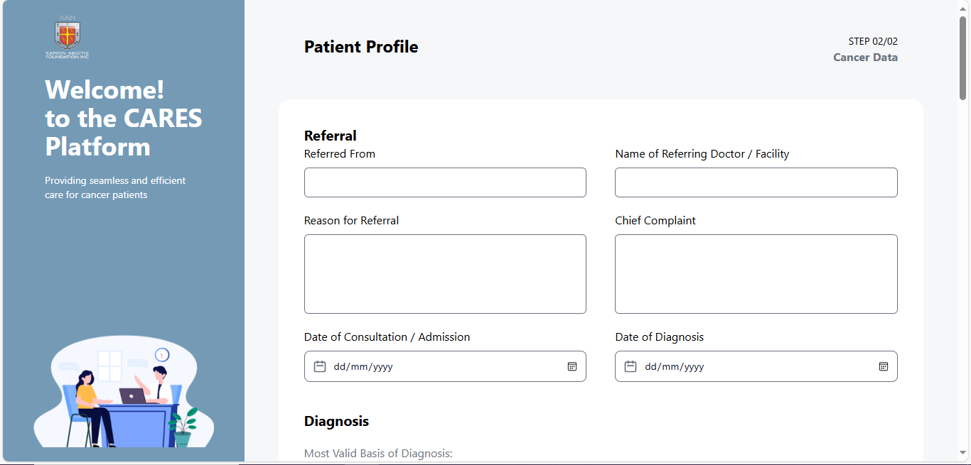

*Figure 7. User Interface for Pre-Screening Form Submission*

The image above shows the user interface for pre screening form submission to be filled up by beneficiary/patient. This includes reffered form, reason for referral, date of consultation, name of referring doctor or facility, chief complaint, and date of diagnosis.

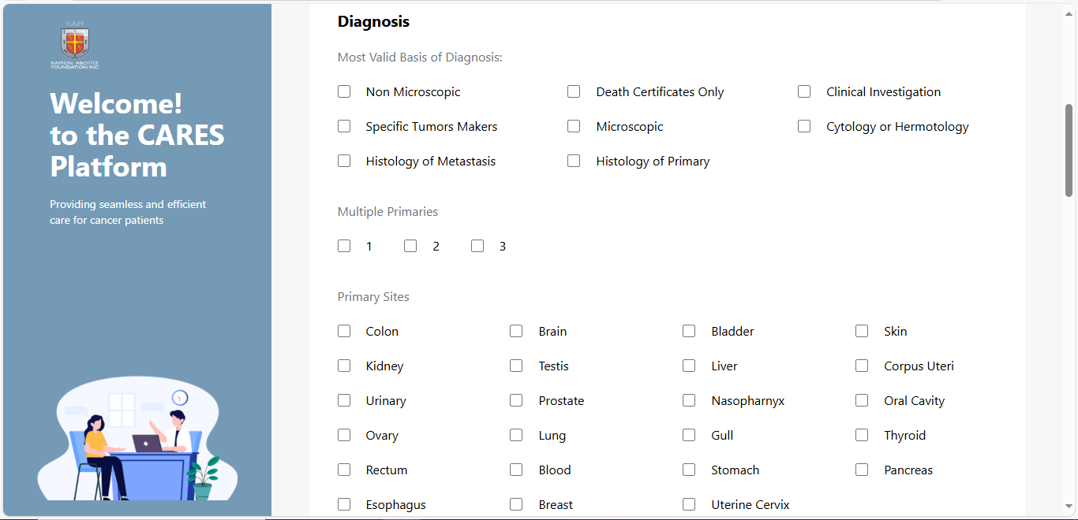

*Figure 8. User Interface for Pre-Screening Form Submission*

This shows the diagnosis part of the form wherein the user checks most valid basis of diagnosis, multiple primaries, and primary sites.

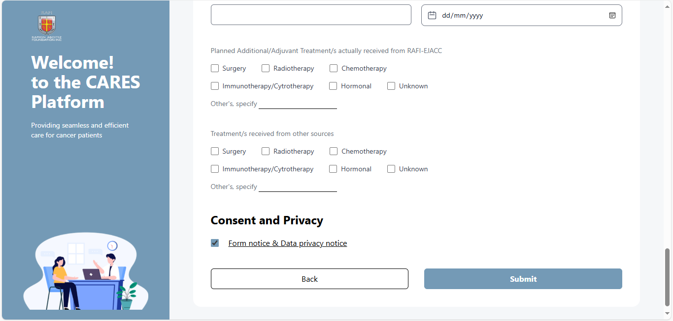

*Figure 9. User Interface for Pre-Screening Form Submission*

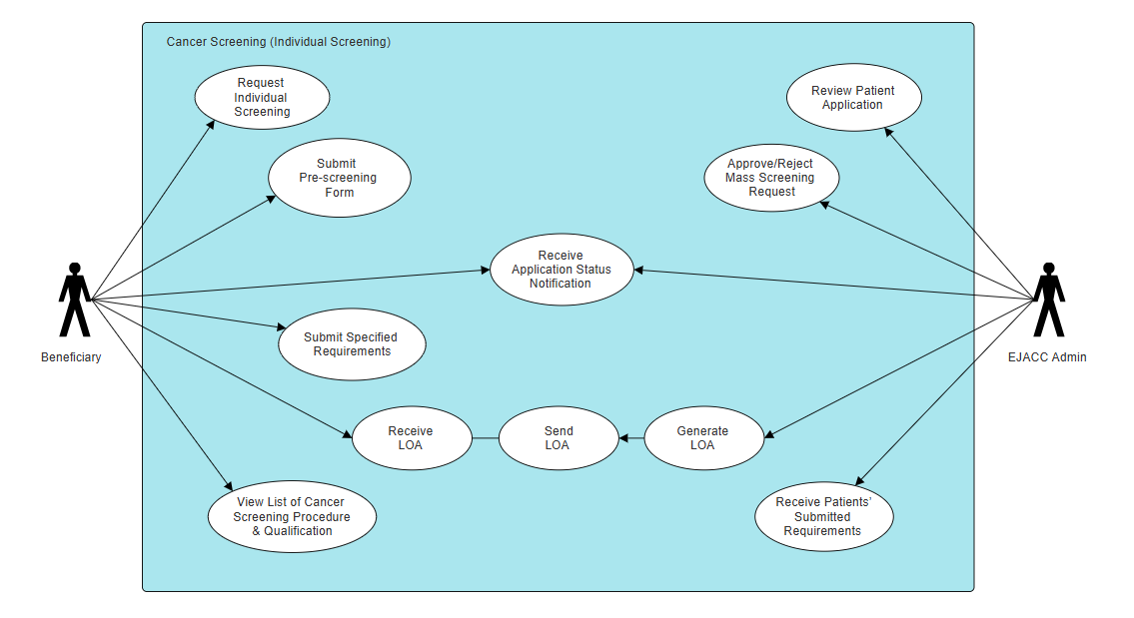 This shows the planned additional treatments received from RAFI-EJACC such as surgery, immunotheraphy, radiotheraphy, chemotheraphy, hormonal or unknown. Also, checkboxes to indicate what treatments have been receied by the beneficiary from other sources. Lastly, a consent and privacy confirmation and buttons to submit the pre-screening form.

*Figure 10. Use Case for Individual Screening*

This use case diagram outlines the process for individual cancer screening, where the beneficiary submits a request and receives updates, while the EJACC Admin reviews applications, approves requests, and processes the issuance of a Letter of Authorization (LOA).

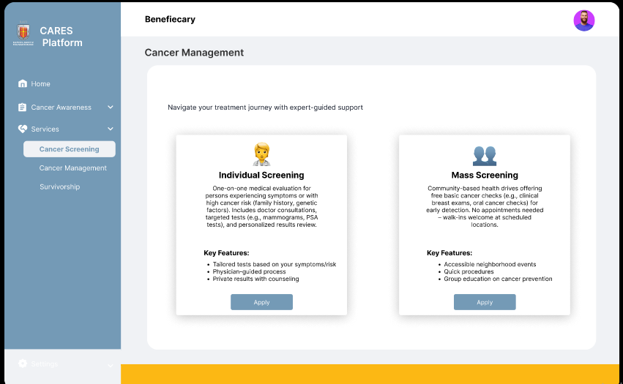

*Figure 11. User Interface for Individual Cancer Screening*

This image shows the interface for the beneficiary to access and request for individual screening. This shows a button to apply, quick explanation on what individual screening is and its key features.



*Figure 12. User Interface for Individual Cancer Screening*

This image shows a sneak peak of the form that the beneficiary has to fill up to request individual screening. This includes the diagnosis, multiple primaries, primary sites. This also has a consent and privacy confirmation feature and a button to submit the application.

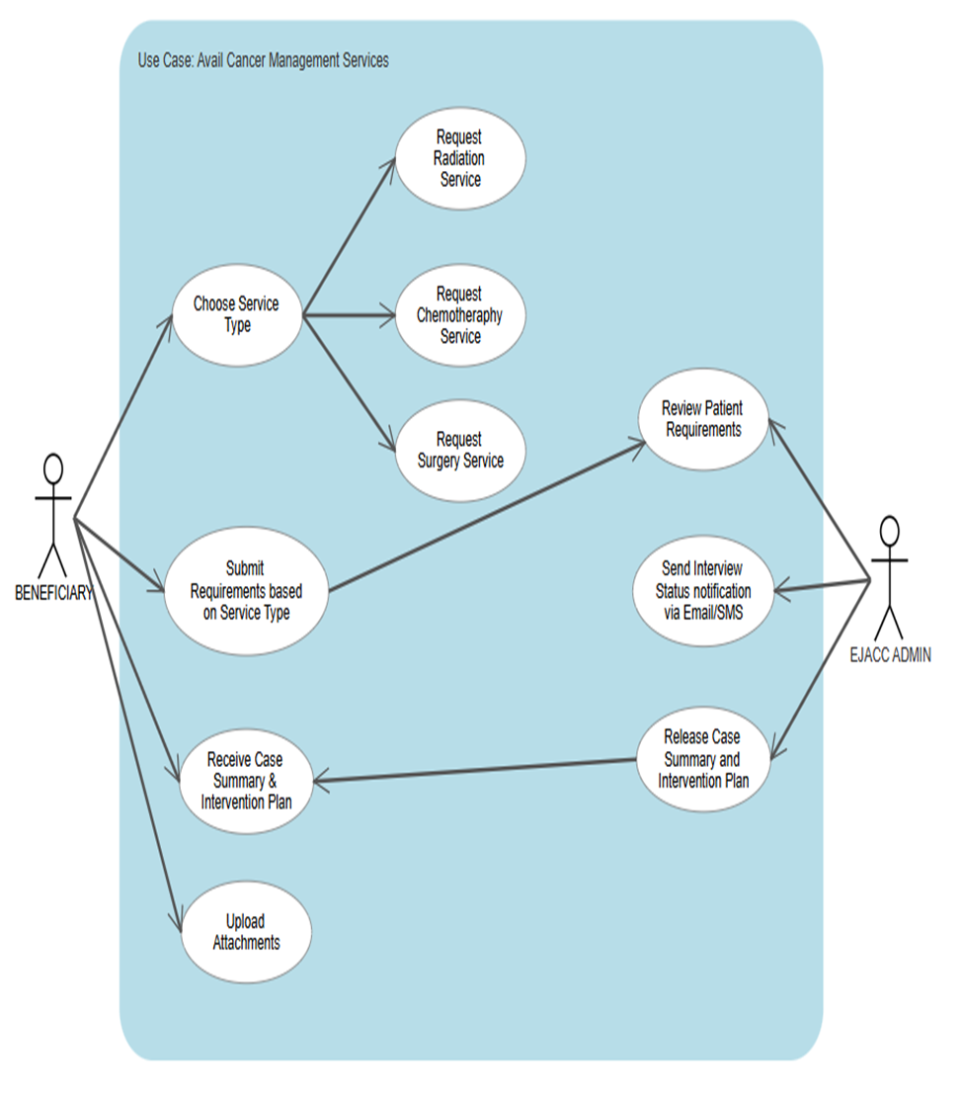

*Figure 13. Use Case to Avail Cancer Management Services*

This use case diagram outlines the process for availing cancer management services, where beneficiaries select a service type, submit requirements, and interact with EJACC Admin for review, notifications, and release of the case summary and intervention plan.

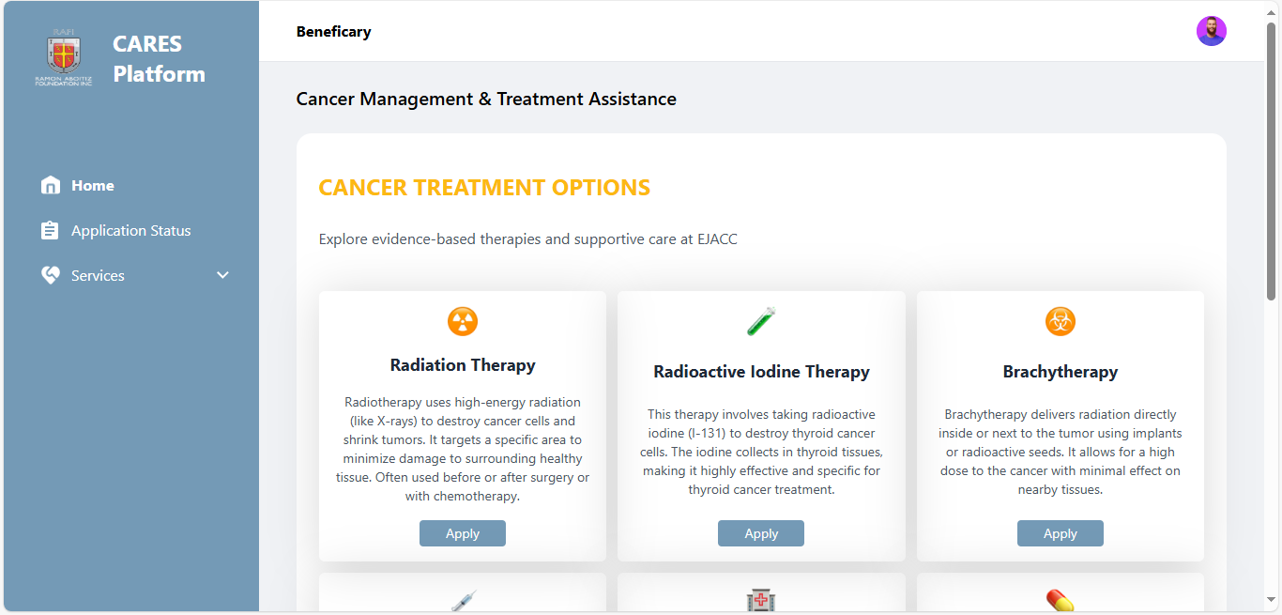

*Figure 14. User Interface for the types of Cancer Management Services*

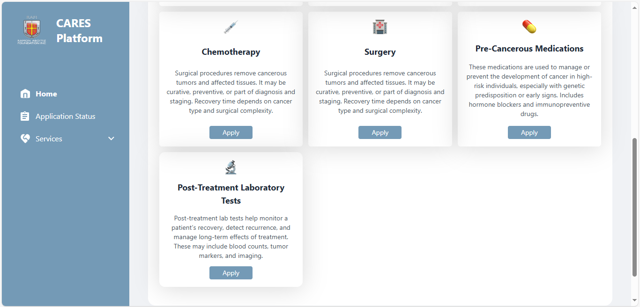

*Figure 15. User Interface for the types of Cancer Management Services*

The images above, figures 13 and 14 shows the different types of cancer management services a beneficiary can avail. This platform even offers applications to avail for pre-cancerous medications and post-treatment laboratory tests ensuring the well-being of patients.

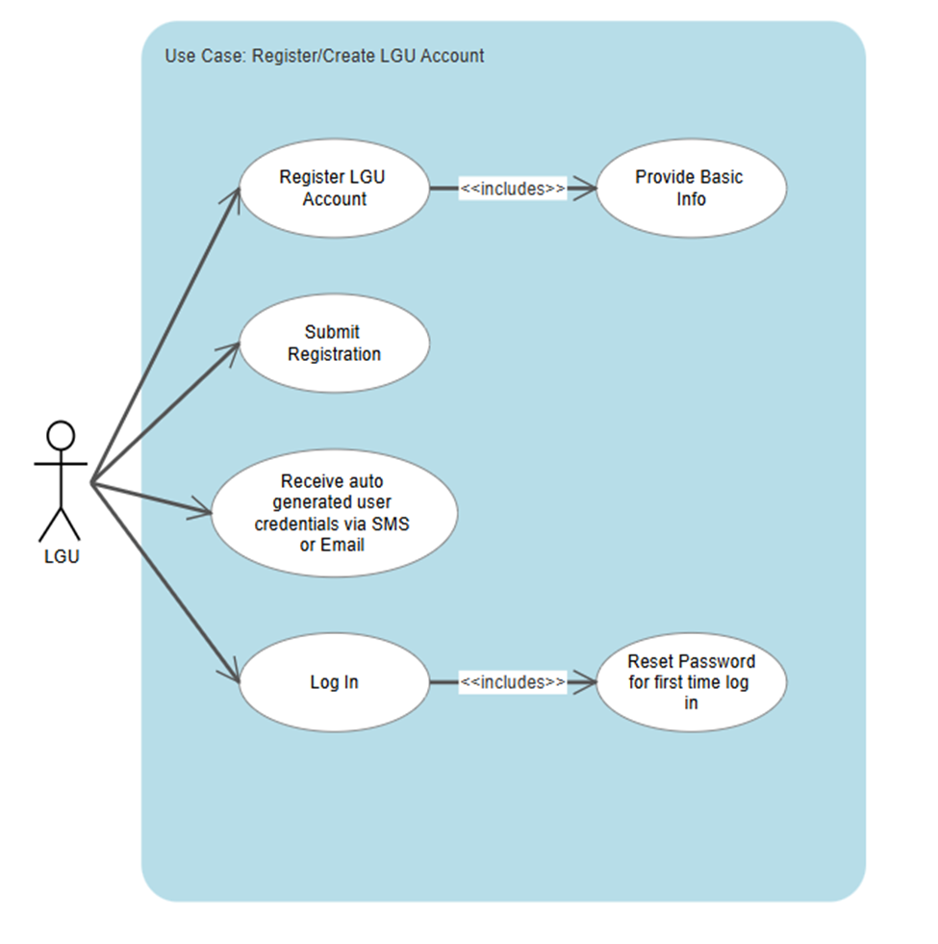

*Figure 16. Use Case for LGU Registration*

This use case diagram shows the process of registering an account as an LGU user, including steps from providing basic information to logging in with system-generated credentials.

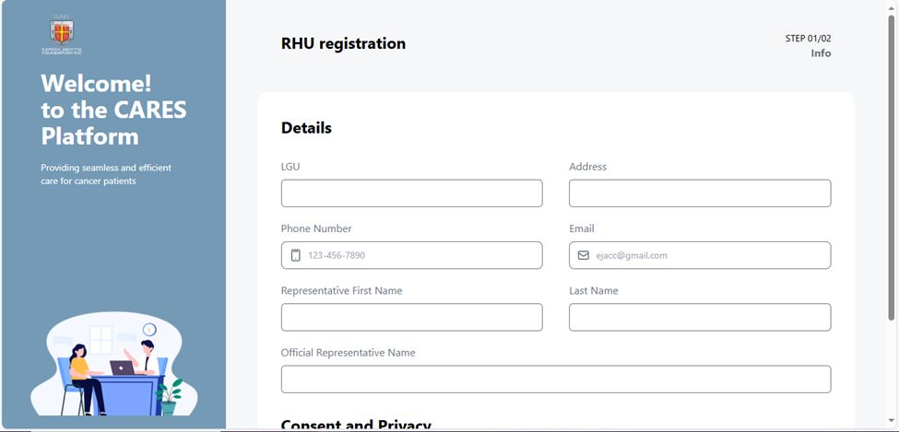

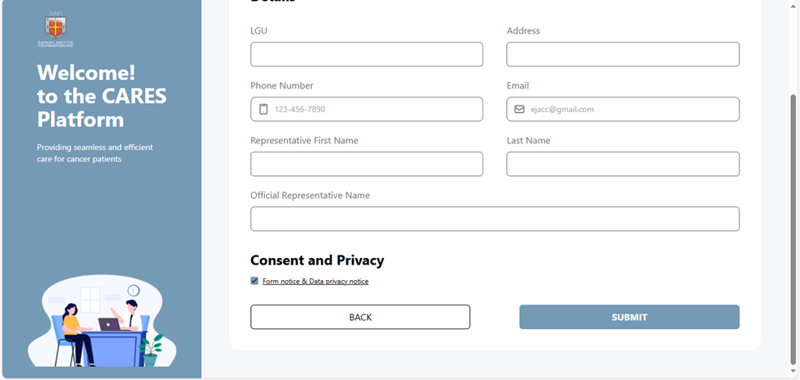*Figure 17. User Interface for LGU/RHU Registration*

*Figure 18. User Interface for LGU/RHU Registration*

The images above shows the user interface for the registration of LGU or RHU. This form asks the LGU/RHU to provide basic details about their unit. This includes the LGU name, address, phone number and email for contact information, the first, last name and official name of the representative handling the account. This form also ask for consent and primary confirmation and a submit button.

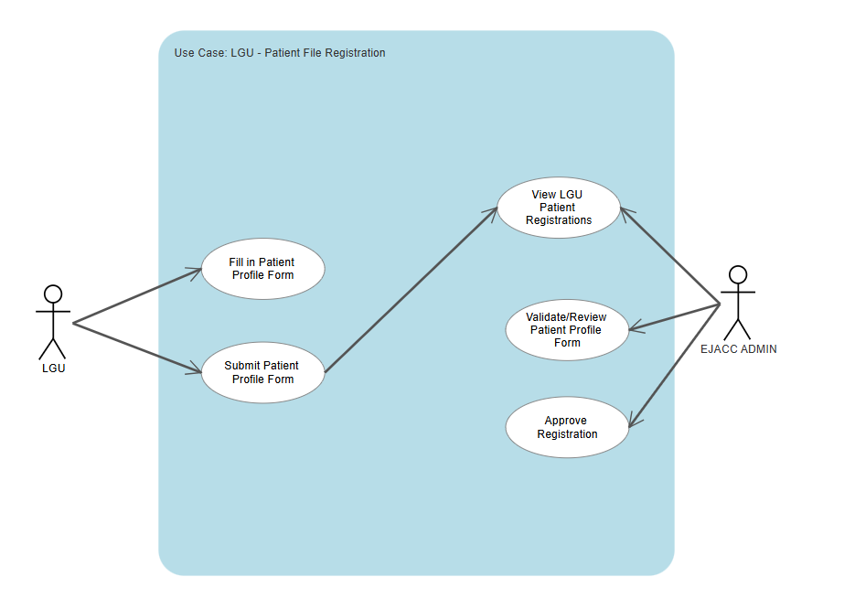

*Figure 19. Use Case for patient file registration*

This use case diagram shows how an LGU user registers a patient by filling out and submitting a profile form, which is then reviewed and approved by the EJACC Admin. The process involves viewing submissions, validating information, and final approval of patient registration.

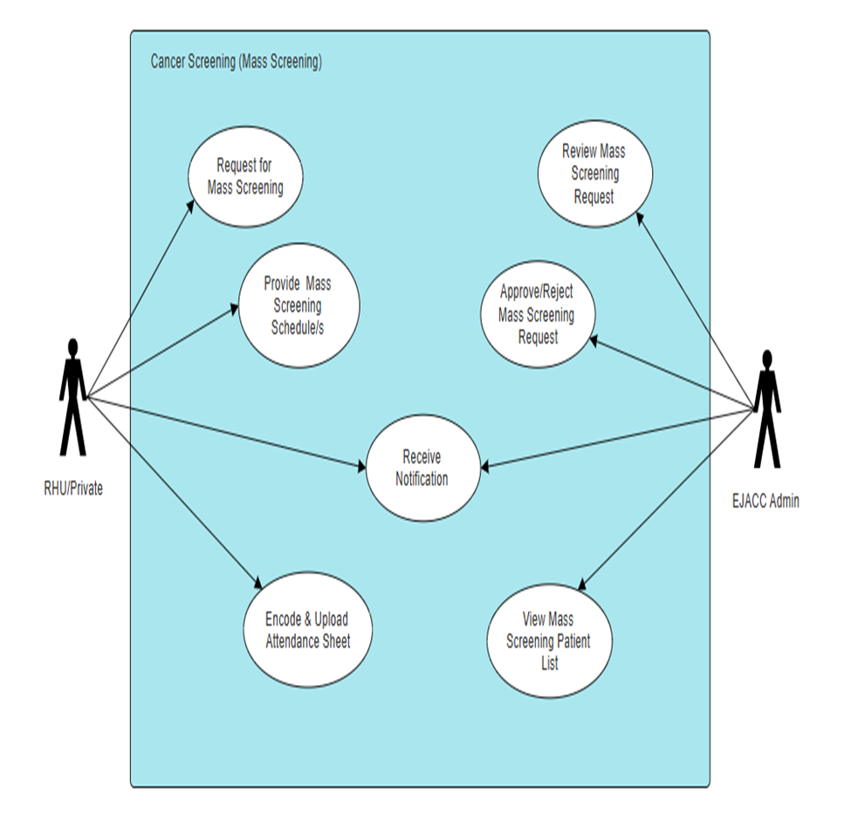

*Figure 20. Use Case for Mass Screening*

This use case diagram illustrates the Mass Screening process in a cancer screening system, detailing the interactions between RHU/Private users and EJACC Admin in scheduling, approving, and managing mass screening events.

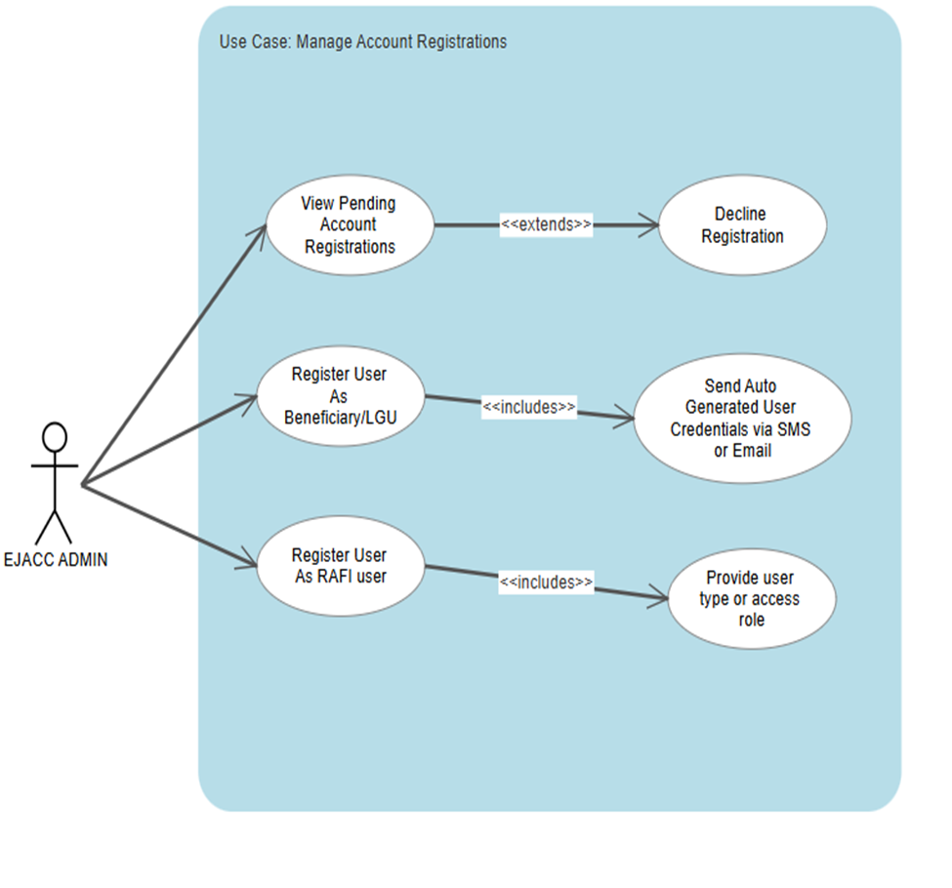

*Figure 21. Use Case to Manage Registrations*

This use case diagram illustrates how the EJACC Admin manages account registrations by viewing pending requests, registering users under specific roles, and performing related actions such as declining registrations and sending credentials.

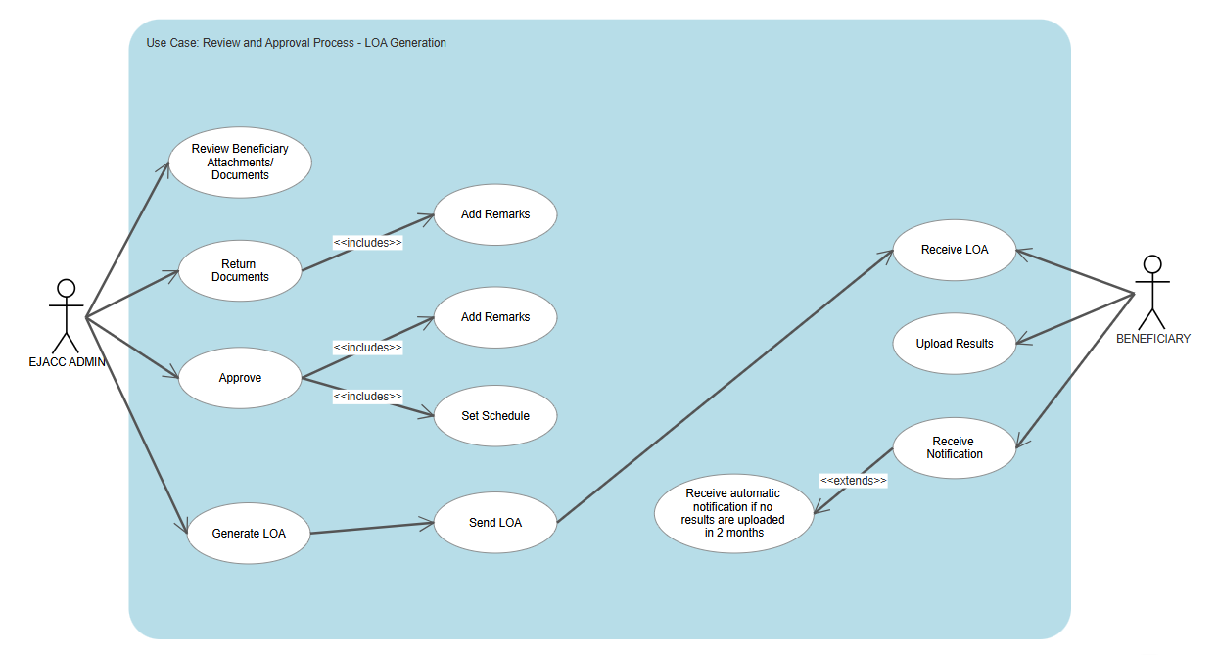

*Figure 22. Use Case for Review and Approval Process(LOA Generation)*

This use case diagram depicts the process of reviewing and approving beneficiary documents for LOA (Letter of Authorization) generation, detailing the interactions between the EJACC Admin and the beneficiary from document review to LOA issuance, result upload, and follow-up notifications.

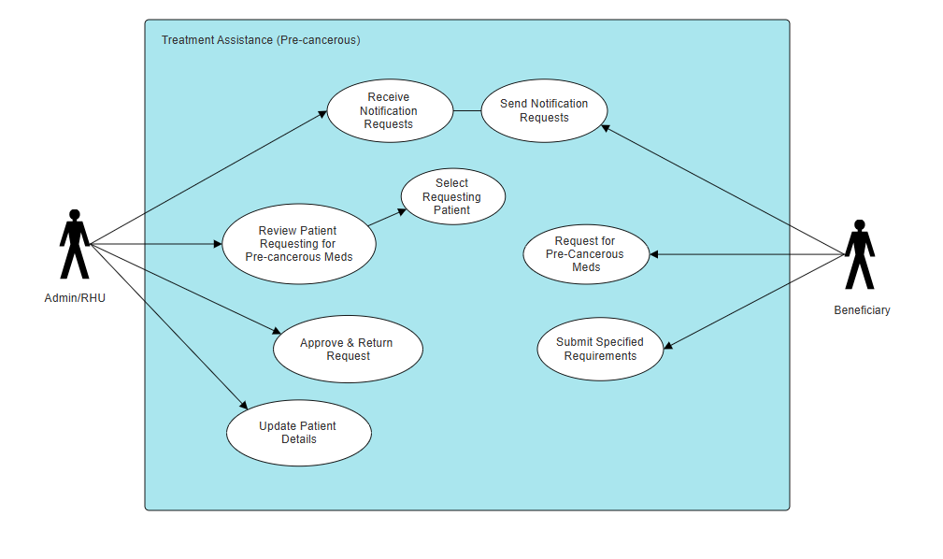

*Figure 23. Use Case to Request Pre-Cancerous Treatment Assistance*

This use case diagram illustrates the process for requesting precancerous treatment assistance, showing the interactions between the Admin/RHU and the Beneficiary during the request, review, and approval process.

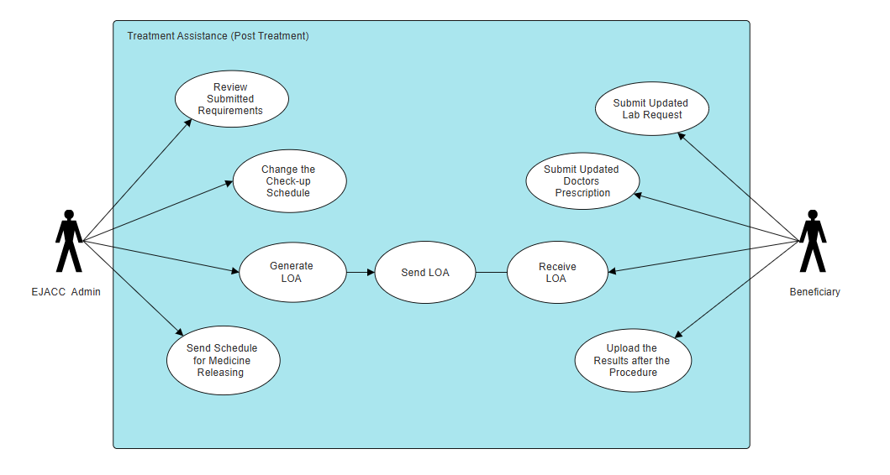

*Figure 24. Use Case for Post Treatment*

This use case diagram illustrates the post-treatment assistance workflow, showing how beneficiaries and EJACC Admin coordinate to manage lab requests, update prescriptions, generate and send LOAs, and handle treatment follow-up actions such as uploading results and scheduling medicine release.

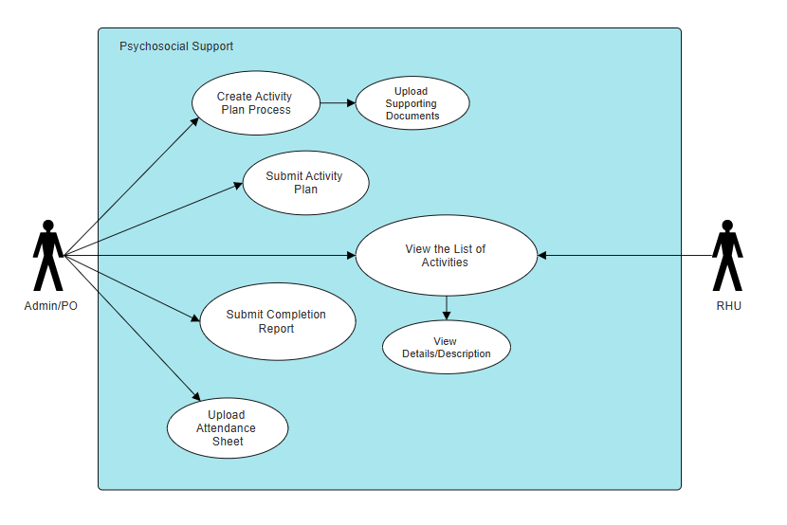

*Figure 25. Use Case to Manage Psychosocial Support Activity Plans*

This use case diagram outlines how Admin/PO and RHU users manage psychosocial support activities, from creating and submitting plans to viewing activity details for better coordination and transparency.

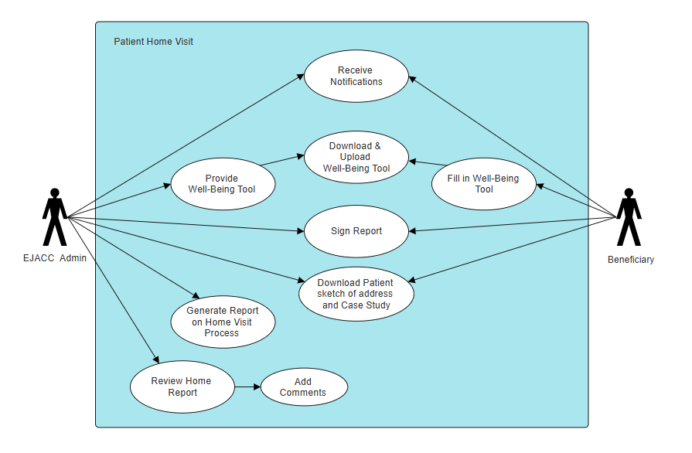

*Figure 26. Use Case to Manage Patient Home Visit Processes*

This use case diagram illustrates the collaborative workflow between the EJACC Admin and the Beneficiary in managing patient home visits, including notification handling, Well-Being Tool usage, report processing, and submission of supporting documents like patient sketches and case studies.

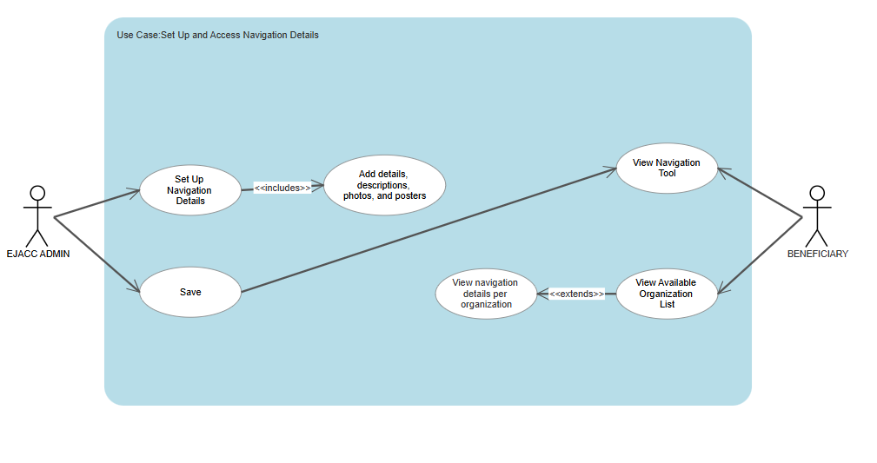

*Figure 27. Use Case to Set up and Access Navigation Details*

This use case diagram outlines how the EJACC Admin sets up the Navigation Tool by entering details, photos, and posters, while Beneficiaries can view overall navigation content, organization-specific details, and a list of available organizations.

**3. Performance Requirements**

**Software:**

The platform should be designed to handle a growing number of users and increasing volumes of patient data without significant degradation in performance. The use of PostgreSQL for database management indicates recognition of the necessity for a scalable solution for storing data.

**Measurement Points:**

The system should provide timely responses to user actions, ensuring a smooth and efficient workflow for EJACC personnel. This includes quick loading times for pages and efficient processing of data input and retrieval.

**4. Other Requirements**

Beyond functional and performance aspects, the development and evaluation processes highlight several other critical requirements:

**4.1 Schedule Feasibility**

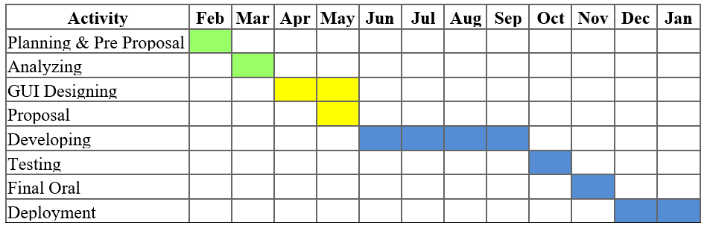

*Figure 15. Schedule Feasibility GANTT Chart*

This schedule feasibility is the proposed time frame for the development of the project with each phase allowed sufficient time for its completion in order to have a smooth workflow. The process is initiated with Planning and Pre-Proposal activities in February and March, where the team brainstorm ideas and define specific objectives. This is followed by the Analyzing phase in March, where requirements are gathered and feasibility of the suggested system is evaluated. In April, the designing of the user interface is attended to, where the system is ensured to be user-friendly and aesthetically pleasing. Our team makes preparations and submits the proposal for evaluation and approval by late April to May. After approval, development occurs between June and September, where the core functionalities of the system are developed and deployed. October is Testing month, where the team can find and rectify problems so that the system can operate as desired. In November, there is the Final Oral presentation to present the project and its results. Finally, Deployment in December to January will see the system launched officially and required support or training will be offered to its users. This well-organized timeline assists the team in going through each of the necessary phases, ensuring comprehensive development while avoiding possible delays.

**4.2 Class Diagram**

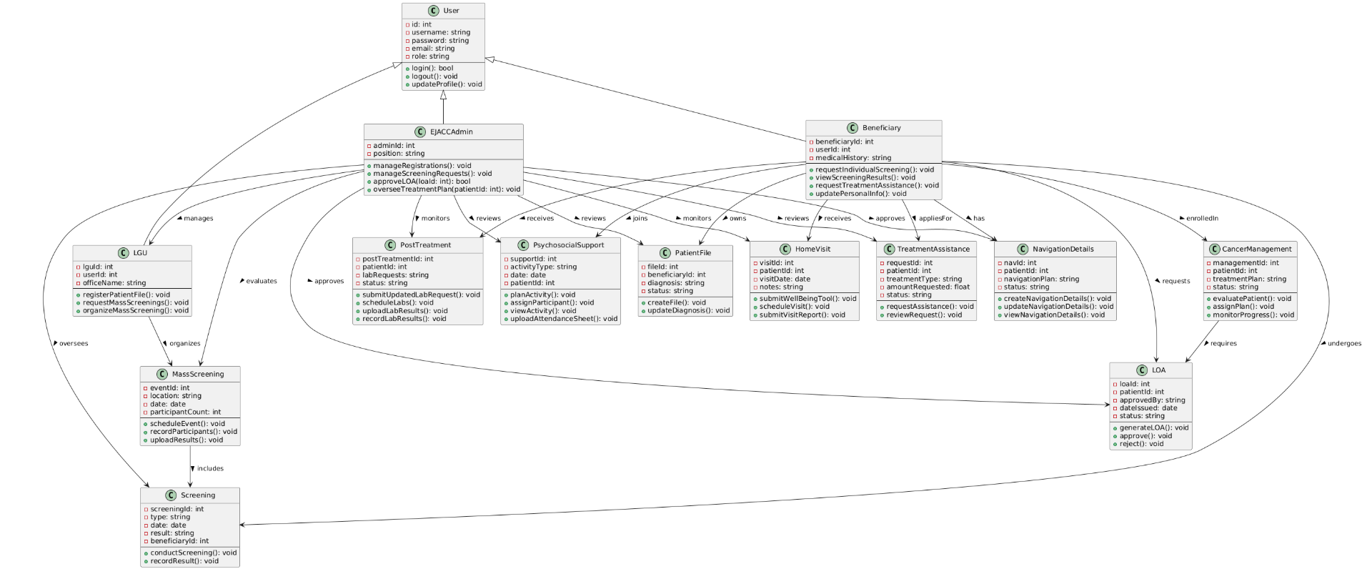

*Figure 16. Class Diagram*

The class diagram outlines the structure of the EJACC patient assistance system and how key entities interact. Central to the system is the *User* class, which defines common user attributes and functions. Inheriting from this class are three roles: *EJACCAdmin, Beneficiary, and LGU*. Admins manage registrations, screening requests, LOA approvals, and treatment plans. Beneficiaries, or patients, can request screenings, view results, and apply for treatment assistance, with their records stored in the *PatientFile* class. Screenings are managed either individually or through *MassScreening* events, typically organized by LGUs.

The system also supports ongoing care through classes like *CancerManagement, TreatmentAssistance, and PostTreatment.* Additional services include *PsychosocialSupport* for mental and emotional well-being, *HomeVisit* for community check-ups, and *NavigationDetails* for personalized care tracking consisting of various organizations offering services that may cater patient needs. This class diagram captures the system’s holistic approach to managing cancer care, emphasizing both patient support and administrative coordination.

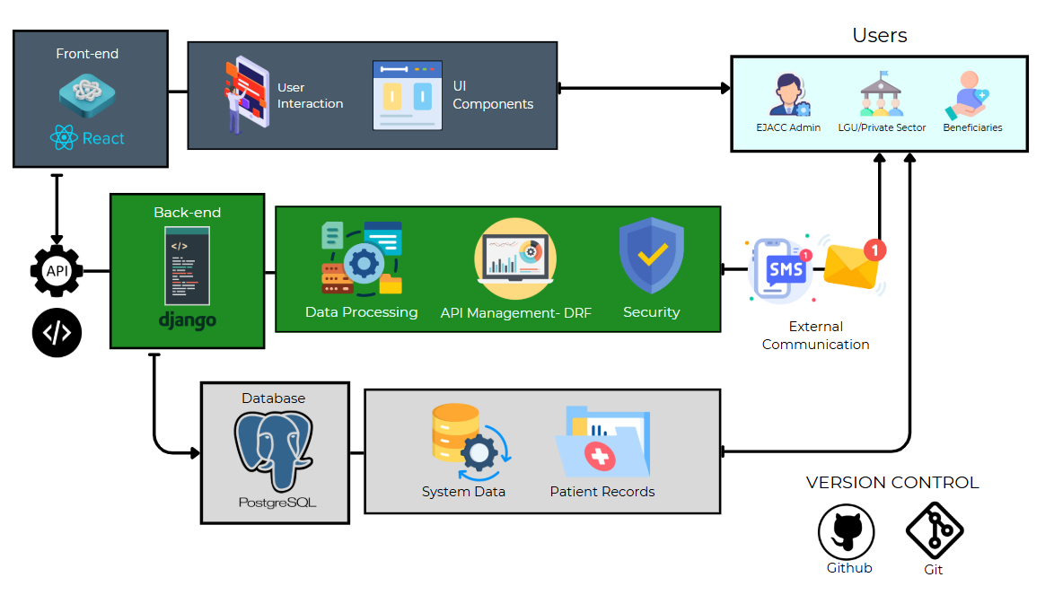**4.3 System Architecture**

*Figure 17. System Architecture*

This system architecture follows a modular and layered design to ensure efficient, secure, and user-friendly delivery of patient assistance services. At the front-end, our system uses *React* to provide an intuitive interface where users including EJACC Admins, LGU or private sector representatives, and beneficiaries can interact with the platform. This layer focuses on smooth user interaction and responsive UI components to enhance the overall user experience. The core functionality resides in the back-end, which is built with *Django*. This layer is responsible for processing data, managing APIs through the *Django REST Framework (DRF)*, and enforcing security protocols to protect sensitive information. It also facilitates external communication via SMS and email notifications, keeping users updated throughout their interaction with the system. The database layer utilizes *PostgreSQL* to store both system-related data and detailed patient records, ensuring data integrity and structured access. To support development and collaboration, the project uses *Git and GitHub* for version control, making it easier for the team to manage code updates and maintain system reliability. Overall, this architecture is designed to support the seamless coordination of cancer-related healthcare services, from user interaction to secure data handling and real-time communication.

**DEFINITION OF TERMS**

To ensure clarity and consistency throughout this study, the following key terms are defined:

**Automated Reporting** – This is the ability of the CARES Platform to automatically produce and present data summaries (e.g., patient demographics, treatment outcomes, resource use) without human input.

**CARES Platform** – This term specifically denotes thecustom-developed, web-based Patient Management System for cancer patientsthat is the primary output of this project. Architecturally based on a React.js frontend, Django backend, PostgreSQL database, and Django REST Framework for API integration, its operationalization in EJACC is distinguished by its deployment, user access, and its proven functionalities in optimizing patient workflows, handling detailed patient information, and optimizing overall service delivery.

**Cancer Patient Tracking** – This pertains to the longitudinal, digitalized observation of a cancer patient's trajectory along the EJACC care continuum. This is attested by the CARES Platform's capacity to track and present the patient's status now, treatment progress, appointments to be scheduled, and follow-up activities, all ensuring continuity of care as well as enabling proactive clinical interventions.

**DASIG Rural Health Units (RHUs)** – These are primary health centers established in rural areas geographically located to address rural populations, and they serve as key referral routes to EJACC for specialized cancer management.

**Data-Driven Decision Making** – This describes the deliberate and systematic utilization of empirical data and analytical insights provided by the CARES Platform's automated reports and real-time dashboards to inform strategic, operational, and clinical choices at EJACC.

**Data Security and Privacy** – These include the robust technical and procedural protections built into the CARES Platform to ensure sensitive patient health information is not accessed, modified, disclosed, or destroyed by unauthorized entities. Operationally, this is realized through functionality such as role-based access controls, data encryption policies, audit trails, and compliance with appropriate national and international healthcare data protection legislation.

**Eduardo J. Aboitiz Cancer Center (EJACC)** – This is the specialized oncology healthcare center within the Ramon Aboitiz Foundation Inc. (RAFI), and it is the direct beneficiary and implementation location of the CARES Platform. It is the main setting in which the system is implemented, operated by healthcare providers, and meant to directly improve cancer treatment and patient care services.

**Electronic Health Records (EHR)** – This is the computerized, patient-focused record of medical data that EHR systematically replaces paper-based charts. Functionally, this capability allows EJACC authenticated healthcare professionals to access, enter, update, and maintain a patient's entire medical history, diagnoses, treatment plans, and clinical notes in real-time, centralized digital form.

**Health Information System (HIS)** – This is a general term for a comprehensive technological system aimed at handling healthcare-related information. Functionally, the CARES Platform is a dedicated module in EJACC's overall HIS system with a specific focus on patient management features and contributing to the effective gathering, storage, and transmission of vital healthcare information.

**Healthcare Digitalization** – This is the deliberate and process-oriented implementation of digital technologies (e.g., the CARES Platform) in EJACC's operational setup to upgrade the delivery of healthcare services. Its operational effectiveness is gauged by the noticeable shift away from manual towards automated processes, resulting in enhanced efficiency, accessibility, and overall patient outcomes within the facility.

**Interoperability** – This denotes the CARES Platform's intrinsic capability to seamlessly exchange and effectively utilize patient information with other distinct healthcare information systems or applications, particularly those utilized by DASIG Rural Health Units (RHUs).

**Patient Management System (PMS)** – This is a generic classification for a software system designed to administer patient-related workflows. In this study, the CARES Platform is the concrete instantiation of a PMS, operationally defined by its functions in systematically tracking patient records, organizing treatment plans, maintaining medical histories, and automating administrative tasks to optimize healthcare service management at EJACC.

**Real-Time Dashboard** – This refers to a dynamic, graphical user interface within the CARES Platform that provides instantaneous and continuously updated visualizations of key performance indicators (KPIs) related to patient data, operational metrics, and treatment progress.

**Resource Allocation** – This describes the strategic and optimized distribution of EJACC's operational assets, including medical personnel, equipment, and financial resources. Operationally, CARES Platform facilitates this by giving data-driven insights through its automated reports to drive more efficient and equitable resource deployment, resulting in better service delivery and operational efficiency.

**Workflow Optimization** – This refers to the measurable enhancement of the effectiveness, efficiency, and streamlining of clinical and administrative workflows at EJACC, which are directly triggered by the deployment and use of the CARES Platform.

**REFERENCES**

Amegroups. (2024). Evaluating the importance of digital tools or approaches to hospital performance using the analytic hierarchy process (AHP)-Delphi approach. *Journal of Hospital Management and Health Policy.*

Brown, L., & White, P. (2024). The role of data visualization and predictive analytics in optimizing hospital resource allocation. *Healthcare Informatics Journal, 29*(1),45-63.

Doe. J., Smith, A., & Lee, R. (2023). Automated reporting and dashboard functionalities in healthcare: Improving decision-making and patient tracking. *Journal of Health IT Innovations, 7*(2),78-92.

Garcia, M., Santos, L., & Chua, E. (2024). Technology-driven patient management: Global trends in healthcare digitalization. *International Journal of Health Systems, 35*(4), 112-130.

IBIMA Publishing. (2024). *Improved healthcare quality through integrated hospital management and digitalization.*

International Journal of Advanced Science and Research in Emerging Technologies (IJASRET). (2024). *Online clinic management system: Digital patient records and automation in healthcare.*

Jiang, S., Smith, R., & Patel, A. (2019).Electronic systems for patients to report and manage side effects of cancer treatment: Systematic review. *Journal of Medical Internet Research, 21*(1),e10875.<https://www.jmir.org/2019/1/e10875/>

Jones, B., Kim, T., & Rodriguez, P. (2021). Improving service coordination in healthcare through centralized patient management systems. *Journal of Medical Informatics, 19*(2), 66-80.

Lee, H., Martinez, J., & Wilson, C. (2022). Enhancing patient experiences with digital platforms: The role of real-time tracking and service coordination. *Digital Health Review, 10*(3), 102-118.

Servidio, P., & Cronin, D. (2018). Digital health transformation: How automation improves hospital performance. *Health Informatics Review, 25*(4), 112-130.

Smith, J., Lee, K., & Thompson, B. (2020). Centralized digital platforms in healthcare: Improving coordination, reducing administrative burdens, and ensuring timely interventions. *Journal of Health Technology*, *18*(2), 78-95.

World Health Organization. (2022). *Digital health and patient management: Strategies for modern healthcare systems.*

Basch, E. (2017). Patient-reported outcomes: basic to advanced methodology. Journal of clinical oncology, 35(5), 530.

Jha, A. K. (2010). Meaningful use of electronic health records: the goal of better health care. *Jama*, 304(15), 1694-1695.

Dolan, T. (2014). Cloud computing in healthcare: benefits and risks. *Journal of healthcare information management*, 28(1), 17.

Buntin, M. B., Jain, S. H., & Blumenthal, D. (2010). Health information technology: laying the infrastructure for national health reform. *Health affairs,* 29(6), 1214-1219.

Department of Health. (n.d.). *Health sector reform updates*. Retrieved from<https://doh.gov.ph>

McKinsey & Company. (n.d.). *Digital health trends 2024*. Retrieved from<https://www.mckinsey.com>

Negosyante, J. (2022). Highlighting digital gaps in local healthcare units.

OECD. (2023). *The role of health information systems in digital health innovation*.

Philippine Department of Health & Department of Information and Communications Technology. (n.d.). *Philippine eHealth Strategic Framework and Plan 2023–2027*.

World Health Organization. (n.d.). *Global strategy on digital health 2020–2025*. Retrieved from<https://www.who.int/publications/i/item/9789240020924>