**Research and Case Evaluation on Auditing**

Prepared: 2025-08-22

**I. Case Study – Role of Audit**

Below are two recent, real-world incidents where security auditing and logging either helped catch an attack or where insufficient logging made detection and response harder. Each case answers: (a) nature of the incident, (b) how auditing contributed, (c) which audit policies could have prevented/mitigated, and (d) lessons learned.

**Case 1: Okta Customer Support System Breach (2023)**

What was the nature of the security incident?

* Threat actor accessed Okta’s customer support case management system between Sept 28–Oct 17, 2023, affecting ~134 customers. Some stolen files were HAR files containing session tokens that could be reused for session hijacking.

How did auditing contribute to identifying or resolving the issue?

* BeyondTrust detected suspicious activity against an in-house Okta admin account through identity telemetry and logs on Oct 2, promptly alerting Okta and containing impact.
* Okta’s subsequent investigation and customers’ own log reviews identified potential session hijacking and misuse of support-uploaded artifacts.

What audit policies or procedures could have prevented or mitigated the incident?

* Continuous monitoring of admin sessions with anomaly alerts (e.g., cookie reuse, unusual IP/device).
* Short-lived, bound session tokens; strict controls on support-file uploads (sanitization, token scrubbing).
* Centralized log collection with at least 90-day retention; alerts on access to sensitive support artifacts.
* Mandatory MFA and phishing-resistant factors (e.g., FIDO2) for all admin and support accounts.

What lessons can be learned about implementing effective audit policies?

* Treat support workflows as sensitive attack surfaces; audit them like production.
* Detect and alert on token theft indicators and unusual admin behaviors quickly.
* Customers should monitor IdP logs for admin actions originating outside expected devices or networks.

**Brief Report**

In September 2023, I learned that Okta experienced a security incident where a hacker got into their customer support case management system. The attacker was able to access files that some customers uploaded for troubleshooting, and a few of those files had session tokens that could be used to take over accounts. Out of all Okta customers, only a small number were affected, but a few well-known companies confirmed they were impacted.

The investigation showed that the problem started from a compromised service account. An employee had logged into their personal Google account on a work laptop, and the service account credentials were accidentally saved there. Once that personal account was breached, the attacker got hold of the credentials. What made things worse was that Okta’s system didn’t immediately catch the unusual file downloads because of a blind spot in how those actions were logged.

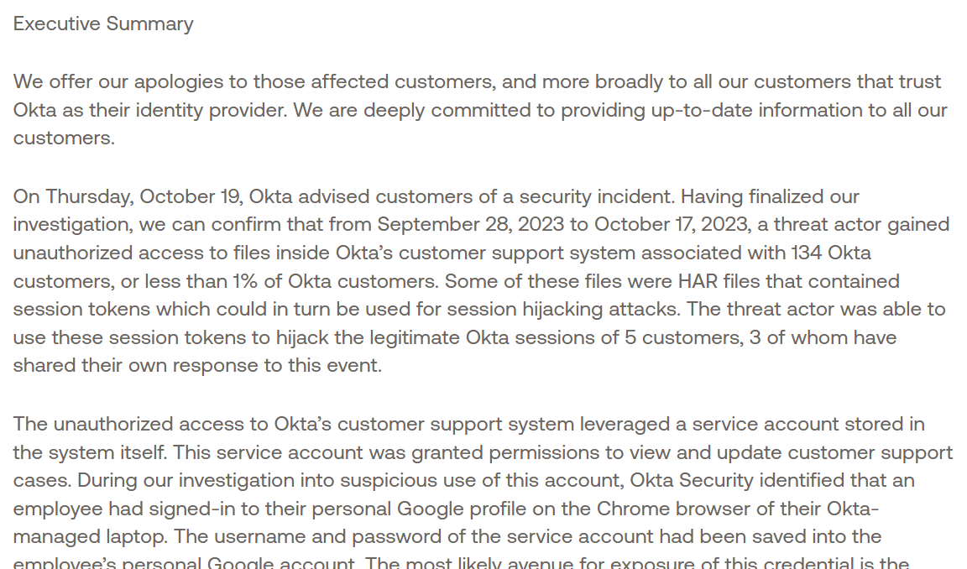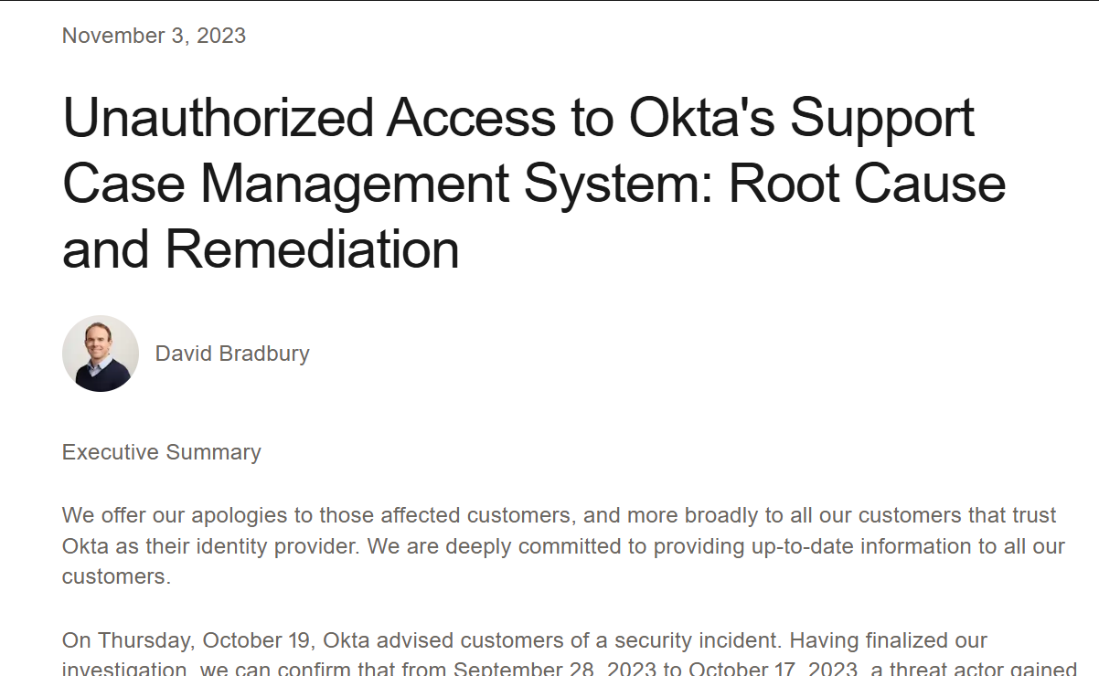To fix this, Okta disabled the compromised account and made several changes to improve security. They blocked personal Google sign-ins on company devices, added stronger monitoring inside the support system, and introduced new protections like session token binding. These steps were done to make sure the same type of issue doesn’t happen again in the future.

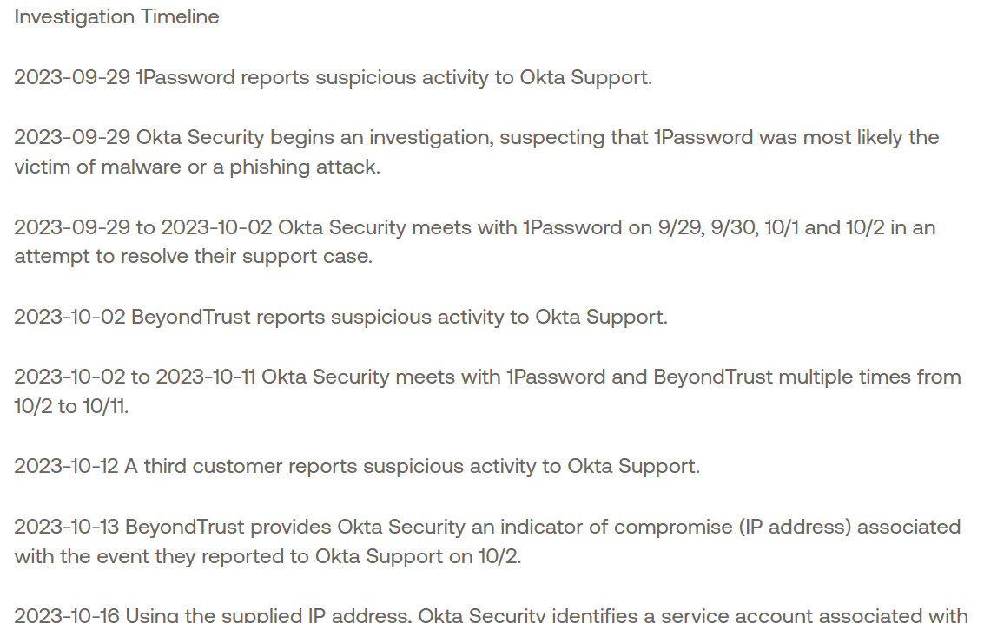

**Case 2: Microsoft Storm-0558 – Forged Tokens & Cloud Email Access (2023–2024)**

Nature of incident:

* China-linked actor 'Storm-0558' acquired a Microsoft consumer signing key and forged tokens to access Outlook Web Access / Exchange Online email for ~25 organizations, including government accounts.

How auditing/logs helped or hindered:

* Lack of comprehensive default cloud audit logs hindered some customers’ ability to see the full scope initially; later, expanded logging made deeper investigations easier.
* Subsequent log availability (Microsoft Purview Audit) improved visibility into token usage and mailbox access patterns.

Audit policies/procedures that could have prevented/mitigated:

* Enable comprehensive audit logging by default across cloud services with long retention (>= 180 days).
* Alert on anomalous token use (e.g., consumer key used against enterprise tenants, impossible travel).
* Protect and segregate signing keys; implement just-in-time access and key-usage audit trails.
* Require strong conditional access and device trust for email access paths.

Lessons learned:

* Default-on, high-fidelity logging is essential for cloud forensic readiness.
* Key material and token issuance pipelines must be auditable end-to-end.
* Customers should test their ability to reconstruct attacks with only their retained logs (tabletop exercises).

⬇️ Screenshot placeholder: Insert your screenshot of one source article here.

**II. Audit Case Analysis – Simulated Audit Log**

Sample log entries (Windows Security / Sysmon style):

|  |  |  |  |
| --- | --- | --- | --- |
| Time (UTC) | Host | Event ID | Summary / Key Fields |
| 2024-08-19 02:41:08 | WS-APP01 | 4625 | Failed logon for svc-backup from 203.0.113.45 (5 attempts in 2 min). |
| 2024-08-19 02:43:12 | WS-APP01 | 4624 (Type 10) | Successful remote logon by user temp.admin from 203.0.113.45. |
| 2024-08-19 02:44:00 | DC01 | 4720 | A user account was created: temp.admin. |
| 2024-08-19 02:44:30 | DC01 | 4728 | temp.admin added to Domain Admins. |
| 2024-08-19 02:46:02 | WS-APP01 | 4688 | Process created: powershell.exe -nop -w hidden -enc <base64>. |
| 2024-08-19 02:47:11 | FS01 | 4670 | Permissions on \\FS01\Finance\Payroll.xlsx changed by temp.admin. |
| 2024-08-19 02:48:19 | EDGE01 | 5156 | Outbound connection allowed to 185.199.110.153:443 from WS-APP01. |
| 2024-08-19 02:50:03 | DC01 | 1102 | The audit log was cleared by temp.admin. |

Why these are suspicious:

* Burst of failed logons (4625) followed by a successful remote logon (Type 10) from the same external IP and at off-hours.
* Creation of a new privileged account (4720) and immediate elevation to Domain Admins (4728).
* Encoded PowerShell execution (4688) indicates potential execution of obfuscated scripts.
* File permission changes on sensitive finance data (4670) and outbound connection shortly after (possible exfiltration).
* Security audit log cleared (1102), a classic anti-forensics behavior.

Recommended actions / policies:

* Enforce MFA and conditional access for all privileged accounts; block remote admin logons except via PAM/JIT.
* SIEM rules for: repeated 4625 followed by 4624, 4720 + 4728 within 10 minutes, any 1102 events, and encoded PowerShell (Sysmon Event ID 1).
* Use write-once (immutable) log storage and retain for ≥ 180 days; forward critical logs to SIEM in near real time.
* Apply least privilege; require approvals for group membership changes; enable Just-In-Time (JIT) admin with time-bound roles.
* Restrict outbound traffic from servers; alert on large transfers to unknown IPs/domains.

**III. Self‑Reflection (150–200 words)**

Security auditing is the backbone of detection and accountability. Good logs turn small clues into clear stories: who acted, from where, and with what effect. In my future organization, I would make audit logging default-on and tamper‑resistant, forward all critical events to a SIEM, and retain logs for at least six months. I would also define alerting rules for risky behaviors—multiple failed logins, new admin creation, log clears, and encoded PowerShell. Privileged actions would require multi‑factor authentication and just‑in‑time access so that high‑risk events are rare and easy to spot. Tabletop exercises would test whether our logs are sufficient to reconstruct an incident. From the Okta and Microsoft cases, my key insight is that visibility must not be optional. When logs are missing or hard to access, investigations stall; when telemetry is rich and centralized, defenders can detect misuse quickly and limit damage. Auditing is not just a compliance checkbox—it is an everyday operating practice that makes prevention, detection, and response work together.