Pneumonia Detection with Artificial Neural Networks

Buse Felamur  
*Faculty of Engineering, Environment and Computing*  
*Coventry University*Coventry, England  
felamurb@uni.coventry.ac.uk

*Abstract*— In this paper, chest x-ray dataset is trained using three different neural network models. Dataset includes white and black x-ray images. Models used for this project are: Convolutional Neural Network, Recurrent Neural Network and lastly Multi-layer Perception Neural Network. Purpose of this is experiment is classifying and finding out which patients has pneumonia without getting help from a doctor. For the experiments python and its libraries were used.

Keywords— Convolutional Neural Network, Recurrent Neural Network, Multi-layer Perception Neural Network, pneumonia, python, x-ray.

# Introduction

As the years pass, worlds population increases. With these increase our needs increase too. For example, getting health care quickly. If we have a condition, we would like to see a doctor or nurse quickly. Sometimes it maybe not be possible to reach one as soon as possible and it may be too late.

Wouldn’t it be good if there was a way to find out what exactly out condition is without waiting for a doctor?

With the help of machine learning techniques, it is possible. It can be used to diagnosis diseases just by checking an x-ray or test results. They might even be faster than actual doctors.

In this project I aimed to do something similar. I tried to use chest x-ray images to predict if the patient has pneumonia or not. What exactly is that? Pneumonia is a inflammation of the tissue in the longs. It can appear in one or both at the same time. [1] It can be deadly or just annoying. It is the reason that more than 1 million adults are hospitalized. 50,000 die from that disease in the US. [2] It is most dangerous if patient is a young child or an elder. It is bad for people with weak immune systems and health problems. [3]

Common symptoms are fever, coughing, sweating, chills, chest pain, headaches, vomiting and many more. [4]

# Literature Review

Over the years, many people did similar projects, using neural networks or other machine learning methods to predict and classify many different illness.

For example a group of reachers (Pranav Rajpurkar, Jeremy Irvin, Kaylie Zhu ,Brandon Yang, Hershel Mehta , Tony Duan , Daisy Ding , Aarti Bagul , Robyn L. Ball , Curtis Langlotz , Katie Shpanskaya , Matthew P. Lungren , Andrew Y. Ng ) used a similar dataset to detect pneumonia at a expert level. [2] They used CheXNet. It is a 121-layerd convolutional neural network trained on ChestX-ray14. They end up with the score of 76,80%.

Another researchers (Benjamin Antin, Joshua Kravitz, and Emil Martayan) prefered to use supervised learning instead. [5] As an addition to previous ones they detect the illness with using logistic regression.

DnetLoc (Dense Network) was used by Sebastian Gundel,, Sasa Grbic , Bogdan Georgescu , S. Kevin Zhou , Ludwig Ritschl , Andreas Maier and Dorin Comaniciu to recognize abnormalities in the chest from x-rays. [6]

Lastly, [7]Ilyas Sirazitdinov, Maksym Kholiavchenko, Tamerlan Mustafaev ,Yuan Yixuan ,Ramil Kuleev, Bulat Ibragimova used deep neural network ensembler to find location of pheumonia from x-ray images. They end up with recall of 0.793

# Data Set

. The dataset used for this project is chest x-ray images dataset from Kaggle. [8] Images can be seen in the figures in this page.

Data is consist of three folders. Train, test and validation data. Each folder contains subfolders for each image category. These categories are normal and pneumonia. Normal stands for healthy and pneumonia means patient with the illness. In the dataset, there are total number of 5,863 images.

X-ray images were selected from patients of Guangzhou Women and Children’s Medical Center at Guangzhou [8]. Doctors did not take these x-ray as an extra. All x-rays were performed as a normal procedure of patients.

After collecting these x-ray images, all of the images were checked for quality. X-rays in bad quality were removed. For the final step, two professional physicians did a final check. They diagnosed the images to make the dataset better.

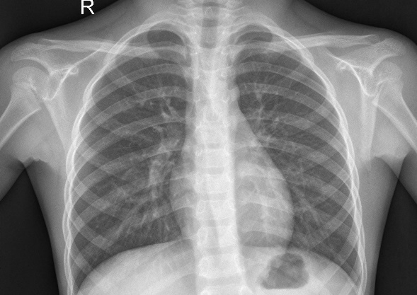

Figure - Normal

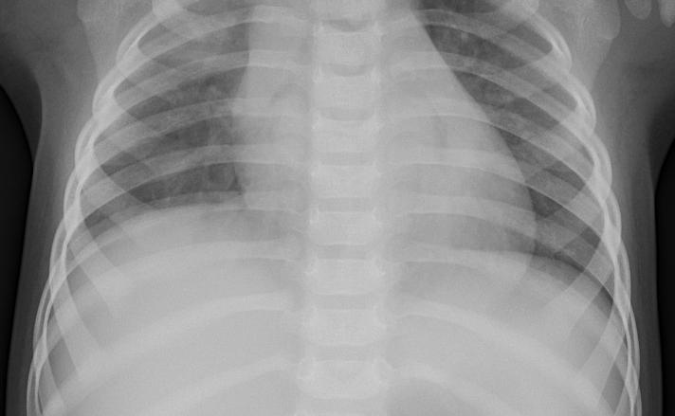

Figure - Pneumonia

# Data Preparation

This part covers the steps of preparing the data. Dataset was already clear. People who made this dataset already removed unclear and low-quality images. [8]

## Convolutional Neural Network

For convolutional neural networks, ImageDataGenerator was used for augmentation. Purpose of image augmentation is to increase the variations of images used for machine learning. It can be done by flipping the image vertically or horizontally, change the rightness, doing different kind of rotations, doing vertical or horizontal shifts and many more. [9] Images were also normalized and transformed so they can fed into our network.

## Recurrent Neural Network

For recurrent neural networks, instead of they were resized normally instead and of course data was edited so it can be feed into recurrent neural network.

## Multi-layer Perception Network

This one is same as before. Resized and edited to fit neural network normally, without ImageDataGenerator.

# Classification Techniques

## Convolutional Neural Network

Convolutional neural networks, shortly CNN, process data over multiple layers of array. They are mostly used for image datasets. Works better with spatial data. Face or normal image recognition can be an example. They are used for classification and regression prediction problems.

Unlike other neural networks, CNN takes two-dimensional array as an input and does not do feature extraction, instead CNN works directly on the images. [10]

There are spatial correlations in the input data. CNN uses these. Every layer of the network connected to input neurons. Input data is handled by these neurons without affecting the outside. This can be seen in the following figure.

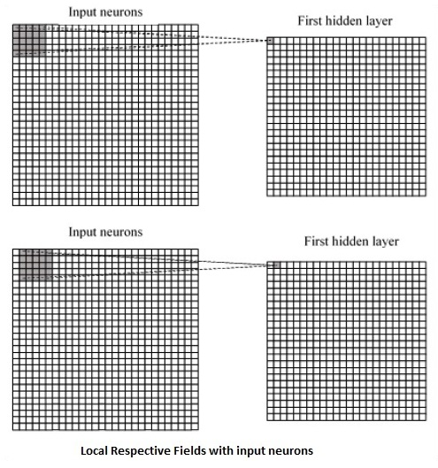

Figure - Local Respective Fields with input neurons

Every connection gets a weight of these neurons, related connection and movement from a layer to different one. Neurons shifts sometimes and we call this convolution.

Shared weight is connection mappings from input layer to feature map. Shared bias is the bias that is included.

This networks also uses layers called pooling layers. They exits just after declaration of CNN. Purpose of these is aiding creating layers according to the old ones.

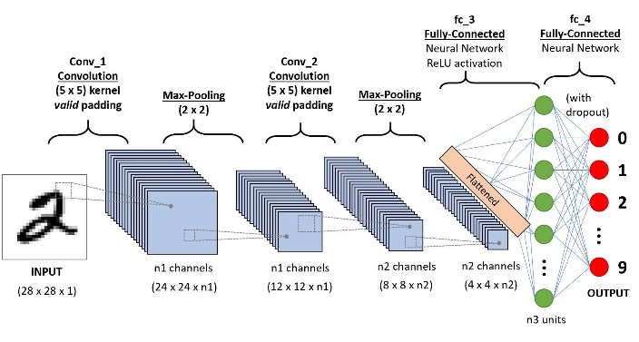

Figure - A CNN sequence to classify handwritten digits

## Recurrent Neural Network

Shortly known as RNNs, Recurrent Neural Networks, made to deal with sequential prediction problems. [11] It is recommended to use them with speech data and test data. Problems for classification and regression prediction can be solved by this too.

When it comes to neural networks, it is expected that each data (inputs and outputs) is self-reliant from other layers. However this network works sequentially.

At first take a example input from our dataset. Network then does computations with using randomly initialized variables. These finishes and now we have a predicted result.

When we compare this expected value to actual result, an error will appear.

Networks goes back using the same path to find the error and adjust variables. It repeats this continuously until network is sure that variables are now correct.

In the end, using these new variables a prediction is made. In the following figure this approach can be seen.

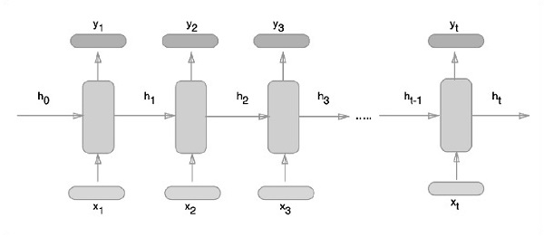

Figure - RNN

## Multi-layer Perception Network

Multi-layer perceptron network also known as feed forward network [12] and vanilla neural network is a basic network. They are classic. These networks made from one or more layers neurons.

At first we put data into input layer and predictions made on the output side. There might be some one or more hidden layers too.

Most of the time MLPs used for tabular datasets. They can also be used to solve classification prediction and regression prediction problems.

Compared to other networks, it very flexible. Mapping from inputs and outputs can be learned by using this network. Because of that this network is good for datasets made from images, time series and documents.

In the following figure it can be seen how it works.

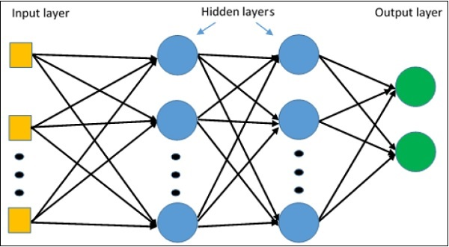

Figure - MLP

# Experiment and Results

## Convolutional Neural Network

For CNN after using ImageDataGenerator, normalizing and shaping data so they can fed into network. Summary, last epoch step, accuracy and loss can be seen in the following figures. We end up with 83.66% accuracy which is pretty good.

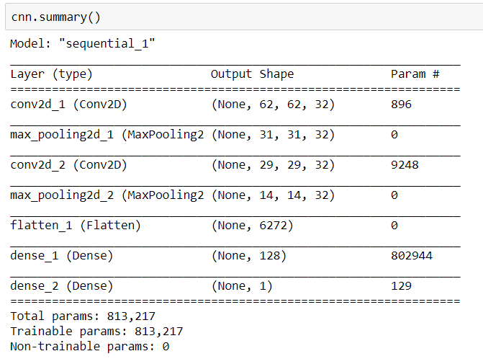

Figure - CNN summary

.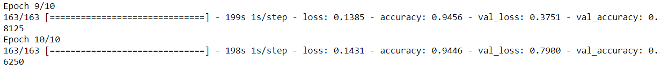

Figure - CNN epoch

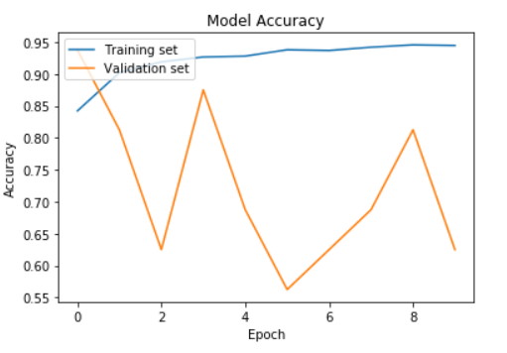

Figure - CNN Accuracy

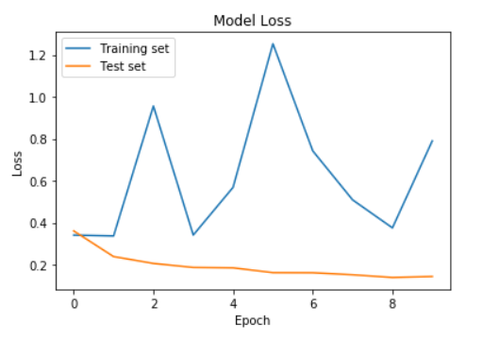

Figure - CNN Loss

## Recurrent Neural Network

#### For RNN after resizing and shaping abbreviation we fed our data to network. Summary, last epoch step, accuracy and loss can be seen in the following figures. Accuracy is %25 which isn’t very good.

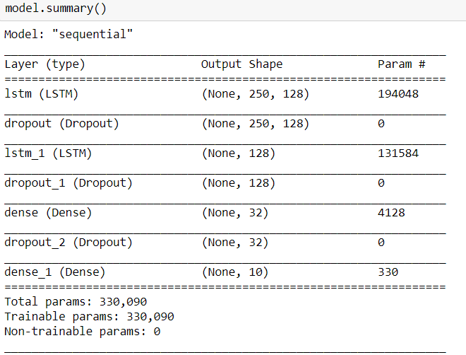

Figure - RNN summary

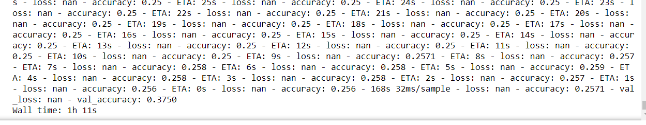

Figure - RNN last epoch

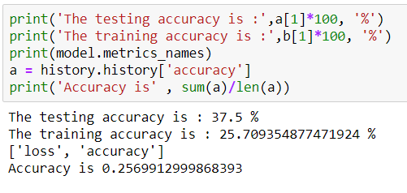

Figure - RNN accuracy

## Multi-layer Perception Network

#### For MLP after resizing and shaping abbreviation we fed our data to network. Summary, last epoch step, accuracy and loss can be seen in the following figures. Accuracy is %99 which is very good.

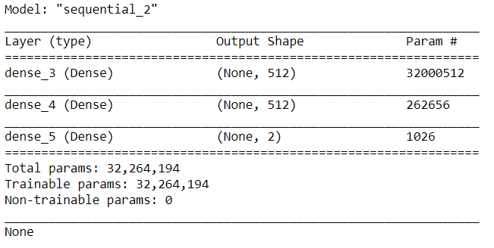

Figure - MLP Summary

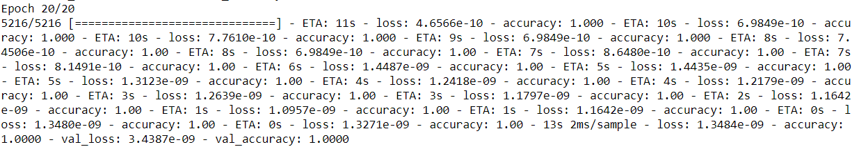

Figure - MLP last epoch

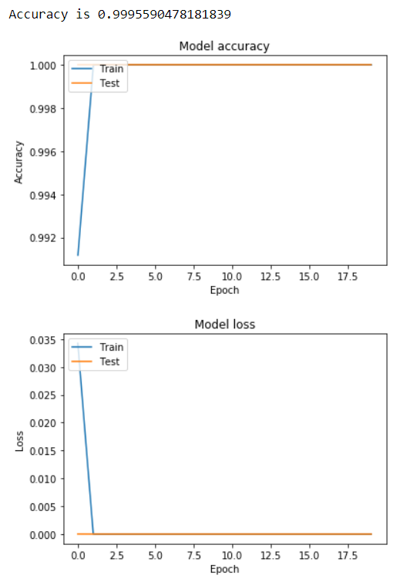

Figure - MLP accuracy and loss

.

# Conclusion

In the end if we compare every result, MLP is best with almost 100% accuracy. I do believe that it might be caused by overfitting too so CNN seems to be the winner here and RNN is the loser with the lowest accuracy.

The reason RNN is lowest is because for both MLP and itself just resizing images is not enough.

Data might be prepared for neural network by the source but still some more preparation could be done by me. Low amount of data is another reason causing this.

# Appendix

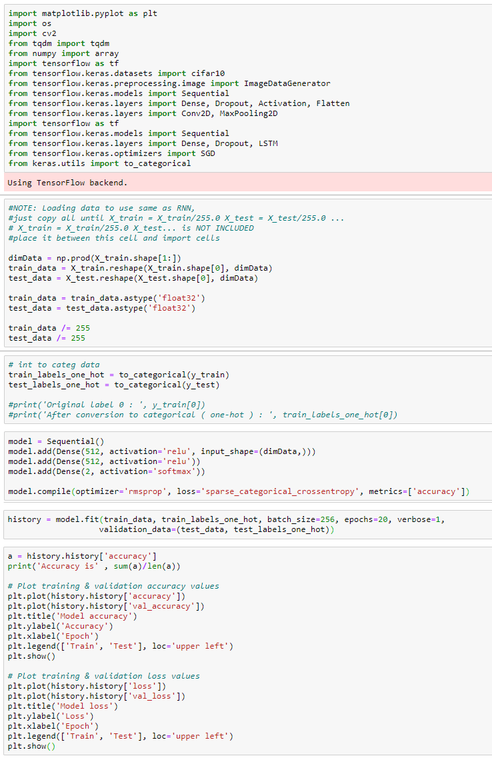

Code – MLP

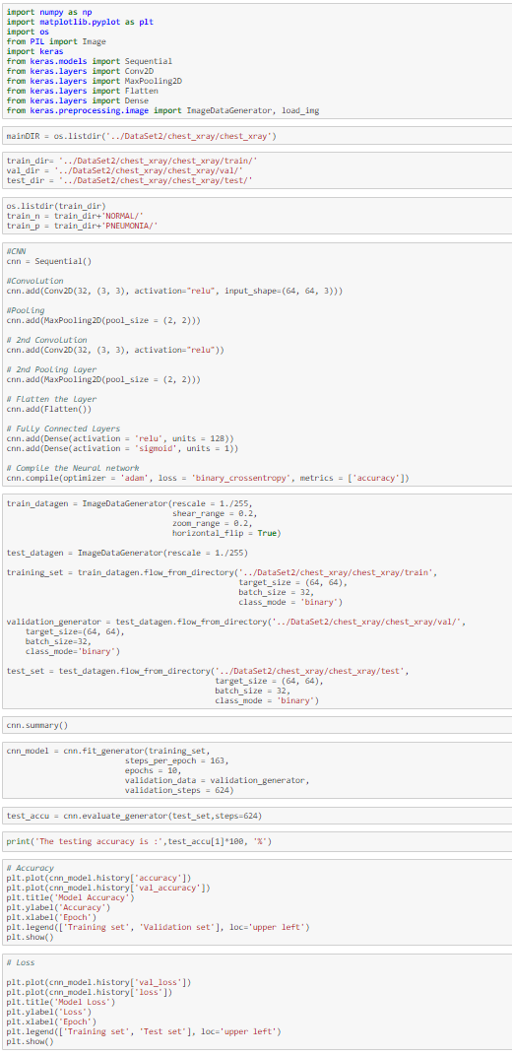

Code – CNN

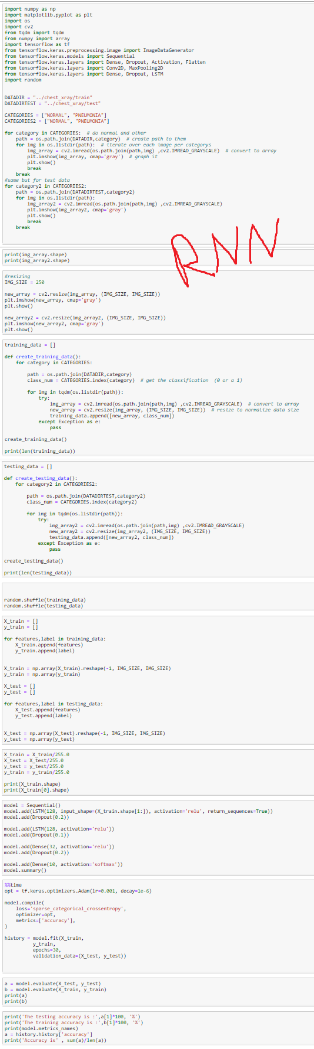

References

|  |  |
| --- | --- |
| [1] | NHS, "Pneumonia," nhs, 30 June 2019. [Online]. Available: https://www.nhs.uk/conditions/pneumonia/. [Accessed November 2019]. |
| [2] | J. I. K. Z. ,. Y. H. M. ,. T. D. ,. D. D. ,. A. B. ,. R. L. B. ,. C. L. ,. K. S. ,. M. P. L. ,. A. Y. N. Pranav Rajpurkar, "CheXNet: Radiologist-Level Pneumonia Detection on Chest X-Rays," 2017. |
| [3] | M. C. Staff, "Pneumonia," mayoclinic, 13 March 2018. [Online]. Available: https://www.mayoclinic.org/diseases-conditions/pneumonia/symptoms-causes/syc-20354204. [Accessed November 2019]. |
| [4] | P. Bree Normandin and Jill Seladi-Schulman, "Everything You Need to Know About Pneumonia," healthline, 20 August 2019. [Online]. Available: https://www.healthline.com/health/pneumonia#is-it-contagious?. [Accessed November 2019]. |
| [5] | J. K. a. E. M. Benjamin Antin, "Detecting Pneumonia in Chest X-Rays with Supervised". |
| [6] | ,. S. G. ,. B. G. ,. S. K. Z. ,. L. R. ,. A. M. a. D. C. Sebastian Gundel, "Learning to recognize Abnormalities in Chest". |
| [7] | M. K. T. M. ,. Y. ,. K. B. I. Ilyas Sirazitdinov, "Deep neural network ensemble for pneumonia localization from a large-scale chest x-ray database," in *Computers & Electrical Engineering*, 2019, pp. 388-399. |
| [8] | P. Mooney, "Chest X-Ray Images (Pneumonia)," 2017. [Online]. Available: https://www.kaggle.com/paultimothymooney/chest-xray-pneumonia. [Accessed November 2019]. |
| [9] | A. Baidya, "How to increase your small image dataset using Keras ImageDataGenerator," 10 September 2018. [Online]. Available: https://medium.com/@arindambaidya168/https-medium-com-arindambaidya168-using-keras-imagedatagenerator-b94a87cdefad. |
| [10] | tutorialspoint, "TensorFlow - Convolutional Neural Networks," [Online]. Available: https://www.tutorialspoint.com/tensorflow/tensorflow_convolutional_neural_networks.htm. [Accessed November 2019]. |
| [11] | J. Brownlee, "When to Use MLP, CNN, and RNN Neural Networks," machinelearningmastery, 19 August 2018. [Online]. Available: https://machinelearningmastery.com/when-to-use-mlp-cnn-and-rnn-neural-networks/. [Accessed November 2019]. |
| [12] | T. v. Schaijk, "Image classification: MLP vs CNN," 12 June 2018. [Online]. Available: https://www.peculiar-coding-endeavours.com/2018/mlp_vs_cnn/. [Accessed November 2019]. |