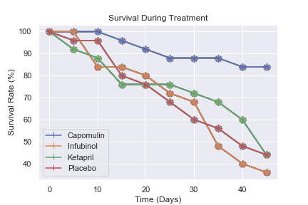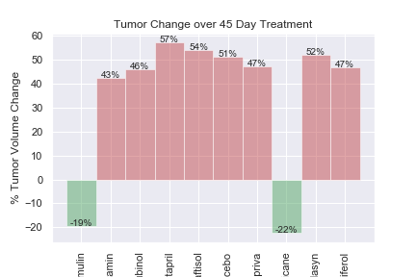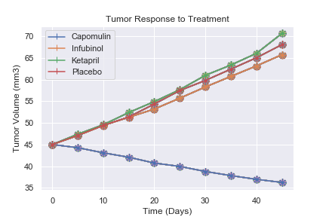

From the results as shown in the graph for the sample of treatments, it is clear that Capomulin seems to be the better treatment as it was the only drug that had a continuous reduction in tumor volume over the trial period. Some might argue that the results for Capomulin need to be excluded as an outlier.

The other 3 treatments in the sample had a steady growth in tumor volume, and even with a small differentiation, Ketapril seems to the least successful treatment.

Of all the treatments that were part of the study, only 2 managed to have a positive change in the tumor volume between the start of the trial period and the end of the trial period. From the graph it is clear that there is a very large difference between these 2 and the other treatments where the volume of change were quite extensive.

### How did the different treatments fair in the changing the tumor volume over the study period

When analyzing the survival rate on the same sample of treatments, Capomulin again performed the best. Although there were some deaths, it happened much later in the study and also not as rapidly over the period as with the other treatments. The other 3 treatments had a similar downwards trend, but of these, deaths on Ketapril slowed down for a good part of the time, and then increased more rapidly after 40 days.

### How did the tumors react to the different treatments?

### Where there a significant survival rate on any of the treatments?

# Below is a short summary of some observations from the Pymaceuticals data analysis

Pymaceuticals write-up