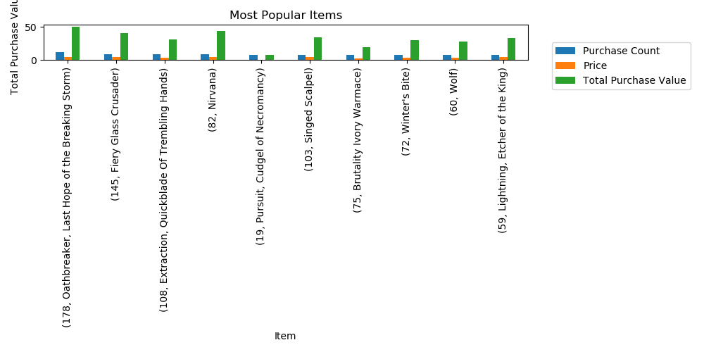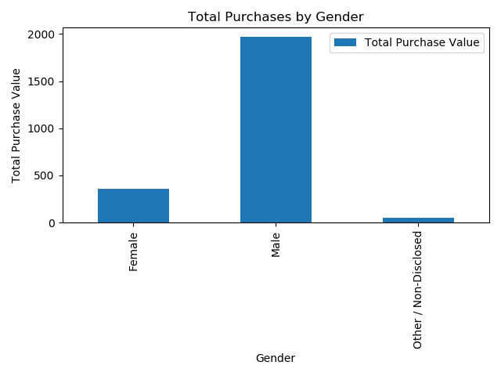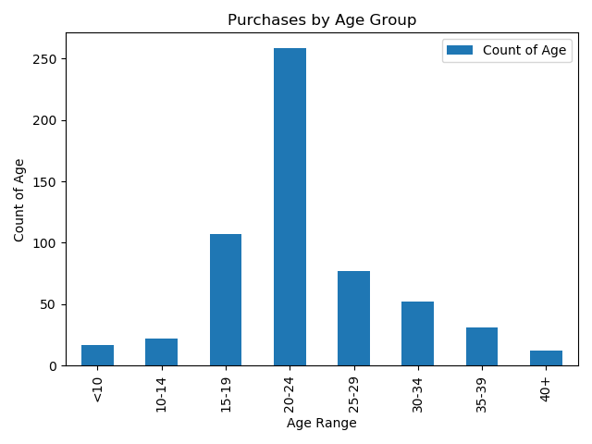

When looking at the relationship between the item price and count of the item purchased for the top 10 most popular items, it is evident that the price of the game does not seem to be the most important factor in the decision to buy the game.

From the analysis it is clear that the 20-24 year age group purchase the most games by far. If we ignore the outliers of ages <10 and ages >40 we still have quite large audience that can benefit from more exposure to our games.

### Is there a lardge gap in terms of gender when looking at who purchase our games?

As generally expected, men purchase more games than women, not only in terms of the amount of games, but also by the total value of their purchases.

In order to reduce this gap, we can look at the type of games most popular for females and attempt to provide more of these types of games for purchase. The business can also attempt to increase their marketing efforts to align more to the preferences of woman.

### How price sensitive are the players?

### What age groups need to be exposed more to our range of games?

# Below is a short summary of some observations from the Heroes of Pymoli data analysis

Heroes of Pymoli write-up