**Design**

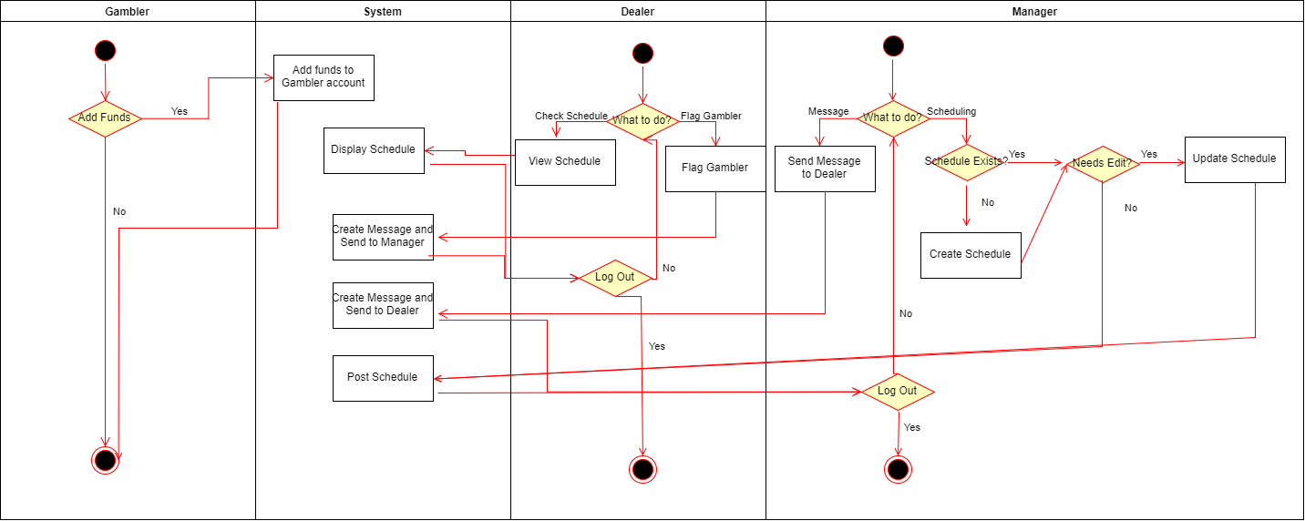

ManageMessages

CreateMessage()

{

instantiate message

account receiver = receiver of the message

add new message to receiver's inbox

}

ManageLogin

CreateAccount(username, password, type)

{

if username is in use

return false

write username + password + type to login file

return true

}

ValidateLoginRequest(username, password)

{

if username is not valid

return false

if username is in file

if password doesnt match

return false

if password matches

if user is gambler

go to gambler page

return true

if user is dealer

go to dealer page

return true

if user is manager

go to manager page

return true

}

ManageSchedule

ViewSchedule()

{

show schedule panel

}

CreateSchedule()

{

instantiate new schedule

}

ManageFunds

AddFunds(funds amount)

{

if ( bank funds - funds amount > 0 )

current funds += funds amount

return true

return false

}

RemoveFunds(funds amount)

{

if ( current funds - funds amount > 0 )

current funds -= funds amount

return true

return false

}