Class Diagram v1

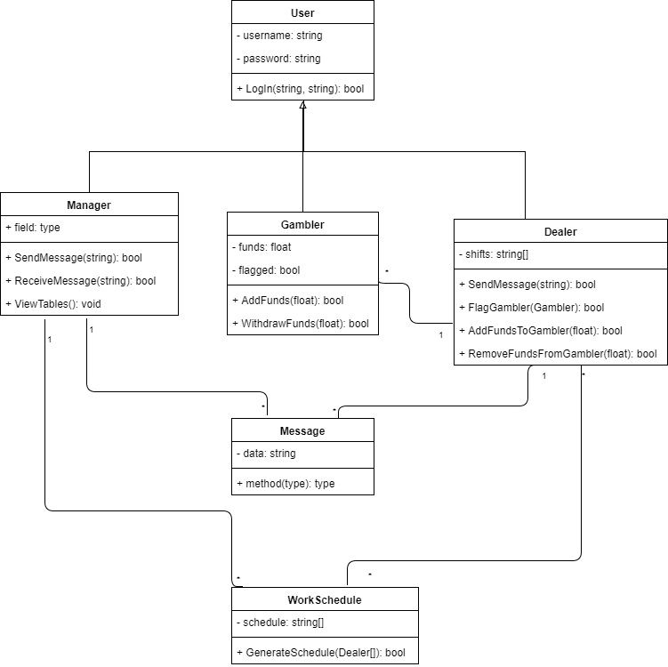

CRC Cards

|  |  |
| --- | --- |
| User | |
| * Maintains information about the user * Manages username and password | * Manager * Gambler * Dealer |

|  |  |
| --- | --- |
| Manager | |
| * Maintains information about the manager * Sends messages to active dealers * Receives messages from active dealers * Views information about active tables | * Message * Dealer * User * WorkSchedule |

|  |  |
| --- | --- |
| Gambler | |
| * Maintains information about the gambler * Adds funds to the Gambler’s account * Withdraws funds from the Gambler’s account | * User * Dealer |

|  |  |
| --- | --- |
| Dealer | |
| * Maintains information about the dealer * Sends messages to the manager * Receives messages from the manager * Adds funds to the gambler’s account * Flags gamblers * Removes funds from the gambler’s account | * User * Gambler * Message * WorkSchedule |

|  |  |
| --- | --- |
| Message | |
| * Maintains information about a message | * Dealer * Manager |

|  |  |
| --- | --- |
| WorkSchedule | |
| * Maintains information about a worker’s schedule * Generates schedules for workers | * Manager * Dealer |

Class Diagram v2

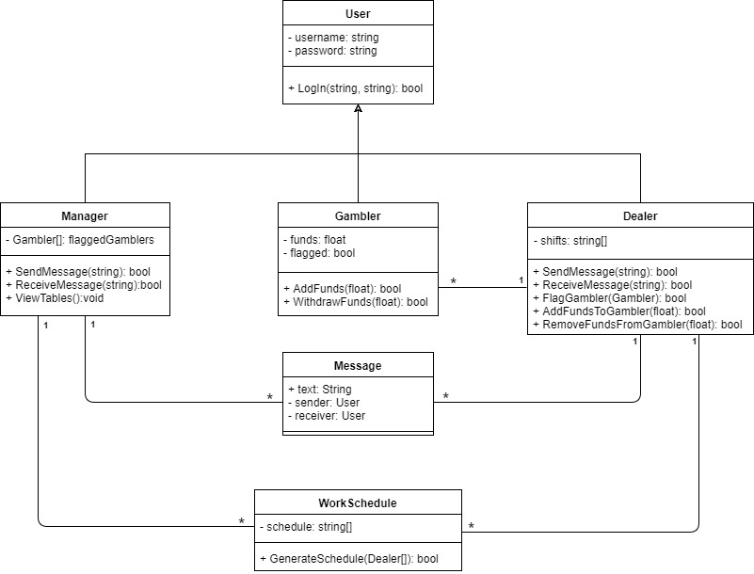

Statechart: Message Class

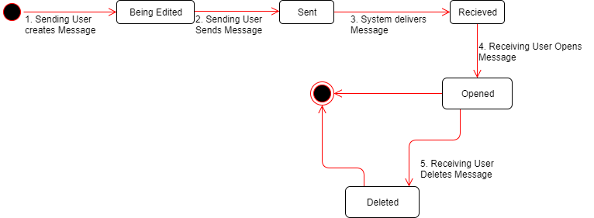

Statechart: WorkSchedule Class

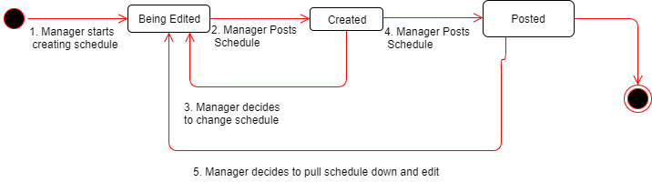

Language Choice

We want to implement our system in C++ using Visual Studio in the .NET framework. We chose to do this because each of us has had at least 2 courses with experience in the language so it would not be that hard to code in the language. Plus, C++ is a powerful OO language that has a framework that is easy to implement the type of system we will be creating.

Workload

We started by figuring out the entity classes together and then arranging them in a class diagram. Then we discussed what data and methods the classes have and assigned them accordingly. After that, Andrew and Tanner worked on CRC cards while Henry, Sully, and Chris created the State Charts. Then Tanner revised the class diagram while the rest of us finished the remaining documentation like this paragraph here and the paragraph about our platform choice.