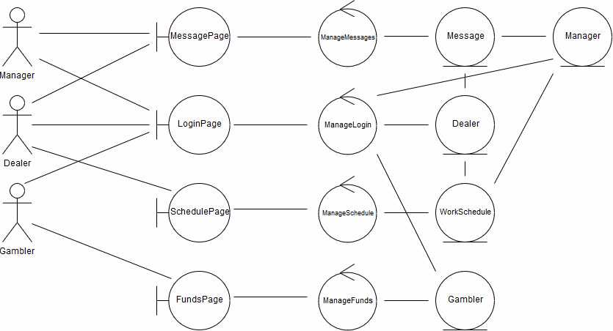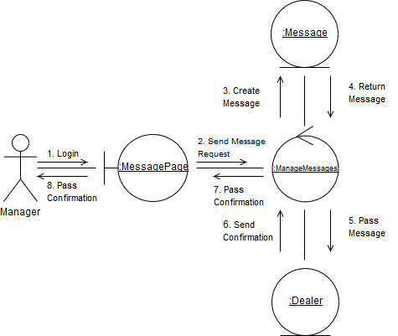

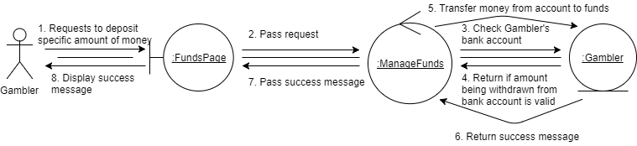

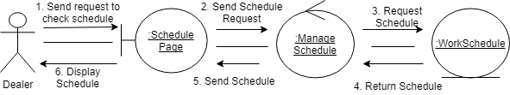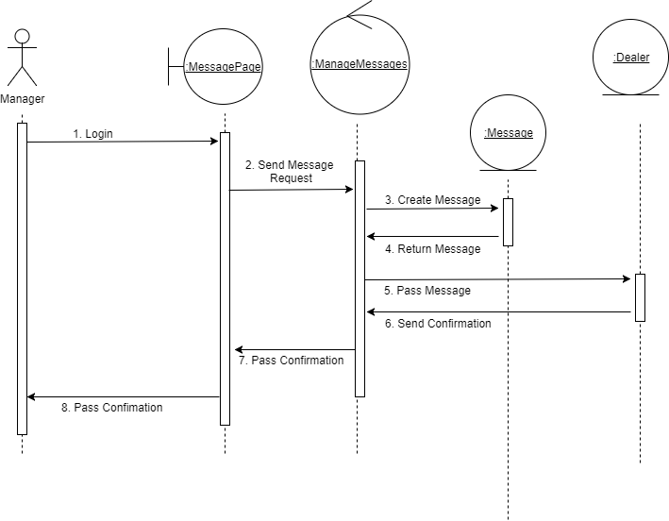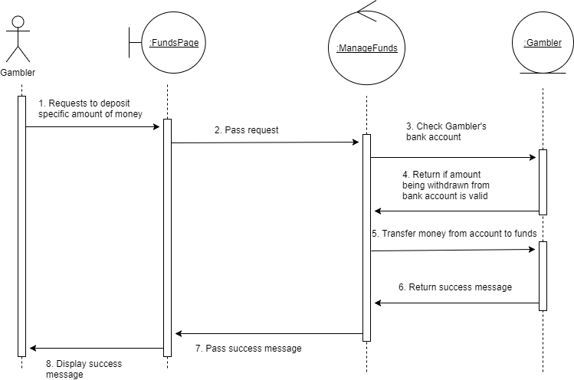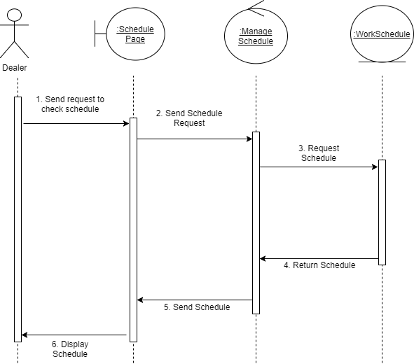

Teamwork Analysis

We have noticed that our group tends to get off track very easily. We were going from work related conversations to casual conversations often and easily. To fix this issue, we looked at how we spent our time during of our meetings. We noticed that our group was spending large amounts of unscheduled break time. So, we decided that one person would make sure that we accomplished certain things at specific times during a meeting. This made sure that we would become more focused and on track.

Work Distribution

For this specific artifact we divided work between analysis and implementation. Sully and Andrew started out with Implementation while everybody else worked on the robustness diagram and the first collaboration diagram. The next time we met we all worked on the remaining diagrams and went over the implementation that Sully and Andrew did briefly.

|  |  |  |
| --- | --- | --- |
| Time Log | 9-Nov | 13-Nov |
| Team Member |  |  |
| Henry Felerski | 3:00-4:00 | 2:00 - 4:45 |
| Andrew Gantenbein | 3:00-4:00 | 2:00 - 3:45 |
| Chris Reeves | 3:00-4:00 | 2:45-4:45 |
| Sullivan Caine | 3:00-4:00 | 3:00 - 4:45 |
| Tanner Hoerter | 2:45-4:00 | 3:50 - 4:45 |