|  |  |
| --- | --- |
| Name | Deposit Funds (created by the team) |
| Actors | Gambler |
| Trigger | Gambler wishes to deposit funds |
| Preconditions | Gambler has logged in |
| Post conditions | Gambler has deposited funds or Gambler has not deposited funds |
| Success Scenario | 1. Gambler clicks to deposit funds 2. System prompts for user input for amount to be deposited 3. Gambler specifies amount of money to be deposited 4. System withdraws funds from bank user’s account 5. System adds withdrawn funds to user’s casino account |
| Alternative Workflows | 4.1. The withdraw fail due to invalid bank account balance |

|  |  |
| --- | --- |
| Name | Withdraw Funds (created by Andrew) |
| Actors | Gambler |
| Trigger | Gambler wishes to withdraw funds |
| Preconditions | Gambler has logged in and has funds in their account |
| Post conditions | Gambler has withdrawn funds from their balance or the system denies their withdrawal request |
| Success Scenario | 1. Gambler clicks to withdraw funds 2. System prompts for user input for amount to be withdrawn 3. Gambler specifies amount of money to be with withdrawn 4. System transfers the amount of money to the user's bank account |
| Alternative Workflows | 4.1. The withdraw failed because the amount specified Is too large.  4.2. The withdraw fails because the gambler cancels the request. |

|  |  |
| --- | --- |
| Name | View Funds (created by Andrew) |
| Actors | Gambler |
| Trigger | Gambler wishes to view funds |
| Preconditions | Gambler has logged in |
| Post conditions | Gambler views the amount of funds that they have |
| Success Scenario | 1. Gambler clicks to view funds 2. System shows the amount of funds that they currently have |
| Alternative Workflows |  |

|  |  |
| --- | --- |
| Name | Organize Employee Schedule (created by Sully) |
| Actors | Manager |
| Trigger | Manager wishes to organize the employee schedule |
| Preconditions | Manager has logged in |
| Post conditions | Employee schedule has successfully changed or error occurs due to bilocation of employees |
| Success Scenario | 1. Manager clicks to organize schedule 2. System prompts for manager input 3. Manager enters desired schedule 4. System updates the official employee schedule |
| Alternative Workflows | 3.1. Manager cancels the process  4.1. Systems displays an error due to employee bilocation |

|  |  |
| --- | --- |
| Name | Create Account (created by Sully) |
| Actors | Gambler, Manager |
| Trigger | User clicks on create account |
| Preconditions | Manager is logged in or user wishing to become gambler is not logged in |
| Post conditions | Account is created or error occurs because an account was already created with the specified username |
| Success Scenario | 1. User clicks create account 2. System prompts user for input regarding username and password 3. User enters necessary information 4. Account is created |
| Alternative Workflows | 2.1 User cancels account creation  3.1 A user enters a username that belongs to an existing account, creation fails  3.2 User does not enter information |

|  |  |
| --- | --- |
| Name | Log In (created by Tanner) |
| Actors | Dealer, Gambler, Manager |
| Trigger | User wishes to log into the system |
| Preconditions | User has valid login credentials |
| Post conditions | User has logged in successfully or user enters invalid login credentials |
| Success Scenario | 1. System prompts User for credentials 2. User enters credentials and clicks log in 3. System displays account screen |
| Alternative Workflows | 2.1. User does not have account and login fails |

|  |  |
| --- | --- |
| Name | Check Work Schedule (created by Tanner) |
| Actors | Dealer |
| Trigger | Dealer wishes to see their work schedule |
| Preconditions | Dealer is logged in to their account |
| Post conditions | Dealer views their work schedule |
| Success Scenario | 1. Dealer clicks to view their work schedule 2. System displays work schedule |
| Alternative Workflows |  |

|  |  |
| --- | --- |
| Name | Report Suspicious Activity (created by Henry) |
| Actors | Dealer, Manager |
| Trigger | Dealer views behavior or trends that may constitute cheating |
| Preconditions | Dealer is assigned to the table according to the schedule and has logged in |
| Post conditions | Manager is alerted to issue |
| Success Scenario | 1. Dealer clicks on option to flag a specific Gambler 2. System notifies Manager of the information |
| Alternative Workflows |  |

|  |  |
| --- | --- |
| Name | Message Dealers (created by Henry) |
| Actors | Manager, Dealer |
| Trigger | Manager wishes to tell Dealer something |
| Preconditions | Manager and Dealer have logged in |
| Post conditions | Message goes through to Dealer |
| Success Scenario | 1. Manager clicks to display Send Message Dialog 2. Manager specifies which Dealer(s) will receive the message 3. Manager specifies message to be sent 4. Manager clicks send 5. Dealer(s) receive the message |
| Alternative Workflows |  |

|  |  |
| --- | --- |
| Name | Track Gambler Winnings (created by Chris) |
| Actors | Manager |
| Trigger | Manager wants to see a gambler’s winnings |
| Preconditions | Manager is logged in and Gambler has an account |
| Post conditions | Manager sees the winnings |
| Success Scenario | 1. Manager wishes to see gambler’s winning 2. Manager selects the gambler 3. Manager clicks show winnings 4. Gamblers winnings are displayed |
| Alternative Workflows |  |

|  |  |
| --- | --- |
| Name | View Tables/Machines (created by Chris) |
| Actors | Manager |
| Trigger | Manager wants to look at the tables and/or machines |
| Preconditions | Manager has logged in |
| Post conditions | System displays the tables/machines |
| Success Scenario | * 1. Manager clicks “Show Tables”   2. System displays the tables and machines |
| Alternative Workflows |  |

**Initial Use Case Diagram**

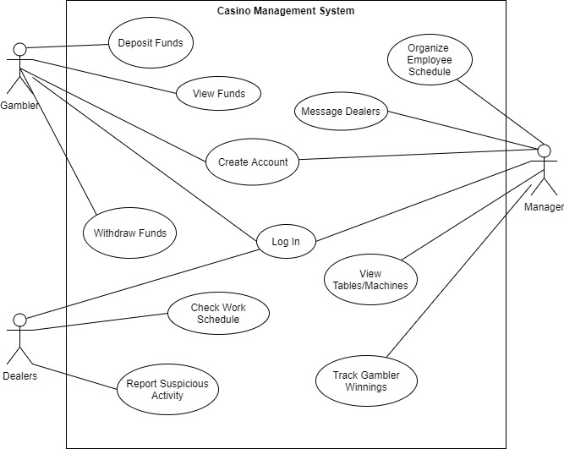

**Revised Use Case Diagram**

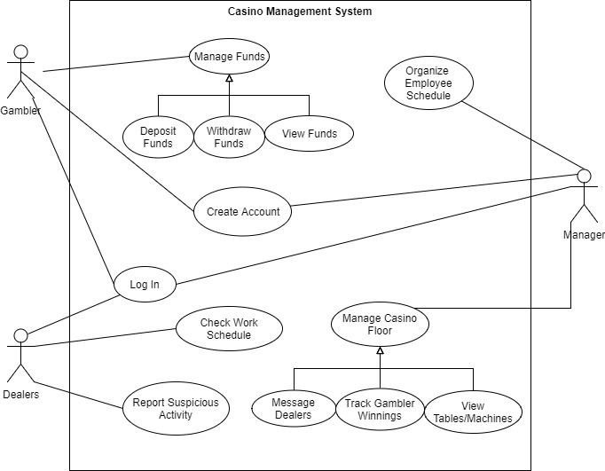

**Workload Descriptions**

When we were working on our use case diagrams, we brainstormed ideas as a team as to what the use cases that we needed for our project would be. Then, we added a few more features to the second version of the use case diagram to get a better description of the functionality of our system. Once the diagrams were done, we split up use case specifications evenly so that we could get them done more efficiently on our own time. Lastly, we came together as a group to review the specifications we did on our own.