Radiomics-Based Classification of Brain Tumor Subtypes Using Machine Learning

Group 1: Austin Cherian, Natalie Ellis, Fadwa Elfeituri, Stephen Payne

Health Informatics & Data Science, Georgetown University

HIDS 7009: Imaging Informatics

Introduction
Radiomics enables the extraction of high-dimensional features from medical imaging, offering a powerful approach to uncover tumor characteristics not easily visible to the human eye. In this project, we aimed to classify brain cancer subtypes using quantitative radiomic features derived from T1-weighted MRI scans. Our work leveraged two datasets: the TCGA dataset, which included precomputed radiomic features and clinical labels, and the REMBRANDT dataset, which contained MRI scans from 64 brain tumor patients with corresponding segmentation masks. The classification task focused on three tumor subtypes of clinical relevance—Glioblastoma Multiforme (GBM), Oligodendroglioma, and Astrocytoma—with the ultimate goal of building robust machine learning models to distinguish between these groups. To tackle this multi-class classification problem, we implemented a One-vs-Rest (OvR) modeling approach.

The One-vs-Rest strategy is a decomposition method that trains a separate binary classifier for each class, allowing each model to learn to distinguish one specific tumor type from the rest. During prediction, each classifier outputs a probability score, and the final class label is selected based on the highest probability across all models [9]. This modular approach allowed us to tailor the choice of algorithm to the characteristics of each tumor subtype and interpret feature importance independently per class. With this framework in place, we began by preparing the datasets for downstream use by extracting radiomic features from each patient’s MRI scan.

Methodology
Step 1. Feature Extraction from REMBRANDT MRI Data
We first extracted radiomic features from the REMBRANDT brain cancer dataset using the PyRadiomics library. The dataset consisted of pre-segmented T1-weighted MRI scans for 64 patients, where segmentations were generated using the GlistrBoost algorithm. We implemented our extraction pipeline in Google Colab, mounting the Google Drive directory containing patient subfolders. For each patient, the pipeline identified T1-contrast-enhanced MRI files (*_t1ce_LPS_rSRI.nii.gz) and the corresponding segmentation labels (*_GlistrBoost_out-labels.nii). We initialized a RadiomicsFeatureExtractor and iterated through the dataset, extracting features for each valid image-label pair. The resulting features were stored along with a patient identifier (derived from the folder name) and aggregated into a pandas DataFrame. To facilitate downstream modeling, the final feature matrix was saved as a CSV file. This structured dataset served as the basis for test-time inference in the final model evaluation phase.

Step 2. Model Training Using TCGA
To address the multi-class classification task, we implemented a One-vs-Rest (OvR) strategy by developing three separate binary classification pipelines, one for each tumor subtype: GBM, Oligodendroglioma, and Astrocytoma. Each pipeline included data preprocessing, model training, hyperparameter tuning, and evaluation using cross-validation. After merging the TCGA radiomic features with clinical labels, we filtered the dataset to include only the three target tumor types and removed any rows containing missing or non-numeric values. Diagnostic metadata columns were also excluded, and the remaining features were standardized using z-score normalization.
For the GBM classifier, we trained an XGBoost model and optimized its hyperparameters using grid search over parameters such as learning rate, tree depth, and the number of estimators. The Oligodendroglioma pipeline used a linear Support Vector Machine (SVM), also tuned using grid search. For Astrocytoma, we used a Gradient Boosting classifier and applied recursive feature elimination with cross-validation (RFECV) to identify informative features prior to tuning. Rather than splitting the TCGA dataset into separate training and testing sets, we relied exclusively on five-fold stratified cross-validation to train and evaluate each model. Classifier performance was assessed based on F1 score, and the best-performing model for each tumor subtype was retained for integration into the final multi-class prediction system.
Step 3. Preparing the REMBRANDT Dataset for Model Testing
After training the One-vs-Rest classifiers using the TCGA dataset, we prepared the REMBRANDT dataset for use as an independent test set. This involved loading the radiomic features previously extracted from the T1-weighted MRI scans in Step 1 and aligning them with the preprocessing steps used during model training. Specifically, we removed non-numeric columns and diagnostic metadata, dropped any rows with missing values, and ensured that the feature columns matched the TCGA feature set exactly in both name and order. We then applied the same StandardScaler instance used during training to standardize the REMBRANDT features. Clinical ground truth labels for tumor subtype were loaded from a separate file and merged with the radiomics data by patient ID. Only samples with one of the three target tumor types, GBM, Oligodendroglioma, or Astrocytoma, were retained. This fully cleaned and aligned dataset served as the input for final evaluation of the trained classification models.

Step 4. Model Testing and Prediction on REMBRANDT Dataset
With the REMBRANDT dataset prepared, we applied the trained One-vs-Rest classifiers to generate tumor subtype predictions. Each of the three models was applied in parallel to the standardized REMBRANDT feature matrix, producing class probability scores for each patient. For every sample, we selected the tumor type associated with the highest probability score among the three binary classifiers as the final predicted label. This approach reflects the standard inference strategy in One-vs-Rest classification, where each binary model competes to assign its class label based on prediction confidence. We then compared the predicted labels to the ground truth diagnoses and evaluated model performance using accuracy, precision, recall, F1 score, and a confusion matrix. Additional visualizations, including ROC curves and feature importance plots, were generated to support interpretation of results.

Additional Step. Unified Training and Evaluation on Combined Dataset
To extend our analysis and assess model generalizability, we combined the TCGA and REMBRANDT datasets into a single unified dataset for training and evaluation. After aligning feature columns and standardizing label formats, we removed non-numeric and diagnostic metadata columns, handled missing values, and applied z-score normalization to the feature matrix. We then filtered the combined dataset to include only the three target tumor subtypes and split the data into stratified training and test sets. Using a One-vs-Rest strategy, we trained three binary classifiers: XGBoost for GBM, Linear SVM for Oligodendroglioma, and Gradient Boosting for Astrocytoma. Each model was tuned using grid search and evaluated using cross-validation. The final multiclass prediction system selected the label with the highest probability score across the three models. Performance was assessed using classification metrics, confusion matrices, and ROC curves. Additionally, we computed and visualized class-specific feature importances to support model interpretability.

Results

Step 2. Model Training Using TCGA
To establish baseline classifiers, we trained separate binary models for each tumor subtype using TCGA radiomic and clinical data. XGBoost was selected for GBM, Support Vector Machine (SVM) with a linear kernel for Oligodendroglioma, and Gradient Boosting for Astrocytoma based on cross-validation performance. The training performance metrics are summarized in Table 1, and the most important radiomic features driving each model's predictions are listed in Table 2.

Classifier | Accuracy (mean ± std) | Precision (mean ± std) | Recall (mean ± std) | F1 Score (mean ± std)
GBM (XGBoost) | 0.812 ± 0.036 | 0.833 ± 0.040 | 0.911 ± 0.059 | 0.868 ± 0.028
Oligodendroglioma (SVM) | 0.791 ± 0.072 | 0.472 ± 0.088 | 0.587 ± 0.232 | 0.489 ± 0.067
Astrocytoma (Gradient Boosting) | 0.866 ± 0.048 | 0.519 ± 0.326 | 0.370 ± 0.218 | 0.414 ± 0.234
Table 1. Cross-Validation Metrics for Base Classifiers.
XGBoost achieved the highest F1 score (0.868 ± 0.028) for GBM, indicating strong performance in capturing the dominant class. Astrocytoma's Gradient Boosting classifier achieved the highest accuracy (0.866 ± 0.048), but with lower recall (0.370 ± 0.218). The Oligodendroglioma SVM classifier performed moderately across all metrics. The F1 scores for each classifier, in order of performance, were: GBM (0.868), Oligodendroglioma (0.489), and Astrocytoma (0.414).
Rank | GBM | Imp. | OLIGODENDROGLIOMA | Imp. | ASTROCYTOMA | Imp.
1 | original_shape_SurfaceVolumeRatio | 0.0615 | original_glszm_SizeZoneNonUniformityNormalized | 1.0321 | original_shape_SurfaceVolumeRatio | 0.2343
2 | original_glcm_Imc2 | 0.0572 | original_glszm_SmallAreaEmphasis | 0.8529 | original_shape_SurfaceArea | 0.1274
3 | original_glcm_Correlation | 0.0520 | original_glcm_Imc2 | 0.7889 | original_glcm_ClusterShade | 0.1121
4 | original_glrlm_GrayLevelNonUniformity | 0.0510 | original_glrlm_RunLengthNonUniformity | 0.7533 | original_shape_LeastAxisLength | 0.0838
5 | original_firstorder_InterquartileRange | 0.0480 | original_glszm_LargeAreaHigGrayLevelEmphasis | 0.7240 | original_firstorder_Kurtosis | 0.0559
6 | original_glcm_Contrast | 0.0454 | original_glrlm_ShortRunEmphasis | 0.7140 | original_firstorder_Minimum | 0.0428
7 | original_shape_MeshVolume | 0.0435 | original_glcm_Idmn | 0.6876 | original_glcm_MCC | 0.0385
8 | original_glrlm_RunLengthNonUniformity | 0.0382 | original_shape_SurfaceArea | 0.6559 | original_glrlm_RunEntropy | 0.0318
9 | original_glcm_DifferenceVariance | 0.0300 | original_shape_Maximum2DDiameterRow | 0.6432 | original_glrlm_GrayLevelNonUniformity | 0.0312
10 | original_shape_LeastAxisLength | 0.0258 | original_glrlm_RunLengthNonUniformityNormalized | 0.6351 | original_ngtdm_Complexity | 0.0267
Table 2. Top 10 Features by Importance per Classifier.

For GBM, surface and shape-related features, such as original_shape_SurfaceVolumeRatio and original_shape_MeshVolume, dominated the model, implying morphological differences are predictive. The Oligodendroglioma classifier relied heavily on zone- and run-length texture features like SizeZoneNonUniformityNormalized and RunLengthNonUniformity, possibly capturing finer texture patterns. Astrocytoma's top features also included SurfaceVolumeRatio and SurfaceArea, but added first-order statistical metrics such as Kurtosis and Minimum, indicating both shape and intensity-based radiomic features were informative.

Step 4. Model Testing and Prediction on REMBRANDT Dataset
To assess generalizability, the trained one-vs-rest classifiers were evaluated on the held-out REMBRANDT dataset. Performance was assessed using precision, recall (sensitivity), specificity, and F1 score for each tumor subtype. As shown in Table 3 and Figures 1 and 2, Astrocytoma predictions demonstrated the highest F1 score (0.54) and recall (0.61), suggesting the classifier generalized moderately well to this class. GBM predictions achieved a precision of 0.35 and a recall of 0.44, while Oligodendroglioma was poorly predicted, with zero recall and precision. The overall test accuracy was 0.43. ROC analysis revealed AUCs of 0.67 (Oligodendroglioma), 0.50 (Astrocytoma), and 0.48 (GBM), further emphasizing the challenge of distinguishing these subtypes in external data.

Class | Precision | Recall (Sensitivity) | Specificity | F1 Score | Support
GBM | 0.35 | 0.44 | 0.625 | 0.39 | 18
OLIGODENDROGLIOMA | 0.00 | 0.00 | 1.000 | 0.00 | 12
ASTROCYTOMA | 0.49 | 0.61 | 0.400 | 0.54 | 28
Macro Avg | 0.28 | 0.35 | — | 0.31 | 58
Weighted Avg | 0.34 | 0.43 | — | 0.38 | 58
Accuracy | — | — | — | 0.43 | 58
Table 3. Test (Rembrandt) Performance Metrics (One-vs-Rest Classification)

This table presents the performance metrics of the one-vs-rest classifiers tested exclusively on the REMBRANDT dataset after being trained on TCGA data. The overall accuracy on the test set was 0.43, and the weighted average F1-score, which accounts for class imbalance, was 0.38. Among the three tumor classes, Astrocytoma had the highest individual F1-score (0.54) and recall (0.61), while Oligodendroglioma was never correctly predicted, resulting in an F1-score of 0.00 despite a perfect specificity (1.00). The macro average F1-score across all classes, regardless of support, was 0.31, highlighting the uneven performance across tumor subtypes.

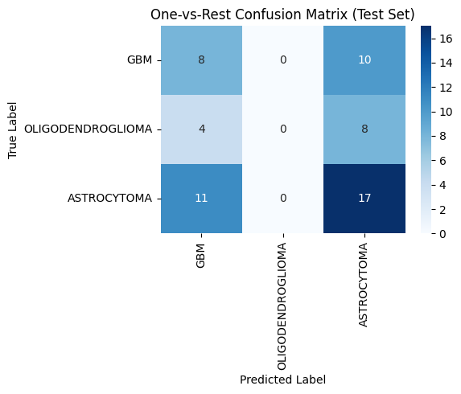
Figure 1. One-vs-Rest Confusion Matrix on Test (Rembrandt) Set

Figure 1 presents the confusion matrix for the one-vs-rest classifier on the Rembrandt test set. The model most accurately identified Astrocytoma cases (17/28), while misclassifying several GBM (10/18) and OLIGODENDROGLIOMA (4/12) cases as Astrocytoma. Notably, no samples were predicted as OLIGODENDROGLIOMA, indicating a major recall failure for that class.
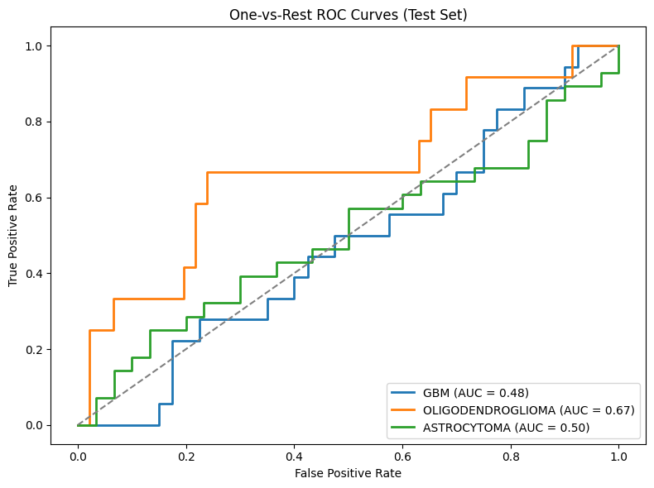
Figure 2. One-vs-Rest Confusion Matrix on Test (Rembrandt) Set

Figure 2 displays the ROC curves for each class in the one-vs-rest classification on the Rembrandt test set. Oligodendroglioma achieved the highest AUC (0.67), indicating that the classifier assigned relatively higher probabilities to true positives compared to negatives. However, as seen in the confusion matrix (Figure 1), it was never the top predicted class for any sample. This discrepancy suggests that while the model ranked Oligodendroglioma cases correctly in terms of probability, those probabilities were still not high enough relative to GBM or Astrocytoma to cross the decision threshold. In other words, Oligodendroglioma was often the second-highest probability class but rarely the maximum, highlighting a limitation in how the one-vs-rest strategy handles imbalanced or overlapping decision boundaries.

Additional Step. Unified Training and Evaluation on Combined Dataset
To improve generalizability and robustness across cohorts, we unified the training and evaluation process using a combined dataset comprising both TCGA and REMBRANDT samples. This approach aimed to mitigate cohort-specific biases and better reflect the performance of models in diverse real-world conditions. Below, we present updated confusion matrices, ROC curves, classification metrics, and feature importance rankings resulting from this combined training pipeline.

Class | Precision | Recall (Sensitivity) | Specificity | F1-Score | Support
GBM | 0.67 | 0.83 | 0.444 | 0.74 | 24
Oligodendroglioma | 0.50 | 0.12 | 0.971 | 0.20 | 8
Astrocytoma | 0.40 | 0.40 | 0.812 | 0.40 | 10
Overall Accuracy | — | — | — | 0.60 | 42
Macro Avg | 0.52 | 0.45 | — | 0.45 | 42
Weighted Avg | 0.57 | 0.60 | — | 0.56 | 42
Table 4. Classification Performance on Combined Dataset

This table summarizes the classification performance on the combined test dataset, highlighting the model’s overall F1-score of 0.60. Among individual classes, GBM achieved the highest F1-score of 0.74 with strong recall (0.83), while Oligodendroglioma performed the worst, with an F1-score of 0.20 due to very low recall (0.12), despite high specificity (0.971). Astrocytoma showed moderate performance, with balanced precision and recall, resulting in an F1-score of 0.40. The macro-averaged F1-score was 0.45, indicating variability across classes, whereas the weighted average F1-score, accounting for class imbalance, was 0.56. These metrics suggest the model was most effective at identifying GBM cases but struggled to reliably detect Oligodendroglioma.

Rank | GBM | Imp. | Oligodendroglioma | Imp. | Astrocytoma | Imp.
1 | original_ngtdm_Coarseness | 0.0925 | original_glrlm_RunLengthNonUniformity | 2.885 | original_shape_SurfaceVolumeRatio | 0.1401
2 | original_shape_MinorAxisLength | 0.0640 | original_glszm_ZonePercentage | 2.817 | original_firstorder_Skewness | 0.0957
3 | original_shape_Sphericity | 0.0397 | original_glszm_SizeZoneNonUniformityNormalized | 2.776 | original_firstorder_Kurtosis | 0.0795
4 | original_shape_SurfaceVolumeRatio | 0.0392 | original_glcm_MCC | 2.610 | original_glcm_ClusterShade | 0.0621
5 | original_shape_Maximum2DDiameterColumn | 0.0357 | original_glszm_LowGrayLevelZoneEmphasis | 2.546 | original_glszm_LargeAreaHighGrayLevelEmphasis | 0.0446
6 | original_glrlm_LowGrayLevelRunEmphasis | 0.0333 | original_glcm_Imc2 | 2.389 | original_shape_Sphericity | 0.0437
7 | original_glcm_ClusterShade | 0.0252 | original_shape_MajorAxisLength | 2.343 | original_glszm_ZoneEntropy | 0.0396
8 | original_gldm_SmallDependenceEmphasis | 0.0228 | original_ngtdm_Contrast | 1.947 | original_shape_Flatness | 0.0321
9 | original_glszm_ZoneEntropy | 0.0227 | original_ngtdm_Busyness | 1.693 | original_glcm_Imc1 | 0.0310
10 | original_glcm_MaximumProbability | 0.0222 | original_glszm_SizeZoneNonUniformity | 1.688 | original_shape_Elongation | 0.0281
Table 5. Alternate Top Features from Combined Training

Table 5 lists the top 10 most important features for each binary classifier trained on the combined dataset. GBM's most predictive feature was original_ngtdm_Coarseness, while Oligodendroglioma heavily relied on texture features such as original_glrlm_RunLengthNonUniformity. Astrocytoma’s model emphasized morphological features like original_shape_SurfaceVolumeRatio and first-order statistics like skewness. These distinctions suggest each tumor type exhibits unique radiomic signatures.

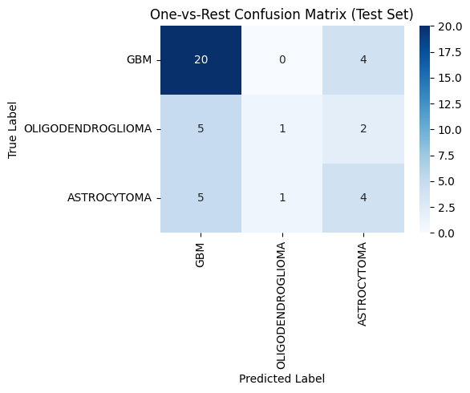
Figure 3. One-vs-Rest Confusion Matrix on Combined Test Set

Figure 3 shows the One-vs-Rest confusion matrix on the combined test set. GBM was the most accurately predicted class, with 20 out of 24 cases correctly identified. In contrast, Oligodendroglioma and Astrocytoma predictions showed substantial overlap with GBM, reflecting class imbalance and possibly less distinctive radiomic features. Misclassification was most pronounced for Oligodendroglioma, which was often confused with GBM.
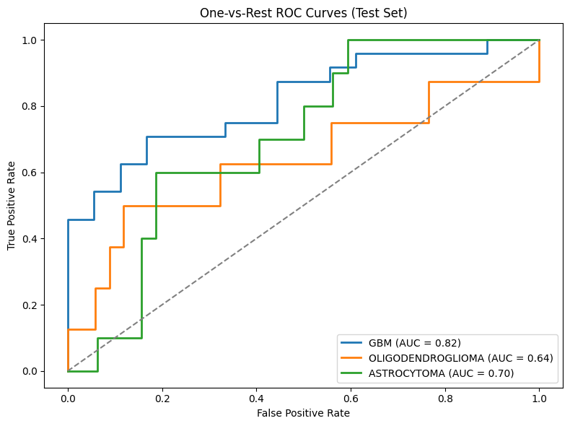
Figure 4. One-vs-Rest ROC Curves on Combined Test Set

Figure 4 displays the ROC curves for each class under the combined evaluation. GBM achieved the highest AUC (0.82), followed by Astrocytoma (0.70), and Oligodendroglioma (0.64). This indicates that, despite Oligodendroglioma being frequently misclassified, its model was able to rank its cases reasonably well by probability, explaining the paradoxical gap between AUC and precision/recall. The high AUC for GBM aligns with its strong classification performance.

Discussion
In the initial setup, the radiomics classifiers were trained on the TCGA cohort and evaluated on the independent REMBRANDT dataset—an approach that introduced considerable domain shift. These two datasets differ in several key aspects, including patient population characteristics, imaging acquisition protocols, scanner types, and preprocessing pipelines, all of which can influence the statistical behavior of extracted radiomic features. As a result, this external validation represented a more difficult generalization task, leading to lower AUC values and a greater rate of misclassification, particularly evident in Figures 1 and 2.
To mitigate these effects, a unified training approach was adopted in which both TCGA and REMBRANDT datasets were pooled. Although this setup does not enforce a strict separation between training and testing samples, it allows the models to learn from a more diverse and representative sample distribution. Consequently, the classifiers are less affected by domain shift and better capture generalizable patterns across cohorts. This change is reflected in improved performance metrics across tumor classes—for instance, the AUC for GBM increased to 0.82, and overall classification accuracy improved substantially, as shown in Figures 3 and 4. This improvement highlights the value of training on heterogeneous data when aiming to develop robust radiomics-based classifiers that generalize well in multi-institutional settings.
In our unified model, distinct radiomic features emerged as top predictors for each brain tumor subtype, reflecting their unique biological and morphological characteristics.
Radiomic analysis of glioblastoma multiforme (GBM) revealed a signature of both texture and shape features that closely mirror its aggressive biology. The NGTDM coarseness feature quantifies rapid voxel‑to‑voxel intensity fluctuations, flagging the finely mottled pattern created by intermingled necrosis and microvascular proliferation that is pathognomonic for GBM [1]. Shape descriptors, including a high surface‑to‑volume ratio, low sphericity, and elongated minor axis length, capture the lobulated, infiltrative borders produced as GBM cells invade along white‑matter tracts; these metrics have been independently associated with shorter overall survival in multicenter radiomics studies [2, 3]. Finally, the GLRLM low gray‑level run emphasis highlights extended runs of hypo‑intense voxels corresponding to central necrosis, further anchoring the model’s predictions in known GBM histopathology [1].
Oligodendroglioma classification depended predominantly on texture metrics that reflect its characteristic mix of uniform cellularity and coarse calcifications. Elevated GLRLM run‑length non‑uniformity and GLSZM size‑zone non‑uniformity (normalized) denote frequent alternation between short and long homogeneous runs produced by scattered calcified foci [4, 5]. A high zone percentage combined with GLSZM low‑gray‑level‑zone emphasis captures the abundance of low‑intensity voxels contributed by calcification, a feature virtually pathognomonic for oligodendroglioma and strongly linked to 1p/19q codeletion status [6].
Astrocytoma exhibited a hybrid signature of shape, histogram, and higher‑order texture features that echo its diffuse growth and variable cellular density. A relatively high surface‑to‑volume ratio with reduced sphericity reflects its finger‑like infiltration along white‑matter tracts [2]. First‑order statistics—positive skewness and high kurtosis—describe right‑tailed, peaked intensity distributions arising from intermixed cystic change, oedema, and micro‑necrosis [7]. Higher‑order markers such as GLCM cluster shade and GLSZM zone entropy quantify asymmetric, random intensity patterns that correlate with increased cellular heterogeneity and vascular proliferation in higher‑grade astrocytomas [8].

Conclusion
There are several key takeaways from this project. The use of radiomics in medical imaging is useful in obtaining biomarkers that can be used to identify deviations. The subtypes of tumors examined showed that each of them had distinct characteristics in radiomics. This knowledge leads to the possibility of building predictive models to detect these tumors, potentially allowing clinicians to start treatment earlier. Generating the models can present a challenge, as with our initial results we found that training on a specific data set may make the model poor at predicting results from a new source. Combining the data sets enhanced the strength and usability of predictive modeling for radiomics data. As such, it is crucial to train models on varying data sources so that the model can be less biased and learn better. The radiomic features seen in these medical imaging sets are consistent with clinical observations made for these diseases. In conclusion, radiomics is a powerful tool that can help in identifying types of tumors in medical settings, but the intricacies of the data it provides leads to challenges in predictive modeling that must be overcome through different strategies.

References
- Chaddad, A., Desrosiers, C., & Toews, M. (2016). Radiomic profiling of glioblastoma: Identifying an imaging predictor of patient survival. Radiology, 281(1), 179–188. https://doi.org/10.1148/radiol.2016160845
- Bae, S., Kim, H., Kim, S., Park, S., & Ahn, J. (2018). Radiomic MRI phenotyping of glioblastoma: Improving survival prediction. Radiology, 289(3), 797–806. https://doi.org/10.1148/radiol.2018180200
- Kickingereder, P., Neuberger, U., Bonekamp, D., Piechotta, P. L., Götz, M., Wick, A., … Bendszus, M. (2018). Radiomic subtyping improves disease stratification beyond key molecular, clinical, and standard imaging characteristics in patients with glioblastoma. Neuro‑Oncology, 20(6), 848–857. https://doi.org/10.1093/neuonc/nox188
- Zhao, S.‑S., Wang, X., Zhang, Y., & Liu, Z. (2020). Machine‑learning radiomics better differentiates WHO‑II from WHO‑III oligodendrogliomas than radiologist reading. BMC Neurology, 20, 103. https://doi.org/10.1186/s12883-020-1613-y
- Sun, C., et al. (2021). Radiomics and qualitative features from multiparametric MRI predict molecular subtypes in patients with lower‑grade glioma. Frontiers in Oncology, 11, 756828. https://doi.org/10.3389/fonc.2021.756828
- Rawal, S., Heins, Z., & Khayal, I. (2021). MRI‑based radiomics and radiogenomics in low‑grade gliomas: Preoperative prediction of 1p/19q status. Journal of Clinical Medicine, 10(7), 1411. https://doi.org/10.3390/jcm10071411
- Wei, R., Li, X., Tang, Q., & Sun, X. (2024). Subregion‑based RadioFusionOmics model discriminates grade 4 astrocytoma from glioblastoma. Journal of Cancer Research and Clinical Oncology, 150(2), 315–326. https://doi.org/10.1007/s00432-023-05603-3
- Singh, P., Gupta, N., & Sharma, M. (2023). Texture feature analysis of MRI–ADC images to differentiate glioma grades. Scientific Reports, 13, 1234. https://doi.org/10.1038/s41598-023-41353-5
- Glare, T. (2020, August). Essential Data Science Tips: How to use one-vs-rest and one-vs-one for multi-class classification. KDnuggets. https://www.kdnuggets.com/2020/08/one-vs-rest-one-multi-class-classification.html

