[**Retro FPGA: Grant Searle's Multicomp**](http://obsolescenceguaranteed.blogspot.com/2014/03/retro-fpga-grant-searles-multicomp.html)

[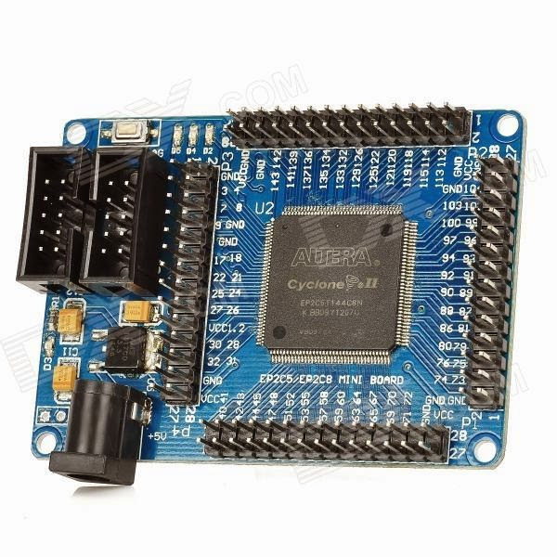](http://3.bp.blogspot.com/-uA34gSLGjHU/UymNvbp37NI/AAAAAAAABBY/cMZs7H5Qcjw/s1600/EP2C5+Cyclone+II+Dev+Board.jpg)A $35 FPGA board that can mimic capable Z80, 6809 or 6502 homebrew computers with serial ports, SD mass storage and even VGA & PS/2 keyboard connectors. Mix and match parts to create the computer you like - all in a simple VHDL file a beginner can understand. Brilliant! A bit like a Lego approach to retrocomputing. It is a great way to learn about programmable hardware, where you can start straight off with something interesting and then can climb the learning curve to extend it. The mind wanders... shall I add a MMU to the 6809? Or add a replica of Cromemco's disk controller so I can maybe, someday, run Z80 Cromix on this thing?   
  
  
I had been wondering how it would be to create a Lego-like box of vintage parts in VHDL and make it into a sort of virtual electronics kit. But in retrocomputing, you have boys, men, Great Men, and then you have Grant Searle. He actually did it, and I stumbled upon his project site a few weeks ago.  
  
There is little to add to his site, so this post is nothing more than how I replicated his project. His site is here: <http://searle.hostei.com/grant/Multicomp/index.html>

[2016 update: $5 PCBs available at Retrobrew forum!](https://www.retrobrewcomputers.org/forum/index.php?t=msg&th=111&start=0&)

This 1-day project turned out to be a introduction in VHDL, sure, but also a lesson in the economics of deflation. It is **amazing** how cheap stuff is these days. Here is my Bill of Materials:

* $23.59 Cyclone II dev board: [example at DX (link)](http://dx.com/p/ep2c5t144-altera-cyclone-ii-fpga-mini-scm-development-board-148979)
* $15 Altera USB blaster, that's including shipping cost: [example at Hobby Components (link)](http://hobbycomponents.com/index.php/dvbd/dvbd-altera/altera-fpga-cpld-usb-programmer-usb-blaster-compatible.html)
* $1.63 (x 2) for two TTL to RS-232 mini converters: [example at DX (link)](http://dx.com/p/mini-rs232-to-ttl-converter-module-board-3-5v-132934)
* $2.51 for Breadboard wires: [example at DX (link)](http://dx.com/p/30cm-breadboard-wires-for-electronic-diy-40-cable-pack-80207)
* $2.56 for a SD card connector board: [example at DX (link)](http://dx.com/p/sd-card-reading-writing-module-for-arduino-148784) although I used one from my old parts box.

Grand total of less than $47... Add a 128K SRAM, two DB-9 serial connectors and a 5V wall wart from the spare parts box, and that's it! You do not even pay shipping costs at DX.com. So ordered, waited two weeks and once the parts came in, picked up a cardboard box from the bin to put it together temporarily. This is the glorious end result of an evening with the soldering iron:

[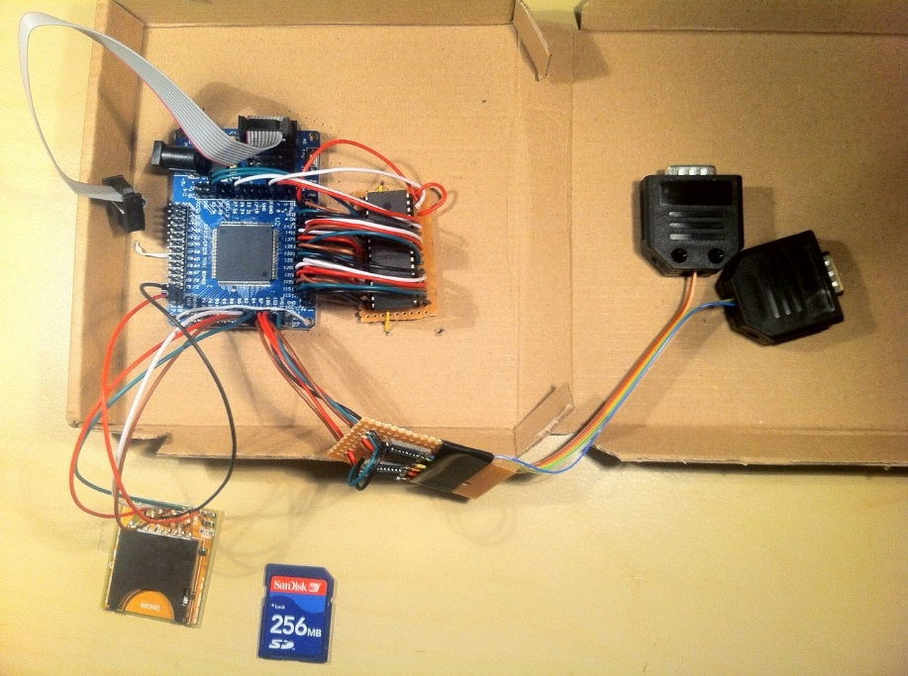](http://4.bp.blogspot.com/-oTOG1F0hukY/UymKTmUEdpI/AAAAAAAABBM/JpLA6Cr-Sbc/s1600/My+Multicomp.JPG)

What's to see here? To the right of the FPGA, there is a 128K SRAM chip ($3 or so) that is connected to the dev board. Below is a TTL-to-RS-232 board containing only two readymade converter board with MAX232s on them. To the left, a SD card connector.  
  
The funny thing is that it takes so little effort. I used the single Female-to-Female breadboard wires by cutting them in half. The wire end then gets soldered to the little SRAM or Serial perfboard, the other end has a neat connector to plug into the dev board.  
  
So:

* What does it do? Well, at the moment, it runs CP/M with a 10MHz Z80 and 128MB of mass storage. For a further $3 or so, I can add the VGA and PS/2 connectors so it does not need a serial terminal to operate.
* What can it do later on? Teach me VHDL whilst working from a starting point that I find interesting. Develop things like MMUs, so I can port OS/9 perhaps. Understand the inner logic in a UART.

Whatever. It is extremely Cool, so many thanks to Grant for this project! I hope it will become the launch platform for many interesting homebrewing hacks.  
  
  
**UPDATE:**  
  
I made a disk image with all major CP/M software for the FPGA Multicomp. You can find it on my main site, here: <http://obsolescence.wix.com/obsolescence#!multicomp-fpga-cpm-demo-disk/c1fom>  
  
  
**UPDATE 2:**  
  
It was time to put the Multicomp in a proper box. Here's how it looks now - and with the DIY done, it is time to dive into VHDL...

[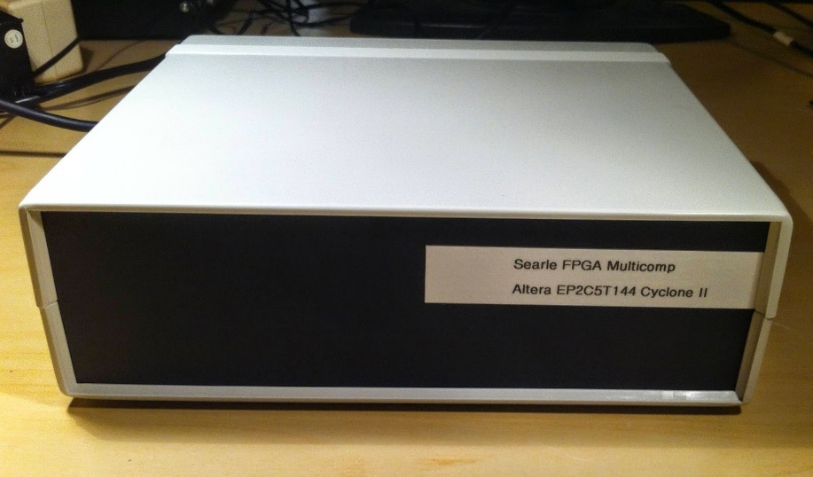](http://4.bp.blogspot.com/-FcRFqd3EuaA/UzsxUY2tyII/AAAAAAAABDk/1fz8jJ81yy8/s1600/front.jpg)

[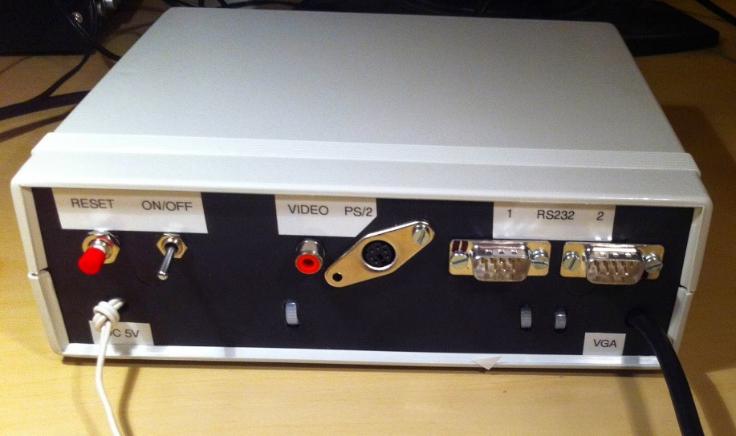](http://3.bp.blogspot.com/-3tED_JPCVxU/UzsxhQUevBI/AAAAAAAABDo/Uz_wcsGXBu8/s1600/back.jpg)

[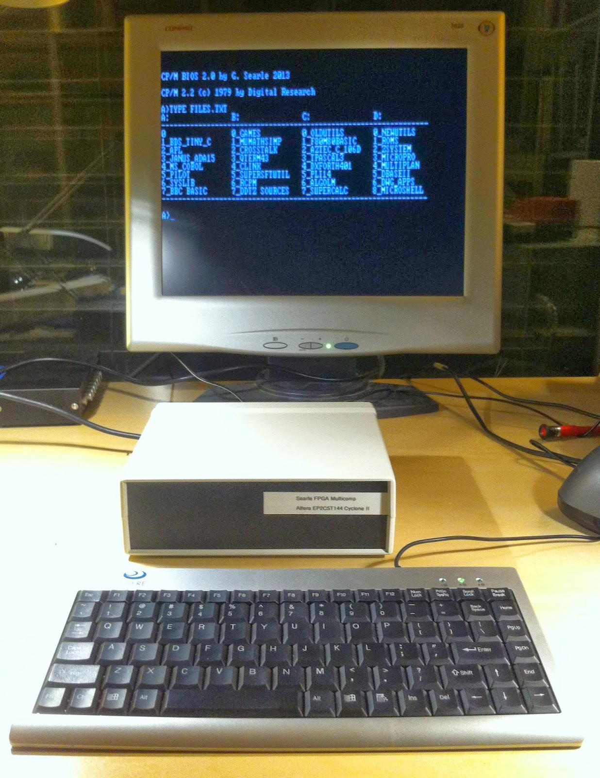](http://4.bp.blogspot.com/-jidyKz5aLQI/UzsxKZg5TYI/AAAAAAAABDY/54IxN5lsOqc/s1600/FPGA_Multicomp+2.jpg)

Inside, a lovely Homebrew mess of wires. The Homebrew look is not intentional - it just reflects my skill set. To my defense, I only wanted to use parts that were already in the junk box. For instance, I chopped off a VGA cable rather than order a VGA connector.

[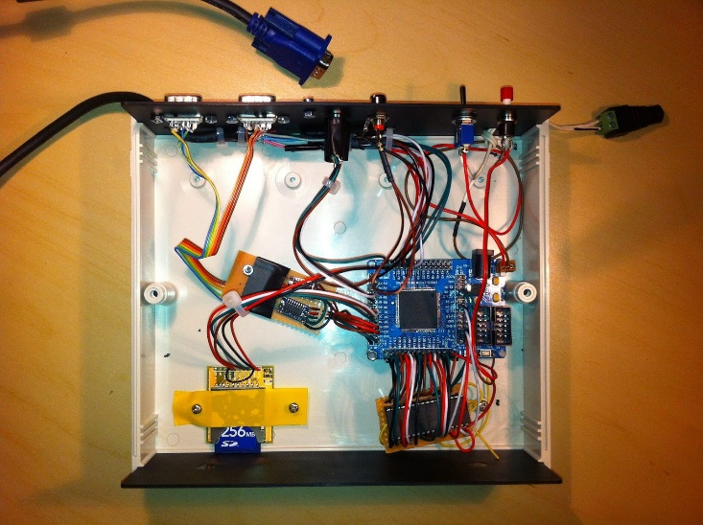](http://4.bp.blogspot.com/-8l6d2nCUQk0/Uzszep_4TII/AAAAAAAABD0/hV9x7eHCxz0/s1600/inside2.jpg)

[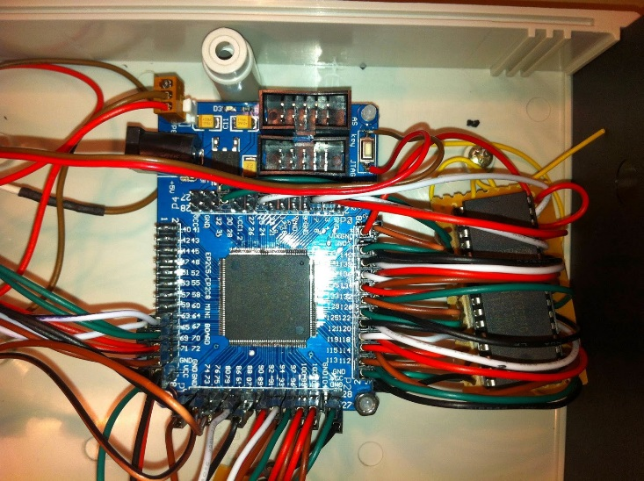](http://4.bp.blogspot.com/-yqlvUy-LRU8/UzszmNmGzXI/AAAAAAAABD8/m4PJhbg-nOQ/s1600/bigmessofwires.jpg)

[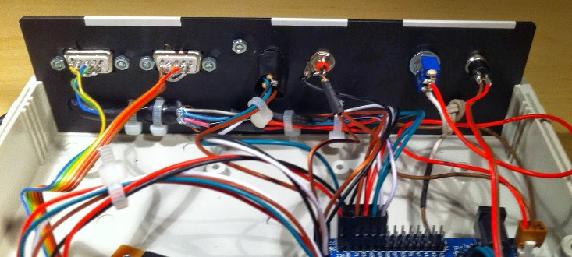](http://3.bp.blogspot.com/-iYDr4tU_Fes/UzszsK3SCAI/AAAAAAAABEE/SbCVXLB-b1g/s1600/insidebackpanel.jpg)

###### This page provides a SD disk image for [Grant Searle's Multicomp CP/M machine](http://searle.hostei.com/grant/Multicomp/cpm/fpgaCPM.html), based on the earlier version for the N8VEM computer. Also, a quick how-to is provided on how to exchange files between the Multicomp and a Windows PC.

[Download Booklet](https://docs.google.com/file/d/0B_jM3_1AFMbMYUcyUUNLdjlyb28/edit?usp=sharing)

[Download Disk Image](https://drive.google.com/file/d/0B_jM3_1AFMbMX3JFTjc1emIxMUU/edit?usp=sharing)

###### What's on the disk image:

###### Languages:

* Aztec C v1.06 (compiles DWG N8VEM support apps)
* BDS C & Tiny C
* APL & Janus ADA v1.5
* Microsoft Cobol, Fortran, Basic, Basic Compiler
* Microsoft Macro-80 assembler
* BBC Basic
* Turbo Pascal v3.0
* DX-Forth 4.01
* PL/I v1.4
* Algol/M

###### Applications:

* WordStar 3.30, CalcStar, DataStar, SpellStar
* muMath & muSimp (CAS math package)
* Microsoft Multiplan
* DBase II
* Qterm, Crosstalk, RCP/M, CLink (not installed yet)

###### Games:

* Infocom Adventures: Zork, Planetfall
* The classic Colossal Cave adventure
* Ladder & Catchum (Donkey Kong/Pacman clones)
* Sargon Chess, Othello
* Star Trek, Wanderer

###### Tools:

* Microshell & microtools - like the unix shell
* Supersoft Utilities 2 - useful unix-like tools

* ZDE - standard editor.
* DDT, DDTZ - standard debuggers/intel mnemonics
* DDTZ80 - standard debugger/Zilog mnemonics
* SID, ZSID - original symbolic debugger
* DEBUGZ - Full-Screen debugger - probably the best
* LINK - Linker & LZ - LinkZ, a faster L80 alternative
* ASM - standard CP/M assembler/Intel mnemonics
* RMAC - macro assembler (v1) from Digital Research
* MAC - later (v2) version of RMAC
* ZTRAN4 - translate Intel to Zilog
* MC.SUB - Submit file for Macro-80 compile cycle
* SUPERSUB - a better Submit
* LS - a better dir
* ZAP - file manager
* NSWP207, WASH15, VFILER - file management tools
* NULU, LBREXT - for lbr archives
* CR, UNCR - (un)crunch *.*z* files
* USQ - unsQueeze *.?q? files
* UNARC, UNZIP - deals with arc, ark & zip files
* SURVEY - inventorise your system & test memory

[Download Manuals](https://docs.google.com/file/d/0B_jM3_1AFMbMSDVJaVA3MHNFTjA/edit?usp=sharing)

[Download Tool Set](https://drive.google.com/file/d/0B_jM3_1AFMbMUGtaTGJ5Q2pQc1k/edit?usp=sharing)

###### How-To

Click on the black buttons to download from Google Drive. **Note: you need to select File->Download from the top menu to actually get the zipped files.** Clicking on the single files*within* the zip archives downloads only that one specific file, uncompressed.

Simply copy the image file to your Compact Flash or SD card using Win32 Disk Imager (provided under the Tool Set button further below) or dd. I've been sloppy: the drive image requires at least a 256MB SD card. But you can chop off the last 128MB, it's not used... I do beg your pardon for the waste of space & bandwidth.

Once you boot from the disk, there is a FILES.TXT on the A: drive that you can type to get a quick overview of what's where.

###### Software Manuals

To the left is a download link containing PDFs of almost all applications on the disk image. Note that these have simply been sourced from all over the net, from public sources. Pro forma: if you feel I'm infringing a copyright that belongs to you, please let me know and I will remove the offending PDF. Warning: 172MB download.

###### 

###### 

###### File Exchange: some useful tools put together

Although Grant provides a tool to transfer files to/from the Multicomp, there are other ways to access the SD card from your PC. The Tool Set download provides:

* a directory structure in the TO_IMG **subdirectory with all the CP/M files** to be shot into the drive image. So deposit any additional files in here if you want to add to this Demo Disk.
* a crude-but-effective cpmtools **batch file to shoot the entire TO_IMG directory onto the drive image**. Be sure to run this on an empty, freshly formatted drive image! Also, a word of caution: the Windows version of cpmtools does not seem to like user numbers above 9. 10-15 are thus off-limits.
* [**Win32 Disk Imager**](http://sourceforge.net/projects/win32diskimager/), to copy disk images to and from the actual SD card.
* [**cpmtools**](http://www.moria.de/~michael/cpmtools/), to read & write files to the Multicomp drives on a disk image. The diskdefs file contains definitions for the Multicomp's A-E drives. Example: "cpmls -f hd0 imagefile.img" shows a dir of the A: drive, hd1 will show the B: drive, etc. See the cpmtools home page for cpmcp and other utils.

Not in the download file is [**cpmcbfs**](http://www.nyangau.org/cpmcbfs/cpmcbfs.htm), which allows you to mount the SD card as a drive on your Windows PC, and read/write straight to it. No need for image files as an intermediate step - but thus also less safe. See its home page. You can copy the diskdefs file from the Tool Set so cpmcbfs understands the Multicomp disk format.

###### In summary

This is not exactly the Ultimate Disk Image & Tool Chain. But I hope it's useful, and please let me know of any software to add or errors to fix.