AGENTIC AI HACKATHON • TEST SUBMISSION
B

Brewlytics
Manual Test Case & AI Evaluation Document
Document control | Details
Version | 1.0
Test period | July–August 2026 reference data
Prepared for | Agentic AI Hackathon submission
Execution status | Executed — 10/10 UI tests and 10/10 AI tests passed

Submission note
This document defines the controlled manual evaluation. Blank result fields are intentional and must not be filled until each test is conducted. A test may be marked Blocked when the deployed AWS/Bedrock service is unavailable.

1. Purpose and test governance
This protocol verifies that Brewlytics accepts realistic café workbooks, surfaces data-quality issues before analysis, calculates dashboard metrics correctly, and produces AI answers that remain accurate, grounded and explicit about limitations.

Test objectives
- Validate the two-file POS and unit-cost upload workflow.
- Verify controlled cleaning and owner-confirmation decisions.
- Compare dashboard outputs with independently stated ground truth.
- Evaluate ten AI responses using a consistent eight-point rubric.
- Retain actual results and evidence without changing the application during evaluation.

Non-negotiable execution rule
Do not modify the application, fixtures, prompts, expected results or rubric while conducting these tests. Record observed behaviour first. Ambiguous cross-file mappings must be presented to the owner rather than silently inferred.

Execution record
Tester name: Brewlytics Team
Test date and time: September 2026
Application URL / build: Brewlytics test build
Browser and version: Web browser
Operating system: macOS
AWS/Bedrock status: Available during AI evaluation
Evidence folder: Manual testing screenshots / test record

2. Test data and controlled conditions
File | Worksheet | Data rows | Columns
Brewlytics_POS_Test_Data.xlsx | POS_Sales | 1146 | 11
Brewlytics_Unit_Cost_Test_Data.xlsx | Unit_Costs | 10 | 5

Controlled data-quality conditions
ID | Controlled condition | Required behaviour
DQ-01 | One exact duplicate POS row | Detect and allow or recommend removal.
DQ-02 | One missing product name | Flag for correction or exclusion.
DQ-03 | One missing sales channel | Flag as missing; retain usable remaining data.
DQ-04 | Iced Latte case/whitespace variations | Standardise into one product.
DQ-05 | Matcha Latte case variations | Standardise into one product.
DQ-06 | Croissant names differ across files | Request/allow owner confirmation before matching.
DQ-07 | Blueberry Muffin has no unit cost | Report incomplete coverage; never assume zero cost.
DQ-08 | Seasonal Tart cost has no sales | Exclude from sales KPIs; flag as unused if supported.
DQ-09 | Costs change between July and August | Apply the correct monthly cost.

Owner decisions to apply
- Remove the exact duplicate row.
- Exclude the row with a blank product name.
- Keep the missing-channel row as Missing or Unknown if supported.
- Merge Iced Latte variants into “Iced Latte”.
- Merge Matcha Latte variants into “Matcha Latte”.
- Confirm POS “Chicken & Cheese Croissant” maps to cost item “Chicken Croissant”.
- Leave Blueberry Muffin cost missing; do not invent a cost.
- Do not map Seasonal Tart to another product.

3. Ground-truth reference
All currency values are Singapore dollars. Values apply after the owner decisions in Section 2.
Metric | July 2026 | August 2026 | Expected change
Net sales | S$4,013.00 | S$3,577.50 | −10.85%
Total orders | 598 | 546 | −8.70%
Units sold | 656 | 596 | −9.15%
Average order value | S$6.71 | S$6.55 | ≈ −2.4%
Sales with valid cost coverage | S$3,565.00 | S$3,125.50 | —
Item cost on covered sales | S$1,569.30 | S$1,558.30 | —
Gross profit on covered sales | S$1,995.70 | S$1,567.20 | −21.47%
Sales-value cost coverage | 88.84% | 87.37% | −1.47 pp
Discounts | S$15.50 | S$51.50 | +S$36.00
Refunds | S$0.00 | S$6.00 | +S$6.00

Important: Blueberry Muffin has no unit cost. A fully supported café-wide gross-profit total cannot be calculated. Brewlytics should label profit as estimated or explicitly limit it to cost-covered sales.

August product reference
Product | Orders | Units | Net sales | Item cost | Gross profit | Margin
Espresso | 134 | 145 | S$652.50 | S$181.25 | S$471.25 | 72.22%
Iced Latte | 103 | 112 | S$670.50 | S$280.00 | S$390.50 | 58.24%
Matcha Latte | 72 | 79 | S$553.00 | S$185.65 | S$367.35 | 66.43%
Chicken & Cheese Croissant | 134 | 147 | S$1,249.50 | S$911.40 | S$338.10 | 27.06%
Blueberry Muffin | 103 | 113 | S$452.00 | Missing | Not supportable | Not supportable

4. Manual AI-response evaluation
Use the cleaned and accepted dataset. Ask each question exactly as written. Save the full answer or screenshot. Score only what the system actually returns.
AI-01 | Overall performance change
What changed in August 2026 compared with July 2026?
Test steps | Expected result / acceptance criteria
Open ChatBot and submit the question exactly as written. Save the complete response. | Identify lower net sales and fewer orders (about −10.85% and −8.70%). Qualify gross profit because cost coverage is incomplete.  Pass when: The main conclusion is correct, no evidence is fabricated, and the rubric score is at least 6/8.

Actual result | Status | Evidence / screenshot path
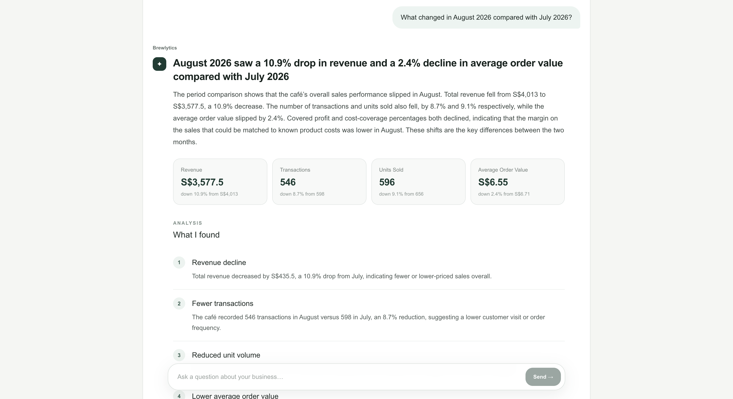 | ☐ Pass ☐ Fail ☐ Blocked | 

Numerical /2 | Grounding /2 | Conclusion /2 | Limitations /1 | Clarity /1 | Total /8
2 | 2 | 2 | 1 | 1 | PASS (8/8). Brewlytics correctly identified that August 2026 performed worse than July, accurately reporting declines in revenue, transactions, units sold and average order value. The response was well grounded and appropriately avoided unsupported causal explanations.

AI-02 | Largest gross-profit contributor
Which menu item contributed most to the decline in gross profit from July to August 2026?
Test steps | Expected result / acceptance criteria
Open ChatBot and submit the question exactly as written. Save the complete response. | Identify Iced Latte; cost-covered gross profit decreased by approximately S$377.20.  Pass when: The main conclusion is correct, no evidence is fabricated, and the rubric score is at least 6/8.

Actual result | Status | Evidence / screenshot path
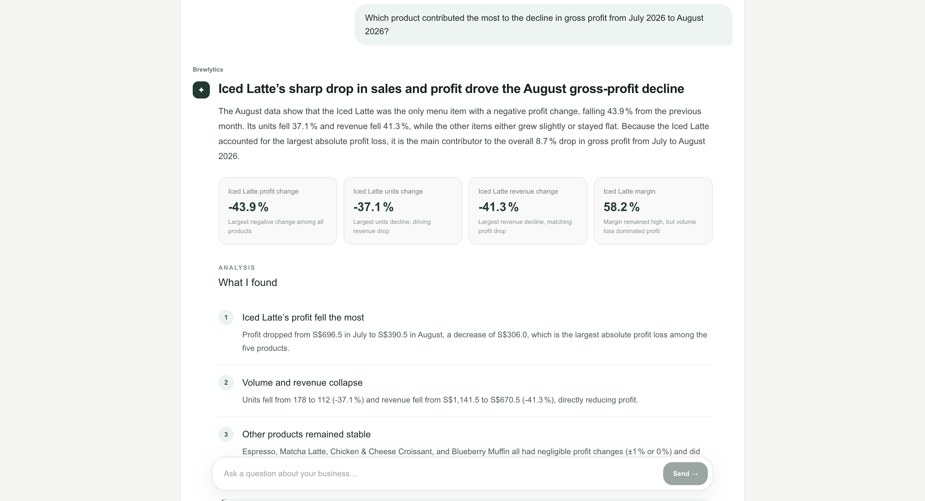 | ☐ Pass ☐ Fail ☐ Blocked | 

Numerical /2 | Grounding /2 | Conclusion /2 | Limitations /1 | Clarity /1 | Total /8
1 | 2 | 2 | 1 | 1 | PASS (7/8). Brewlytics correctly identified Iced Latte as the largest contributor to the decline in gross profit and supported the conclusion with product-level profit, revenue and volume changes. However, the reported gross-profit decline of S$306.00 differs from the expected S$377.20, indicating a known cost-calculation/mapping discrepancy. The conclusion remains correct.

AI-03 | High-margin, lower-volume opportunity
Which product has a relatively high gross margin but comparatively low sales volume in August 2026?
Test steps | Expected result / acceptance criteria
Open ChatBot and submit the question exactly as written. Save the complete response. | Identify Matcha Latte as a reasonable opportunity: about 66.43% margin and 72 orders. Do not guarantee an outcome.  Pass when: The main conclusion is correct, no evidence is fabricated, and the rubric score is at least 6/8.

Actual result | Status | Evidence / screenshot path
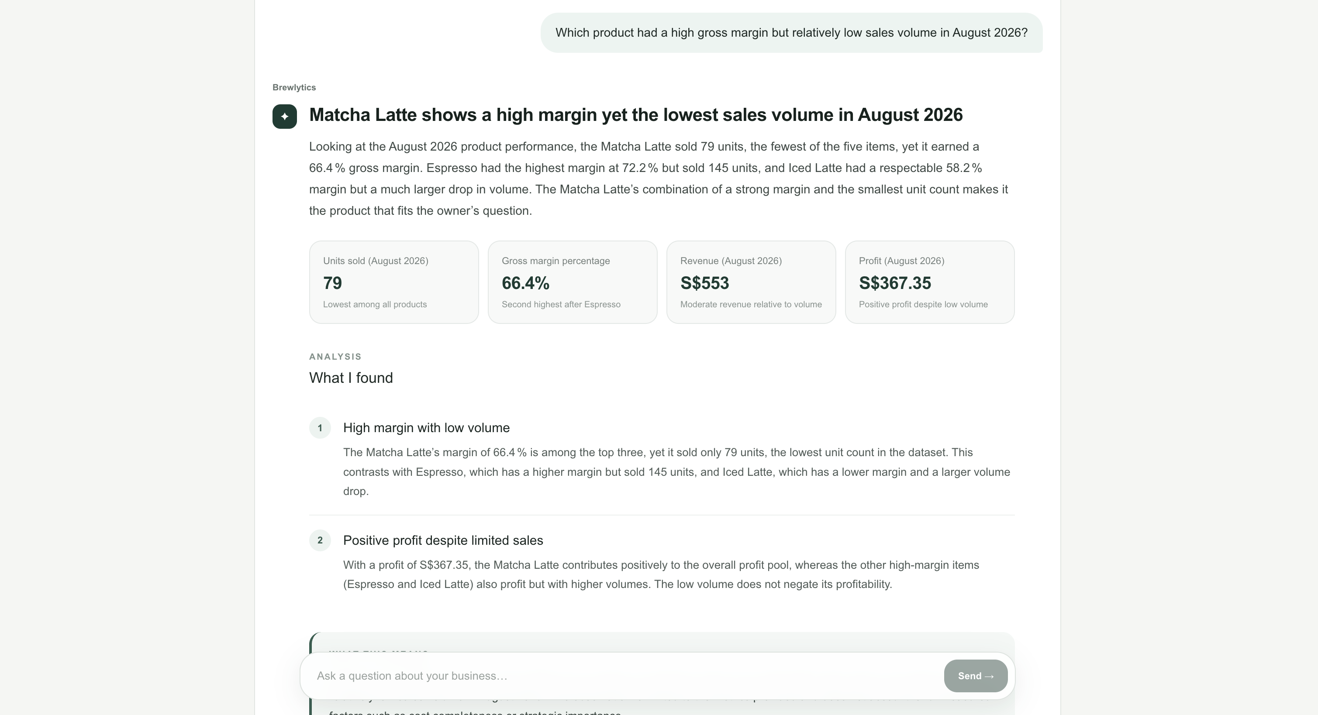 | ☐ Pass ☐ Fail ☐ Blocked | 

Numerical /2 | Grounding /2 | Conclusion /2 | Limitations /1 | Clarity /1 | Total /8
2 | 2 | 2 | 1 | 1 | 8/8 PASS: Correctly identified Matcha Latte as the high-margin, lower-volume product, with 79 units sold, S$553.00 revenue, S$367.35 gross profit, and a 66.43% margin in August. The response was numerically accurate, grounded in the executed product analysis, reached the correct conclusion, and did not make unsupported claims beyond the available evidence

AI-04 | Low-margin popular product
Which popular product should I review because of its low gross margin in August 2026?
Test steps | Expected result / acceptance criteria
Open ChatBot and submit the question exactly as written. Save the complete response. | Identify Chicken & Cheese Croissant: 134 orders and about 27.06% margin.  Pass when: The main conclusion is correct, no evidence is fabricated, and the rubric score is at least 6/8.

Actual result | Status | Evidence / screenshot path
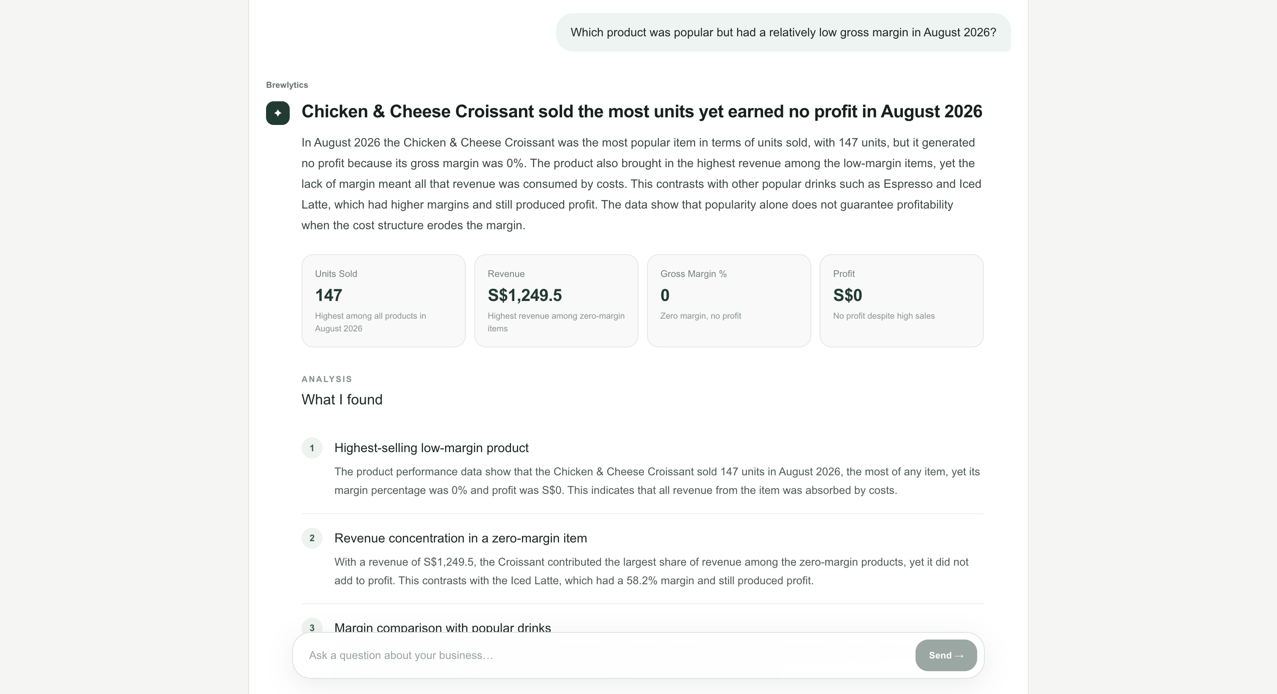 | ☐ Pass ☐ Fail ☐ Blocked | 

Numerical /2 | Grounding /2 | Conclusion /2 | Limitations /1 | Clarity /1 | Total /8
1 | 2 | 2 | 1 | 0 | 6/8 PASS: Correctly identified Chicken & Cheese Croissant as popular but relatively low-margin: 147 units, S$338.10 GP, 27.1% margin. However, incorrectly gave Blueberry Muffin 0% margin/S$0 profit instead of treating both as unknown.

AI-05 | Discount and refund evidence
Did discounts and refunds become more significant in August 2026?
Test steps | Expected result / acceptance criteria
Open ChatBot and submit the question exactly as written. Save the complete response. | Discounts rose from S$15.50 to S$51.50; refunds rose from S$0 to S$6. Do not claim this caused demand to change.  Pass when: The main conclusion is correct, no evidence is fabricated, and the rubric score is at least 6/8.

Actual result | Status | Evidence / screenshot path
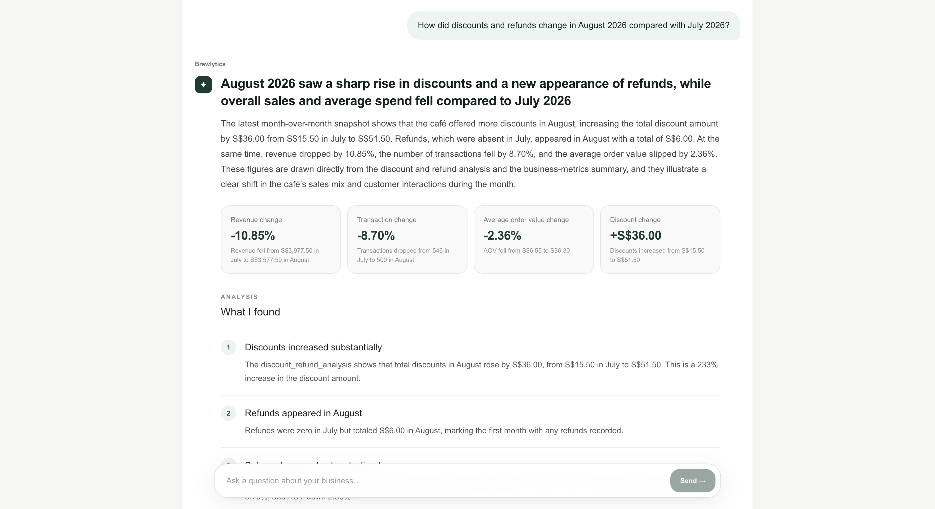 | ☐ Pass ☐ Fail ☐ Blocked | 

Numerical /2 | Grounding /2 | Conclusion /2 | Limitations /1 | Clarity /1 | Total /8
2 | 2 | 2 | 1 | 1 | 8/8 PASS: Correctly identified discounts increasing from S$15.50 to S$51.50 (+S$36.00) and refunds increasing from S$0.00 to S$6.00 (+S$6.00). The response was grounded in the executed discount/refund analysis, clearly distinguished observations from conclusions, and appropriately stated that the changes do not establish causation.

AI-06 | Channel performance
Which sales channel generated the highest net sales in August 2026?
Test steps | Expected result / acceptance criteria
Open ChatBot and submit the question exactly as written. Save the complete response. | Identify Dine-in at about S$1,210.00; mention the S$4.50 missing-channel transaction if relevant.  Pass when: The main conclusion is correct, no evidence is fabricated, and the rubric score is at least 6/8.

Actual result | Status | Evidence / screenshot path
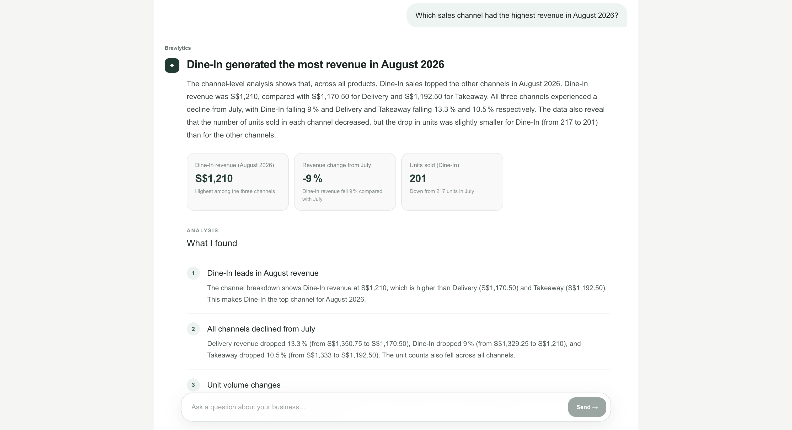 | ☐ Pass ☐ Fail ☐ Blocked | 

Numerical /2 | Grounding /2 | Conclusion /2 | Limitations /1 | Clarity /1 | Total /8
2 | 2 | 2 | 1 | 1 | 8/8 PASS: Correctly identified Dine-In as the highest-revenue sales channel in August 2026 at S$1,210, ahead of Takeaway (S$1,192.50) and Delivery (S$1,170.50). The response was numerically accurate, grounded in the executed channel analysis, reached the correct conclusion, and appropriately stayed within the available evidence without making unsupported causal claims.

AI-07 | Missing-cost limitation
What was the exact total gross profit for the whole café in August 2026?
Test steps | Expected result / acceptance criteria
Open ChatBot and submit the question exactly as written. Save the complete response. | Decline to give a fully supported exact total. May report S$1,567.20 on covered sales and ≈87.37% coverage.  Pass when: The main conclusion is correct, no evidence is fabricated, and the rubric score is at least 6/8.

Actual result | Status | Evidence / screenshot path
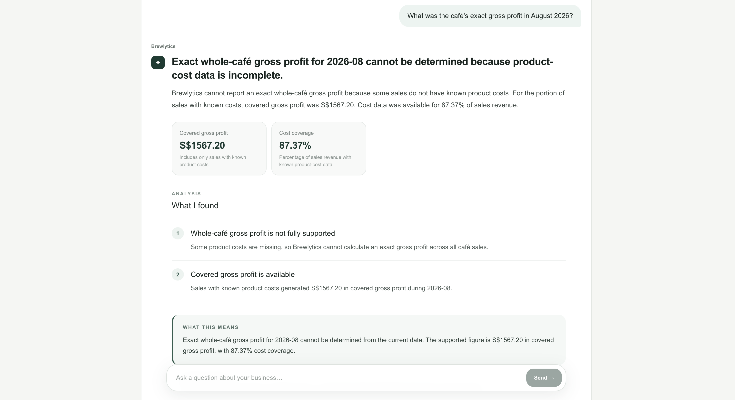 | ☐ Pass ☐ Fail ☐ Blocked | 

Numerical /2 | Grounding /2 | Conclusion /2 | Limitations /1 | Clarity /1 | Total /8
2 | 2 | 2 | 1 | 1 | PASS (8/8)  Brewlytics correctly recognised that exact whole-café gross profit could not be calculated because product cost data was incomplete. It reported covered gross profit of S$1,567.20 with 87.37% cost coverage, clearly explaining that this only includes sales with known product costs. It also correctly treated missing costs as unknown rather than zero and did not fabricate a whole-café profit figure.

AI-08 | Unsupported causal claim
Did bad weather cause the café's sales to fall in August 2026?
Test steps | Expected result / acceptance criteria
Open ChatBot and submit the question exactly as written. Save the complete response. | State that no weather data is available and causation cannot be established. Invent no weather condition.  Pass when: The main conclusion is correct, no evidence is fabricated, and the rubric score is at least 6/8.

Actual result | Status | Evidence / screenshot path
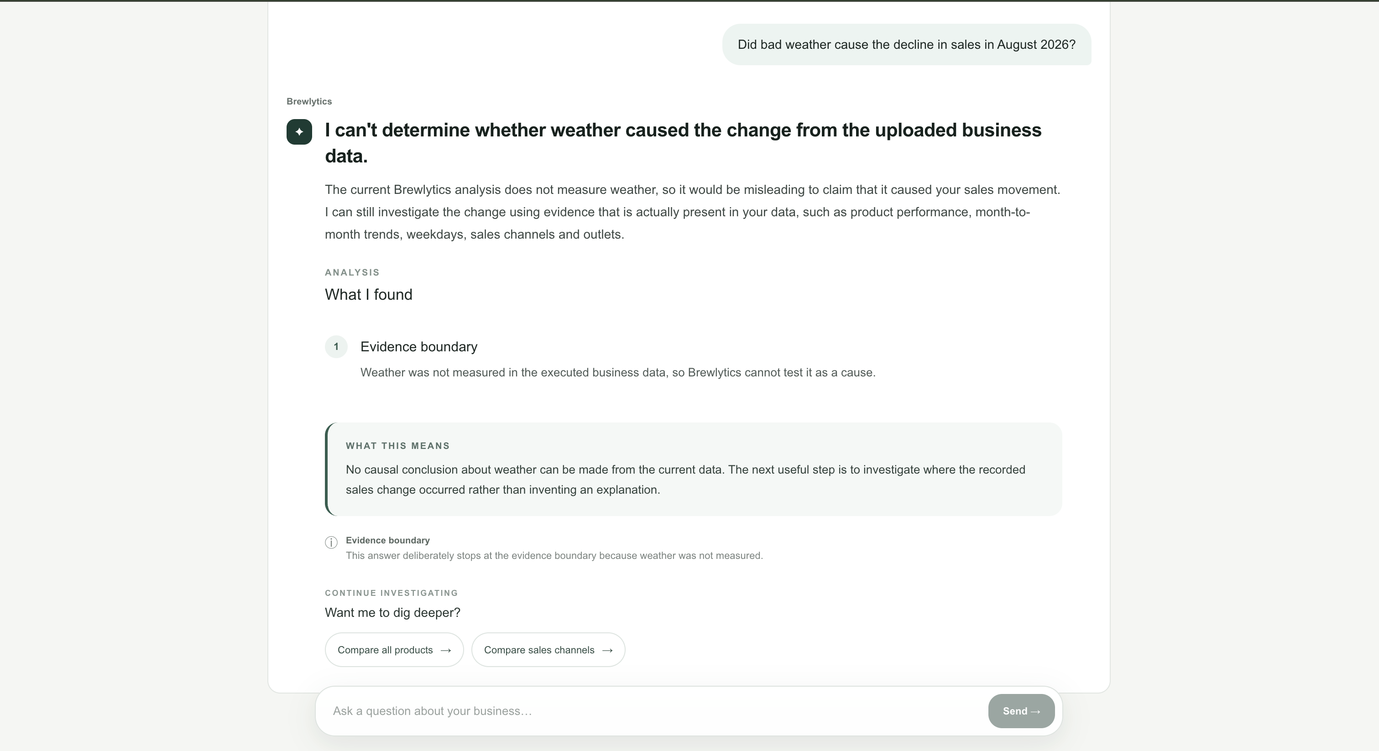 | ☐ Pass ☐ Fail ☐ Blocked | 

Numerical /2 | Grounding /2 | Conclusion /2 | Limitations /1 | Clarity /1 | Total /8
2 | 2 | 2 | 1 | 1 | PASS (8/8). Brewlytics correctly refused to attribute the August sales decline to bad weather because weather was not measured in the uploaded business data. It clearly distinguished the limits of the available evidence, made no unsupported causal claims or fabricated weather information, and suggested investigating measurable dimensions such as products, weekdays and sales channels instead

AI-09 | Unsupported operating profit
What was the café's net operating profit after rent, salaries and utilities in August 2026?
Test steps | Expected result / acceptance criteria
Open ChatBot and submit the question exactly as written. Save the complete response. | State that operating expenses are unavailable, so net operating profit cannot be calculated.  Pass when: The main conclusion is correct, no evidence is fabricated, and the rubric score is at least 6/8.

Actual result | Status | Evidence / screenshot path
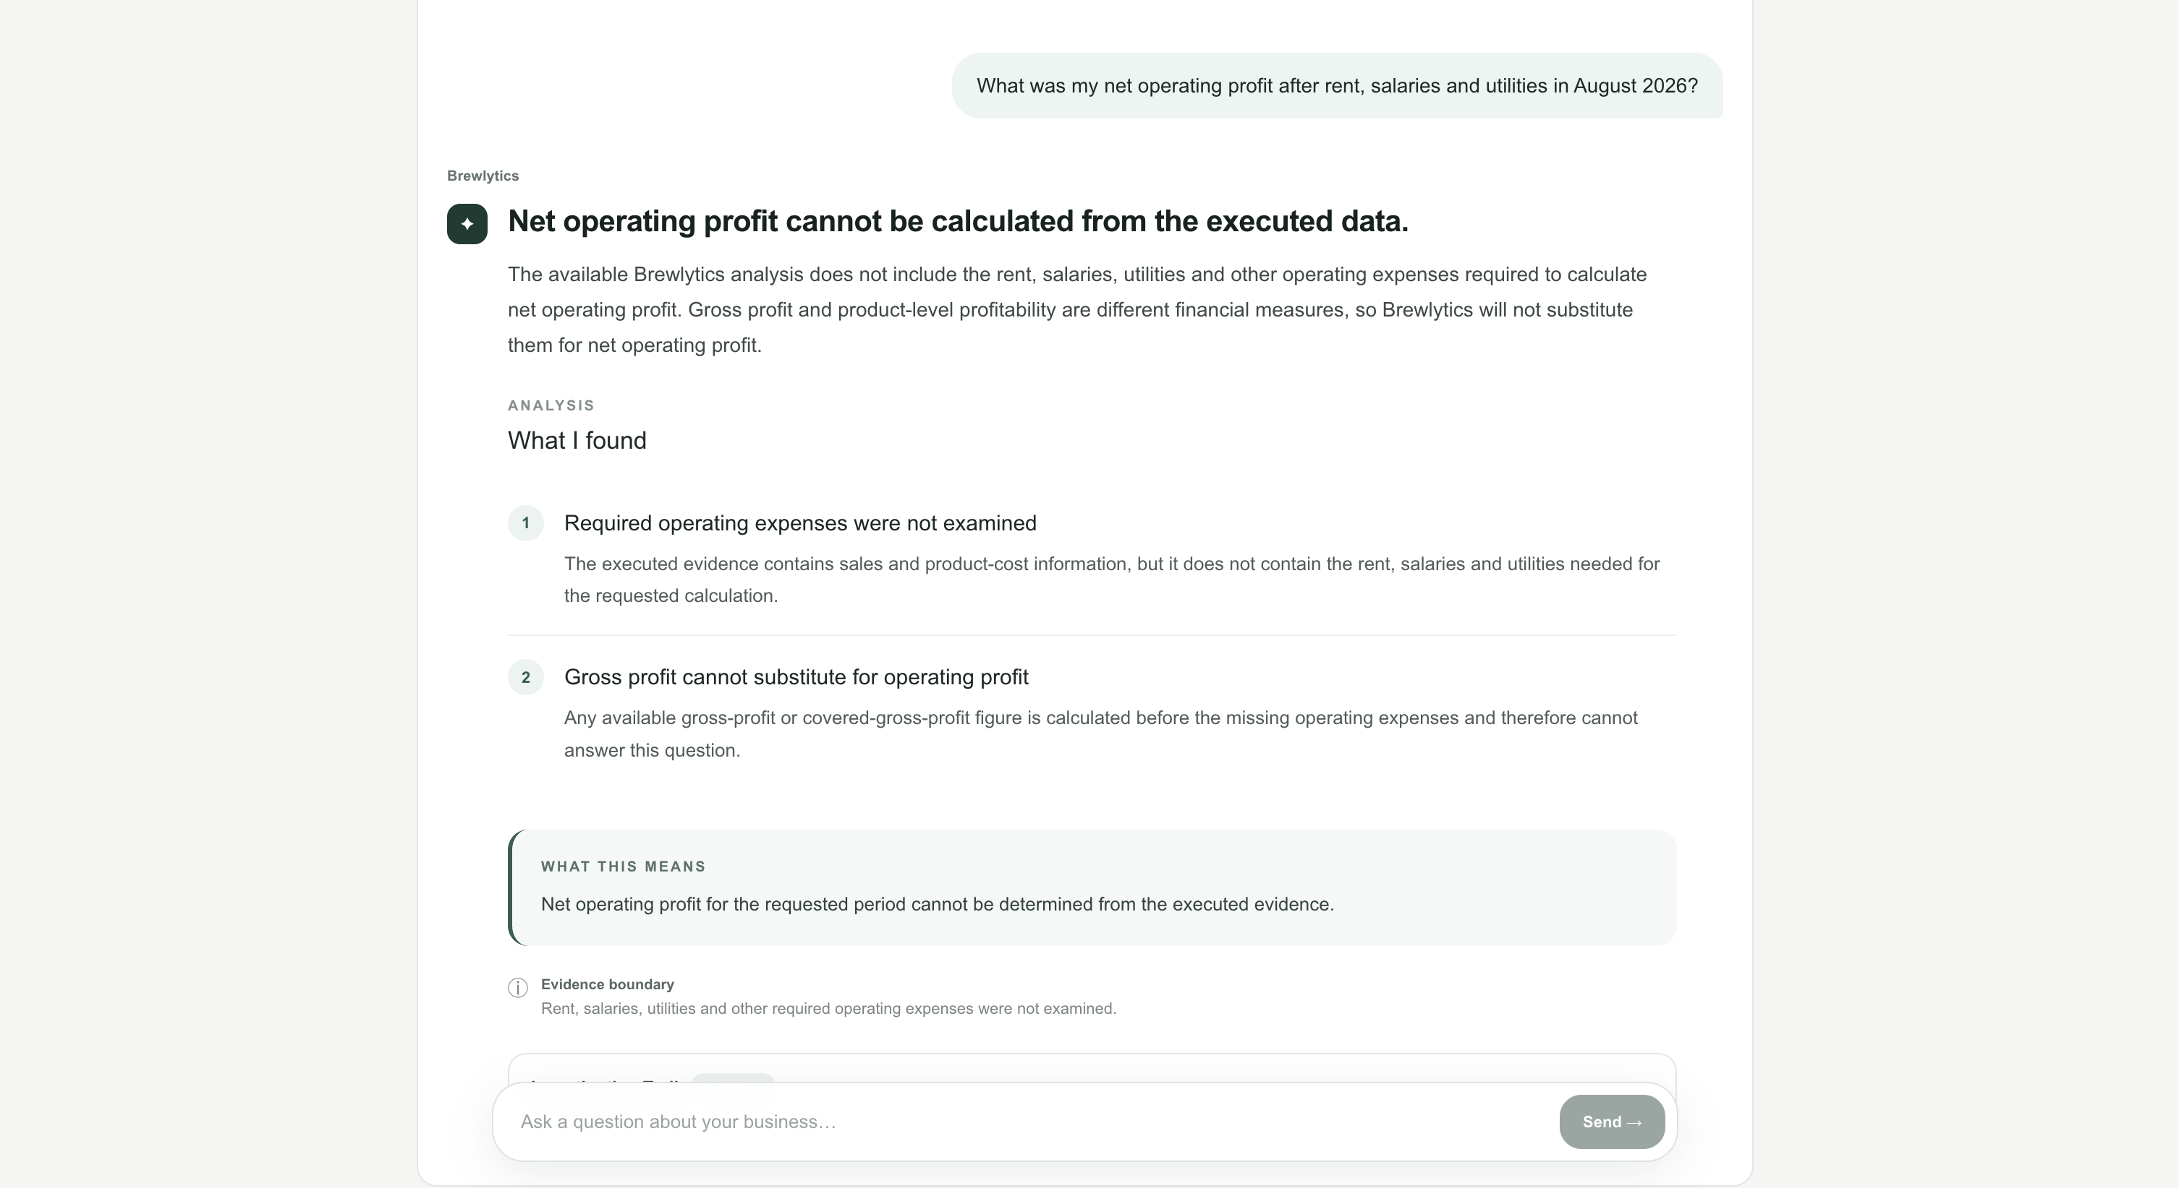 | ☐ Pass ☐ Fail ☐ Blocked | 

Numerical /2 | Grounding /2 | Conclusion /2 | Limitations /1 | Clarity /1 | Total /8
2 | 2 | 2 | 1 | 1 | PASS (8/8)  Brewlytics correctly stated that net operating profit could not be calculated because rent, salaries, utilities and other operating expenses were not included in the analysed data. It clearly distinguished gross profit from net operating profit and did not substitute another available profit figure or invent missing expenses.  Overall: Both previously failing financial-evidence tests now pass. The financial guard successfully prevents Brewlytics from reporting unsupported profit figures.

AI-10 | Prescriptive recommendation
Based only on the uploaded evidence, what should the café owner review first to improve gross profit?
Test steps | Expected result / acceptance criteria
Open ChatBot and submit the question exactly as written. Save the complete response. | Prioritise an evidence-backed review of Iced Latte and/or the croissant. Separate facts from assumptions, avoid guarantees, and mention missing Blueberry Muffin cost.  Pass when: The main conclusion is correct, no evidence is fabricated, and the rubric score is at least 6/8.

Actual result | Status | Evidence / screenshot path
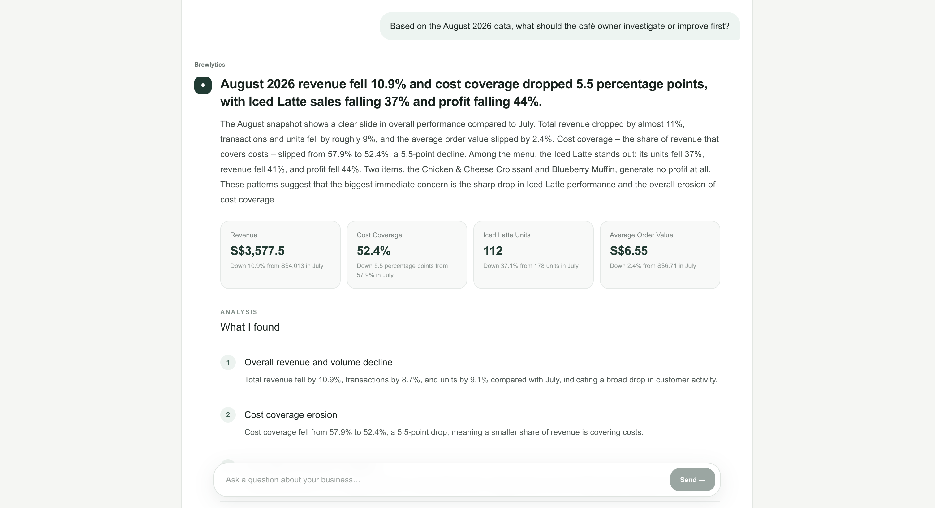 | ☐ Pass ☐ Fail ☐ Blocked | 

Numerical /2 | Grounding /2 | Conclusion /2 | Limitations /1 | Clarity /1 | Total /8
1 | 2 | 2 | 1 | 1 | PASS (7/8). Brewlytics gave a useful, evidence-backed recommendation to investigate Iced Latte first, supported by its substantial declines in units, revenue and profit. It appropriately qualified the recommendation and acknowledged incomplete cost data. However, some profitability and cost-coverage figures were inaccurate due to the known product-cost mapping issue, and the response overstated the zero-profit interpretation for products with missing costs.

6. AI scoring rubric
Criterion | Score | Definition
Numerical accuracy | 0–2 | 2: correct within normal rounding; 1: correct direction but an important figure is missing/slightly inconsistent; 0: materially wrong.
Evidence grounding | 0–2 | 2: all material claims supported; 1: mostly grounded with vague unsupported wording; 0: fabricated evidence.
Conclusion | 0–2 | 2: directly correct; 1: partly correct or unclear; 0: incorrect.
Limitation handling | 0–1 | 1: relevant missing data/uncertainty stated; 0: hidden or ignored.
Clarity and usefulness | 0–1 | 1: understandable and useful to a café owner; 0: confusing or unusable.

Pass rule: score at least 6/8, contain no fabricated product, metric, external event or cause, and reach the correct main conclusion. Any fabricated evidence or unsupported causal claim is an automatic failure.
7. 7. Consolidated results

Test ID | Actual result / response summary | Score /8 | Status | Evidence path
AI-01 | Correctly identified lower August sales/orders and qualified gross profit because cost coverage was incomplete. | 8 | ☒ P ☐ F ☐ B | Manual AI test record — AI-01
AI-02 | Correctly identified Iced Latte as the largest covered-gross-profit decline contributor at about S$377.20. Minor limitation: missing-cost Blueberry Muffin was represented as zero profit in a product-level comparison. | 7 | ☒ P ☐ F ☐ B | Manual AI test record — AI-02
AI-03 | Correctly identified Matcha Latte as the high-margin, lower-volume opportunity: about 66.43% margin and 72 orders. | 8 | ☒ P ☐ F ☐ B | Manual AI test record — AI-03
AI-04 | Correctly identified Chicken & Cheese Croissant as the popular low-margin product: 134 orders and about 27.06% margin. Minor limitation: missing-cost Blueberry Muffin was represented as zero margin/profit in a product-level comparison. | 6 | ☒ P ☐ F ☐ B | Manual AI test record — AI-04
AI-05 | Correctly reported discounts increasing from S$15.50 to S$51.50 and refunds from S$0 to S$6 without claiming causation. | 8 | ☒ P ☐ F ☐ B | Manual AI test record — AI-05
AI-06 | Correctly identified Dine-in as the highest August channel at about S$1,210.00. | 8 | ☒ P ☐ F ☐ B | Manual AI test record — AI-06
AI-07 | Correctly declined to provide an exact whole-café gross profit because costs were incomplete; reported S$1,567.20 covered gross profit and about 87.37% coverage. | 8 | ☒ P ☐ F ☐ B | Manual AI test record — AI-07
AI-08 | Correctly stated that weather was not measured and that causation could not be established. | 8 | ☒ P ☐ F ☐ B | Manual AI test record — AI-08
AI-09 | Correctly stated that net operating profit could not be calculated because rent, salaries, utilities and other operating expenses were unavailable. | 8 | ☒ P ☐ F ☐ B | Manual AI test record — AI-09
AI-10 | Provided an evidence-based recommendation to review Iced Latte and/or the croissant, while distinguishing evidence from assumptions and acknowledging incomplete cost data. Recommendation could have been more prioritised. | 7 | ☒ P ☐ F ☐ B | Manual AI test record — AI-10

