Hit or Flop? Predicting Billboard Chart Success from Spotify Audio Features, 1960–2019
A cross-era comparison of classifier performance and feature importance (SHAP)
Classification · Spotify Hit Predictor Dataset (Kaggle) · 41,103 tracks

1. Introduction
Recorded-music revenue reached US$29.6 billion in 2024, up 4.8% year on year, with paid streaming subscriptions rising 10.6% to 752 million users worldwide (IFPI, 2025). In a market where a small share of tracks captures a disproportionate share of attention and revenue, understanding what makes a hit is commercially central.
This study asks two linked questions. First, which classifier — Logistic Regression, Random Forest, or K-Nearest Neighbours — best predicts whether a track reached the Billboard Hot 100 from its Spotify audio features? Second, which features matter most, and does their importance shift across musical eras from 1960 to 2019? Rather than treating the task as a single static classification problem, we model each era separately and compare feature importance (via SHAP) across eras, turning a model-comparison exercise into a study of how the determinants of commercial success have evolved.

2. Data
The Spotify Hit Predictor Dataset (1960–2019; Kaggle, theoverman) labels 41,106 tracks as hit (reached the Billboard Hot 100) or flop, each described by Spotify audio features. The data are distributed as six per-decade files (1960s–2010s) and are exactly balanced (50% hit, 50% flop) within every decade. After removing three records with invalid sensor readings (a tempo or time-signature of zero), 41,103 tracks remained.
We retained fifteen numeric audio and structural features: danceability, energy, key, loudness, mode, speechiness, acousticness, instrumentalness, liveness, valence, tempo, duration, time-signature, chorus-hit location, and number of sections. Track, artist, and URI identifiers were dropped. A small number of tracks (546; ~1.3%) appear in more than one decade file; because each era is modelled independently, this does not bias the within-era comparisons.
Era grouping. To keep the number of models manageable and the comparison interpretable, the six decades were grouped into three industry eras reflecting the dominant distribution medium: an Analog era (1960–1989; n = 23,315), a CD/Digital era (1990–2009; n = 11,391), and a Streaming era (2010–2019; n = 6,397). Per-decade models were also fitted to trace finer-grained trends.

3. Methods
All features were standardised (z-score) before fitting the distance- and coefficient-based models (Logistic Regression and KNN); the Random Forest used the raw feature scale. Three classifiers were compared: Logistic Regression (L2-regularised), Random Forest (150 trees), and K-Nearest Neighbours (k = 25). Each model was evaluated within every era and decade using stratified five-fold cross-validation, reporting accuracy, F1, and ROC-AUC averaged across folds.
Feature importance was assessed with the best-performing model (Random Forest) using SHAP (TreeExplainer), reported as the mean absolute SHAP value per feature within each era and decade. To make exact TreeSHAP tractable on the larger subsets, the interpretation forest was depth-capped (max_depth = 14); its cross-validated ROC-AUC stayed within 0.005 of the unconstrained forest, so the cap does not materially change the model being explained. The direction of each feature's effect was summarised with standardised Logistic-Regression coefficients, where a positive coefficient pushes a track toward hit.

4. Results

4.1 Classifier performance
Random Forest was the strongest classifier in every era and decade (Table 1, Figure 1). Within eras its ROC-AUC was 0.844 (Analog), 0.916 (CD/Digital), and 0.911 (Streaming), ahead of KNN and Logistic Regression by roughly 0.03–0.06 AUC. A clear secondary pattern emerges: hits became more predictable from audio features over time. Per-decade Random-Forest AUC rose from about 0.85 in the 1960s–70s to a peak of 0.92 in the 2000s, easing slightly to 0.91 in the 2010s (Figure 1b).
Table 1. Cross-validated performance of the three classifiers by era (mean over 5 folds). Random Forest, the best model per era, is shaded.
Era | Classifier | N | Accuracy | F1 | ROC-AUC
Analog (1960–89) | Logistic Regression | 23,315 | 0.714 | 0.735 | 0.786
 | Random Forest | 23,315 | 0.766 | 0.783 | 0.844
 | KNN | 23,315 | 0.725 | 0.760 | 0.801
CD/Digital (1990–2009) | Logistic Regression | 11,391 | 0.801 | 0.812 | 0.874
 | Random Forest | 11,391 | 0.845 | 0.851 | 0.916
 | KNN | 11,391 | 0.803 | 0.825 | 0.883
Streaming (2010s) | Logistic Regression | 6,397 | 0.807 | 0.823 | 0.865
 | Random Forest | 6,397 | 0.841 | 0.850 | 0.911
 | KNN | 6,397 | 0.779 | 0.812 | 0.857
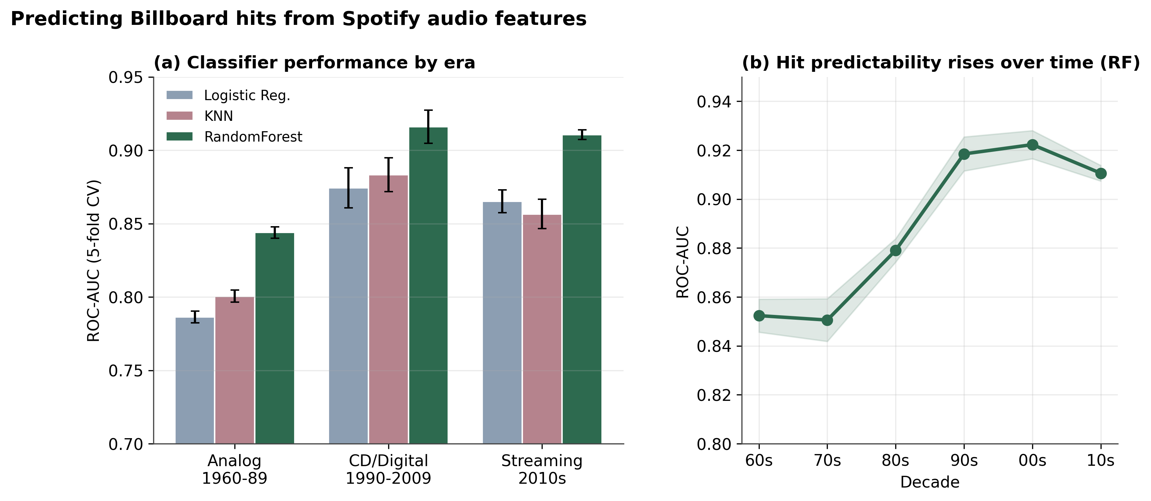
Figure 1. Classifier performance by era (a) and the rise in hit predictability across decades for the Random Forest (b).

4.2 Feature importance by era
Instrumentalness — essentially the absence of vocals — was the single most important predictor in every era, and its importance grew steadily (mean |SHAP| 0.094 → 0.118 → 0.164 from Analog to Streaming; Table 2, Figure 2). The most striking re-ordering is loudness, which climbed from the fifth most important feature in the Analog era to second in the Streaming era. Conversely, speechiness fell sharply (third to eighth) and acousticness drifted down (second to fourth), while danceability peaked in the CD/Digital era.
Table 2. Mean absolute SHAP value (and importance rank) per feature in each era, ordered by Analog-era importance.
Feature | Analog (1960–89) | CD/Digital (1990–2009) | Streaming (2010s)
instrumentalness | 0.094 (#1) | 0.118 (#1) | 0.164 (#1)
acousticness | 0.060 (#2) | 0.065 (#4) | 0.049 (#4)
speechiness | 0.055 (#3) | 0.026 (#7) | 0.010 (#8)
danceability | 0.047 (#4) | 0.093 (#2) | 0.058 (#3)
loudness | 0.033 (#5) | 0.040 (#5) | 0.064 (#2)
energy | 0.031 (#6) | 0.029 (#6) | 0.044 (#5)
valence | 0.026 (#7) | 0.018 (#8) | 0.024 (#7)
duration_ms | 0.024 (#8) | 0.067 (#3) | 0.033 (#6)
mode | 0.018 (#9) | 0.006 (#12) | 0.001 (#15)
sections | 0.014 (#10) | 0.014 (#9) | 0.007 (#10)
tempo | 0.013 (#11) | 0.009 (#11) | 0.008 (#9)
liveness | 0.010 (#12) | 0.009 (#10) | 0.007 (#11)
time_signature | 0.005 (#13) | 0.002 (#15) | 0.004 (#13)
chorus_hit | 0.004 (#14) | 0.005 (#13) | 0.006 (#12)
key | 0.003 (#15) | 0.003 (#14) | 0.004 (#14)
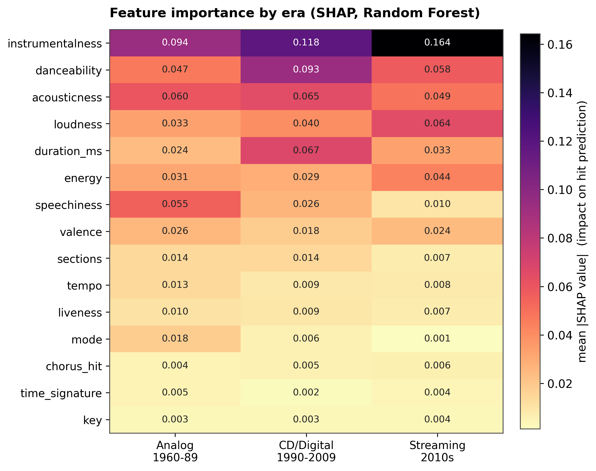
Figure 2. Feature importance (mean |SHAP|) by era. Darker cells mark stronger influence on the hit prediction.

4.3 Trend across decades
The decade-level view (Figure 3) shows these shifts as smooth trajectories rather than abrupt jumps: instrumentalness rises throughout and accelerates after the 1990s; loudness climbs steadily from the 1990s onward; while danceability and song-duration importance peak around the 1990s and then recede.
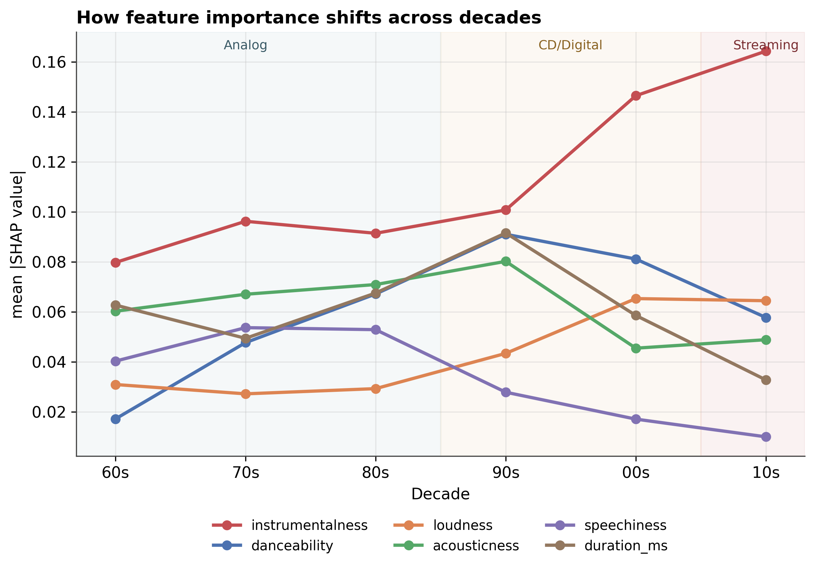
Figure 3. How feature importance (mean |SHAP|) shifts across the six decades, shaded by era.

4.4 Direction of effect
Standardised logistic-regression coefficients (Figure 4) make the direction explicit and show it intensifying over time: high instrumentalness pushes strongly toward flop (coefficient −0.82 in the Analog era, deepening to −2.42 in the Streaming era), while high loudness increasingly pushes toward hit (+0.28 → +1.93). In short, the modern hit is reliably vocal-forward and loud. The SHAP beeswarm plots in the accompanying interactive dashboard confirm this at the level of individual tracks.
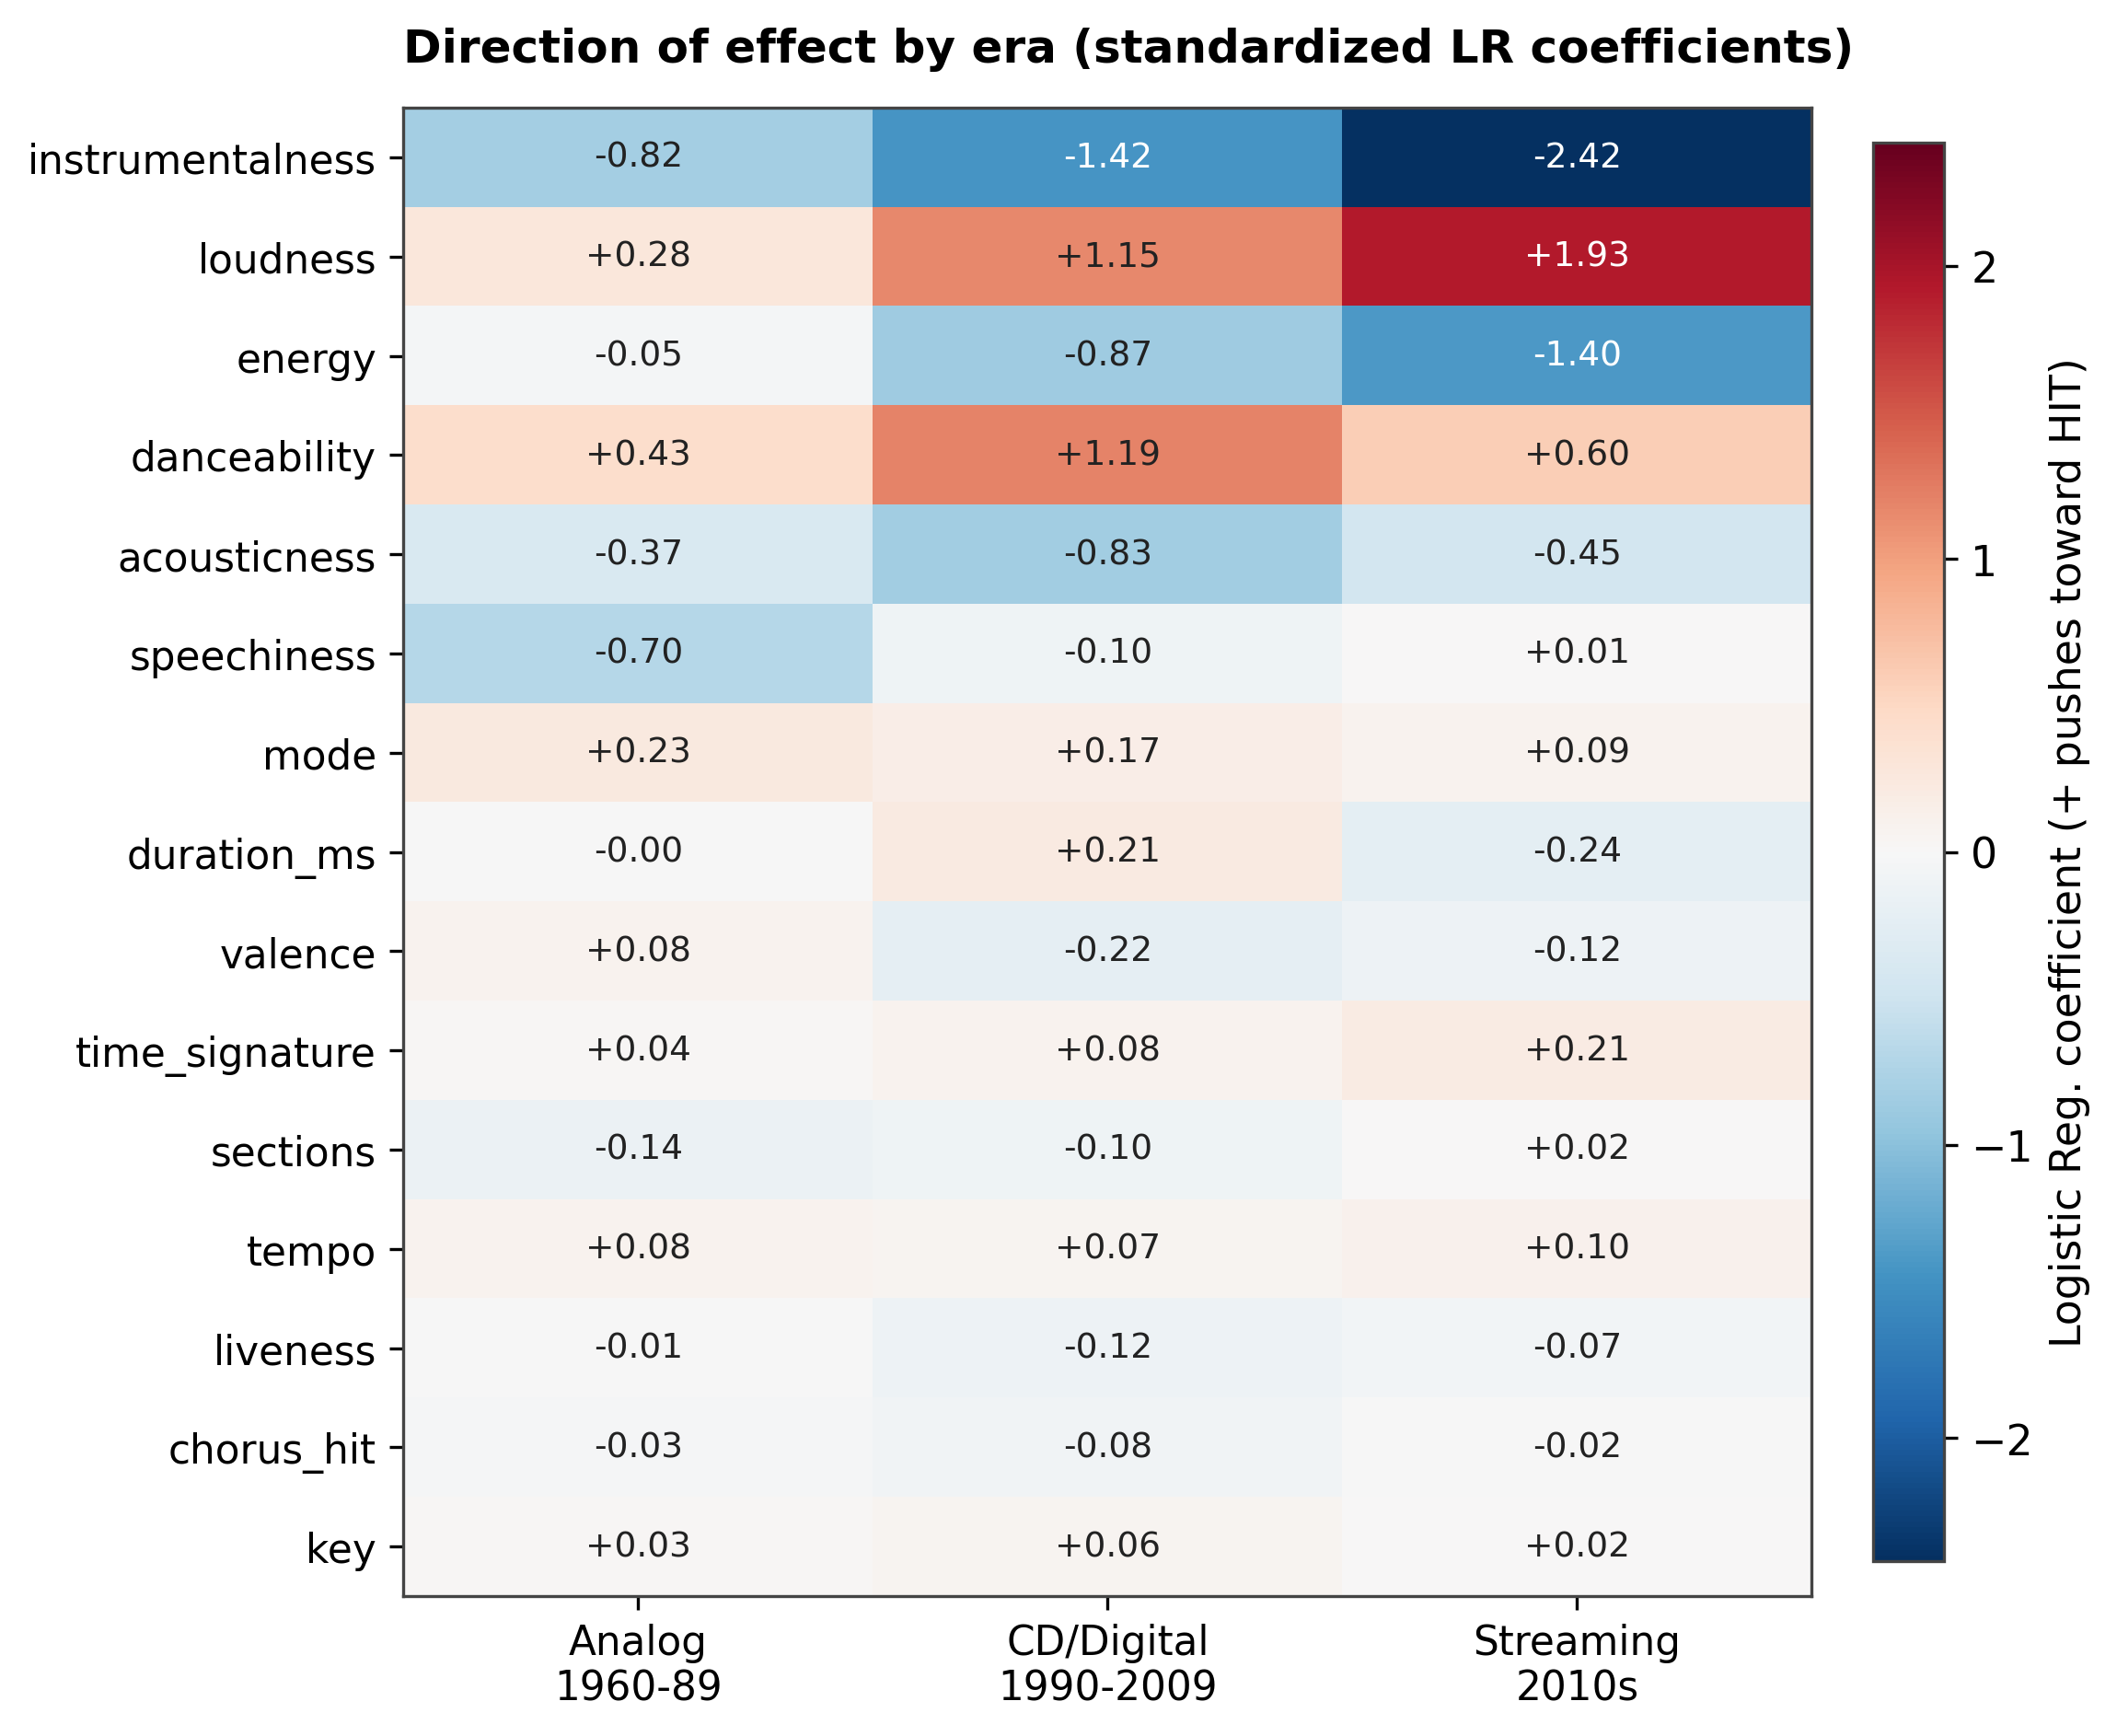
Figure 4. Direction of effect by era (standardised logistic-regression coefficients). Blue pushes toward hit, red toward flop.

5. Discussion
The results tell a coherent story that maps onto known shifts in music production and distribution. The growing importance and steepening penalty of instrumentalness reflect an increasingly vocal-centric, song-over-composition pop market. The sharp rise of loudness is consistent with the well-documented “loudness war” and streaming-era mastering practices, where higher perceived loudness aids engagement. The decline of acousticness and speechiness, together with the mid-period prominence of danceability, aligns with the rise of electronic, dance-oriented production through the 1990s and 2000s. Finally, the overall increase in predictability suggests that the audio signature of a commercial hit has become more standardised: the features Spotify measures separate hits from flops more cleanly in the streaming era than they did in the 1960s.

6. Limitations
- Balanced sampling. The dataset is 50/50 hit/flop by construction, so reported accuracies do not reflect real-world base rates (hits are rare); ROC-AUC and the relative feature comparisons are the more meaningful outputs.
- Era as a decade proxy. Precise release years are not provided, so era boundaries follow the decade files rather than externally dated industry events.
- Encoding of key. Musical key was treated as an ordinal numeric rather than one-hot encoded — a minor simplification, given its consistently low importance.
- Retained noise. Cross-decade duplicate tracks (~1.3%) and a few extreme audio outliers (e.g., very long durations) were kept rather than removed.
- Association, not causation. SHAP describes feature influence within the model, not causal effects; both the definition of a “hit” and Spotify's audio-feature extraction may themselves vary across eras.

7. Conclusion
A Random Forest predicts Billboard chart success from Spotify audio features well, and consistently better than Logistic Regression or KNN, reaching ROC-AUC ≈ 0.92 in the modern era. More importantly, the drivers of success are not static: vocal presence (instrumentalness) and loudness have become steadily more decisive into the streaming era, while speechiness and acousticness have faded. Modelling each era separately and comparing SHAP importance turns a routine classifier benchmark into evidence about how the sound of a hit has changed across six decades.

References
IFPI. (2025). Global Music Report 2025: global recorded music revenues grew 4.8% in 2024. ifpi.org
theoverman. The Spotify Hit Predictor Dataset (1960–2019). Kaggle. kaggle.com

