Research Plan Summary
Horizon-Adaptive Weighted Ensemble for Multi-Horizon Crime Forecasting
Dataset: Chicago Crimes 2001–present (City of Chicago, ijzp-q8t2) • Target venue: IEEE Access (Scopus-indexed) • Prepared June 2026
Note: This summary consolidates the agreed plan. Research questions and the contribution come from the supervisor's recommendations (refined); hypotheses are derived by the author and marked PROPOSED for approval. See the Provenance section for the source of each item.

1. Background & Problem
Short-term crime forecasting supports patrol allocation and resource planning. Chicago's open data portal logs ~8 million reported incidents since 2001 and updates daily, making it one of the richest public crime time series available. Forecasting weekly counts per police district is complicated by strong seasonality, long-run trend shifts, and a sharp structural break during 2020 (COVID-19).

2. Research Gap & Positioning
A plain “ensemble of SARIMA + Prophet + XGBoost” on Chicago crime is a saturated template (already published, e.g., Neural Computing & Applications 2025), and state-of-the-art spatiotemporal models (ST-GNNs, attention) chase raw accuracy. This study does not compete with those on accuracy. Instead, it targets an under-tested question: when does ensembling help, and is the optimal model mix stable across forecast horizons and across a regime shift?

3. Contribution & Novelty
A weighted ensemble whose member weights are re-estimated per forecast horizon (and per regime) beats both the best single model and the conventional static inverse-RMSE ensemble for district-level weekly crime counts — and this advantage is largest at longer horizons and across the 2020 COVID structural break.
The contribution is the mechanism and the finding (the optimal mix is not constant; it shifts with horizon and regime), not the assembly of off-the-shelf models. Three concrete novelty hooks:
- Horizon-adaptive weighting — a separate constrained weight vector is fit per horizon; the weight ordering changes with horizon.
- Regime robustness — rolling/adaptive weights re-allocate authority across the 2020 break (the “weight-trajectory” figure is the memorable result).
- Honest evaluation — a seasonal-naive floor plus per-horizon Diebold–Mariano tests; the paper reports when ensembling does not help.

4. Research Questions
From the supervisor's recommendations (wording refined):
- RQ1. Among SARIMA, Prophet, and XGBoost (lag/calendar features), which best forecasts next-week district-level crime counts, and does the ranking hold as the horizon grows to 4/8/12 weeks?
- RQ2. Does a weighted ensemble beat the best single model across horizons with statistical significance (Diebold–Mariano), and does a horizon-adaptive weighting scheme beat a static inverse-RMSE scheme?
- RQ3. How do the optimal model and weights shift across the 2020 regime break and across districts — i.e., is adaptivity the source of the gain?

5. Hypotheses (Proposed — derived by author)
These were not given in the recommendations; they are the testable predictions implied by the contribution, offered for the supervisor's approval.
- H1. At short horizons (h=1) strong single models (SARIMA / seasonal-naive) are competitive; the ensemble's advantage over the best single model grows with horizon (h=4/8/12).
- H2. The optimal base-model weights are not constant across horizons — the best mix at h=1 differs from h=12 (motivating horizon-adaptive weighting).
- H3. Across the 2020 break, a regime/rolling-adaptive ensemble outperforms the static inverse-RMSE ensemble, with weight mass shifting from SARIMA toward XGBoost during the shock and reverting afterward.
- H4. Ensemble gains over the best single model are larger in higher-volatility districts than in stable ones.
- H5. The adaptive ensemble beats the seasonal-naive baseline at all horizons; where it does not, this is reported as a finding.

6. Scope (Locked)
Decision | Locked value
Spatial unit | 22 active police districts (001–012, 014–020, 022, 024, 025)
Target | Weekly total incident count per district
Secondary slice | Top crime types (THEFT, BATTERY, CRIMINAL DAMAGE, ASSAULT, DECEPTIVE PRACTICE) — heterogeneity sub-analysis only
Horizons | 1, 4, 8, 12 weeks (direct strategy; recursive as sensitivity)
Period | 2001 – latest complete week (data current to ~mid-2026)
2020 break | Featured/modeled through (break indicator + adaptive weights); also a robustness regime

Why district totals (not per-type cells): even the lowest-volume district (D020) averaged ~109 incidents/week in 2024, so weekly totals never hit zero and MAE/RMSE/MAPE/SMAPE stay well-behaved.

7. Data Summary (from EDA on the real data)
- 305 months, Jan 2001 – May 2026; ~8M incidents; peak month Jul 2002 (46,015).
- Long-run decline: annual ~486k (2001) → ~262k (2019) → ~259k (2024); strong summer seasonality.
- 2020 structural break: annual −18.7% (2019→2020); April 2020 trough 12,958 (−38% vs April 2019); partial recovery from 2022.
- 22 clean districts; artifacts dropped (031, blank, retired 013/021/023).
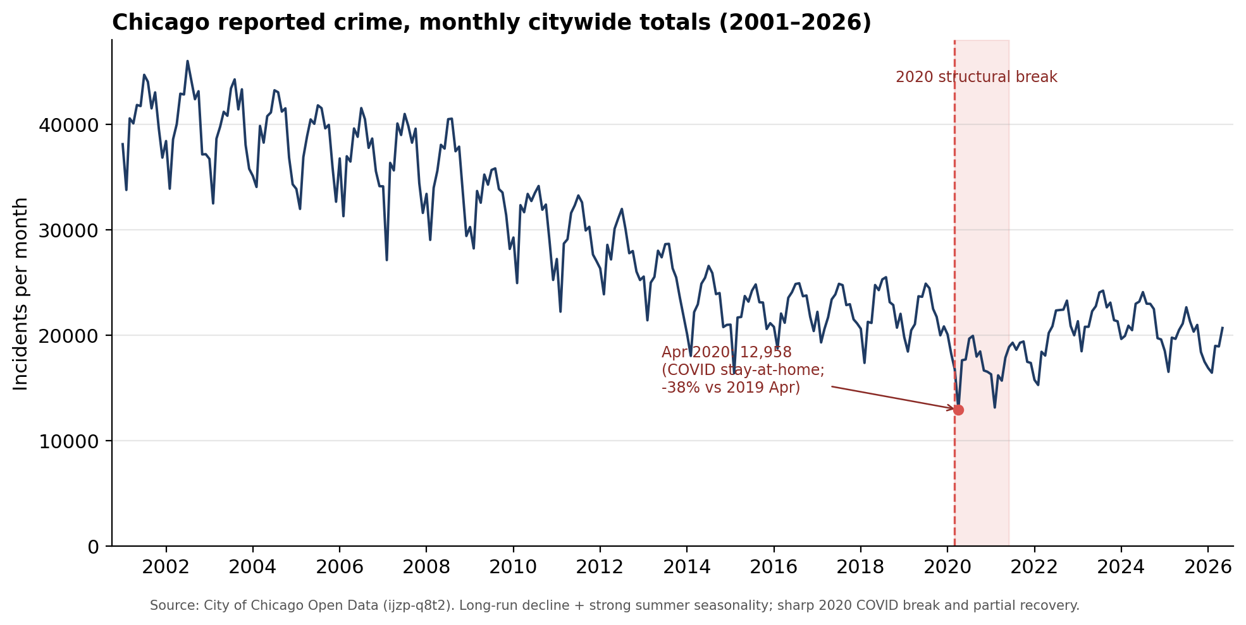
Figure 1. Monthly citywide reported crime (2001–2026); the 2020 COVID structural break is shaded.

8. Methodology
- Aggregate raw incidents to a weekly district × week panel; absent weeks are true zeros (filled, not deleted).
- Strictly temporal split + rolling-origin CV (no shuffling): train ≤ 2021, validation 2022–2023, test 2024+.
- Feature engineering (for XGBoost): lags, rolling statistics, calendar/holiday flags, 2020 break indicators — leakage-safe.
- Base models: seasonal-naive baseline, SARIMA (auto_arima, cached), Prophet, and a global XGBoost across the panel (district as feature).
- Ensemble: static inverse-RMSE baseline plus horizon-adaptive and regime-adaptive constrained-weight variants; weights fit on validation only (no test leakage).
- Evaluate at 1/4/8/12 weeks; analyze robustness, significance, and interpretability (below).
Workload note: 22 districts are handled by one automated pipeline (a single global XGBoost; SARIMA/Prophet looped with cached parameters and parallelized), not 22 manual fits. The pipeline is prototyped on a small subset of districts, then scaled to all 22.

9. Evaluation
- Metrics: MAE and RMSE primary; MAPE/SMAPE reported with the zero/low-count caveat; MASE (error scaled by the seasonal-naive) to express skill relative to the floor.
- Baseline: seasonal-naive (same week last year) as the mandatory floor.
- Significance: Diebold–Mariano test, ensemble vs best single model, per horizon.

10. Robustness & Stability
Sensitivity across districts, random seeds, and weight schemes; confidence intervals; pre/within/post-2020 regimes. Centerpiece: the weight-trajectory analysis showing authority shifting between members across the 2020 break.

11. Interpretability
SHAP applied to the XGBoost member only, framed explicitly as explaining that component (not the full ensemble); surfaces the dominant lag/calendar drivers.

12. Ethics & Responsible Use
Reported crime (CLEAR data) reflects enforcement and reporting, not true crime, and carries feedback-loop risk. This work forecasts aggregate district-level workload for resource planning, not individuals or specific locations; no demographic features are used and locations are block-level only. Results should not be used for targeting decisions.

13. Provenance (where each item comes from)
Item | Source
Topic & dataset (Chicago crime, weekly time series) | Supervisor recommendation (message 1)
Research questions RQ1–RQ3 | Supervisor recommendation (message 2); wording refined by author
Contribution: horizon-adaptive ensemble + 2020-break robustness | Supervisor recommendation (message 2, options a & b); validated via literature scan + council review
Models (SARIMA, Prophet, XGBoost), weighted ensemble, multi-horizon | Supervisor recommendation (message 2)
Metrics, Diebold–Mariano test, SHAP | Supervisor recommendation (message 2)
Scope: 22 districts, weekly totals, temporal split + rolling-origin CV | Supervisor methodology list; confirmed by author EDA
Decision to keep all 22 districts (vs a subset) | Author decision, evidence-based (published Chicago studies use 22; council 5/5)
Hypotheses H1–H5 | Derived by author from the contribution — PROPOSED for approval
Global-model / automation approach | Author design choice (global forecasting models for many related series)
Data facts (305 months, −18.7% in 2020, district volumes) | Author EDA on the actual dataset

14. Starter References (IEEE style)
[1] City of Chicago, “Crimes — 2001 to Present,” Chicago Data Portal, dataset ijzp-q8t2.
[2] R. J. Hyndman and G. Athanasopoulos, Forecasting: Principles and Practice, 3rd ed. OTexts, 2021.
[3] F. X. Diebold and R. S. Mariano, “Comparing predictive accuracy,” J. Bus. Econ. Stat., vol. 13, no. 3, 1995.
[4] S. J. Taylor and B. Letham, “Forecasting at scale,” The American Statistician, vol. 72, no. 1, 2018.
[5] T. Chen and C. Guestrin, “XGBoost: A scalable tree boosting system,” in Proc. KDD, 2016.
[6] S. M. Lundberg and S.-I. Lee, “A unified approach to interpreting model predictions,” in NeurIPS, 2017.
[7] P. Montero-Manso and R. J. Hyndman, “Principles and algorithms for forecasting groups of time series: Locality and globality,” Int. J. Forecasting, vol. 37, no. 4, 2021.

